

Module Code: BMIH4002
Module Name: Food and Beverage Operation
Assignment Title: Menu Engineering
Assignment No: 2
Student ID: 2241338
Student Name: Adam Maria-Monica
Lecturer’s name: Antoinette Milne

Table of Contents
1. PART 1: Restaurant Concept 3
1.1 Target Audience 3
1.2 Reasoning behind Menu Choices 3
2 PART 2: Menu Design 5
3 References 11

PART 1: Restaurant Concept
The new option added to the menu of Hotel Trinity is the famous, delicious and most demanded dishes from Spain, Italy, and France. The new menu offers a variety of dishes from various cultures in one place (De and Aiking, 2019), with an outstanding ambience and quality service. In today's business environment, where consumer preferences and demands are the most focused elements within the hospitality sector, as the sector is consumer-centric (Wood, 2013), Trinity Hotel is also focused towards ensuring that consumers' demand and needs are being met with the time and they are being provided with quality service as well (Aleksandrovna et al., 2021). The newly added dishes within the menu belong to different countries and cultures, and as there is demand for these dishes (Laiet al., 2019; Nurjamal and Abish, 2023).

1.1 Target Audience
Target audience is described by the Kitunenet al., (2019) as the market segment to whom businesses want to target and focus in order to sell their services and products. Hotel Trinity targets various types of consumers, such as vegetarians and non-vegetarians, as their new menu includes a variety of dishes (Li et al., 2020). As Italian cuisine is important in the world, the menu will be served according to the demands and preferences of the target audience. It is vital to understand the unique tastes that customers want, as it is important for a successful cooking experience. With reference to Spanish, French, and Italian cuisine, price targeting enables the establishment of a menu to enhance customer satisfaction and loyalty. From the graph, it has been analyzed that French cuisine is famous among customers to about 97% (Statista, 2023), which will help to attract customers efficiently.

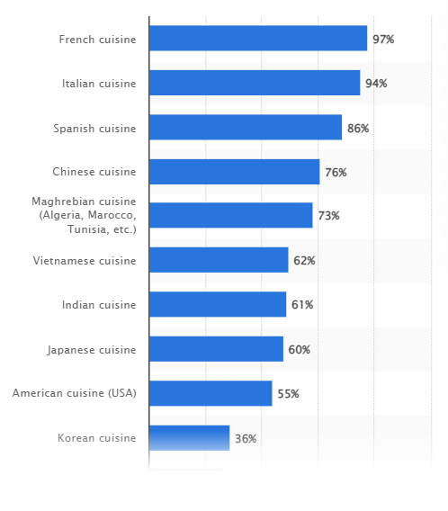
Figure 1: Do you enjoy the following types of international cuisine?
(Source: Statista, 2023)

Reasoning behind Menu Choices
According to Han (2021), consumers are very important for business within the hospitality sector, and their demands have a significant and direct on the financials and revenues of the hospitality industry (Klouvidakiet al., 2023). As the hospitality industry aims to provide consumers with quality service, providing them with dishes of their choice can help in providing quality service (Aliet al., 2021). The main reason behind the menu choice is the customers, as the hospitality sector depends heavenly on consumers and makes sure to provide them with all the demanded dishes with quality services.

PART 2: Menu Design
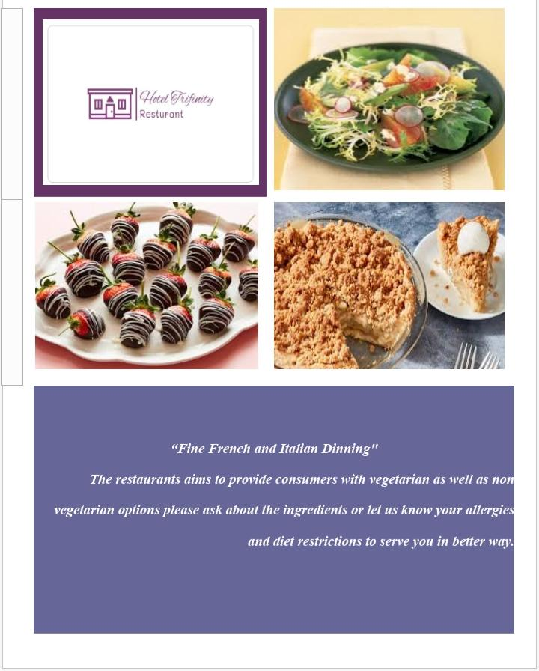
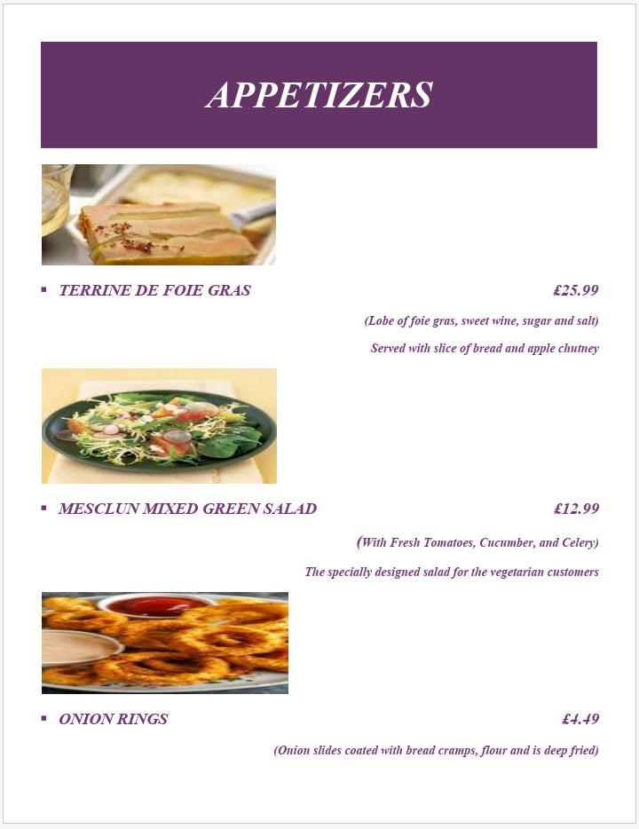
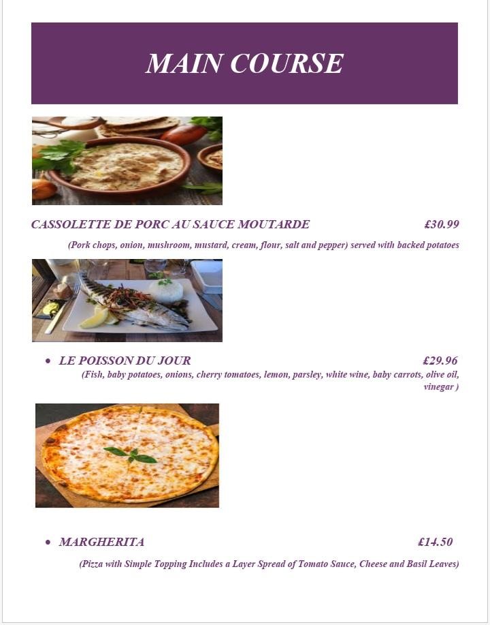

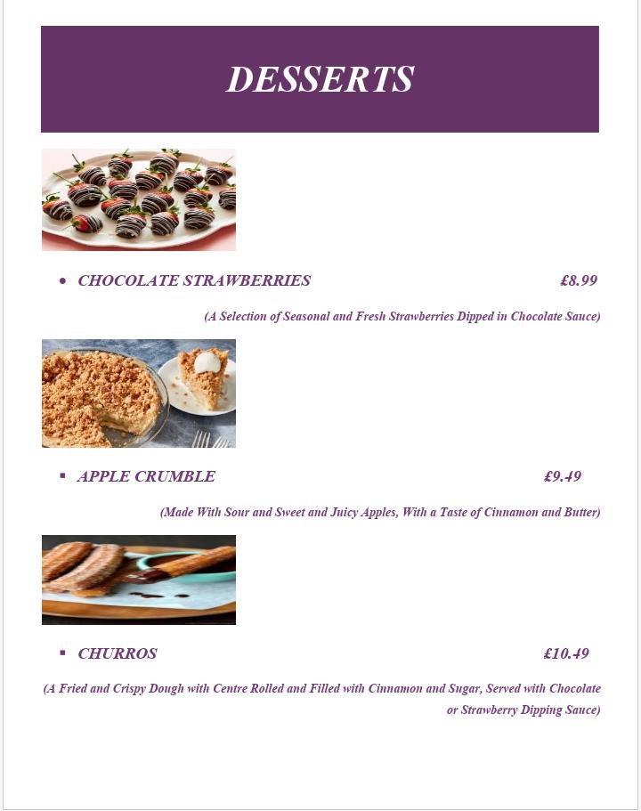
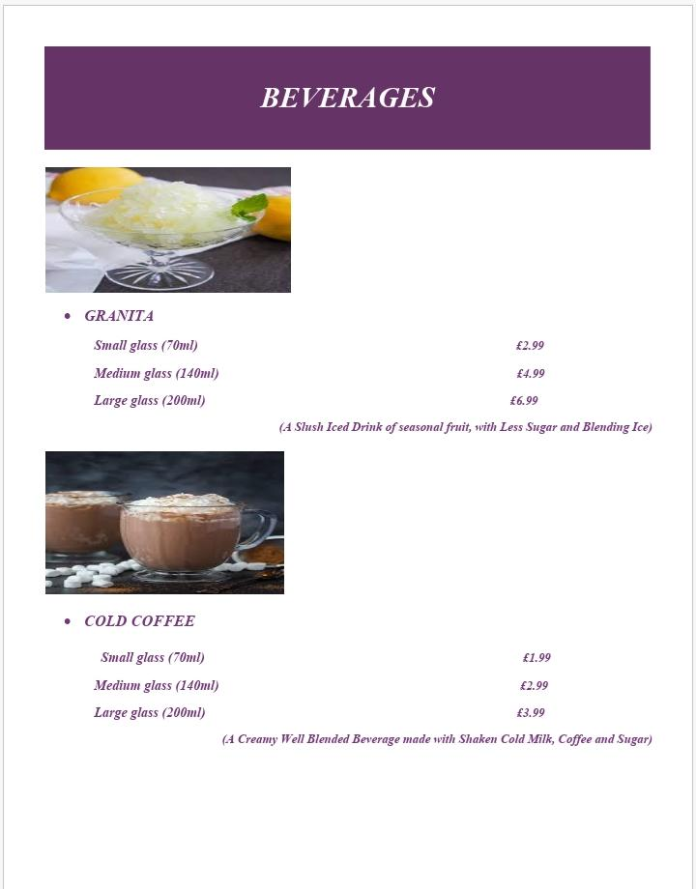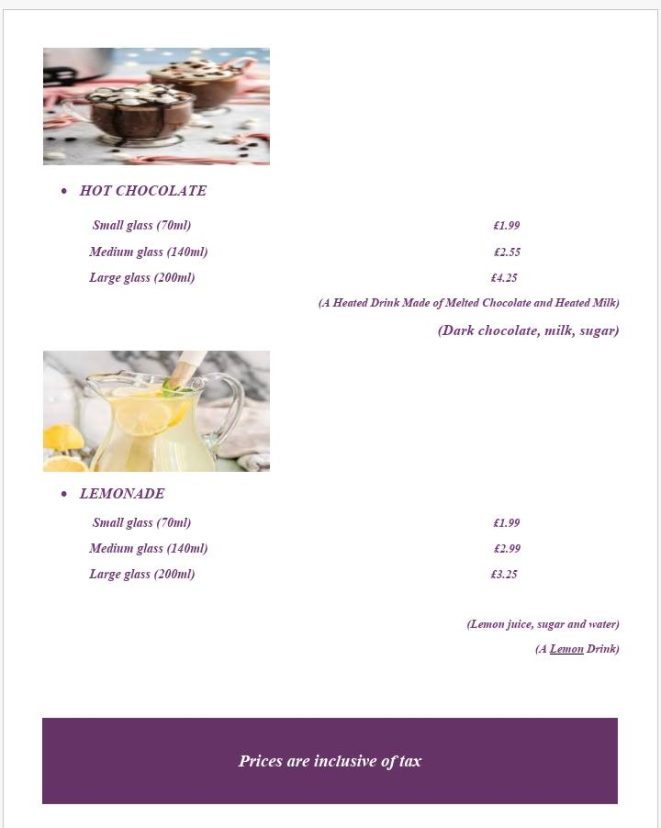

References
Aleksandrovna, T.M., Nazhmidenovna, D.G., Mizamgalievna, A.E., Rysty, B., Gulmira, B., Madina, A. and Shakizada, N., 2021. Sustainable hotel development. Academy of Strategic Management Journal, 20, pp.1-16.
Ali, BJ, Gardi, B., Othman, BJ, Ahmed, SA, Ismael, NB, Hamza, PA, Aziz, HM, Sabir, BY, Anwar, G.(2021). Hotel Service Quality: The Impact of Service Quality on Customer Satisfaction in Hospitality. International Journal of Engineering, Business and Management 5, no. 3 (2021): 14-28.
De Boer, J. and Aiking, H., 2019. Strategies towards healthy and sustainable protein consumption: A transition framework at the levels of diets, dishes, and dish ingredients. Food Quality and Preference, 73, pp.171-181.
Han, H., 2021. Consumer behaviour and environmental sustainability in tourism and hospitality: A review of theories, concepts, and latest research. Journal of Sustainable Tourism, 29(7), pp.1021-1042
Kitunen, A., Rundle-Thiele, S., Kadir, M., Badejo, A., Zdanowicz, G. and Price, M., 2019. Learning what our target audiences think and do: Extending segmentation to all four bases. BMC Public Health, 19, pp.1-10.
Klouvidaki, M.I., Antonopoulos, N., Styliaras, G.D. and Kanavos, A., 2023. Virtual Restaurants: Customer Experience Keeps Their Businesses Alive. Information, 14(7), p.406.
Li, P.H., Keppo, I., Xenitidou, M. and Kamargianni, M., 2020. Investigating UK consumers’ heterogeneous engagement in demand-side response. Energy Efficiency, 13(4), pp.621-648
Lai, I.K., Hitchcock, M., Yang, T. and Lu, T.W., 2018. Literature review on service quality in hospitality and tourism (1984-2014) Future directions and trends. International Journal of Contemporary Hospitality Management, 30(1), pp.114-159.
Nurjamal, K. and Abish, M., 2023. TRADITIONAL DISHES IN DIFFERENT CULTURE. UNIVERSAL JOURNAL OF SOCIAL SCIENCES, PHILOSOPHY AND CULTURE, 1(3), pp.59-68.
Wood, R.C., 2013. Key concepts in hospitality management. Key Concepts in Hospitality Management, pp.1-200.
Statista, 2023. Do you enjoy the following types of international cuisine? [Online] Available at < https://www.statista.com/statistics/1154077/world-cuisine-appreciation-rate-france/> [Accessed on 7th November 2023].

