

Strategic Management
LCMB7003
Lecturer: Amare Desta
Task 2 Individual Assignment
“Critically evaluate the emergence of “Virtual Organisations”
Student Name : Atik Yasinbhai Vahora
Student ID: 2315701

Table of contents
Introduction 3
Discussion 3
- The emergence of virtual organisation 3
- Strategic management issues associated with planning, designing, and leading virtual organisations 5
- Benefits of Virtual Organisation 8
- Challenges of Virtual Organisation 8
- Example of Virtual Organisation 9
- Future Trends and Inference 9
Conclusion 10
Refernce List 11

Introduction
A virtual organisation can be referred to as a dependent organisation on electronic linking for the completion of the procedure. Generally, it is a type of network that was made by the “Information and Communication Technology” that is both flexible and can meet the market dynamics. It is a network with no vertical or horizontal boundaries. Hence, this essay will discuss the emergence of virtual organisations. This essay will also focus on the emergence of virtual organisations and illustrate strategic management issues in leading, planning, and designing strategies for those organisations.

Source: (en.hocmarketing.org,2023)

Discussion
The emergence of virtual organisation
A virtual organisation is a type of operation where the employees of the organisation operate from various geographic locations to work as a unit. According to Asatiani et al. (2021), organisations are now embracing the idea of a virtual work environment rapidly in the chase of the benefits in cost savings to enhance the employee's morale and increase their productivity. Almost 43% of the employees are working remotely from their other team members (Yang et al., 2022). The emergence of virtual work environments is noticeable in occupations that are knowledge-intensive where both the products of the labour and the raw material are based on the information ratio of physical artefacts. Matilla et al. (2022) said that “Low-cost computing and universal internet access” through the basis of cloud services has enhanced the exchange of information by making it more efficient and easier which resulted in releasing the knowledge workers to perform the respective works independently from different locations. This was the main cause for the emergence of such virtual organisational entities which depend on the geographically dispersed network as both individuals or teams that operate without a physical premise sometimes. These organisations operate in various formats of virtual work environments hence they cannot completely rely on the physical interactions among the employees.
As stated by Shaik et al. (2019), “global mobility and technological development” has evolved from the expansion of the range of teams beyond the traditional forms toward the global forms and is dispersed geographically that is operated virtually, and connected technologically which is generally known as the “Global Virtual Teams (GVTs)”. These teams can also be known as “multicultural and multinational distributed teams” or “transnational teams”. These global virtual teams are a form of organising the work through mediated technology communication through a workforce that is spread across all boundaries and cultures which has become a standard for all the forms and types of organisations instead of being limited to the large firms. This is due to the increase in the virtual forms of mediated work through the multicultural and technological nature of the workforce that has become a unique and endemic type of form which is well advised by the researchers to understand the challenges of the virtual organisation.
According to Asatiani et al. (2021), organisational culture can be both beneficial and challenging in virtual organisations. As an efficient organisational culture can help the employees to foster healthy competition in the process, it is beneficial. However, a lack of communication can lead to numerous challenges in the process. These virtual organisations are more culturally diverse as compared to their work environment which has exhibited a “low degree of virtuality”. Here, the cultural diversity in the accumulated organisations is found to be more diverse culturally and beneficial in these virtual organisations. These differences in cultural diversity have helped virtual organisations to know more about diversity and have effective communication. The differences between the staff can be beneficial for the virtual organisation because different people from different regions have diverse thought processes which can contribute to efficient views in the team. A diverse culture also means that it will hThave an impact on the performance of the organisation which can be inclusive and result in a benefit for the virtual organisation. Davidavičienė et al. (2020) said that cultural diversity contributes a lot in achieving the organisations' goals cultural diversity helps in maximizing and developing various skills among the employees because in a culturally diverse workplace, various types of employees have their own set of diverse skill sets and talents and when this wide range of ideas come together then it enables a huge collection of diverse ideas and skill sets which is beneficial for the virtual organisation.
As per Lee (2021), leadership and communication are both interdependent, leadership of a virtual team or virtual organisation is way different from the traditional way of leadership. Virtual or e-leadership is important for leading virtual team projects. Virtual leadership is a way of managing the teams of the organisation through a different working environment. It means that the virtual leaders have to oversee the progress of the team project from completely different regions with completely different time zones from the other employees of the organisation or the virtual team. These types of leaders generally depend on various types of technologies that help them communicate with all the remote employees about their allocated tasks and responsibilities. Virtual leaders always focus on motivating and encouraging remote employees to achieve their organisational goals. They also manage and facilitate the organisation through virtual or online communication depending on the leader's specific leadership styles that are different from face-to-face communications. Although the role of the virtual leader is also similar to that of a traditional leader yet virtual leaders have different means to achieve their goals which allows them to showcase their commitment to achieving the organisation's goals.
Strategic management issues associated with planning, designing, and leading virtual organisations
The process and the stabilisation of the business largely depend on the development of the strategies within the organisation. Each of the strategies is important to recognise the independent execution of the policies. The strategic management issues can be solved with the proper planning, and design as well as some of the effective methods are being implemented to lead the virtual organisations. The most common challenge is setting unrealistic goals along with the organisation's lack the ability to align. The virtual environment provides various challenges in leadership most particularly within communication. Different factors like downsizing, rightsizing, outsourcing, reorganization, and reengineering are used to reduce the workforce of the organisation. In addition to that the reduction strategies are being planned in order to increase the strength of the management while reflecting the current change within the environment. Varied issues such as the setup, maintenance cost as well as cultural issues were the challenges that were also faced. Virtual management as well as project management often require new methods to conduct innovative approaches. Language barrier is an issue that often reduces the opportunity for information communication. In addition to that, there arises a chance of interpreting each other in a different context which means that the High context cultures which include (Asian, Arabian, and Southern European) will face the problem of communicating with the low context cultures which include “Swiss, German, American, Australian” (Lee, 2021). Differences within the perception mean the members can only see what is presented in front of them. There lies a difference within the culture of the company when there is an interaction between the global vendors and the consultants. In addition to that, the time zone consideration as well as the different cultures are seen within the virtual communication.
Virtual teams are important in maintaining the increased economic infrastructure. Most companies prefer effective strategies in order to visualise the growth within the virtual team. In addition to that the virtual teams and the technologies are used to mitigate the issues that are faced by the individual. After the pandemic, the utilisation of technological gadgets has also increased. Some of the physical factors that relate to the distances are thereby coupled with the “cognitive, social, and emotional challenges faced by virtual teams”. Most people have started using the virtual team in order to avoid physical existence thereby minimising the cost of the resources (Morrison-Smith and Ruiz, 2020). All the geographical as well as the cultural, coordination mechanism have been identified for the traditional DSD teams. Geographical distance, Motivation and awareness in distributed collaborations establishing trust, and Informal and face-to-face communication are the four factors that affect the virtual items. Motivating others plays an important role in establishing strong connections with the members of the team. In addition to that most of the leaders often visualise the nature of the people while having a common ground. Alignment with the goals and the process is the responsibility of the leaders.
One of the most impactful issues faced by organisations is presented in terms of ineffective communication leading virtual organisational activities. As Labanauskaitė et al. (2020) suggest communication is an integral part of any business, it is essential to ensure that effective methods of communication can be implemented in the first place. This way, the leaders can ensure that their objectives can be met effectively. Garro-Abarca et al. (2021), mentioned that communication can prove to be a real problem for organisations performing in a virtual context. In virtual teams and processes, communication is performed through emails, phone calls, video conferences and other digital methods. These are often associated with several constraints as the individuals are unable to perform within the physical boundaries (Andersen et al., 2020). These can lead to several difficulties associated with establishing an efficient communication strategy. Moreover, the employees are unable to interact with the individuals directly in person. This can also lead to various challenges and issues such as irregular updates, inefficiencies and avoidance. In the case of a virtual organisation, the interviews also take place in a virtual environment, which makes it rather difficult for the managers to hire efficient candidates. This has an overall negative impact on the organisation’s business processes and performs associated objectives accordingly.
Trust is also a key factor within an organisational context. There must be adequate relationships between the managers, team leaders and the employees to perform the associated tasks respectively. The trust factor works as a key term to ensure that the leaders can trust a certain job role and responsibility to the employees, that they believe the employee is capable of performing. In addition to this, the managers can also trust these assisted responsibilities for the team leaders to enable them to manage and handle their team adequately (Knight et al., 2020). However, in a virtual organisational context, the managers, leaders and employees perform within their respective boundaries. The managers and the leaders can't monitor a virtual environment. Thus, it can lead to trust issues between the individuals, which can lead to conflicts among the associated stakeholders. This can also lead to a further negative impact on organisational performance. Moreover, productivity is another crucial factor in any business body. There is always a chance of low productivity for businesses that perform in a virtual context. Low productivity is considered an initial step in the destruction of a business body. Additionally, there are burnout risks for the employees as well as they perform outside of a physical barrier.
Even though there are several issues and challenges in managing a virtual team or organisation, eliminating these risks can lead to a better environment. Several organisations that have been operating in the market as virtual businesses have performed above their expectations (Morrison-Smith and Ruiz, 2020). Experts believe that getting rid of common issues like communication barriers, trust issues and low productivity can be avoided by implementing adequate business processes. Leaders can ensure to implementation of effective processes like the utilisation of Teamwork and related tools to perform the associated requirements as per the business objectives.
Benefits of Virtual Organisation
- Organisation able to hire suitable people without any restriction of location. It became feasible to fulfil continuously changing customer and market requirements in a competitive manner.
- To assist in precisely tailored services as per customer requirement become relevant.
- Virtual Organizations allows end to end service to its customers.
- It is also a cost-saving in terms of meet new customers virtually by using Teams, Google Hangouts, Zoom Calls etc.
- Virtual Organisation also able to hire suitable candidates without restriction of Job Location. So, associate can able to work without any location restriction.
- It allows to deal with new customers globally which are at any corner of the world.
- Business dealing becomes faster by using virtual communication.
During, the pandemic and disaster Virtual Organisation can survive if they have proper Network connectivity. (Dr. Anupama,2010)

Challenges of Virtual Organisation
- Trust is one of the important factors while doing business with Virtual Organizations. It needs to build at several levels:
- Authentication
- Work Policies
- Standard Operating Procedures.
- Virtual Organisations are mainly dealing globally, so they have to adhere the legal rules and regulations of each country.
- VO, also has to consider the different time zones as compare with base location or operating location.
- Apart from that to manage day to day operations is also challenging as associates are at different location. (Dr. Anupama,2010)
Examples of Virtual Organisation
Tata Consultancy Services is a virtual organisation founded in 1968 by J.R.D. Tata. TCS helps businesses transform through technology. They are providing solutions in almost all sectors such as Banking, Communication, Education, Healthcare, Insurance, Manufacturing, Retail, Capital Markets, Consumer Goods and Distribution, Energy, Resources and Utilities, High Tech, Life Sciences, Public Services and Travel and Logistics. TCS has many offices around the world.
Alibaba is the leading B2B ecommerce platform for global trade. It connects millions of buyers and sellers of nearby 200 countries. It has 200 million plus products and 5,900 product categories (Alibaba,2023).
Back market is a global marketplace for refurbished devices. They are selling almost all kind of refurbished electronic devices with guarantee and after sales services (backmarket,2024).

Future Trends and Inference
AI and automation driven tools can smooth workflows, automate same tasks, and improve the decision-making process (Brynjolfsson & McAfee, 2017). The gig economy such as short duration contracts and freelance work. Online platforms like Upwork and Fiverr have made it easier for firms to connect with freelancers (Kuhn & Maleki, 2017). Apart from that we can see increasing trend of Hybrid Work Models. Organisations such as Infosys, TCS have started Hybrid Work where employee has to work few days at home and few days at office. It improves the work-life balance and also maintain the work culture. Also, remote work can contribute to decentralize populations, as workers may choose to live in more affordable or desirable locations outside of major urban centres (Saval,2021).

Conclusion
To conclude this essay that discussed the emergence of the virtual organisation, it was found that almost most of the employees are working remotely which often highlights communication issues from their other team members. The emergence of virtual work environments is noticeable in knowledge-intensive occupations. Further, there is a brief discussion on the main components of the virtual organisational structure while discussing virtual leadership, the benefits of cultural diversity in such organisations, and its global mobility. This essay also has a brief discussion on the issues that these virtual organisations face while communicating with each other because of the lack of a proper working environment and also due to employees working remotely. Then there is a brief discussion on the other issues that these virtual organisations face while leading, designing, and planning.

Reference list
Alibaba. “Find Quality Manufacturers, Suppliers, Exporters, Importers, Buyers, Wholesalers, Products and Trade Leads from Our Award-Winning International Trade Site. Import & Export on Alibaba.com.” Alibaba, 2023, www.alibaba.com/. Accessed 28 Apr. 2024.
Andersen, H.H., Nelson, I. and Ronex, K., 2020. Virtual facilitation: Create more engagement and impact. John Wiley & Sons.
Asatiani, A., Hämäläinen, J., Penttinen, E. and Rossi, M., 2021. Constructing continuity across the organisational culture boundary in a highly virtual work environment. Information systems journal, 31(1), pp.62-93.
Brynjolfsson, E., & McAfee, A. (2017). The business of artificial intelligence. Harvard Business Review, 95(4), 50-59
Davidavičienė, V., Al Majzoub, K. and Meidute-Kavaliauskiene, I., 2020. Factors affecting knowledge sharing in virtual teams. Sustainability, 12(17), p.6917.
Garro-Abarca, V., Palos-Sanchez, P. and Aguayo-Camacho, M., 2021. Virtual teams in times of pandemic: Factors that influence performance. Frontiers in psychology, 12, p.624637.
Knight, E., Daymond, J. and Paroutis, S., 2020. Design-led strategy: how to bring design thinking into the art of strategic management. California management review, 62(2), pp.30-52.
Kuhn, K. M., & Maleki, A. (2017). Micro-entrepreneurs, dependent contractors, and entrepreneurs: Understanding the new breed of micro-entrepreneurs and their motivations. The Academy of Management Perspectives, 31(2), 148-166.
Lee, M.R., 2021. Leading virtual project teams: Adapting leadership theories and communications techniques to 21st century organizations. Auerbach Publications.
Labanauskaitė, D., Fiore, M. and Stašys, R., 2020. Use of E-marketing tools as communication management in the tourism industry. Tourism Management Perspectives, 34, p.100652.
Matilla, D.M., Murciego, A.L., Jiménez-Bravo, D.M., Mendes, A.S. and Leithardt, V.R., 2022. Low-cost Edge Computing devices and novel user interfaces for monitoring pivot irrigation systems based on Internet of Things and LoRaWAN technologies. Biosystems Engineering, 223, pp.14-29.
Morrison-Smith, S. and Ruiz, J., 2020. Challenges and barriers in virtual teams: a literature review. SN Applied Sciences, 2(6), pp.1-33.
“(PDF) Benefits and challenges of Virtual Organizations.” ResearchGate, www.researchgate.net/publication/281079578_Benefits_and_challenges_of_Virtual_Organizations. Accessed 28 Apr. 2024.
Saval, N. (2021). Remote work and the future of cities. Environment and Planning A: Economy and Space, 53(1), 3-7.
Shaik, F.F. and Makhecha, U.P., 2019. Drivers of employee engagement in global virtual teams. Australasian Journal of Information Systems, 23.
“What Is a Virtual Organization? A Comprehensive Guide to Understanding.” En.hocmarketing.org, en.hocmarketing.org/what-is-a-virtual-organization-a-comprehensive-guide-to-understa-6653. Accessed 25 Apr. 2024.
Yang, L., Holtz, D., Jaffe, S., Suri, S., Sinha, S., Weston, J., Joyce, C., Shah, N., Sherman, K., Hecht, B. and Teevan, J., 2022. The effects of remote work on collaboration among information workers. Nature human behaviour, 6(1), pp.43-54.
“Your Refurbished (Super) Market.” Www.backmarket.com, www.backmarket.com/en-us. Accessed 28 Apr. 2024.

Task 1 Group Task
- Precis
- Summary
- Presentation Slides

- Precis
The role of outsourcing management process in improving the effectiveness of logistics outsourcing
Changing customer expectations, stiff global competition and the continuous expansion of the supply chain due to globalisation have motivated organisations to outsource their logistics-related activities to a third-party Vendor Company so that they can ensure competitive advantage. Outsourcing logistics activity not only increases flexibility in the organisation but also reduces the costs associated with the logistics. However, despite the advantages associated with logistics outsourcing, it has also been identified that logistics outsourcing does not necessarily offer a satisfactory level of performance. As an example, JD.com can have stalled outsourcing in logistics due to the uncontrollable behaviour of third parties (Zhu et al. 2017). Therefore, to ensure effective outsourcing, the outsourcing management process is important so that it can enhance the efficiencies of logistic outsourcing. A lack of effective outsourcing practices increases the possibility of outsourcing failure. Outsource management is effective in managing the interface activities among the suppliers as well as customers. It is effective in implementing logistic outsourcing and ensuring operational efficiencies by providing a structured work sequence in managing the timing and content of work.
Logistic outsourcing is of two types Advanced Logistics Outsourcing (ALO) and Basic Logistics Outsourcing (BLO). BLO is associated with outsourcing the traditional and basic logistics-related activities, whereas, ALO contracts out both the strategic as well as functional activities to the third-party logistics (Zhu et al. 2017). For effective management, the Outsourcing Management Process (OMP) is important in both the outsourcing process. Actually, the outsourcing management process is working as the governance of the logistic outsourcing. Therefore, an effective management system always improves the efficiencies of outsourcing in logistics.
In this paper, two sets of hypotheses were thus developed, one to check on the interrelationships between ALO and cost and delivery performance and the other to check on the interdependencies between BLO and cost and delivery performance. Another set of hypotheses was also developed based on the relationships of OMP to ALO and BLO (Zhu et al. 2017). A set of 250 subsidiaries of publicly listed manufacturing firms in China were selected with at least five years of experience in the logistic outsourcing processes and managers from either logistics or sales departments. The results identified presented more significant implications of BLO than ALO on the cost and delivery performances in the absence of proper OMP. The results further implied that BLO is independent of OMP whereas the results implied that ALO can be more effective than BLO only in the presence of right OMP measures. Thus the paper emphasised that OMP may not be effective and efficient for every logistics outsourcing type. Firms can benefit from utilising ALO through OMP in case of dual logistics outsourcing which might increase complexities in management processes. Risks can thus arise for businesses due to the awareness of the conditions that are investing in management while involved in BLO or while utilising ALO ignoring them completely. Thus, firms can benefit from logistics outsourcing approaches by employing the right 3PL provider or OMP approaches to reduce such risks and enhance operational efficiency.

- Summary
- accurate & relevant source of information and restate the author's argument but without your opinion.

Global business organisations have increased outsourcing their logistics activities to different third-party logistics vendors to expand their global supply chain and maintain their competitive positions. It has been observed from studies that 36% of overall warehouse operations and 51% of transportation expenses of shippers are significantly related to outsourcing activities of global businesses (Zhu et al., 2017). Logistic outsourcing has emerged as a popular strategic approach that offers varied benefits to businesses making it a crucial part of business corporate strategy. Another crucial aspect is OMP without which the advantages of logistics outsourcing can not be leveraged fully. Among the OMP approaches, governance and operational mechanisms were found to be two of the crucial areas. It was identified that a lack of proper governance mechanisms is the main reason behind failed transactions in logistics outsourcing. Governance mechanisms including integrative, relational and transactional processes help businesses attain successful logistics outsourcing through third-party vendors. The increased usage of logistics outsourcing has developed into two major categories which are BLO and ALO. Through BLO only the facility-based basic and traditional logistics activities such as warehousing and transportation are managed. Whereas, ALO contracts out both strategic and functional activities related to order processing, purchasing, designing logistics information systems integration and supply chain optimisation are managed. ALO thus emerged as more complex and difficult than BLO as the involved parties are considered inexperienced for the strategic tasks included in ALO as they are generally related to more management-focused tasks which are conducted in BLO.
The paper has focused on the Social Exchange Theory (SET) to present the impacts of these mechanisms on the overall outsourcing processes of logistics (Zhu et al., 2017). Processes maintained through integrative governance mechanisms help businesses foster collaborations with 3PLs and the firms can then share resources in a more synchronised and responsive manner. Through transnational governance mechanisms, contracts are generated to offer businesses contractual control over 3PLs to enhance their operational performance and customer satisfaction, however, these can not be the ultimate control provider as every contingent condition can not be included in contracts in advance. Whereas, through realistic governance mechanisms based on SET, inter-organisational relationships are built to develop relational norms, trust and commitment. However, the paper also focused on the Resource-Based View (RBV) to present the importance of operational mechanisms to attain successful outcomes of the integrated governance mechanisms in the logistics outsourcing approaches (Zhu et al., 2017). The theory suggests that businesses can benefit from resources if those are valuable, inimitable, non-substitutable and rare and achieve sustainable competitive advantage among their competitors. Logistics outsourcing may be a valuable resource for businesses to improve their competitive advantages, however, the availability of 3PL providers in the market makes it not so inanimate. Thus, sustainable competitive advantage lies in the strategic and effective resource organisation approaches of the businesses rather than the outsourcing actions. By these arguments, the study presents proper OMP measures as a vital aspect of making logistics outsourcing successful significantly which was also presented in the conceptual model of the paper in Figure 1.
Based on the previous research works which in general showcased the positive impacts of BLO on both cost and delivery performance, hypotheses were generated to find the relationships between BLO and cost and delivery performance separately as H1a and H1b respectively. Similarly focusing on the previous studies which showed positive implications of ALO on cost and delivery performance H2a and H2b were developed respectively. Another set of hypotheses was developed to check on the moderating effects of OMP on basic logistics outsourcing on cost and delivery performance respectively as H3a and H3b. Lastly, hypotheses to check the impact of OMP on advanced logistics outsourcing on cost and delivery performance were developed as H4a and H4b respectively (Zhu et al., 2017). To test these hypotheses, a sample of 250 subsidiaries of Chinese manufacturing companies was chosen from the population of 2346 subsidiaries for a survey based on the inclusion criteria that they have at least five years of experience in logistics outsourcing and 80% of the informant managers were from logistics departments and the rest were from sourcing or sales departments.
From the sample demographics and measurement items of logistics, OMP, cost and delivery performance presented in Tables 1, 2 and 3 respectively it was identified that firms with more experience in logistics outsourcing were more willing to allocate a greater budget for logistics outsourcing and the impact of LIT on performance was also controlled as it showcased contribution to advanced supply chain and logistics integration success. Common method bias, non-response bias and validity and reliability of the gathered information were thoroughly checked as well.
For results, Table 4 showcased the mean score for BLO stood at 9.104 higher than ALO at 7.464 which indicated basic logistics activities are generally outsourced rather than strategic, customer-facing and IT-intensive ALO activities (Zhu et al., 2017). Table 5 models 1 to 6 indicated the impact of logistics outsourcing on cost and delivery based on the integration of OMP as well as the exclusion of OMP which showcased that BLO has a more direct impact on cost and delivery than ALO in the absence of OMP. Thus it was found that BLO independently impact cost and delivery performance but in the case of ALO, OMP must be incorporated (Zhu et al., 2017). Table 6 indicated that ALO becomes insignificant and performance impact mainly depends on the interaction terms which implies that interaction between OMP and ALO can generate a stronger effect than the main effect of BLO on delivery and cost performance.
The study was conducted as the first attempt to shed light on the role of OMP in logistics outsourcing as well as on the performance impact on dual trends of logistics outsourcing. The findings of the study directly linked to the research questions and obtained relationships between the research variables. Limitations of the study were identified as the limited sample population of Chinese manufacturing companies for which the author mentioned the scope of further studies to be conducted with other cultures.

- Presentation Slides
Slide 1.
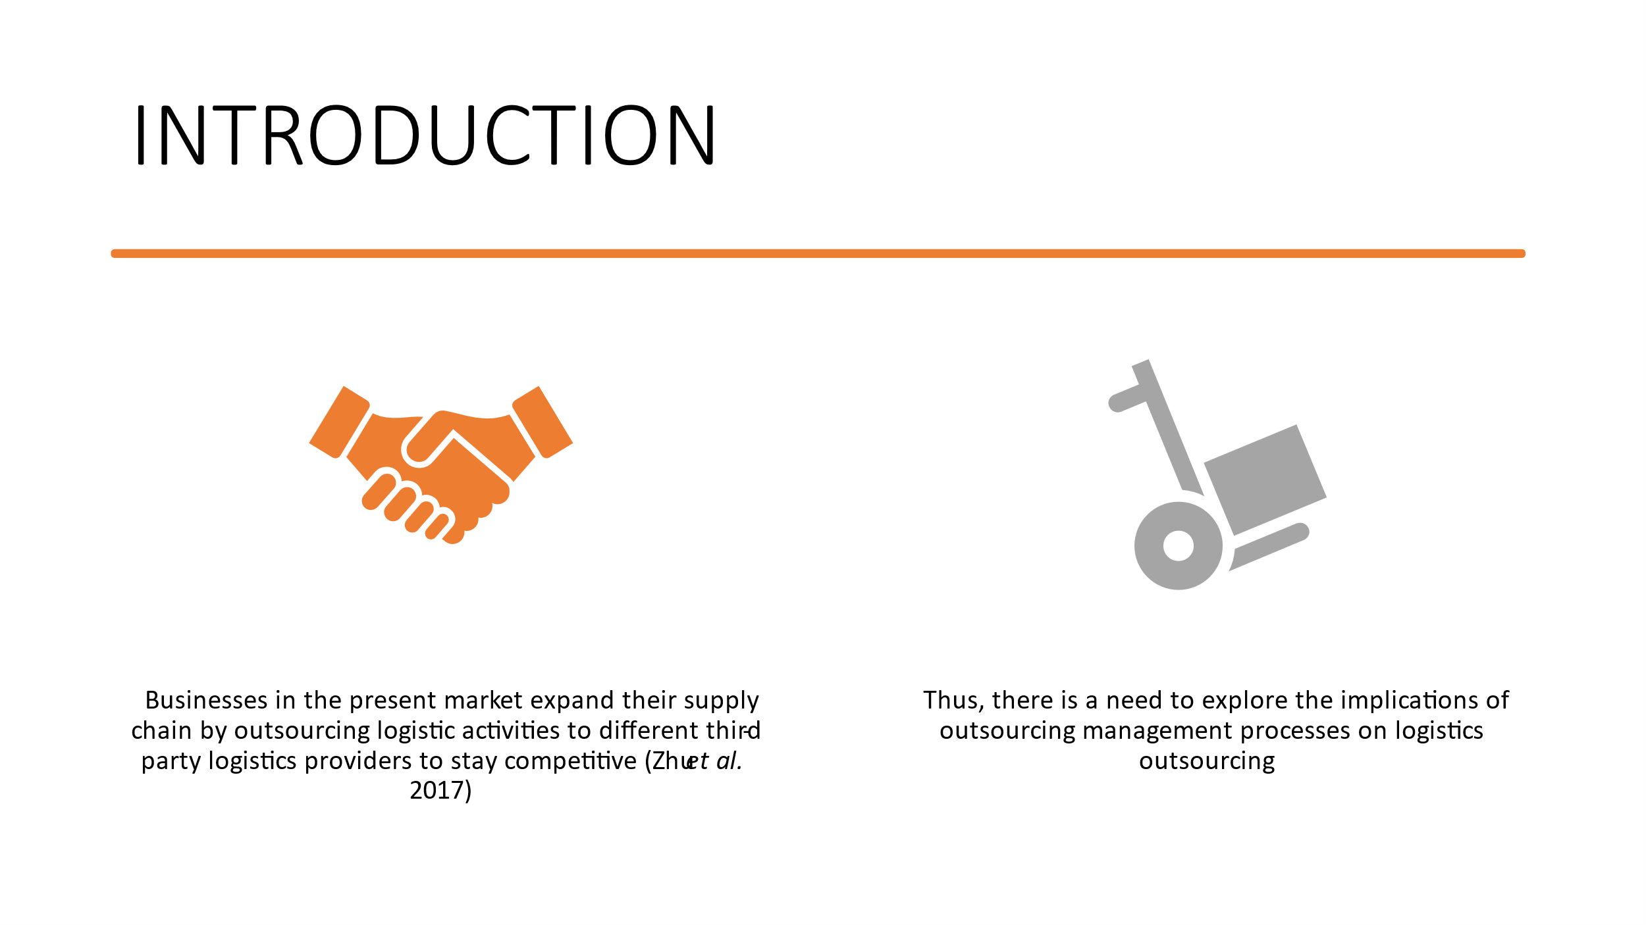
Slide 2.
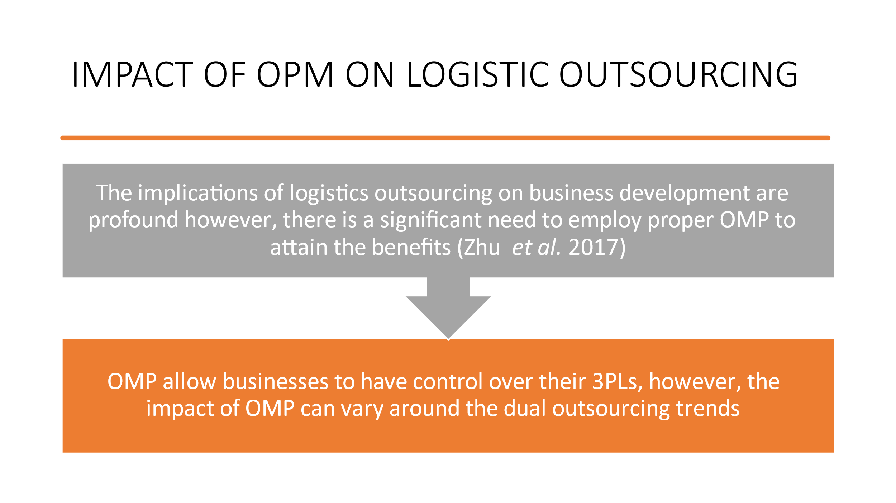

Reference List : Zhu, W., Ng, S.C., Wang, Z. and Zhao, X., 2017. The role of outsourcing management process in improving the effectiveness of logistics outsourcing. International Journal of Production Economics, 188, pp.29-40.

