

ASSESSMENT COMPONENT 1

Micro-tech Session

Student Name: Florence Odonkor
Student ID: 1818734
Module Name: Complementary Therapies
Module Code: BMHP5001
Lecturer Name: Bianca Sanfilippo
Date:09/12/21

INTRODUCTION

According to Jenkins, ’People's entire bodies are considered in the holistic approach’ (Jenkins, 2006). A holistic massage approach aims at providing the necessary support that looks at the entire body and not just a part of it, the support will consider the physical, emotional, spiritual and social wellbeing of the individual. For example, a holistic massage therapy will focus on the general health of the entire body and not just a part of the body. The image below posses a question about how our bodies can be out of balance at times.

. 
(Holisticintegrativewellness.com. 2021)

COMPLEMENTARY THERAPY AND ALTERNATIVE THERAPY

Complementary therapies and Alternative therapies are generally used alongside conventional treatments, the difference is when and how it is used. Complementary and Alternative Therapy are defined as “diagnosis, treatment and prevention which complements orthodox medicine by contributing to a common whole, by satisfying a demand not met by orthodoxy or by diversifying the conceptual frameworks of conventional medicine.” (E. Ernst, 2000). Which means when Complementary therapy is used with conventional medicine, but Alternative therapy are usually used in place of conventional medicine or treatment. As shown in the image below.
In the United Kingdom, complementary and alternative medicine (CAM) users tend to be more urban and well-educated, wealthy, middle age and employed, especially those who suffer from panic attacks, anxiety and depression. Complementary treatments practitioners visit in the UK have increased from 20% in 1998 to about 27% in 2000 (Fox et al 2010).
Some examples of complementary and Alternative medicine are; Botanical medicine, Acupuncture and Traditional Chinese medicine, Other Traditional medicine practices, Mind-Body practices, Nutrition and Dietary Supplements, Integrative Health/Medicine, Yoga and Ayuveda etc.

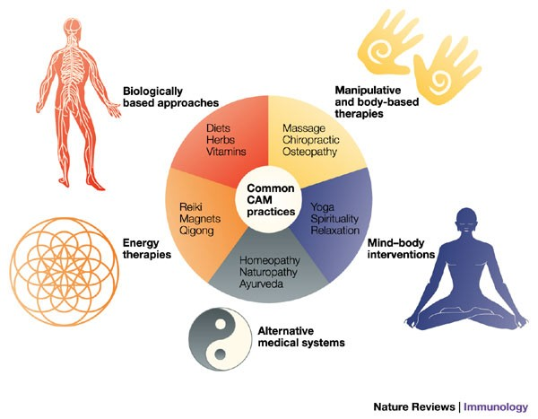
(Natural-therapy.com. 2019).

DEFINITION OF THERAPY
The Therapy directory defines ‘Massage as a treatment to relax, revive and heal the body, using manual hands-on movements and manipulation of the soft tissues and muscles in the body, massage therapy works to promote healing and enhance a person’s overall well-being’. (Therapy-directory, 2019), The process may involve applying pressure on the tendons, ligaments, joints and other connective tissues. From the above definition it can be concluded that, massage is manipulation of soft tissues to administer healing to the whole or affected body area.

THE BACKGROUND OF MASSAGE THERAPY

The history and background of massage therapy is one of the oldest therapies around, The therapy is a healing practice that goes back thousands of years, According to Natural Therapy Researchers, the first written records of massage therapy were found in China called “the yellow emperor’s classic book of medicine” (2700 B.C), in India from the Ayurveda practice known in English as “faith health” (3000 B.C) and Egypt from tomb paintings (2500 B.C). Massage as practice of using touch and applying pressure to the surface skin as a method of healing comes from diverse customs and techniques rooted in ancient history. As shown in the image below.

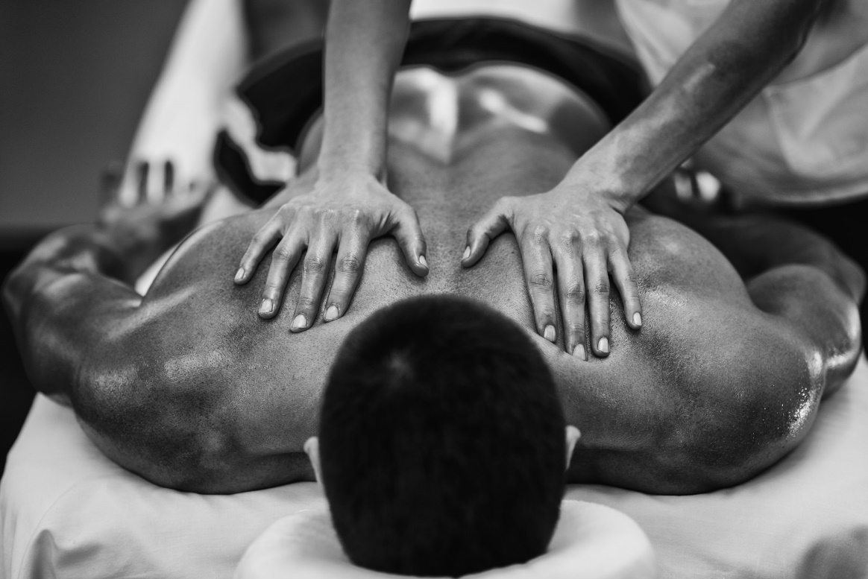
(Formagym.com. 2021)

IMPORTANT AND EFFECTIVENESS OF MASSAGE

The above benefits confirm the importance and effectiveness of massage as a form of therapy for healing. In reviewing the effectiveness of massage therapy for chronic and non-malignant pain, Tsao, examined the effects of massage for variety of both chronic and acute pain, which showed a considerably positive result in many cases. (Tsao, 2007).
In another study, Moyer et al. (30), in their meta-analysis showed that timing is essential to the effectiveness of the therapy as immediate or delayed assessment of pain can have significant outcome on the treatment. In this study, Moyer and colleagues (30) confirmed that massage therapy did not exhibit a significant effect on the immediate assessment of pain, however, indicated that massage therapy demonstrates significant effect on the long-term assessment or overall outcome of pain. (Moyer et al, 2004).

PURPOSE AND BENEFITS OF MASSAGE

There are enormous uses of massage therapy, some of benefits include the following;
. Reduce muscle tension
. Improve blood circulation
. Stimulation of the lymphatic system
. Relaxation
. Increase joint mobility and flexibility
. Concentration and alertness is improved
(Better Health Channel, 2012)

MOST COMMON SIDE EFFECTS AND RISKS

Massage therapy is known to be one of the most common therapies, however, there are some common side effects and risk, which develops when the therapy is not administer rightly. While complaints of reaction to treatment and side effects may be minor, some can be serious varying depending on the style or method used.
Some common examples side effects may include the following.
- Lingering Pain – Due to pressurised techniques used in a deep tissue massage
- Muscle aches, Fatigue, headaches, inflammation and bruising

CONTRAINDICATIONS OF MASSAGE THERAPY

The contraindications of massage therapy are areas or conditions that are contraindicated and must be avoided when giving a massage. Some of the areas of conditions include; Cuts or open wounds, Bruises, Varicose veins, Broken bones, Burns, Fever, Contagious diseases, Blood clots, Kidney and liver conditions and inflammation.
(Shelbourne Physiotherapy ,2021)

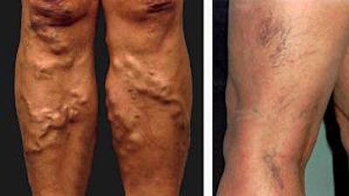
(4remedy.com. (2013).

COMPARISON TO TRADITIONAL TREATMENTS

Comparing orthodox chemical therapy and massage traditional therapy In patient with Parkison´s diseases.
This diseases is progressive end with results in disability.
Orthodox (clinical therapy) Massage therapy
Treatment drugs (levodopa) Traditional japonese massage
Neuro surgery Meuromuscular
Radio therapy Alexander tharapy

HOW MASSAGE CAN ENHANCE CURRENT ORTHODOX MEDICAL TREATMENTS
Massage therapy can enhance orthodox medicines in many ways and for the chosen disease for this assessment is Parkinson’s disease.
The use of massage alongside orthodox medicine can help the patiemt by alleviating muscle and joint stiffness and the patient can be supported by applying the Alexander’s massage technique in a holistic health and wellbeing, making them indipendent.
For exemple, in Parkinson´s disease, massage can enhance orthodox medical treatments by alleviating muscle and joint stiffness. Patients can be supported by the Alexander´s technique. It can support patients holistic health and wellbeing and support their independency.

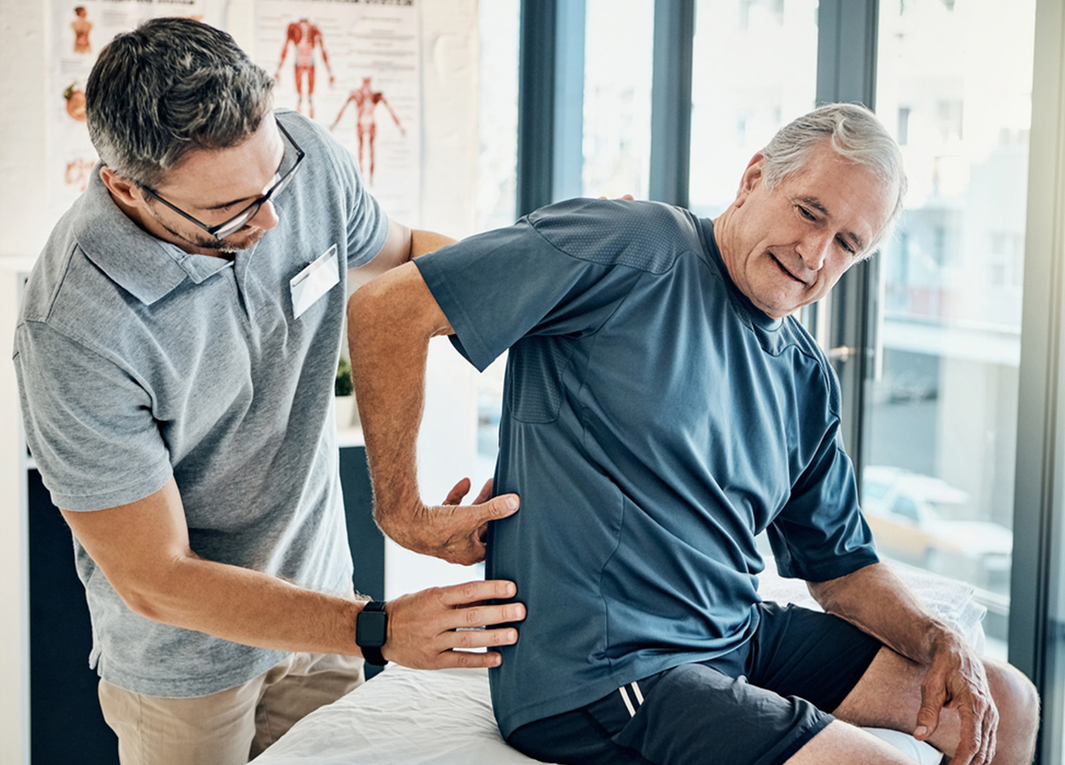
(Ihealthspot.com. 2021)

CONCLUSION

Massage therapy plays a very effective role in the healing of patients when used complementarily or as alternative mean to conventional medicine or treatment.
As noted above massage therapy provides enormous benefits for variety of health conditions, majority of them when assessed early, the therapy can be very useful in treating it. Therefore, it is essential to make massage therapy a primary source of treatment for many health problems. Although, less popular compared to conventional and orthodox medicine, it is considerably more natural and very effective method of treatment and healing.

REFERENCES

- Anon | 2019 | Therapy-directory.org.uk. (2019). Massage Therapy - Therapy Directory. [online] Available at: https://www.therapy-directory.org.uk/articles/massagetherapy.html [Accessed 8 Dec. 2021]

- Anon | 2021| Formagym.com. (2021). [online] Available at: https://formagym.com/wp-content/uploads/2020/02/shutterstock_402722176-scaled.jpg [Accessed 8 Dec. 2021].
- Shelbourne Physiotherapy (2021) Contraindications of Massage Therapy. (online). Available at: https://www.massagevictoria.com/contraindications-of-massage-therapy/ (Accessed: 29th November 2021).

- Better Health Channel (2012). Massage. [online] Vic.gov.au. Available at: https://www.betterhealth.vic.gov.au/health/conditionsandtreatments/massage [Accessed 8 Dec. 2021].

- Tsao, J.C.I. (2007). Effectiveness of Massage Therapy for Chronic, Non-Malignant Pain: A Review. Evidence-Based Complementary and Alternative Medicine, [online] 4(2), pp.165–179. Available at: https://www.ncbi.nlm.nih.gov/pmc/articles/PMC1876616/ [Accessed 8 December 2021]
- Moyer, C.A., Rounds, J. and Hannum, J.W. (2004). A Meta-Analysis of Massage Therapy Research. Psychological Bulletin, 130(1), pp.3–18.

- Ernst, E. (2000). The role of complementary and alternative medicine. BMJ, [online] 321(7269), pp.1133–1135. Available at: https://www.ncbi.nlm.nih.gov/pmc/articles/PMC1118903/. [Accessed 8 Dec. 2021]

- Anon. Year: 2021 Holisticintegrativewellness.com. (2021). [online] Available at: https://www.holisticintegrativewellness.com/wp-content/uploads/sites/339/2019/10/12-Graphic-A.png [Accessed 7 Dec. 2021].

- Anon. 2018., nhs.uk. (2018). Complementary and alternative medicine. [online] Available at: https://www.nhs.uk/conditions/complementary-and-alternative-medicine [Accessed 8 Dec. 2021].

- Anon. Year:2021. Springernature.com. (2021). [online] Available at: https://www.media.springernature.com/full/springer-static/image/art%3A10.1038%2Fnri1486/MediaObjects/41577_2004_Article_BFnri1486_Fig1_HTML.jpg [Accessed 8 Dec. 2021].

- Anon | 2019 | Natural-therapy.com. (2019). History of Massage Therapy. [online] Available at: https://www.natural-therapy.com/blog/history-of-massage-therapy/. [Accessed 8 Dec. 2021]

- Neu, M., Pan, Z., Workman, R., Marcheggiani-Howard, C., Furuta, G. and Laudenslager, M.L., 2014. Benefits of massage therapy for infants with symptoms of gastroesophageal reflux disease. Biological research for nursing, 16(4), pp.387-397.

- Anon | 2013 |4remedy.com. (2013). [online] Available at: http://www.4remedy.com/files/health_92.jpg [Accessed 9 Dec. 2021].

- Ihealthspot.com. (2021). [online] Available at: https://wp02-media.cdn.ihealthspot.com/wp-content/uploads/sites/596/2020/06/30134437/physical-therapy.jpg [Accessed 10 Dec. 2021].

‌

‌

‌

‌

‌

‌

‌

