

Title Page

Student Name: Mumina Akther Shobnom
Student Number: 2245201
Module Name: Health, Wellbeing, and Sustainable Development
Module Code: BMHP6030
Lecturer Name: Tommy Adattu
Assignment Title: Assignment 2 Report

Introduction
Health and wellbeing encompass not only the absence of disease but the holistic physical, mental, and social capacity of individuals to thrive (WHO, 1948). Sustainable development refers to meeting present needs without compromising future generations’ ability to meet theirs, integrating economic, social, and environmental pillars (UN, 2015). The World Health Organisation’s Sustainable Development Goals (SDGs), established in 2015, comprise 17 interlinked goals to guide global progress through 2030 (UN, 2015). SDG 3 targets universal health access and disease reduction, while SDG 1 seeks to end poverty in all its forms, recognising that poverty is both a driver and consequence of ill health (World Bank, 2022; WHO, 2020). In 2019, an estimated 8% of the world's population lived in extreme poverty, and health inequities remained stark, with nearly half the global population lacking essential health services (World Bank, 2022; WHO, 2020). These goals are inherently interconnected: poverty limits access to nutritious food, clean water, and care, which in turn undermines health outcomes (Marmot et al., 2008).
This report critically evaluates SDG 3 and SDG 1 policies and initiatives at the global level, within the UK, and in a specified local context. It incorporates relevant theories/models and concludes with evidence-informed recommendations to strengthen implementation across scales.

Section 1: SDG 3 “Good Health and Well-Being”
Sustainable Development Goal 3 (SDG 3) aims to “ensure healthy lives and promote well-being for all at all ages” (UN, 2015). It encompasses targets across maternal and child health, infectious and non-communicable diseases (NCDs), universal health coverage (UHC), substance abuse, mental health, and environmental health determinants (WHO, 2020). Achieving SDG 3 is central to broader development, as it impacts poverty reduction, economic productivity, and equity (Kickbusch et al., 2016). However, progress remains uneven globally, with low-income countries experiencing disproportionate burdens of disease and limited access to quality health services (GBD, 2020).
Critical Evaluation of Global Policies and Initiatives
The WHO’s Global Action Plan for Healthy Lives and Well-Being (GAP) was launched to accelerate SDG 3 progress through coordinated multilateral action (WHO, 2019). GAP emphasises shared financing, joint data platforms, and tackling inequalities, reflecting Systems Theory, which focuses on interrelated health determinants within complex adaptive systems (WHO, 2019; De Savigny and Adam, 2009). While GAP facilitates interagency coherence, critics note it lacks enforceable accountability mechanisms and is overly reliant on donor funding, limiting sustainability (Harman et al., 2021).
The Global Financing Facility (GFF) supports reproductive, maternal, newborn, child, and adolescent health (RMNCAH) by promoting country-led investment cases (World Bank/GFF, 2017). GFF has improved domestic resource mobilisation but is criticised for insufficient attention to NCDs and mental health, reflecting a policy gap in comprehensive health prioritisation (Shiffman and Smith, 2007).
The International Health Regulations (IHR) provide a legal framework for epidemic preparedness (WHO, 2005). The COVID-19 pandemic exposed weaknesses in global compliance and health system resilience (McCloskey et al., 2020). Inadequate surveillance and response capacities in many countries reveal gaps between normative expectations of IHR and real-world capacities, undermining SDG 3 resilience targets.
Critical Evaluation of Global, National and Local Examples
National
The NHS Long Term Plan (2019) aligns with SDG 3 through commitments to prevention, mental health services, and tackling inequalities (NHS England, 2019). The Plan employs Health Belief Model principles by incentivising preventive behaviours and screening uptake (Rosenstock, 1974). UHC coverage in the UK is strong, but rising NCD prevalence and regional health disparities persist, particularly in deprived areas (Public Health England, 2020). Critics argue that austerity-related cuts to social spending have limited the NHS’s capacity to address the wider social determinants of health (Bambra et al., 2020).
Global
Kenya’s Health Sector Strategic Plan operationalises UHC and access to essential medicines (Ministry of Health, Kenya, 2018). The plan integrates community health volunteers to bridge access gaps at local levels, reflecting Community Empowerment Theory, which supports participatory health engagement (Wallerstein, 2006). Progress in maternal mortality reduction has been noted, yet health workforce shortages and financing gaps constrain implementation (Aninanya et al., 2016).
Local
The London Health Inequalities Strategy addresses obesity, tobacco control, and mental wellbeing (GLA, 2018). Its multi-sectoral approach resonates with the Social Determinants of Health Framework, advocating interventions beyond clinical care (Marmot et al., 2008). While the strategy has increased cross-agency action, data fragmentation and inconsistent borough-level implementation have limited measurable outcomes.
Theoretical Integration
Social Determinants of Health (SDH) and Systems Theory provide essential lenses for evaluating SDG 3. SDH foregrounds how poverty, education, and environment shape health outcomes (Marmot et al., 2008). Systems Theory underscores complexity and interdependence across sectors, health systems do not operate in isolation but within economic, political, and sociocultural matrices (De Savigny and Adam, 2009). These models illuminate why disease-specific interventions may fail without systemic support and equity-based policies.

Global Maternal Mortality Trends (2000–2023)
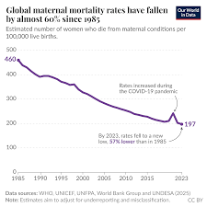
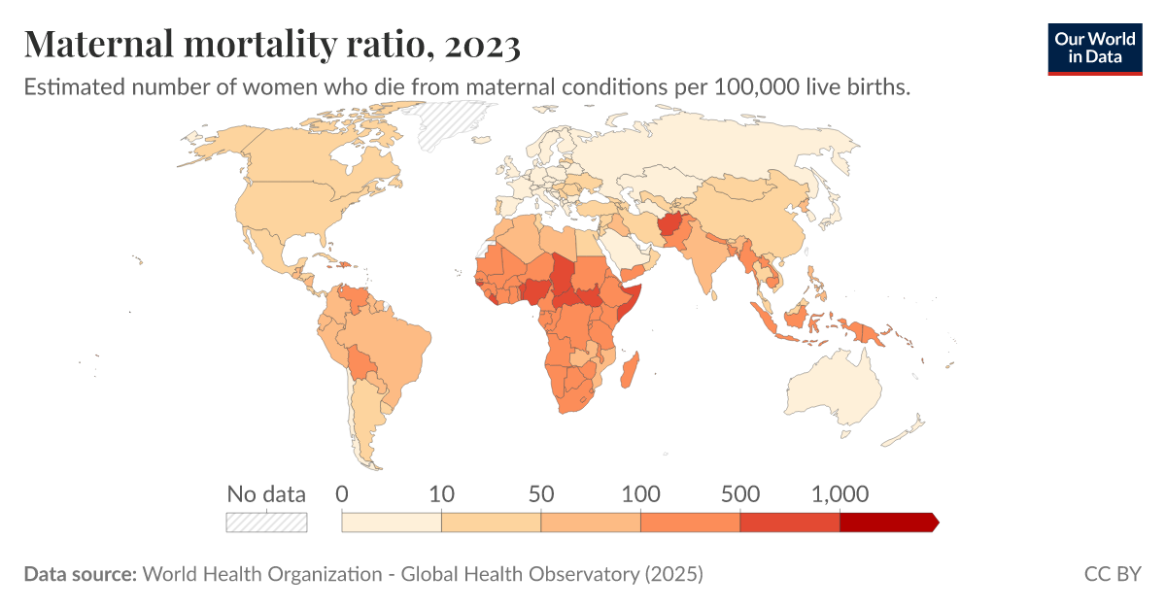

Recommendations
- Strengthen accountability mechanisms in global frameworks (For example, legally binding financing commitments for SDG 3). Evidence suggests accountability improves implementation fidelity (Harman et al., 2021).
- Expand investment in NCDs and mental health at global financing institutions. Current funding remains disproportionately focused on infectious diseases (GBD, 2020).
- Enhance surveillance capacities in LMICs to meet IHR obligations, supported by technology transfer and sustainable financing (McCloskey et al., 2020).
- Promote equitable domestic resource allocation for health in national budgets, guided by burden of disease metrics to address disparities (Bambra et al., 2020).
- Integrate health equity impact assessments into all public policies, recognising SDH influences (Marmot et al., 2008).
- Strengthen primary health care (PHC) as the backbone of UHC to improve preventive care and reduce hospital burdens (WHO, 2020).
- Build community health workforce capacity through training and remuneration to sustain local health engagement (Aninanya et al., 2016).
- Foster multi-sectoral governance platforms at national and local levels to align health, education, housing and environment.
- Data harmonisation systems across local and national levels to track SDG 3 indicators reliably.
- Targeted interventions for vulnerable populations (e.g., migrants, low-income groups) to reduce inequalities.
- Incentivise preventive health behaviours through policy (taxes on tobacco/sugar) and education campaigns.
- Improve mental health services integration into PHC to address treatment gaps.
- Climate-health policy linkage to address environmental determinants of health.
- Strengthen public financing frameworks to reduce out-of-pocket expenditure and catastrophic health costs.
- Regular independent reviews of national SDG 3 progress to inform adaptive policymaking.
- Cross-country learning networks to share best practices in implementing SDG 3.

Section 2: SDG 1 “No Poverty”
Overview of SDG 1
Sustainable Development Goal 1 (SDG 1) aims to “end poverty in all its forms everywhere” by 2030 (UN, 2015). It emphasises not only the eradication of extreme poverty but also the reduction of national poverty rates, implementation of social protection systems, and building resilience to economic, social, and environmental shocks (World Bank, 2022; UN, 2015). Poverty is recognised as multidimensional, affecting health, education, and human capital, and remains a major barrier to sustainable development (Alkire and Foster, 2011; Sachs, 2012).
Globally, extreme poverty declined from 36% in 1990 to about 8% in 2019, yet progress stalled due to the COVID-19 pandemic, conflict, and climate change risks (World Bank, 2022). Inequalities persist across regions, with Sub-Saharan Africa bearing the highest poverty burden (UNDP, 2021). Thus, achieving SDG 1 requires integrated policies that address economic, social, and institutional determinants of poverty (Sumner et al., 2015).

Critical Evaluation of Global Policies and Initiatives
The World Bank’s Poverty Reduction Strategy Papers (PRSPs) have been a cornerstone of global anti-poverty strategy since the late 1990s. PRSPs promote country-led, evidence-based frameworks to reform public spending, strengthen governance, and stimulate growth (World Bank, 2001). While PRSPs facilitated policy dialogue and donor alignment, critics argue they often prioritised macroeconomic stability over social protection expansion, leaving vulnerable groups inadequately supported (Saad-Filho, 2006).
The UN’s Global Partnership for Poverty Eradication and Sustainable Development seeks to mobilise international cooperation and financing for SDG 1, leveraging multi-stakeholder partnerships (UN, 2022). However, its voluntary nature and reliance on partner commitments limit enforceability and dilute accountability. The Social Protection Floor Initiative (SPF), supported by the ILO and WHO, advocates universal social protection systems to reduce vulnerability (ILO/WHO, 2011). Social protection has been shown to reduce poverty and inequality effectively (Gentilini et al., 2020), yet global SPF implementation remains uneven due to fiscal constraints and limited institutional capacity in low-income countries.
A Capabilities Approach, as conceptualised by Sen (1999), emphasises expanding people’s real freedoms and choices rather than solely increasing income. This theoretical lens critiques income-focused policies and advocates multidimensional poverty measures. The Multidimensional Poverty Index (MPI) operationalises this approach, capturing deprivations in health, education, and living standards (Alkire et al., 2015). The MPI’s adoption by global institutions exemplifies the shift toward broader poverty metrics, yet challenges remain in data availability and policy integration.

Critical Evaluation of National and Local Examples
United States
The U.S. Federal Poverty Reduction Framework includes targeted programs such as the Earned Income Tax Credit (EITC), Supplemental Nutrition Assistance Program (SNAP), and Temporary Assistance for Needy Families (TANF). Evidence shows these programs reduce poverty significantly when effectively targeted (Haskins and Sawhill, 2009). For example, EITC lifted millions out of poverty in the early 21st century (Hotz and Scholz, 2003). However, critics highlight that U.S. social safety nets remain fragmented, with eligibility gaps and regional disparities. The Residual Welfare Model operating in the U.S. emphasises limited state responsibility, which can perpetuate poverty traps and fail to address structural inequality (Moffitt, 2002).

India
India’s National Rural Employment Guarantee Act (NREGA) guarantees 100 days of paid work annually to rural households, aiming to reduce rural poverty and vulnerability (Dreze and Khera, 2017). Evaluations show positive impacts on household earnings and food security (Imbert and Papp, 2015). However, implementation challenges such as delayed payments and labour enforcement vary across states, and persistent underemployment limits long-term poverty reduction. The program’s success highlights how universal rights-based approaches can strengthen social protection.

Greater Manchester (UK)
Greater Manchester’s Poverty Action Plan (GMCA, 2019) integrates employment support, childcare access, and local benefit advice to reduce poverty. Its multi-agency design reflects systems thinking, recognising the interconnectedness of labour markets, housing, and health outcomes (Gilbert et al., 2018). Early evaluations suggest improvements in job placements and service alignment, yet structural issues such as housing affordability and wage stagnation persist. Localism models like GMCA underscore the importance of tailored, place-based strategies alongside national frameworks.

Theoretical Integration
Several theoretical lenses strengthen the evaluation of SDG 1:
- Capabilities Approach (Sen, 1999): Emphasises expanding agency and freedoms beyond income.
- Social Determinants of Poverty Theory: Highlights how education, health, and environment influence poverty outcomes (Mohan et al., 2018).
- Systems Theory: Suggests that poverty is embedded in complex socio-economic systems requiring integrated policy interventions (De Savigny and Adam, 2009).
These models provide frameworks that go beyond income measures, advocating for multidimensional and structural policy designs to achieve sustainable poverty reduction.

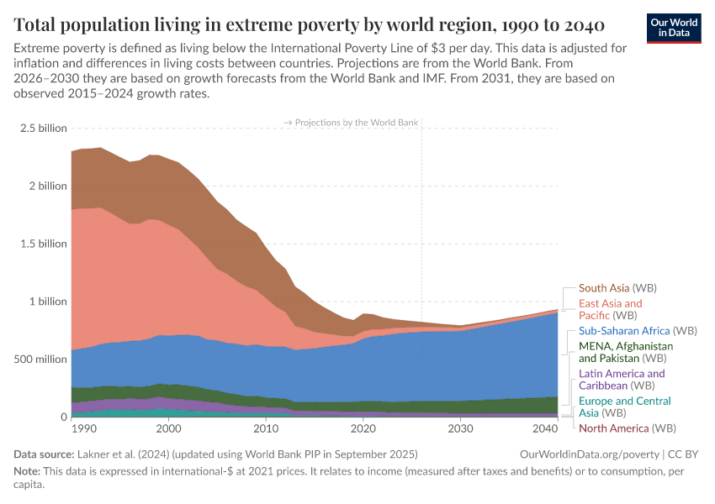
Figure: Global trends in extreme poverty and regional distribution (World Bank / Our World in Data).
Recommendations
- Institutionalise Social Protection Floors globally, with fiscal and technical support for low-income countries (Gentilini et al., 2020).
- Adopt and integrate multidimensional poverty measurement (MPI) in national planning (Alkire et al., 2015).
- Enhance transparency and accountability mechanisms for international partnerships (UN, 2022).
- Expand universal basic services, including healthcare and education, to complement cash transfers.
- Strengthen labour market policies that support decent work and living wages.
- Invest in early childhood development, critical for long-term human capital formation.
- Increase progressive taxation to finance social spending without regressive impacts.
- Promote gender-sensitive policies to address women’s disproportionate poverty burden.
- Build resilient rural livelihoods through diversified agriculture and climate adaptation.
- Scale up digital inclusion initiatives to improve access to education and employment.
- Support local, place-based strategies that align with national poverty goals.
- Leverage public-private partnerships for skills training and employment schemes.
- Implement conditional cash transfer programs tied to education and health outcomes.
- Monitor poverty trends in real time using big data and household surveys.
- Ensure inclusive governance through community participation in policymaking.

Conclusion
SDG 3 (Good Health and Well-Being) and SDG 1 (No Poverty) are fundamentally interconnected pillars of sustainable development. Poverty remains both a determinant and consequence of poor health, reinforcing cycles of inequality that hinder social and economic progress. The evaluation of global initiatives such as universal health coverage frameworks and social protection floors, alongside national and UK-local strategies, demonstrates measurable progress but also persistent structural gaps in funding, accountability, and equity. Theoretical perspectives, including the Social Determinants of Health framework, the Capabilities Approach, and systems thinking, highlight that fragmented or disease-specific interventions are insufficient without addressing wider socioeconomic conditions. Achieving meaningful progress requires coordinated, multi-sectoral action, strengthened governance, equitable financing, and community-level engagement. Without sustained political commitment and integrated policy design, the ambition of ending poverty and ensuring health and wellbeing for all by 2030 will remain aspirational rather than transformative.

References
Alkire, S. and Foster, J. (2011). ‘Counting and multidimensional poverty measurement’, Journal of Public Economics, 95(7-8), pp. 476–487. Available at: https://doi.org/10.1016/j.jpubeco.2010.11.006 (Accessed: 10 March 2026).
Alkire, S. et al. (2015). Multidimensional Poverty Index 2015. Oxford Poverty and Human Development Initiative. Available at: https://ophi.org.uk/multidimensional-poverty-index/mpi-2015-results/ (Accessed: 10 March 2026).
Aninanya, G.A. et al. (2016). ‘Implementation and effectiveness of community health strategy on maternal and child health in Kenya’, BMC Public Health, 16:192. Available at: https://pubmed.ncbi.nlm.nih.gov/26869686/ (Accessed: 11 February 2026).
Bambra, C. et al. (2020). ‘The COVID-19 pandemic and health inequalities’, Journal of Epidemiology and Community Health, 74(11), pp. 964–968. Available at: https://pubmed.ncbi.nlm.nih.gov/32747500/ (Accessed: 11 February 2026).
De Savigny, D. and Adam, T. (2009). Systems Thinking for Health Systems Strengthening, Geneva: WHO. Available at: https://www.who.int/alliance-hpsr/resources/9789241563895/en/ (Accessed: 11 February 2026).
Dreze, J. Khera, R. (2017). ‘Rural poverty and the public distribution system’, Economic and Political Weekly, 52(3). Available at: https://www.epw.in/journal/2017/3/commentary/rural-poverty-and-public-distribution-system.html (Accessed: 08 March 2026).
GBD (2020). Global Burden of Disease Study 2019 Results. IHME. Available at: http://www.healthdata.org/gbd (Accessed: 11 February 2026).
Gentilini, U. et al. (2020). ‘Social Protection and Jobs Responses to COVID-19’, World Bank Policy Research. Available at: http://documents1.worldbank.org/curated/en/2020/06/354284286/social-protection-jobs-responses-covid-19(Accessed: 07 March 2026).
Gilbert, R. et al. (2018). ‘Place-based strategies and inclusive growth’, Regional Studies, 52(2), pp. 171–182. Available at: https://doi.org/10.1080/00343404.2017.1369828(Accessed: 07 March 2026).
GLA (2018). London Health Inequalities Strategy. Greater London Authority. Available at: https://www.london.gov.uk/what-we-do/health/londons-health/health-inequalities (Accessed: 11 February 2026).
Harman, S. et al. (2021). ‘Global health governance and policy’, Global Public Health, 16(3), pp. 307–319. Available at: https://pubmed.ncbi.nlm.nih.gov/33206151/ (Accessed: 9 February 2026).
Haskins, R. and Sawhill, I. (2009). ‘Creating an Opportunity Society’, Brookings Institution Press. Available at: https://www.brookings.edu/book/creating-an-opportunity-society/(Accessed: 07 March 2026).
Hotz, V.J. and Scholz, J.K. (2003). ‘The Earned Income Tax Credit’, American Economic Review, 93(2). Available at: https://doi.org/10.1257/000282803321946932(Accessed: 07 March 2026).
Imbert, C. and Papp, J. (2015). ‘Labour Market Effects of India’s Employment Guarantee’, Econometrica, 83(6). Available at: https://doi.org/10.3982/ECTA11648 (Accessed: 07 March 2026)
Kickbusch, I. et al. (2016). ‘Global health diplomacy’, Bulletin of the World Health Organisation, 94(6), pp. 442–443. Available at: https://www.who.int/bulletin/volumes/94/6/16-179065.pdf (Accessed: 9 February 2026).
Marmot, M. et al. (2008). Closing the Gap in a Generation, WHO. Available at: https://www.who.int/publications/i/item/9789241563703 (Accessed: 9 February 2026).
McCloskey, B. et al. (2020). ‘Strengthening health systems during COVID-19’, The Lancet, 395(10231), pp. 1327–1329. Available at: https://doi.org/10.1016/S0140-6736(20)30775-0 (Accessed: 9 February 2026).
Ministry of Health, Kenya (2018). Health Sector Strategic Plan. Available at: http://www.health.go.ke/ (Accessed: 9 February 2026).
Moffitt, R. (2002) ‘Welfare Programs and Labour Supply’, Tax Policy and the Economy, 16. Available at: https://doi.org/10.1086/tpe.16.20020704(Accessed: 05 March 2026).
Mohan, P. et al. (2018). ‘Social determinants of poverty’, Social Science & Medicine, 200, pp. 238–245. Available at: https://pubmed.ncbi.nlm.nih.gov/29473707/(Accessed: 05 March 2026)
NHS England (2019). The NHS Long Term Plan. Available at: https://www.longtermplan.nhs.uk/ (Accessed: 8 February 2028).
Public Health England (2020). Health Profile for England 2020. Available at: https://www.gov.uk/government/collections/health-profile-for-england (Accessed: 8 February 2026)
Rosenstock, I.M. (1974). ‘Historical origins of the Health Belief Model’, Health Education Monographs, 2, pp. 328–335. Available at: https://doi.org/10.1177/109019817400200403 (Accessed: 8 February 2026).
Sachs, J.D. (2012). The Age of Sustainable Development. Columbia University Press. Available at: https://cup.columbia.edu/book/the-age-of-sustainable-development/9780231173155(Accessed: 05 March 2026).
Shiffman, J. and Smith, S. (2007). ‘Generation of global political priority for global health initiatives’, Lancet, 370(9595), pp. 1370–1379. Available at: https://doi.org/10.1016/S0140-6736(07)61579-7 (Accessed: 8 February 2026)
Sumner, A. et al. (2015). ‘Poverty and distributional issues in the post–2015 goals’, Global Policy, 6(1), pp. 4–16. Available at: https://doi.org/10.1111/1758-5899.12102(Accessed: 26 February 2026).
UN (2015). Transforming our World: The 2030 Agenda for Sustainable Development. Available at: https://sdgs.un.org/2030agenda (Accessed: 8 February 2026)
UN. (2022). Global Partnership for Poverty Eradication and Sustainable Development. Available at: https://www.un.org/partnerships/sdgs (Accessed: 12 February 2026).
UNDP. (2021). Human Development Report 2021. Available at: http://hdr.undp.org/en/2021-report (Accessed: 12 February 2026).
United Nations (2015). Transforming our world: the 2030 Agenda for Sustainable Development. Available at: https://sdgs.un.org/2030agenda (Accessed: 5 February 2026).
United Nations (2025) Goal 1: No Poverty. Available at: https://www.un.org/sustainabledevelopment/poverty/ (Accessed: 5 February 2026)
(Accessed: 5 February 2026).
WHO (2026) Sustainable Development Goals (SDGs). Available at: https://www.who.int/data/gho/data/themes/sustainable-development-goals (Accessed: 5 February 2026).
UK Sustainable Development Goals data (2025) Reporting status. Available at: https://sdgdata.gov.uk/reporting-status/ (Accessed: 5 February 2026).
WHO (2005). International Health Regulations (2005). Available at: https://www.who.int/health-topics/international-health-regulations (Accessed: 5 February 2026).
WHO (2011). Social Protection Floor for a Fair and Inclusive Globalisation. Available at: https://www.ilo.org/global/publications/ilo-bookstore/order-online/books/WCMS_165750/lang--en/index.htm(Accessed: 07 March 2026).
WHO (2019). Global Action Plan for Healthy Lives and Well-Being. Available at: https://www.who.int/initiatives/sdg-global-action-plan (Accessed: 5 February 2026).
World Bank. (2001). Poverty Reduction Strategy Papers (PRSPs). Available at: https://www.worldbank.org/en/topic/poverty/brief/poverty-reduction-strategy-papers (Accessed: 12 February 2026).
World Bank. (2022). Poverty and Shared Prosperity 2022. Available at: https://www.worldbank.org/en/publication/poverty-and-shared-prosperity (Accessed: 11 February 2026).
World Bank. (2023). Progress and Challenges in Ending Extreme Poverty. Available at: https://blogs.worldbank.org/en/opendata/progress-challenges-ending-extreme-poverty (Accessed: 25 February 2026).
World Bank. (2025). June 2025 Update to Global Poverty Lines. Available at: https://www.worldbank.org/en/news/factsheet/2025/06/05/june-2025-update-to-global-poverty-lines (Accessed: 25 February 2026).

