

Assessment 1

Gabriela Malinova
(2210803)
BA Business Management
Module: Management Economics
Module code: LCBB5008
Lecturer: Riaz Bhatti

Table of Contents
Q1a) Fundamental Economic Problems: 2
COVID-19 Rules of Doing Business 2
Shortages of Supply and Demand due to an Increase in Demand 3
The Effects of BREXIT on the Demand and Supply Chain Facilities 4
Panic Buying of Scarce Resources 4
Shortage of Fuel Supply 5
Rocketed Price Changing in the Cost of Fuel 6
High Borrowings of Funds to Meet the Surging High Cost of Living 7
Furlough and Redundancies 7
Bankruptcies Due to Lack of Funds to Pay the High Borrowings Resulted in the High Cost of Living 7
The shift in Consumer Appetite from Services to Goods. 8
Q1b) Various Ways of Solving the Challenges 9

Figure 1: Working Adults in the UK, May 2020 to May 2021 3
Figure 2: Reasons for driver shortage 4
Figure 3: Decomposition of estimated potential supply growth 2020 5
Figure 4: Stock levels and proportion of forecourts receiving a delivery 6
Figure 5: Oil prices (Jan,2020-Dec,2021) 7
Figure 6: % Cutting back on essentials into savings 8

Q1a) Fundamental Economic Problems:

COVID-19 Rules of Doing Business
The COVID-19 pandemic has significantly impacted businesses globally and in the UK, leading to strict regulations such as social distancing, workplace testing, and contact tracing. Organizations must also equip staff with remote work tools and technology to avoid disruptions. Flexible working hours have been introduced for roles not remotely performable, ensuring businesses can continue operations despite the challenges posed by the pandemic (GOV.UK, 2021), (Office for National Statistics, 2021).

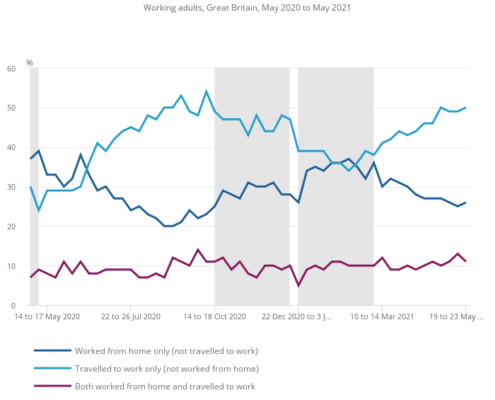
Figure 1: Working Adults in the UK, May 2020 to May 2021
(Office for National Statistics, 2021)

Shortages of Supply and Demand Due to an Increase in Demand
The UK economy experienced a decline in domestic output due to COVID-19 limits, resulting in an 8.2% drop in overall goods and services value between 2019 and 2020. Non-market production grew by 5.3%, while market output fell by 9.0%. Travel limitations led to a 4.8% decline in the current price gross value added. Consumer spending decreased, with government, health, and educational services experiencing the most. Intermediate usage decreased by 7.5% between 2019 and 2020 (Office for National Statistics, 2021b).

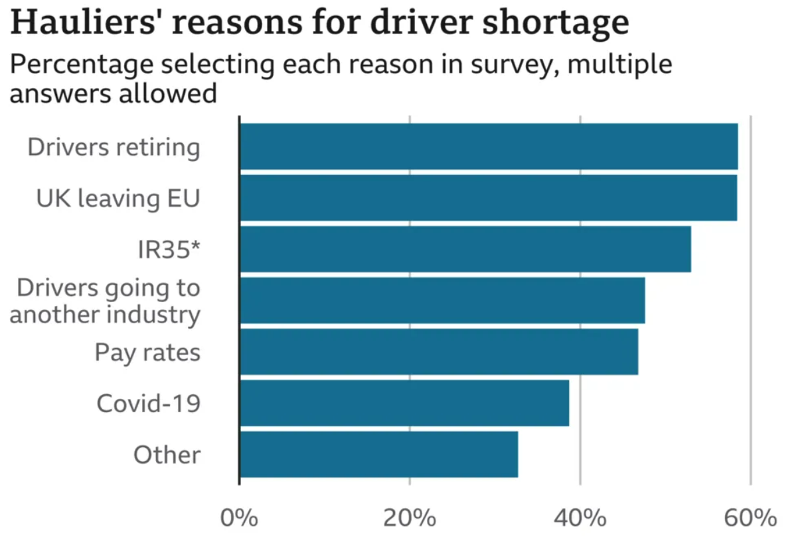Figure 2: Reasons for driver shortage
(BBC News, 2021)

The Effects of BREXIT on the Demand and Supply Chain Facilities
Brexit has disrupted UK supply networks, leading to delays, higher costs, and shortages of essential goods. Customs inspections, taxes, and new regulations have slowed import and export procedures, impacting industries like the car. The uncertainty has also changed consumer confidence and spending patterns, with customers favoring homegrown items over imported ones due to rising costs or decreased EU goods supply. Local firms have benefited but face challenges in scaling up to meet increased demand (Spital and van Aerssen, 2023), (PwC, 2017).
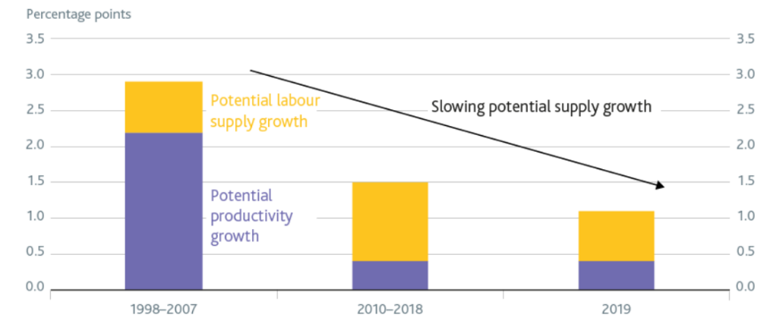
Figure 3: Decomposition of estimated potential supply growth 2020
(Bank of England, 2020)

Panic Buying of Scarce Resources
Throughout history, panic buying has been observed during major occurrences like World Wars I and II as well as the COVID-19 epidemic in the present (Arafat et al., 2020). The amount of food in UK households has grown by 1 billion (Nicola et al., 2020). The price of the product rises in tandem with the growth in demand. For retailers, however, supplies may take some time if demand spikes quickly (Flora Southey, 2020).

Shortage of Fuel Supply
The early lockdown led to a decline in demand, resulting in higher stock levels at 59% full on March 26. Deliveries decreased in response to the downstream oil industry, reaching 12% on March 29. However, deliveries increased to meet demand, especially following the Prime Minister's recovery plan. Delivery rates reached 38% in the last week, but stock levels ended the month at 43% full (Khamkar, n.d.).

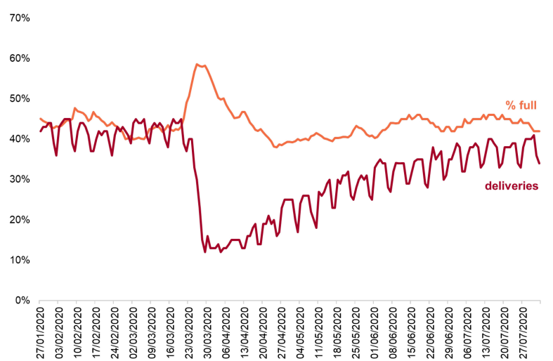
Figure 4: Stock levels and proportion of forecourts receiving a delivery
(Khamkar, n.d.)

Rocketed Price Changing in the Cost of Fuel
The COVID-19 pandemic caused a drop in gasoline demand in early 2020, lowering Brent crude oil prices to below $20 per barrel. However, as the pandemic subsided, fuel costs rose. Gasoline demand increased after lockdown measures were lifted, and a rebound in prices was initiated by economic activity and vaccination rollouts. In 2021, fuel prices surged due to supply chain issues, OPEC+ output curbs, and a recovering global economy. The UK gasoline market experienced significant volatility, highlighting the global oil supply-demand balance and fuel's crucial role in economic activity (Countryeconomy, 2020), (Troderman, 2022).

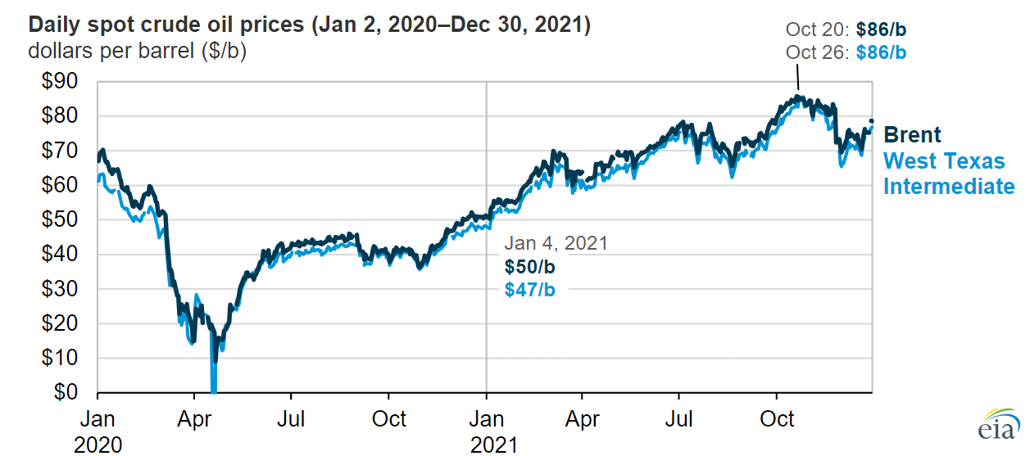
Figure 5: Oil prices (Jan,2020-Dec,2021)
(Troderman, 2022)

High Borrowings of Funds to Meet the Surging High Cost of Living
Retail sales decline as household budgets grow tighter. Approximately 60% of British citizens believe they should reduce their non-essential expenditures and gas, electricity, or gas use; moreover, over two-thirds feel they should reduce their grocery and automobile usage. At a 10-year high, more households adjust their spending to pay for necessities (Romei, 2022).

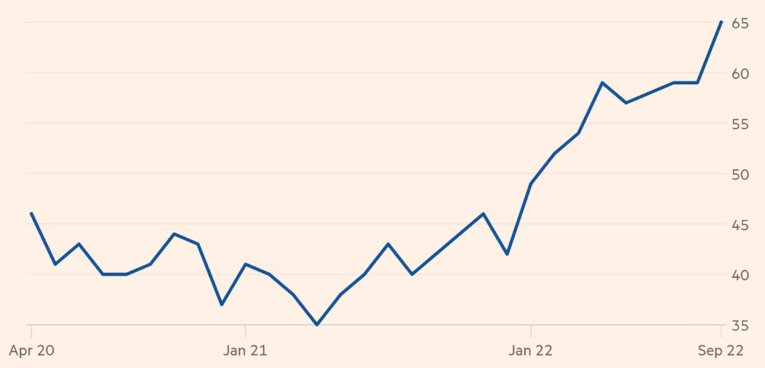Figure 6: % Cutting back on essentials into savings
(Romei, 2022).

Furlough and Redundancies
Furloughing 11.7 million workers cost the government £70 billion. On May 8, 2020, the total number of persons on furlough reached a peak of 8.9 million. After that, levels gradually decreased until a second lockdown was declared in November 2020. When the third lockdown started in January 2021, numbers increased once more, although they were still far lower than they were during the first lockdown (Clark, 2021).

Bankruptcies Due to Lack of Funds to Pay the High Borrowings Resulted in the High Cost of Living
In January 2022, 1,560 firm insolvencies were officially recorded. This is comparable to the quantity recorded in January 2020, two years earlier (pre-pandemic; 1,508).
575 individual bankruptcies were filed, which is a 32% decrease from January 2021 and a 63% decrease from January 2020 (GOV.UK, 2022).

The shift in Consumer Appetite from Services to Goods.
During the coronavirus epidemic, household expenditure on services decreased. The tightening and loosening of expenditure limitations in high-contact service industries was the primary cause of this decline in service spending during the coronavirus epidemic (Lee et al., 2022).

Q1b) Various Ways of Solving the Challenges

Government Intervention
- funding for heavy-duty vehicles (HGVs);
- visas for European HGV license holders;
- letters to inactive HGV license holders;
- tax relief;
- temporary visas for poultry workers;
- military personnel on hand to deliver fuel;
- energy bill and council tax rebate to support people through the pressures of rising living expenses
- postponed implementing strict regulations on EU goods imports into Great Britain.

(Institute for Government, 2021)

Relaxing Some of the Stringent COVID-19 Rules
The UK government has implemented temporary measures to support businesses during the pandemic, including allowing leave accrued over two years, increasing debt thresholds, easing working hours for delivery drivers, and preventing evictions for commercial renters. Additionally, businesses can operate as takeaways without planning approval, and temporary constructions and land use are allowed (GOV.UK, 2020).

Developing Shortage Management Team Strategy
A specialized shortfall management team is established to anticipate and address supply constraints caused by COVID-19 and Brexit uncertainty, utilizing forecasting models and data analytics for company continuity (Kilpatrick, 2020).

Create and Improve Supplier Corporations Network
To lower the risk of supply chain disruption and build strong partnerships for adaptable, dependable supply chains, businesses must strengthen and diversify their supplier networks in the wake of Brexit (McKinsey & Company, 2022).

Create Alternative Ways to Reduce Waste
Overstock and spoiling may be avoided by utilizing digital technologies to optimize inventory management; additional waste reduction can be achieved by recycling and reusing resources (European Environment Agency, 2021).

Assess and Improve Its Supply Chain
Companies can find areas of risk and opportunity by using methods like SWOT analysis (Strengths, Weaknesses, Opportunities, Threats). Putting cutting-edge technologies like blockchain and IoT into practice may increase efficiency and transparency.

Work with Suppliers to Reduce the Price
By utilising favorable price agreements and supplier network improvement partnerships, joint ventures, bulk purchasing, and improved conditions negotiation can result in lower expenses and an increased profit margin (FasterCapital, 2024).

Keep Stakeholders Informed and Up-to-date
A company must provide regular updates, honest financial reporting, and a multi-channel communication plan to keep stakeholders informed and involved to maintain trust and confidence (Anderson, 2023).

Q2a) Relevance of Demand and Supply

Pricing Strategy to Manage Demand and Supply Pressure
Dynamic pricing modifies prices in real-time in response to supply and demand in the market. When there is a lot of volatility, this helps balance demand. Prices may be modestly raised during panic purchasing to control demand and guarantee a steady supply (Gibson, 2024).

Competition and Driving Prices Low
Value-Added Services
To keep a competitive advantage and satisfy customers, a product might be made more appealing without drastically reducing its price by providing free delivery, extended warranties, or packaged services (Clary, 2023).

Helps the Expansion of Business's Productivity
Many firms, particularly in the retail and service industries, moved their activities online in response to lockdowns and social distancing tactics. Amazon served as an excellent example of this adaption, stepping up the administration of their online platform to meet the demand, creating logistics, and guaranteeing efficient delivery services. This relocation increased productivity and reach while preserving business continuity (Milanesi, 2022).

Marketing Strategy and Promoting the Business Concept
Businesses revised their marketing plans to fit the new standard. In order to interact with customers who were spending more time online, digital marketing became increasingly important, with an emphasis on online advertising, social media engagement, and content marketing. This made it easier for companies to successfully market their ideas in a setting where people are socially isolated (Gotsi, 2020).

Helps to Balance Inventory Management Strategy
The Just-In-Time (JIT) system and other doping techniques became essential. Maintaining an efficient balance between stockouts and overstocking was made possible by diversifying supplier bases, increasing demand forecasting accuracy, and optimizing inventory levels (Baluch and Bottorff, 2023).

Finance Attraction through Investment
An Initial Public Offering is the process by which private corporations make their shares available to the public through the stock market. This process allows a larger pool of potential investors to buy shares in the company, raising money for expansion and enabling investors who were previously unable to fund the company to do so (Hargreaves Lansdown, n.d.).

Q2b) Difference Between Elasticity and Inelasticity of Demand:

The elasticity of demand refers to the change in demand when there is a change in another economic factor, such as price or income.
Demand is considered inelastic if the demand for a good or service remains unchanged even when the price changes.
Elastic goods include luxury items and certain food and beverages, as price changes can have an impact on demand to a great extent.
Inelastic goods may include items such as tobacco and prescription drugs, as demand often remains constant despite price changes.
(Hall, 2020)

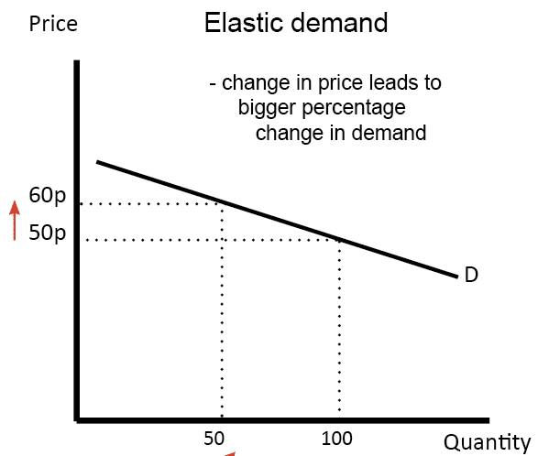
Figure 7: Elastic Demand
(Pettinger, 2019)

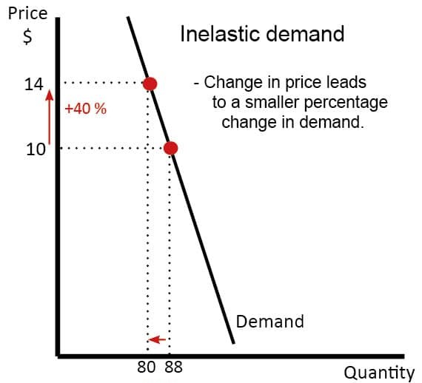
Figure 8: Inelastic Demand
(Pettinger, 2019)

- Advantage of Elastic Demand:
The degree to which a good's quantity sought is responsive to price changes is measured by its elasticity of demand. The capacity to determine an ideal price is a key benefit of knowing demand elasticity. Companies may examine how customers respond to various price points and modify their pricing tactics accordingly. This makes it possible for businesses to determine pricing that increases revenue while retaining clients. For example, if a product has a high degree of elasticity, a slight drop in price may result in a significant rise in sales, which would improve overall income (Suttle, 2010).
- A disadvantage of Elastic Demand
One disadvantage, though, is the need to always keep an eye on rivals' marketing tactics. The market is dynamic, and rivals frequently change the products, promotions, and pricing they provide. A business must continuously monitor these developments and modify its own strategies—which might require significant resources—to remain competitive. This constant watchfulness necessitates a large investment in data analysis and market research, taking time and resources away from other business domains (Inspired Economist, 2023).

Q2c) The Laws of Supply and Demand

While creating or marketing products, business owners need to understand the four fundamental laws of supply and demand. Higher prices and volumes result from increased demand, giving sellers a lucrative opportunity. On the other hand, when demand declines, fewer people are interested in purchasing an item or service, which results in reduced costs and quantities. Goods and services become easily accessible from a greater range of vendors when supply exceeds demand, pushing sellers to lower their prices in an effort to draw customers away from rivals.
Businesses can use time-sensitive discounts, such flash sales, seasonal promotions, and cheaper bulk buys, to reduce prices and boost sales. Another tactic is to restrict supply; luxury companies frequently produce their goods in lower quantities to control the amount available on the market. A higher price tag is justified by the scarcity, and this may be done by increasing the profit margin per item. This strategy requires marketing strategies that uphold a unique and appealing brand image.
When choosing your product selection, you must take your target audience's buying behaviors into account in order to create demand. By providing products and services that meet current consumer needs or instilling new ones, you can convince people that your product solves an unidentified problem, build brand awareness, and spark new consumer trends. Examples of this type of content include explainer videos, instructional infographics, and customer testimonials.
Any firm must properly price its goods, and supply and demand curves may be used to determine the price point that maximizes revenues without deterring customers. Although the value of goods and services is determined by the market, small business owners may increase sales and profits by influencing consumer behaviour.
(Taylor, 2021)

References
Anderson, L. (2023). Council Post: How To Create An Effective Stakeholder Communication Plan. [online] Forbes. Available at: https://www.forbes.com/sites/forbesagencycouncil/2023/10/27/how-to-create-an-effective-stakeholder-communication-plan/.
Arafat, S.M.Y., Kar, S.K., Marthoenis, M., Sharma, P., Hoque Apu, E. and Kabir, R. (2020). Psychological Underpinning of Panic Buying during Pandemic (COVID-19). Psychiatry Research, [online] 289(1), p.113061. doi:https://doi.org/10.1016/j.psychres.2020.113061.
Baluch, A. and Bottorff, C. (2023). What is just in time inventory (JIT)? [online] Forbes Advisor. Available at: https://www.forbes.com/advisor/business/just-in-time-inventory/.
Bank of England (2020). Has Brexit affected the supply capacity of the economy? [online] www.bankofengland.co.uk. Available at: https://www.bankofengland.co.uk/bank-overground/2020/has-brexit-affected-the-supply-capacity-of-the-economy.
BBC News (2021). How Serious Is the Shortage of HGV drivers? BBC News. [online] 15 Oct. Available at: https://www.bbc.co.uk/news/57810729.
Clark, H. (2021). Examining the end of the furlough scheme. commonslibrary.parliament.uk, [online] 1(1). Available at: https://commonslibrary.parliament.uk/examining-the-end-of-the-furlough-scheme/.
Clary, N. (2023). What is Bundling ? Benefits and Strategies for Product Bundle Pricing - WIdebundle. [online] WideBundle - Blog. Available at: https://blog.widebundle.com/what-is-bundling/.
Countryeconomy (2020). Crude Oil Brent US Dollars per Barrel April 2020 | countryeconomy.com. [online] countryeconomy.com. Available at: https://countryeconomy.com/raw-materials/brent?dr=2020-04#:~:text=The%20oil%20price%20for%20Brent%20crude%20oils%20in [Accessed 27 Jul. 2024].
European Environment Agency (2021). Digital technologies will deliver more efficient waste management in Europe — European Environment Agency. [online] www.eea.europa.eu. Available at: https://www.eea.europa.eu/themes/waste/waste-management/digital-technologies-will-deliver-more.
FasterCapital (2024). Supplier negotiations: Driving Down Costs through Bulk Purchasing. [online] FasterCapital. Available at: https://fastercapital.com/content/Supplier-negotiations--Driving-Down-Costs-through-Bulk-Purchasing.html.
Flora Southey (2020). Panic buying amid coronavirus fears: How much are we spending… and why is it a problem? [online] foodnavigator.com. Available at: https://www.foodnavigator.com/Article/2020/03/27/Panic-buying-amid-coronavirus-fears-How-much-are-we-spending-and-why-is-it-a-problem.
Gibson, K. (2024). Dynamic Pricing: What It Is & Why It’s Important | HBS Online. [online] Business Insights Blog. Available at: https://online.hbs.edu/BLOG/POST/WHAT-IS-DYNAMIC-PRICING.
Gotsi, M. (2020). Seven ways marketing has changed during Covid-19 | CIM Exchange. [online] www.cim.co.uk. Available at: https://www.cim.co.uk/content-hub/editorial/seven-ways-marketing-has-changed-during-covid-19/ [Accessed 30 Jul. 2024].
GOV.UK (2020). Rules that have been relaxed to help businesses during the coronavirus (COVID-19) pandemic. [online] GOV.UK. Available at: https://www.gov.uk/guidance/rules-that-have-been-relaxed-to-help-businesses-during-the-coronavirus-pandemic.
GOV.UK (2021). COVID-19 Response: Summer 2021. [online] GOV.UK. Available at: https://www.gov.uk/government/publications/covid-19-response-summer-2021-roadmap/covid-19-response-summer-2021.
GOV.UK (2022). Commentary - Monthly Insolvency Statistics January 2022. [online] GOV.UK. Available at: https://www.gov.uk/government/statistics/monthly-insolvency-statistics-january-2022/commentary-monthly-insolvency-statistics-january-2022.
Hall, M. (2020). Elasticity vs. Inelasticity of Demand: What’s the Difference? [online] Investopedia. Available at: https://www.investopedia.com/ask/answers/012915/what-difference-between-inelasticity-and-elasticity-demand.asp.
Hargreaves Lansdown (n.d.). What are IPOs and how do they work? [online] Hargreaves Lansdown. Available at: https://www.hl.co.uk/shares/ipos-and-new-issues/what-are-ipos [Accessed 30 Jul. 2024].
Inspired Economist (2023). Elasticity of Demand: Understanding its Impact on Pricing and Revenue - Inspired Economist. [online] Inspired Economist. Available at: https://inspiredeconomist.com/articles/elasticity-of-demand/.
Institute for Government (2021). Supply chain problems. [online] Institute for Government. Available at: https://www.instituteforgovernment.org.uk/explainer/supply-chain-problems.
Khamkar, F. (n.d.). Special feature -Supply and demand of transport fuels during COVID-19 Supply and demand of transport fuels during COVID-19. [online] Available at: https://assets.publishing.service.gov.uk/government/uploads/system/uploads/attachment_data/file/920566/Supply_and_demand_of_transport_fuels_during_COVID-19.pdf.
Kilpatrick, J. (2020). Managing Supply Chain Risk and Disruption: COVID-19 | Deloitte Global. [online] www.deloitte.com. Available at: https://www.deloitte.com/global/en/services/risk-advisory/analysis/covid-19-managing-supply-chain-risk-and-disruption.html.
Lee, T., Skipper, H., Khaliq, M. and Dey-Chowdhury, S. (2022). Coronavirus (COVID-19) and its effects on household consumption, UK - Office for National Statistics. [online] www.ons.gov.uk. Available at: https://www.ons.gov.uk/economy/nationalaccounts/uksectoraccounts/articles/coronaviruscovid19anditseffectsonhouseholdconsumptionuk/january2020todecember2021#changes-in-spending-on-goods-and-services.
McKinsey & Company (2022a). Building supply chain resilience, but risks remain | McKinsey. [online] www.mckinsey.com. Available at: https://www.mckinsey.com/capabilities/operations/our-insights/taking-the-pulse-of-shifting-supply-chains.
McKinsey & Company (2022b). Building supply chain resilience, but risks remain | McKinsey. [online] www.mckinsey.com. Available at: https://www.mckinsey.com/capabilities/operations/our-insights/taking-the-pulse-of-shifting-supply-chains.
Milanesi, C. (2022). Amazon’s Business Is Growing And Diversifying And So Is Its Sustainability Strategy. [online] Forbes. Available at: https://www.forbes.com/sites/carolinamilanesi/2022/08/01/safamazons-business-is-growing-and-diversifying-and-so-is-its-sustainability-strategy/.
Nicola, M., Alsafi, Z., Sohrabi, C., Kerwan, A., Al-Jabir, A., Iosifidis, C., Agha, M. and Agha, R. (2020). The Socio-Economic Implications of the Coronavirus and COVID-19 Pandemic: a Review. International Journal of Surgery, 78(1), pp.185–193.
Office for National Statistics (2021a). Business and individual attitudes towards the future of homeworking, UK - Office for National Statistics. [online] www.ons.gov.uk. Available at: https://www.ons.gov.uk/employmentandlabourmarket/peopleinwork/employmentandemployeetypes/articles/businessandindividualattitudestowardsthefutureofhomeworkinguk/apriltomay2021.
Office for National Statistics (2021b). Business and individual attitudes towards the future of homeworking, UK - Office for National Statistics. [online] www.ons.gov.uk. Available at: https://www.ons.gov.uk/employmentandlabourmarket/peopleinwork/employmentandemployeetypes/articles/businessandindividualattitudestowardsthefutureofhomeworkinguk/apriltomay2021.
Pettinger, T. (2019). Price Elasticity of Demand (PED) | Economics Help. [online] Economicshelp.org. Available at: https://www.economicshelp.org/microessays/equilibrium/price-elasticity-demand/.
PwC (2017). Supply Chain: Your Brexit Competitive Advantage. [online] Available at: https://www.pwc.com/gx/en/issues/assets/brexit-supply-chain-paper.pdf#:~:text=An%20EU%20customs%20border%20means%20higher%20costs%2C%20more [Accessed 27 Jul. 2024].
Romei, V. (2022). How the cost of living crisis is squeezing UK households. Financial Times. [online] 7 Oct. Available at: https://www.ft.com/content/4a37a6ce-5dc4-460f-9655-becf6f5bb881.
Spital, T. and van Aerssen, K.F. (2023). The Impact of Brexit on UK Trade and Labour Markets. www.ecb.europa.eu, [online] 3(3). Available at: https://www.ecb.europa.eu/press/economic-bulletin/articles/2023/html/ecb.ebart202303_01~3af23c5f5a.en.html.
Suttle, R. (2010). The Importance of E-Business. [online] Bizfluent. Available at: https://bizfluent.com/facts-7229698-importance-e-business.html.
Taylor, R. (2021). What is Supply and Demand? [online] Fleximize. Available at: https://fleximize.com/articles/002211/what-is-supply-and-demand.
Troderman, J. (2022). Crude oil prices increased in 2021 as global crude oil demand outpaced supply - Today in Energy - U.S. Energy Information Administration (EIA). [online] www.eia.gov. Available at: https://www.eia.gov/todayinenergy/detail.php?id=50738.

