Name and Student Number: Mirela Mihaela Motohoi(2206811)
Module Code: BMIH5006
Module name: Sustainable Hospitality & Tourism Management
Lecturers Name: Ruth-Taylor Davies



Introduction 3
Understanding Sustainability Concepts 3
Theoretical Model 4
Analysis 4
Sustainable Practice In Rural, Coastal, Urban Areas and Transport Sector 4
Sustainable Practice 5
Practical Application 5
Benefits of Sustainability in IHG 5
Challenges in Integrating Sustainability in IHG 6
The Future Trends of the IHG in Hospitality Industry 6
Recommendation 7
Conclusion 7
Reference 7

Sustainability in the Hotel and Hospitality Industry of Intercontinental Hotels Group (IHG Hotels & Resorts)

Introduction
Within the context of the modern corporate world, the incorporation of sustainability into their systems has become an essential component, and this is especially true in the tourist and hospitality industry. The Intercontinental Hotel Group (IHG) is one of the firms that has made significant strides in ensuring that sustainability continues to be an integral element of their business operations. Within the scope of this article, we will investigate a variety of facets of sustainable tourism, including its definition and several instances, before moving on to discuss how IHG has been able to successfully include these characteristics. In addition to this, it offers forecasts for the future and makes recommendations for other ways in which IHG may improve its sustainability initiatives.
Figure 1
Source: (Singh et al., 2024)
An extensive assortment of brands that are easily distinguishable is acknowledged and valued by a significant number of individuals all around the world. Regardless of the needs that our owners have, we have a reputable hotel brand that is available to both our customers and our owners.
Figure 2
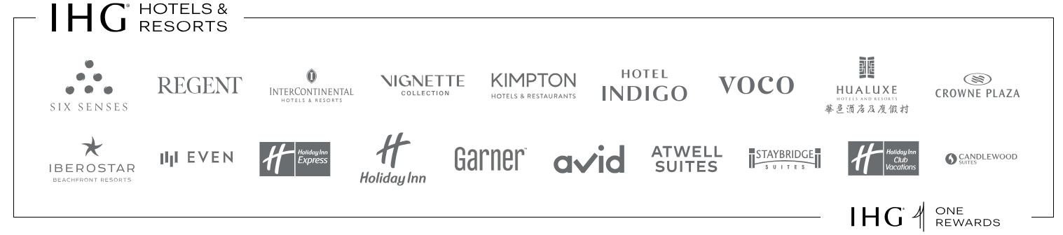
Source: (Park and Shin, 2024).
Figure 3
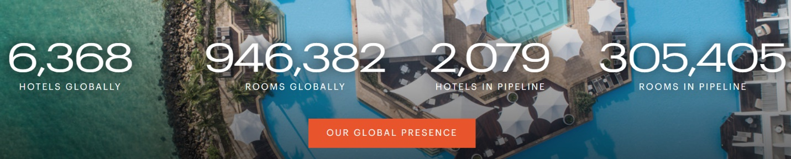
Source: (Singh et al., 2024).
Figure 4
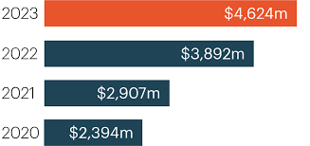
Source: (Park and Shin, 2024)
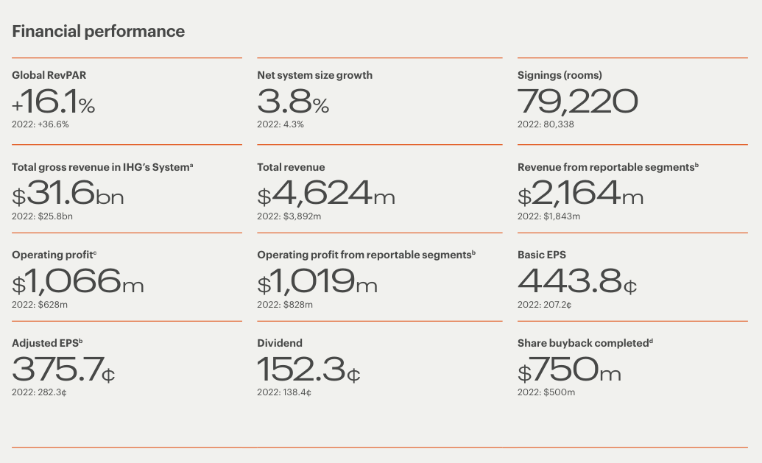
Figure 5
Source: (McGregor et al., 2024).
This resulted in the development of IHG's business platform through various investments in their brands, loyalty, digital offer, and sustainability moves aimed at ensuring that customers were completely satisfied. This not only helped them to increase estate and generate more profits, but it also helped them to increase the demand for travel, which continued to increase throughout the year 2023, demonstrating that people have a strong desire to move from one location to another (McGregor et al., 2024).

Understanding Sustainability Concepts

In hospitality and tourism, sustainability is about avoiding preventing meeting making ends meet for the present and future generations without interfering with meeting their requirements (Singh et al., 2024). As for IHG, sustainability according to what it stands for in sustainability and CSR involves taking care of the environment, being socially responsible and carrying out activities that are ecologically viable. (Mathews, 2024).
Figure 6
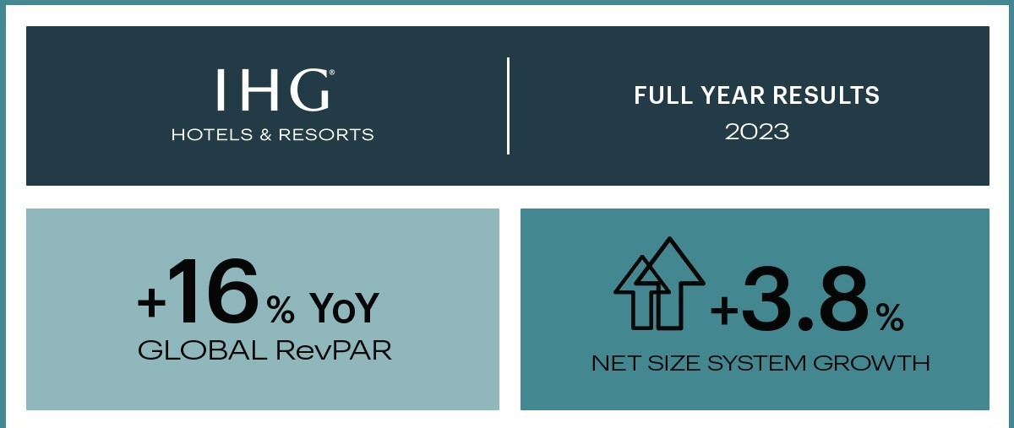
Source: (Singh et al., 2024).
Demand for travel was usually high across the board in all market sectors. When compared to the previous year, revenue per available room climbed by 16%, and it was 11% higher than the peak that was reached before the pandemic in 2019. Taking everything into consideration, the resilience of our company, in conjunction with an efficient organizational structure, made it possible for the profit from the reportable sectors to climb by 23%, therefore crossing the USD 1 billion mark for the very first time. Additionally, the adjusted profits per share increased by 33% (Mathews, 2024). This contributes to the ongoing creation of value for our clientele by utilizing returns from investments in a variety of programs, such as the announcement made today about an additional share repurchase program worth $800 million, among other things, such as payments made through dividends, which are anticipated to have returned more than one billion dollars back into their hands within twenty-four hours since the announcement (McGregor et al., 2024).
Despite having a very strong performance in terms of finances and trading, IHG was able to expand their portfolio and take their brands to a worldwide level. 275 new hotels were launched by IHG in 2023, and the company also signed up to build 556 further hotels. We are also able to modify quarterly openings after taking into account the inclusion of Iberostar hotels to our system by IHG; this increased by 27% year over year, and signings increased by 50% in the fourth quarter, making it one of our most productive quarters to date (Mathews, 2024).
Figure 7
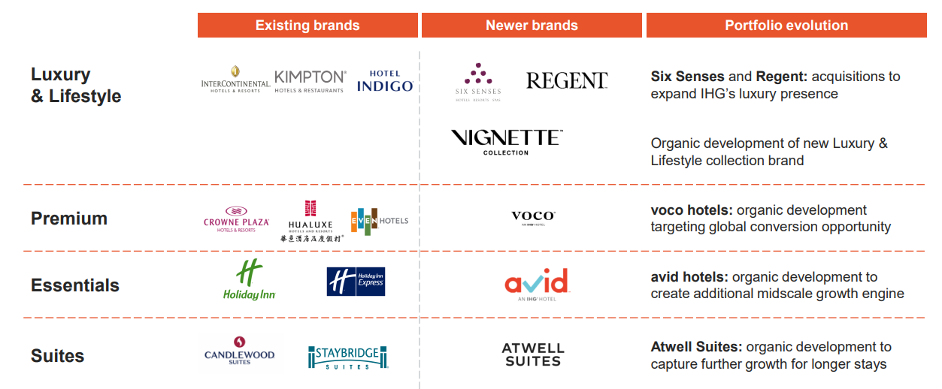
Source: (McGregor et al., 2024).

Theoretical Model
In business strategies, ethicality, social justice and environmental stewardship are interwoven with corporate social responsibilities. Organizations’ implementations of sustainability practices are guided by approaches such as the Triple Bottom Line idea or initiatives such as the Green Key (Alok Bihari Singh et al., 2023). “Journey to Tomorrow,” which is IHG’s approach to corporate social responsibility, has been developed in line with worldwide sustainability objectives so as to positively transform societies and ecosystems. (Park and Shin, 2024).
Figure 8
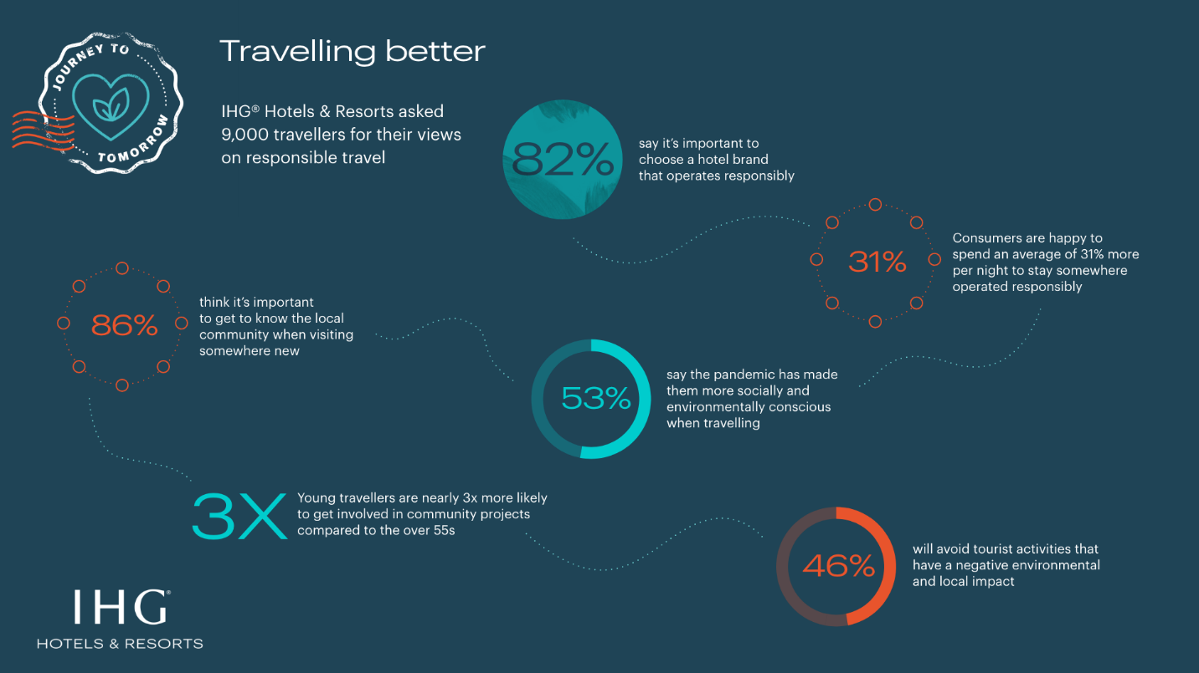
Source: (McGregor et al., 2024).

Analysis

Sustainable Practice In Rural, Coastal, Urban Areas and Transport Sector
The IHG Green Engage system is promoted by IHG to help hotels in rural areas manage their environmental impact by conserving natural resources and supporting biodiversity thus helping local economies and enhancing eco-tourism (Osman Ahmed El-Said et al., 2024).
IHG properties in coastal regions apply beach clean-up programs, efficaciously reduce the extent of water pollution using advanced waste management systems, as well as make use of renewable energy sources e.g. The InterContinental Bora Bora Resort & Thalassa Spa uses seawater to air-conditioning hence cutting down on energy consumption greatly (Park and Shin, 2024).
In towns, IHG uses environmentally-friendly building practices, efficient technologies and comprehensive waste reduction schemes. For instance, the Kempton Fitzroy London has energy-efficient lights, water saving equipment as well as a good recycling facility.
IHG encourages the use of public transport, electric vehicles, and carbon offset programs. To cut its carbon footprint, the InterContinental Los Angeles Downtown has bike-sharing programs at its charging stations for electric vehicles.

Sustainable Practice
IHG's green engage system demonstrates that the company is committed to preserving the environment. It provides assistance to hotels in measuring, monitoring, and managing their impact on the environment, with a particular emphasis on the saving of energy and water, the management of waste, and the source of sustainable materials. It is anticipated that by the year 2023, more than 5,900 facilities owned and operated by IHG will be participating in the Green Engage initiative (Dev, 2024).
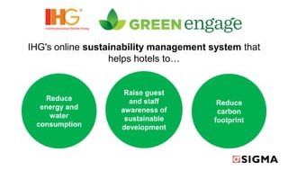
Figure 9

Source: (Dev, 2024).

Practical Application
Steps for Achieving Accreditation Sustainably to be certified just like Green Key, IHG should:
Energy Efficiency: Use lighting, HVAC systems and renewable energy sources which are energy-efficient. For instance, InterContinental San Francisco relies on LED lighting and energy management systems (Alok Bihari Singh et al., 2023).
Save water by using low pressure tabs, waste water purifiers and gathering rain water. Crowne Plaza Copenhagen Towers gathers rainwater for non-potable use such as watering the gardens.
Reduce single-use plastics, develop comprehensive recycling programs, compost organic waste. This Holiday Inn Express & Suites in Monterey Bay has come up with a zero waste initiative which has led to a significant decrease in its contributions to landfills when it comes to Waste Management.
Procure eco-friendly products, support local suppliers, and ensure ethical labor practices. For 90% of its food and beverage products, the Regent Porto Montenegro sources locally.

Benefits of Sustainability in IHG
Excess Resource usage: Reduced expenses for operations after preceding energy as well as water by lessening like that of InterContinental Boston’s energy-conserving moves. This Leads to Elevated Status: Kimpton Hotel Monaco Seattle for example has managed to build a good image together with high customer loyalty as seen through positive responses regarding their Green projects. (Singh et al., 2024). Regulatory compliance is very important in regions with strict environmental laws because it helps meet environmental regulations while avoiding fines. Market differentiation involves being outstanding in a competitive market by having eco-friendly alternatives such as those offered by EVEN Hotels like wellness and sustainability features.

Challenges in Integrating Sustainability in IHG
The high upfront costs are associated with the use of sustainable technologies and infrastructure, as in the case of solar panel installation at the Holiday Inn Express Waikiki. Employee Training: Staff members must first grasp what sustainable practices are all about before they can put them into practice; hence the need for detailed training programs just as it is done at the InterContinental New York Barclay (Park and Shin, 2024). Incorporating sustainability into existing processes is difficult especially when dealing with aged properties. Customer Perspective: At the Hotel Indigo Bali Seminyak Beach’s customer engagement programs, patrons get educated on sustainable approaches' significance and merit.

The Future Trends of the IHG in Hospitality Industry
Several key trends will shape the hotel and hospitality industry in the future:
Focus on renewable energy increases: Hotels will expand their uptake of renewable sources such as solar and wind power. IHG’s Crowne Plaza Adelaide is currently using solar energy. (Osman Ahmed El-Said et al., 2024).
Advanced Waste from the Holiday Inn Express & Suites in Monterey Bay will be common through innovations in waste reduction and recycling technologies. Hotels like the InterContinental Fiji Golf Resort & Spa will follow suit by having more community engagement programs and similar community-based projects. (McGregor et al., 2024).
The Stay Bridge Suites London - Vauxhall aims to make educating its guests about sustainability practices a regular component of the hotels’ service. (Mathews, 2024).

Recommendation
The International Hotel Group (IHG) ought to make investments in additional buildings that are equipped with solar panels, wind turbines, and other kinds of renewable electricity in order to further its sustainability initiatives. Through the development of these initiatives that provide economic and other forms of assistance to local communities in underserved places, the goal of improving community involvement is being accomplished. 2024, according to McGregor et al. Research activities into the complex procedures of waste management that lead to zero wastes are included in the process of engaging in waste mitigation innovations. Conducting Frequent Sustainability Checks: Inspection of many components with the purpose of carrying out changes based on the most recent sustainability benchmarks (Mathews, 2024).

Conclusion
Because of their dedication to environmental responsibility, IHG is widely regarded as a leader in the hospitality sector. Putting into action tactics that are friendly to the environment not only helps the company save money, but it also helps the firm boost its reputation, which is another name for its brand recognition. To ensure that it continues to be relevant and to take care of the planet and its beneficiaries or stakeholders, the International Humanitarian Foundation (IHGF) must continue to evolve in light of the growing significance of sustainability. in the year 2024. For the hotel and hospitality business, these efforts will be the driving force behind a tourist approach that is both comprehensive and responsible, which will undoubtedly have a significant impact on the future.

Reference
Alok Bihari Singh, Gaurav Gaurav, Sarkar, P., Govind Sharan Dangayach and Makkhan Lal Meena (2023). Current Understanding, Motivations, and Barriers Towards Implementing Sustainable Initiatives in the Hospitality Industry in the Age of Automation and Artificial Intelligence. Recent Patents on Engineering, 18. doi:https://doi.org/10.2174/0118722121239293230926034213.
Dev, C.S. (2024). Hotel Brand Overload: The Coming Shakeout. ecommons.cornell.edu. [online] Available at: https://ecommons.cornell.edu/items/748a96a0-ee0e-4622-b8b0-7acad06b5c15.
Mathews, A. (2024). An evaluation of cost cutting measures in the hotel industry with a view on two Nordic hotels. [online] www.theseus.fi. Available at: https://www.theseus.fi/handle/10024/859544 [Accessed 1 Jun. 2024].
McGregor, K., Becken, S., Sera Vada and Mackey, B. (2024). Enhancing compliance assessment through regenerative transformations – A food waste perspective. Journal of sustainable tourism, pp.1–20. doi:https://doi.org/10.1080/09669582.2024.2348118.
Osman Ahmed El-Said, Sayed Elhoushy, Smith, M. and Marwa Youssif (2024). Crisis-driven innovation in hospitality: How do international hotel chains innovate to recover from a global crisis? International journal of hospitality management, 120, pp.103758–103758. doi:https://doi.org/10.1016/j.ijhm.2024.103758.
Park, Y.-N. and Shin, M. (2024). Effect of customers’ subjective knowledge on accepting ESG (environmental, social, governance) activities in the hospitality industry. Journal of Travel & Tourism Marketing, 41(1), pp.51–67. doi:https://doi.org/10.1080/10548408.2023.2269975.
Singh, R., Gehlot, A., Shaik Vaseem Akram, Amit Kumar Thakur, Lovi Raj Gupta, Neeraj Priyadarshi and Bhekisipho Twala (2024). Integration of advanced digital technologies in the hospitality industry: A technological approach towards sustainability. Sustainable Engineering and Innovation, 6(1), pp.37–56. doi:https://doi.org/10.37868/sei.v6i1.id208.

