James Fitches
2217780
Applied Computing/Software Engineering
L4: Introduction TO WEB AND DATABASE CONCEPTS
Assignment

Table of Contents
Introduction 3
Requirements 3
Implementation 4
Pages: 4
index.html 4
services.html 5
testing.html 6
guide.html 7
request.html 8
contact.html 9
about.html 10
Validation: 11
index.html 11
services.html 11
testing.html 11
guide.html 11
request.html 11
contact.html 12
about.html 12
style.css 12
Evaluation 13
Usefulness 13
Search Engine Optimisation (SEO) 13
Accessibility 14
Perceivable: 14
Operable: 14
Understandable: 14
Robust: 14
References 15
Appendices 16
Script listings: 16
index.html 16
services.html 24
testing.html 32
guide.html 42
request.html 48
contact.html 54
about.html 63
style.css 69

Introduction

For the assignment website I chose to do the Welsh Transplant and Immunogenetics Laboratory (WTAIL). Their existing site was first created in 2010 (by me) and ported to WordPress in 2016 with little design or structural change. No further work was done to modernise the site so here I have applied a modern framework and responsive layout to the content.
This assignment report documents the design, layout, and coding structure for the website.

Requirements

This website provides information on the services provided by the Welsh Transplant and Immunogenetics Laboratory (WTAIL). These services are supplied for the benefit of patients requiring an organ or bone marrow transplant.
WTAIL also encompasses three other organisations. The Welsh Histocompatibility and Immunogenetics Service (WHAIS), the Welsh Bone Marrow Donor Registry (WBMDR) and the UK National External Quality Assessment Service for Histocompatibility and Immunogenetics (UK NEQAS for H&I)
The information presented is primarily a source of clinical advice for the medical and scientific community and services provided by WTAIL. WHAIS are responsible for the testing of transplant patients in Wales requiring a pancreas or kidney.

Implementation

Pages:

index.html
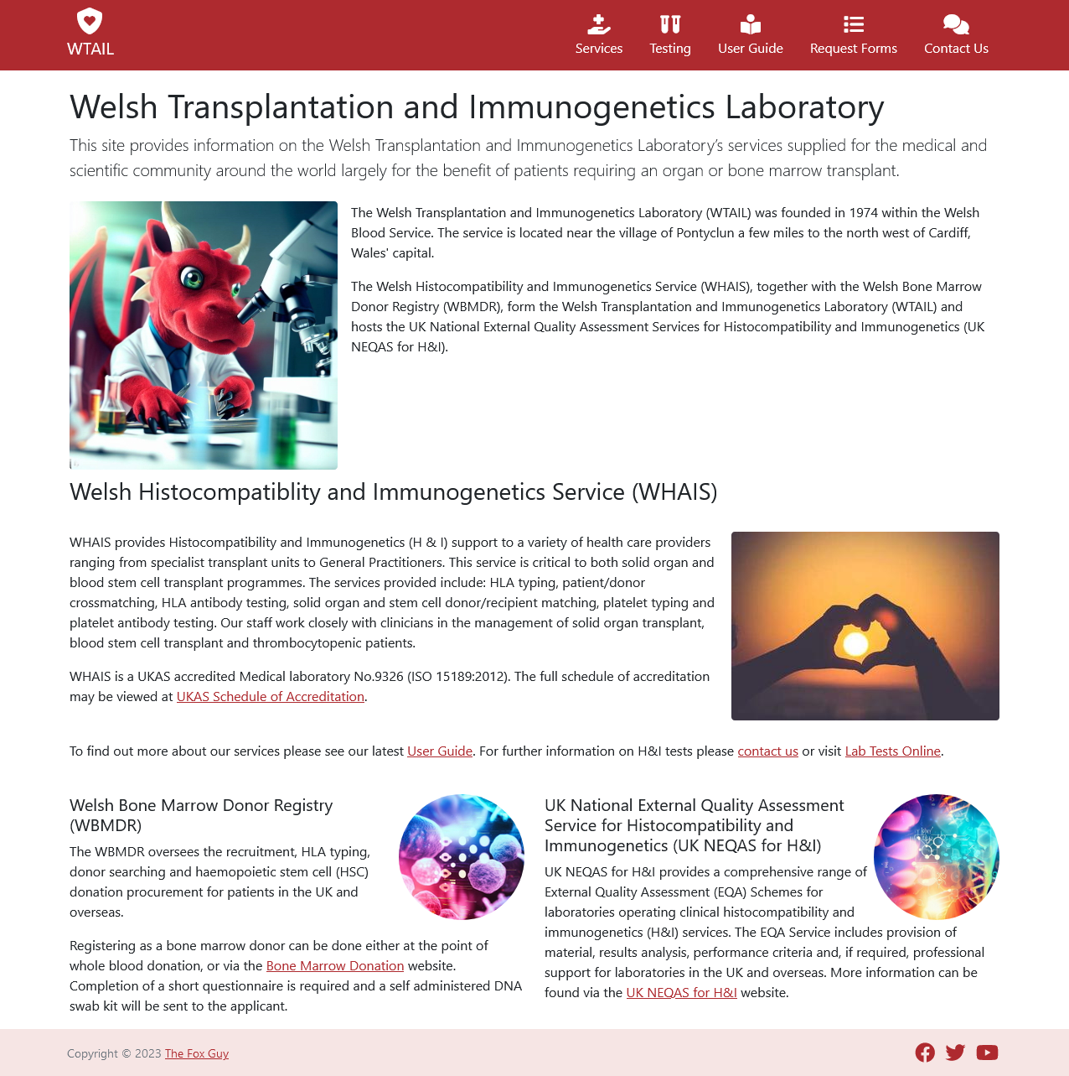

services.html
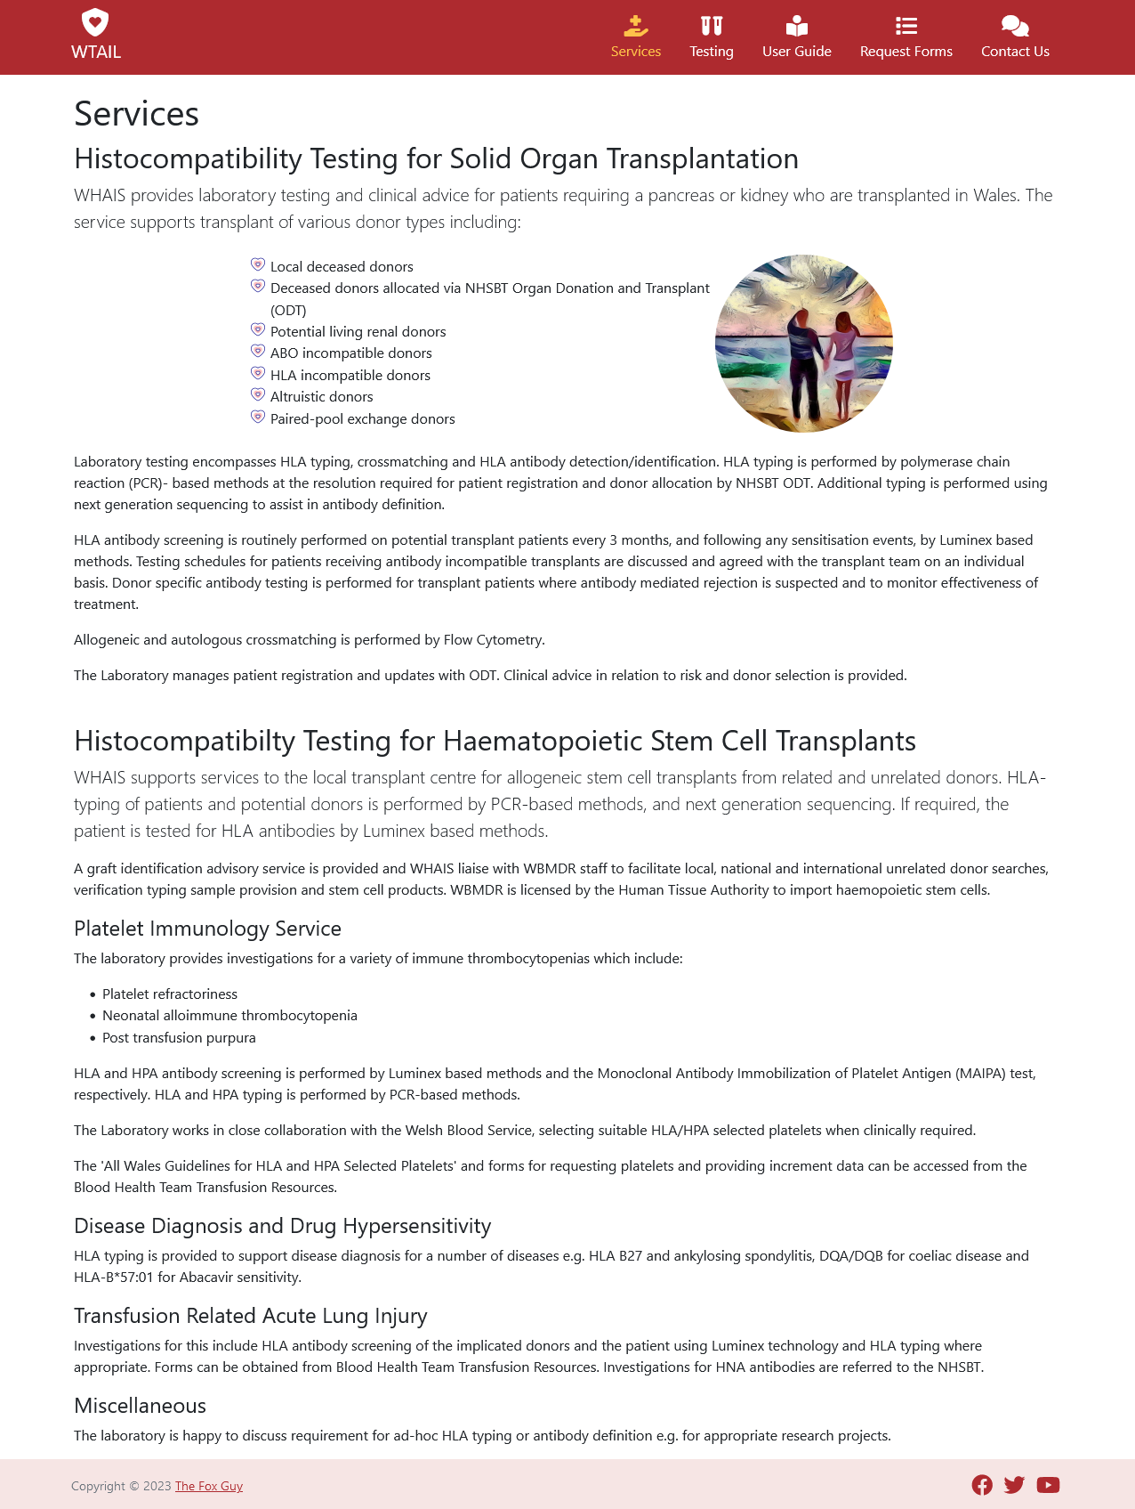

testing.html
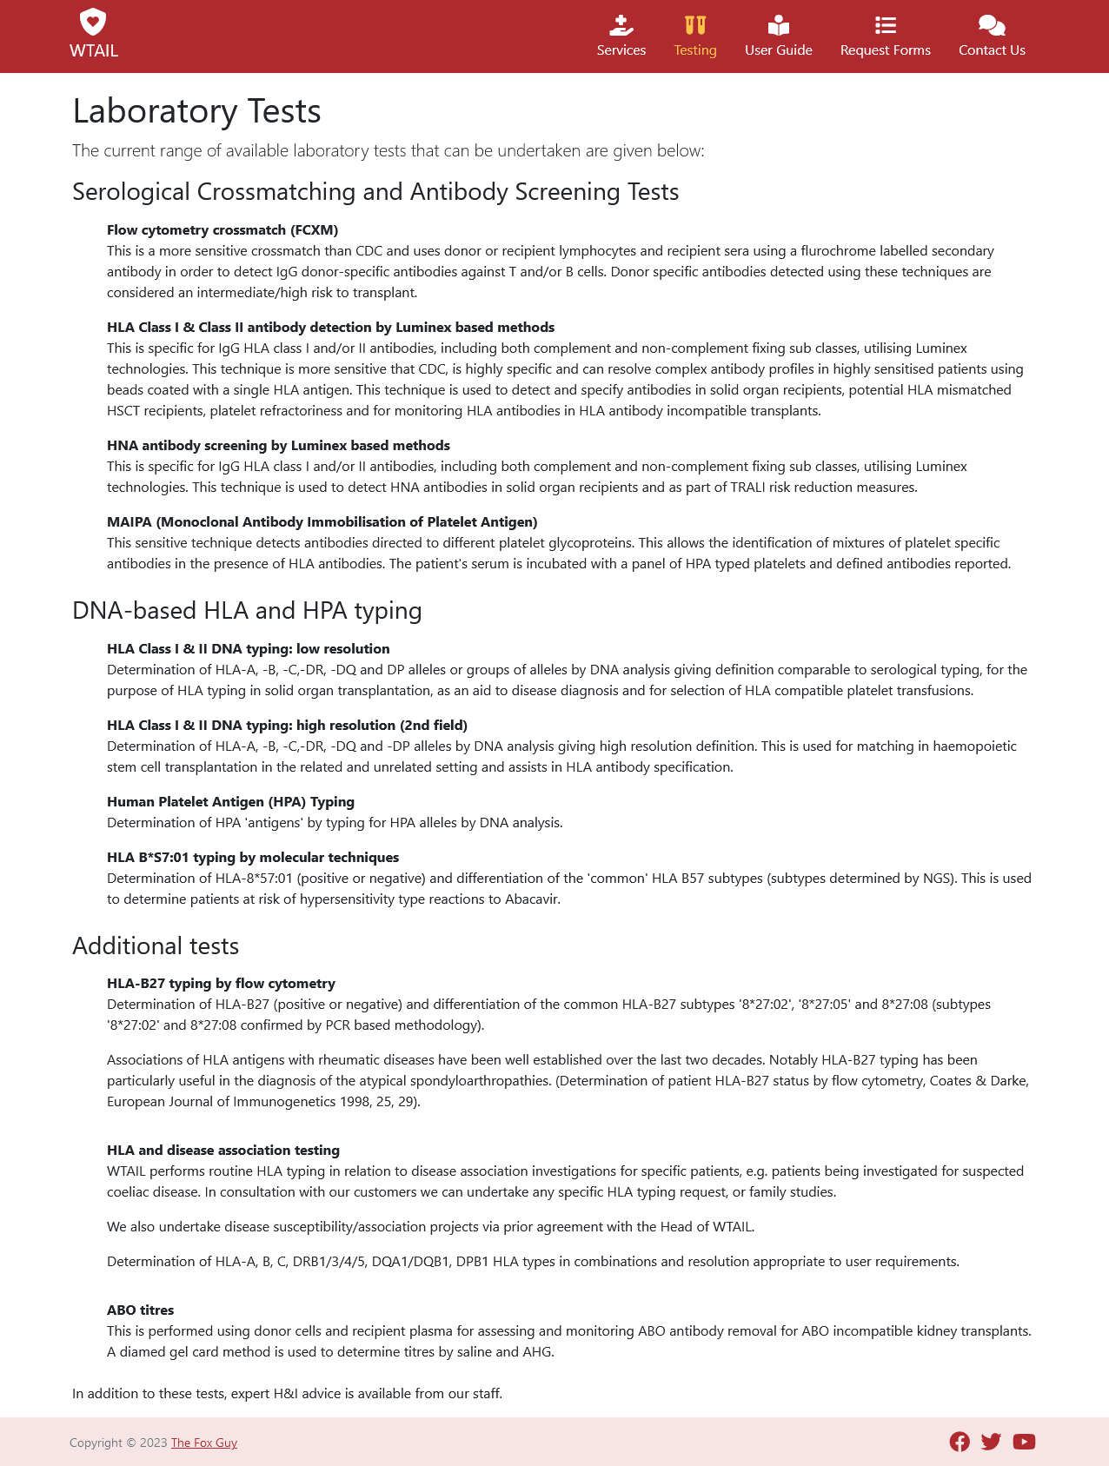

guide.html
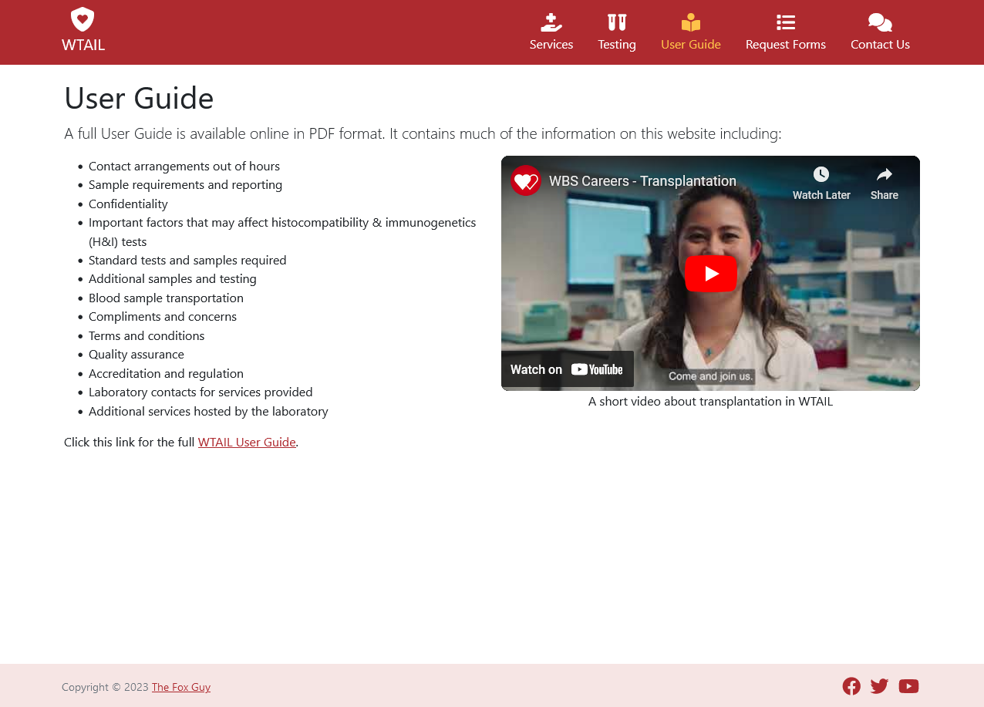

request.html
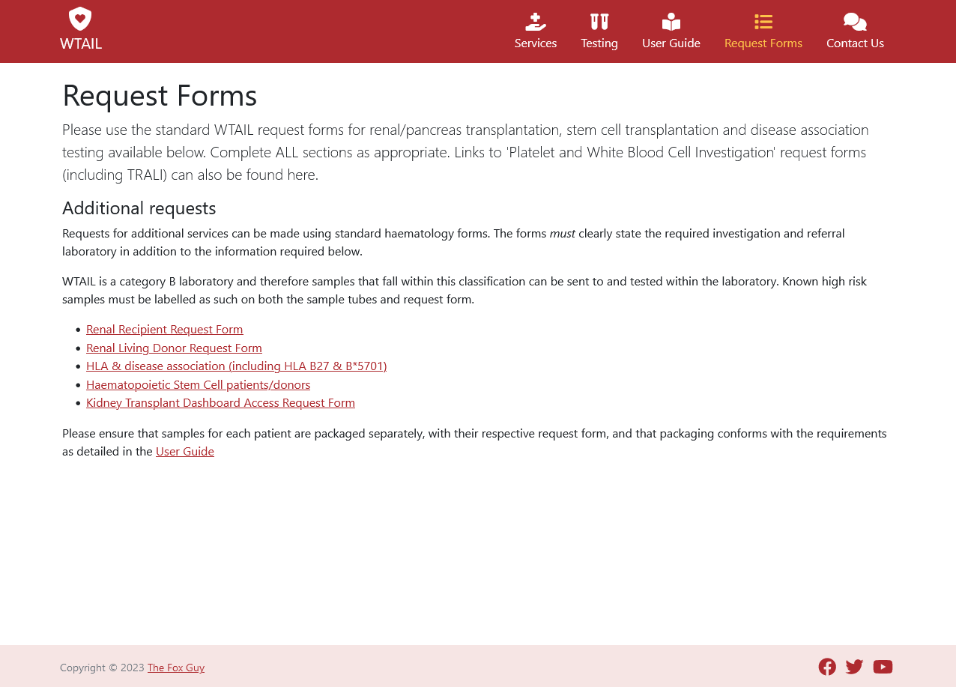

contact.html
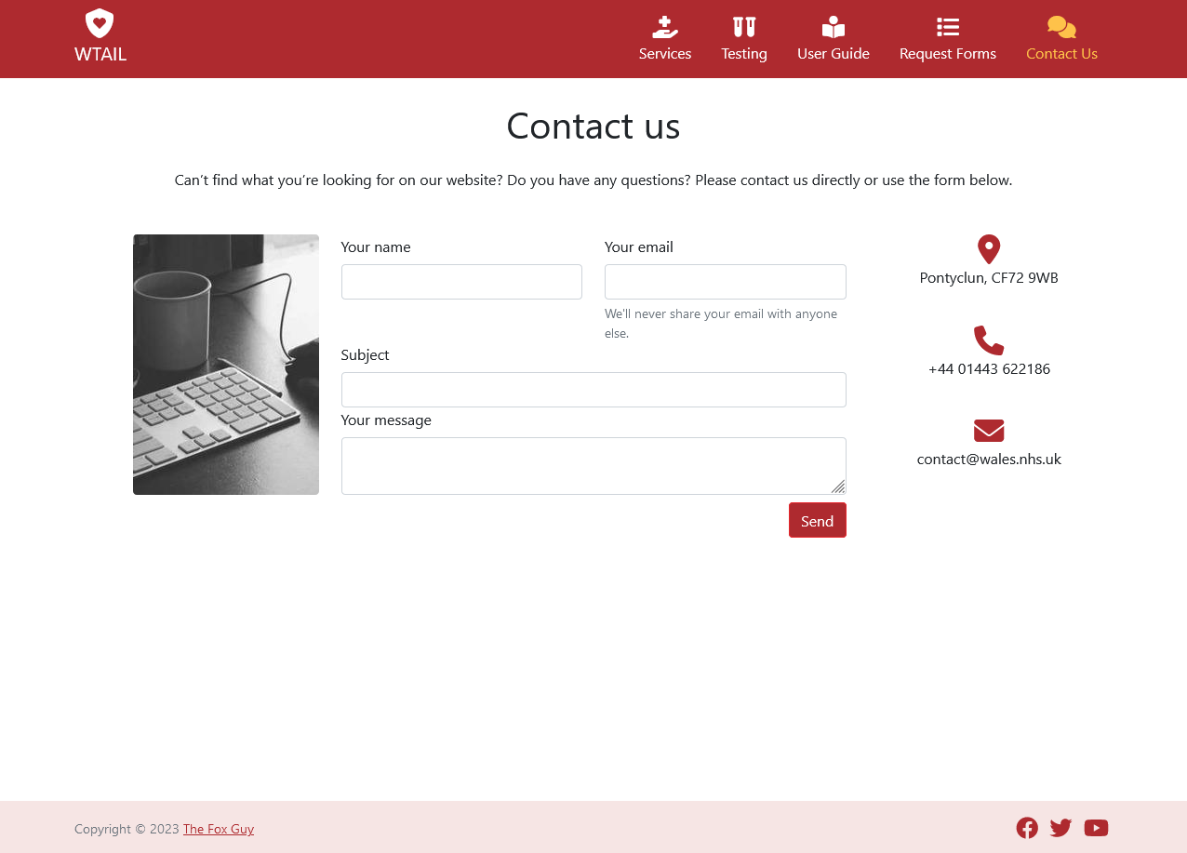

about.html
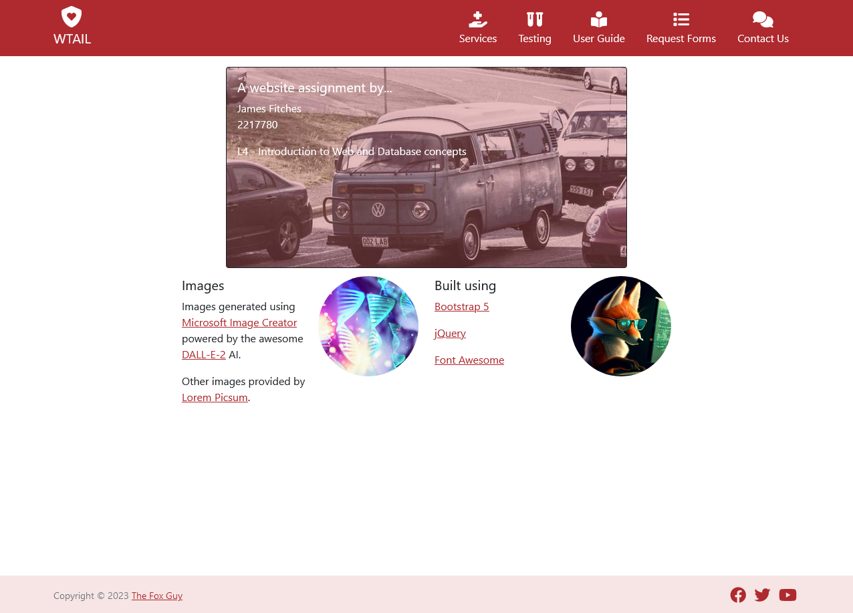

Validation:

All pages were tested using the W3C Markup Validation Service [1] with the following results:

index.html
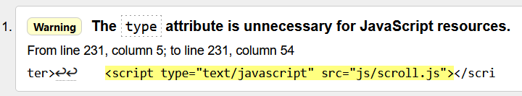
Optional since the advent of HTML5, JavaScript is now the de facto language of modern browsers so its use is deprecated where JavaScript is implied. Removed type attribute from tag. [2][3]

services.html
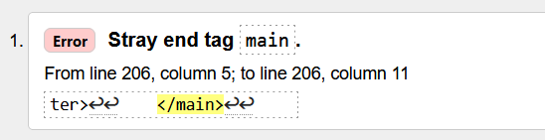
Unnecessary (duplicated) closing tag. Removed.

testing.html
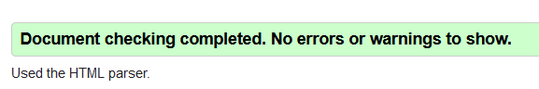

guide.html

request.html

contact.html

about.html

style.css
Tested using the W3C CSS Validation Service [4].


Evaluation

Usefulness

The site provides factual and mainly text based information on the provision of clinical laboratory services. The text is presented in an easy to read and accessible manner using the standard headings to denote document structure. Images are used in places to break up the text.
The site uses a standard simple, clean layout. Navigation is provided by a top menu with labelled icons representing links to the website's pages. The menu is scroll linked to show or hide itself as the user scrolls the page up and down, while not as noticeable on larger screens it maximises screen space on smaller and mobile devices. A helpful scroll to top button appears once the user scrolls down.
The site is built on the Bootstrap [5] framework and utilises jQuery [6] and Font Awesome [7].
The site can be improved by:
- Utilise an API framework such as Node JS [8] and Express [9] or the Python based Django [10] to serve (render) pages (via endpoints).
- Using a template engine to split HTML pages into reusable blocks. This enables simpler improvement and maintenance of the code while reducing repeated errors.
- Replace PDF form downloads with smart web forms to gather and validate the required information. This dramatically reduces transcription errors and can provide hard copy print outs if required.
- Collect form data via the REST API into a database.
- Interface collected form data to internal NHS systems while adhering to healthcare interoperability standards such as FHIR, HL7 and SNOMED [11].
- Make site multilingual. This may be regulatory [12].

Search Engine Optimisation (SEO)

Various on-page SEO [13] techniques have been applied to the site to help improve indexing and increase listing prominence, these include:
- Validating the HTML/CSS of the site against W3C validator services.
- Including a "title" tag in the header.
- Including "description" and "keyword" meta tags in the header. These allow search engines to better index the site.
- Using H1 tags for page titles.
- Using descriptive image names and text alt attributes for IMG tags.
- Optimising images to reduce their size for online transmission.
- Checking for and eliminating any broken links.

Accessibility

The WCAG 2.1 guidelines [14] define four principles [15] for web site accessibility, all pages have been tested using the Firefox Accessibility Inspector:

Perceivable:

Information is presented in clear and concise format. The text is displayed in black on white for high contrast and readability. Text alternatives are specified for non-textual elements. Colours have been compared using a contrast checker to adhere to WCAG standard.

Operable:

Pages are descriptively titled with headings and labels. A simple navigation utilising labelled icons provides both visual and textual identification of the link to assist the user with selection.

Understandable:

All information is provided in plain English with attention to spelling and grammar. Navigation is simple and presented in common locations with easy to recognise symbols.

Robust:

The site uses a standard industry framework that ensures the site is responsive to the media device upon which it is viewed. Alternative descriptions are used wherever and whenever possible to complement assistive technologies.

References

[1] W3C, "Markup Validation Service", [Online] Available: http://validator.w3.org [Accessed 01/05/2023]
[2] W3C, "HTML <script> type Attribute", [Online] Available: https://www.w3schools.com/tags/att_script_type.asp [Accessed 01/05/2023]
[3] MDN, "Web docs", [Online] Available: https://developer.mozilla.org/en-US/docs/Web/HTML/Element/script [Accessed 01/05/2023]
[4] WC3, "CSS Validation Service", [Online] Available: http://jigsaw.w3.org/css-validator/ [Accessed 01/05/2023]
[5] Bootstrap, [Online] Available: https://getbootstrap.com/ [Accessed 15/04/2023]
[6] jQuery, [Online] Available: https://jquery.com/ [Accessed 15/04/2023]
[7] Font Awesome, [Online] Available: https://fontawesome.com/ [Accessed 15/04/2023]
[8] Node JS, [Online] Available: https://nodejs.org/ [Accessed 01/05/2023]
[9] Express, [Online] Available: https://www.npmjs.com/package/express [Accessed 01/05/2023]
[10] Django, [Online] Available: https://www.djangoproject.com/ [Accessed 01/05/2023]
[11] T Benson, G Grieve, "Principles of health interoperability: FHIR, HL7 and SNOMED CT", Fourth edition, 2021, Springer, [Online] Available: https://www-vlebooks-com.ezproxy.uwtsd.ac.uk/Product/Index/2140822?page=0 [Accessed 01/05/2023]
[12] Welsh Language Commissioner, "Welsh language standards", [Online] Available: https://www.welshlanguagecommissioner.wales/public-organisations/welsh-language-standards [Accessed 01/05/2023]
[13] E Enge, "The art of SEO", 2012, O'Reilly, [Online] Available: https://www-vlebooks-com.ezproxy.uwtsd.ac.uk/Product/Index/421563?page=0 [Accessed 99/99/2023]
[14] W3C, "Web Content Accessibility Guidelines", [Online] Available: https://www.w3.org/TR/WCAG21/ [Accessed 01/05/2023]
[15] W3C, "Understanding the Four Principles of Accessibility", [Online] Available: https://www.w3.org/WAI/WCAG21/Understanding/intro#understanding-the-four-principles-of-accessibility [Accessed 01/05/2023]

Appendices

Script listings:

index.html

<!doctype html>
<html lang="en" class="h-100">

<head>
<!-- meta tags -->
<meta charset="utf-8">
<meta http-equiv="X-UA-Compatible" content="IE=edge">
<meta name="viewport" content="width=device-width, initial-scale=1">
<meta name="description" content="Welsh Transplantation and Immunogenetics Laboratory">
<meta name="keywords" content="Transplantation, Immunogenetics, Histocompatibility, NHS, Wales">
<meta name="author" content="James Fitches">
<meta name="generator" content="handcraft">

<!-- Bootstrap -->
<link href="https://cdn.jsdelivr.net/npm/bootstrap@5.1.3/dist/css/bootstrap.min.css" rel="stylesheet"
integrity="sha384-1BmE4kWBq78iYhFldvKuhfTAU6auU8tT94WrHftjDbrCEXSU1oBoqyl2QvZ6jIW3" crossorigin="anonymous">

<!-- Font Awesome, Solid + Brands (freebies) -->
<link href="asset/fontawesome/css/fontawesome.css" rel="stylesheet">
<link href="asset/fontawesome/css/brands.css" rel="stylesheet">
<link href="asset/fontawesome/css/solid.css" rel="stylesheet">
<link href="css/style.css" rel="stylesheet">

<title>WTAIL - Home</title>
</head>

<body class="d-flex flex-column h-100 pt-5 pt-lg-3">
<header>
<div id="navbar" class="px-3 py-2">
<div class="container">
<div class="d-flex flex-wrap align-items-center justify-content-center justify-content-lg-start">

<!-- Logo -->
<a href="index.html"
class="d-flex align-items-center my-2 my-lg-0 me-lg-auto text-white text-decoration-none">
<div class="text-sm-bottom text-center">
<i class="fa-solid fa-shield-heart fa-2xl"></i>
<div class="navbar-brand d-none d-sm-block">WTAIL</div>
</div>
</a>

<!-- Navigation -->
<ul class="nav col-12 col-lg-auto my-2 justify-content-center my-md-0 text-small">
<li>
<a href="services.html" class="nav-link text-white">
<span class="d-block mx-auto mb-1">
<i class="fa-solid fa-hand-holding-medical fa-xl fa-center"></i>
</span>
Services
</a>
</li>
<li>
<a href="testing.html" class="nav-link text-white">
<span class="d-block mx-auto mb-1">
<i class="fa-solid fa-vials fa-xl fa-center"></i>
</span>
Testing
</a>
</li>
<li>
<a href="guide.html" class="nav-link text-white">
<span class="d-block mx-auto mb-1">
<i class="fa-solid fa-book-open-reader fa-xl fa-center"></i>
</span>
User Guide
</a>
</li>
<li>
<a href="request.html" class="nav-link text-white">
<span class="d-block mx-auto mb-1">
<i class="fa-solid fa-list fa-xl fa-center"></i>
</span>
Request Forms
</a>
</li>
<li>
<a href="contact.html" class="nav-link text-white">
<span class="d-block mx-auto mb-1">
<i class="fa-solid fa-comments fa-xl fa-center"></i>
</span>
Contact Us
</a>
</li>
</ul>
</div>
</div>
</div>
</header>

<main class="flex-shrink-0">
<div class="container mt-5 mt-lg-2">
<div class="mt-5 mt-sm-2 mt-lg-3 pt-4 pt-lg-0"></div>

<h1>Welsh Transplantation and Immunogenetics Laboratory</h1>
<p class="lead">
This site provides information on the Welsh Transplantation and Immunogenetics Laboratory’s services
supplied for the medical and scientific community around the world largely for the benefit of patients
requiring an organ or bone marrow transplant.
</p>

<div class="row">
<div class="py-2 py-lg-2">
<img src="img/dragon-boffin.jpg" class="rounded float-sm-start imgshadow mx-auto d-block me-sm-3"
alt="A Welsh dragon working in a medical laboratory">

<div class="mx-2">
<p>
The Welsh Transplantation and Immunogenetics Laboratory (WTAIL) was founded in 1974 within
the Welsh Blood Service. The service is located near the village of Pontyclun a few miles to
the north west of Cardiff, Wales&apos; capital.
</p>
<p>
The Welsh Histocompatibility and Immunogenetics Service (WHAIS), together with the Welsh
Bone Marrow Donor Registry (WBMDR), form the Welsh Transplantation and Immunogenetics
Laboratory (WTAIL) and hosts the UK National External Quality Assessment Services for
Histocompatibility and Immunogenetics (UK NEQAS for H&I).
</p>
</div>
</div>
</div>

<h3>Welsh Histocompatibility and Immunogenetics Service (WHAIS)</h3>
<div class="row">
<div class="col-lg-12 py-2 py-lg-4">
<img src="https://picsum.photos/id/815/320/225"
class="rounded float-sm-end imgshadow mx-auto d-block" alt="hands forming heart over sunset">

<p>
WHAIS provides Histocompatibility and Immunogenetics (H & I) support to a variety of health care
providers ranging from specialist transplant units to General Practitioners. This service is
critical to both solid organ and blood stem cell transplant programmes. The services provided
include: HLA typing, patient/donor crossmatching, HLA antibody testing, solid organ and stem
cell donor/recipient matching, platelet typing and platelet antibody testing. Our staff work
closely with clinicians in the management of solid organ transplant, blood stem cell transplant
and thrombocytopenic patients.
</p>
<p>
WHAIS is a UKAS accredited Medical laboratory No.9326 (ISO 15189:2012). The full schedule of
accreditation may be viewed at <a
href="https://www.ukas.com/wp-content/uploads/schedule_uploads/00007/9326-Medical-Single.pdf"
target="_blank">UKAS Schedule of Accreditation</a>.
</p>
</div>
</div>

<p>
To find out more about our services please see our latest <a href="guide.html">User Guide</a>. For
further information on H&I tests please <a href="contact.html">contact us</a> or visit <a
href="https://labtestsonline.org/" target="_blank">Lab Tests Online</a>.
</p>

<div class="row pt-4">
<div class="col-lg-6">
<img src="img/organic-1.jpg" class="float-end rounded-circle imgshadow" width="150" height="150"
alt="Welsh Bone Marrow Donor Registry">
<h5>Welsh Bone Marrow Donor Registry (WBMDR)</h5>
<p>
The WBMDR oversees the recruitment, HLA typing, donor searching and haemopoietic stem cell (HSC)
donation procurement for patients in the UK and overseas.
</p>
<p>
Registering as a bone marrow donor can be done either at the point of whole blood donation, or
via the <a href="https://www.wbmdr.org.uk/" target="_blank">Bone Marrow Donation</a> website.
Completion of a short questionnaire is required and a self administered DNA swab kit will be
sent to the applicant.
</p>
</div>

<div class="col-lg-6">
<img src="img/organic-2.jpg" class="float-end rounded-circle imgshadow" width="150" height="150"
alt="UK NEQAS for H&I">
<h5>UK National External Quality Assessment Service for Histocompatibility and Immunogenetics (UK
NEQAS for H&I)</h5>
<p>
UK NEQAS for H&I provides a comprehensive range of External Quality Assessment (EQA) Schemes for
laboratories operating clinical histocompatibility and immunogenetics (H&I) services. The EQA
Service includes provision of material, results analysis, performance criteria and, if required,
professional support for laboratories in the UK and overseas. More information can be found via
the <a href="https://ukneqashandi.org.uk/" target="_blank">UK NEQAS for H&I</a> website.
</p>
</div>
</div>
</div>

</main>

<footer class="footer mt-auto py-3 bg-footer">
<button type="button" class="btn btn-floating btn-lg shadow-none" id="btn-back-to-top">
<i class="fas fa-angle-up text-white"></i>
</button>
<div class="container">
<div class="float-sm-end mb-1 mb-sm-0">
<a href="#" title="Facebook" target="_blank">
<i class="fa-brands fa-facebook fa-xl mx-1"></i></a>
<a href="#" title="Twitter" target="_blank">
<i class="fa-brands fa-twitter fa-xl mx-1"></i></a>
<a href="#" title="YouTube" target="_blank">
<i class="fa-brands fa-youtube fa-xl mx-1"></i></a>
</div>
<span class="text-muted small">Copyright &copy; 2023 <a href="about.html">The Fox Guy</a></span>
</div>
</footer>

<script src="js/scroll.js"></script>
<script src="https://cdn.jsdelivr.net/npm/bootstrap@5.1.3/dist/js/bootstrap.bundle.min.js"
integrity="sha384-ka7Sk0Gln4gmtz2MlQnikT1wXgYsOg+OMhuP+IlRH9sENBO0LRn5q+8nbTov4+1p"
crossorigin="anonymous"></script>
</body>

</html>

services.html

<!doctype html>
<html lang="en" class="h-100">

<head>
<!-- meta tags -->
<meta charset="utf-8">
<meta http-equiv="X-UA-Compatible" content="IE=edge">
<meta name="viewport" content="width=device-width, initial-scale=1">
<meta name="description" content="Welsh Transplantation and Immunogenetics Laboratory">
<meta name="keywords" content="Transplantation, Immunogenetics, Histocompatibility, NHS, Wales">
<meta name="author" content="James Fitches">
<meta name="generator" content="handcraft">

<!-- Bootstrap -->
<link href="https://cdn.jsdelivr.net/npm/bootstrap@5.1.3/dist/css/bootstrap.min.css" rel="stylesheet"
integrity="sha384-1BmE4kWBq78iYhFldvKuhfTAU6auU8tT94WrHftjDbrCEXSU1oBoqyl2QvZ6jIW3" crossorigin="anonymous">

<!-- Font Awesome, Solid + Brands (freebies) -->
<link href="asset/fontawesome/css/fontawesome.css" rel="stylesheet">
<link href="asset/fontawesome/css/brands.css" rel="stylesheet">
<link href="asset/fontawesome/css/solid.css" rel="stylesheet">
<link href="css/style.css" rel="stylesheet">

<title>WTAIL - Services</title>
</head>

<body class="d-flex flex-column h-100 pt-5 pt-lg-3">
<header>
<div id="navbar" class="px-3 py-2">
<div class="container">
<div class="d-flex flex-wrap align-items-center justify-content-center justify-content-lg-start">

<!-- Logo -->
<a href="index.html"
class="d-flex align-items-center my-2 my-lg-0 me-lg-auto text-white text-decoration-none">
<div class="text-sm-bottom text-center">
<i class="fa-solid fa-shield-heart fa-2xl"></i>
<div class="navbar-brand d-none d-sm-block">WTAIL</div>
</div>
</a>

<!-- Navigation -->
<ul class="nav col-12 col-lg-auto my-2 justify-content-center my-md-0 text-small">
<li>
<a href="services.html" class="nav-link text-secondary">
<span class="d-block mx-auto mb-1">
<i class="fa-solid fa-hand-holding-medical fa-xl fa-center"></i>
</span>
Services
</a>
</li>
<li>
<a href="testing.html" class="nav-link text-white">
<span class="d-block mx-auto mb-1">
<i class="fa-solid fa-vials fa-xl fa-center"></i>
</span>
Testing
</a>
</li>
<li>
<a href="guide.html" class="nav-link text-white">
<span class="d-block mx-auto mb-1">
<i class="fa-solid fa-book-open-reader fa-xl fa-center"></i>
</span>
User Guide
</a>
</li>
<li>
<a href="request.html" class="nav-link text-white">
<span class="d-block mx-auto mb-1">
<i class="fa-solid fa-list fa-xl fa-center"></i>
</span>
Request Forms
</a>
</li>
<li>
<a href="contact.html" class="nav-link text-white">
<span class="d-block mx-auto mb-1">
<i class="fa-solid fa-comments fa-xl fa-center"></i>
</span>
Contact Us
</a>
</li>
</ul>
</div>
</div>
</div>
</header>

<main class="flex-shrink-0">
<div class="container mt-5 mt-lg-2">
<div class="mt-5 mt-sm-2 mt-lg-3 pt-4 pt-lg-0"></div>
<h1>Services</h1>

<h2>Histocompatibility Testing for Solid Organ Transplantation</h2>
<p class="lead">
WHAIS provides laboratory testing and clinical advice for patients requiring a pancreas or kidney who
are transplanted in Wales. The service supports transplant of various donor types including:
</p>

<div class="row py-2 justify-content-center">
<div class="col-10 col-lg-8">
<img src="img/beach-sml.jpg" class="float-sm-end rounded-circle imgshadow mx-auto d-block"
alt="Welsh Bone Marrow Donor Registry">
<ul class="mt-3 mt-sm-0" style="list-style-image: url('img/heart-sml.png');">
<li>Local deceased donors</li>
<li>Deceased donors allocated via NHSBT Organ Donation and Transplant (ODT)</li>
<li>Potential living renal donors</li>
<li>ABO incompatible donors</li>
<li>HLA incompatible donors</li>
<li>Altruistic donors</li>
<li>Paired-pool exchange donors</li>
</ul>
</div>
</div>

<p>
Laboratory testing encompasses HLA typing, crossmatching and HLA antibody detection/identification. HLA
typing is performed by polymerase chain reaction (PCR)- based methods at the resolution required for
patient registration and donor allocation by NHSBT ODT. Additional typing is performed using next
generation sequencing to assist in antibody definition.
</p>
<p>
HLA antibody screening is routinely performed on potential transplant patients every 3 months, and
following any sensitisation events, by Luminex based methods. Testing schedules for patients receiving
antibody incompatible transplants are discussed and agreed with the transplant team on an individual
basis. Donor specific antibody testing is performed for transplant patients where antibody mediated
rejection is suspected and to monitor effectiveness of treatment.
</p>
<p>
Allogeneic and autologous crossmatching is performed by Flow Cytometry.
</p>
<p>
The Laboratory manages patient registration and updates with ODT. Clinical advice in relation to risk
and donor selection is provided.
</p>

<h2 class="pt-4"> Histocompatibility Testing for Haematopoietic Stem Cell Transplants</h2>
<p class="lead">
WHAIS supports services to the local transplant centre for allogeneic stem cell transplants from related
and unrelated donors. HLA-typing of patients and potential donors is performed by PCR-based methods, and
next generation sequencing. If required, the patient is tested for HLA antibodies by Luminex based
methods.
</p>
<p>
A graft identification advisory service is provided and WHAIS liaise with WBMDR staff to facilitate
local, national and international unrelated donor searches, verification typing sample provision and
stem cell products. WBMDR is licensed by the Human Tissue Authority to import haemopoietic stem cells.
</p>

<h4>Platelet Immunology Service</h4>
<p>
The laboratory provides investigations for a variety of immune thrombocytopenias which include:
</p>
<ul>
<li>Platelet refractoriness</li>
<li>Neonatal alloimmune thrombocytopenia</li>
<li>Post transfusion purpura</li>
</ul>
<p>
HLA and HPA antibody screening is performed by Luminex based methods and the Monoclonal Antibody
Immobilization of Platelet Antigen (MAIPA) test, respectively. HLA and HPA typing is performed by
PCR-based methods.
</p>
<p>
The Laboratory works in close collaboration with the Welsh Blood Service, selecting suitable HLA/HPA
selected platelets when clinically required.
</p>
<p>
The 'All Wales Guidelines for HLA and HPA Selected Platelets' and forms for requesting platelets and
providing increment data can be accessed from the Blood Health Team Transfusion Resources.
</p>

<h4>Disease Diagnosis and Drug Hypersensitivity</h4>
<p>
HLA typing is provided to support disease diagnosis for a number of diseases e.g. HLA B27 and ankylosing
spondylitis, DQA/DQB for coeliac disease and HLA-B*57:01 for Abacavir sensitivity.
</p>

<h4>Transfusion Related Acute Lung Injury</h4>
<p>
Investigations for this include HLA antibody screening of the implicated donors and the patient using
Luminex technology and HLA typing where appropriate. Forms can be obtained from Blood Health Team
Transfusion Resources. Investigations for HNA antibodies are referred to the NHSBT.
</p>

<h4>Miscellaneous</h4>
<p>
The laboratory is happy to discuss requirement for ad-hoc HLA typing or antibody definition
e.g. for appropriate research projects.
</p>
</div>
</main>

<footer class="footer mt-auto py-3 bg-footer">
<button type="button" class="btn btn-floating btn-lg shadow-none" id="btn-back-to-top">
<i class="fas fa-angle-up text-white"></i>
</button>
<div class="container">
<div class="float-sm-end mb-1 mb-sm-0">
<a href="#" title="Facebook" target="_blank">
<i class="fa-brands fa-facebook fa-xl mx-1"></i></a>
<a href="#" title="Twitter" target="_blank">
<i class="fa-brands fa-twitter fa-xl mx-1"></i></a>
<a href="#" title="YouTube" target="_blank">
<i class="fa-brands fa-youtube fa-xl mx-1"></i></a>
</div>
<span class="text-muted small">Copyright &copy; 2023 <a href="about.html">The Fox Guy</a></span>
</div>
</footer>

<script src="js/scroll.js"></script>
<script src="https://cdn.jsdelivr.net/npm/bootstrap@5.1.3/dist/js/bootstrap.bundle.min.js"
integrity="sha384-ka7Sk0Gln4gmtz2MlQnikT1wXgYsOg+OMhuP+IlRH9sENBO0LRn5q+8nbTov4+1p"
crossorigin="anonymous"></script>
</body>

</html>

testing.html

<!doctype html>
<html lang="en" class="h-100">

<head>
<!-- meta tags -->
<meta charset="utf-8">
<meta http-equiv="X-UA-Compatible" content="IE=edge">
<meta name="viewport" content="width=device-width, initial-scale=1">
<meta name="description" content="Welsh Transplantation and Immunogenetics Laboratory">
<meta name="keywords" content="Transplantation, Immunogenetics, Histocompatibility, NHS, Wales">
<meta name="author" content="James Fitches">
<meta name="generator" content="handcraft">

<!-- Bootstrap -->
<link href="https://cdn.jsdelivr.net/npm/bootstrap@5.1.3/dist/css/bootstrap.min.css" rel="stylesheet"
integrity="sha384-1BmE4kWBq78iYhFldvKuhfTAU6auU8tT94WrHftjDbrCEXSU1oBoqyl2QvZ6jIW3" crossorigin="anonymous">

<!-- Font Awesome, Solid + Brands (freebies) -->
<link href="asset/fontawesome/css/fontawesome.css" rel="stylesheet">
<link href="asset/fontawesome/css/brands.css" rel="stylesheet">
<link href="asset/fontawesome/css/solid.css" rel="stylesheet">
<link href="css/style.css" rel="stylesheet">

<title>WTAIL - Laboratory Tests</title>
</head>

<body class="d-flex flex-column h-100 pt-5 pt-lg-3">
<header>
<div id="navbar" class="px-3 py-2">
<div class="container">
<div class="d-flex flex-wrap align-items-center justify-content-center justify-content-lg-start">

<!-- Logo -->
<a href="index.html"
class="d-flex align-items-center my-2 my-lg-0 me-lg-auto text-white text-decoration-none">
<div class="text-sm-bottom text-center">
<i class="fa-solid fa-shield-heart fa-2xl"></i>
<div class="navbar-brand d-none d-sm-block">WTAIL</div>
</div>
</a>

<!-- Navigation -->
<ul class="nav col-12 col-lg-auto my-2 justify-content-center my-md-0 text-small">
<li>
<a href="services.html" class="nav-link text-white">
<span class="d-block mx-auto mb-1">
<i class="fa-solid fa-hand-holding-medical fa-xl fa-center"></i>
</span>
Services
</a>
</li>
<li>
<a href="testing.html" class="nav-link text-secondary">
<span class="d-block mx-auto mb-1">
<i class="fa-solid fa-vials fa-xl fa-center"></i>
</span>
Testing
</a>
</li>
<li>
<a href="guide.html" class="nav-link text-white">
<span class="d-block mx-auto mb-1">
<i class="fa-solid fa-book-open-reader fa-xl fa-center"></i>
</span>
User Guide
</a>
</li>
<li>
<a href="request.html" class="nav-link text-white">
<span class="d-block mx-auto mb-1">
<i class="fa-solid fa-list fa-xl fa-center"></i>
</span>
Request Forms
</a>
</li>
<li>
<a href="contact.html" class="nav-link text-white">
<span class="d-block mx-auto mb-1">
<i class="fa-solid fa-comments fa-xl fa-center"></i>
</span>
Contact Us
</a>
</li>
</ul>
</div>
</div>
</div>
</header>

<main class="flex-shrink-0">
<div class="container mt-5 mt-lg-2">
<div class="mt-5 mt-sm-2 mt-lg-3 pt-4 pt-lg-0"></div>

<h1>Laboratory Tests</h1>
<p class="lead">
The current range of available laboratory tests that can be undertaken are given below:
</p>

<h3>Serological Crossmatching and Antibody Screening Tests</h3>
<ul>
<li class="d-flex justify-content-between align-items-start border-0">
<div class="my-2 ms-2 me-auto">
<div class="fw-bold">Flow cytometry crossmatch (FCXM)</div>
This is a more sensitive crossmatch than CDC and uses donor or recipient lymphocytes and
recipient sera using a fluorochrome labelled secondary antibody in order to detect IgG
donor-specific antibodies against T and/or B cells. Donor specific antibodies detected using
these techniques are considered an intermediate/high risk to transplant.
</div>
</li>

<li class="d-flex justify-content-between align-items-start border-0">
<div class="my-2 ms-2 me-auto">
<div class="fw-bold">HLA Class I & Class II antibody detection by Luminex based methods</div>
This is specific for IgG HLA class I and/or II antibodies, including both complement and
non-complement fixing sub classes, utilising Luminex technologies. This technique is more
sensitive that CDC, is highly specific and can resolve complex antibody profiles in highly
sensitised patients using beads coated with a single HLA antigen. This technique is used to
detect and specify antibodies in solid organ recipients, potential HLA mismatched HSCT
recipients, platelet refractoriness and for monitoring HLA antibodies in HLA antibody
incompatible transplants.
</div>
</li>

<li class="d-flex justify-content-between align-items-start border-0">
<div class="my-2 ms-2 me-auto">
<div class="fw-bold">HNA antibody screening by Luminex based methods</div>
This is specific for IgG HLA class I and/or II antibodies, including both complement and
non-complement fixing sub classes, utilising Luminex technologies. This technique is used to
detect HNA antibodies in solid organ recipients and as part of TRALI risk reduction measures.
</div>
</li>

<li class="d-flex justify-content-between align-items-start border-0">
<div class="my-2 ms-2 me-auto">
<div class="fw-bold">MAIPA (Monoclonal Antibody Immobilisation of Platelet Antigen)</div>
This sensitive technique detects antibodies directed to different platelet glycoproteins. This
allows the identification of mixtures of platelet specific antibodies in the presence of HLA
antibodies. The patient's serum is incubated with a panel of HPA typed platelets and defined
antibodies reported.
</div>
</li>
</ul>

<h3>DNA-based HLA and HPA typing</h3>
<ul>
<li class="d-flex justify-content-between align-items-start border-0">
<div class="my-2 ms-2 me-auto">
<div class="fw-bold">HLA Class I & II DNA typing: low resolution</div>
Determination of HLA-A, -B, -C,-DR, -DQ and DP alleles or groups of alleles by DNA analysis
giving definition comparable to serological typing, for the purpose of HLA typing in solid organ
transplantation, as an aid to disease diagnosis and for selection of HLA compatible platelet
transfusions.
</div>
</li>

<li class="d-flex justify-content-between align-items-start border-0">
<div class="my-2 ms-2 me-auto">
<div class="fw-bold">HLA Class I & II DNA typing: high resolution (2nd field)</div>
Determination of HLA-A, -B, -C,-DR, -DQ and -DP alleles by DNA analysis giving high resolution
definition. This is used for matching in haemopoietic stem cell transplantation in the related
and unrelated setting and assists in HLA antibody specification.
</div>
</li>

<li class="d-flex justify-content-between align-items-start border-0">
<div class="my-2 ms-2 me-auto">
<div class="fw-bold">Human Platelet Antigen (HPA) Typing</div>
Determination of HPA 'antigens' by typing for HPA alleles by DNA analysis.
</div>
</li>

<li class="d-flex justify-content-between align-items-start border-0">
<div class="my-2 ms-2 me-auto">
<div class="fw-bold">HLA B*S7:01 typing by molecular techniques</div>
Determination of HLA-8*57:01 (positive or negative) and differentiation of the 'common' HLA B57
subtypes (subtypes determined by NGS). This is used to determine patients at risk of
hypersensitivity type reactions to Abacavir.
</div>
</li>
</ul>

<h3>Additional tests</h3>
<ul>
<li class="d-flex justify-content-between align-items-start border-0">
<div class="my-2 ms-2 me-auto">
<div class="fw-bold">HLA-B27 typing by flow cytometry</div>
<p>
Determination of HLA-B27 (positive or negative) and differentiation of the common HLA-B27
subtypes '8*27:02', '8*27:05' and 8*27:08 (subtypes '8*27:02' and 8*27:08 confirmed by PCR
based methodology).
</p>
<p>
Associations of HLA antigens with rheumatic diseases have been well established over the
last two decades. Notably HLA-B27 typing has been particularly useful in the diagnosis of
the atypical spondyloarthropathies. (Determination of patient HLA-B27 status by flow
cytometry, Coates & Darke, European Journal of Immunogenetics 1998, 25, 29).
</p>
</div>
</li>

<li class="d-flex justify-content-between align-items-start border-0">
<div class="my-2 ms-2 me-auto">
<div class="fw-bold">HLA and disease association testing</div>
<p>
WTAIL performs routine HLA typing in relation to disease association investigations for
specific patients, e.g. patients being investigated for suspected coeliac disease.
In consultation with our customers we can undertake any specific HLA typing request, or
family studies.
</p>
<p>
We also undertake disease susceptibility/association projects via prior agreement with the
Head of WTAIL.
</p>
<p>
Determination of HLA-A, B, C, DRB1/3/4/5, DQA1/DQB1, DPB1 HLA types in combinations and
resolution appropriate to user requirements.
</p>
</div>
</li>

<li class="d-flex justify-content-between align-items-start border-0">
<div class="my-2 ms-2 me-auto">
<div class="fw-bold">ABO titres</div>
This is performed using donor cells and recipient plasma for assessing and monitoring ABO
antibody removal for ABO incompatible kidney transplants. A diamed gel card method is used to
determine titres by saline and AHG.
</div>
</li>
</ul>

<p>
In addition to these tests, expert H&amp;I advice is available from our staff.
</p>

</div>
</main>

<footer class="footer mt-auto py-3 bg-footer">
<button type="button" class="btn btn-floating btn-lg shadow-none" id="btn-back-to-top">
<i class="fas fa-angle-up text-white"></i>
</button>
<div class="container">
<div class="float-sm-end mb-1 mb-sm-0">
<a href="#" title="Facebook" target="_blank">
<i class="fa-brands fa-facebook fa-xl mx-1"></i></a>
<a href="#" title="Twitter" target="_blank">
<i class="fa-brands fa-twitter fa-xl mx-1"></i></a>
<a href="#" title="YouTube" target="_blank">
<i class="fa-brands fa-youtube fa-xl mx-1"></i></a>
</div>
<span class="text-muted small">Copyright &copy; 2023 <a href="about.html">The Fox Guy</a></span>
</div>
</footer>

<script src="js/scroll.js"></script>
<script src="https://cdn.jsdelivr.net/npm/bootstrap@5.1.3/dist/js/bootstrap.bundle.min.js"
integrity="sha384-ka7Sk0Gln4gmtz2MlQnikT1wXgYsOg+OMhuP+IlRH9sENBO0LRn5q+8nbTov4+1p"
crossorigin="anonymous"></script>
</body>

</html>

guide.html

<!doctype html>
<html lang="en" class="h-100">

<head>
<!-- meta tags -->
<meta charset="utf-8">
<meta http-equiv="X-UA-Compatible" content="IE=edge">
<meta name="viewport" content="width=device-width, initial-scale=1">
<meta name="description" content="Welsh Transplantation and Immunogenetics Laboratory">
<meta name="keywords" content="Transplantation, Immunogenetics, Histocompatibility, NHS, Wales">
<meta name="author" content="James Fitches">
<meta name="generator" content="handcraft">

<!-- Bootstrap -->
<link href="https://cdn.jsdelivr.net/npm/bootstrap@5.1.3/dist/css/bootstrap.min.css" rel="stylesheet"
integrity="sha384-1BmE4kWBq78iYhFldvKuhfTAU6auU8tT94WrHftjDbrCEXSU1oBoqyl2QvZ6jIW3" crossorigin="anonymous">

<!-- Font Awesome, Solid + Brands (freebies) -->
<link href="asset/fontawesome/css/fontawesome.css" rel="stylesheet">
<link href="asset/fontawesome/css/brands.css" rel="stylesheet">
<link href="asset/fontawesome/css/solid.css" rel="stylesheet">
<link href="css/style.css" rel="stylesheet">

<title>WTAIL - User Guide</title>
</head>

<body class="d-flex flex-column h-100 pt-5 pt-lg-3">
<header>
<div id="navbar" class="px-3 py-2">
<div class="container">
<div class="d-flex flex-wrap align-items-center justify-content-center justify-content-lg-start">

<!-- Logo -->
<a href="index.html"
class="d-flex align-items-center my-2 my-lg-0 me-lg-auto text-white text-decoration-none">
<div class="text-sm-bottom text-center">
<i class="fa-solid fa-shield-heart fa-2xl"></i>
<div class="navbar-brand d-none d-sm-block">WTAIL</div>
</div>
</a>

<!-- Navigation -->
<ul class="nav col-12 col-lg-auto my-2 justify-content-center my-md-0 text-small">
<li>
<a href="services.html" class="nav-link text-white">
<span class="d-block mx-auto mb-1">
<i class="fa-solid fa-hand-holding-medical fa-xl fa-center"></i>
</span>
Services
</a>
</li>
<li>
<a href="testing.html" class="nav-link text-white">
<span class="d-block mx-auto mb-1">
<i class="fa-solid fa-vials fa-xl fa-center"></i>
</span>
Testing
</a>
</li>
<li>
<a href="guide.html" class="nav-link text-secondary">
<span class="d-block mx-auto mb-1">
<i class="fa-solid fa-book-open-reader fa-xl fa-center"></i>
</span>
User Guide
</a>
</li>
<li>
<a href="request.html" class="nav-link text-white">
<span class="d-block mx-auto mb-1">
<i class="fa-solid fa-list fa-xl fa-center"></i>
</span>
Request Forms
</a>
</li>
<li>
<a href="contact.html" class="nav-link text-white">
<span class="d-block mx-auto mb-1">
<i class="fa-solid fa-comments fa-xl fa-center"></i>
</span>
Contact Us
</a>
</li>
</ul>
</div>
</div>
</div>
</header>

<main class="flex-shrink-0">
<div class="container mt-5 mt-lg-2">
<div class="mt-5 mt-sm-2 mt-lg-3 pt-4 pt-lg-0"></div>

<h1>User Guide</h1>
<p class="lead">
A full User Guide is available online in PDF format. It contains much of the information on this website
including:
</p>

<div class="row mb-3 mb-lg-0">
<div class="col-lg-6 col-md-12 align-self-center">
<ul>
<li>Contact arrangements out of hours</li>
<li>Sample requirements and reporting</li>
<li>Confidentiality</li>
<li>Important factors that may affect histocompatibility & immunogenetics (H&I) tests</li>
<li>Standard tests and samples required</li>
<li>Additional samples and testing</li>
<li>Blood sample transportation</li>
<li>Compliments and concerns</li>
<li>Terms and conditions</li>
<li>Quality assurance</li>
<li>Accreditation and regulation</li>
<li>Laboratory contacts for services provided</li>
<li>Additional services hosted by the laboratory</li>
</ul>
<p>
Click this link for the full <a
href="https://portal.welsh-blood.org.uk/wtail/wp-content/uploads/sites/2/2023/02/WTAIL-USER-GUIDE-2022.pdf"
target="_blank">WTAIL User Guide</a>.
</p>
</div>

<div class="col-lg-6 col-md-12">
<div class="ratio ratio-16x9 vid-rounded">
<iframe src="https://www.youtube.com/embed/L8HeJ7HboHg" title="WBS Careers - Transplantation"
allow="accelerometer; autoplay; clipboard-write; encrypted-media; gyroscope; picture-in-picture; web-share"
allowfullscreen></iframe>
</div>
<div class="text-center">A short video about transplantation in WTAIL</div>
</div>
</div>
</div>

</main>

<footer class="footer mt-auto py-3 bg-footer">
<button type="button" class="btn btn-floating btn-lg shadow-none" id="btn-back-to-top">
<i class="fas fa-angle-up text-white"></i>
</button>
<div class="container">
<div class="float-sm-end mb-1 mb-sm-0">
<a href="#" title="Facebook" target="_blank">
<i class="fa-brands fa-facebook fa-xl mx-1"></i></a>
<a href="#" title="Twitter" target="_blank">
<i class="fa-brands fa-twitter fa-xl mx-1"></i></a>
<a href="#" title="YouTube" target="_blank">
<i class="fa-brands fa-youtube fa-xl mx-1"></i></a>
</div>
<span class="text-muted small">Copyright &copy; 2023 <a href="about.html">The Fox Guy</a></span>
</div>
</footer>

<script src="js/scroll.js"></script>
<script src="https://cdn.jsdelivr.net/npm/bootstrap@5.1.3/dist/js/bootstrap.bundle.min.js"
integrity="sha384-ka7Sk0Gln4gmtz2MlQnikT1wXgYsOg+OMhuP+IlRH9sENBO0LRn5q+8nbTov4+1p"
crossorigin="anonymous"></script>
</body>

</html>

request.html

<!doctype html>
<html lang="en" class="h-100">

<head>
<!-- meta tags -->
<meta charset="utf-8">
<meta http-equiv="X-UA-Compatible" content="IE=edge">
<meta name="viewport" content="width=device-width, initial-scale=1">
<meta name="description" content="Welsh Transplantation and Immunogenetics Laboratory">
<meta name="keywords" content="Transplantation, Immunogenetics, Histocompatibility, NHS, Wales">
<meta name="author" content="James Fitches">
<meta name="generator" content="handcraft">

<!-- Bootstrap -->
<link href="https://cdn.jsdelivr.net/npm/bootstrap@5.1.3/dist/css/bootstrap.min.css" rel="stylesheet"
integrity="sha384-1BmE4kWBq78iYhFldvKuhfTAU6auU8tT94WrHftjDbrCEXSU1oBoqyl2QvZ6jIW3" crossorigin="anonymous">

<!-- Font Awesome, Solid + Brands (freebies) -->
<link href="asset/fontawesome/css/fontawesome.css" rel="stylesheet">
<link href="asset/fontawesome/css/brands.css" rel="stylesheet">
<link href="asset/fontawesome/css/solid.css" rel="stylesheet">
<link href="css/style.css" rel="stylesheet">

<title>WTAIL - Request Forms</title>
</head>

<body class="d-flex flex-column h-100 pt-5 pt-lg-3">
<header>
<div id="navbar" class="px-3 py-2">
<div class="container">
<div class="d-flex flex-wrap align-items-center justify-content-center justify-content-lg-start">

<!-- Logo -->
<a href="index.html"
class="d-flex align-items-center my-2 my-lg-0 me-lg-auto text-white text-decoration-none">
<div class="text-sm-bottom text-center">
<i class="fa-solid fa-shield-heart fa-2xl"></i>
<div class="navbar-brand d-none d-sm-block">WTAIL</div>
</div>
</a>

<!-- Navigation -->
<ul class="nav col-12 col-lg-auto my-2 justify-content-center my-md-0 text-small">
<li>
<a href="services.html" class="nav-link text-white">
<span class="d-block mx-auto mb-1">
<i class="fa-solid fa-hand-holding-medical fa-xl fa-center"></i>
</span>
Services
</a>
</li>
<li>
<a href="testing.html" class="nav-link text-white">
<span class="d-block mx-auto mb-1">
<i class="fa-solid fa-vials fa-xl fa-center"></i>
</span>
Testing
</a>
</li>
<li>
<a href="guide.html" class="nav-link text-white">
<span class="d-block mx-auto mb-1">
<i class="fa-solid fa-book-open-reader fa-xl fa-center"></i>
</span>
User Guide
</a>
</li>
<li>
<a href="request.html" class="nav-link text-secondary">
<span class="d-block mx-auto mb-1">
<i class="fa-solid fa-list fa-xl fa-center"></i>
</span>
Request Forms
</a>
</li>
<li>
<a href="contact.html" class="nav-link text-white">
<span class="d-block mx-auto mb-1">
<i class="fa-solid fa-comments fa-xl fa-center"></i>
</span>
Contact Us
</a>
</li>
</ul>
</div>
</div>
</div>
</header>

<main class="flex-shrink-0">
<div class="container mt-5 mt-lg-2">
<div class="mt-5 mt-sm-2 mt-lg-3 pt-4 pt-lg-0"></div>

<h1>Request Forms</h1>

<p class="lead">
Please use the standard WTAIL request forms for renal/pancreas transplantation, stem cell
transplantation and disease association testing available below. Complete ALL sections as appropriate.
Links to 'Platelet and White Blood Cell Investigation' request forms (including TRALI) can also be found
here.
</p>
<h4>Additional requests</h4>
<p>
Requests for additional services can be made using standard haematology forms. The forms <em>must</em>
clearly state the required investigation and referral laboratory in addition to the information required
below.
</p>
<p>
WTAIL is a category B laboratory and therefore samples that fall within this classification can be sent
to and tested within the laboratory. Known high risk samples must be labelled as such on both the sample
tubes and request form.
</p>
<ul>
<li>
<a href="https://portal.welsh-blood.org.uk/wtail/wp-content/uploads/sites/2/2021/01/217-Renal-Request-Form.pdf"
target="_blank">Renal Recipient Request Form</a>
</li>
<li>
<a href="https://portal.welsh-blood.org.uk/wtail/wp-content/uploads/sites/2/2023/02/Renal-Living-Donor-Request-Form.pdf"
target="_blank">Renal Living Donor Request Form</a>
</li>
<li>
<a href="https://portal.welsh-blood.org.uk/wp-content/uploads/sites/2/2022/03/259-HLA-Dis.-Assoc-Request-Form.pdf"
target="_blank">HLA & disease association (including HLA B27 & B*5701)</a>
</li>
<li>
<a href="https://portal.welsh-blood.org.uk/wp-content/uploads/sites/2/2022/03/260-BMT-request-form-doc.pdf"
target="_blank">Haematopoietic Stem Cell patients/donors</a>
</li>
<li>
<a href="https://portal.welsh-blood.org.uk/wp-content/uploads/sites/2/2023/01/Kidney-Transplant-Dashboard-Access-Request-Form.doc"
target="_blank">Kidney Transplant Dashboard Access Request Form</a>
</li>
</ul>
<p>
Please ensure that samples for each patient are packaged separately, with their respective request form,
and that packaging conforms with the requirements as detailed in the <a href="guide.html">User Guide</a>
</p>
</div>
</main>

<footer class="footer mt-auto py-3 bg-footer">
<button type="button" class="btn btn-floating btn-lg shadow-none" id="btn-back-to-top">
<i class="fas fa-angle-up text-white"></i>
</button>
<div class="container">
<div class="float-sm-end mb-1 mb-sm-0">
<a href="#" title="Facebook" target="_blank">
<i class="fa-brands fa-facebook fa-xl mx-1"></i></a>
<a href="#" title="Twitter" target="_blank">
<i class="fa-brands fa-twitter fa-xl mx-1"></i></a>
<a href="#" title="YouTube" target="_blank">
<i class="fa-brands fa-youtube fa-xl mx-1"></i></a>
</div>
<span class="text-muted small">Copyright &copy; 2023 <a href="about.html">The Fox Guy</a></span>
</div>
</footer>

<script src="js/scroll.js"></script>
<script src="https://cdn.jsdelivr.net/npm/bootstrap@5.1.3/dist/js/bootstrap.bundle.min.js"
integrity="sha384-ka7Sk0Gln4gmtz2MlQnikT1wXgYsOg+OMhuP+IlRH9sENBO0LRn5q+8nbTov4+1p"
crossorigin="anonymous"></script>
</body>

</html>

contact.html

<!doctype html>
<html lang="en" class="h-100">

<head>
<!-- meta tags -->
<meta charset="utf-8">
<meta http-equiv="X-UA-Compatible" content="IE=edge">
<meta name="viewport" content="width=device-width, initial-scale=1">
<meta name="description" content="Welsh Transplantation and Immunogenetics Laboratory">
<meta name="keywords" content="Transplantation, Immunogenetics, Histocompatibility, NHS, Wales">
<meta name="author" content="James Fitches">
<meta name="generator" content="handcraft">

<!-- Bootstrap -->
<link href="https://cdn.jsdelivr.net/npm/bootstrap@5.1.3/dist/css/bootstrap.min.css" rel="stylesheet"
integrity="sha384-1BmE4kWBq78iYhFldvKuhfTAU6auU8tT94WrHftjDbrCEXSU1oBoqyl2QvZ6jIW3" crossorigin="anonymous">

<!-- Font Awesome, Solid + Brands (freebies) -->
<link href="asset/fontawesome/css/fontawesome.css" rel="stylesheet">
<link href="asset/fontawesome/css/brands.css" rel="stylesheet">
<link href="asset/fontawesome/css/solid.css" rel="stylesheet">
<link href="css/style.css" rel="stylesheet">

<!-- jQuery -->
<script src="https://cdn.jsdelivr.net/npm/jquery@3.6.4/dist/jquery.min.js"></script>

<title>WTAIL - Contact</title>
</head>

<body class="d-flex flex-column h-100 pt-5 pt-lg-3">
<header>
<div id="navbar" class="px-3 py-2">
<div class="container">
<div class="d-flex flex-wrap align-items-center justify-content-center justify-content-lg-start">

<!-- Logo -->
<a href="index.html"
class="d-flex align-items-center my-2 my-lg-0 me-lg-auto text-white text-decoration-none">
<div class="text-sm-bottom text-center">
<i class="fa-solid fa-shield-heart fa-2xl"></i>
<div class="navbar-brand d-none d-sm-block">WTAIL</div>
</div>
</a>

<!-- Navigation -->
<ul class="nav col-12 col-lg-auto my-2 justify-content-center my-md-0 text-small">
<li>
<a href="services.html" class="nav-link text-white">
<span class="d-block mx-auto mb-1">
<i class="fa-solid fa-hand-holding-medical fa-xl fa-center"></i>
</span>
Services
</a>
</li>
<li>
<a href="testing.html" class="nav-link text-white">
<span class="d-block mx-auto mb-1">
<i class="fa-solid fa-vials fa-xl fa-center"></i>
</span>
Testing
</a>
</li>
<li>
<a href="guide.html" class="nav-link text-white">
<span class="d-block mx-auto mb-1">
<i class="fa-solid fa-book-open-reader fa-xl fa-center"></i>
</span>
User Guide
</a>
</li>
<li>
<a href="request.html" class="nav-link text-white">
<span class="d-block mx-auto mb-1">
<i class="fa-solid fa-list fa-xl fa-center"></i>
</span>
Request Forms
</a>
</li>
<li>
<a href="contact.html" class="nav-link text-secondary">
<span class="d-block mx-auto mb-1">
<i class="fa-solid fa-comments fa-xl fa-center"></i>
</span>
Contact Us
</a>
</li>
</ul>
</div>
</div>
</div>
</header>

<main class="flex-shrink-0">
<div class="container mt-5 mt-lg-2">
<div class="mt-5 mt-sm-2 mt-lg-3 pt-4 pt-lg-0"></div>

<h1 class="font-weight-bold text-center my-4">Contact us</h1>
<p class="text-center w-responsive mx-auto mb-sm-5">
Can’t find what you’re looking for on our website? Do you have any questions? Please contact us directly
or use the form below.
</p>

<div class="row mb-5">
<div class="col-md-3 mb-md-0 mb-5">
<img src="https://picsum.photos/id/366/200/280"
class="img-fluid rounded float-sm-end imgshadow mx-auto d-none d-md-block"
alt="keycoard, mouse and coffee cup">
</div>

<div class="col-md-6 mb-md-0 mb-5">
<form id="contact-form" name="contact-form" action="index.html" method="POST">
<div class="row">
<div class="col-md-6">
<div class="mb-0">
<label for="name" class="form-label">Your name</label>
<input type="text" id="name" name="name" class="form-control">
</div>
</div>
<div class="col-md-6">
<div class="mb-0">
<label for="email" class="form-label">Your email</label>
<input type="text" id="email" name="email" class="form-control"
aria-describedby="emailHelp">
<div id="emailHelp" class="form-text">We'll never share your email with anyone
else.</div>
</div>
</div>
</div>

<div class="row">
<div class="col-md-12">
<div class="mb-0">
<label for="subject" class="form-label">Subject</label>
<input type="text" id="subject" name="subject" class="form-control">
</div>
</div>
</div>

<div class="row">
<div class="col-md-12">
<div class="mb-0">
<label for="message" class="form-label">Your message</label>
<textarea id="message" name="message" rows="2" class="form-control"></textarea>
</div>
</div>
</div>

<div class="row">
<div class="col-md-12">
<div class="text-end mt-2">
<input class="btn btn-primary" type="submit" value="Send">
</div>
</div>
</div>
</form>

<!-- <div class="text-end mt-2">
<a class="btn btn-primary" onclick="document.getElementById('contact-form').submit();">Send</a>
</div> -->
<div class="status"></div>
</div>

<div class="col-md-3 text-center">
<ul class="list-unstyled mb-0">
<li>
<i class="fas fa-map-marker-alt fa-2x text-primary"></i>
<p>Pontyclun, CF72 9WB</p>
</li>

<li>
<i class="fas fa-phone mt-4 fa-2x text-primary"></i>
<p>+44 01443 622186</p>
</li>

<li>
<i class="fas fa-envelope mt-4 fa-2x text-primary"></i>
<p>contact@wales.nhs.uk</p>
</li>
</ul>
</div>
</div>

</div>

<!-- Confirm form submission modal -->
<div id="submitModal" class="modal fade" data-bs-backdrop="static" tabindex="-1"
aria-labelledby="submitModalLabel" aria-hidden="true">
<div class="modal-dialog">
<div class="modal-content">
<div class="modal-header bg-modal text-white">
<i class="fa-solid fa-shield-heart fa-2xl mr-2"></i>
<h5 class="modal-title mx-2" id="submitModalLabel">Thankyou for your enquiry.</h5>
<button type="button" class="btn-close" data-bs-dismiss="modal" aria-label="Close"></button>
</div>
<div class="modal-body">
We will be in touch shortly.
</div>
<div class="modal-footer">
<button type="button" class="btn btn-primary" data-bs-dismiss="modal">Close</button>
</div>
</div>
</div>
</div>

</main>

<footer class="footer mt-auto py-3 bg-footer">
<button type="button" class="btn btn-floating btn-lg shadow-none" id="btn-back-to-top">
<i class="fas fa-angle-up text-white"></i>
</button>
<div class="container">
<div class="float-sm-end mb-1 mb-sm-0">
<a href="#" title="Facebook" target="_blank">
<i class="fa-brands fa-facebook fa-xl mx-1"></i></a>
<a href="#" title="Twitter" target="_blank">
<i class="fa-brands fa-twitter fa-xl mx-1"></i></a>
<a href="#" title="YouTube" target="_blank">
<i class="fa-brands fa-youtube fa-xl mx-1"></i></a>
</div>
<span class="text-muted small">Copyright &copy; 2023 <a href="about.html">The Fox Guy</a></span>
</div>
</footer>

<script>
$('#contact-form').submit(function (e) {
$('#submitModal').modal('show');
e.preventDefault();
})
</script>

<script src="js/scroll.js"></script>
<script src="https://cdn.jsdelivr.net/npm/bootstrap@5.1.3/dist/js/bootstrap.bundle.min.js"
integrity="sha384-ka7Sk0Gln4gmtz2MlQnikT1wXgYsOg+OMhuP+IlRH9sENBO0LRn5q+8nbTov4+1p"
crossorigin="anonymous"></script>
</body>

</html>

about.html

<!doctype html>
<html lang="en" class="h-100">

<head>
<!-- meta tags -->
<meta charset="utf-8">
<meta http-equiv="X-UA-Compatible" content="IE=edge">
<meta name="viewport" content="width=device-width, initial-scale=1">
<meta name="description" content="Welsh Transplantation and Immunogenetics Laboratory">
<meta name="keywords" content="Transplantation, Immunogenetics, Histocompatibility, NHS, Wales">
<meta name="author" content="James Fitches">
<meta name="generator" content="handcraft">

<!-- Bootstrap -->
<link href="https://cdn.jsdelivr.net/npm/bootstrap@5.1.3/dist/css/bootstrap.min.css" rel="stylesheet"
integrity="sha384-1BmE4kWBq78iYhFldvKuhfTAU6auU8tT94WrHftjDbrCEXSU1oBoqyl2QvZ6jIW3" crossorigin="anonymous">

<!-- Font Awesome, Solid + Brands (freebies) -->
<link href="asset/fontawesome/css/fontawesome.css" rel="stylesheet">
<link href="asset/fontawesome/css/brands.css" rel="stylesheet">
<link href="asset/fontawesome/css/solid.css" rel="stylesheet">
<link href="css/style.css" rel="stylesheet">

<title>WTAIL - About</title>
</head>

<body class="d-flex flex-column h-100 pt-5 pt-lg-3">
<header>
<div id="navbar" class="px-3 py-2">
<div class="container">
<div class="d-flex flex-wrap align-items-center justify-content-center justify-content-lg-start">

<!-- Logo -->
<a href="index.html"
class="d-flex align-items-center my-2 my-lg-0 me-lg-auto text-white text-decoration-none">
<div class="text-sm-bottom text-center">
<i class="fa-solid fa-shield-heart fa-2xl"></i>
<div class="navbar-brand d-none d-sm-block">WTAIL</div>
</div>
</a>

<!-- Navigation -->
<ul class="nav col-12 col-lg-auto my-2 justify-content-center my-md-0 text-small">
<li>
<a href="services.html" class="nav-link text-white">
<span class="d-block mx-auto mb-1">
<i class="fa-solid fa-hand-holding-medical fa-xl fa-center"></i>
</span>
Services
</a>
</li>
<li>
<a href="testing.html" class="nav-link text-white">
<span class="d-block mx-auto mb-1">
<i class="fa-solid fa-vials fa-xl fa-center"></i>
</span>
Testing
</a>
</li>
<li>
<a href="guide.html" class="nav-link text-white">
<span class="d-block mx-auto mb-1">
<i class="fa-solid fa-book-open-reader fa-xl fa-center"></i>
</span>
User Guide
</a>
</li>
<li>
<a href="request.html" class="nav-link text-white">
<span class="d-block mx-auto mb-1">
<i class="fa-solid fa-list fa-xl fa-center"></i>
</span>
Request Forms
</a>
</li>
<li>
<a href="contact.html" class="nav-link text-white">
<span class="d-block mx-auto mb-1">
<i class="fa-solid fa-comments fa-xl fa-center"></i>
</span>
Contact Us
</a>
</li>
</ul>
</div>
</div>
</div>
</header>

<main class="flex-shrink-0">
<div class="container mt-5 mt-lg-2 h-100">
<div class="mt-5 mt-sm-2 mt-lg-3 pt-4 pt-lg-0"></div>

<div id="about-card" class="card bg-dark text-white mx-auto my-2">
<img class="card-img" src="https://picsum.photos/600/300" alt="Random Image">
<div class="card-img-overlay">
<h5 class="card-title">A website assignment by...</h5>
<p class="card-text">James Fitches<br>2217780</p>
<p class="card-text">L4 - Introduction to Web and Database concepts</p>
</div>
</div>

<div class="row py-4 py-lg-1 justify-content-center">
<div class="col-lg-4 mb-sm-3">
<img src="img/organic-3.jpg" class="float-end rounded-circle imgshadow" width="150" height="150"
alt="Welsh Bone Marrow Donor Registry">
<h5>Images</h5>
<p>
Images generated using <a href="https://www.bing.com/images/create" target="_blank">Microsoft
Image Creator</a> powered by the awesome <a href="https://openai.com/product/dall-e-2"
target="_blank">DALL-E-2</a> AI.
</p>
<p>
Other images provided by <a href="https://picsum.photos/" target="_blank">Lorem Picsum</a>.
</p>
</div>

<div class="col-lg-4">
<img src="img/foxguy.jpg" class="float-end rounded-circle imgshadow" width="150" height="150"
alt="The Fox Guy">
<h5>Built using</h5>
<p>
<a href="https://getbootstrap.com/" target="_blank">Bootstrap 5</a>
</p>
<p>
<a href="https://jquery.com/" target="_blank">jQuery</a>
</p>
<p>
<a href="https://fontawesome.com/" target="_blank">Font Awesome</a>
</p>
</div>
</div>
</div>
</main>

<footer class="footer mt-auto py-3 bg-footer">
<button type="button" class="btn btn-floating btn-lg shadow-none" id="btn-back-to-top">
<i class="fas fa-angle-up text-white"></i>
</button>
<div class="container">
<div class="float-sm-end mb-1 mb-sm-0">
<a href="#" title="Facebook" target="_blank">
<i class="fa-brands fa-facebook fa-xl mx-1"></i></a>
<a href="#" title="Twitter" target="_blank">
<i class="fa-brands fa-twitter fa-xl mx-1"></i></a>
<a href="#" title="YouTube" target="_blank">
<i class="fa-brands fa-youtube fa-xl mx-1"></i></a>
</div>
<span class="text-muted small">Copyright &copy; 2023 <a href="about.html">The Fox Guy</a></span>
</div>
</footer>

<script src="https://cdn.jsdelivr.net/npm/jquery@3.6.4/dist/jquery.min.js"></script>
<script src="js/scroll.js"></script>

<script src="https://cdn.jsdelivr.net/npm/bootstrap@5.1.3/dist/js/bootstrap.bundle.min.js"
integrity="sha384-ka7Sk0Gln4gmtz2MlQnikT1wXgYsOg+OMhuP+IlRH9sENBO0LRn5q+8nbTov4+1p"
crossorigin="anonymous"></script>
</body>

</html>

style.css

/* Custom styles */

body {
padding: 0;
margin: 0;
font-size: 100%;
}

main>.container {
padding: 60px 15px 0;
}

a {
color: #ae2a2f;
}

a:hover {
color: #e7272d;
}

#navbar {
position: fixed;
top: 0;
width: 100%;
transition: top 0.3s;
background-color: #ae2a2f;
}

ul.nav a:hover {
color: #fed886 !important;
}

.text-primary {
color: #ae2a2f !important;
}

.text-secondary {
color: #fed886 !important;
}

.text-muted{
color: #5c5c5c !important;
}

.btn-primary {
color: #fff;
background-color: #ae2a2f;
border-color: #e7272d;
}

.btn-primary:hover,
.btn-primary:focus,
.btn-primary:active,
.btn-primary.active,
.open>.dropdown-toggle.btn-primary {
color: #fff;
background-color: #e7272d;
border-color: #ae2a2f;
}

.bg-footer {
background-color: #f6e5e4;
}

.bg-modal {
background-color: #ae2a2f;
}

#btn-back-to-top {
position: fixed;
bottom: 20px;
right: 20px;
border: 0;
border-radius: 50%;
display: none;
background-color: #ae2a2f;
}

#btn-back-to-top:hover {
background-color: #e7272d;
}

.li-bullet-heart {
list-style-image: url('/img/heart-sml.png');
}

.vid-rounded {
border-radius: 10px;
overflow: hidden;
}

#about-card {
max-width: 600px;
}

#about-card>div {
background-color: rgb(174, 42, 47, 0.3)
}

/* tweaks */
.fa-center {
text-align: center;
width: 100%;
}

.navbar-brand {
margin-right: 0;
padding-bottom: 0;
}

