Luke Morgan
2103329
Critical Review, Submission 2

Portfoloio
Video Link here:
https://youtu.be/BLRMdPHzBJY

Business card

Development
I made a few different designs before reaching this one.
Before using blender to create the wireframe for the Churchill Tank. I initially created one in Maya which looked like this. 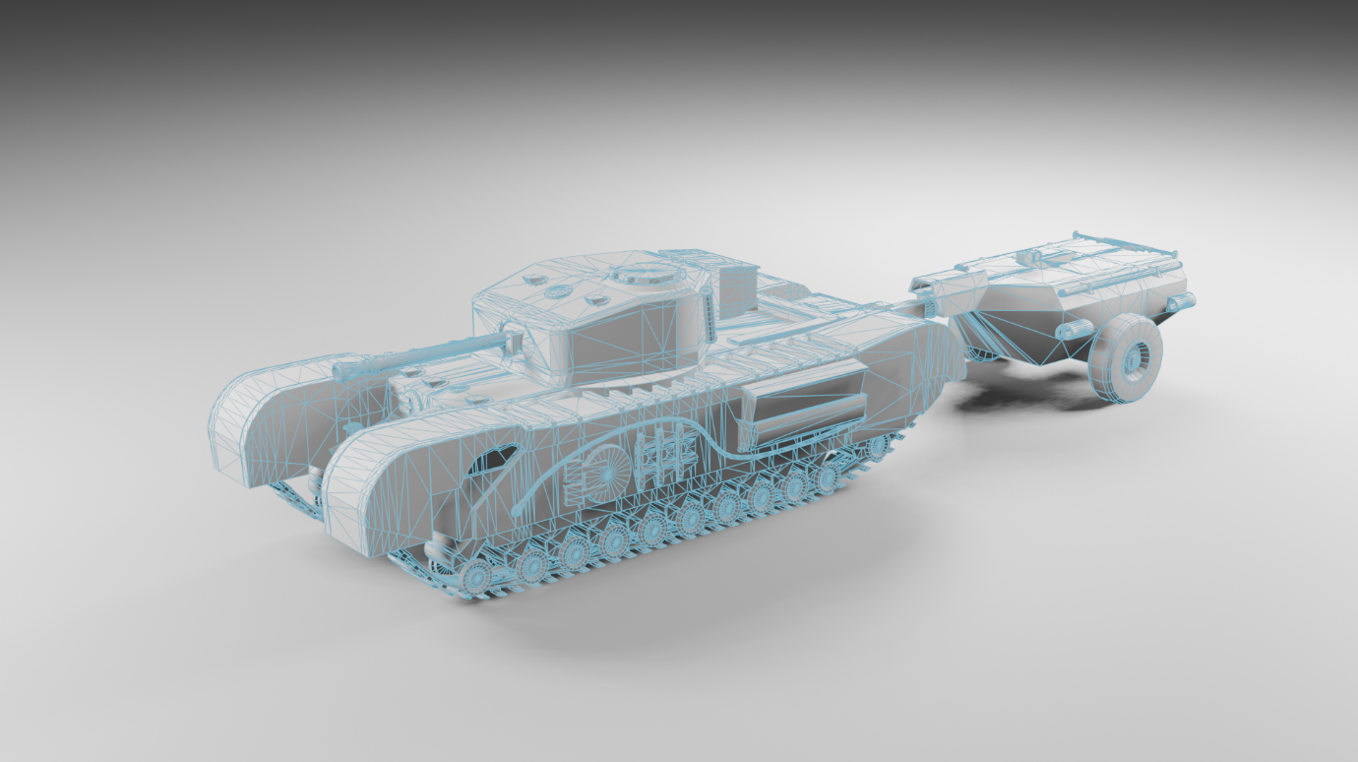
I think this wireframe looks nicer but doesn’t work as practically as the wireframe isn’t as clear on the card.
The second wireframe in blender looks nicer and rendering in general is better in blender I used it for the remainder of the renders.

Final Design:
Front:
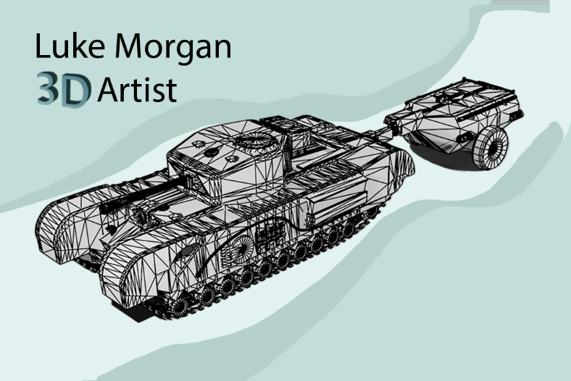
Back:
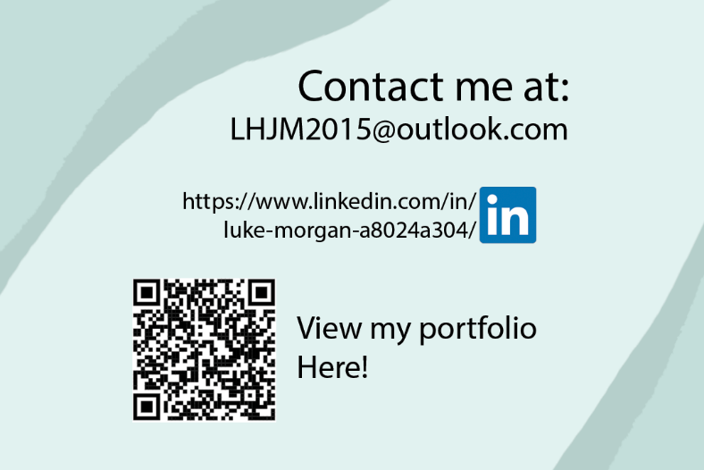

Bibliography

[1] | Arts Univercety of Plymouth , “TOP TIPS ON BUILDING A CREATIVE PORTFOLIO,” Arts Univercety of Plymouth , 4 January 2024. [Online]. Available: https://www.aup.ac.uk/posts/top-tips-on-building-a-creative-portfolio. [Accessed 2 May 2024].
[2] | Shift4cube, “Turnaround Camera - Create Stunning 360 Turntable Animations | Free Add-On | shift 4 cube,” 12 July 2023. [Online]. Available: https://www.youtube.com/watch?v=0zOtCbRIuoU. [Accessed 2 May 2024].
[3] | Vista Print, “What information should you put on your business card?,” 2 March 2021. [Online]. Available: https://www.vistaprint.co.uk/hub/business-card-information-essentials. [Accessed 2 May 2024].
[4] | BenSound, “BenSound,” 2012. [Online]. Available: https://www.bensound.com/. [Accessed 2 May 2024].
[5] | D. Cube, “How to Render Wireframes Blender Tutorial,” December 29 2019. [Online]. Available: https://www.youtube.com/watch?v=TGVmZJVKECQ&t=224s. [Accessed 2 May 2024].
[6] | J. Antonio, “3 Ways to Render Wireframes in Maya,” 25 Mar 2020. [Online]. Available: https://www.youtube.com/watch?v=fwB4iHUMpfA. [Accessed 2 May 2024].

