

Assessment Component 1

Case study - Supporting Paper

Student name: Erkan Paca
Student ID: 2010132

Module name: Children, Young People and Families
Module code: (BMHP5004_LON)
Lecturer name: Bianca Sanflippo
Word count: 1000

Introduction
This report analysis a case about a family facing adversity. These adversities that family suffer from include, domestic violence which family under child protection plan, alcohol addiction, anti-social behaviour, poor parenting skills, mental health issues and poor school attendance.

A case study family from Norfolk

Holy the mother of single parent of three children, Sarah (13), Mark (9) and Kyle (2). She has an issue with alcohol addiction and suffers from anxiety along with panic attack. She struggles to keep her family intact and also finds it hard to set any limitations for her children.
Additionally, the family not only they were subjected to anti-social behaviour on the estate they also took part and caused anti-social behaviour too. Additionally, school attendance for children was in poor condition. These factors made children easily vulnerable and exposed to abuse and neglect, and this concerned the social services to step-in to intervene and implement the right intervention called ‘The Families Unit’. For this family the agency provided 11 months of work which led a quality of life successfully.
Vulnerability is, someone who is easily expose for hurt, or harmed physically, mentally, and emotionally. (Merriam-Webster, 2022).

The Family

The case is about the family from Norfolk facing adversities.

For this particular family have to deal with difficulties like domestic violence which resulted in emotional abuse and neglect, alcohol addiction, poor parenting skills, anti-social behaviour, mental health issues and poor school attendance.

The risk factors and vulnerability

The below risk factors broadly explained in the picture along with protective measures:

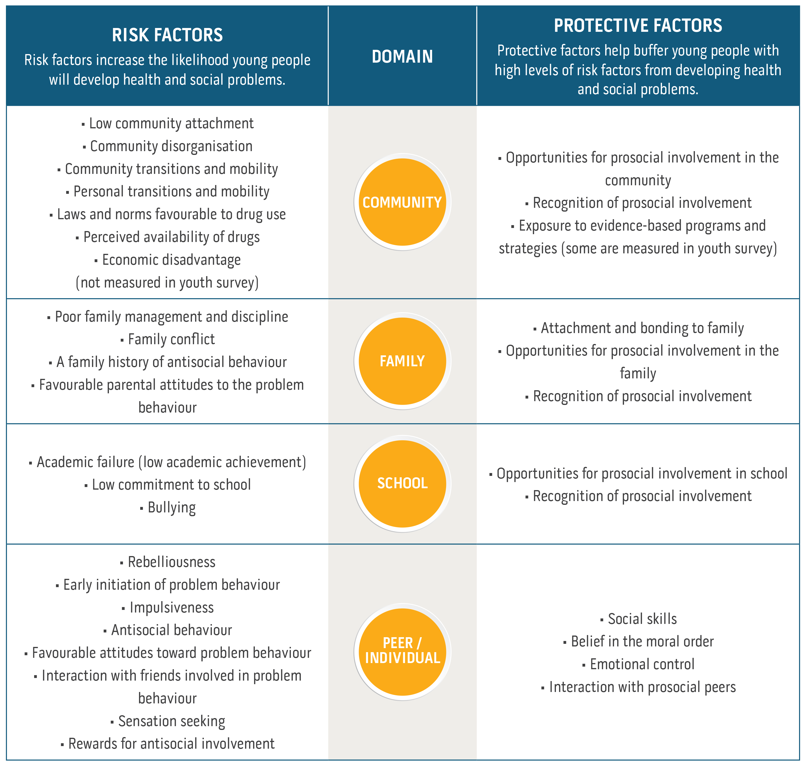(Communities That Care,2022)

Due to these factors mentioned in this report, the family have put children in great risk and easily expose to any type of abuse and harm. The matter was very concerning and created unsafe environment for the children to be in, therefore, social services were involved with domestic violence, and provided a safer home for the family by involving The Families Unit.
According to (Children Act,1989) which is the land mark policy in health & social care. Children who are in this type of circumstances easily exposed to vulnerability, that they can be harmed and be very susceptible for any abuse and neglect, such as Victoria Climbie murder case which had made a great impact for the policy, and updated accordingly as, ‘Children Act 2004’, as ‘every child matters’ with the contribution of Lord Laming report, which was published in 2003.
This particular family is different than any other average family because, these factors had created an unsafe, unprotected environment in their own home.
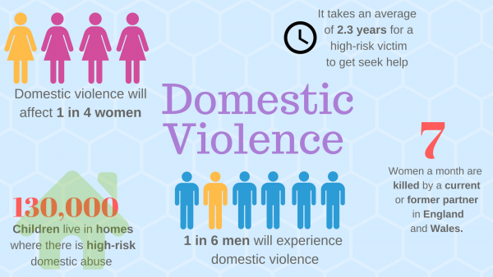
(Solent Journalism, 2017)

In England, the Department for Education is accountable and the main body for child protection. (CPD Online College, 2019).

The impact of these factors on the Children health & wellbeing

Domestic violence cripples a child’s fundamental need for safety and security. It can damage child’s behaviour, cognitive development, educational achievement and general wellbeing. (Holt, Buckley, and Whelan, 2008). Excessive drinking can have an impact on the person’s mental health, makes them depressive and cause accidents. It can also lead you to become involved in criminal activities. (National Institute for Health & Care Excellence, 2011).
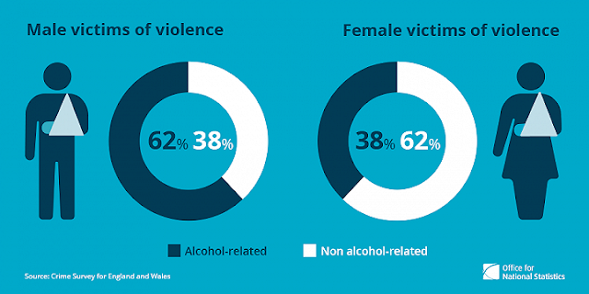

- Parental substance misuse including alcohol misuse can scar parents’ and jeopardize the effort to acknowledge what children need consequently exposing them at risk of abuse. (NSPCC, 2018). Once alcohol misuse becomes excessive, it can create problems such as depression, physical unwell-being and accidents.
- Unpredictable relationships can have a negative impact on child’s wellbeing, feeling depressive, anxious, unable to make decisions, low self-esteem, and physical complaints. (Women’s Aid, 2015)
- Physical abuse can be triggered by substance misuse, alcohol addiction for parents to cope with their own emotions overall. (Cleaver, Unell, and Aldgate, 2011).
- Parents who have dependency in alcohol can easily be involved in criminal activities for financial reasons. (Brophy, 2006).
- The Family, not only they were subjected to anti-social behavior, they were also causing for it too. As a result of that children feeling anxious, fearful, isolated, and hopeless. (Victim support, nd)
‘One girl expressed her feelings in ChildLine that’;
“My dad has a drug and alcohol problem. He makes me sleep with other men so he can get drugs. He also raped me before by putting drugs in my drink” Girl, 15 (NSPCC,2018).
Parents who use drugs or alcohol unacceptably can cause child to feel insecure, easily to be exposed to harm, unprotected, due to their parent’s incapability to care for them. (Cleaver, Unell, and Aldgate, 2011).
Some of the psychological effects, self-blame, non-satisfactory educational achievement, poor attendance, social isolation, creating cognitive, behavioural or, emotional issues. (Altobelli & Payne, 2014).

Factors determining and influencing vulnerability

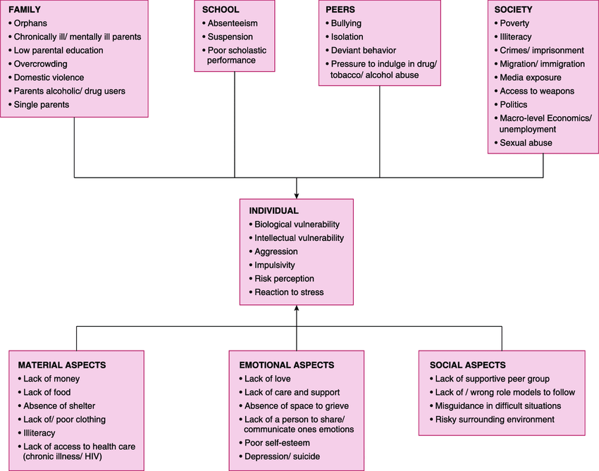
(Indian J Community Med, 2015).

Analysis

Health care professionals work should be based on the assessment to find out the concerns and the factors of vulnerabilities, once established, the right intervention can be made in multidisciplinary approach. This requires an examination, and, holistic approach on child’s cognitive progression, parents’ capacity to provide basic needs for the children and the effect of other ecological factors. (Bogg.2013; Cleaver, Unell and Aldgate, 2011).
Preventions for child abuse are made by policies and updated sometimes in the event of horrific incident such as murder of Victoria Climbie case made an impact on Children Act 1989 and was replaced with Children Act 2004, prepared by Lord laming report and contributed significantly.
Children Act 1989, section17 identifies the Child in need.
Children Act 1989, section 47 identifies regardless, if there is a reasonable cause to suspect that the Child is in dander of any harm, abuse and neglect.
Children Act 1989 of section 20 or section 31A, if the child is in need of accommodation.
Data Protection Act 1989 protect the shared information in mutual respect.
The Equality Act 2010 which practiced by social services given right to all children should be treated, protected and cared equally
United Nations Convention on the Rights of the Child (UNCRC,1991) article 19 places a duty on governments to protect all children. The article 28 in this case was applied and protected the children’s right to be educated.
Working Together to Safeguard Children (2018) they have a responsibility to work in multi-agency and promote, protect the welfare of children.

The family was at risk therefore particular intervention made via assessment frame work to support them;

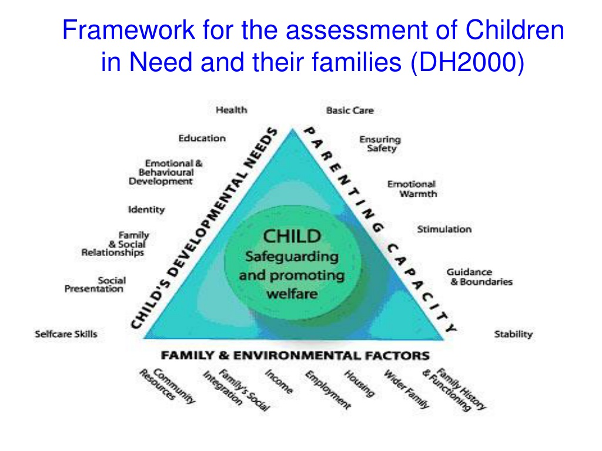
Pinterest Image, (Nd)
The assessment was made according to Working Together to Safeguard Children (2018) as a guide to protect children and promote welfare through multi-agency approach.
The family needed a specific assessment work based on the parental capability, children cognitive needs and the environment factors that affects the family, in summary that is holistic approach because the family had a weak parental capability to support. Basic theory implemented to keep the family together and supported in a holistic manner in line with the policy of Children Act 1989.
Discussion and Evaluation
The interventions had a good impact and was very effective with this family after working with them 11 months with the Families Unit, and these interventions include poor attendance rate risen to %96, mother stopped consuming alcohol, parental capability improved significantly, also family was moved to different location and the issue with anti-social behaviour solved efficiently. Children are more involved with activities and happier and no longer under child protection plan.
Early intervention timely manner is essential responding a child or family’s needs can significantly minimise the risk elements and maximise the safeguarding elements in child’s life. (Early Intervention Foundation, EIF,2021).
Timely support can provide children the help required to achieve the full prospective, and also construct their adult life positively. (EIF,2021).
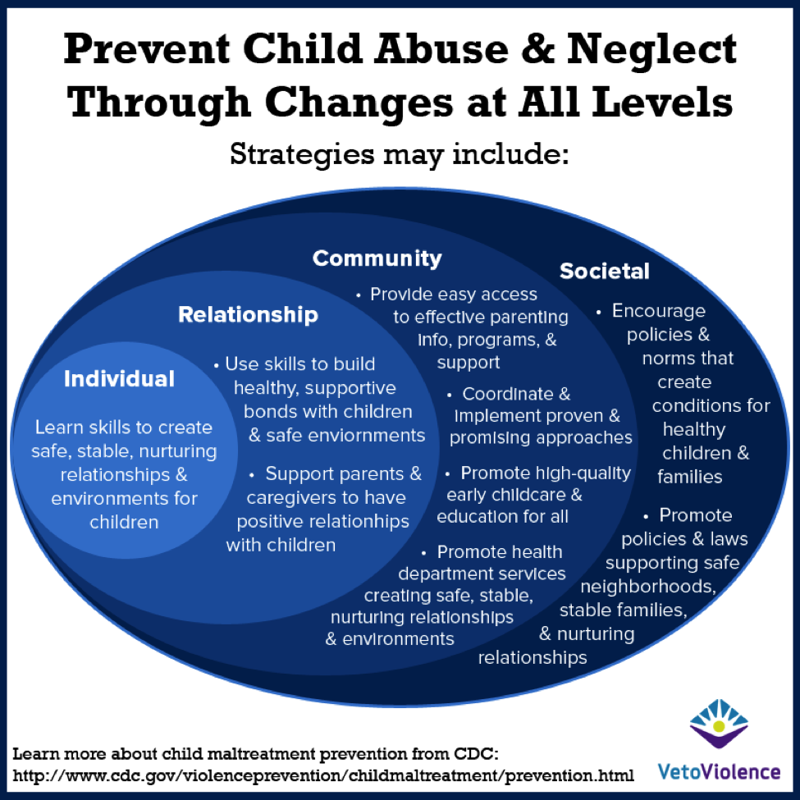(Image CDC, 2019).

References
Altobelli, C, Payne, C. (2014) Noticing the hidden harm. BACP children & young people, March:4-8 [online] Available at: https:// www.bacp.co.uk/bacp-journals/bacp-children-young-people-and-families-journal/march-2014/noticing-the-hidden-harm/ (Accessed: 02/04/2022)
Bogg, D. (2013) Parental substance use: the challenge for social work. Families upfront, 9: 18-19 [online] Available at: https://learning.nspcc.org.uk/children-and-families-at-risk/parental-substance-misuse (Accessed: 03/04/2022)
CDC (2019) Prevent child abuse and neglect through all changes at all level: [online] Available at: https://vetoviolence.cdc.gov/apps/main/home (Accessed:05/04/2022)
Children Act (1989), [online] Available at: www.childrenact1989.legislation.gov.uk (Accessed: 30/03/2022)
Children Act (2004), c.31 [online] Available at: https://www.legislation.gov.uk/ukpga/2004/31/contents (Accessed; 30/03/2022)
Cleaver, H, Unell, l. Aldgate, J. (2011) Children’s need: parenting capacity: child abuse: parental mental illness, learning disability, substance misuse, and domestic violence (PDF). London: The Stationery Office (TSO) [online] Available at: https://www.learning.nspcc.org.uk/children-and-families-at-risk/parental-substance-misuse (Accessed: 31/03/2022)
Communities That Care (2022) Risk & Protective Factors: Image [online] Available at: https:// www.communitiesthatcare.org.au/how-it-works/risk-and-protective-factors
Early Intervention Foundation (EIF) (2021) About early intervention: [online] Available at: https://www.eif.org.uk/reports (Accessed:06/04/2022)
Equality Act (2010) [online] Available at: https://www.legislation.gov.uk/ukpga/2010/15/contents (Accessed; 31/03/2022)
Indian J Community Med, (2015). Image [online] Available at: https://www.researchgate.net/publication/280103880/figure/download/factors-determining-and-influencing-vulnerability.png (Accessed:04/04/2022)
Solent Journalism (2017) Domestic violence: Image [online] Available at: https://www.solentjournalism.co.uk/local-councils-receive-funding-to-support-domestic-abuse-survivors/ (Accessed:06/04/2022)
S, Holt, H Buckley, S Whealan (2008) The Impact of exposure to domestic violence on children and young people: A review of the literature [online] Available at: https://www.sciencedirect.com/science/article/pii/SO145213408001348 (Accessed: 01/04/2022)
Legislation.Gov.UK (1998) Data Protection Act 1989: [online] Available at: https://www.legislation.gov.uk/ukpga/1998/29/contents (Accessed:03/04/2022)
Merriam-Webster (2022) Definition of Vulnerable [online] Available at: https://www.merriam-webster.com/dictionary/vulnerable (Accessed: 31/03/2022)
National Institute for Health and Care Excellence (2011) Alcohol-use disorders: diagnoses, assessment, and management of harmful drinking and alcohol dependence. London; NICE [online] Available at: https://www.nice.org.uk/guidance/CG115 (Accessed: 02/04/2022)
NSPCC (2018) Parental substance misuse: Children living in families facing adversities: [online] Available at: https://www.learning.nspcc.org.uk/research-resources/2018/children-living-in-families-facing-adversity (Accessed: 01/04/2022)
Pinterest (Nd) Social Work Theory: Image [online] Available at: https://www.pinterest.com/pin/529665606167487682/ (Accessed: 05/04/2022)
Pinterest (Nd) Domestic violence causes: [online] Available at: https://www.pinterest.com/pin/the-real-cost-of-alcohol--372250725426422256/ (Accessed:06/04/2022)
United Nations (1989) The United Nations Convention on the Rights of the Child [online] Available at: https://layout 1 (unicef.org.uk) (Accessed: 31/03/2022)
Women’s Aid (2015) Controlling behavior in relationships: talking to young people about healthy relationship (PDF) Bristol: Women’s Aid Federation of England (WAFE) [online] Available at: https://learning.nspcc.org.uk/safeguarding-child-protection/healthy-and-unhealthy relationships (Accessed: 01/04/2022)

