Dand Martin AWE - 1810440

This report investigates Academic Skills, the use of and application to the author. Specific learning strategies and techniques are researched based upon the author’s character type and learning preference. Analysis of a prior Group Presentation is made and theories previously held are brought into question through research done.
Academic Skills
OME Study Skills Year 1 Assignment

Academic Skills

Contents
1 Introduction 1
1.1 Task Description 1
2 Skills Evaluation 2
2.1 What are Essential Skills for Learning 2
2.2 Self-Critique 2
2.2.1 16 Personalities 3
2.2.2 Via Institute Character Profile Survey 3
2.2.3 VARK (Visual, Aural, Read/Write, Kinesthetic) Questionnaire 5
2.2.4 Self-Evaluation of Academic Skills 5
2.3 Strengths 6
2.4 Areas for Improvement 6
3 Application 7
3.1 Reflection on Year 1 7
3.2 Group Presentation Analysis 7
4 Conclusion and Evaluation 8
4.1 Images 9
5 References 10
6 Appendix 11

Introduction
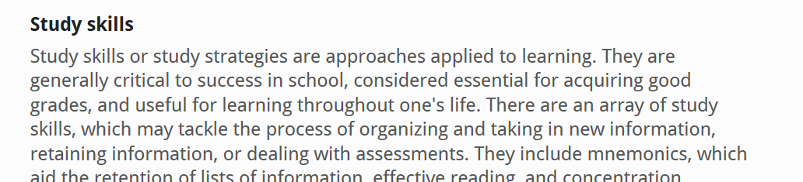
Figure 1 - What are Study Skills? [1]

Task Description
For his assignment, the task was set to produce a report summarising the application of the Study Skills Module that has been delivered to the OME Professional class throughout this educational year and how it will enhance the learning potential of the author of this document.
Previously in the year a series of Group Presentations were delivered to the rest of the cohort entitled ‘Academic Writing and Plagiarism Avoidance’. Each member of the group produced and presented a section of the assigned presentation, the content of which is attached in the Appendix. The presentation delivered by the author’s group will be analysed within this report.

Skills Evaluation

What are Essential Skills for Learning
Before any analysis, the criteria for critique must be identified. In this case, the skills required for effective learning in a Higher Education environment are those criteria. It is generally accepted that the following skills are essential for Higher Learning. [2] [3]
- Note-taking
- Time Management/Self-Motivation
- Independent Learning
- Research
- Essay/Report Writing
- Presentation Skills
- Exam Technique
These skills, alongside a strong grasp of written English and the ability to read effectively are the foundations of the ability to learn. The ability to take notes effectively assists with the retention and recall of valuable information given during lectures. Self-motivation prompts good time management, which in turn helps with independent learning and research. Successful research feeds into a well-constructed essay or report. Writing an essay or report that one is confident in will feed that confidence into the delivery of a presentation or performance during an exam. It can clearly be seen that there is a definite flow of utility throughout the process of learning.

Self-Critique
A further requirement for a self-critique will be a knowledge of the subject. One way of doing this would be to find out the personality type of the subject, and the most effective approach to learning for this type.
The philosopher Carl Jung proposed (in a very basic generalisation) that every person can be identified by a set number of personality types [4]. Around the same time, Katherine Cook Briggs and her daughter Isabel Briggs Myers took this idea and expanded on it to form a process for personality profiling. Whilst this is not considered a particularly reliable method for analysing personality with any degree of repeatable accuracy [5], if combined with other tools could give the author a more scientific basis from which to back up the theories already present about their personality.
To that end, the author performed the Myers-Briggs Type Indicator test (MBTI) [6], with the results shown below. The author also carried out two further assessments in order to establish a baseline from which to base the action plan. These tests were the Via Institute Character Profile Survey [7], and the VARK Questionnaire [8]. The Via Survey was selected in order to provide a second indicator of personality to reinforce the findings of the MBTI test, and the VARK Questionnaire to specifically target and confirm if what the author considers are his preferred learning styles are those best suited to him and his personality type.

16 Personalities
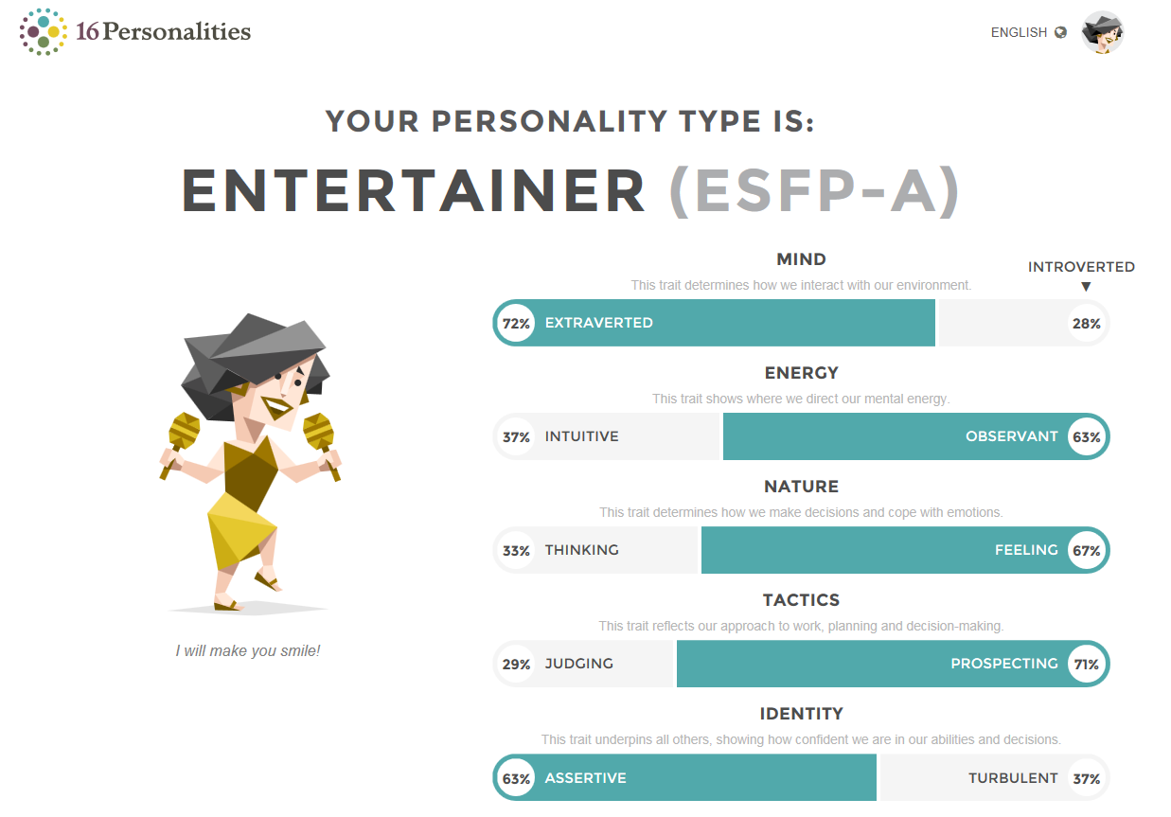
Figure 2 - 16 Personalities Survey Results
When the learning style of this personality type was researched, the following was found [9]:
- A person of this character type retains more information when they are enjoying the subject
- The best type of topic to be learned by the ESFP is that with a solid foundation and a realised direct practical application
- The best teaching delivery medium is multiple types of active learning methods, group work is preferred, and the material should be presented multiple times to increase the knowledge retention.

Via Institute Character Profile Survey
The author’s traits were described in descending hierarchy as follows:
1: Humour. Liking to laugh and tease; bringing smiles to other people; seeing the light side; making (not necessarily telling) jokes.
2: Honesty. Speaking the truth but more broadly presenting oneself in a genuine way and acting in a sincere way; being without pretence; taking responsibility for one's feelings and actions.
3: Kindness. Doing favours and good deeds for others; helping them; taking care of them.
4: Hope. Expecting the best in the future and working to achieve it; believing that a good future is something that can be brought about.
5: Bravery. Not shrinking from threat, challenge, difficulty, or pain; speaking up for what’s right even if there’s opposition; acting on convictions even if unpopular; includes physical bravery but is not limited to it.
6: Love. Valuing close relations with others, in particular those in which sharing & caring are reciprocated; being close to people.
7: Fairness. Treating all people the same according to notions of fairness and justice; not letting feelings bias decisions about others; giving everyone a fair chance.
8: Leadership. Encouraging a group of which one is a member to get things done and at the same time maintain good relations within the group; organizing group activities and seeing that they happen.
9: Zest. Approaching life with excitement and energy; not doing things halfway or half-heartedly; living life as an adventure; feeling alive and activated.
10: Teamwork. Working well as a member of a group or team; being loyal to the group; doing one's share.
11: Perseverance. Finishing what one starts; persevering in a course of action in spite of obstacles; “getting it out the door”; taking pleasure in completing tasks.
12: Social intelligence. Being aware of the motives/feelings of others and oneself; knowing what to do to fit into different social situations; knowing what makes other people tick.
13: Curiosity. Taking an interest in ongoing experience for its own sake; finding subjects and topics fascinating; exploring and discovering.
14: Forgiveness. Forgiving those who have done wrong; accepting others’ shortcomings; giving people a second chance; not being vengeful.
15: Judgment. Thinking things through and examining them from all sides; not jumping to conclusions; being able to change one's mind in the light of evidence; weighing all evidence fairly.
16: Gratitude. Being aware of and thankful for the good things that happen; taking time to express thanks.
17: Creativity. Thinking of novel and productive ways to conceptualize and do things; includes artistic achievement but is not limited to it.
18: Humility. Letting one's accomplishments speak for themselves; not regarding oneself as more special than one is.
19: Perspective. Being able to provide wise counsel to others; having ways of looking at the world that make sense to oneself/others.
20: Love of learning. Mastering new skills, topics, and bodies of knowledge, whether on one's own or formally; related to the strength of curiosity but goes beyond it to describe the tendency to add systematically to what one knows.
21: Appreciation of Beauty & Excellence. Noticing and appreciating beauty, excellence, and/or skilled performance in various domains of life, from nature to art to mathematics to science to everyday experience.
22: Prudence. Being careful about one's choices; not taking undue risks; not saying or doing things that might later be regretted.
23: Spirituality. Having coherent beliefs about the higher purpose and meaning of the universe; knowing where one fits within the larger scheme; having beliefs about the meaning of life that shape conduct and provide comfort.
24: Self-Regulation. Regulating what one feels and does; being disciplined; controlling one's appetites and emotions.
This analysis seems to reinforce the results generated by the MBTI test, in that the authors strengths seem to cover more ephemeral attributes with traits supporting learning appearing more towards the middle of the list.

VARK (Visual, Aural, Read/Write, Kinesthetic) Questionnaire
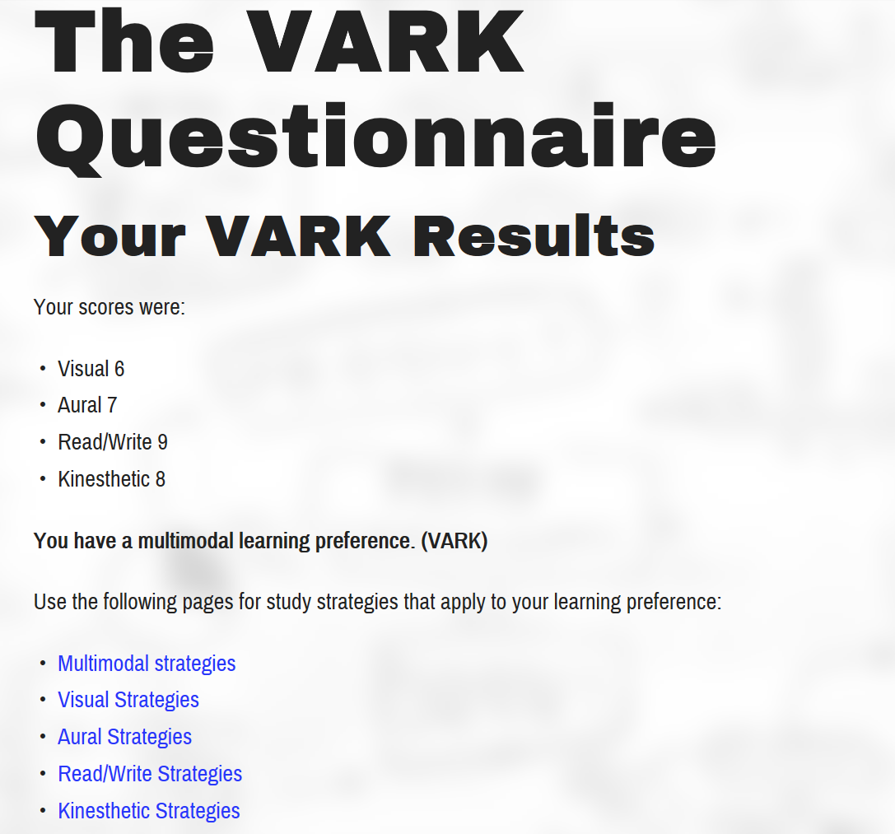
Figure 3 - VARK Questionnaire results
This analysis reinforces the findings from research on the ESFP character type, in that the learning preferences are over multiple types of delivery. The author’s original stance was that of a strong leaning towards a kinesthetic learning preference, so this is an interesting analysis. However, it seems supported by evidence as the author has shown an affinity for Mathematics (exam results returned at 80% average during the formation of this report). As Mathematics has little to no capability for a kinesthetic approach to learning, this indicates a capability in the author to retain information through other processes.

Self-Evaluation of Academic Skills
A document that was supplied to the group (to be completed in support of this report) was a Self-Evaluation of Academic Skills. This document was completed by the author before any personality or learning strategy assessment was completed and this can be found in the appendix. The group was also supplied with a template for the formation of a personal strategy based on the Self-Evaluation. This can also be found in the appendix, with sections of the resulting plan discussed within further sections of this report.
The author initially formed an action plan based purely on the supplied self-evaluation form as shown in the dated columns. However, once the other assessments had been completed, it became clear that this needed to be amended as there were other considerations raised after these surveys. It was also brought to the author’s attention that the scoring for the Self-Evaluation should be adjusted, as the majority of the evaluated statements were in the ‘Neither Agree or Disagree’ section which was unhelpful for assigning gradients of ability.

Strengths
The first, and most important strength of the author’s learning capability, is the fact that this is a practical topic, with easily realised applications. This is a subject in which the author is interested , and despite the initial learning being heavily theoretical, it is easy to see how the principal theoretical foundation can be built into the subject as a whole. This give the author an enthusiasm and desire to learn.
The second strength is that the author has a particularly strong enjoyment, understanding and retention capability within the subject of Mathematics. As this is an engineering subject, most of the fundamental laws and theory behind it is the manipulation of numbers, which gives the author a strong advantage.
The author’s note-taking technique is particularly strong, in that the notes are comprehensive and well-ordered. The author has also been audio-recording the dialog within the lectures and as part of the revision process will be listening to the lectures again, re-writing the notes for increased retention and to keep as references for future study.
The fourth strength is an innate enthusiasm for new things, possessed by the author. This desire for learning is one of the main reasons that the author decided to apply for this course and has fuelled the focus and effort put into this process, despite the length of time since the author was last in formal education (a period of over 2 decades).

Areas for Improvement
Throughout each assessment, the aspect of time management has come up as an area that requires work. ESFP characters are said to struggle with this learning strategy, and this theory is certainly backed up by the self-assessment supplied by the author. This is the aspect that the author believes needs the most work to overcome. To this end, a program of revision should be generated for use, in order to ensure there is enough time allotted to cover the subjects required before the exam period. The author has assigned a completion date of the 3rd May 2019 for this plan, as this is the weekend before the study leave week.
The author also believes that another skill that requires improvement is the self-analysis and evaluation of the author’s own work. This skill is not something that can be instantly learned and applied, as it is an ongoing task. As the author’s style of formal writing evolves throughout this course, this skill will likewise constantly be evolving. At the point of handing in any formally submitted work, the author will receive feedback from the marking tutor. The only real way to enhance the author’s self-analysis skills will be to analyse the feedback given and ensure that all advice given is applied to future works. One way of monitoring any improvement would be to re-read any submitted work and analyse it before receiving the feedback, and compare it to the feedback received.
Another concern raised based on the self-evaluation is that of memory strategies. According to the previous research done, ESFP character types learn best and retain more information if there is a range of methods applied to learning, and if the material is repeated often. Further research was done, focussing on different types of memory strategies in order to integrate them into the revision program previously discussed [10].
The last issue to be focussed on concerns identifying relevant information in text, and the strategies used for this capability. As with the concern regarding self-analysis of the author’s work, this will be a long-term improvement activity. There are several potential strategies for this, but some will need adjusting. One example of this is highlighting potentially relevant information for later analysis. In the current age of electronic learning medium, this will not be as easy to implement. There is a greater focus on this skill in the delivery of learning to younger students now [11], and these sources may still apply to a mature student.

Application

Reflection on Year 1
As previously stated, the author of this report has not been a part of formal education for over 20 years, and initially came into this course with a deal of trepidation. With this in mind, the Study Skills module of this course has been invaluable in re-organising a mind from an occupational mind-set to an educational one. The study made into academic honesty and the correct way to credit properly other people’s efforts when creating original work, and the formation of different styles of academic writing has helped to create a framework where the author can mentally ‘tick off’ the various points required to create a piece of work that is his own (a learning strategy the author finds very effective).
During the module, a lecture was delivered focussing on a suitable back-up strategy for any work done. The strategy chosen by the author is three-fold. As work is done by the author at any one of multiple locations (University campus, in the office at work or at home on the author’s personal laptop), it was considered that a high-capacity password-locked USB drive would be required as a useful mobile storage media. Secondly, it was considered that the author’s personal laptop would be the workstation used most throughout his educational life, and as such would be the central work hub for storing any work done. The issue with these methods of storage is that they are both subject to theft or damage, which could quite easily result in the loss of work. As a result of this consideration, the third method of backing up the author’s work was a ‘Cloud’ solution. Each time a piece of formal work is updated, the author will email a copy of the changes made to himself and store the relevant email in a folder in his Gmail account. This combination of cloud-based and hardware-based backup creates a very strong insurance policy against the loss of any work produced.
This strategy will need to be updated as the author’s academic journey progresses, as the size of the files will increase as the author completes further years and the formal work increases in size and complexity. For future years, a larger removable hard drive (perhaps even more than one) will be considered, as will the transfer of work into OneDrive or another cloud storage system.

Group Presentation Analysis
The Group Presentation (entitled ‘Academic Writing and Plagiarism Avoidance’) was assigned and delivered quite early in the module. The base material was delivered in lecture format, and the main work was to be done during the breaks between attendance sessions at the University. The cohort was separated into four groups and the author’s group (ultimately made up of the author, M. Dand, J. Timberlake, J. Martin and S. James) met to discuss the format and division of research. The adjusted notes from this meeting are detailed in the Appendix. Shortly after the initial meeting, one of the students initially assigned to the author’s group dropped out of the course, and the section of research assigned to him was passed onto J. Timberlake. The general template for the presentation was created by S. James and J. Martin during the initial group strategy meeting and reviewed by the rest of the team before the assembly of the disparate information. The other members of the group will analyse their own contributions to the project and the author of this document will be focussed on his own work in line with the plan for the improvement of his self-analysis and evaluation of his own work.
The first point for analysis is the absence of notes from the author’s presentation section. The lecture regarding Digital Backup and the subsequent exercise reviewing the backup strategy was carried out after the presentation, and the author’s notes used for the delivery of the presentation were saved on the University server. This has resulted in the absence of these notes as the author is compiling this report at a different location.
The next point for analysis is in the structure of the slides. During a lecture delivered in the module, a video was played from a TedTalk regarding the structure of effective PowerPoint presentations [12]. The general gist of this talk was the following:
- Present a single message per slide
- Try not to present text in too much detail
- Bigger is better
- Contrast directs attention
- Have 6 or fewer objects on each slide
- Use a dark background as it is more memorable
With these points in mind, the slides delivered by the author could have adhered more closely to these guidelines. There was too much detail in the slide information for effective attention grabbing, the slides themselves were quite samey and could have commanded more interest with some more visual aspects. This aspect was somewhat mitigated as the information was faded into the slide one statement at a time, but a greater focus on visuals combined with speech delivery would have been more effective. There was some visual interaction in the final slide, along with an item designed to provoke further thought and/or debate.
Another aspect to engender comment was the actual delivery of the subject matter. The author tends to hesitate and use ‘filler noises’ when thinking during public speaking (um, er, errm), and the delivery could have been practised more in order to mitigate this personal habit. This would be less prevalent if the speech were more rehearsed. The author has the confidence to present, but confidence is not enough for a smooth and effective delivery.

Conclusion and Evaluation
Before this study, the author held some definite opinions regarding his learning capability. Until this academic year, he had been out of formal education for over twenty-two years and held some reservations about his retention of the material. He strongly believed that he had a strong affinity for kinesthetic learning and that he was not of an academic bent. The various assessments taken as a part of this study have reaffirmed the author’s opinion of himself as a person but illuminated some aspects of his learning capability that he was not initially aware of. The one aspect that these assessments did not seem to consider that seemed a strong oversight was the actual desire to learn. This part of the personality should have been given a much stronger focus and could be an avenue for further investigation (however this would be more of a psychological study rather than engineering). It is a newly held belief of the author that this is a psychological factor that provides a great deal of impetus to the learner’s capabilities. Given the recall of the subjects last learned at A-Level (Maths and Physics in 1996) and the length of time between initial learning and recall today, this seems to have a solid grounding in fact.
The fact that the author had not established a strong backup strategy before attending the course has delivered a strong message, as there is one key part of evidence of work absent from this report (Group Presentation delivery notes). Any future work, and any digital notes will be stored in multiple locations to prevent this occurring again.
A last consideration to arise from this study is the fact that an academic plan must be in place throughout the entire academic life of the student. Whilst some parts of a plan can be realised and put in place in a short space of time, some parts can only be monitored and efficiently delivered through continuous improvement and evolution. As the student’s portfolio grows, the backup strategy must grow. As the capability of the student improves and therefore changes, analysis of work (both belonging to the student and that of other people) must improve apace.
Study Skills is a subject that affects all aspects of every student’s academic life, no matter what the subject of study.

Images
Figure 1 - What are Study Skills? [1] 1
Figure 2 - 16 Personalities Survey Results 3
Figure 3 - VARK Questionnaire results 5
Figure 4 - Self Evaluation of Academic Skills 11
Figure 5 - Skills Action Plan, with dates focus of plan changed 11
Figure 6 - Amended notes after Group Presentation Planning meeting 12
Figure 7 - Slides Presented by M Dand #1 12
Figure 8 - Slides Presented by M Dand #2 13
Figure 9 - Slides Presented by M Dand #3 13
Figure 10 - Slides Presented by M Dand #4 14
Figure 11 - Slides Presented by M Dand #5 14
Figure 12 - Slides Presented by M Dand #6 15
Figure 13 - Group Presentation References List - 1 15
Figure 14 - Group Presentation References List - 2 16

References

[1] | “Definitions.net,” STANDS4 LLC, [Online]. Available: https://www.definitions.net/definition/study+skills. [Accessed 09 April 2019].
[2] | “Oxford Royale Academy,” Oxford Programs Limited, [Online]. Available: https://www.oxford-royale.co.uk/articles/13-skills-university.html. [Accessed 09 April 2019].
[3] | University of Oxford, “University of Oxford,” Department for Continuing Education, [Online]. Available: https://www.conted.ox.ac.uk/about/student-study-skills. [Accessed 09 April 2019].
[4] | C.G.Jung, Psychological Types, Rascher Verlag, 1921.
[5] | W. L. Gardner and M. J. Martinko, “Using the Myers-Briggs Type Indicator to Study Managers: A Literature Review and Research Agenda,” Journal of Management, vol. 22, no. 1, pp. 45-83, 1996.
[6] | “16 Personalities,” Neris Analytics Limited, [Online]. Available: https://www.16personalities.com/free-personality-test. [Accessed 11 March 2019].
[7] | “Via Institue on Character,” Via Institue on Character, [Online]. Available: https://www.viacharacter.org/www/Character-Strengths-Survey. [Accessed 11 March 2019].
[8] | “VARK - A Guide to Learning Preferences,” VARK Learn Limited, [Online]. Available: http://vark-learn.com/the-vark-questionnaire/. [Accessed 09 April 2019].
[9] | “HumanMetrics,” HumanMetrics Inc, [Online]. Available: http://www.humanmetrics.com/personality/esfp-learning-style. [Accessed 10 April 2019].
[10] | D. Van Blerkom, “Memory Strategies,” in College Study Skills: Becoming a strategic learner, Boston, Wadsworth-Cengage, 2009.
[11] | Clemson University, “Clemson University Reading Recovery Training Center,” Clemson University Reading Recovery Training Center, [Online]. Available: https://readingrecovery.clemson.edu/introduction-to-determining-importance/. [Accessed 10 April 2019].
[12] | D. J. Phillips, “How to avoid death By PowerPoint,” TedTalks, Stockholm, 2014.

Appendix
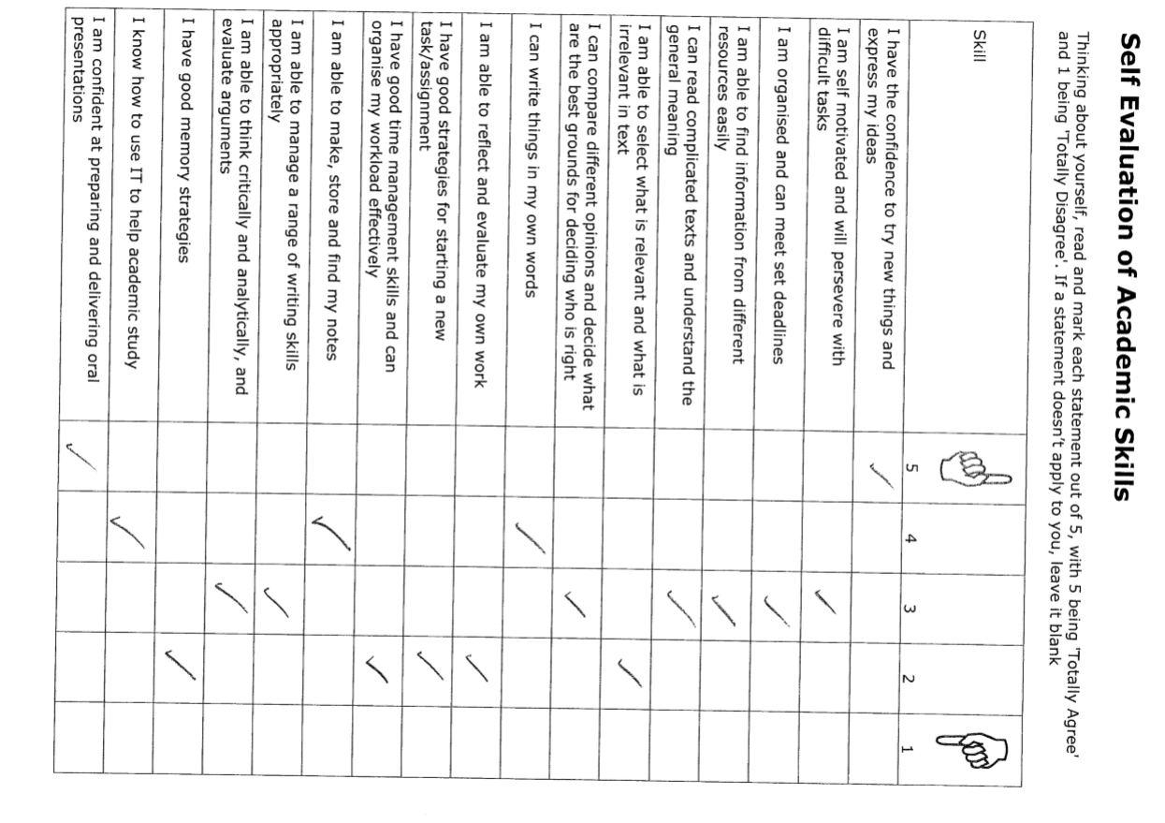
Figure 4 - Self Evaluation of Academic Skills
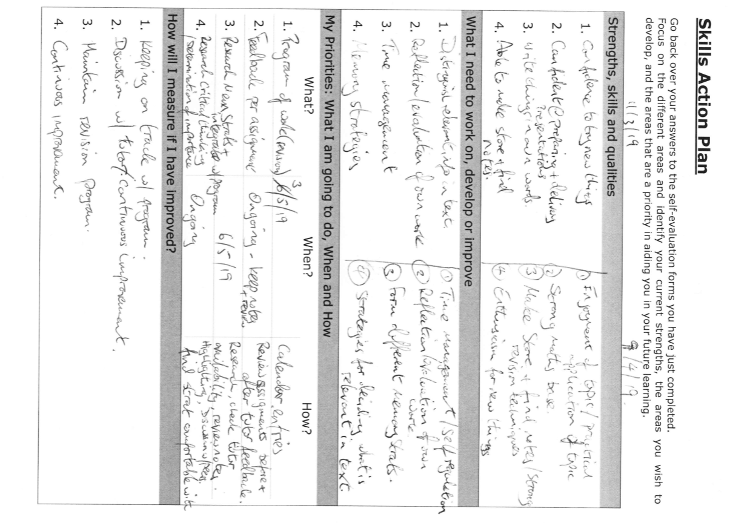
Figure 5 - Skills Action Plan, with dates focus of plan changed
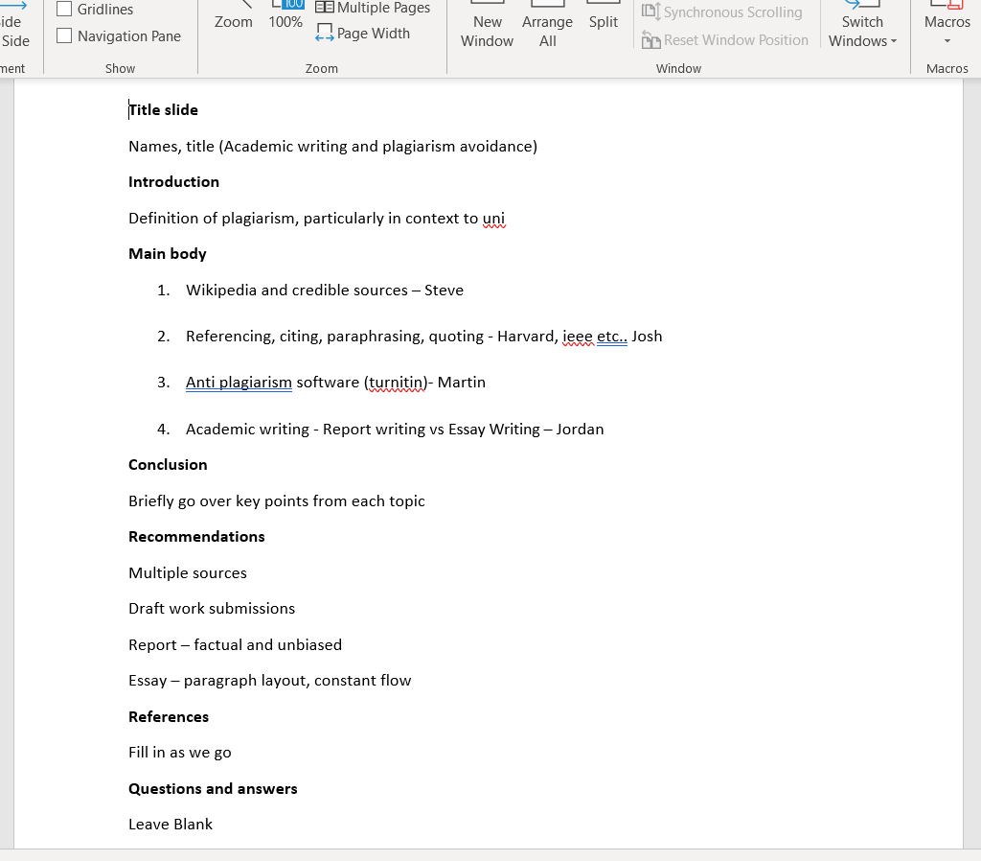
Figure 6 - Amended notes after Group Presentation Planning meeting
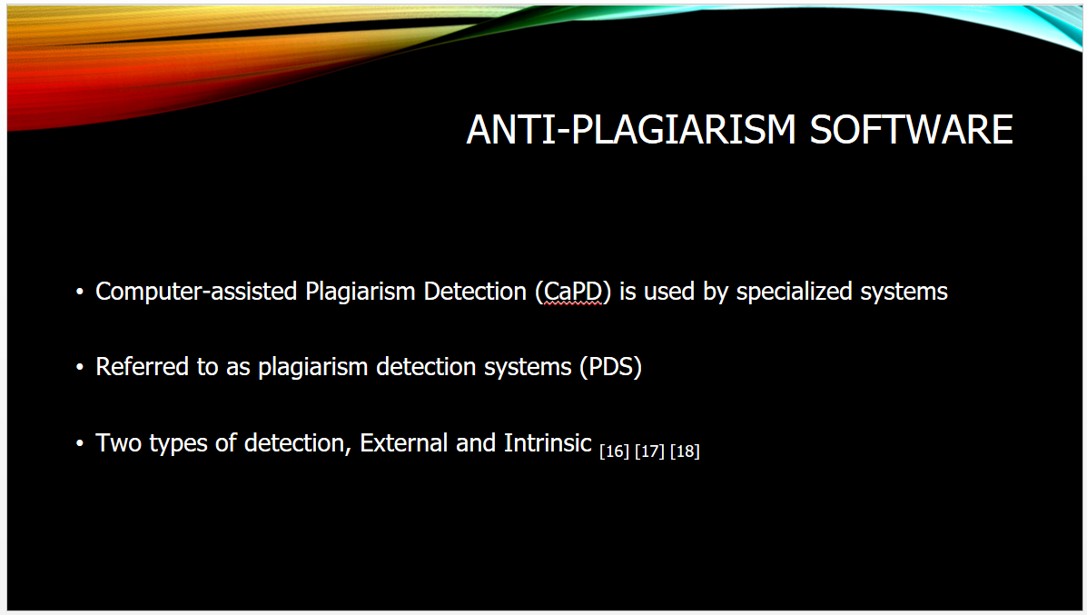
Figure 7 - Slides Presented by M Dand #1
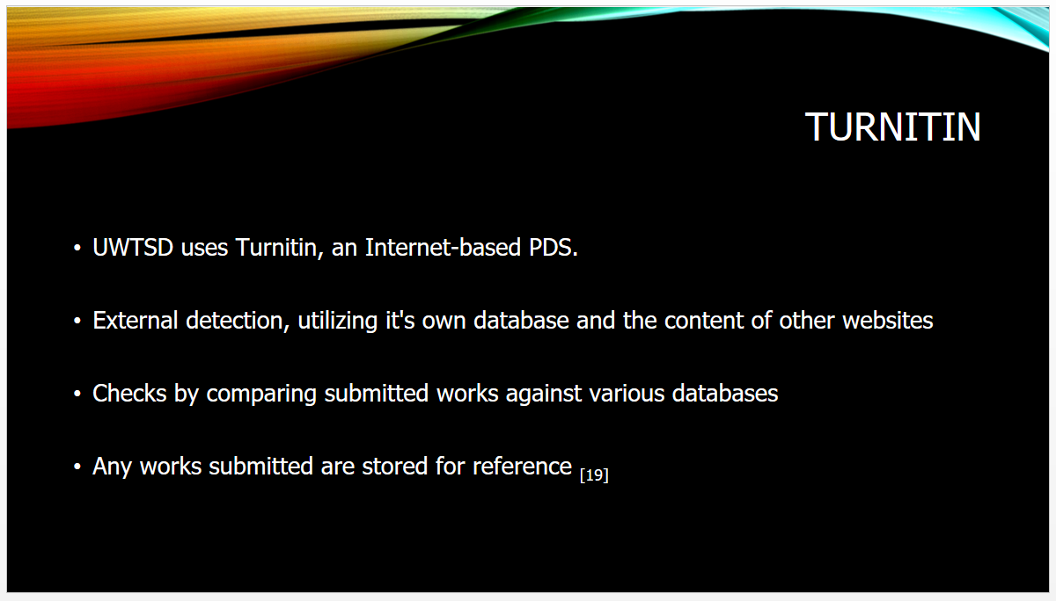
Figure 8 - Slides Presented by M Dand #2
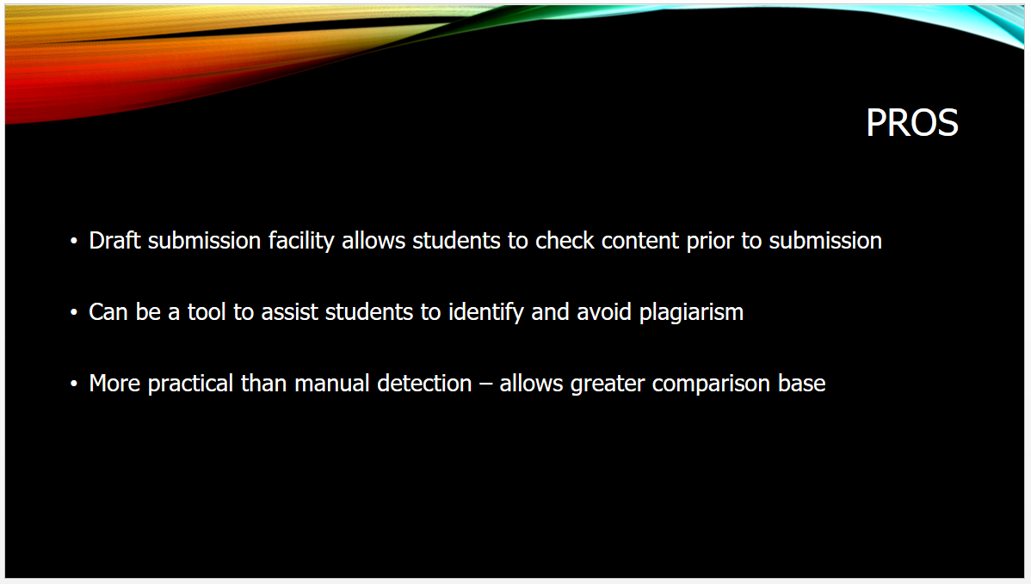
Figure 9 - Slides Presented by M Dand #3
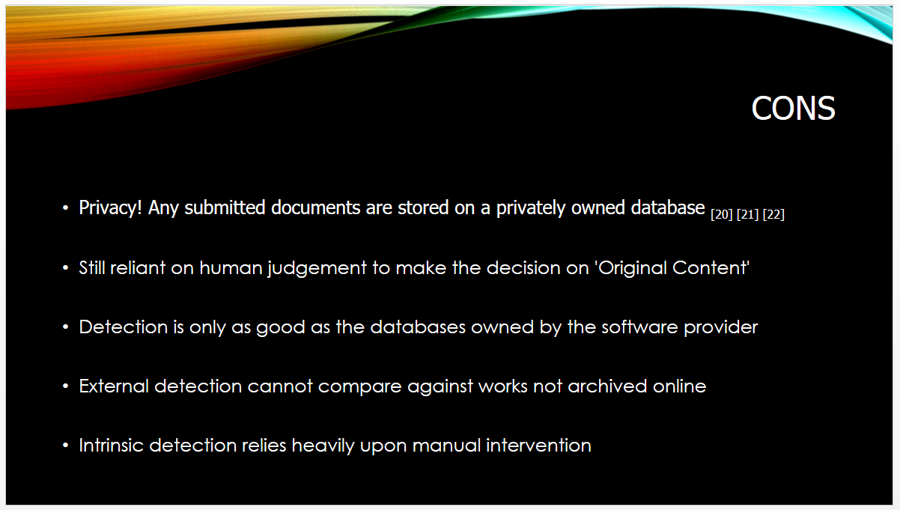
Figure 10 - Slides Presented by M Dand #4
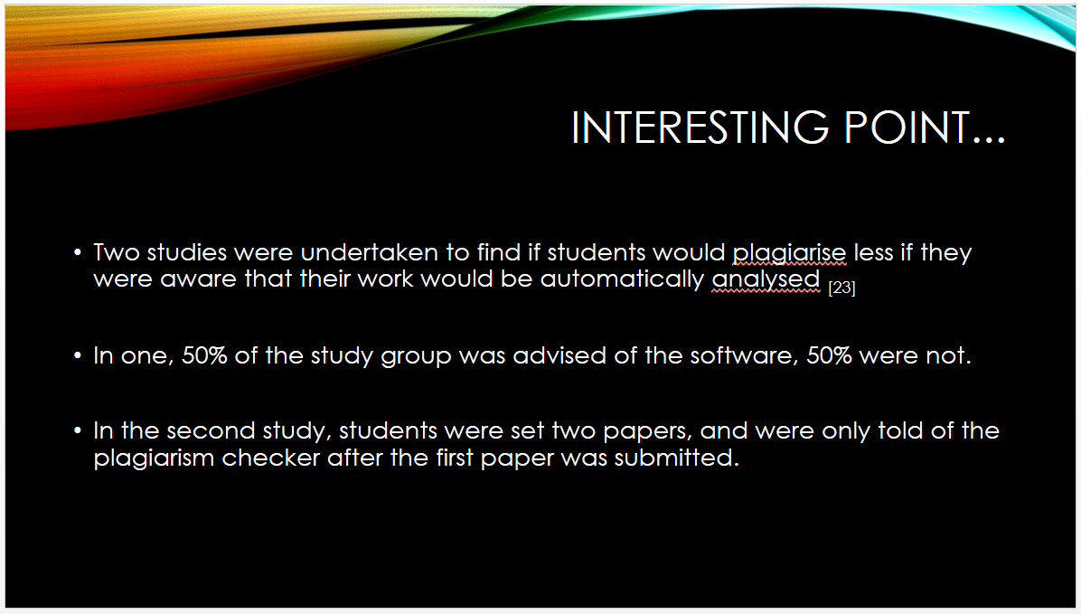
Figure 11 - Slides Presented by M Dand #5
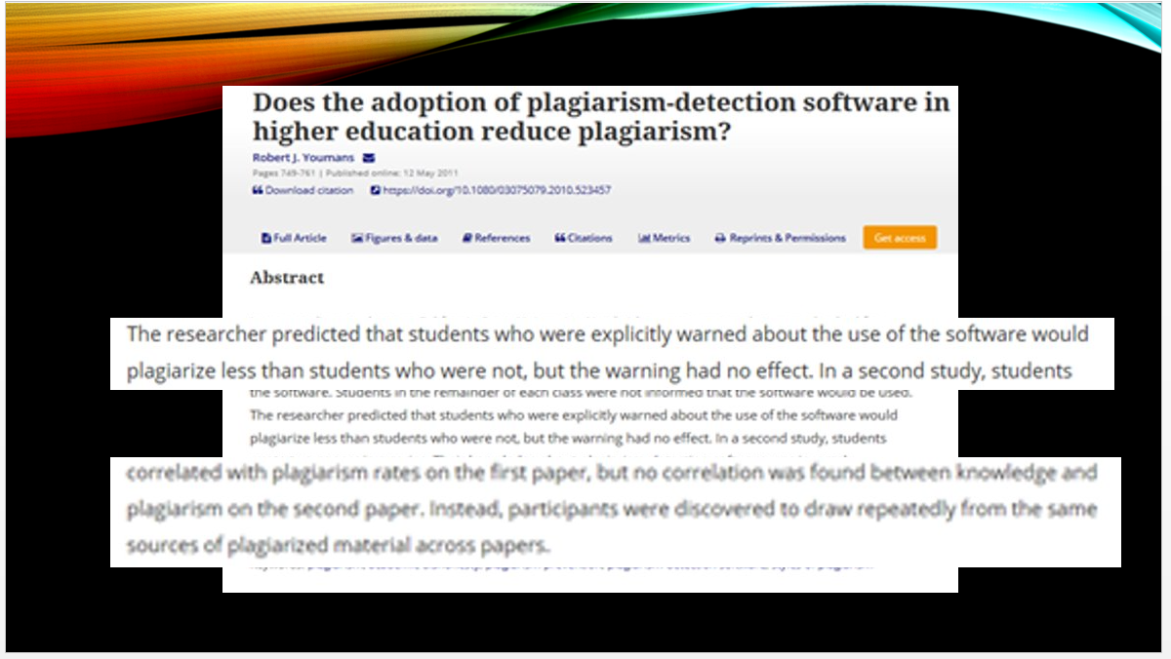
Figure 12 - Slides Presented by M Dand #6
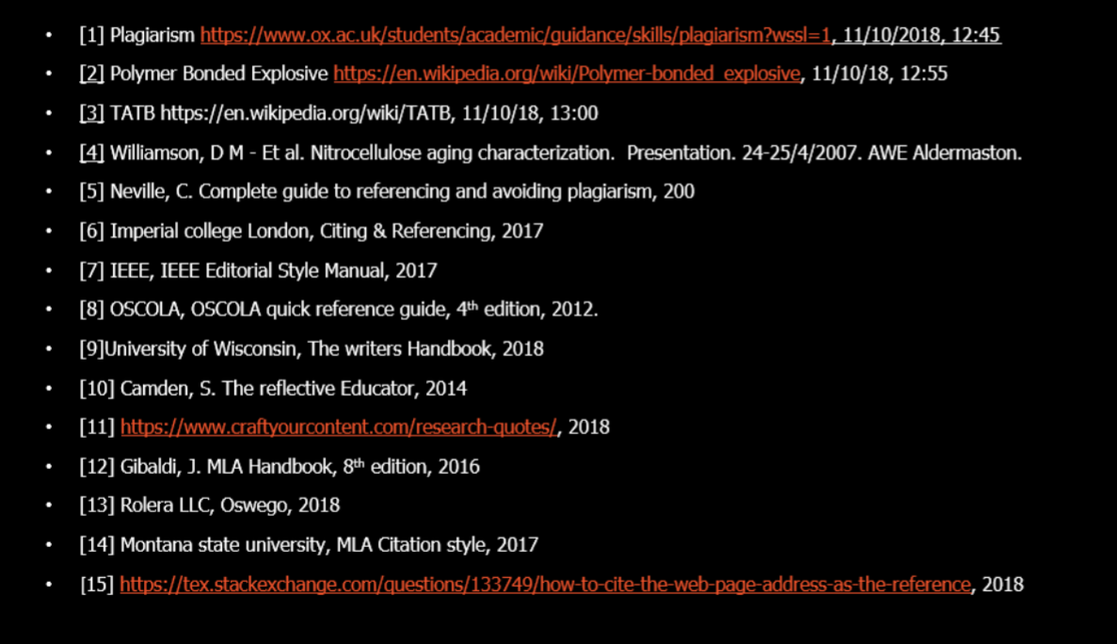
Figure 13 - Group Presentation References List - 1
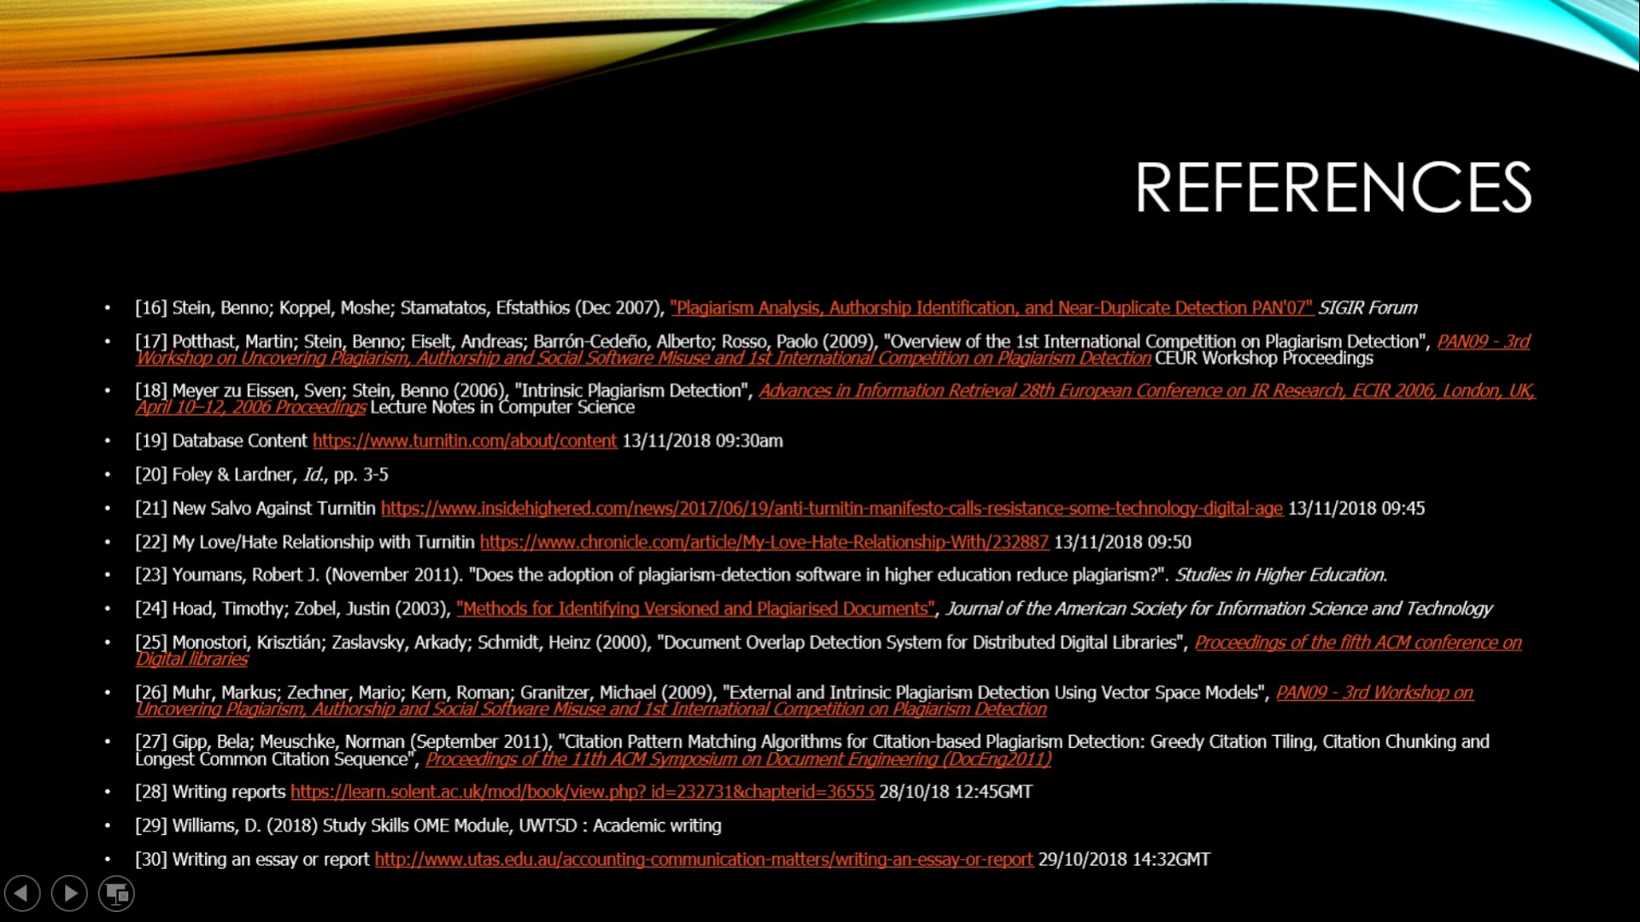
Figure 14 - Group Presentation References List - 2

