Title Page
Fundamentals of Electrical and Electronic Systems
Circuit Design Report
Author Stephen Deane
Date 10th January 2025
Student number:2307720

Contents
Contents 2
1 Introduction 3
2 Results 7
3 Discussion 12
4 Conclusion 13
5 References 13

Figure 1 - The 555-timer circuit needed to be replaced 3
Figure 2 - 555-timer IC diagram 3
Figure 3 - 555 timer Pin Description [3] 4
Figure 4 - Diagram of a monostable circuit 5
Figure 5 - Diagram of a distable circuit 5
Figure 6 - Diagram of an astable circuit 6
Figure 7 - Circuit replicated in proteus 7
Figure 8 - proteus Resistor values 8
Figure 9 - Oscilloscope on time 8
Figure 10 - Oscilloscope off time 9
Figure 11 - Proteus capacitor off time 10
Figure 12 - Proteus capacitor on time 10
Figure 13 Bread board build 11
Figure 14 - Bread board with power supply displayed 11
Figure 15 - Physical oscilloscope on time 12
Figure 16 - Physical oscilloscope off time 12

Table 1 - Physical time values 12
Table 2 - compared values from simulated and physical 12

Equation 1 - Ohms law 7
Equation 2 - To work out values of R3 and R4 7
Equation 3 - Values for R3 and R4 7
Equation 4 - proteus on time 9
Equation 5 - proteus off time 9
Equation 6 - Proteus overall period 9
Equation 7 - Proteus frequency 9
Equation 9 - proteus capacitor off time 11
Equation 10 - proteus capacitor on time 11
Equation 11 - proteus capacitor Period 11
Equation 12 - Proteus Capacitor frequency 11

Introduction
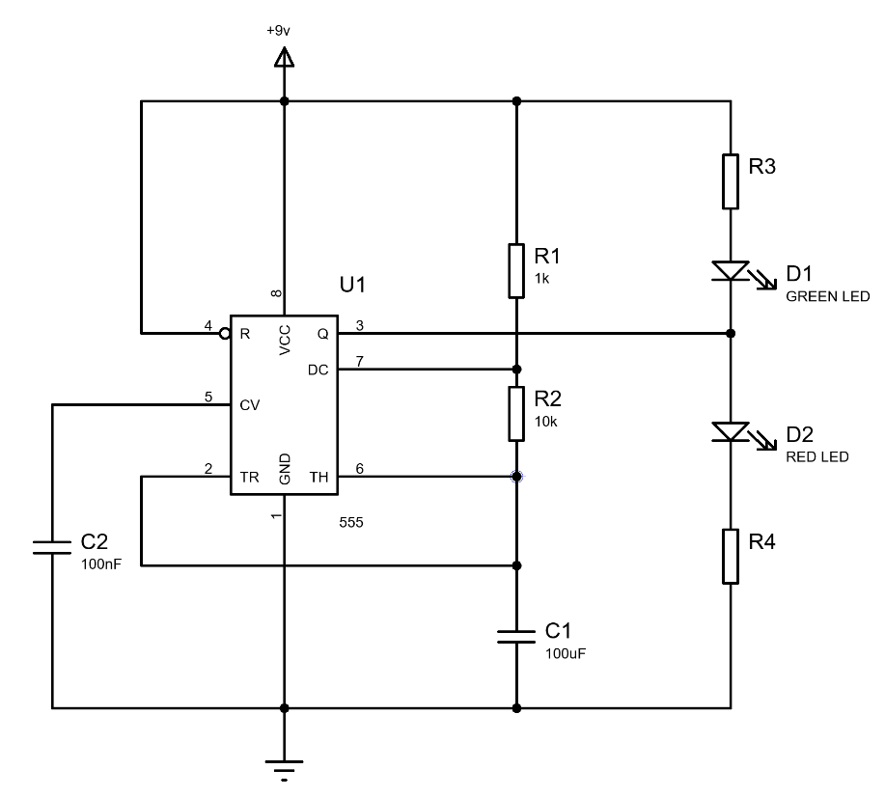
In this report the student has been asked to simulate / build a 555-timing integrated circuit. this type of circuit can be used to generate pulses, create time delays, and oscillate. The student was given a copy of figure 1 to first simulate using the design software called proteus.
Figure 1 - The 555-timer circuit needed to be replaced
Once the student had assembled the simulation, they were then required to work out different factors as this would be used to understand what components will be required to build the bread board.
- The resistance of the R3 and R4 resistors
- The on and off time
- The period timings of the led lights
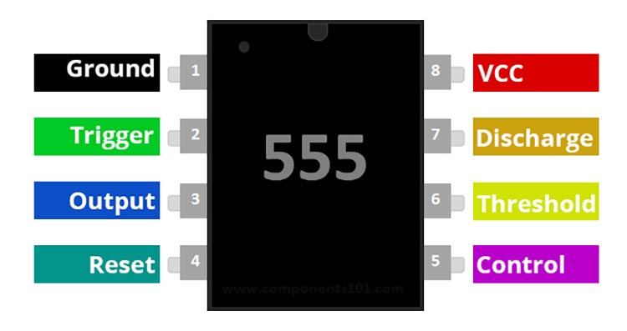
- The Frequency of the whole cycle
Figure 2 - 555-timer IC diagram
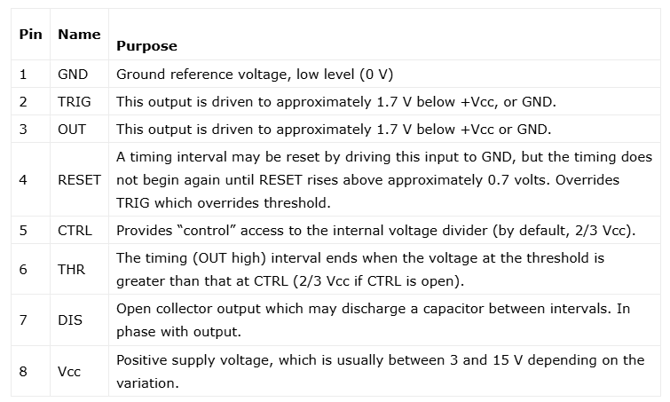
The above is required as these values would be used to understand what components will be required. Once the simulation on proteus was finalized the student then need to build a physical copy on a bread board.
Figure 3 - 555 timer Pin Description [3]
One of the key items used in this circuit is an 8 pin 555 timer microchip. Figure 2 shows a diagram of the 555 microchip. Important information about the triple five timer is as such below.
- The most common make up is made of 25 transistors, 2 diodes, and 15 resistors.
- It was created by electronics engineer Hans Camenzind in 1971.[5]
- By changing to a direct resistance, the design was able to reduce the external pins from nine to eight.
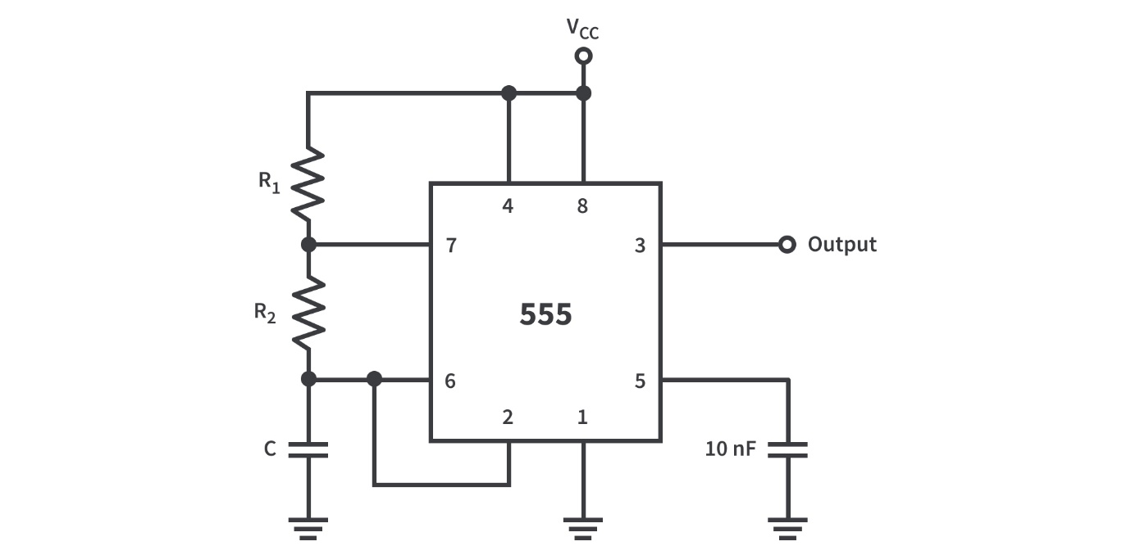
- There are 3 modes of circuits that the 555 – timer has. The first is a monostable circuit which is known as a one-shot mode meaning that when triggered only a single pulse is generated then it returns to a stable state. This is used in time delay generation and touch switches.
Figure 4 - Diagram of a monostable circuit

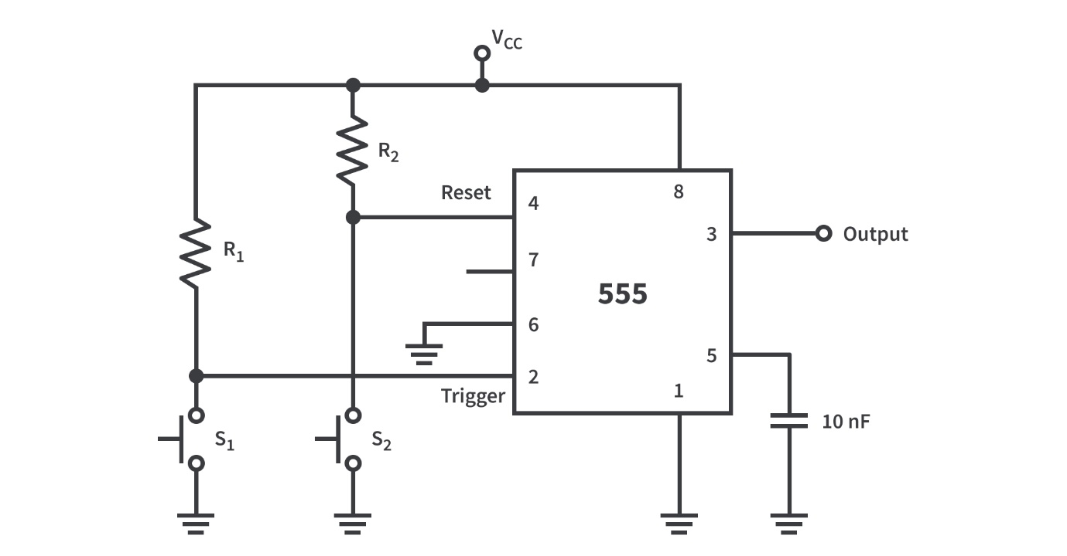
The next mode is distable this is where the timer switches between two different stable modes.
Figure 5 - Diagram of a distable circuit

The last mode and the one the student used in this assessment was astable. In this mode the 555 IC acts as an electronic oscillator where the output is constantly swaps between on and off time as per the configured period. This mode is used for things like led’s and lamp flashers.
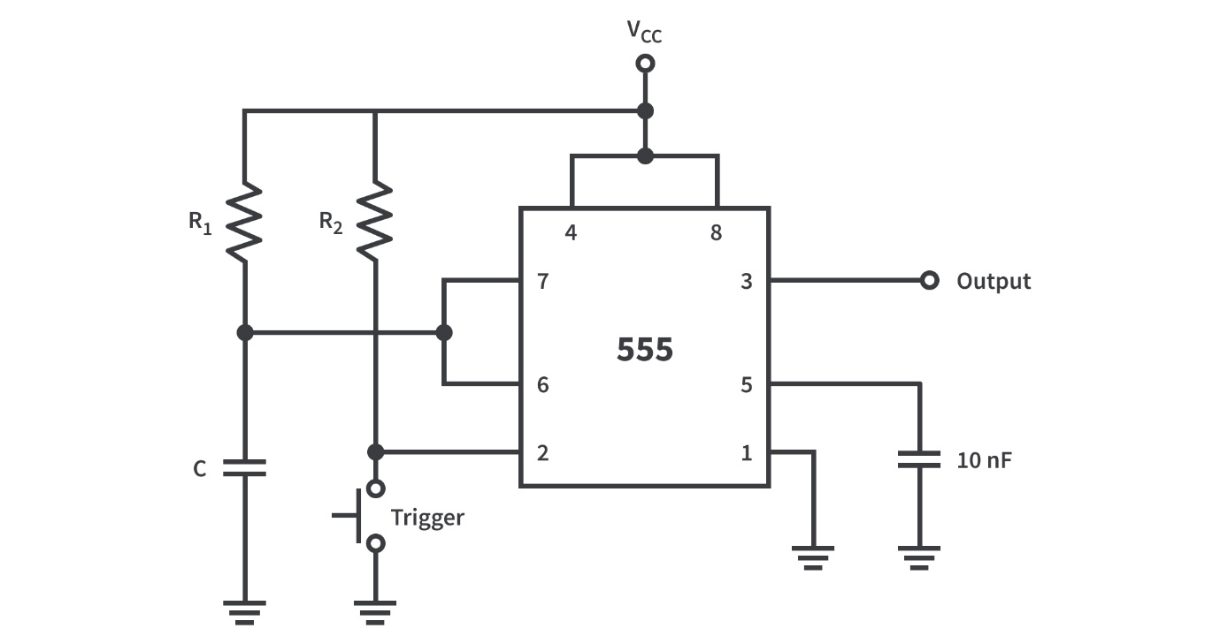
Figure 6 - Diagram of an astable circuit

Results
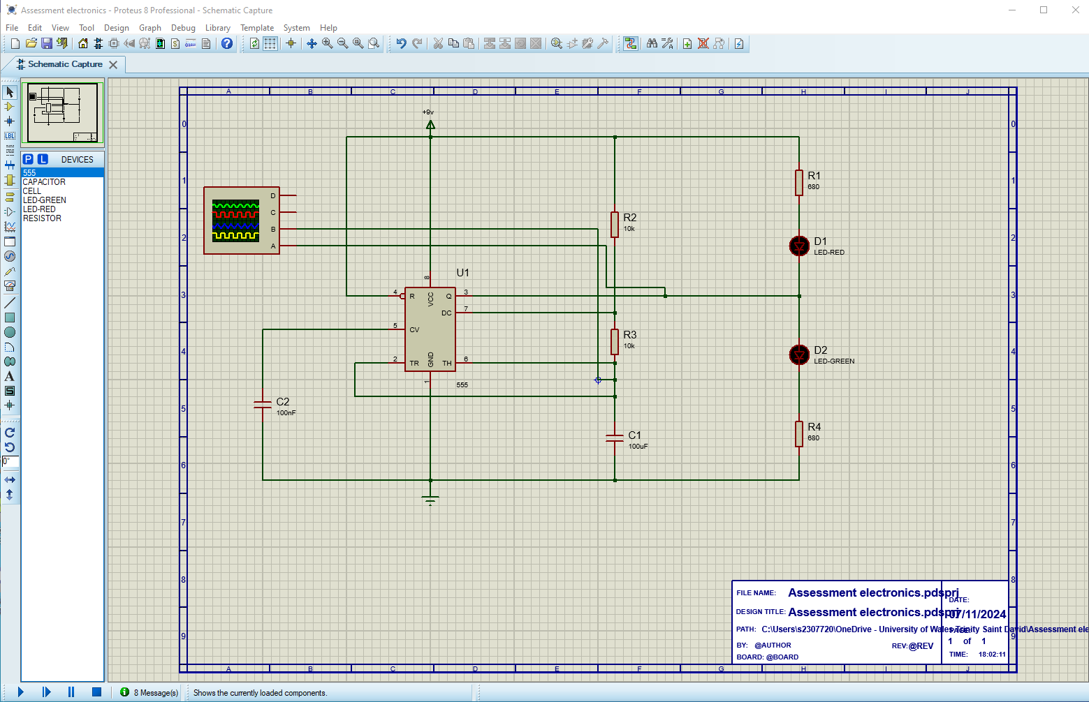
As stated previously for this assignment the student had to replicate the circuit in figure 1 using the software proteus. This can be seen below in the figure 7.
Figure 7 - Circuit replicated in proteus
When the student was recreating the circuit, they needed to work out the what the values of the resistors R3 and R4. This was done using the below equation.
$$V=I x R$$
Equation 1 - Ohms law
Then by rearranging equation 1 the student can calculate the values of the resistors.
$$R= \frac{V}{I}=\frac{Vsupply-V forward}{I}$$
Equation 2 - To work out values of R3 and R4
Then by adding in all other values that are know it will help the student work out R.
$$R= \frac{9V-2.2V}{10mA}=680 ohms$$
Equation 3 - Values for R3 and R4
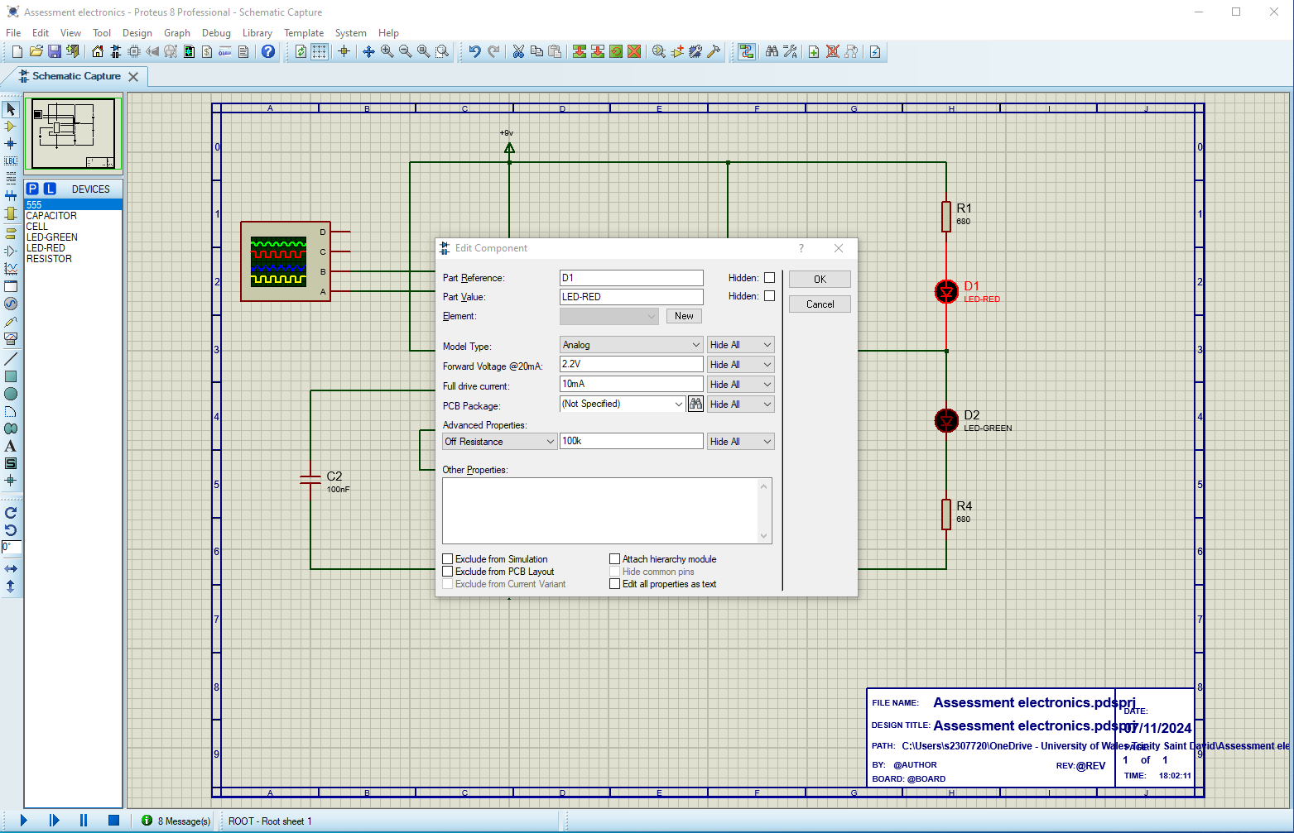
Figure 8 - proteus Resistor values
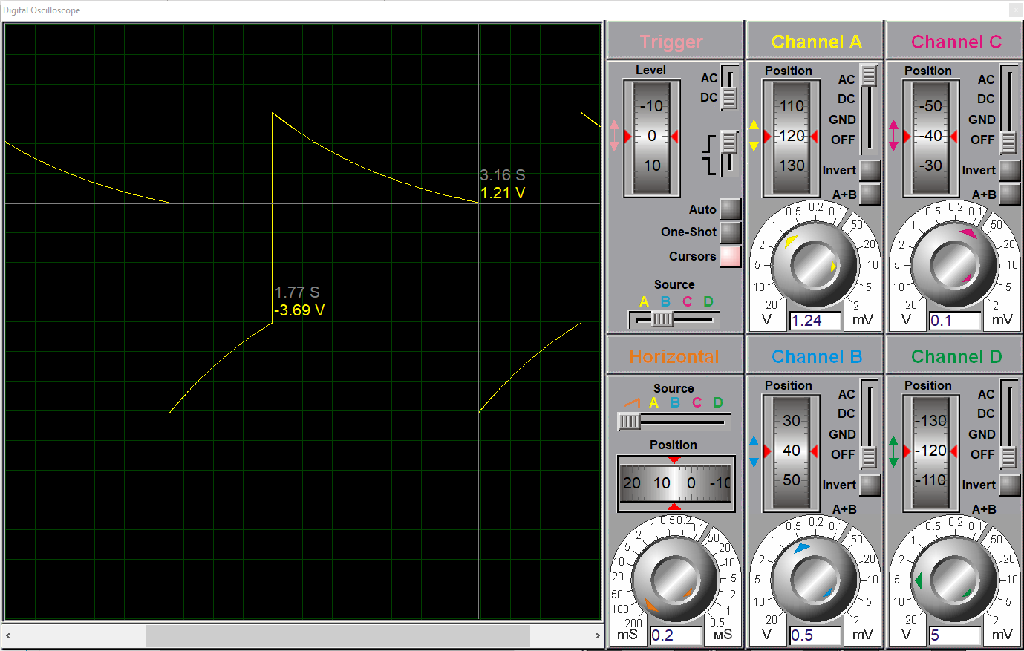
An oscilloscope was then added to the circuit so that the student could measure the on and off time. The on and off time can be seen in figure 8 and 9. The on time starting on the straight incline at 1.77s and ending at the downward curve at 3.16s. The off time is the straight decline at 1.07s ending at the upwards curve 1.77s.
Figure 9 - Oscilloscope on time
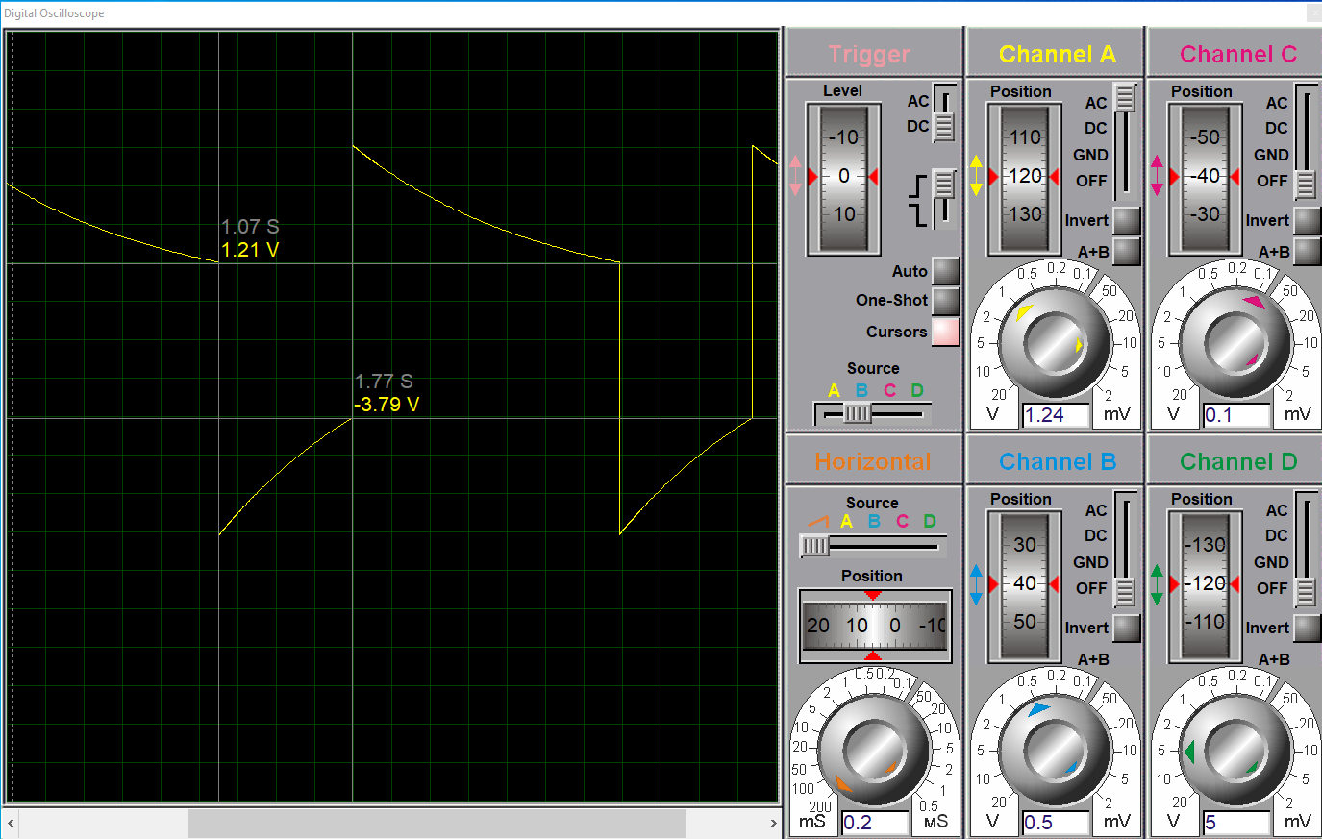
From this the student needed to work out the individual on and off time along with the overall period. To work out the on and off time the student takes the end time and subtracts the starter time such as.
Figure 10 - Oscilloscope off time
$$On time=3.16s-1.77s=1.39s$$
Equation 4 - proteus on time
The same can then be done for the off time
$$off time=1.77s-1.07s=0.7s$$
Equation 5 - proteus off time
The results from both the on and off time can be used to work out the overall period
$$T \left(Period\right)=on time+off time=1.39s+0.7s=2.09s$$
Equation 6 - Proteus overall period
From this the student can work out the frequency. To work out the frequency it is just the time take to complete a full cycle in hertz units.
$$Frequency =\frac{1}{T} = \frac{1}{2.09}=0.478Hz$$
Equation 7 - Proteus frequency
From this the student was able to work out the simulated frequency was 0.48Hz. The student also worked out all the same values from the 100µF capacitor. This can be seen below.

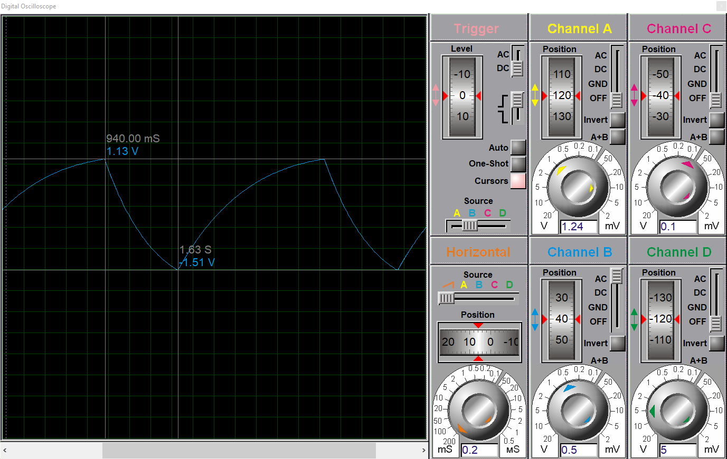
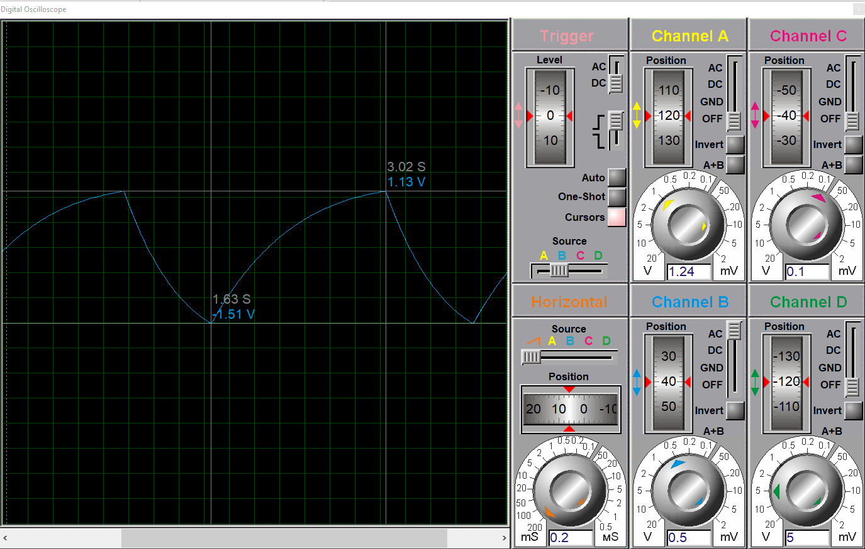
Figure 11 - Proteus capacitor off time
Figure 12 - Proteus capacitor on time

For the off time, 940.00mS has been converted to S from mS for consistency. All of the workings can be seen below.
$$Off time= 1.63s -0.94s=0.69s$$
Equation 9 - proteus capacitor off time
$$On time=3.02s-1.63s=1.39$$
Equation 10 - proteus capacitor on time
$$T \left(Period\right)= 0.69s+1.39s=2.08s$$
Equation 11 - proteus capacitor Period
$$Frequency= \frac{1}{2.08}=0.480Hz$$
Equation 12 - Proteus Capacitor frequency
The student can see that the overall everything matches up, apart from the of off time which seems to be down to the student not being very familiar with the proteus software so maybe not have has all the correct settings aligned.
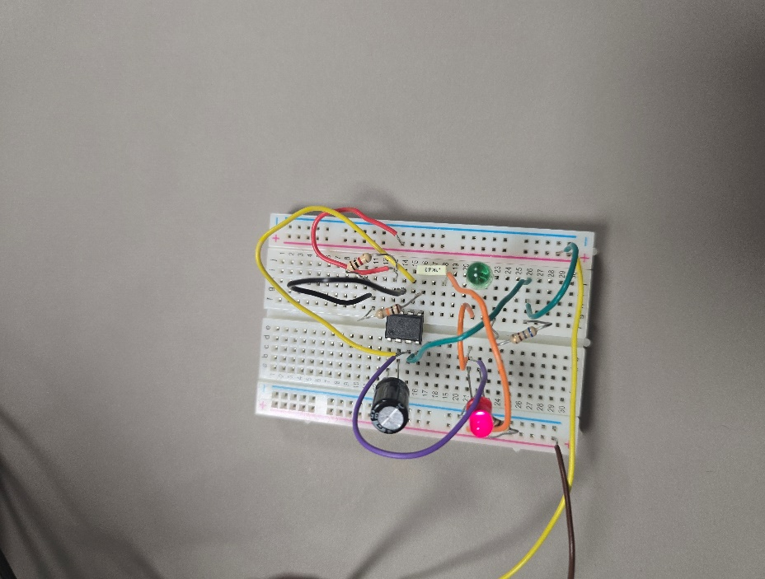
Now that the student had completed the simulated aspect of this assignment, they needed to replicate it once again but this time it would be done physically on a bread board. This was to prove that they could take all the theory and put it into practice. Once the student was finished the build, the board was attached to a power supply set at 9V. This can be seen below
Figure 13 Bread board build
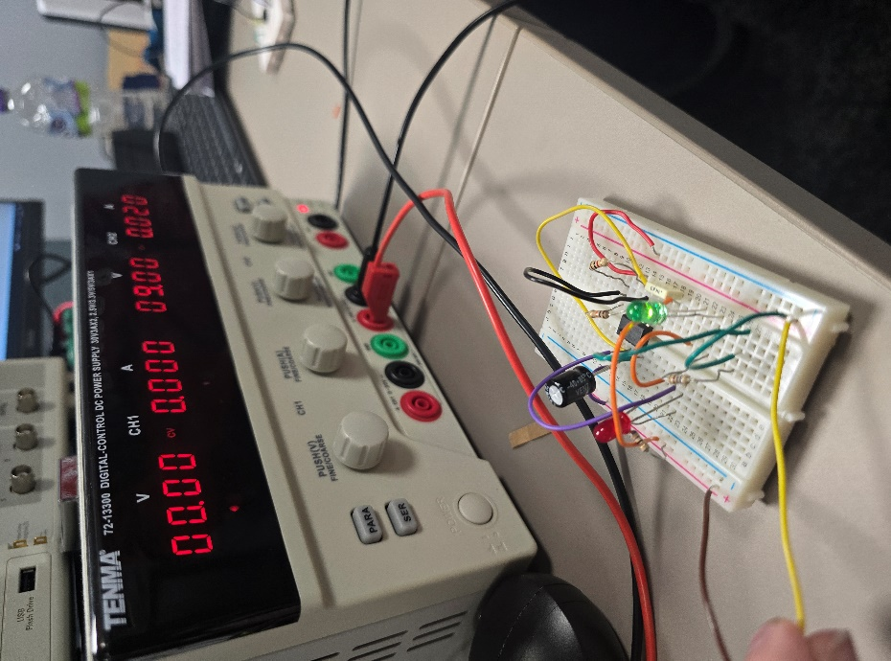
Figure 14 - Bread board with power supply displayed

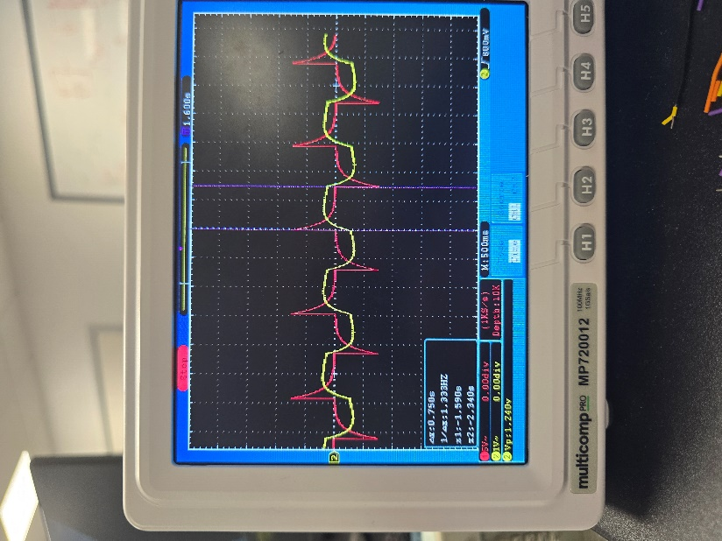
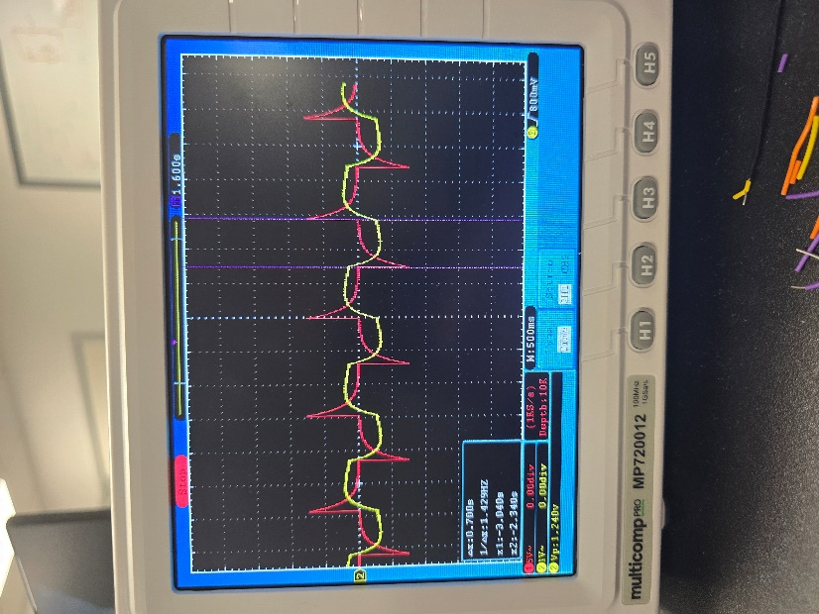
Like the simulated version the physical circuit is then attached to a oscilloscope, this is to ensure that all parts have been added correctly and that the student gets the same results for both physical and simulated circuit. Figures 14 and 15 show the bread board oscilloscope.
Figure 15 - Physical oscilloscope on time
Figure 16 - Physical oscilloscope off time
When the oscilloscope is connected the student used it to analyse the on and off time values. With the particular oscilloscope it does the calculations for the on and off time.
Calculation | Value
Off time -2.340s - -3.040s | 0.700s
On time -1.590s – 2.340s | 0.750s
T (period) 0.700s + 0.750s | 1.45s
Frequency $\frac{1}{1.45}$ | 0.69Hz
Table 1 - Physical time values

Discussion
From table 1 the student can compare the two different circuit builds and put both sets of results into table 2.
Circuit | On time | Off time | T (period) | Frequency
Proteus software | 0.69s | 1.39s | 2.08s | 0.48Hz
Physical build | 0.75s | 0.70s | 1.45s | 0.69Hz
Table 2 - compared values from simulated and physical
The student can use table 2 to compare the resulting vales from both the simulated and physical circuits. The student can see that the two sets of data are very different from each other which is not what was expected, the student believed that they would see very similar if not parrel figures when completing the bread board. The difference in results is speculated to be due to the students experience and knowledge of building circuits before under taking this task, when building the bread board the student would experience phases of the circuit working as intended and what would seem as a faulty connection with only the red led light illuminating. Human error would be the biggest factor any discrepancies as certain parts used like resistors all look very similar with only different colour strips along the body distinguishing them from one another, so the student might have used the wrong part while not realising their mistakes.
When doing research for this assignment the student looked in to how timer circuits can be used in relation to their overall course, it seems the most common use is for Electronic Delay Detonators for quarrying or mining with many benefits such as [4]
- higher precision
- reduction of air blast
- the blast can be programmed to what is required from a range of different delays
- built in safety features compared to other detonators

Conclusion
Even though the student had varying data in this assessment they believed that it was still a good challenge giving them a better understanding of electronic systems. Given that the data was vastly different between the proteus system and physical bread board it has shown as an interest point for the student to do more research so they can get more parrel data when attempting to making a circuit again. This would be more achievable with having a better understanding of all the equipment involved and the most optimal building methods.
The student would also be interested in looking into how widely the triple five timers are used in the weapons industry such as ordnance systems or other types of detonators.

References
[1] “Comprehensive Guide to 555 Timer with Pinout, Specs, and Operating Modes,” Components101. Accessed: Dec. 17, 2024. [Online]. Available: https://components101.com/articles/555-timer-pinout-specs-and-operating-modes

[2] J. Upadhyay, “555 Timer - 1. Introduction to 555 Timers,” CircuitBread. Accessed: Dec. 17, 2024. [Online]. Available: https://www.circuitbread.com/tutorials/555-timer-1-introduction-to-555-timers

[3]E. Bureau, “555 Timer IC Pin Diagram, Circuit, Working, Datasheet, Modes,” EFY Group. Accessed: Jan. 09, 2025. [Online]. Available: https://www.electronicsforu.com/technology-trends/learn-electronics/555-timer-working-specifications

[4] M. Cardu, A. Giraudi, and P. Oreste, “A review of the benefits of electronic detonators,” Rem: Revista Escola de Minas, vol. 66, pp. 375–382, Sep. 2013, doi: 10.1590/S0370-44672013000300016.

[5 ]C. Atwell, “The Origin, Explanation, and Applications of Triple-Five Timers,” Electronic Design, Oct. 20, 2022. Accessed: Jan. 13, 2025. [Online]. Available: https://www.electronicdesign.com/technologies/analog/article/21252714/electronic-design-the-origin-explanation-and-applications-of-triple-five-timers

