- Explain the relevance of the communication cycle for effective communication in management
- Explain, with examples, the importance of selecting an appropriate tone, language, and level of formality in management communications.
- Assess the effectiveness of a range of verbal and written communication methods within your area of the organisation.
- Evaluate theories of motivation relevant to your workplace
- Evaluate the principal factors that may affect performance and motivation in the workplace.
- Select a theory of motivation - apply it to your workplace – evaluate the impact.
- Develop appropriate criteria to evaluate one's own ability to communicate effectively.
- Collect and analyse feedback on own verbal and written communication skills.
- Evaluate own communication skills as a manager, identifying strengths and areas for improvement, then Produce a PDP to address these.

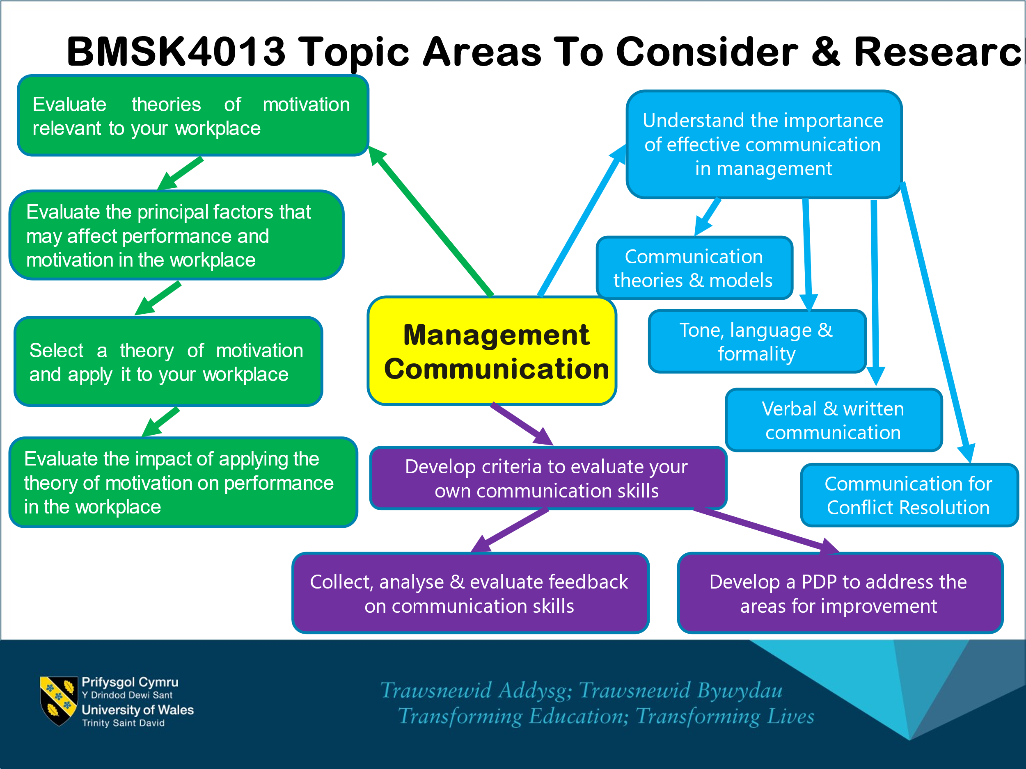

Explain the relevance of the communication cycle for effective communication in management
Explain, with examples, the importance of selecting an appropriate tone, language, and level of formality in management communications.
Assess the effectiveness of a range of verbal and written communication methods within your area of the organisation.
Evaluate theories of motivation relevant to your workplace
Evaluate the principal factors that may affect performance and motivation in the workplace.
Select a theory of motivation - apply it to your workplace – evaluate the impact.
Develop appropriate criteria to evaluate one's own ability to communicate effectively.
Collect and analyse feedback on own verbal and written communication skills.
Evaluate own communication skills as a manager, identifying strengths and areas for improvement, then produce a PDP to address these.

Engagement 10 marks
You should include at least ten references. These should be taken from appropriate journals, textbooks and reliable websites. A reference list in APA V7 convention. In-text citations should correspond to the reference list and in the correct format.
Knowledge 30 marks
You should explore theoretical concepts relating to effective communication (such as Shannon & Weaver, Schramm, Berlo, etc.).
Understanding of the key theories should be demonstrated. Employ criticality and evaluate the appropriateness of different levels of formality, language structure, content and different modes of communication with different audiences.
Consideration of verbal and non-verbal communication in the workplace scenario should be discussed.
Assess a range of verbal and written communication methods in your organisation.

Cognitive 20 marks
Explain theories of motivation and conflict.
Examine the effect of motivation and conflict on performance in the workplace.
Apply theory to your workplace and examine the impact.
Describe a professional conflict resolution strategy.

Practical 30 marks
Practical Skills, such as collecting feedback on one's own communication skills and abilities, developing criteria to evaluate one's own skills, and producing a PDP to address areas for improvement, should be included here.
Transferable 10 marks
Demonstrate effective report writing skills, with appropriate diagrams, graphs, charts, and tables included as evidence of your ability to use, understand and or handle data. Consider layout, grammar, and report structure.

Example outline
Introduction (300 words)
- Introduce the importance of effective communication in management, mentioning key theoretical frameworks like Shannon & Weaver and Schramm.
- State the essay's objective: to explore management communication, motivation theories, their application in the workplace, and the personal development of communication skills.

Relevance of the Communication Cycle for effective communication in management (300)
What is it?
- Idea Formation
Sender has an idea to be communicated.
- Message Encoding
Encoded into words, symbols, and gestures that will convey meaning.
- Message Transmission
Messages can be transmitted in a verbal, written, or visual manner.
- Decoding
Message must be decoded into its intended meaning.
- Feedback
It occurs when the sender and receiver check to ensure the message was understood as intended.
- Action/Reaction

- Why is it effective?

Consider:
- Clarity of Message
- Selection of the Appropriate Channel
- Feedback for Mutual Understanding
- Adjusting Communication Strategies
- Cultural Sensitivity and Inclusivity

Theoretical Frameworks of Communication (600 words)
- Shannon & Weaver Model: Explain the model's relevance to clear messaging in management. Include examples from management practices.
- Schramm's Loop: Discuss the importance of feedback in management communication.
- Berlo’s SMCR Model: Analyse how each component influences the effectiveness of managerial communication.
- Relate to the workplace
- Be critical (what works, what doesn’t and why)

Importance of Tone, Language, and Formality (500 words)
- Explain why selecting an appropriate tone, language, and level of formality is crucial in management communications.
- Provide examples of different scenarios in management (e.g., crisis communication, team motivation) where varying levels of formality and tone are applied.
- Critically evaluate the impact of these choices on employee engagement and perception.
- Relate to the workplace
- Be critical (what works, what doesn’t and why)
Communication Methods in the Organisation (500 words)
- Assess a range of verbal and non-verbal and written communication methods used in your organisation (e.g., meetings, emails, newsletters).
- Discuss the effectiveness of these methods in fostering teamwork, collaboration, and organisational culture.
- Link to theories and concepts as appropriate.
- Relate to the workplace
- Be critical (what works, what doesn’t and why)

Theories of Motivation and their Application (500 words)
(Apply theory to workplace and examine the impact)
- Overview of Motivation Theories: Briefly review Maslow's Hierarchy of Needs, Herzberg's Two-Factor Theory, McGregor’s X and Y Theory.
- Application to the Workplace: Apply these theories to understand employee motivation in your workplace.
- Motivation Theories-Effectiveness today. Briefly describe how effective they are in modern society.
- Intrinsic and extrinsic motivation: Difference between intrinsic and extrinsic motivation. Which is more effective.
- Theory of Motivation and Conflict: Discuss how motivation theories can address and transform conflict in the workplace.
  - Firstly start with theories of conflict
  - Realistic Conflict Theory:
Suggests that conflict arises when resources are scarce, leading to competition over the limited resources.

  - Social Identity Theory
Proposes that individuals identify with certain groups, and intergroup conflict arises as a result of competition between these groups for status and resources.

  - Integrated Conflict Management Theory
Focuses on how organizational structures, power dynamics, and personal behaviours interact to produce conflict situations and resolutions.
- Conflict resolution strategy:
Describe a professional conflict resolution strategy and the role of motivation.
  - Thomas-Kilmann Conflict Model
    - five strategies for conflict resolution:
Avoiding, competing, accommodating, compromising, collaborating.
    - Suggests that individuals have preferred ways of dealing with conflict but can choose different styles depending on the situation.
    - Pros and Cons of each stage.

Forbes (Bridges, 2019) suggests:
    - Never Let The Conflict Escalate
    - It’s Not About Winning
    - Listen
    - Find Common Ground
    - Apologize Quickly, Forgive Quickly
- Relate to the workplace
- Be critical (what works, what doesn’t and why)

Evaluating Communication Skills and Developing a PDP (200 words)
PDP in Appendix. Overview in main text of below.
- Outline criteria for evaluating effective communication skills in management.
- Describe a process for collecting and analysing feedback on your own communication skills.
- Based on this evaluation, identify strengths and areas for improvement, proposing a Personal Development Plan (PDP) to address these (See Appendix A).

Conclusion (300 words)
- Summarise the critical findings from the essay, emphasising the importance of effective management communication, the application of motivation theories in the workplace, and the continuous development of communication skills.
- Reflect on the implications of these findings for organisational success and personal leadership development.

References
Compile a list of references used throughout your essay in APA V7 format. Ensure to include a wide range of sources, such as peer-reviewed journals, authoritative textbooks, and credible websites, to support your arguments and provide a comprehensive view of the topics discussed.
E.g.
Berlo, D. K. (1960). The Process of Communication. New York: Holt, Rinehart & Winston.
(Was a major influence in transforming the study of speech into the study of communication)

Bridges, F. (2019, March 1). 5 Steps To Conflict Resolution In The Workplace. Forbes. https://www.forbes.com/sites/francesbridges/2019/02/28/5-steps-to-conflict-resolution-in-the-workplace

Herzberg, F., Mausner, B., & Snyderman, B. (1959). The motivation to work (2nd ed.). John Wiley.
(A study of job motivation in which more than 200 industrial employees)

Maslow, A. H. (1943). A theory of human motivation. Psychological Review, 50(4), 370-396.
(Motivational theory in psychology comprises a five-tier model of human needs, often depicted as hierarchical levels within a pyramid. Applications include workplace motivation).

Mintzberg, H. (1975). The manager’s job: Folklore and fact. Harvard Business Review, 53(4), 49-61.
(This work challenges conventional wisdom about managerial roles. When asked what they do, managers often cite activities like planning, organising, coordinating, and controlling. However, Mintzberg’s research reveals a different reality - Interpersonal Roles: These involve interactions with others, such as being a figurehead, leader, or liaison. Informational Roles: Managers gather, process, and disseminate information within their organisations. Decisional Roles: Managers make choices, allocate resources, and resolve conflicts).

Shannon, C. E., & Weaver, W. (1949). The Mathematical Theory of Communication. Urbana, IL: University of Illinois Press.
Seminal work in the field of communication theory.
Three Levels of Communication Problems:
Technical Problem, Semantic Problem, Effectiveness Problem.
Mathematical Theory of Communication:
Mathematical framework for communication. He addresses the technical level, focusing on the engineering aspects of transmitting symbols. Significance of this theory in understanding the other two levels—semantic and effectiveness.

Thomas, K. W., & Kilmann, R. H. (1974). Thomas-Kilmann Conflict Mode Instrument. Tuxedo, NY: Xicom.
(A tool developed to measure an individual’s response to conflict situations, the model focuses on two key dimensions: assertiveness and cooperation. These dimensions interact to form five distinct conflict resolution modes. Each mode has advantages and disadvantages, depending on the context)

Expanding Each Section
To reach the required word count and depth of analysis:
- Incorporate multiple examples from real-life management scenarios, academic case studies, or hypothetical situations to illustrate points.
- Use direct quotes and paraphrasing from your sources to support your analysis. Ensure each point is critically evaluated, considering strengths and weaknesses.
- Include diagrams, graphs, charts, and tables, where relevant, especially when discussing feedback analysis or motivational theories' impact on performance. Explain these visual aids in the text to integrate them into your argument.

Final Tips
- Maintain a critical and analytical tone throughout the essay.
- Ensure your writing is clear, concise, and free of jargon to make it accessible to all readers.
- Regularly refer back to the essay question to ensure all aspects are covered comprehensively.
This structure provides a scaffold for your essay, guiding a detailed and critical exploration of management communication and motivation theories. Expand upon each section with thorough research and analysis to develop a comprehensive and insightful essay.

