University of Wales Trinity Saint David

Engineering Academic Discipline



Electronic Circuits Testing and Applications

Charlie Morrish
2405178

BEng Motorcycle Engineering
06/04/2025
Electrical Control Systems (ACHA4010)
1815/4000

Contents of Report
Contents
1. Task 3 4
1.1 Scope Time Division Calculations 4
1.2 Function Generator Output 4
1.2.1 Square Wave 4
1.2.2 Sin Wave Output 5
1.3 Basic Capacitor Calculations 5
1.4 Capacitor Discharge Table 6
1.5 Plot log(V) Gradient 6
1.6 Gradient Calculations and Comparisons 6
1.6.1 Gradient Calculations 6
1.6.2 Comparison Table 6
1.7 Capacitor Uses 7
1.8 Inaccuracies Question 9
2. References 11

Figures
Figure 1: Oscilloscope Trace of a Pulse Width Modulation [PWM] Signal 4
Figure 2: Oscilloscope Trace of a Non-Ideal Square Wave Signal 5

Task 3

Scope Time Division Calculations

𝑃𝑒𝑟𝑖𝑜𝑑(𝜏)= 1𝑓
𝑇𝑖𝑚𝑒 𝑝𝑒𝑟 𝐷𝑖𝑣𝑖𝑠𝑖𝑜𝑛=1𝑓÷10
𝑇𝑖𝑚𝑒 𝑝𝑒𝑟 𝐷𝑖𝑣𝑖𝑠𝑖𝑜𝑛= 1250÷10=400×10−6
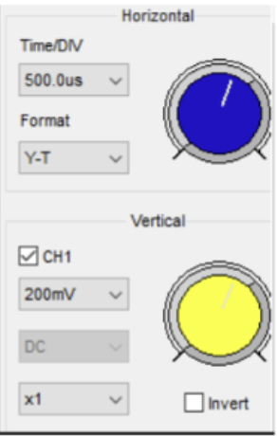

Function Generator Output

Square Wave
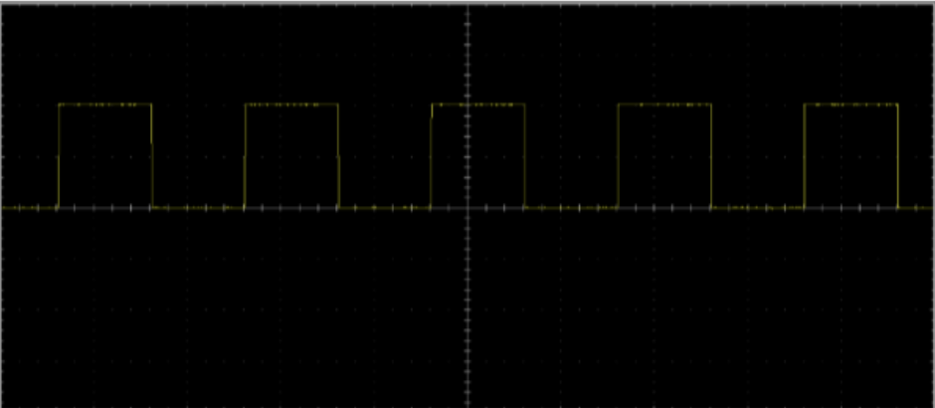
Figure 1: Oscilloscope Trace of a Pulse Width Modulation [PWM] Signal
The provided image is of an oscilloscope display capturing a periodic square wave, which is identified as a Pulse Width Modulation signal. The horizontal axis indicates the progression of time, and the vertical axis shows the corresponding voltage levels. The signal exhibits distinct high-voltage pulses and low-voltage periods. A key observation is the fluctuation in the width of the high-voltage pulses as the signal progresses. The initial pulses show a change in width, signifying a modulation of the duty cycle (the proportion of the cycle spent at the high voltage level). This type of PWM signal is frequently employed as a rudimentary Digital-to-Analog Converter. By averaging the voltage over time, an analogue output proportional to the duty cycle can be derived. The pattern observed in the oscilloscope trace is typical of a PWM signal generated by a microcontroller for the purpose of creating a DAC output.

Sin Wave Output
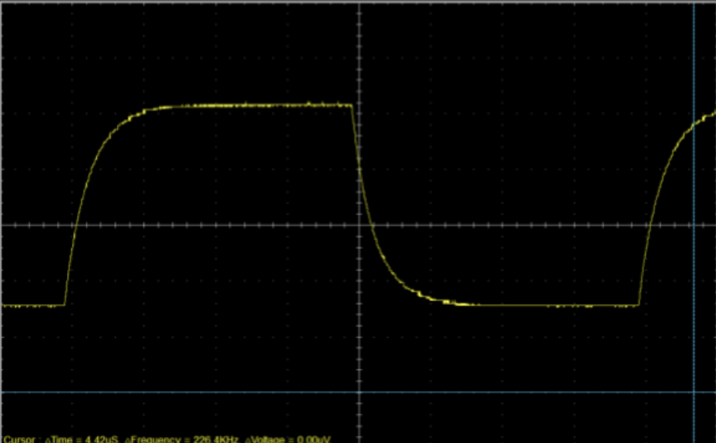
Figure 2: Oscilloscope Trace of a Non-Ideal Square Wave Signal
An oscilloscope trace in the image depicts a periodic waveform approximating a square wave, with voltage plotted on the vertical axis and time on the horizontal axis. The signal transitions between defined low and high voltage states. However, the rising and falling edges are not ideal vertical lines; instead, they exhibit a noticeable slew rate, indicating a gradual change in voltage. While the steady-state high and low voltage levels are maintained, these non-ideal transitions suggest the influence of reactive components (capacitance and/or inductance) or the frequency response limitations of the measurement system. The oscilloscope provides data indicating time difference of 4.42, corresponding to a frequency of 226.4 kHz, and a voltage difference greater than or equal to 0.00V at the cursor. Consequently, the image illustrates a practical square wave signal with bandwidth-limited transitions, deviating from the theoretical instantaneous switching.

Basic Capacitor Calculations
𝐶=𝜏𝑅
𝐶=60×10−6100=0.602𝜇𝐹

Capacitor Discharge Table
Time (s) | Voltage (V) | ln (V) | dy = y2 – y1  dy = ln(V)2-ln(V)1 | dx = x2- x1  dx = Time2 – Time1 | dy/dx

Plot log(V) Gradient

Gradient Calculations and Comparisons

Gradient Calculations

Comparison Table
 | Capacitance | Delta | Percentage difference
Actual | 1 µF | x | X
Marker Calculation
Gradient Calculation

Capacitor Uses
While there are many uses for capacitors in the automotive industry, there are a few that are generalised in every aspect of the topic and a few more specified ones for uses in things like motorcycles or aircraft.
Some examples would be:
- Voltage Stabilisation [The electrical system in a vehicle experiences constant fluctuations due to varying engine loads, the activation of different electrical components (e.g. lights, wipers, etc.), and the charging/discharging of the battery. Capacitors act like small, temporary electrical reservoirs. When the voltage dips, the capacitor discharges slightly to compensate, and when the voltage surges, it absorbs the excess energy. This smoothing effect is crucial for the reliable operation of sensitive electronics like microcontrollers, sensors, and communication modules, preventing malfunctions or damage due to unstable power. Different types and values of capacitors are strategically placed throughout the vehicle’s electrical network to handle various frequency ranges of voltage fluctuations]
- Energy Storage (Supercapacitors) [While becoming more common in cars (especially hybrid cars and EVs), supercapacitors have specific advantages in other applications: Regenerative braking (They can quickly capture and store the kinetic energy generated during braking, releasing it for rapid acceleration. This is particularly beneficial in stop-and-go traffic and can improve fuel efficiency), Start-Stop Systems (Supercapacitors can provide the high current needed for quick and reliable engine restarts, reducing the strain on the lead-acid battery), Power assist (In some high-performance motorcycles, supercapacitors can provide a burst of power for acceleration), and Emergency Power (In certain aircraft systems, supercapacitors can provide backup power for critical functions in case of primary power failure, although batteries are still the primary backup. Their rapid discharge capability is advantageous in specific scenarios)]
- Power Supply Filtering [Beyond just stabilizing the overall voltage, capacitors are essential for filtering out unwanted noise and ripple in the DC power supply. This noise can originate from the alternator, switching power supplies within ECUs, or other electrical devices. Capacitors, particularly electrolytic and ceramic types, have different frequency response characteristics. They are often used in combination to effectively filter out a broad spectrum of noise. Clean power is vital for the accurate functioning of digital circuits, reducing errors in data processing and ensuring the integrity of signals transmitted between different electronic modules]
- Audio System Smoothing [High-power car audio systems can draw significant and rapidly changing amounts of current. Capacitors (often large electrolyte types) are placed near the amplifier to act as a local energy reserve. This prevents voltage drops on the main power line when the amplifier demands a sudden surge of current for bass notes or loud transients. By ensuring a stable power supply, the capacitor helps to maintain the clarity, punch, and overall quality of the audio output, preventing distortion and protecting the amplifier]
- Lighting Systems [LED Lighting (Capacitors in LED drivers help to smooth the rectified AC voltage to provide a stable DC current to the LEDs. This prevents flickering and ensures consistent brightness, contributing to safety and driver comfort. They are also used in timing circuits for dimming and other control functionalities). HID Lighting (High-Intensity Discharge lamps require a high-voltage ballast to ignite and maintain arc. Capacitors in the ballast circuitry help to stabilize the voltage and current, ensuring proper operation and preventing premature lamp failure)]
- On-Board Chargers (OBCs) [The OBC in an EV converts AC power from the charging station into DC power to charge the high-voltage battery. Capacitors within the OBC are critical for: Input Filtering (Smoothing the incoming AC voltage and filtering out noise from the grid), Power Factor Correction (Improving the efficiency of the charging process by ensuring the current drawn from the grid is in phase with the voltage. Capacitors are key components in PFC circuits), DC Link Capacitors (Stabilizing the intermediate DC voltage within the charger before it is converted to the battery charging voltage. These capacitors need to handle high voltages and currents and have high reliability), Output Filtering (Smoothing the DC voltage supplied to the battery to ensure a clean and stable charging current)]
- DC-DC Converters [EVs and hybrids have high-voltage battery packs that power the electric motors. However, the vehicle’s auxiliary systems (lights, infotainment, power windows, etc) typically operate at lower voltages. DC-DC converters step down the high voltage to the required lower voltages. Capacitors in these converters play crucial roles in: Input and Output Filtering (Smoothing the input voltage from the high-voltage battery and the output voltage supplied to the low-voltage systems), Energy Storage (Temporarily storing n=energy to ensure a stable output voltage even under fluctuating loads), and Switching Circuit Stabilization (Providing stable operating conditions for the switching transistors within the converter)]
- Sensor Systems [Modern vehicles rely on a multitude of sensors for safety, performance, and convenience. Capacitors are integrated into various sensor types and their associated circuitry: Capacitive Sensors (Some sensors directly utilize the principle of capacitance change to measure physical quantities like pressure, fluid levels, and proximity. The change in capacitance due to the measured variable is converted into an electrical signal), and Signal Conditioning (In the circuitry connected to other types of sensors, capacitors are used for filtering noise, stabilizing bias voltages, and coupling or decoupling AC signals to ensure accurate and reliable sensor readings are sent to the ECUs)]
- EMI Suppression [Modern vehicles are packed with electronic devices that can both generate and be susceptible to electromagnetic interference. Capacitors, often in conjunction with inductors, form filter circuits that suppress this unwanted electromagnetic noise. They can be used to prevent emissions from one component from interfering with another (e.g. preventing the engine control unit from causing noise in the radio) and to make electronic modules more resilient to external electromagnetic fields. Specific capacitor types, like ceramic capacitors with low inductance, are particularly effective at high-frequency EMI suppression]
- ECU Functionality [ECUs are the brains of modern vehicles, controlling everything from engine timing and fuel injection to braking systems and airbag deployment. Within these complex electronic modules, capacitors play numerous vital roles. They are used for: Power decoupling (Providing local energy storage close to integrated circuits to handle sudden current demands during switching operations, ensuring stable operation), Timing circuits (In oscillator circuits, capacitors help determine the frequency of clock signals that synchronize the operation of the microcontroller and other digital components), Filtering (Smoothing out power supply lines within the ECU and filtering noise from sensor inputs), and Signal coupling/decoupling (Passing AC signals while blocking DC signals between different stages of a circuit)]

Inaccuracies Question
Measurements in practical electronic circuit testing often deviate from specified or calculated values due to a combination of factors. Component tolerances are a primary source of inaccuracy; resistors, capacitors, and inductors possess inherent variations in their stated values. For instance, a 1µF capacitor may have an actual capacitance within a range of ±10% of the nominal value.
Measurement instruments themselves introduce inaccuracies. Oscilloscopes and multimeters have limitations in resolution, accuracy, and calibration. Oscilloscope probes can also affect the circuit under test, introducing capacitance and inductance. Environmental conditions, such as temperature fluctuations, can also influence component values and instrument readings.
Wiring and connections in breadboard circuits can add resistance, affecting current flow and voltage drops. Furthermore, the act of measurement can alter the circuit’s behaviour. For example, attaching a multimeter can change the circuit’s resistance.
To mitigate these inaccuracies, it is crucial to use calibrated instruments, consider component tolerances, and employ appropriate measurement techniques. Error analysis, including statistical methods, can help quantify and understand the uncertainties in measurements.

2. References
Electricity-Magnetism, 11/06/2023. Matan. [Online]
Available at: How do capacitors and inductors help in voltage regulation? – Electricity – Magnetism
[Accessed 12/04/2025]

YouTube, 21/03/2018. Keysight Labs. [Online]
Available at: How to Measure the Time Constant with an Oscilloscope
[Accessed 12/04/2025]

YouTube, 25/09/2019. The Engineering Mindset. [Online]
Capacitors Explained - The basics how capacitors work working principle
[Accessed 13/04/2025]

