

Installing and Managing Virtual Networked Systems

INTRODUCTION TO COMPUTER SYSTEMS (ACCA4021)

13-05-2021

—

WORD COUNT: 1673

—

JOSH PERRY (1903738)

Table of Contents

Section | Page(s)
- Introduction | 1
- Setting up the Server and Client Virtual Machines | 2
- Setting up the Server Virtual Machines | 2
- Setting up the Client Virtual Machines | 2
- Observational Task | 2
- Configuration of Virtual Network | 3
- Investigating Utility Software | 4
- Performance Monitor | 4
- Reliability Monitor | 4
- Computer Manager | 4
- System Configuration | 4
- Configuration of Virtual Network with the Use of an Active Directory Domain | 5
- Creating the Active Directory Domain | 5
- Installing Clients and Basic Object Creation in Active Directory | 5
- DHCP Installation and Configuration | 6
- Installation | 6
- Configuration | 6
- Observational Tasks | 7
- Appendix | 8-24
- References | 25

- Introduction
This report details the steps taken to set up and configure a network consisting of several virtual machines (Two servers and two clients). Each section will detail the steps taken to correctly configure the network and the virtual machines themselves. At the end of the report is a short section of observational tasks completed after each section of the creation of the network.

- Setting up the Server and Client Virtual Machines
  - Setting up the Server Virtual Machines
Initially, the author created the Server 1 Virtual Machine. This was done by adding a new machine in Oracle VirtualBox then naming it, selecting the type of OS and version. (See fig. 1)
Next, was to allocate enough RAM to the machine. Oracle recommends 2048MB, however, the author allocated 4096MB. (See fig. 2)
Next, was to create a virtual hard drive for the machine, this was created as a fixed size (20GB) virtual drive image (VDI). The VDI was appropriately named. (See fig. 3)
Next was to assign a disk image for the machine to boot from, to install the OS from, as with any first-time installation. (See fig. 4)
Physical Address Extension (PAE/NX) was enabled. While not recommended, the author had to enable Nested hardware virtualization (VT-x/AMD-x) due to the boot failing on previous attempts with this option disabled. (See fig. 5)
The final steps in this section of the process were to enable and configure the network adapters. The first step was to change the network type it was attached to from NAT to Internal Network. Then the name of adapter 1 was changed to PublicNet (See fig. 6) and the name of adapter 2 to PrivateNet1 (See fig. 7).
The system was then ready to be run and Windows Server ready to be installed.
After installation and setup, the machine was cloned (See fig. 8) to create Server 2.
The same steps of changing the name for network adapters was repeated with server 2, with the only difference being the name of adapter 2 was PrivateNet2.

  - Setting up the Client Virtual Machines
All steps followed were the same, up until selecting a disk image to boot from. The clients use a different OS to that of the Servers (Windows 10 (x64)). (See figs. 9 & 10)
Again, with the naming of the network adapters, the same approach was followed however, the client machines only had one network adapter each. Client 1 had PrivateNet1, and Client 2 had PrivateNet2.

- Configuration of Virtual Network
This required assigning names and IP addresses to each of the network adapters on each machine, thus networking them together in a basic IPv4 network. The author first started with Assigning the names for the network adapters. (See fig.12). Then they assigned the PublicNet and PrivateNet IP addresses to the appropriate network adapters for the server machines. (See figs. 13 & 14).
The same was done for Server 2 and Client 2, with their respective IP addresses and names. To confirm if the network was setup correctly, the author used the ping and tracert function to ping and trace the signal from Server 1 from client 1 and did the same from client 1 to server 1 to ensure the network was setup correctly. This test was also completed with Server 2 and Client 2. The author had also completed the test from Server 1 to Server 2 via the PublicNet addresses. Furthermore, the author had also attempted to do this from client 1 to client 2 to ensure that they were not connected in any way by mistake. (See figs. 15-17)

- Investigating Utility Software
  - Performance Monitor
The performance monitor houses some of the most important analytical tools. This highly powerful resource monitor offers a much more intricate and detailed view of resource usage and metrics than task manager. There are options to add various counters to the viewing pane that are organized by colour code and give an in-depth view at how certain data moves, resource usages and especially for this purpose, network analytics. (See fig. 18)
  - Reliability Monitor
The reliability monitor will show the reliability of the system, recounting all events in the systems lifetime, incredibly useful for diagnosing recurring issues, and finding out more information on errors. It sorts events in a traffic light system, blue for informational events, amber for warnings and red for critical issues. (See fig. 19)
  - Computer Management
Computer Management contains many useful tools for administrators. This software allows the user to create scheduled tasks, such as weekly scans, reminders, and backups. It also is home to the ‘local users and groups’ tab where a user can add other users, edit permissions and add users to groups. Furthermore, from here the device manager is accessible, form where you can see all hardware connected to the computer. In this section a user can enable/disable and edit the functions and permissions of hardware and their drivers. There is also the storage tab where users can view their storage devices and their capacity and even create or remove partitions and format drives. Finally, there is the services tab, where the user can enable and disable or restart services on the computer. This is particularly useful if certain services are experiencing issues and need to be restarted or disabled. (See figs. 20-24)
  - System Configuration Utility
The system configuration utility is where a user can edit the boot order of the computer, which is useful if the user would need to boot from removable media or to remove an item from the boot order. Furthermore, the user can access the startup pane, which allows the user to change what software will automatically start upon logging in. (See figs. 25 & 26)

- Configuration of virtual Network with the Use of an Active Directory Domain
  - Creating the Active Directory Domain
Firstly, the author had to install the Active Directory Domain Services role. This was done using the add role wizard. (See fig. 27)
After running through the wizard, the author proceeded to elevate the server to domain controller through the promotion wizard, this entailed setting up the domain name, adding a forest, and setting a password. (See fig. 28)
After completing the wizard, the server restarted, and the admin account was listed as UWTSD/ Administrator, confirming it was the domain Controller.

  - Installing Clients and Basic Object Creation in Active Directory
After creating the AD DS, the author had to add a new Computer to the domain, naming it appropriately (See figs. 29 & 30). Then renaming the computer on the client machine and changing the domain name and the preferred DNS of the PrivateNet1 adapter to the IP address of PrivateNet1 IP from Server. As an extra measure the author used the gpupdate /force command to ensure the group policy had updated.
After this, the author created a new user in the AD DS Users tab called Client and gave it a default password to test if the domain user could log into the client machine, which it did. (See figs. 31-33)

- DHCP installation and Configuration
  - Installation
Installing the DHCP service was straightforward using the Server manager. Starting the setup wizard led to installing the DHCP package and selecting a server to deploy it to. (See fig. 34)
  - Configuration
After installation came setting up the scope. A straightforward directive since there is only one client on the network. (See figs.35 & 36)
After setting up the scope, the author changed the IPv4 settings on the Client machine to obtain the IP address automatically, this was done to test whether the DHCP has worked correctly. (See fig. 37)
Testing with the ipconfig commands confirmed that the DHCP network was up and running correctly as the IP released, and renewed when prompted with no issues.

- Observational Tasks
- The advantages of using a type 2 hypervisor program are that they are designed to be used on desktop/laptop hardware. They run differently to a type 1 in the sense that a type 1 is designed to be installed directly onto a physical server, wherein the hypervisor runs under the OS. Conversely, a type 2 hypervisor is designed to run on top of an existing OS and creates virtual machines above itself, thus creating the possibility to run an entire virtual network on one physical machine. (See fig. 11)
- Monitoring tools are essential pieces of software that allow a network administrator to view the status of critical network devices and allows them to be notified when errors occur that will negatively impact the network. An advanced approach to network monitoring will even allow administrators to “…set thresholds for acceptable performance, and … [it] can send alerts to administrators via email or SMS text message.” [1], an example of this would be with the sue of scheduled tasks, when a certain trigger is met, the computer can automatically send out alerts via email to an administrator if an appropriate task is designed.
- Active Directory Services serve as the ‘phonebook’ of all users, groups, and computers on a domain. The directory “allow [sic] sysadmins to organize the data into logical hierarchies” [2]
- Brief Definitions of the following terms in the context of an Active Directory Domain Service:
  - Domains:
    - A domain is a group of objects that “share the same Active Directory database” [3]
  - Forests/Trees
    - Forests can be thought of as an assortment of objects that share the same global directory. Trees can be thought of as the next level down from a forest. A forest is a collection of trees. Trees are a collection of domains sharing the same namespace.
  - Schema
    - Every object has its own unique characteristics, this can be what it contains, what its function is etc. This information is called the Schema.
  - Objects
    - An object is a generic name for any entity within a forest/tree/domain. Objects can be users, computers, groups etc.
  - Domain Controller
    - The domain controller is essentially the server itself. More so the OS on the server. This is responsible for responding to requests to and from the domain.
- There are four main stages of DHCP operation, that is server discovery where the client will broadcast a message to discover a DHCP server, the next is the offer stage, where the DHCP server will offer the client an IP address. Stage three is the request stage, where the client will request to use the offered IP address. The final stage is acknowledgement, the DHCP server acknowledges the clients use of the IP address.

- Appendix
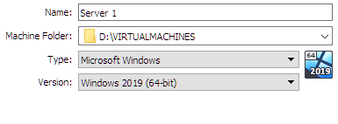
Figure 1- Basic Settings of Virtual Machine in VirtualBox
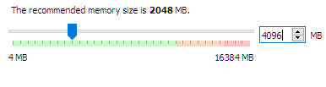
Figure 2- Allocating RAM to Virtual Machine
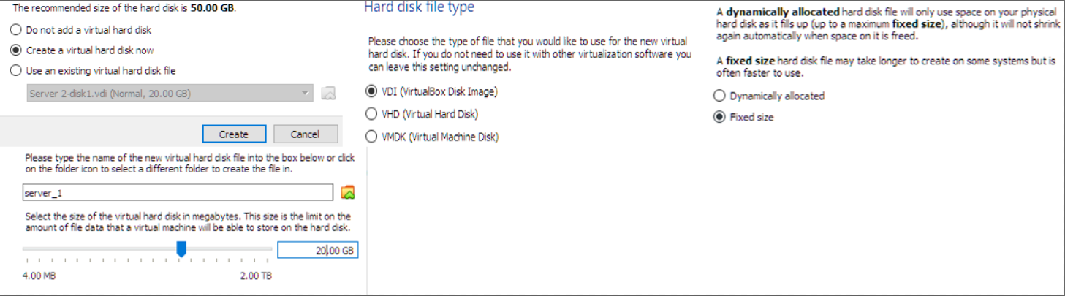
Figure 3- Virtual Hard Drive Setup Process
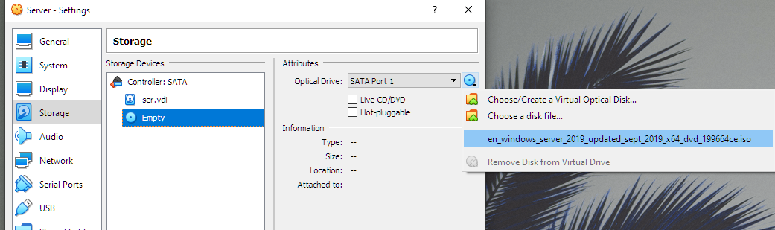
Figure 4- Assigning Disk Image of OS to Boot From
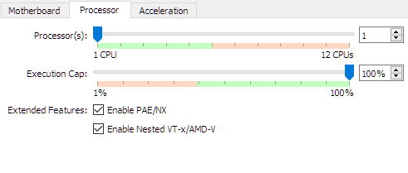
Figure 5- Enabling PAE/NX and Nested VT-x/AMD-x

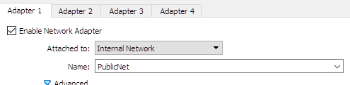
Figure 6- Network Adapter 1 Settings
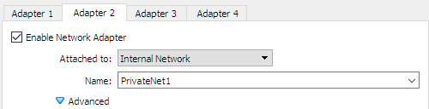
Figure 7- Network Adapter 2 Settings
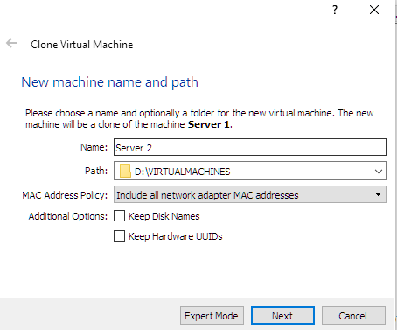
Figure 8- Cloning the Server 1 Machine
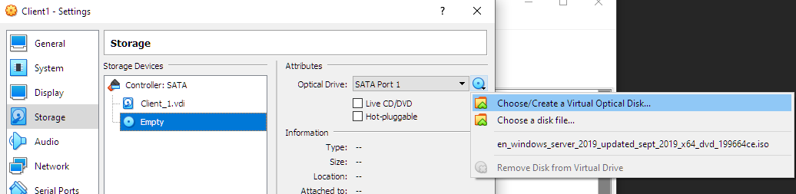
Figure 9- Assigning the Client OS Boot Disk

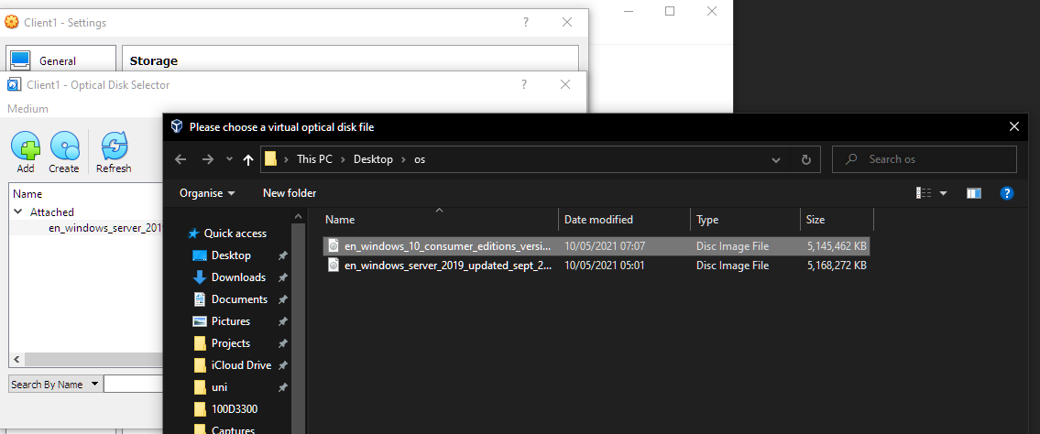
Figure 10- Choosing the OS ISO for Client 1
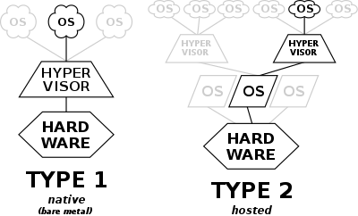
Figure 11- Type 1 and Type 2 Hypervisors [4]
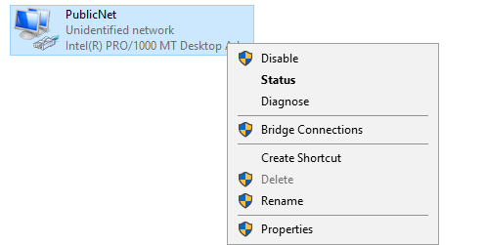
Figure 12- Renaming the Network Adapter in Windows
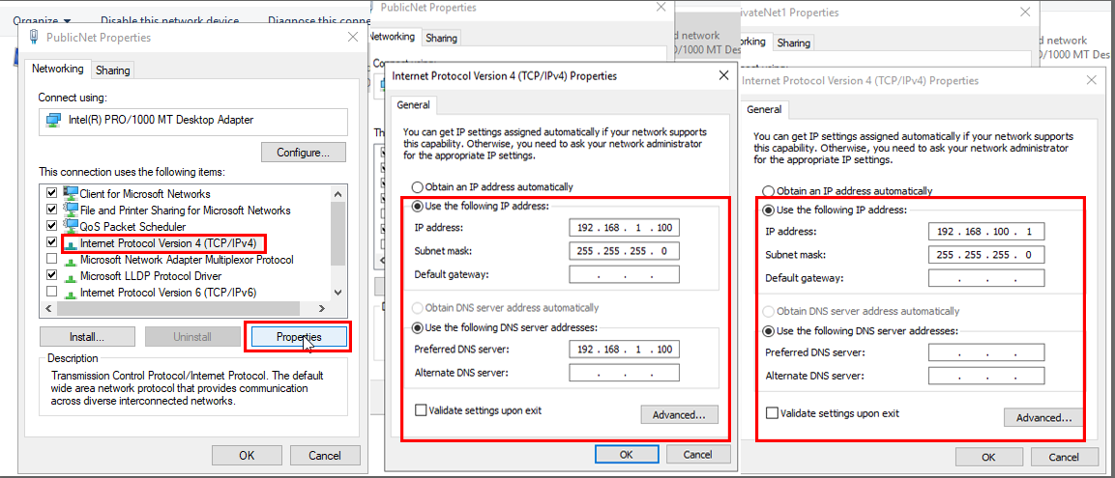
Figure 13- Assigning the IPv4 Addresses for Server 1 in Windows Server 2019
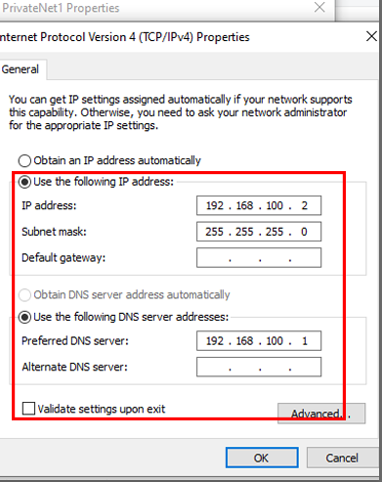
Figure 14- Assigning the IPv4 Address for Client 1 in Windows 10
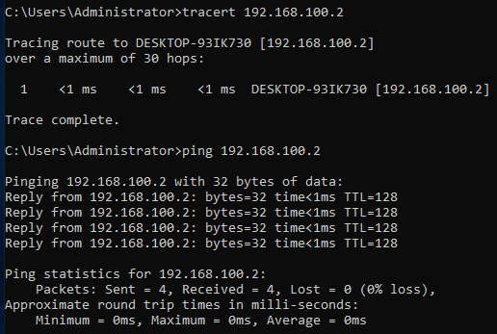
Figure 15- Tracert & Ping Test from Server 1 to Client 1, PrivateNet1
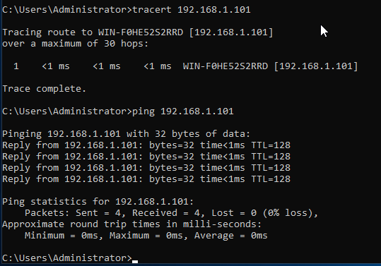
Figure 16- Tracert & Ping Test from Server 1 to Server 2 PublicNet
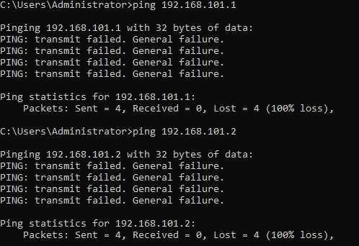
Figure 17- Ping Test from Server 1 to Server 2, PrivateNet 2
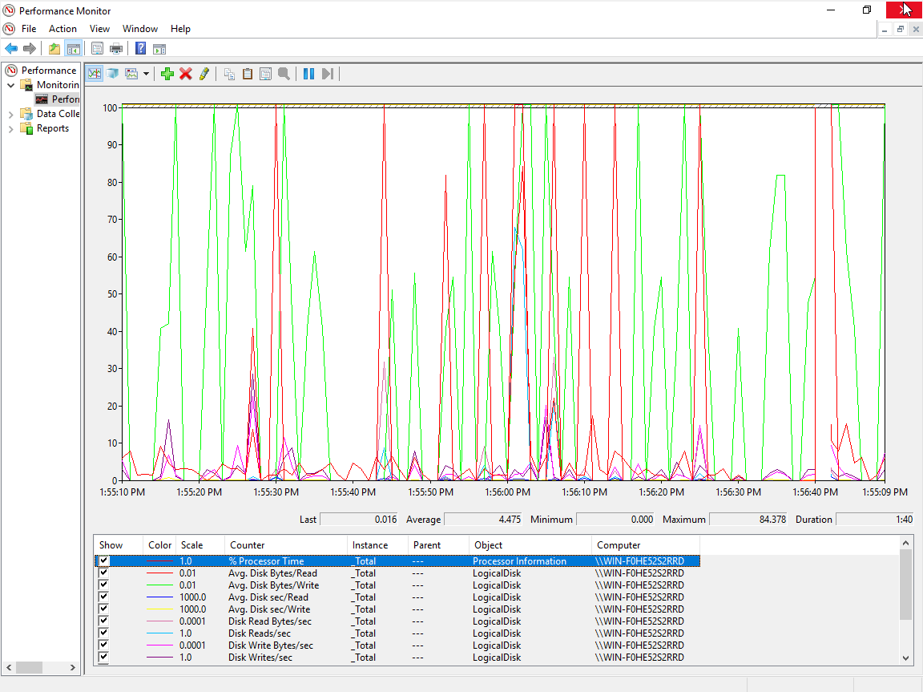
Figure 18- Performance Monitor with Various Counters
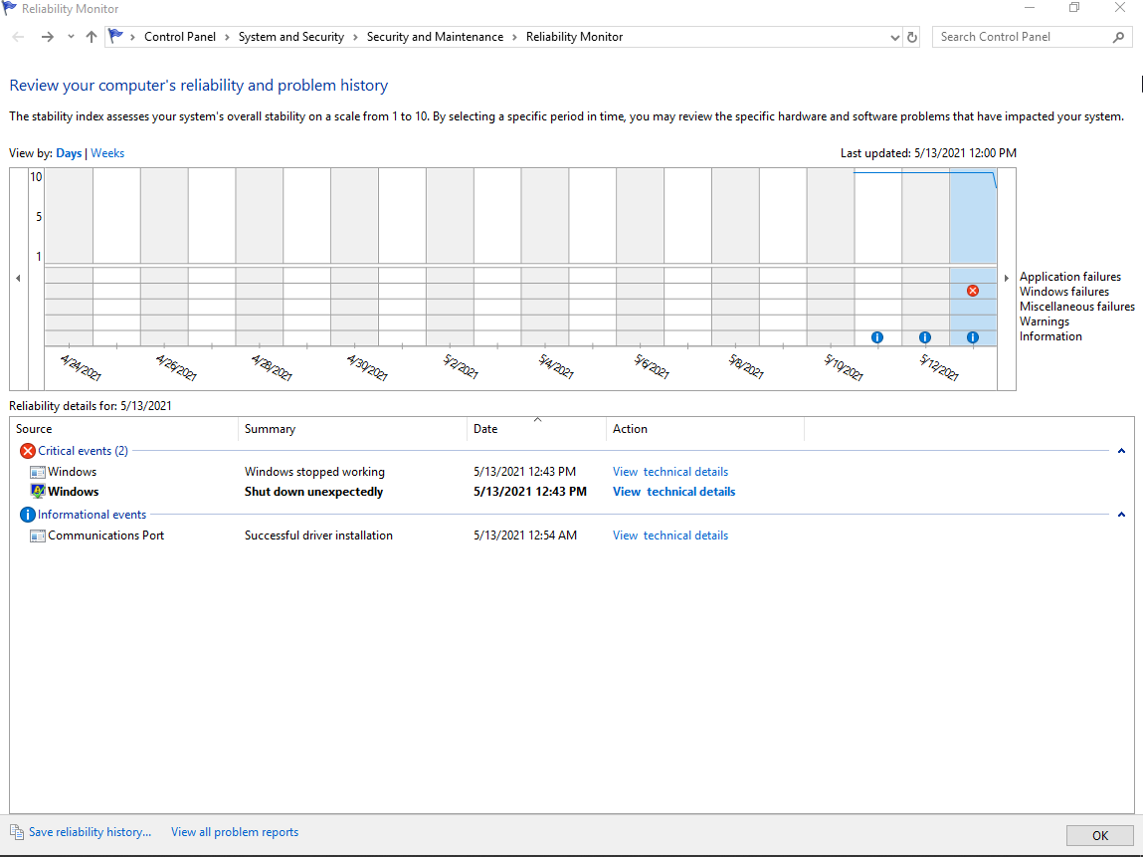
Figure 19- Reliability Monitor Detailing All Previous Events
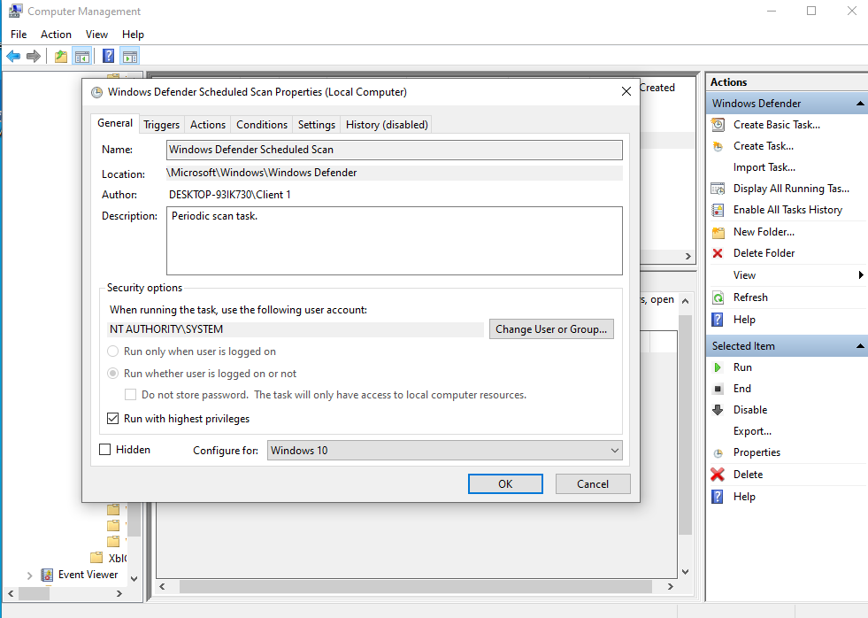
Figure 20- Computer Management- Scheduling Tasks
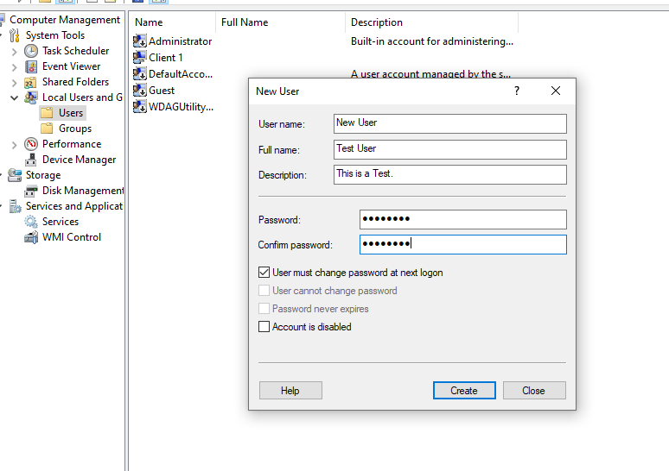
Figure 21- Computer Management- Creating a Local User
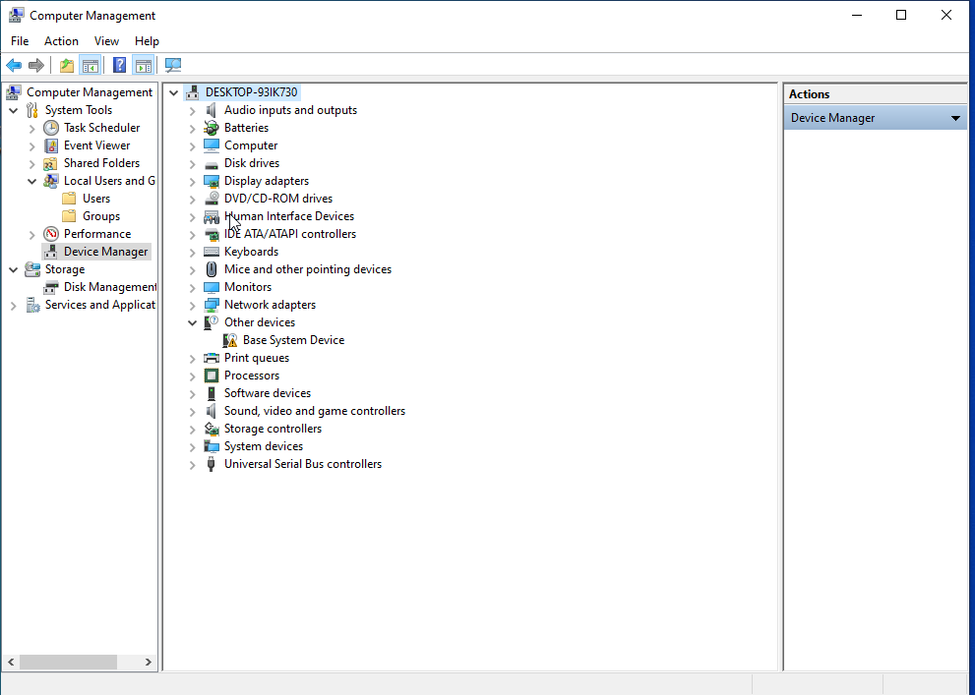
Figure 22- Computer Management- Device Manager
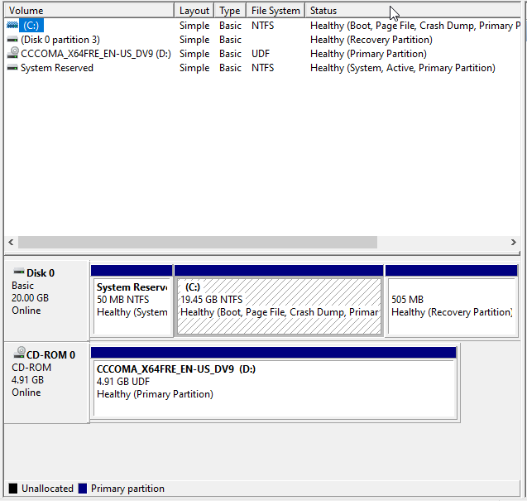
Figure 23- Computer Management- Disk Manager
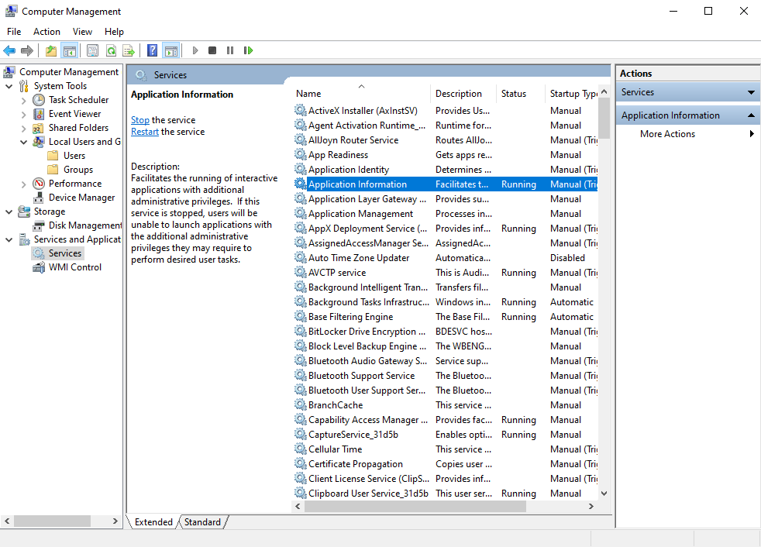
Figure 24- Computer Management- Services Manager
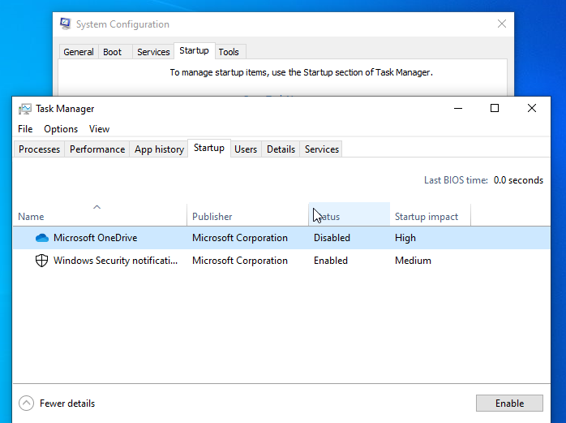
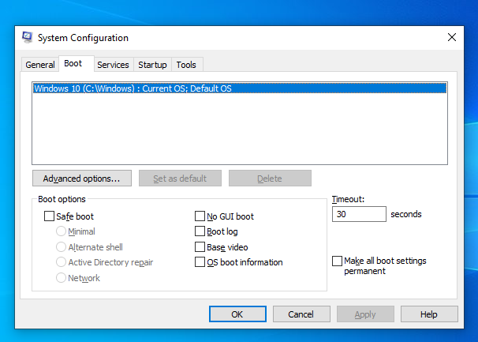
Figure 25- System Configuration- Startup Tab

Figure 26- System Configuration Boot Order Tab
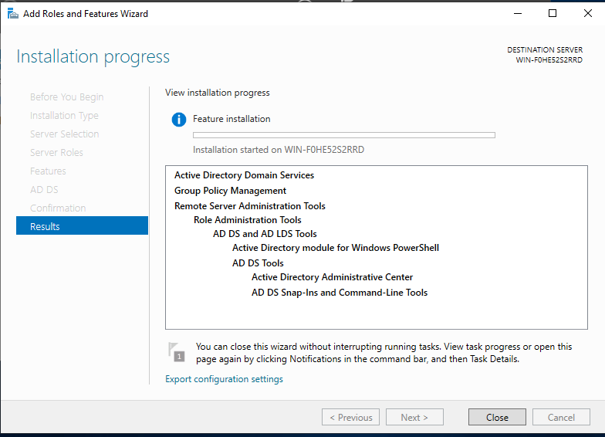
Figure 27- MS Server 2019- Server Tools- Adding Roles Wizard

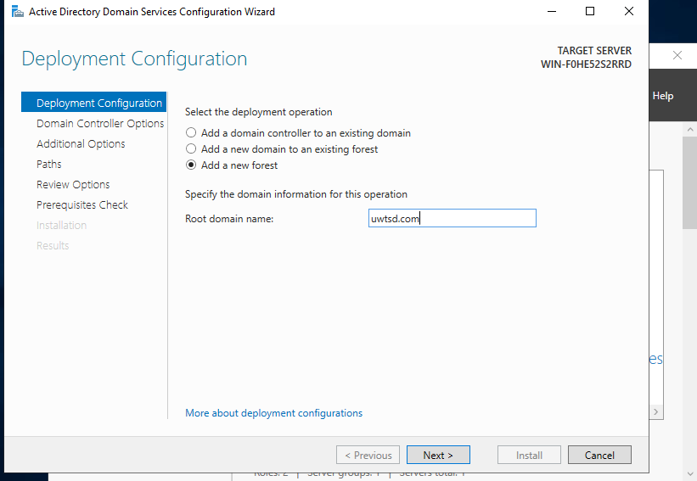
Figure 28- Promoting a Server to Domain Controller

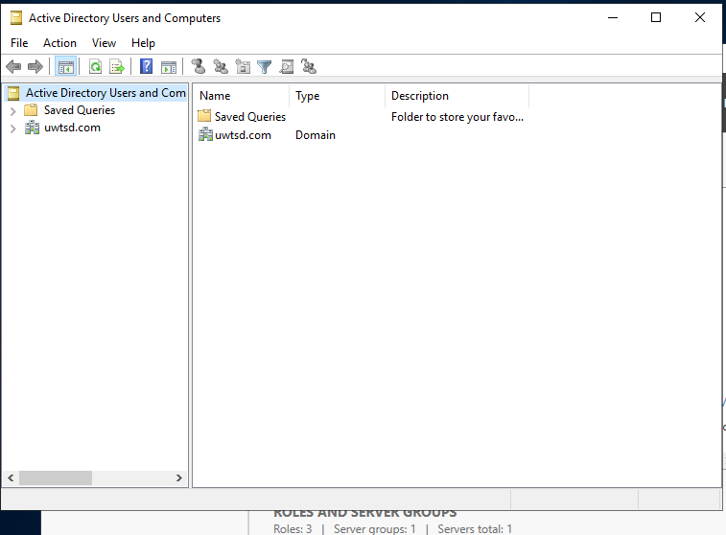
Figure 29- Beginning the Object Creation Stage
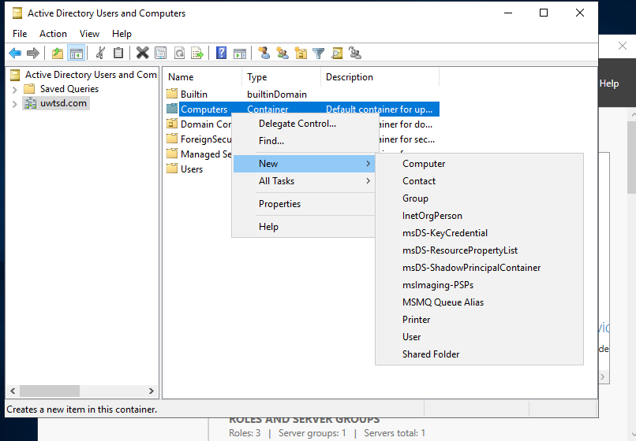
Figure 30- Adding the Client to the Domain
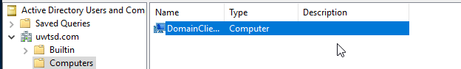
Figure 31- DomainClient1 is now Added to the Domain
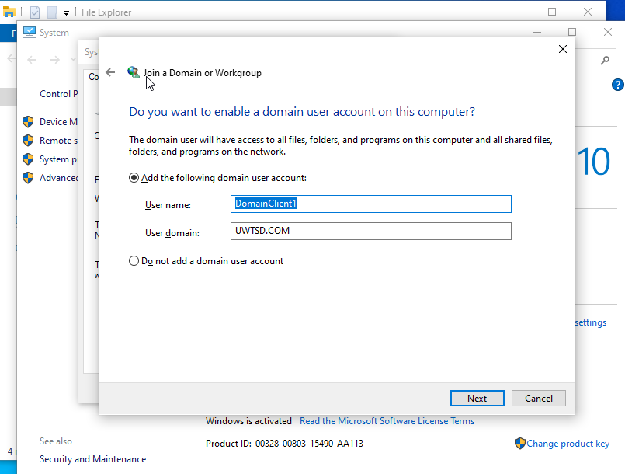
Figure 32- Adding the Client to the Domain
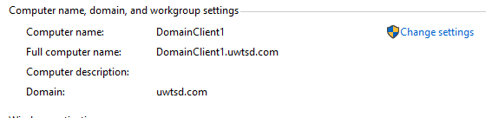
Figure 33- Successful Login of a Domain User
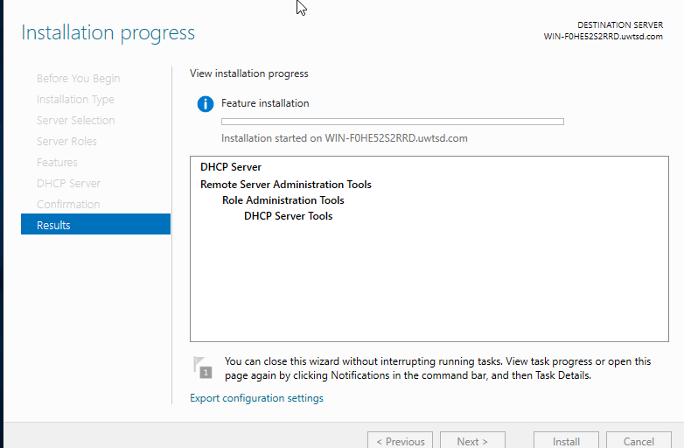
Figure 34- Installation of DHCP
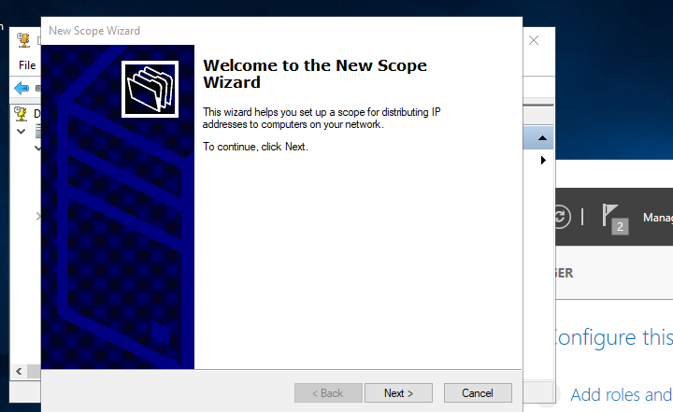
Figure 35- Beginning of Assigning Scope
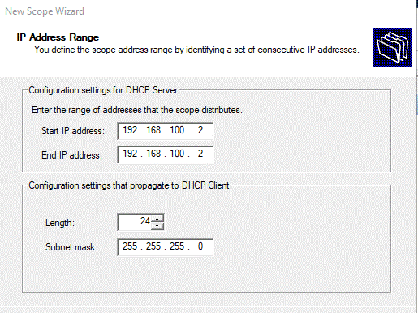
Figure 36- Assigning the Scope
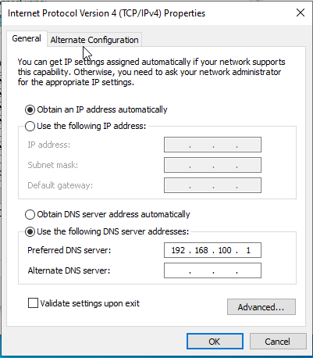
Figure 37- Switched back to Obtain IP address automatically to test DHCP
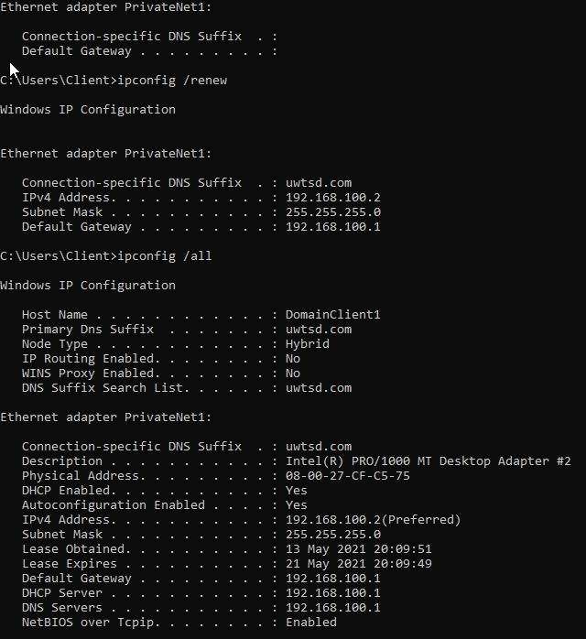
Figure 38- Results of DHCP Testing with IPconfig commands

- References

[1] Spiceworks, "IT Research, Tips & Articles » Why Network Monitoring?," Spiceworks, [Online]. Available: https://www.spiceworks.com/it-articles/why-network-monitoring/#:~:text=Network%20monitoring%20software%20keeps%20an,administrators%20when%20things%20go%20wrong.&text=It%20can%20check%20whether%20crucial,servers%2C%20are%20up%20or%20down.. [Accessed 10 05 2021].
[2] J. Petters, "Active Directory Domain Services (AD DS): Overview and Functions," Varonis, 29 03 2020. [Online]. Available: https://www.varonis.com/blog/active-directory-domain-services/#:~:text=Active%20Directory%20Domain%20Services%20(AD%20DS)%20are%20the%20core%20functions,%2C%20LDAP%2C%20and%20rights%20management.. [Accessed 11 05 2021].
[3] Wikipedia, "Active Directory," Wikipedia, 9 05 2021. [Online]. Available: https://en.wikipedia.org/wiki/Active_Directory#:~:text=A%20domain%20is%20defined%20as,the%20structure%20is%20the%20forest.. [Accessed 12 05 2021].
[4] Wikipedia, "Hypervisor," 08 04 2021. [Online]. Available: https://en.wikipedia.org/wiki/Hypervisor#/media/File:Hyperviseur.svg. [Accessed 28 04 2021].

