
Skills for the Workplace
Module Assignment Submission
Student Name: | Callum Jennings
Student Number: | 2007363
Module No: | BMSK4006
Module Title: | Part 1 Business Plan

Statement of Confirmation of Authenticity
By the act of making this submission, the student declares that this is the work of the student named above. The work has not, in whole or in part, been knowingly presented elsewhere for assessment, or where assessment has been built on a previous assessment, this has been identified. Where materials have been used from other sources it has been properly acknowledged. If this statement is untrue, the student acknowledges that an assessment offence has been committed.
Attention is drawn to the plagiarism and unfair practice policies of both the University and of ILM.



Table of Contents
Executive Summary 4
Business Overview 4
Marketing 5
Appendices 10
References 14

Executive Summary
My name is Callum, I am a 24-year-old male who, from a young age has had a passion and love for high-end and bespoke fashion such as, quality cut suits, designer watches and accessories. I myself am a proud owner of twelve different watches totalling in excess of £3,000 and eight suits totalling in excess of £2,000 along with a various amount of high-end smart dress shoes along with designer trainers, t shirts and jeans. Throughout the years covering various purchases at different establishments, I found one common trait, just because it costs a lot, that does not always secure you the best product, and this is commonly found within light apparel such as t-shirts and hoodies. I found that sometimes the high price tag only allows you to be the proud owner of a brand name and an image, leaving myself with a product that deteriorates and diminishes quickly and ending up heavily disappointed in the purchase. My business idea consists of creating high quality printed t-Shirts with various logos and designs, with all designs being similar to the company logo. This business and brand name will be, Diamond Apparel.

Business Overview
My business will consist of the use of high-quality material being used to design and create stylish and affordable t-shirt’s. Where customers will be able to choose what colour, size and style they would like. Although this business venture will require a sole trader’s licence as I will be the legal owner and manager for the company and be liable for any loss or gains that business may bring. The overall running of the business will be run like one big family, each customer will be treated as an individual who is special to me, and I believe that this is what most high street, franchise, clothing manufactures forget to incorporate when dealing with new and potential regular customers. The personal touch. With our shirts varying in different sizes for the customer, we will be able to provide a high level of service and products to any age, gender, shapes and sizes. For this business to get up and running, I am asking the bank for a small loan of £1,000 paid back in monthly instalments along with investing £500 of my own savings.

Product and Service Details

Customers will be able to contact myself via email or via one of the company’s various personal social media platforms being monitored by myself, with details of their order, once payment has been received via PayPal or a bank transfer, the printing and distribution process will begin. Shipment of the product will be shipped at a high standard, with the offer of sending a free replacement if the product arrives damaged in anyway. Each t-shirt sold will be individually packaged within our custom frosted zip lock bags and packaged into a black padded envelope, to help protect the product from things such as water damage or tearing in transit.

Operations

Location -
The business itself will be run from home. After speaking with my mortgage advisor and home insurance company I now I have permission to run the operation from my garage. As no material change will be happening to the garage no planning permission is needed and due to the fact that no customers will be physically coming to the address, the running of the business will not cause a nuisance, hindrance or be disruptive to neighbouring properties.

Equipment –
- Heat pressing machine. Appendices A. Purchased from (www.amazon.co.uk, n.d.)
- Frosted Zip lock bags for shipping. Appendices B. Purchased from (Etsy, n.d.)
- Shipping envelopes. Appendices C. Purchased from (www.priorydirect.co.uk, n.d.)
- T-shirts varying in size and colour. Appendices D. Purchased from (cart.ebay.co.uk, n.d.)
- Custom Vinyl print. Appendices E. Purchased from (Badgers Heat Transfers, n.d.)
- Storage containers. Appendices F. Purchased from (Adexa Direct, n.d.)
(Please see appendices in order of appearance for reference)

Production and distribution service –

To create our high-quality printed t-shirts, the materials that are being used for the t shirts is 100% cotton, allowing the print to remain on the fabric after multiple washes without fading or peeling. All t-shirts will be pre ironed before applying the print allowing for a much better transfer. Once the shirt of the customers size and colour has been chosen, it will then be place onto the heat press and the vinyl placed onto the shirt. Once everything has been lined up, the lid is then closed on the heat press and a timer is set so that no shirts or prints get burned. Upon the timer releasing the locking mechanism, the paper of the vinyl sheet can be peeled back leaving the in transfer on the shirt. At the businesses launch, the products available to the customer will be limited to standard crew neck t-shirts with limited number of colours to choose. Once further marketing information and income becomes available, I will then have a variety of colours and style of t-shirts available, with the hope of moving over to hoodies, jackets and hats being made alongside t-shirts.

Health and safety and licences –
Due this business set up being small, (Government Digital Service, 2017) states that no licence is needed for this operation as it does not meet any requirements. (Appendices G.) Health and safety is different. (www.nibusinessinfo.co.uk, n.d.) simply covers the safety of workplace machinery, equipment and tools. This article says that regular checks should be completed on all equipment, using the manufacturer guidelines and using one’s own judgement to help prevent breakdowns and potential increased risks. As the equipment that would be used is heat orientated, the article also explains what to do to keep the workspace area clear of potential hazards and risks such as, clear floors, proper ventilation and to check all smoke and fire alarms regularly. (HSE, 2014) explains that a small business with fewer than five employees will not need to write down a health and safety policy. This is also the same for Fire Safety in the workplace assessment. However, it is recommended to do so as it is the simplest way to communicate any findings and demonstrate if required that a fire risk at the premises. A news article by (Ltd, 2019) discusses what is needed to complete a fire risk assessment, see Appendices H for more information.

Marketing
Marketing and pre-production marketing will be done through social media i.e., Instagram, Snapchat and Facebook, with Instagram being the main source of ordering the product alongside using a business email address. (Canva, n.d.) is a website that I have used to create high quality business cards and the brand logo. See appendices I for pricing information.
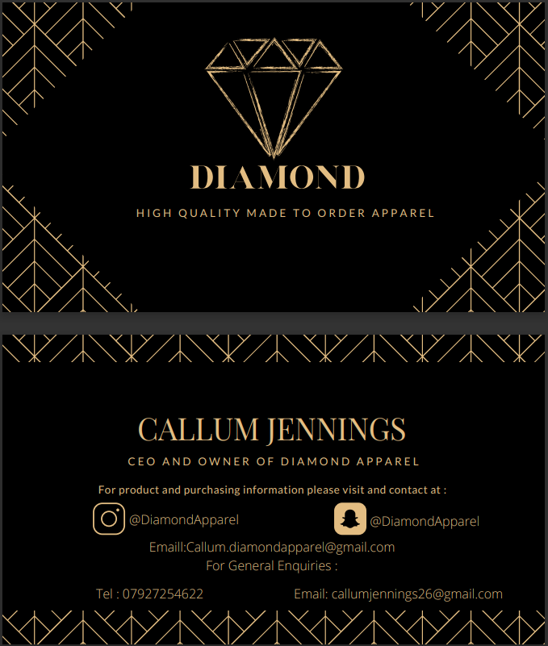
Business Cards.

Front.

Back.

Comparing this business to other apparel and clothing companies and seeing what makes this brand different is the quality of the prints and the materials used for the clothing. All of our t-shirts are made with 100% cotton allowing for a more comfortable and breathable fit. Pre-production marketing will be completed by taking surveys from, at first, friends and family by giving them one t-shirt in their size for free along with six business cards each if they like the product, one for them and five to pass out to their friends to allow for a larger reach into the public who may like the product. Using SWOT analysis Humphreys. A. (1960’s) I can use it to help further production and use it to help for future projections.

S.W.O.T. Analysis
Strengths –
- Cheap.
- Quick production.
- High quality.
- Can be run alongside full-time job roll.
Weakness –
- Initial limited options.
- Small workspace.
- Outsourced products.
- Increased housing utility bills.

Conversion strategies
Matching strategies
Threat –
- Delayed shipments of materials.
- Failure.
- Covid-19.
- Competition.
- Delayed shipment of finished product.
Opportunities –
- Successful business and brand.
- Full time business opportunity.
- Increase in product types.
- Increase in new print designs.

Conversion strategies

After an extensive search online, the only other small clothing companies are run outside of Cardiff and are not local to myself. This allows me to potentially be the only small, personally printed apparel company within a 50 mile plus radius. The small clothing companies that are run within Cardiff have clothing stores and mass produce their clothing using staff members and industrial printing machines. Doing this means that these companies loose to personal touch and the overall quality of the product diminishes.

Targeting market.
With products ranging in different sizes, and using neutral colours such as black, white and red, allows me to target everyone and anyone who likes the product. Any shape, any size, anybody. Alongside the growing of the company and with increase in demand and sales, more products will become available over time, varying in colours and designs to help further boost the business. With plans in the future of being able to distribute hoodies, hats and even mugs. I believe that the initial start up products will be enough to help launch the success of the brand.

Marketing Objectives.
Using the first order of business cards (X100) I believe using friends, family and handing out cards through to the local business estate near my home I will spread enough awareness to spark an interest into the brand. As a regular user in social media and along with seeing many social media accounts and pages on my Instagram and Facebook from different clothing companies, allows me to see what other brands are doing and helps me work out how to advertise my brand differently to theirs. I will be avoiding Advertisement and distribution via Ebay, due to them increasing commission prices as of July 2021. (Facebook et al., 2020) discusses how Ebay will now be taking a rate of 12.8% from new Ebay sellers. For this reason, sales via Ebay will be avoided to decrease costing. With the creation of the brands own personal Instagram and Snapchat accounts, people will be able to follow the accounts, keeping up to date with new products, prices and latest news.

Finance.
As this will be a sole trading company, and that I will be the only person working for the company, I have decided not to take a wage within the first year of operation. Any and all sales made from the products will be reinvested back into the company for stock replenishment and any repayment fees. This makes the pricing for the products a lot simpler. With a lot of branded companies selling t shirts in excess of £10 and even £25, as seen on (Original Penguin, n.d.) website (Appendices J). The t-shirts printed by Diamond Apparel will start at the cheapest costing £7 and the most expensive being £8.50 with postage and packaging included. While competitors sell their shirts at a higher rate for 100% cotton. Diamond Apparel supplies the same high-quality product, at the fraction of the price. The annual projections for the first year are all based on the premise that all t-shirts sold are the cheapest option being £7. Doing this allows me to see how much I would need to sell minimum, in order to break even at the end of the financial year. Within the first quarter of production, I aim to sell at minimum 15 t-shirts each month, increasing every quarter. Provided all 15 t-shirts that are being sold are the cheapest option being £7, this would bring the first three months sales to £105 a month. The second quarter would increase to 25 t-shirts bringing in £175 a month. The third quarter will have a larger increase in sales with the hopes of selling 40 t-shirts, bringing £280 a month. The final quarter of the financial year’s projection are based on successful advertising, customer satisfaction and overall brand success. With an increase up to 60 t-shirts a month. This would generate sales of £420 a month. The amount of t-shirts being sold each month are based on the ability to print and package the t-shirt within 5 minutes each. Using these figures, I can project only spending 1 hour a month in the first quarter moving up to 5 hours a month in the final quarter. At the end of the financial year, with all sales being based on the cheapest product being sold, and including any outbound payments such as, postage each month as seen on (www.postoffice.co.uk, n.d.) (see appendices K) for £3.20 per package, advertisement with the purchase of 100 business cards within the first month and every 6 months thereafter, totalling £23 per order. Stock replenishment after the first 6 months of £300. Goods for resale includes t-shirts, Ziplock bags, envelopes and vinyl print transfers which equals to £940.50. Equipment is Heat press machine and storage containers for the t-shirts, adds up to £202.79. the closing balance equates to £1,191.62p. This brings a total loss of £308.40p from the initial investment of £1000 bank loan and £500 owners’ capital, with £50 a month for the first 6 months in owners’ capital being added also. Continuing to use the cheapest option to project future figures, a monthly production of 100 plus t-shirts will be needed in order to make a comfortable side venture. Provided the more expensive option of £8.50 along with potential new products being sold within the second year of production, this business plan may be considered to create a full-time job. Please see appendices L for further information on how I came to these figures.

Appendices
A
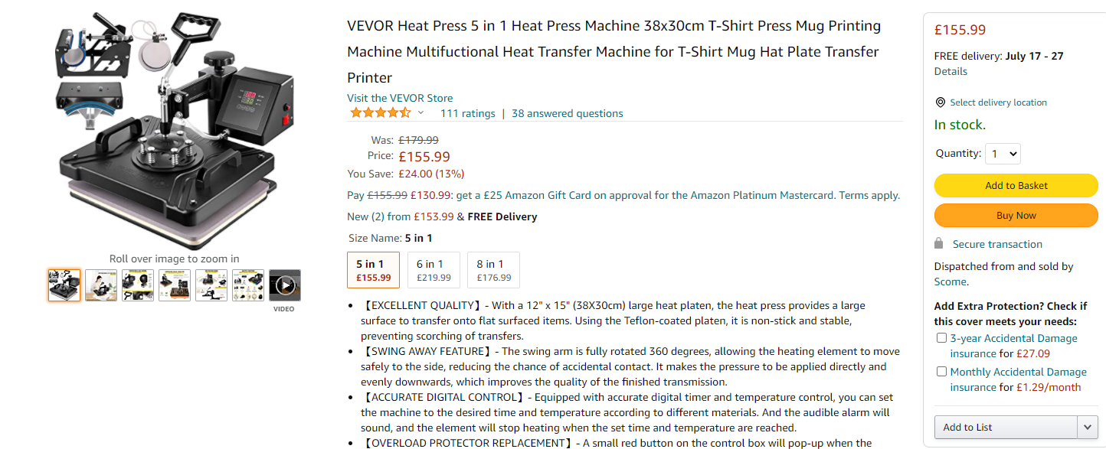
B
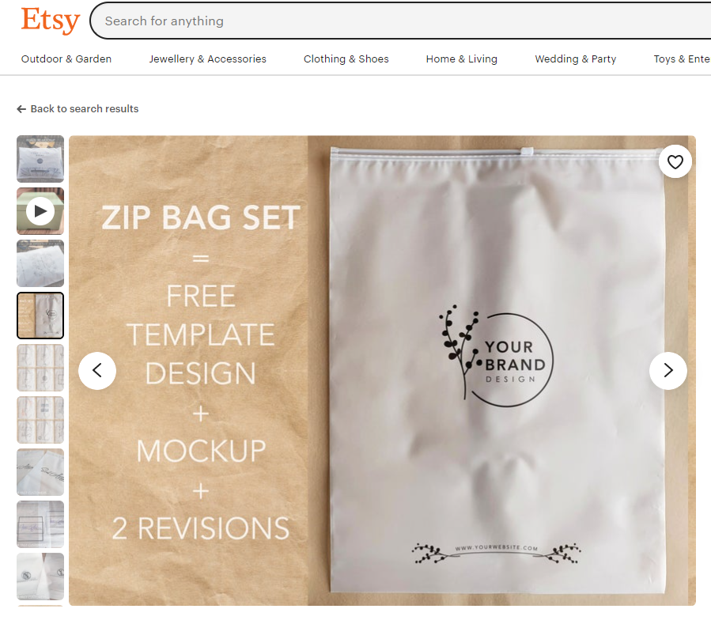

C
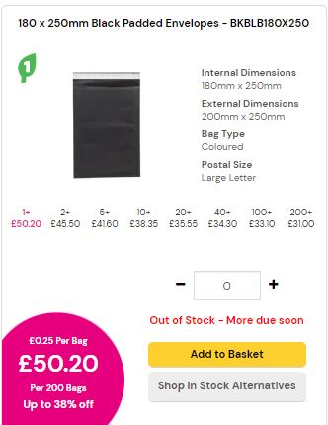

D
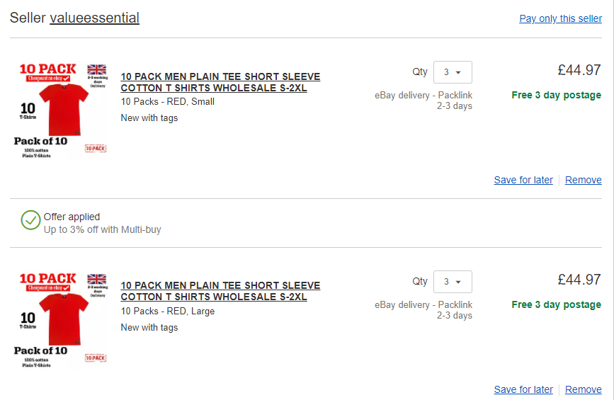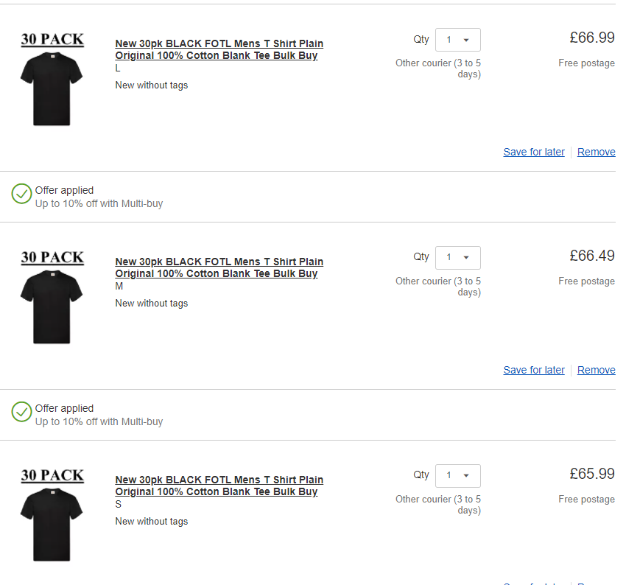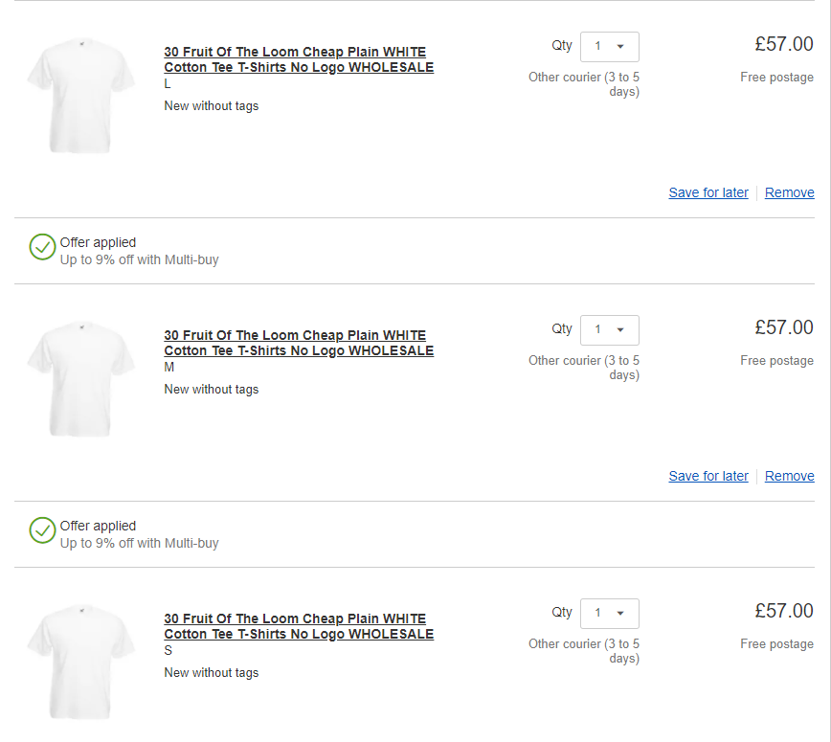

E
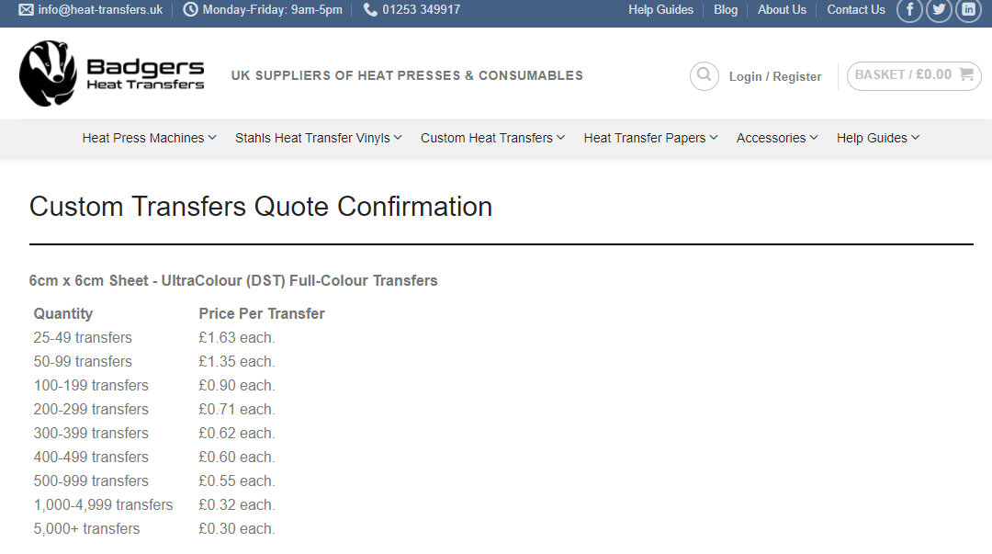
F
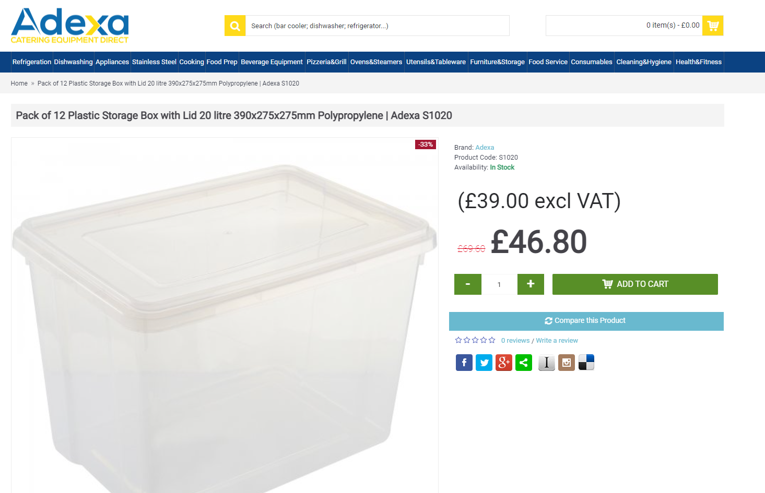

G
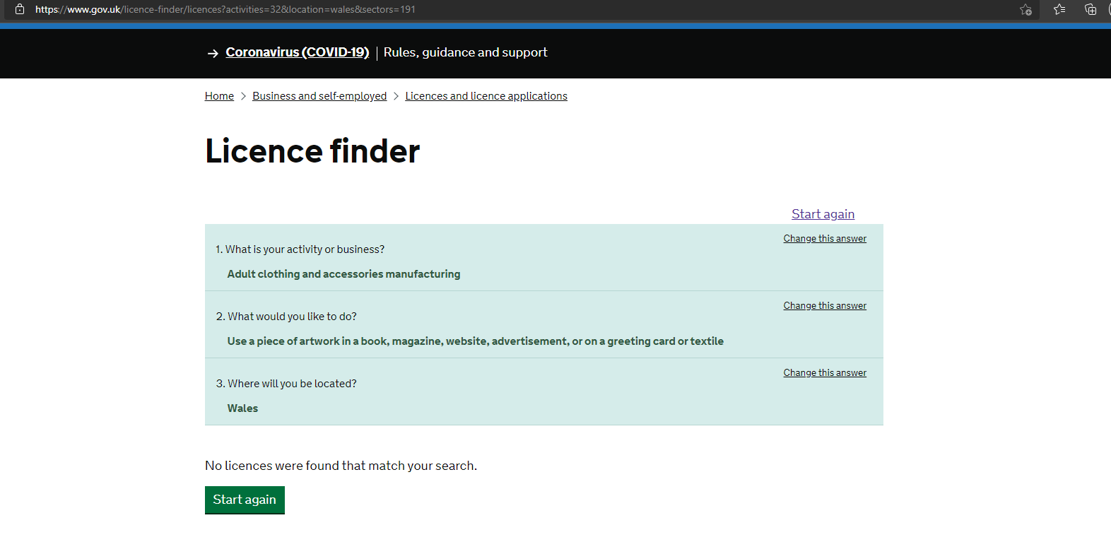

H
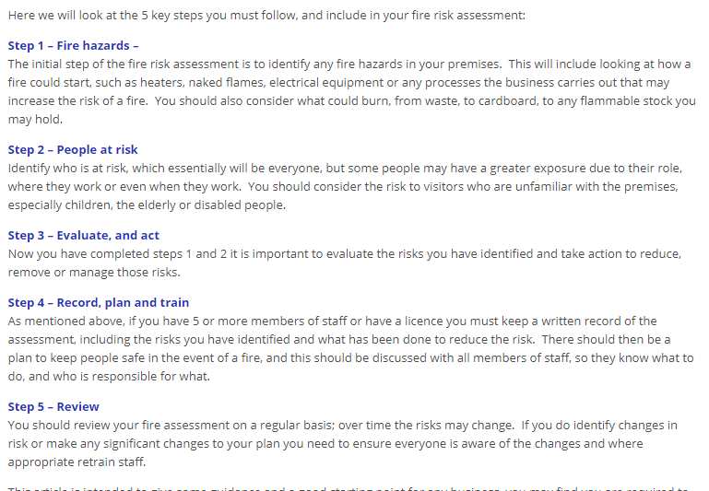

I
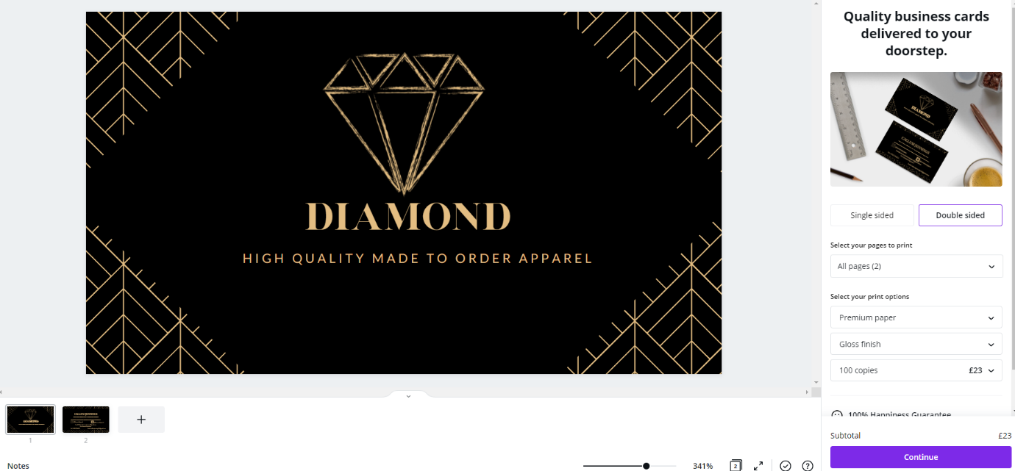

J
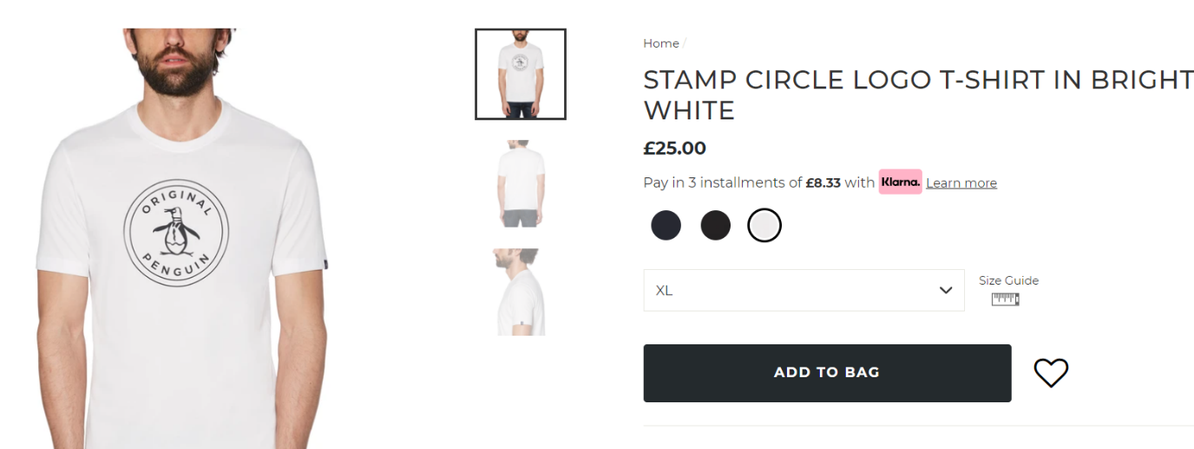

K
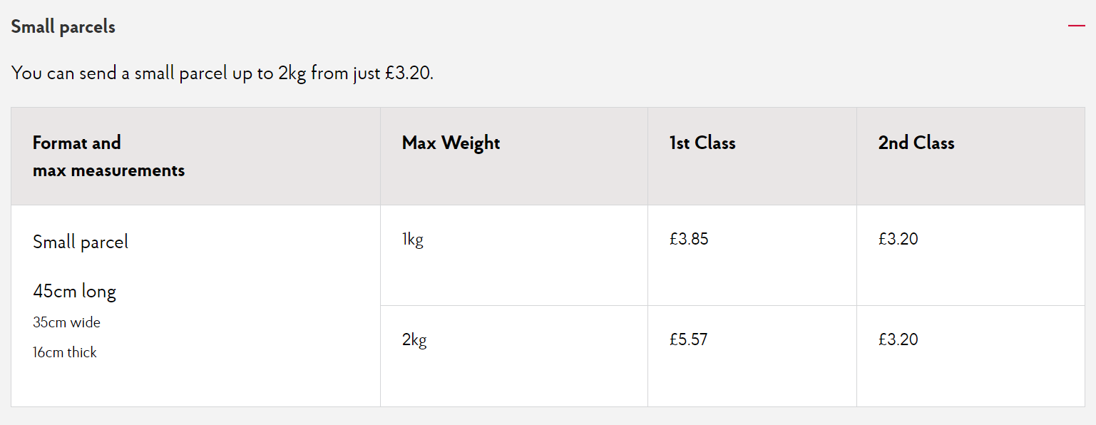

L
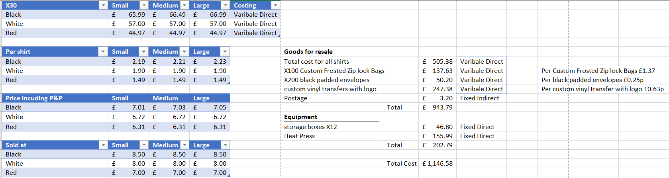

References

www.amazon.co.uk. (n.d.). VEVOR Heat Press 5 in 1 Heat Press Machine 38x30cm T-Shirt Press Mug Printing Machine Multifuctional Heat Transfer Machine for T-Shirt Mug Hat Plate Transfer Printer : Amazon.co.uk: Home & Kitchen. [online] Available at: https://www.amazon.co.uk/VEVOR-Machine-Printing-Multifuctional-Transfer/dp/B086PCHM2Y/ref=asc_df_B086PCHM2Y?tag=bingshoppinga-21&linkCode=df0&hvadid=80745486796929&hvnetw=o&hvqmt=e&hvbmt=be&hvdev=c&hvlocint=&hvlocphy=&hvtargid=pla-4584345024100750&psc=1 [Accessed 30 Jun. 2021].
Etsy. (n.d.). 100 Custom Frosted Zipper Bags, Custom Zip Lock Bags, Frost Bag, Shipping Bags, Business Package, Custom Packaging. [online] Available at: https://www.etsy.com/uk/listing/877622049/100-custom-frosted-zipper-bags-custom?ga_order=most_relevant&ga_search_type=all&ga_view_type=gallery&ga_search_query=frosted+zipper+bags&ref=sr_gallery-1-3&pro=1&variation0=1936345567&variation1=1697089460 [Accessed 30 Jun. 2021].
www.priorydirect.co.uk. (n.d.). Coloured Padded Envelopes | Sustainable Bubble Lined Bags. [online] Available at: https://www.priorydirect.co.uk/bubble-lined-bags/coloured/ [Accessed 30 Jun. 2021].
cart.ebay.co.uk. (n.d.). eBay. [online] Available at: https://cart.ebay.co.uk/ [Accessed 30 Jun. 2021].
Badgers Heat Transfers. (n.d.). Custom Heat Transfers | UK MADE | FAST DELIVERY. [online] Available at: https://heat-transfers.uk/custom-transfers/ [Accessed 30 Jun. 2021].
Adexa Direct. (n.d.). Pack of 12 Plastic Storage Box with Lid 20 litre 390x275x275mm Polypropylene | Adexa S1020. [online] Available at: https://adexa.co.uk/Pack-of-12-Plastic-Storage-Box-with-Lid-20-litre-390x275x275mm-Polypropylene-Adexa-S1020?language=en¤cy=GBP&msclkid=2eef067540151348936666a992995b38 [Accessed 30 Jun. 2021].
Government Digital Service (2017). Licence finder. [online] GOV.UK. Available at: https://www.gov.uk/licence-finder [Accessed 4 Jul. 2021].
www.nibusinessinfo.co.uk. (n.d.). Equipment maintenance and checks for safety | nibusinessinfo.co.uk. [online] Available at: https://www.nibusinessinfo.co.uk/content/equipment-maintenance-and-checks-safety#:~:text=Any%20daily%20checks%20should%20be%20undertaken%20as%20recommended [Accessed 4 Jul. 2021].
HSE (2014). Health and Safety made simple.
Ltd, M.R. (2019). As a small business owner, do I need to carry out a fire risk assessment? [online] Morgan Richardson Ltd. Available at: https://www.morganrichardson.co.uk/as-a-small-business-owner-do-i-need-to-carry-out-a-fire-risk-assessment/#:~:text=As%20a%20small%20business%20owner%2C%20do%20I%20need [Accessed 4 Jul. 2021].
http://www.facebook.com/vvvliet (2018). Albert Humphrey biography and publications | ToolsHero. [online] ToolsHero. Available at: https://www.toolshero.com/toolsheroes/albert-humphrey/ [Accessed 10 Jul. 2021].
Facebook, Twitter, Whatsapp and Mailme (2020). eBay shakes up seller fees and switches to direct payments – what you need to know. [online] MoneySavingExpert.com. Available at: https://www.moneysavingexpert.com/news/2020/11/ebay-axes-paypal-sellers-bank-accounts-upping-fees/#:~:text=When%20an%20item%20sells%2C%20eBay%20charges%20a%20flat [Accessed 10 Jul. 2021].
Original Penguin. (n.d.). Original Penguin® | Mens Clothing & Accessories | Original Penguin®. [online] Available at: https://www.originalpenguin.co.uk [Accessed 12 Jul. 2021].
www.postoffice.co.uk. (n.d.). UK Standard Delivery | Post Office. [online] Available at: https://www.postoffice.co.uk/mail/uk-standard [Accessed 14 Jul. 2021].

