A PRACTITIONER’S HANDBOOK FOR EARLY CHILDHOOD TRANSITIONS

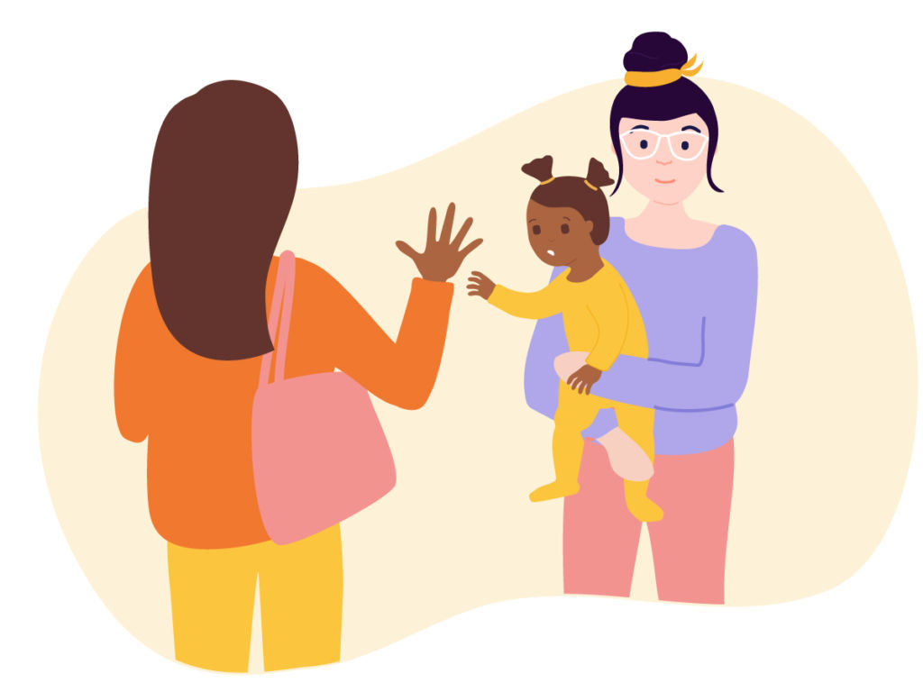

(Source: Famly, 2020)

A practitoner’s guide to support under 3-year-olds durning their transiton from home to nursery.

Human development
ECEY4001/C

Contents page

- Introduction 3
- Transitions 4
- Communication 6
- The importance of play 7
- The role of the adult 8
- The needs of the child 10
- Partnerships 12
- Interventions 13
- Proposed outcomes 15
- Reference list 16

An introduction describing the importance of this handbook for children under the age of 3 entering nursery for the first time.
This handbook has been produced to provide guidance and to enable early year’s practitioners to provide positive transition outcomes and experiences for babies and young children attending nursery for the first time. The handbook focuses on the importance of efficient communication for everyone involved in children’s learning and development throughout transitions. The handbook illustrates the importance of the role of the adult, the needs of the child, partnerships, interventions, and proposed outcomes.
The function of the handbook
By using this handbook, early year’s practitioners can successfully support babies and young children throughout their transitions by gaining an extensive knowledge and understanding of the importance of communicating efficiently. The handbook will ensure transitions run smoothly and effectively in nurseries for the child, parents, and the practitioner.

What is a transition?
A transition means moving onwards in life on a long journey of changes, not just one single change. (Early Years Matters, 2022) It is moving from one important event to another. For example, from home to nursery. It means adapting to a change in a way of life, by learning new things, meeting new people and friends, and having new experiences. (Queensland government, 2022). It is vital that early year’s practitioners comprehend the importance of transitions in childcare settings evaluating how a child develops and at the same time considering the child’s wellbeing. (Welsh government, 2017).

The five C’s of transition
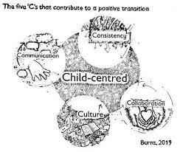

Education Scotland (2020) emphasises important key aspects ensuring effective transitions from home to nursery. These include:
- Parents may want to support and help their child by staying to settle and assure them in their new unfamiliar environment.
- Having transactional communication with parents and families to ensure positive relationships.
- Making sure the child has opportunities to express how they feel by encouraging play, story time, talk and discussion.
- Practitioners must observe the child frequently and pick up on body language to know how they need to support the child.
- Structured routines must be set in place to ensure the child can see parents and siblings.
- Practitioners need to plan together to ensure the child has a holistic transition
- Practitioners need to support a child by encouraging transitional comforts such as a blanket or teddy bear to help the child feel comfortable and relaxed.

Communication
Why do we communicate?
Everyone needs to be able to communicate to share each other’s knowledge, information, and ideas. By doing so, we can learn and better our knowledge, help others socialise, build relationships, and learn to trust and ask questions. We also communicate to avoid misunderstandings and confusion. (The Chartered Institute of Payroll Professionals, 2022)
Types of communication:
- Written communication
- Listening
- Formal and informal
- Visual
- Nonverbal
- Verbal
(University of The People, 2022)
7 Cs of communication
During all the stages of transition, communication is of paramount importance. A practitioner needs to be aware of the seven Cs of communication.
1. Clear
2. Concise
3. Correct
4. Complete
5. Coherent
6.Concrete
7.Courteous
(Revolution Learning and Development, 2022)
Communication plays a vital role in a child’s development. It is imperative for an early year’s practitioner to communicate efficiently with a child to meet the child’s needs. Communicating effectively, verbally, or non-verbally, an early year’s practitioner can build positive relationships with children, parents, families, staff members, communities, and other professionals. By communicating effectively, you can develop and build strong relationships which helps social, emotional development stated by Nursery resources (2019). Children develop multiple skills through play. Play boosts children’s communication skills, therefore they can learn and share ideas with other children. Communication through body language such as eye contact, smiling, waving, and getting down to the child’s level gives children a better understanding of what someone is trying to say. (Parkfield nursery, 2022).

The importance of play
According to Wood, (2013) play unveils creativity, motivation, and learning. Similarly, Moyles (2010, p20) states that play is extremely creative, imaginative, and unrestrictive.
The benefits of play
A child can massively benefit from playing. Play helps develop emotional, physical, social, and cognitive skills. (Canning, 2011)
Emotional benefits:
- Reduces stress and anxiety
- Improves self confidence
- Builds self esteem
- Improves understanding and expressing feelings
Physical benefits:
- Helps strengthens muscles and bones
- Improves reflexes and balance
- Improves co-ordination
- Improves gross motor skills
Social benefits:
- Collaborative learning
- Communication skills
- Taking turns
- Negotiation skills
Cognitive benefits:
- Literacy skills
- Numeracy skills
- Independent thinking
- Problem solving
(Blahey, 2022)

The role of the adult

Parents
It is crucial that parents communicate effectively in partnership with an early year setting to ensure smooth transitions. Parents must support their child through transitioning to nursery by open and candid from the very start of their child’s transition so that the nursery have enough important information that they need to be aware of about the child, so that they can support them and meet their needs.
Setting manager
The role of a setting manager is to supply professional management and leadership in the early years setting. They must build positive relationships with staff members, children and parents and family members. A setting manager has a great deal of responsibilities. Management in an early year’s setting must adhere to guidelines and procedures. Regulations must be updated regularly to ensure early years practitioners are always following the correct guidelines. Childcare settings in Wales must oblige the National Minimum Standards. National minimum standards are put in place to ensure childcare settings are providing sufficient care for babies and young children. (Care Inspectorate Wales, 2016) There are many standards within the National Minimum Standards that tie in with transitioning which are:
- Assessment
- Meeting individual needs
- Working in partnerships with parents
- Opportunities for play and learning
- Nurture and wellbeing
- Staffing ratio
- Equal opportunities

Keyworker
As an early year’s practitioner, it is your duty to ensure that a child’s transition into nursery runs as smoothly as possible. It is important to always have effective communication skills with the child and parents throughout transitions. Communication skills such as listening and respecting the parents and child’s needs and wishes are vital when communicating. Having good eye contact, posture and providing time and attention aids effective communication with both parties. UNCRC article 12 expresses that all children have the right to voice their feelings and views.
Susan Isaac focused on early years holistic development. She strongly believed that cognitive and emotional development are mutually significant. She stated: ‘Play is the work of children’. In her opinion, an early year’s practitioner must ensure that children feel safe, secure, and comfortable by creating a welcoming environment at a nursery to encourage play and to ensure a smooth transition for a child starting nursery. It is important to understand what the child is going through and to have patience when supporting a child transitioning to nursery. (Mickelburgh, 2018)
It is important that a childcare practitioner observes babies and young children and notice when a child is feeling overwhelmed and unsure. It is imperative that practitioners know how to react when a child is feeling emotional and distressed. When working with children, practitioners should communicate with the child by listening to them and showing support, love, and empathy. During transitions, some children can find it extremely difficult adapting to change. Practitioners must provide time and attention to children. It important that you respect the children, be positive, show kindness. Maria Montessori believed that it is vital that practitioners observe children to gain a better understanding of the child’s learning and behaviour. (Montessori parenting, 2022)
Jerome Bruner believed that practitioners should support children by scaffolding. Scaffolding is where a practitioner guides, helps, and supports a child learning independently. Practitioners should encourage and motivate a child by supporting them so that they can develop and learn. (Simply psychology, 2017)
Role modelling
It is imperative that early year’s practitioners set a good example and must be a good role model for children in a setting. Albert Bandura’s social learning theory highlights the significance of modelling, imitating, and observing behaviour. He believed that young children learn from each other by watching and listening as is stated by Keenan, Evans and Crowley (2016). This is demonstrated in the Bobo doll experiment. Therefore, it is crucial that early year’s practitioners show respect, compassion, and kindness to others.

The needs of the child
Early Childhood Outdoors (2020) states that Froebel understood the importance of connecting a child’s experience improved by the natural world through the observation of the beauty of nature. Froebel regarded outdoor activities such as experiencing the wealth of outdoor learning in the garden where children learn directly about all aspects of nature as opposed to the indirect learning of information. Cowgate Under 5’s Centre (2015) emphasises that Froebel thought that children’s play is a key factor for developing and learning emotionally, intellectually, and physically. Froebel was the first educator to perceive this. His work was further supported by Maria Montessori who was extremely influenced and inspired by Froebel’s work.
Froebel strongly believed that children are creative, active, and curious learners that develop and learn by doing, taking part in activities and self-reflection. Froebel strongly believed that every child is unique and that early year’s practitioner’s must treat every child with respect and value their achievements. Whilst also acknowledging that some children with additional needs may need extra support from time to time. In this circumstance, early year’s practitioners can work with professional services to support and fulfil the child’s needs especially through transitions. (Tovey, 2016).
Bruce (2012) states that in the eyes of Froebel, play characterises the human condition and living life and absorbing every aspect of it. Through the act of play, children have better concentration, mind development, and greater willingness to persist in an activity and this satisfies their needs to a far greater extent. A child must be allowed to be creative in learning. This can be achieved through making materials available to them such as painting activities, drawing, and using blocks. Froebel created gifts which were educational materials such as wooden blocks for children to play with. This was creative play which encouraged young children to explore and experiment.
Frobel’s work shows the fundamental concepts of children and their transition. His theory displays the importance of childcare practitioners observing children to help learn about the child. Froebel’s principles and theories have a massive impact in childcare settings today. His principles are relatable article 31 in UNCRC. The article states that children have the right to play, relax and participate in extensive variety of cultural and creative activities.

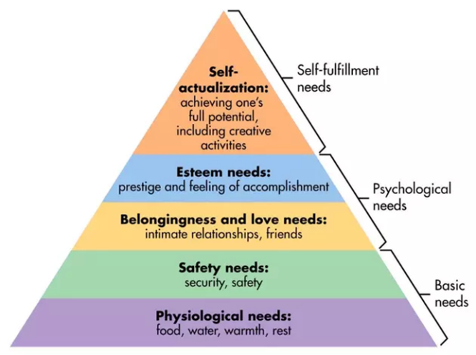
Maslow’s Hierarchy of Needs
The humanist Maslow created the hierarchy of needs which illustrates five important steps that invigorates behaviour. Maslow set these needs in order starting from the bottom which are the underlying elements of the fundamental requirements of basic needs which are physiological and provides an individual with a feeling of safety. Finally moving upwards towards the top of the pyramid which is self-actualisation which means an induvial becomes the best version of themself. He believed in a holistic approach to encourage child development.
(Pursuit of Happiness, 2022)
(Source: simplypsychology.org/maslow, 2020)

Maslow’s hierarchy of needs is linked to early year’s transitions as every child must have basic needs to survive and must feel safe and secure to ensure they form and build positive relationships with others, develop self-esteem, and develop as individuals. If a child does not have these needs, it is doubtful that they will achieve them.
The Theory of Winnicott (1964) explains the importance of the role of a mother and primary carer. It explains that a baby cannot possibly survive without the care of someone. Winnicott points out the importance of care and nurture. These are the key factors for providing a supportive milieu for a child that is completely dependent on others. This important discovery must be communicated to practitioners who seek to be caring and confident educators. John Locke stated that a child’s mind is a blank slate, also known as tabula rasa. He believed that learning is amusing, pleasant and enjoyable for children. (Association For Psychology Science, 2005)
The social reformers Rachel and Margaret Macmillan focused massively on children’s physical, socio emotional and cognitive development. They enhanced the health and holistic wellbeing for children. They petitioned for frequent medical checks to be put in place in schools and nurseries as they believed poor health and hygiene have harmful effects on children. They believed children should play outdoors as much as possible to better their health and reduce diseases. (English Heritage, no date). This ties in with article 24 of the UNCRC states the significance of health and health services for children which voices every child has the right to be provided with superior healthcare, healthy food, and clean water to ensure that every child has the opportunity a healthy existence.

Partnerships
Bronfenbrenner’s bioecological model of human development.
Bronfenbrenner discovered fascinating concepts focusing on a child being in the middle of the ecological system. He believed that a holistic approach to child development is paramount. Bronfenbrenner’s ecological system is made up of five significant levels which are the microsystem, the mesosystem, the ecosystem, the macrosystem and the chronosystem. (Hayes. N, O’Toole. L, Halfpenny. M. A, 2017)
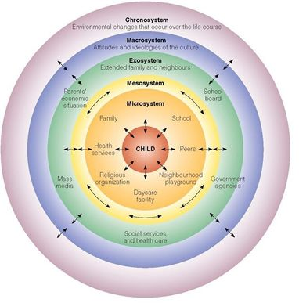

Source: simplypsycology.org/bronfenbrenner, 2020)

This model will help the practitioner to determine how they fit into the child’s education. The model explains what can assist, influence, and directly affect a child’s development. The usual order of influence starts with the parents expanding to family, brothers, and sisters and then to grandparents. Normally, babies and young children are in childcare initially and this leads to exposure to the wider community. It is possible that young children go to playgroups or places of worship for educational development. It is more than likely that babies and young children will have had experiences of medical, social services and healthcare. The keyperson involved with the child must abide by the wishes of the parents in every aspect of the child’s care and development. There must be consultation between parents and childcare services about all aspects of their development prior to support services.

The Family Information Service is one of the most beneficial sources of finding any help required. This service is linked to local authorities. They serve to provide essential guidance and assistance for parents. Article 18 UNCRC supports this as it states that the government must support parents by introducing support services. Every aspect of the wider community that the child is involved with must be passed on to the practitioners so that they have a thorough understanding of the child. for example, in the situation where a practitioner can discuss any extra- circular activities and relationships.
Vygotsky reinforces this notion specifying that a child’s life centres around family and the community. He also stipulates that when the key person involved with the child expresses important issues to the child by means of direct communication, the overall affect will be that the child will feel important, valued and furthermore, will have a sense of great belonging. (The education people, 2021).

Interventions
There are many interventions that are put in place to ensure successful transitions from home to nursery. These include building positive relationships and creating strong links between children and their families before the child starts nursery. It is paramount that a childcare setting is always well organised, consistent, professional, and welcoming.
Security objects
When a young child transitions from home to nursery, bringing security objects to the nursery with them like a blanket, toy, teddy bear or doll help them feel comfortable and secure. Comfort objects help babies and children adapt to an emotional transition. When the child is parted from their parents, their special comfort can make them feel calm, reassured, comfortable, and secure. (Healthy children, 2021)
Welcome pack
A welcome pack given to parents is beneficial as practitioners can find out all important information they need to know about a child. Parents can fill in a child record form to convey information so that a practitioner has enough information about a child so that they can meet their needs. (Bluesky nursery, 2022)
Home visits
Home visits helps build relationships with the child and parents. It can help build trust in a child’s comfortable environment. At home, a child can feel safe, secure, and happy. Home visits can help you learn more about the child’s fears, likes, and dislikes. (Village nursery, 2016).
Settling in sessions
A child can benefit from attending the nursery for settling in sessions before fully starting. Parents are encouraged to reassure the child. The child can become more familiar with the nursery each time they attend and build confidence, and feel more comfortable, safe, and secure in their new environment. Some children need more settling in sessions more than others, it depends on how quickly the child settles. Once they are settled, the child can stay for an hour without their parents. (BusyBees, 2022)
Handovers
After every session, practitioners carry out handovers with the parents. This enables practitioners and parents to talk and discuss how the child has been in nursery and build trust. Practitioners can discuss concerns, issues, and positive outcomes with parents.

Te Whariki, the New Zealand curriculum states the significance for children to have a sense of belonging in their environment, and within families and communities. It also focuses on the well being of the child. Ministry of education (1996) states that the curriculum describes play and communication as the main aspect of learning. It includes 4 main principles which are:
- Empowerment
- Holistic development
- Family and community
- Relationships
The foundation phase and flying start are curriculums in Wales which are carried out by practitioners. The curriculums focus on equality, and wellbeing of a child. (Welsh Government, 2017)
- Parents must feel comfortable in asking questions regarding their child’s transition from home to nursery.
- It is important to make sure positive relationships are formed by staff when meeting the child and their parents when the child has settling in sessions. It is important to provide many opportunities to parents to visit the nursery.
- You must allow the child to play and be included in activities during settling in sessions
- A child must be given at lest 2 weeks to settle in at the nursery.
- It is important to make the child feel safe and secure at the nursery. By singing songs, reading books and a child having their own coat peg or bottle which helps the child feel more comfortable and at ease.

Proposed outcomes
Every practitioner would hope that a child under their care would be confident, extremely happy, and possess social and emotional skills to deal with all aspects of transitions. They would need to be comfortable and feel happy in the process which supports their needs.
It is of paramount importance that a child’s development must be measured and evaluated as is stated by Loris Malaguzzi and The Reggio Emilia approach. He emphasised the significance of observations and recording to have a better understanding of a child’s needs and to assess a child’s learning and nurturing. (The Reggio Emilia approach to early years education, 2022)
Observations is another key aspect of a child’s development which centres around the key person who responds to the child’s needs and who is a position to provide a scope for babies and young children to mature from one step to the next. Maria Montessori believed that observations is an essential key to learn about a child. Through observations a practitioner can find out about the child’s interests, likes, dislikes, fears, needs and capabilities. (Authentic Institute of Montessori, 2022)
Holistic assessment is another critical aspect of ensuring a child will have the best possible provisions for nurture, gaining skills in confidence and ensuring their wellbeing in the future during one transition to the other. (Brooker, 2008)

Reference list
Association For Psychological Science (2005) Empirical Science for the Spotless Mind. Available at: https://www.psychologicalscience.org/observer/empirical-science-for-the-spotless-mind (Accessed: 20th November 2022).
Authentic institute of Montessori (2022) Faithful Observation & Humility. Available at: ttps://aimmontessoriteachertraining.org/faithful-observation-humility (Accessed: 13th November 2022).
Blahey, L. (2021) The Power of Play: 6 benefits for child development. Available at: The Power of Play: 6 Benefits for Child Development | Edmonton Public Library (epl.ca) (Accessed: 12th November 2022).
Bluesky nursery (2022) Welcome pack. Available at: https://blueskynursery.co.uk/welcome-pack/ (Accessed: 20th November 2022).
Brooker, L. (2008). Supporting Transitions in the Early years. Maidenhead; Open University Press.
Bruce, T. (2001) Learning through play: Babies, Toddlers and the Foundation Years. Hodder & Stoughton: London.
BusyBees (2022) Settling In. Available at: https://www.busbeeschildcare.co.uk/settling-in (Accessed: 21st November 2022).
Canning, N. (2011) Play and practice in the Early Years foundation stage. London: SAGE.
Care Inspectorate Wales (2016) National Minimum Standards for Regulated Childcare for Children up to the age of 12 years. Available at: https://www.careinspectorate.wales/sites/default/files/2018 01/160411regchildcareen.pdf (Accessed: 15th November 2022).
Cowgate Under 5’s Centre (2015) Froebelian Ethos. Available at: A Froebelian Approach | Cowgate Under 5's Centre (cowgateunder5scentre.co.uk) (Accessed: 13th November 2022).
Daynurseries.co.uk (2022) The Reggio Emilia approach to early years education. Available at: https://www.daynurseries.co.uk/advice/the-reggio-emilia-approach-to-early-years-education (Accessed: December 1st 2022).
Early Childhood Outdoors (2020) Learning in the outdoors and listening to Froebel. Available at: earlychildhoodoutdoors.org (Accessed: 16th November 2022).
Early Years Matters (2022) Transitions. Available at: https://www.earlyyearsmatters.co.uk/eyfs/positive-relationships/transitions/ (Accessed: December 3, 2022).
Education Scotland (2020) Realising the ambition: Being Me. Available at: realisingtheambition.pdf (Accessed on: 15th November 2022).
English Heritage (no date). Rachel & Margaret McMillan: Nursery pioneers: Blue plaques. Available at: https://www.english-heritage.org.uk/visit/blue-plaques/margaret-mcmillan/ (Accessed: December 3, 2022).
Hayes, N., O’Toole. L. and Halpenny, A-M. (2017) Introducing Bronfenbrenner: A guide for practitioners and students in Early years Education. London: Routledge.
Healthy children.org (2021) Transitional Objects: Security Blankets & Beyond. Available at: https://www.healthychildren.org/English/ages stages/baby/Pages/Transitional-Objects.aspx (Accessed: 16th November 2022).
Keenan, T. and Evans, S. and Crowley, K. (2016) An introduction to child development. 3rd Ed. London: SAGE.
Mickelburgh, J. (2018) Educational pioneers: Susan Iassacs, 1885-1948, The Foundation Stage Forum Ltd. Available at: https://eyfs.info/articles.html/teaching-and-learning/educational-pioneers-susan-isaacs-1885-1948-r40/ (Accessed: December 3, 2022).
Ministry of Education (1996) Early Education Curriculum. Available at: https://www.education.govt.nz/assets/Documents/Early-Childhood/Te-Whariki-1996.pdf (Accessed: 17th November 2022).
Montessori parenting.org (2022) Observation. Available at: https://montessoriparenting.org/observation/ (Accessed: 20th November 2022).
Moyles, J. (2010) ‘Practitioner reflection on play and playful pedagogies’ in Moyles, J. (ed) Thinking about play. Berkshire: Open University Press.
Nursery Resources (2019) The Importance of Communication With Parents in EYFS. Available at: https://www.nurseryresources.org/articles/parents-as-partners/communication-with-parents/ (Accessed: 20th November 2022).
Parkfield Nursery (2022) The Importance Of Communication At Nursery. Available at: https://www.parkfieldnursery.co.uk/the-importance-of-communication-at-nursery.html (Accessed: 12th November 2022).
Pursuit of Happiness (2022) Abraham Maslow. Available at: https://www.pursuit-of-happiness.org/history-of-happiness/abraham-maslow/ (Accessed: 17th November).
Queensland Government (2022) Early Childhood Education and Care. Available at: https://earlychildhood.qld.gov.au/early-years/transitions/moving-to-school/transition-statements (Accessed: December 3, 2022).
Revolution Learning and Development (2022) The 7cs of communication. Available at: https://www.revolutionlearning.co.uk/article/the-7-cs-of-communication/ (Accessed: 10th November 2022)
Simply psychology (2019) Bruner - Learning Theory and Education. Available at: https://www.simplypsychology.org/bruner.html (Accessed: 8th November 2022).
Simply Psychology.org (2020)
Simply Psychology.org (2020) Bronfenbrenner’s Ecological Systems Theory. [image] Available at: https://www.simplypsychology.org/Bronfenbrenner.html (Accessed: 6th November 2022).
Simply Psychology.org (2020) Maslow’s Hierarchy of Needs. [image] Available at: https://simplypsychology.org/maslow (Accessed: 8th November 2022).
The chartered institute of payroll professionals (2022) The importance of communication. Available at: https://www.cipp.org.uk/resources/news/the-importance-of-communication.html (Accessed: 14th November 2022)
The education people (2021) Exploring Pedagogy - Introducing Lev Vygotsky. Available at: https://www.theeducationpeople.org/blog/exploring-pedagogy-introducing-lev-vygotsky/ (Accessed: 30th November 2022).
Tovey, H. (2016) Froebel’s Principles and Practice Today. London: SAGE.
UNICEF (2019) UNCRC Summary. Available at: https://www.unicef.org.uk/rights-respecting-schools/wp-content/uploads/sites/4/2017/01/Summary-of-the-UNCRC.pdf (Accessed: 6th November 2022).
University of The People (2022) Types of Communication – Back to Basics. Available at: https://www.uopeople.edu/blog/types-of-communication-back-to-basics/. (Accessed: 6th November 2022).
Village nursery (2016) Home visits. Available at: https://village-nursery.co.uk/ (Accessed: 20th November 2022).
Welsh Government (2017) Flying Start-Annex Transition Guidance. Available at: https://gov.wales/sites/default/files/publications/2019-07/flying-start-transition-guidance-for-professionals.pdf (Accessed: 9 November 2022).
Winnicott, D. (1964) The child, The Family and The Outside world. Penguin: London.
Wood, E. (2013) Play, learning and the early childhood curriculum. 3rd edn. London: SAGE.

