Soraya Devine Beckford - Baptiste - 1709426
Certificate of Higher Education in Skills for the Workplace
Digital Skills and Research Methods

Bullying in a work placement

Introduction
The purpose of this report is to find out about bullying and find out ways to prevent it whether its legal advice, ways to report or manage it and what to do if it happens to you at work to develop awareness effectively.
There are more young children, teenagers and young adults that get bullied rather than adults in professional jobs. This is my own primary observational resource I believe hormones and insecurities is what triggers bullying and bullies hate something about themselves and pick on people who maybe more vulnerable or have a lower self-esteem.

What is bullying
Bullying can refer to aggressive behavior that an individual shows this is repetitive and intentional behaviour. Bullying includes force, threats, abuse, intimidating remarks or aggressive behaviour to others. This can be happen in school, work placement, outside in the world and even with your family. The negative effects of bullying on an individual can cause mental and physical health problems which increase and could become server to depression or anxiety.

Bullying is divided into four basic types of abuse; emotional,verbal, physical, and cyber. When at work ACAS uses there ‘Bullying and harassment leaflet’ which quotes that workplace bullying is “offensive, intimidating, malicious or insulting behaviour, an abuse or misuse of power through means that undermine, humiliate, denigrate or injure the person being bullied”. This can be looked at as harassment. (Philip .L March 2017)
“harassment” is defined in the Equality Act 2010 (Philip landau 2017). This is means dealing with unwanted conduct of violating a your dignity. The Equality Act 2010 protects you from being discriminated about your age, disability, gender reassignment, race, religion or belief, sex and sexual orientation.

Type of bullying.

There are 4 types of bullying the first type of bullying is physical bullying. Physical bullying includes hitting, kicking, tripping, pinching and pushing or damaging property. This is anything that a person can feel and see physically.Secondly, Verbal bullying includes name calling, insults, teasing, intimidation, homophobic or racist remarks, or verbal abuse. This is anything that is direct and what can be said or shown.

Social bullying this sort of bullying is often harder to recognise and is often carried out behind the back of the person who is being bullied. It includes lying, fake rumours and spreading gossip and also encouraging others to turn against someone. Cyberbullying is when you are harassing someone online by them sending or posting mean messages, usually anonymously.

Bullying at work

Workplace bullying can be defined as repeated, health harming mistreatment of one or more persons by one or more persons that can include verbal abuse, offensive conduct, and work interference which can cause a lot of mental health damage when in the place of work. This is can be seen as intimidation annoyance and create a risk to the health and safety of the employees. This reduce their work performance when at work and distracts them from tasks.

Workplace bullying puts unnecessary strain on the employees, which is the employer and organizations responsibility to provide a bully free environment for their employees. Employees should have the right to feel safe in their work environment and be free from workplace bullying. I believe that employers need to be held accountable and have a plan in place to protect the employees from bullies this can be by having meeting, knowing how to contact HR to report incidents and can rely on manger to deal with problems which can be relatable by following the Equality Act and legislations that been put into place. This is to have a better understanding on how to report, raise awareness and help prevent workplace bullying.
o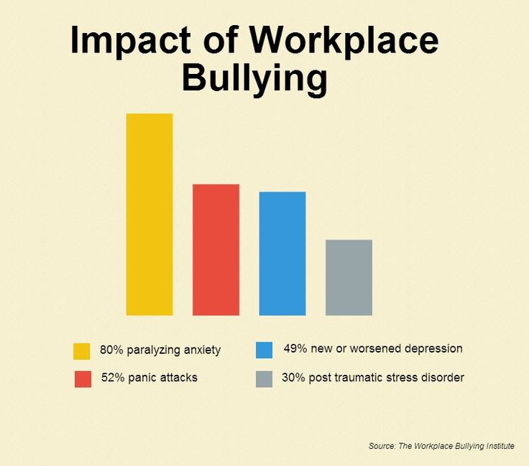
This chart shows the impact on what bullying can do to your mental state and how it can lead to the highest of 80% of people who suffer from paralyzing anxiety.
Bullying in the workplace is often associated with poor management which is a lack of presence of management in a work setting. Managers need to be aware of the impact that bullying has on the staff as this can have a major effect on employees health, clients and the organization/business title. It is important to be aware of potential signs and symptoms associated with bullying in a workplace.

Bullying has a big impact on your health. It affects you whether its physically or mentally. When dealing with health issues your GP may sign you off work because of the stress levels and anxiety reasons.
A survey on a population of 10000 employees was conducted and the result was that 92% of them said that they were currently being bullied out of which around 50% were being bullied by their bosses. (Essays, UK.November 2013)
A study under the name “Bullying at work 2008” revealed the following facts:
Fact one : Since 3 years, 70% of the managers were being bullied
Fact two : Till then, 63% of the employees were being bullied
Fact three: 30% of the employees were witness to such practice of the workplace bullying
Fact four: In around 42% of the bullying cases, it was reported that no action had been taken by their organizations till then in such matters.
While doing my research i wanted to know what percentage of men bully than women. According to WBTI men bullies adopted the following tactics in more number than the women bullies (Essay UK 2013):

Bullying tactics | Men bullies | Women bullies
Yelling in public places | 65% | 57%
Verbal abuse | 55% | 43%
Non- appreciation of others work | 58% | 48%
Opposition of the complaints registered by others | 53% | 41%
Mistreatment with mental vulnerability | 47% | 46%
Blaming others for being unsuccessful | 35% | 27%
Calling others by bad names | 21% | 9%
Threatening others of endangering their jobs | 23% | 10%

The effects of workplace bullying.

Workplace bullying has load of effects not just to the person being bullied this can come between costs on an organization:
Costs of hiring the new employees in place of those who have left the organization due to bullying, this brings profits and business funds down as well as gives the business a bad name as so many old employees left because how they were treated in the work setting.

Another effect can be diversion of the efficient efforts of the employees away from the productivity, most people who are being bullied won't come to work being productive their mood will be down they can't interact with other colleagues or clients properly as they are feeling insecure and afraid because of their mental state due to the bullying. Looking at the costs for keeping an eye on the employees means not giving your full attention the workplace and worried about whos upsetting who when really everyone should be focusing on their task and meeting customers individual needs. Being a bully wash away the profit earning capacity of the organization because there is high rate of staff turnover, absenteeism, low self-esteem among the employees along with less job satisfaction.

This means the organization has a fewer efficiency and productivity from the employees when at work. The physical or mental problems posed by bullying on the staff makes them feel uncomfortable in their work environment, underestimates their efficiencies and consequently leads to a loss in the organization because the employees won't be fully dedicated and honest toward the organization and may leave or get sacked because of their mental state or mood.

Difference between bullying and harassment in a work setting.
Harassment is when you are very offensive in nature which can lead to serious situations in the terms of contract of an employee regarding their employment.
Harassment is mostly in physical form which involves for example; touching or , damaging one's precious possessions. Where as bullying is psychological in nature although it may become physical later on but only in case of the male targets and not the female targets. Harassment is mainly focused on a particular individual for example someone's gender, creed, color or religion. Whereas bullying focuses on mostly those individuals who are competent enough or vulnerable.

Preventions
When at work the best way to prevent bullying is to know where to find help, the right legal advice and how you can deal or prevent it from happening or happening again. In every workplace they will have policy and procedures, depending on what sector of employment you work in could differ on what policies and procedure is designed to the employee. Employers have a duty of care for all their employees to prevent bullying and harassment in a work setting.

One of the main legislations all work placements follow is ‘The Health and Safety at Work Act 1974’. This is for the welfare of employees. Managers should first consider whether the situation can be resolved informally. For example, you could discuss your concerns with your line manager, an HR representative, trade union official, or even the person who is bullying you (if you are able to).

If the situation cannot be resolved informally, you may wish to escalate matters by following a formal grievance. Employers should investigate the matter and hold a meeting with the two employees.Employer should have a grievance policy that explains how the process works. The grievance is lodged with HR or a line manager. If the grievance is not upheld, you have the right to lodge an appeal. the person bullying you could be disciplined or even dismissed.

What I would do
While writing this report I was starting a new job in caring for the elderly. When I started I realised the deputy manager was not as professional as I thought but I didn’t let that stop me I needed to work and earn a decent income as well as gain experience in the caring sector. When applying for the job and getting a interview it was all texted based nothing was on email based. After the first day of work she was very constructive and was demanded to see how I was doing.

I then started receiving abuse texts messages from her due to me being upset because she put me on the shift that I didn't want to do. I reported this to the Head Manager and she said she would look into it. The second day the verbal abuse got worse she told me to ‘shut up’ ‘I don't have upbringing’ ‘use my brain’. I replied with intellect and killed her with kindness and reported it once again after receiving more abuse. Day three of working my clients got switched up, One client had a dog and I have a big thobia my manager called me saying what's your problem considering this was in kent and it's my second day and i'm by myself. After going through abuse after 3 days of working with the company and having no help from the Head manager I then resigned and said I will not be coming back she swore to me on the phone and threatened to bring me to court she also discriminated me saying ‘this isn't the hood’ we are at work why we talking about the hood?. I then called ACAS due to this and they gave me step by step advice
- Write a grievance complaint
- If that doesn't sort things out, ask manager for a meeting
- If that does work go down the discrimination route which can lead to court and justice rights.

Conclusion
Overall, I believe bullying is not nice, I feel like professionalism is a key when in a business environment and is a big thing to implicate and progress on in life. When writing my essay I gained knowledge on the statistics percentage of people who bully at work and how it affects their mental state. This was shocking as looking at statistic and contrasting my first primary observational resource to secondary shows I was wrong about children being bullied more than adults.

I found out mainly males had a high percentage than females. I believe that bully should not happen in a working environment and employers need to educate and use more procedures to prevent any of the following from happening in there organisation. In conclusion, every bully has different characteristics. As a result, there’s no clear scheme or strategy that can stop the problem from ever occurring in business or everyday life. However, by being able to spot, deal , and offer long-term bullying support, you’ve targeted bullying at all junctures. This minimizes the chances of the problem ever returning to your place of business or educational institution or even starting.

References :

- UKEssays. (November 2013) ‘Workplace bullying’ . [online]. Available from: https://www.ukessays.com/essays/employment/workplace-bullying.php?vref=1 [Accessed 9 August 2018].

- (Carsten K.W.,De Dreu, Michele J. G). (2007)‘ The psychology of conflict Management in Organizations’

- Philip.L (March 2017) ‘ Guidian careers’ (newspaper article) avalible from https://www.theguardian.com/careers/2017/mar/29/bullying-at-work-your-legal-rights (accessed 2 august 2018)

