Title: How do contemporary female artists respond to the image of the female body when portrayed as a result of the male psyche?

Name: Jessica Parry

Student Number: 1701355

Programme: Contextual Practices

Module: Independent Inquiry

Module Code: ADAD6001

Supervisor: Professor Sue Williams

Date of Presentation (submission): 7th December 2019

Word Count: 6497
(excludes title page, table of contents, list of illustrations, in-text titles of chapters, in-text titles of figures of illustrations & bibliography)

“Submitted in partial fulfilment of the requirements for the degree of BA (Hons) Fine Art: Studio, Site & Context, University of Wales Trinity Saint David, Swansea”
Table of Contents:

Table of Contents: pg. 2 pg. 2 - 3

List of Illustrations: pg. 4 pg. 4 - 6

Introduction: pg. 7 pg. 7 - 8
(Word Count – 252)

Case Study 1: pg. 9 pg. 9 - 13
(Word Count – 1119)

Case Study 2: pg. 14 pg. 14 - 15
(Word Count – 308)

Case Study 3: pg. 16 pg.16 - 23
(Word Count – 1776)

Case Study 4: pg. 24 pg. 24 - 28
(Word Count – 879)

Case Study 5: pg. 29 pg. 29 - 32
(Word Count – 814)

Case Study 6: pg. 33 pg. 33 - 36
(Word Count – 855)

Conclusion: pg. 37 pg. 37 – 39
(Word Count – 494)

Bibliography: pg. 40 pg. 40 – 47
(Word Count – 660)

List of Illustrations

Figure 1: Manet, E. (1863) Olympia [Oil on canvas] Musee d’Orsay.
Available at:
https://www.musee-orsay.fr/en/collections/works-in-focus/painting.html?no_cache=1&zoom=1&tx_damzoom_pi1%5BshowUid%5D=4042
(Accessed: 5th September 2019)

Figure 2: De Kooning, Willem. (1952-53) Woman V [Oil and charcoal on canvas]
National Gallery of Australia.
Available at:
https://nga.gov.au/international/catalogue/detail.cfm?IRN=47761
(Accessed: 19th October 2019)

Figure 3: Voher/Nachher. (1990-1993) ‘ORLAN <<The Reincarnation of Saint Orlan>>’ [simulation]. [screenshot]
Available at:
http://www.medienkunstnetz.de/works/reincarnation/
(Accessed: 27th October 2019)

Figure 4: Vladmir Sichov for Sipa-Press. ORLAN. (November 21, 1993) ‘Sourire de plaisir’ ‘(Smile of Delight)’ [cibachrome in Diasec mount]. Edition of seven. [photograph] France.
Available at:
https://culturacolectiva.com/art/orlan-performance-artist-plastic-surgery
(Accessed: 26th October 2019)

Figure 5: Saville, Jenny. (1993) Plan [Oil on Canvas]
Available at: http://www.artnet.com/artists/jenny-saville/plan-zLXfju8zqPpJWq0HsCi0WA2
(Accessed: 3rd November 2019)

Figure 6: Saville, Jenny. (2009) WITNESS [Oil on Canvas]
Available at: http://www.artnet.com/artists/jenny-saville/witness-nVxbDXbxFvn-k43Ftm4mZg2
(Accessed: 3rd November 2019)

Figure 7: Sherman, Cindy. (1987) Untitled #175 [photograph]
Available at: http://www.artnet.com/magazineus/features/saltz/cindy-sherman-at-moma-2-23-12_detail.asp?picnum=7
(Accessed: 9th November 2019)

Figure 8: Chadwick, Helen. (1991) Loop My Loop [Cibachrome transparency, glass, steel, electrical apparatus]. Edition of three.
Available at: https://www.richardsaltoun.com/artists/101-helen-chadwick/works/17928-helen-chadwick-loop-my-loop-1991/
(Accessed: 10th November 2019)

How do contemporary female artists respond to the image of the female body when portrayed as a result of the male psyche?

"When an image is presented as a work of art, the way people look at it is affected by a whole series of learnt assumptions [...] Beauty, form, status" (Berger. 1972:11).

This applies to how female body image is perceived by the informed and concerned gaze. Within this discussion the male gaze in relation to the female form shall be considered as well as the heavily concerned feminine response within a contemporary context.

Popular and socially constructed culture and an individual’s perspective/gaze will influence the ideology with respect to female body image. The issues surrounding this will be explored and answered through a series of case studies that reveal the development of an argument, through research and synthesising upon a variety of historical and contemporary sources. These include examples of key philosophers, such as Sigmund Freud, John Berger, Judith Butler and Naomi Wolf, providing a balance of gendered views. Psychoanalytical and philosophical theories in conjunction with extensive research will be a key point of critical analysis to support visual sources.
Visual artists such as Edouard Manet, Orlan, Cindy Sherman and Jenny Saville provide examples which will be considered in conjunction with these key philosophers. These will also be thoroughly and formally investigated, argued and discussed through a series of considered sub-questions- with the aim of forming a conclusion derived from this investigation.
The sub questions that will provide a basis of the investigation are as follows: ‘Is the female body an object of sexualisation?’ and ‘Is flesh a fetish or a phobia?

Case Study 1

The aim of this case study is to argue and formalise through critical, coherent analysis, the notion of how traditional historical perspectives have proven to have influenced contemporary body ideologies from a gendered gaze- but in this particular case from the male gaze. In order to address this, the piece titled Olympia, which was produced in 1863 by Edouard Manet, has been evaluated. That male dominated discourse of approaching the female nude will be outlined within this case study with the sub-question of ‘Is the body an object of sexualisation?’
Figure 1: Olympia

Regarding Olympia, English art critic, John Berger has once described in his book, Ways of Seeing, "The ideal was broken. But there was little to replace it except the 'realism' of the prostitute" (Berger. 1972:63), formally stating that the subject of the female nude is indeed a prostitute and not the idyllic image of a woman. In addition to this, another source states, that Manet has showed "for the first time the non-traditional unconventional nude [...] captivating yet repulsive" (Bolton. 2002:28)
These firm and bold statements reveal that this painting does not convey the ideal, delicate image of a woman. The piece conveys the opposite as supported by the French philosopher Michel Foucault who states that this was a "clumsy way of formulating something that was an aesthetic scandal" (Foucault. 2009:63). Within the piece’s historical context, it certainly caused shock at the time as it wasn’t the conventional nude normally portrayed up to that point in time.

The purity of Olympia’s white skin is commonly associated with the ideology of belonging to a goddess. Olympia (i.e. the name suggestive of a goddess and therefore ought to be presented as an idyllic image of a woman), has been presented by Manet in an unconventional way for the era in which it was painted.

The figure’s body language has been presented as the ideal only from the artist’s male gaze as "deriving in a pose from classical Venuses" (Bolton. 2002:28). This directly confronts a correlation between ideology and body language and how an interpretation from the male perspective, can suggest the female form as being an object of sexualisation.
In synthesis with the body language, Bolton suggests in support of the sexual nature of the piece that "the gesture of the hand [...] was seen as a means of drawing attention to her sex rather than concealing it" (Bolton. 2002:28), the male gaze is making the object explicitly erotic.
Foucault also indicates support in the sexual nature of the piece via his description, "breast and leg [...] a gilded space which caresses her body and which is in one way the principle of the body's visibility" (Foucault. 2009:65). The gesture of “caresses” upon evaluation is clearly an obvious application of a sexual use of body language in terms of the male identifying this through that particular terminology.
In further support of the object’s sexualisation, Naomi Wolf in her book The Beauty Myth proposed that in relation to body language, such as is portrayed in this piece by Manet, she states "Beauty pornography looks like this: the perfected woman lies prone; pressing down her pelvis" (Wolf. 1990:105). This correlates exactly with the visual analysis of the reclining nature of the nude in this piece and the positioning of her hand which signifies the female body as an object of sexualisation.
The presentation of the female nude and the consideration of body language directly suggests erotica from the perspective of the male gaze and it is abhorrent in our contemporary female psyche to observe a woman downgraded, as an object of her time, together with the added conflicting issues of colour and white purity.

The notion of purity through the skin colour can also be considered as an important notable dialect between class and race with the addition of cultural references.
As stated within The Harvard Crimson, there is a strong reference to the cultural context in the distinction and confliction between skin colour and race, with respect to the maid and to Olympia herself within the composition. There is evidently a “racial division” (Damas. 2018). The cultural status between subjects can be evaluated upon here. The race of the maid and her darkened skin, traditionally within the historical context when Manet had painted the piece, portrays black slavery which was not uncommon. However, upon thorough analysis of the presentation of the maid, she does not appear to be in rags and is somewhat dressed as if she’s serving the upper class. This has now generated the issue as to whether or not Olympia is of the upper class. In addition to this, the maid is presenting Olympia with a bouquet of flowers, suggesting a payment from Olympia’s acts of prostitution. Referring to Olympia belonging to the upper class and the white purity of her skin, this can further enhance the significance towards the female nude being of interest to the male gaze. The notion of desire and perfection of the pure white flesh of the female in the piece attracts the male gaze to the female nude, like a moth to light. This can develop into Manet presenting the female nude as an object of sexualisation.

Psychoanalysis has an impact on the male perspective and interpretation of the female nude. Sigmund Freud, the founder of psychoanalysis, theorises that the male psyche is influenced by the Oedipus Complex i.e. the primitive desire for one’s mother. As firmly stated by Freud, ‘‘Oedipus dreams, in which the dreamer has sexual intercourse with his own mother" (Freud. 1976:522). This reveals that the primitive desire is embedded in the male psyche.

Subconsciously the male psyche will have this psychoanalytical, primitive theory embedded when observing the female form and flesh. This therefore will result in the male interpreting the image of the female as an object of desire. Relating to Manet’s Olympia it can be concluded that deep within the male artist's psyche, this psychoanalytical theory is at the core of the once subconscious now conscious influence behind the reasoning as to why the artist has painted the female nude in such a sexual, provocative way.
As Roth (an interpreter of Freuds’ psychoanalytical works) states "Oedipal struggles create powerful, deeply charged feelings in every child, feelings so deeply charged that they have to be repressed." (Roth. 2001:73)
This can also contribute towards Manet’s psyche and that once repressed feeling has now been exposed through painting the female form in such a sexual way, hence that core use of body language.

The Oedipus Complex, can also be stated to have influenced the psyche of the contemporary artist Willem De Kooning. Upon research and psychoanalytical dissection, this deep-seated influence has been discovered within the following case study.

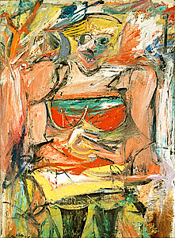
Case Study 2

Figure 2: Woman V

In the early 1950's the abstract artist Willem De Kooning compiled a series of six abstract paintings of women. De Kooning has approached the female nude in a completely opposing way in comparison to Manet. The artist has confronted and visually challenged the presentation of the nude through abstracting the contours of the form in a purely fragmented and distorted dissection of pure shape and colour. However, evidently there is that strong suggestion of female flesh constructed by the artist's use of vigorous brushwork as a means of visual violence through painterly disruption. The flesh is not deemed soft unlike Olympia. A female nude and the issue of sexualisation of the female form is lurking within the composition. De Kooning himself has stated that he was influenced by other pieces of art of females with prominent breasts such as the Mesopotamian figurines at the Metropolitan Museum, New York.

However similar to Manet‘s Olympia, the Freudian psychoanalytical theory of the Oedipus Complex can be argued as a subconscious notion within De Kooning’s psyche.
Even though the artist himself has never actually stated this, his wife, Elaine, has suggested this theory being present - “the ferocious woman he painted didn’t come from living with me. It began when he was three years old” (Morris. 1999:70).
This does suggest, the theory of the Oedipus Complex is present within the artist's psyche. As previously discussed within Manet’s Olympia, the artist's repressed thoughts are exposed with the reproduction of the female form as an object of sexual desire.

This traditional notion of the female form as an object of desire, as depicted by artists such as Manet, has been challenged by several contemporary female artists.
The French performance artist, Orlan, has challenged this traditional notion as a core part of her practice but in particular through her series titled Reincarnation of Saint Orlan.

Case Study 3

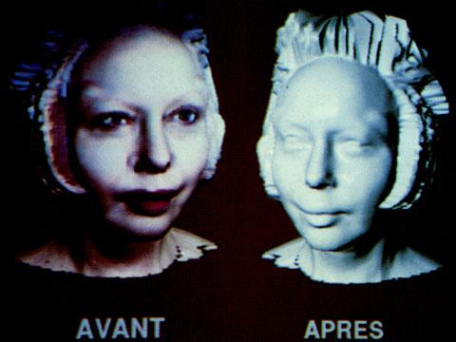
Orlan is a contemporary performance artist who has undergone a series of cosmetic procedures (plastic surgery), not for aesthetic reasons but to challenge that ideology developed through the Oedipus Complex from the male psyche as previously discussed.

Figure 3: ORLAN <<The Reincarnation of Saint Orlan>>

As stated by the contemporary theorist Kate Ince regarding Orlan:

The commonest misinterpretation of the objectives of ‘Reincarnation’ is the view that Orlan’s aim in undergoing surgery, is quite simply, to become more beautiful […] but her work is recuperable within the ideology of ideal female beauty that governs the practice of cosmetic surgery in the West. (Ince. 2000:44).

Orlan has challenged the ideology of how women are traditionally viewed. The cosmetic surgery she has had does not necessarily enhance beauty in the traditional way, but in a more unconventional proposition. Orlan has gone against what conventional cosmetic procedures were originally used for. Rather than enhancing beauty, she’s conflicted against it.
As stated within the British Association of Aesthetic Plastic Surgeons glossary, the definition of plastic surgery is defined the same as cosmetic surgery. It reveals that both are ‘’a surgical speciality involving restoration, reconstruction, or alteration of the body’’. Orlan is altering and reconstructing her body through her work, but not for that ideal perfection of perceived improvement that is stereotypical of the western culture to seek within such plastic and artificial procedures. That quest for perfection has been obliterated.
Orlan's new persona challenges that ideological quest for beauty, core to the traditional male gaze, where the female nude has been subjected to eroticism. Ince has argued that the female subject has never existed but only has through the patriarchy of the male gaze. Therefore, through the repressed male psyche of the Freudian Oedipal Theory,this was the only way the female form can be portrayed as a subject matter. Orlan is reincarnating that new persona, breaking the traditional rules originating from the male gaze, defining what shall be perceived as a rebellious act of what once was considered to be desirable.
Some of the cosmetic surgery she has had involves procedures that reflect historical art of the female form as perceived by male artists. For example, as stated by Kate Ince;

Orlan's self-remodelling; each feature is surgically re-sculpted to match a specific feature of a different great icon in the history of Western art: [...]the forehead of Leonardo's Mona Lisa, the chin of Botticelli's Venus [...] parody of the fetishistic fragmentation of the female body by male artists (Ince. 2000:6).

Reflecting on a sub-question, ‘Is flesh a fetish or a phobia?’, Orlan’s surgical reconstruction and the specifics of what she wanted to challenge in relation to the ideologies developed from the male gaze, flesh and it's surgical manipulation can be identified as a fetish from the male gaze.
The physical process of the removal of flesh in most cases, such as liposuction (which shall be further discussed as a development within Case Study 4), can be viewed as a phobia from a female perspective, where the boundary of the skin is broken in order to remove excess flesh from internal parts of the body.

Orlan believes that "I think that the body is obsolete" (Ince. 2000:96). This proves that she is on the quest to push boundaries within the contemporary, challenging that quest for an identity. An obsolete body is one which isn’t much use, therefore signifying that the body is no longer identified or seen as an object of eroticism and therefore not an object of sexualisation. Orlan has transformed her body into something less visually appealing as a notion of beauty. As stated by the film critic, Barbara Creed "the monstrous feminine constitutes an important and complex stereotype which can be broken into a number of different figures of female horror" (Ince. 2000:68). This can be used to support Orlan's new monstrous and grotesque persona.
Orlan and her re-figuration of her face has composed exactly this. An opposition of the ideal feminine appearance and therefore contributing towards the monstrous feminine. She challenges the concepts of contemporary beauty and the extremes that women of and within the stereotypical western culture seek through cosmetic procedures.
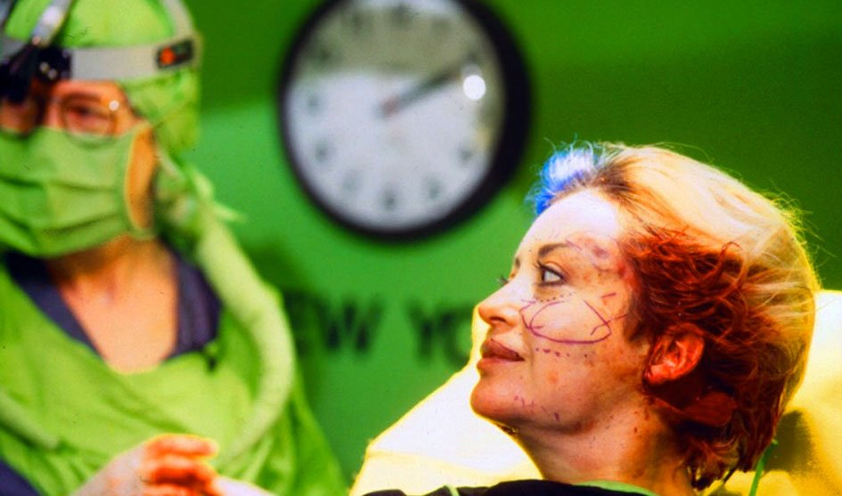

Figure 4: (November 21, 1993) ‘Sourire de plaisir’ ‘(Smile of Delight)

Judith Butler is a critical gender theorist and philosopher core to understanding the concept of performativity. Orlan is most definitely a performance artist therefore this notion of performance of gender in synthesis with The Reincarnation of Saint Orlan will be evaluated and formally discussed in correlation to the question of overall discussion.

As Butler as stated in her book Gender Trouble, "Her/his performance destabilizes the very distinctions between the natural and artificial" (Butler. 1990:xxxi). Orlan’s series of cosmetic procedures, involves facial re-construction and the re-configuration of her flesh in order to challenge the ideology of a woman derived from the traditional, male gaze. Orlan has performed that very distinction between the natural and artificial. The ‘natural’ being her flesh as a physical substance originated directly from the sperm and egg.
Considering religious contexts and rites within this notion of raw, natural flesh but in particular the generic term within Orlan’s series Reincarnation, Naomi Wolf has proposed that "Woman began as an inanimate piece of bone; malleable, unsculpted, unauthorized, raw - imperfect" (Wolf. 1990:71), emphasising upon that origin of the woman and beauty being a punishment of Eve- that the reincarnation of the woman should be forbidden, like Eve eating that apple. A woman shouldn’t be punished for beauty and the contemporary crisis to reach that beauty from cosmetic procedures. The punishment within the quest for that ideal beauty becomes embedded within the psyche of the woman. As stated by Wolf, "since women should be addicted to 'beauty', this life-threatening addiction is not real" (Wolf. 1990:212).
By the contemporary woman observing those desirable nudes of the past, which were produced directly by the repressed male gaze through the Oedipus Complex, the contemporary woman craves for that beauty standard, therefore this ‘addiction’ to perfection through cosmetic surgery becomes a narcissistic yet sadistic influence upon the contemporary woman’s psyche. Orlan challenges this through her reincarnation of her ‘monstrous femme’.

This malleability of the female flesh within the contemporary reveals that the woman is subjected to change fitting the social standards of her time. The notion of malleability appears via the physical manipulation of the female flesh through the hand of the surgeon. The hand of the surgeon and its manipulation of flesh will be discussed and developed upon further within Case Study 4.
The female was meant to be ‘inanimate’ and ‘unsculpted,’ but Orlan has challenged this. She’s spoken out, performed and reacted against the ideology derived from the male gaze and Oedipus Theory. As a result, the male psyche has influenced the contemporary female psyche where one’s flesh must be sculpted in order to fit into that subjective ideology. Orlan challenges this. Reincarnation is that quest against this. Against the beauty standards of what’s deemed perfect within the contemporary- not as a Reincarnation for that newly profound beautiful goddess, but as a Reincarnation of the challenged beauty ideologies she seeks out and performs so beautifully.
Orlan has indeed become animated. She has challenged the very notion of the female form as an object of sexualisation by making her appearance as grotesque and unconventional towards the ideal as physically possible with her exaggerated use of cosmetic procedures.
Her features are exaggerated yet are carefully considered as a conflict with those features derived from classical male-orientated pieces of historical art.
Even though that ‘unsculpted’ form is deemed to be considered as ‘raw’ therefore ‘imperfect’ as argued by Wolf, Orlan has challenged that raw flesh as a malleable substance, therefore becoming sculpted yet, sculpted as the ‘monstrous femme’ challenging that need for perfection.
In contrast to the ‘natural’ flesh, the ‘artificial flesh’ is an addition or removal of flesh, physically intervened with by an outsider, in this case the modern, artificial world where the artificial touch of the surgeon is transforming her flesh, that once natural and organic substance. Therefore, this concludes the fact that Orlan’s series of serious performances does indeed challenge that notion between the natural and artificial through the physical manipulation of her flesh as a performance. This is an example of how a female artist has responded so deeply to the point of extremism and literally pushing her own bodily boundaries.

Developing upon what performativity is in synthesis to gender, Butler also firmly states that "gender is culturally constructed" (Butler. 1990:8). This enhances and signifies that correlation between cosmetic surgery and gender. Cosmetic surgery signifying that physical manipulation of flesh, as a contemporary means of cultural construction. This manipulation of flesh can be considered as ‘carnal’ a term derived from Orlan’s manifesto herself.
Orlan was born a woman, but that doesn’t necessarily mean now, that she classifies herself as one. She has previously stated that "I think that the body is obsolete" (Ince. 2000:96), therefore a room for change, possibly evaluating that gender has no means to her and she classifies herself as what she wants. The notion of gender fluidity has become apparent now within Orlan’s practice. This newly developed notion of gender fluidity can also be reflected within the term gender binary, a term identified in Butler’s book Gender Trouble. It has been described within that analysis book that gender binary is classifying a genre of actions perceived as the norm of a given sex.
When considering exactly what one’s gender is, Butler considers that the performer's given anatomical characteristics may differ from the gender one may carry out and therefore perform.

Upon evaluation, in synthesis with Orlan, her ‘anatomical sex’ is female. Her given genitalia are belonging to that categorised female yet considering the notion of gender as a performance, her gender through her Reincarnation series has become culturally constructed. To develop and enhance upon this discussion further, Butler has also suggested that "gender is the variable cultural construction of sex" (Butler. 1990:152). Cosmetic surgery has constructed Orlan’s sex in the contemporary, therefore her psyche too.

Concluding upon gender in synthesis with Orlan’s Reincarnation series, Butler has firmly noted that "gender is performative" (Butler. 1990:xv). Orlan is first and foremost a performance artist. That very notion of performance coincides with Butler’s statement and the acts in Orlan’s case which contribute towards this, are neither masculine nor feminine. It’s simply Orlan’s face that is being constructed as a rebellious act towards those deemed social norms. Her face belongs to social constructions derived from the male gaze which she strongly challenges.
These "constructions" are understood as "distortions"(Butler. 1990:162) which then concludes upon the psyche of one’s body image as an influenced distortion from the derived and suppressed male gaze.
Orlan is rejecting strongly, the woman being observed as an object of desire.

Case Study 4
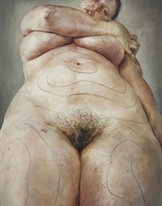

Figure 5: Plan

Through researching and exploring into the notions of cosmetic surgery as an influence upon the contemporary female’s psyche and perception towards one’s body image, Orlan has been considered through her visual contribution through the notion of performance. In contrast to Orlan within this case study, the work of the notable, contemporary female painter, Jenny Saville will be discussed. Saville has also tackled the issue of the socially constructed body. How Saville’s primary observation of cosmetic procedures and that physical manipulation of flesh, has influenced her painting practice will be formally discussed.
In an interview between Saville and Schama- a British art historian, Saville has formally stated that she

as an artist learnt a lot from observing plastic surgery [...] when you see inside of the body, the half-inch thickness of flesh, there's a realization that it's a tangible substance, so paint mixed a flesh colour suddenly became a kind of human paste (Schama. 2005:124)

The comparison between flesh and paint is a site of intrigue and has revealed that she has thought of both being very similar through their malleable physical properties. Her media of oil paint has become like a human paste to capture the notion of the figure. The observation of the internal flesh has influenced the way she has applied paint to canvas, to capture that external boundary- that external boundary being the human skin. This can be reflected within her painting Plan.
Plan is a depiction of the female nude through a direct perspective. The impact upon the spectator would be somewhat profound through that direct persona belonging to a real woman. Saville has painted a piece which has been proved to cause the effect of “to break up and tear apart our self-image" (Gray. 2005:9), therefore making one question their own body- their own status.
“Status” as a word of reflection in relation to John Berger at the very start of this overall discussion. Status, as an observation the female and her psyche within this contemporary context will evaluate upon herself, in direct confrontation with the socially constructed culture- a term derived from Butler and the stereotypical norms (what the ideal woman of her time is meant to look like). According to Wolf, the contemporary, socially constructed culture is part of "the Surgical Age" (Wolf. 1990:184). Saville, as well as Orlan have both challenged the conformity of this era.
Saville has dissected the skin where the real woman is confronted with the marks and gestures that reveal the embodiment within her quest for perfection, following that craving to please the ideology derived from the traditional and historical male gaze, originating from the Freudian, psychoanalytical Oedipus Complex.
The visual marks on the woman’s skin in the piece suggest she will be undergoing a cosmetic procedure, suggestive of liposuction, as if that’s the social norm to fit in within the social beauty standards within the contemporary woman’s psyche.
As stated by Naomi Wolf, “breasts, thighs, buttocks, bellies; the most sexually central parts of women, whose 'ugliness' therefore becomes an obsession [...] The parts which beauty surgeons most often cut open" (Wolf. 1990:119). This can be argued as the reasoning behind why Saville has chosen those particular surgical marks around the female’s stomach presumably for liposuction. Saville is not necessarily considering the woman’s nude body being observed as an object of sexualisation but highlights the female psyche for perfection influenced by the psyche of the male gaze. These marks are deemed to signify those areas where the removal of fat will occur from a sexually central part of the female body. This is positive within the contemporary as an attempt is being made to highlight this issue and erase that socially constructed standard.
Also, developing upon this notion, the removal of fat can be viewed as a phobia to the individual undergoing the surgery. This phobia of fat however, and as cosmetic surgery has been previously described as addictive, can enhance that correlation of flesh as a phobia. This may influence a physical and psychological decline where one’s mental health can influence one’s physical health. This will be expanded upon more within case study 5.

Saville has described the cosmetic procedures generated by the hand of the surgeon as belonging to “Michelangelos of the flesh,” (Scala. 2009:65). Saville herself has carefully constructed a painterly and sculptural impact upon the socially constructed, external flesh- the skin.
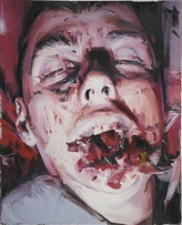
This external, internal correlation of direct observation can be observed within the vigorous brushwork within Saville’s painting titled WITNESS-

Figure 6: WITNESS

Even though this painting by Saville does not depict a direct confrontation with the notion of cosmetic surgery, it has evidently revealed her observation of watching a cosmetic surgeon manipulate the flesh as a malleable and sculpturally raw substance. The flesh has become a grotesque exposure of the internal, breaking that boundary of skin, entering the external. The site where the external boundaries enters the internal, is the mouth.

This leads on perfectly into the following case study involving the work of the visual artist Cindy Sherman, in synthesis with philosophers which will be formally discussed as to how one’s body image can be influenced by the male psyche. This is how another contemporary female artist responds to the image of the female body, but now, not necessarily that of the literal form.

Case Study 5


Within a contemporary context the visual artists such as Orlan- a performance artist, and Jenny Saville- a painter, have been formally discussed in synthesis with philosophers in correlation to my question of exploration. The visual artist, Cindy Sherman will be introduced into this discussion even though Sherman can generally be described as a performance artist, within this current study, an image will be under investigation which is not typical of Sherman’s usual literal figurative work.

Figure 7: Untitled #175

Even though this photograph depicts vomit, it is the prior mindset of the individual that generated the vomit that is of interest in this discussion.
The feminist art historian Rosemary Betterton within her book titled An Intimate Distance, has described the consumption of food as being "Femininity and the consumption of food are intimately connected" (Betterton. 1996:131). This precisely deals with the subject matter of Sherman’s photograph. It suggests that the contents in the image belong to that of a female and possibly one suffering from a psychological eating disorder, such as bulimia. This condition is where one feels so deeply repulsed by the food one has consumed that they reject it and vomit as a potential desire for thinness and hence appeal to the male gaze/psyche.
A flight from femininity takes place. One rejects the source of the excess fat from one’s body. This rejection of fat rejects femininity which contributes to rejecting fertility. Wolf suggests that “all fat is female; it is the medium and regulator of female sexual characteristics” (Wolf. 1990:192). As a result of this, the internal has become exposed externally, the physical reaction of one’s psyche through that quest for ideal perfection as a dysmorphic deformity is carried out, risking one’s health as a punishment for beauty. The female’s psyche has reached an extreme conclusion as a consequence of the male gaze. Within the historical contexts, where the male desired that ideological perfection of the female body, now within the contemporary, the female has punished herself for eating in an era where she must look like that ideological female nude. The contemporary is influenced by the historical perceptions and psyche of the male derived from the past.
As Naomi Wolf has stated that there is a "repetitive loop of trivial alertness is how women's minds are altered where food is concerned" (Wolf. 1990:97). This indicates that psychologically, women have that sense of control of what food is consumed, giving them a sense of control where in the patriarchal past, it was the male that dominated and controlled the female. She has rejected this and become her own person but with punishing results. This modernistic, obliteration of the male dominance and the female becoming her own person, has resulted in the sadistic psychological harm and damage that she must do to herself. Following the ideology generated by the male gaze and the Oedipal mind set, she must reject and feel repulsed if her malleable flesh changed with age and weight and with the only thing she is in control of - food – and it is the spillage of excess that she can keep in control.
In contrast to this, Betterton has described Laura Mulvey’s (a British Feminist Film Theorist) interpretation of Sherman’s photographs as "Mulvey argues that the exposure of femininity as fetish, is taken to its logical conclusion in the development of Cindy Sherman's photographs." (Betterton. 1996:135)

As a development, even though the woman’s psyche has been physically programmed to reject the intake and consumption of food, Mulvey is arguing that the rejection of food has been seen as a feminine characteristic and also as a fetish. One can question whether or not it’s the vomit that is the fetishized object or the female’s body. However, it can be concluded that through the male gaze, the female body is a fetish with respect to what men desire as an object of sexualisation. However, the woman’s flesh has become to the woman herself and her psyche a phobia, as she rejects it.
In addition to this within the book titled Female Fetishism A new look, it’s been suggested that ‘’the psychoanalytic links to individuation and gratification are very similar to sexual release’’ (Gamman & Makinen. 1994:124). This indicates that a correlation and co-existence occurs between that relationship of gratification and the female body and the notion of binging and vomiting, is similar to that of a sexual release.

It can be concluded that this photo by Sherman confronts the moral reality through the grotesque rawness and gratification of the truth behind the psyche of the woman within the contemporary, resulting from the body ideologies generated from the past and the male gaze. Flesh becomes a fetish through the male gaze, whilst the tangible and malleable substance becomes a phobia within the women’s psyche.

The following final case study captures a conceptual approach to the portrayal of the female form through the work of Helen Chadwick.

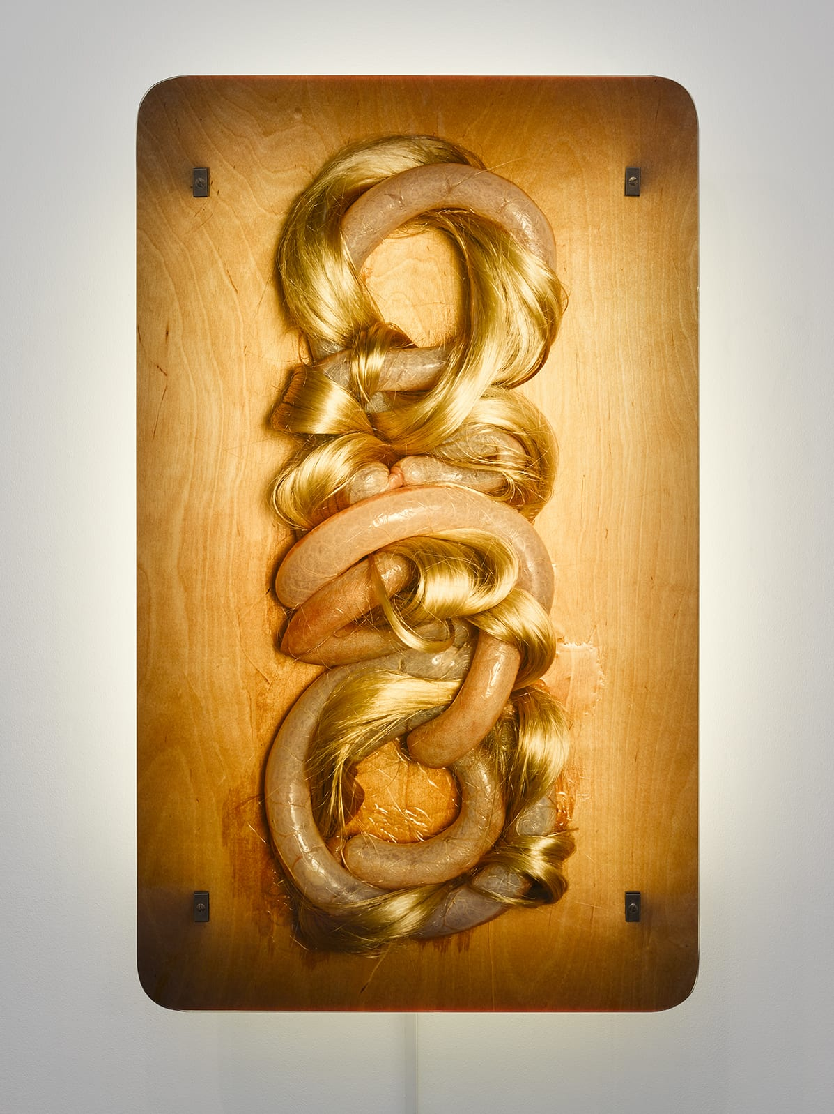
Case Study 6

Figure 8: Loop My Loop

In the piece Loop My Loop, created by Helen Chadwick in 1991, long, blonde apparently female hair is combined with the intestines from a pig. The conversational dominance and power between the objects enhance the significance between the two. Both are figurative. The hair from the literal human figure. The intestine from an animal. This sculptural yet painterly piece of contemporary art contributes to answering sub questions such as ‘Is the female body an object of sexualisation?’ and ‘Is flesh a fetish or a phobia?’
First and foremost, Rosemary Betterton has described "Helen Chadwick as fetishist" (Betterton. 1996:157). This is highly pertinent in understanding the visual analysis and research into this piece.
Developing upon this, also described by Betterton the contents of this piece are subjective of "gleaming pig intestines intertwined with golden Barbie doll hair in a braided embrace, seems more deliberately perverse in its pleasures." (Betterton. 1996:142).
From the male perspective such as through the likes of John Berger, he has stated that “Hair is associated with sexual power" " (Berger. 1972:55). Hair is deemed as belonging to sexualising the body within the male gaze. In contrast to this, from the female perspective when discussing the significance of hair such as by the likes of Kate Ince, "female hair almost always connotes sexuality" (Ince. 2000:87).
When considering these sources from a balance of gendered views, the hair within Chadwick’s conceptual piece can most definitely be identified as being an object of sexualisation. This figurative notion of the hair in direct visual synthesis with the grotesque intestine can also be observed as the strangulation of the male organs captured through a strong visual statement by Chadwick. The materials in dialect with one another can suggest the patriarchy of power and struggle of past representations of the female form from the male gaze, but now within the contemporary Chadwick has challenged this. The objects come together to reveal how flesh and hair can signify the presence of the female form without the full literal and conventional portrayal being evident.

This painterly sculpture could be evaluated as a synthesis between the human physical characteristics showing similarity to that of an animal through raw exposure of anatomical complexities. This comparison could also indicate the human psyche being rather animal-like. This can correspond to enhance the previously discussed psychoanalytical theory of the Oedipus Complex, where it was stated that the theory consists of the male psyche as being influenced by the Oedipus Complex i.e. the primitive desire for one’s mother. When evaluating the male gaze in relation to the observation of the female form, that gaze is primitive as a result of the Oedipus Complex present. Therefore, that male psyche is primitive, linking that comparison between the human – animal hybrid of instinctive behaviour towards the opposite sex, but in this case, that desire and attraction towards the female nude.
To further evaluate and enhance this discussion, Darwin’s proposed theory of “sexual selection” (Jones. Ratterman. 2009) in relation to primitive psyche can signify that development of one sex identifying a sexual relation with the opposing through physical attraction.
That physical attraction has been socially constructed within the contemporary as previously discussed through the likes of Orlan and Cindy Sherman as a result of the modern female psyche being disrupted. This is due to socially constructed beauty standards generated from the historical male gaze in synthesis to the primitive psyche.

The concept of the ideal beauty doesn’t exist. With that in mind, Naomi Wolf’s bold statement "Ideal beauty is ideal because it does not exist: the action lies in the gap between desire and gratification." (Wolf. 1990:143) has been proven. The woman can identify herself as being any means possible, therefore a binary is formed. This concept of a binary has been generated through the visual materials from Chadwick’s piece where flesh and hair can signify the presence of the female form without the full literal and conventional portrayal.
That notion of gender fluidity is present as there are no restrictions or defined conformities to how the woman must live her life or how she must feel in order to be deemed perfect. A woman is a woman and can perform however she wants without a conformity of what and who she must look like.
This leads into the evidence that the interpretation lies upon the spectator’s own perspective of the work.
Also, considering that ‘pleasure’ as described by Betterton in relation to the piece’s contents, that ‘pleasure’ can now be referred to as being that pleasurable viewing satisfaction the artist so much challenges which is from the male gaze.
The ‘desire’ is this satisfaction and the ‘gratification’ is the flesh.

This piece by Chadwick can be concluded to have successfully argued and identified that, within the contemporary, there are no conformities to what a woman must look like. Therefore, the artist has conceptually responded to the image of the female body. The theory of the status of the body as generated by Berger has also been challenged yet is now obliterated too. The male psyche has been concluded as being primitive and this contemporary female artist, has challenged that.

Conclusion

Evaluating the works of male artists such as Manet leads to an understanding of how the male psyche and underlying psychology, such as the Oedipus Complex, can result in the female form being identified as an object of sexualisation. Through the works they produced, they revealed the visual consciousness of the painter, i.e. painting directly the erotic and fetishised female nude, they fantasied and wanted to seek pleasure from.

Some contemporary female artists have strongly responded to the traditional image of the female body as portrayed by the male psyche. Orlan has challenged the stereotypical portrayal of the female nude generated from the male gaze. Orlan created a new persona challenging the notions of gender fluidity, rebelling against the traditional function of cosmetic surgery. Cosmetic surgery is addictive and considered as a punishment for seeking socially constructed beauty. Orlan has been extreme in her practice to challenge the notion that the female body is an object of sexualisation.

Jenny Saville observations of cosmetic surgery have influenced her painting practice. Saville has questioned the status of the body within the contemporary and through compositions such as the piece- Plan, she challenges the notion of the female body as an object of sexualisation.

Cindy Sherman’s photo of vomit allowed development into the contemporary female psyche as a result of socially constructed conformities of female perfection and the drastic female psychological problems that have resulted from the male gaze.
Helen Chadwick has presented a painterly sculpture challenging the contemporary identification of the female form traditionally present in the male psyche. Chadwick’s piece Loop My Loop is confrontational, conflicting with historical concepts of the female nude from the male gaze. The intertwined intestines and hair result in a strangulation of the male psyche.

Flesh has been identified as both a fetish and a phobia. A fetish within the male gaze derived from underlying psychology issues such as the Oedipus Complex. A phobia within the contemporary female’s psyche due to the stereotypical images of perfections and conformities.

The historical representation of the female body has certainly been engraved as a notion of ideological perfection within the contemporary woman’s psyche yet the female artists discussed challenge the notion of the female body being portrayed as an object of sexualisation and perfection.

Some contemporary female artists, as discussed, are continuously producing work that challenge the patriarchy of the past- that historic male gaze and the male’s dominance throughout art history.

Being a female within the contemporary is a struggle, both psychologically and physically. If the historical male gaze observed woman as perfect without any socially constructed standards to meet and allowed the woman to just be a woman irrespective of who and what she must look like or be, then this addiction and confliction towards constructed beauty standards would not exist. There should be no punishments for a woman being who she is in her raw and pure form.

A woman should just be allowed to breathe without any crippling pressure.

Bibliography:

Berger, J. (1972) Ways of Seeing. London: British Broadcasting Corporation. London: Penguin Books/Penguin Group.
ISBN: 0-14-013515-4O

Bolton, L. (2002) History & Techniques of the Great Masters Manet.
London: Quantum Publishing.
ISBN: 1-86160-474-2

Foucault, M. (2009) Michel Foucault Manet and the Object of Painting.
London: Tate Publishing.
ISBN: 978-1-85437-845-3

Greer, G. (2011) 'Artists have always glamorised prostitution. Manet savaged all their delusions', The Guardian, 6th February.
Available at:
https://www.theguardian.com/artanddesign/2011/feb/06/manet-olympia-prostitution-courtesan
(Accessed: 30th June 2019)

Simblet, S. (2001) Anatomy for the Artist.
London: Dorling Kindersley Limited.
ISBN: 0-7513-3441-3

Harris, B.
Zucker, S.
Manet, Olympia. [video] Available at:
https://www.khanacademy.org/humanities/ap-art-history/later-europe-and-americas/modernity-ap/v/manet-olympia-1863-exhibited-1865
(Accessed: 5th September 2019)

Butler, J. (1990) Gender Trouble. Routledge Publishing.
ISBN: 0-415-38955-0

Laing, T.S. (2017) A MACAT ANAYSIS Judith Butler's Gender Trouble.
London: Macat International Ltd. Exclusively Distributed by Routledge Publishing.
ISBN: 978-1-912127-76-4

Emin, T. (2005) Strangeland Tracey Emin.
Great Britain: Hodder and Stoughton.
ISBN: 0-340-76944-0

Betterton, R. (1996) An Intimate Distance Woman, Artists and The Body.
Routledge Publishing.
ISBN: 0-415-11085-8
Ince, K. (2000) ORLAN MILLENNIAL FEMALE Dress, Body, Culture.
Oxford: Berg.
ISBN: 1-85973-339-5

Mollon, P. (2000) Ideas in Psychoanalysis The Unconscious.
Cambridge: Icon Books Ltd
ISBN: 1-84046-187-X

Segal, J. (2000) Ideas in Psychoanalysis Phantasy
Cambridge: Icon Books Ltd
ISBN: 1-84046-189-6

Roth, P. (2001) Ideas in Psychoanalysis The Superego
Cambridge: Icon Books Ltd
ISBN: 1-84046-246-9

Wolf, N. (1990) The Beauty Myth. London: Chatto & Windus Limited
ISBN: 0-7011-3431-3

Morris, C. (1999) The Essential Cindy Sherman
New York: The Wonderland Press. New York: Harry N. Abrams, Incorporated
ISBN: 0-8109-5808-2

Crippa, E. Mullins, C. Spires, H.
(2018) All Too Human Bacon, Freud and a Century of Painting Life
Tate Publishing
ISBN: 978-1-84976-583-1

Scala, Mark. W.
Edwards, Susan. H.
Braun. E
(2009) Paint Made Flesh
Vanderbilt University Press
ISBN: 978-0-8265-1622-0

Grosenick, U. Becker, I. (2003) Icons Women Artists in the 20th and 21st Century
Taschen
ISBN: 3-8228-2437-2

(1996) The 20th-Century Art Book. Phaidon Press Limited.
ISBN: 0-7148-3850-0

Morris, C. (1999) The Essential Willem de Kooning
New York: The Wonderland Press. New York: Harry N. Abrams, Incorporated
ISBN: 0-8109-5811-2

Barker, C. (2004) The SAGE Dictionary of Cultural Studies
London: SAGE Publications Ltd
ISBN: 978-0-7619-7341-6

Richards, A.
Freud, S. (1976) The Interpretation of Dreams. The Penguin Freud Library Volume 4
London: Penguin Books
ISBN: 0-14-013794-7

Gray, J.
Nochlin, L.
Sylvester, D.
Schama, S.
(2005) Saville. Gagosian Gallery.
New York: Rizzoli International Publications, Inc.
ISBN: 978-0-8478-2757-2

Ashton, D.
Pittman, L.
(2008) Cecily Brown. Gagosian Gallery.
New York: Rizzoli International Publications, Inc.
ISBN: 978-0-8478-3092-3

Hasler, A. (2019) 'Artist Statement' Andrea Hasler.
Available at: http://www.andreahasler.com/info/statement/
(Accessed: 12th September 2019)

Chanter, T. (2010) 'Abjection, or Why Freud Introduces the Phallus: Identification, Castration Theory, and the Logic of Fetishism" Wiley Online Library.
Available at:
https://onlinelibrary.wiley.com/doi/abs/10.1111/j.2041-6962.2004.tb01014.x
(Accessed: 13th September 2019)

PSYCHOTHERAPY - Jacques Lacan [video]
Available at: https://www.youtube.com/watch?v=5OnhOXq7m4w
(Accessed: 14th September 2019)

Jacques Lacan - The Mirror Stage [video]
Available at: https://www.youtube.com/watch?v=agTYUU4gTOo
(Accessed: 14th September 2019)

McShirley, C. (2019) ‘What is Body Image?’ Psychealive
Available at: https://www.psychalive.org/what-is-body-image/
(Accessed: 10th October 2019)

Durand, Regis (2004) ORLAN: Carnal Art. Paris: Flammarion.
ISBN: 2080304313
Vladmir Sichov for Sipa-Press. ORLAN. (November 21, 1993) ‘Sourire de plaisir’ ‘(Smile of Delight)’ [cibachrome in Diasec mount]. Edition of seven. [photograph] France

(2017) ‘Glossary’ British Association of Aesthetic Plastic Surgeons
Available at:
https://baaps.org.uk/patients/glossary/
(Accessed: 27th October 2019)

‘Manifesto of Carnal Art’ ORLAN
Available at: http://www.orlan.eu/texts/
(Accessed: 3rd November 2019)

(2019) ‘Jenny Saville’ Gagosian
Available at: https://gagosian.com/artists/jenny-saville/
(Accessed: 3rd November 2019)

(2019) ‘Jenny Saville’ Artnet
Available at: http://www.artnet.com/artists/jenny-saville/2
(Accessed: 3rd November 2019)

(2019) ‘Torso 2 by Jenny Saville’ Artnet
Available at:
http://www.artnet.com/artists/jenny-saville/torso-2-CsDSmtQMPLUWonIkOsvFfw2
(Accessed: 3rd November 2019)

Gamman, L.
Makinen, M.
(1994) Female Fetishism A new look. London: Lawrence & Wishart Limited.
ISBN: 0-85315-755-3

Damas, A. G (2018) ‘Revisiting the Female Gazes in Manet’s ‘Olympia’’
The Harvard Crimson
Available at: https://www.thecrimson.com/article/2018/4/24/olympia-revisited/
(Accessed: 28th November 2019)

Jones, G. A.
Ratterman, L. N.
(2009) ‘Mate choice and sexual selection: What have we learned since Darwin?’
PNAS Proceedings of the National Academy of Sciences of the United States of America
Available at: https://www.pnas.org/content/106/Supplement_1/10001
(Accessed: 28th November 2019)

