MODULE NUMBER: LCMB7014

MODULE NAME: International Business

STUDENT NAME: Andrea Lester

STUDENT NUMBER: 1912330

SUBMISSION DATE: 28/07/23

WORD COUNT: 5000, 10%

ASSIGNMENT TITLE: An Analysis of International Business MNE’s

Section Name | Page Number
TITLE PAGE
CONTENTS PAGE
INTRODUCTION TO REPORT | 2
BACKGROUND AND HISTORY OF SAMSUNG ELECTRONICS | 3-7
CASE STUDY ANALYSIS | 8-9
INTERNATIONAL ACTIVITIES | 10-15
CRITICAL EVALUATION OF STRATEGIES AND TRAINING PROGRAMS | 15-17
CONTEXTUAL FACTORS | 18-27
RECOMMENDATIONS | 27-28
CONCLUSION | 29
REFERENCE LIST | 30-34

INTRODUCTION TO REPORT
This report will begin by providing a brief overview of a multinational enterprise known as Samsung, focusing on the history and background of the company. Throughout the report a critical analysis will be conducted, and the results will circulate various types of approaches used by the corporation, to distribute its products and services. The report will verify different contextual factors influencing the company’s decisions in regard to globalisation strategies.

When it comes to multi-national corporations, there are three types of strategies they may use to transfer or distribute their products and services. The polycentric procedure relates to a set of strategies being utilised within the host country, whereas the ethnocentric procedure is linked to the home country and the geocentric procedure is used as a worldwide approach (Ewah and Osang, 2018). Samsung Electronics employs the geocentric strategy.

According to Cavusgil et al., (2014) international business relates to an organisation’s national boundaries, based on trade and investment activities. Because the prominent aspect of international business is the interchange for national borders. Some may suggest that international business is a frontier business where enterprises categorise, invent, manufacture, advertise and direct further activities that add value on a universal scale (Cavusgil, 2014). The report will review the corporation’s financial statements and conclude by presenting recommendations that will help the company to continue to prosper across the globe.

BACKGROUND AND HISTORY OF SAMSUNG ELECTRONICS
Subsidiaries
In 1938 Samsung was created by a gentleman called Lee Byung-Chul. At present the company has 244 branches worldwide manufacturing tons of appliances. In February 2017, the South Korean database Chosun Biz set the total amount of Samsung subsidiaries at 58, this has proven to be insignificant since the company regularly purchase, trade, combine and retitle numerous divisions. Samsung manages a lot of branches and many of them are amongst South Korea’s major organisations in their own individual right. In fact, the Group is the biggest family-owned enterprise in South Korea, so big that some have predicted that the entire South Korean economy would collapse if Samsung systems were to fail. (eFinance Management, 2022). Samsungs greatest subsidiaries are Harman international business, smart things, and semes, they all retain similar departments. Due to Samsungs discretionary agreement, subsidiaries decisions cannot be made by adopting international strategy, dynamic coordination is required by the human resource management team in charge of the decision-making process. Samsungs competitors may differ, when it comes to smart phone technologies, the main competitors are Apple and Huawei. What does Samsung do (Korea Expose, 2023).

Figure 1: Samsung Subsidiaries
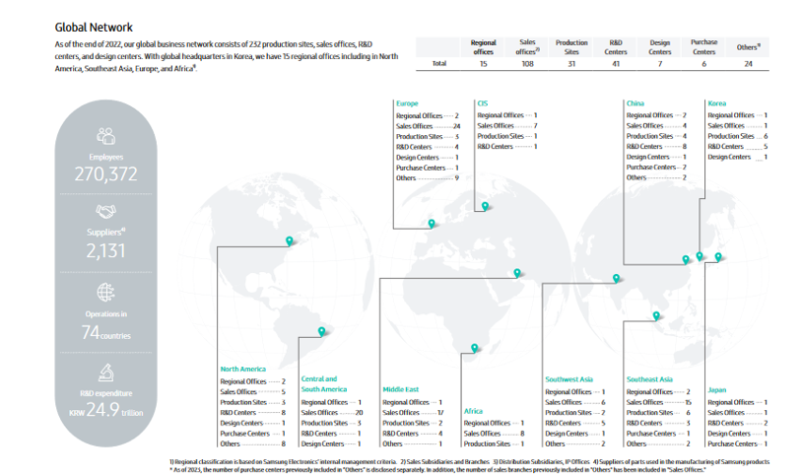
Samsung electronics sustainability report (Samsung, 2023).

Employees and their responsibilities
Samsung has over 200 locations in more than 70 countries, and in each and every department there are 268,000 employees performing innovative tasks. Which contribute to the development of Samsung’s products and services. The company’s staff members play an important role, as they manage resources and strengthen business operations. In areas such as designing, financing, communications, human resources and corporate sustainability, to ensure the future success of the business has been achieved on a global scale. Job field careers (Samsung UK, 2021). Samsung believes that the diversity creativity and passion of the workers has led to their brand being recognised all over the world, as one of the most innovative technology companies.
This is the reason why Samsung values employee penetration and encourages them, to come together to share their knowledge and expertise, to continue to drive innovation forward. Working at Samsung careers (Samsung, 2021).
Figure 2: Samsung Employees
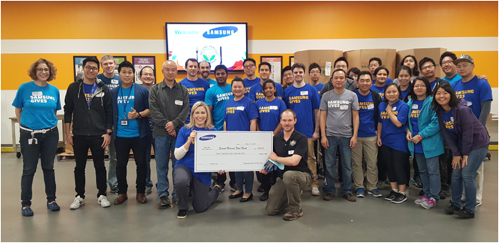
(Samsung Newsroom US, 2019).

The institutions hard work does not go unnoticed, considering the company was recently announced by Forbes, as the world’s best employers and recognised as one of America’s leading enterprises due to their professionalism. The next step for Samsung is to support the next generation of female leaders, by cultivating their abilities, so they can excel in their career. Diversity and inclusion fostering a diverse culture to create a better future (Samsung UK, 2023).

Figure 3: Samsung awards and recognition
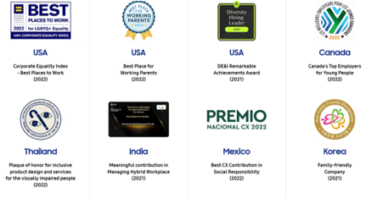
Diversity and inclusion fostering a diverse culture (Samsung UK, 2023).

Table 1: Female employees, job roles
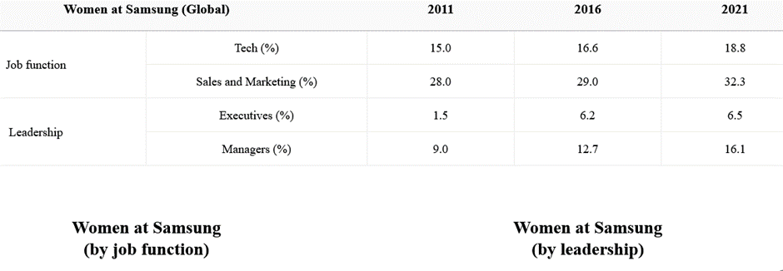
Diversity and inclusion fostering a diverse culture (Samsung UK, 2023).

Chart 1: Female employees, statistics
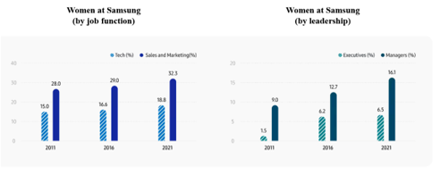
Diversity and inclusion fostering a diverse culture (Samsung UK, 2023).
Brief overview of financial report 2022/23
Throughout the year of 2022, Samsungs profits had increased, due to a high demand in smart phone sales. According to the company’s financial report, at present profits have decreased, and pronounced as an adverse growth rate. Since no sales were made within the TV market. Which is predicted to continue, while stipulation for premium products is expected to grow. To boost operating profits, Samsung will concentrate on improving productivity. This will be done by expanding the sales of selected products and by distributing a series of new models by enhancing operations and maintaining cost leadership. Earnings presentation financial reports (Samsung,2023).
Chart 2: Samsung’s financial position 2015-2022
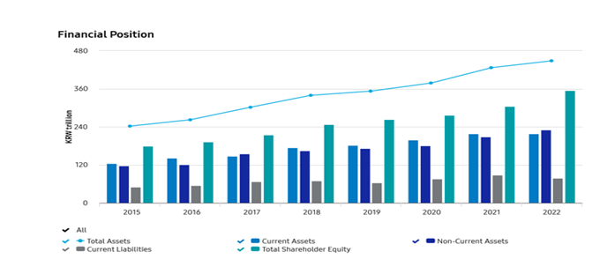
Financial highlights (Samsung Electronics, 2023).

Table 2: Samsungs financial results/data
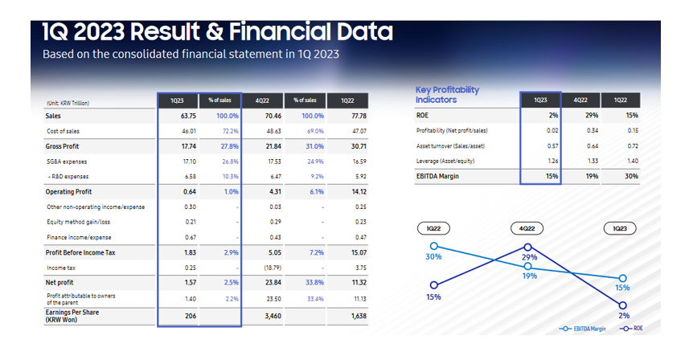
Earnings presentation financial reports (Samsung,2023).
CASE STUDY ANALYSIS
Ethics and principles
Samsung shows commitment to its customers and members by obeying local legislations and guidelines, as well as appointing a strict code of conduct which is compulsory to all employees. The company views ethical guidance not only as a tool to respond to the prompt changes that may occur, in international business settings, but also as a mechanism for creating trust, with several business partnerships such as customers, stakeholders, co-workers, co-founders and local districts. Samsungs core values state that the enterprise is nothing but people, this phrase shows how Samsung sees and treats its employees, as reported by Samsung’s sustainability report 2016. Samsung group emulate effortless business values by devoting its expertise and innovations to design and deliver first-class products and services, which subsidise to the global society, to reach this goal. Samsung sets high standards on its people and technologies, and the company’s motivation comes from maintaining strong values, which they believe is key to running a successful business. Implementing these core values, along with a strict code of conduct is at the heart of every decision the enterprise makes. In a declaration of the company’s contract, to combine social liability as a global leading enterprise, Samsung publicised five principles. The theories act as the substructure for its international code of conduct, in conformity with statutory and law-abiding guidelines, as well as the achievement of its collective social responsibilities (Samsung, 2023).

The organisation believes that all individuals are talented and bring some kind of skill or ability to the table, it is Samsungs duty to ensure all employees are supported to take their skills and abilities further (Samsung, 2023). This suggests that the steps Samsung is taking exhibits a comprehensive approach towards talent management. Samsungs theory supporting the talent management process can be procured by investigating the corporation using the image figure 4 provided below. The company’s ethics are classified in four groups: stable, exclusive, inclusive, and developable. Company info about us (Samsung, 2023).

Figure 4: Talent Management Philosophy
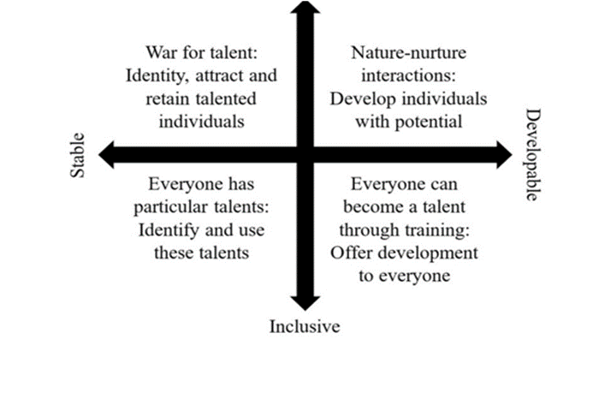
(Cue Media, 2022).

INTERNATIONAL ACTIVITIES
Advantages and disadvantages of international strategies
As expressed in Sherry, (2021) article, multinational procedures are used by many organisations, to navigate employment, exercise authority or manage human resources. Although the implementation process of such strategies has proven to be a success, each one comes with its own strengths and weaknesses.

Table 3: Comparison of the Four Staffing Approaches
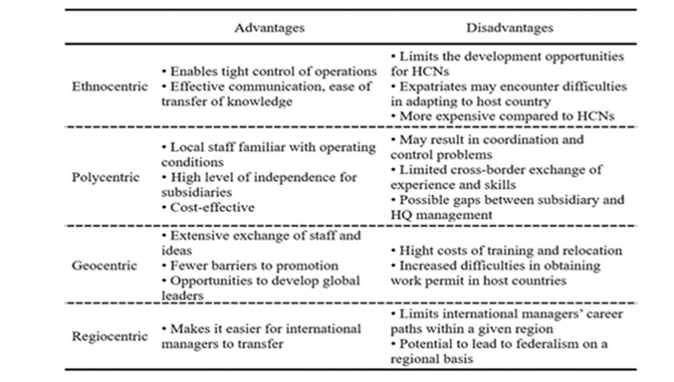
(Cue Media, 2022).

- Ethnocentric- the benefits of applying the ethnocentric strategy. is the coherence of its legislative structure, with regard to the surge of information. As well as its directness enclosed by management control. The downside is that it lacks receptiveness and variability, which is caused by the dominance of national culture. And as a result, a reduced performance has been perceived (Sherry, 2021).

- Polycentric- the advantage of the polycentric strategy is that it targets demanding penetration of external markets. Pertaining to their location, to ensure gross sales improve. The strategy also enhances liberation and mobility which constitutes to sustainability. On the flip side the disadvantages of employing this strategy may include communication barriers, igniting chaos, extreme growth and hesitancy from local authorities. to obey rules and regulations set by management teams up in head office (Sherry,2021).

- Geocentric- this strategy has multiple benefits, when it comes to, return on investments, human capital, quality product/ services and global development. The method helps to promote a sustainable corporation, achieve greater quality of produce and resources as well as running the best facilities generating more profits. The strategy is said to be adjustable and receptive to make changes, which confirms its lucrative and can be used anywhere in the world. International businesses should adopt this strategy if their primary focus is not only based on accomplishing market success, but also to sustain the triumph existence on the market and to guarantee long term equilibrium. However, the limitation of the strategy consists of high costs, corresponding to personnel and human resource management. Expenditure may transpire, due to training programmes, effective communication channels and transporting costs (Sherry, 2021).

- Regio centric- this strategy is based on regional examination because the process requires professional collaboration throughout national borders, primarily within a restricted geographical region. The production benefits of applying this strategy, includes the supremacy of a corporation’s products, by positioning the brand in the subconsciousness of that district. Not to mention the conformed potential, of practicing the uniqueness of that particular country, in regard to differentiating a product. The advantages of regio-centric products are presumed to enhance marketing performance. The disadvantage however is that managerial positions of subsidiaries are concealed by residents born in that country where the branches are located. Which means they have an extremely low chance of being promoted into an international managerial position (Hanfan and Setiawan, 2018).

Samsung’s strategy approach
Samsung uses a geographic approach when it comes to selecting its members, by using this approach Samsung has successfully overcome the cultural and institutional difficulties and can now adopt human resources adequately. This approach has helped to enhance the organisations performance and upgrade its global strategies. Imposing a geocentric approach has helped Samsung to maintain stability and achieve a competitive advantage. Samsung Electronics employs universal strategies to make substantial amounts of economic progression, by distributing its systemised products globally.
The company’s aim is to minimise costs as much as possible, by picking adequate locations, where tax reductions and other resources are available. International business strategies are split into four categories international, global, cosmopolitan, and universal. A multinational business strategy is usually recognised as a general combination of regional rapidness (Cue Media, 2022).

Figure 5: International Business Strategies
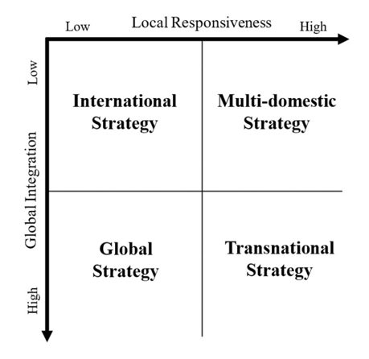
(Cue Media, 2022).

Samsungs training programmes
The five cross cultural training programmes Samsung provides to support migrants, contains formal training, cultural activity, vocabulary training, awareness training and practical experience. The enterprise delivers pre and post departure training which includes, adaptation programmes based on language and cultural perceptiveness. As well as cultural diversity communication and training abilities to help employees understand the expatriates, to ease the process of readjustment and to prevent cultural shock.

Therefore, it could be argued that the programmes Samsung creates has been a success, as it’s helped many foreigners to overcome their cultural discrepancies. Samsungs goal is to become one of the most ethical establishments in the whole world, by regularly training members of staff and administrating monitoring systems to assess employee performance, while executing honest and straightforward collaborative management (Cue Media, 2022).

USA training programmes
In the United States an individual culture system is applied to monitor staff performance, the strategy is used to determine the amount of pay, bonuses and commission an employee may receive, and this is why the US believe that shared ownership programmes are highly recommended (Cue Media, 2022).

Mexico training process
Mexico has an extreme influence on distance culture because the rewards employees receive are priority based. Performance related pay and staff ownership in Mexico is not commonly used. These types of changes may threaten Samsungs strategy processes in regard to rewarding migrants who reside in the United States and Mexico (Cue Media, 2022).

Table 4: Three General Corporate Motives for Transferring Employees
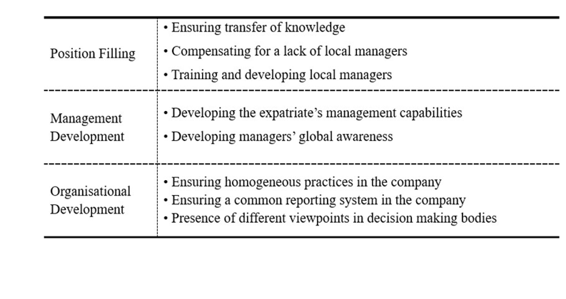
(Cue Media, 2022).

CRITICAL EVALUATION OF STRATEGIES AND PROGRAMMES
Reflecting back on the strategies and training programmes used by Samsung, I have decided to critically evaluate them, to confirm what the company is doing well, and the areas that need to be improved on. by enforcing the geocentric strategy, I imagine Samsung has accumulated the knowledge and skills to know how to adapt to the culture of any international country they may choose to open a franchise in. as well as the exact steps to take to tackle and pull through any barriers that may hinder the process. Using this approach, I suspect the company has been able to upgrade their strategies and better the organisations overall performance. Practicing international techniques, I presume has benefitted the company in a positive way and help them to make considerable amounts of progression, when it comes to selecting the right candidates and disbursing their products and services.
The companies aim to reduce costs, by choosing appropriate locations, shows their committed to advance their facilities further. Nevertheless, the author believes that the international training programmes Samsung designs to support its employees has helped them to overcome barriers and understand each other’s culture differences. I for one believe that Samsung will achieve their goal in becoming one of the most ethical enterprises in the world, because they make substantial amounts of effort to encourage their colleagues in any way they can. The company always puts employee’s wellbeing at the heart of everything they do, which is so important, they are the faces that drive the company forward. As previously mentioned in the employee and responsibility chapter on pages 4-6 the employees are the reason why Samsungs company is recognised all over the world. Assessing and monitoring staff performance regarding training programmes is a good idea. I myself suspect that this process gives Samsung the opportunity to identify employee’s strengths and weakness, so the company can provide the relevant training to help them to improve on the areas that need to be work on. On the other hand, the author feels that, providing training programmes in different countries could affect Samsung’s strategy process, as some countries may have strict rules and regulation in place disrupting the structure of the company.

According to Tallman, Luo and Buckley (2018) responding to complicated and influential forces, requires MNC’s, to create a business design, that’s the substructure for the company’s global identification. The business model must be seen as competent, by universal markets before it can be allocated a subsidiary, within the country the enterprise would like to transfer to. A business design provides details based on what the company does and how they create value relating to the marketplace. Intrinsically most business designs justify or at least signify that the initiatives and proficiencies of a firm is complex and regulatory, when it comes to the framework that ties these facilities and proficiencies together (Tallman, Luo and Buckley, 2018). The following chapter will discuss the strengths, weakness, opportunities and threats based on Samsungs strategy and training procedures. And describe different types of external factors hindering or improving the process.

CONTEXTUAL FACTORS
SWOT Analysis
Culp et al., (2016) stated that a SWOT analysis is an intentional mechanism, used by many establishments to assess and monitor the strengths, weaknesses, opportunities and threats of an organisation’s performance or process, to ensure organisational goals have been met. However, a SWOT analysis can also be considered as a straightforward procedure, which can be incorporated with a designed activity. If used correctly the tool can support businesses, to maintain stability and achieve a competitive advantage (Culp et al., 2016).

Figure: 6
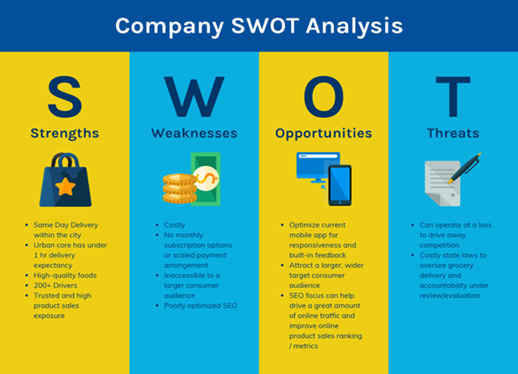
(Vennage, 2023).

Strengths:
- opening subsidiaries and hiring employees from the same country I believe is a strength. Because it allows Samsung to familiarize themselves with the country’s way of living, which will help the organisation learn how to adapt (Hisrich, 2015).

- The staff employed from the homeland, will know customers’ demands in terms of electronic items, which will give Samsung the upper hand to produce the products and distribute them to that particular populace (Hisrich, 2015).

- The Strategy Story (2023) stated that another strength of Samsungs is related to their skilled staff members within the management and technical departments, as they all have contributed to the firms’ growth as well as their success. Samsungs competencies to engage and hold on to top talented workers, has enabled the company to stay ahead of the game (The Strategy Story, 2023).

Weaknesses:
- Even though Samsungs training programmes are highly beneficial, the programmes can become time consuming, especially if it takes longer for one employee to learn a skill than the other, due to language barriers or struggling to understand culture differences (Makridakis, 2017).

- Even if, orientation combines various types of benefits, there is still complications and immeasurable impacts causing Samsungs supply chain to become vulnerable. Due to external factors such as, natural disasters, international disputes and global financial downturns. These types of factors can disturb productivity, enhance costs and affect the organisations overall performance. Samsung Swot Analysis (The Strategy Story, 2023).

Opportunities:
- Samsung has the opportunity to form strategic partnerships and recruit more people from all over world, while developing training programmes, which supports and enhances their skills and abilities (Samsung Newsroom, 2023).

- Samsung will support its employees by creating more opportunities. So, they can be promoted to different position, so they have the chance to expand within their career. A journey towards a sustainable future investing in people how Samsung puts its employees first (Samsung Newsroom, 2023).

Threats:
- Some external factors may influence Samsung’s strategy and training processes, such as legal restrictions relating to a country’s right of policy and legislation.

- As expressed by Business Strategy Hub (2023) as society becomes more diverse and electronic, governmental figures and local authorities have started to issue their guidelines. Which is escalating legal and regulative laws. Threating the stability of companies all over the world (Business Strategy Hub, 2023).

PESTLE
Conforming to Rastogi and Trivedi (2016) article PESTLE analysis is a tactical planning tool, used to assess the influence external factors may have on a company’s project. The formula is a good way for organisations to capture any potential risks or difficulties which may hinder the firm’s strategy process (Rastogi and Trivedi, 2016).
Figure 7:
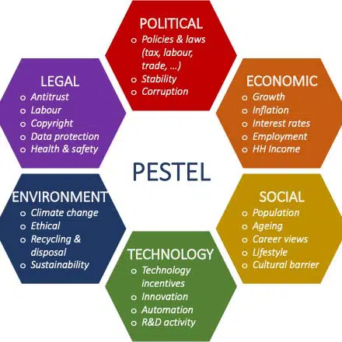
(Spring Works, 2022).

POLITICAL
- Local governments where Samsung subsidiaries reside, can seriously impact the company’s operations, due to modifications of tax policies, employment laws, ecological regulations, trading restrictions and tariffs and economical consistency can all affect Samsungs employment strategies.

- Trading agreements can purposely make Samsungs products and services become combative. This is because Samsung benefits from free trading agreements that South Korea has with different countries. And as a result, the agreement minimises tariffs which makes their resources become competitive. Samsung Pestle Analysis (The Strategy Story, 2023).

- Trading blockages can ease firms like Samsungs, by introducing new products to the market. Resulting in reduced costs, covering expenses of doing business and expanding the supply when it comes to talented employees (247 Caseanalysis, 2023).

ECONOMIC
- Unemployment figures, often leads to customers spending less. Reducing the command for Samsung products. In contrast lower levels of unemployment rates, may enhance customers spending and their request for Samsungs items. Samsung Pestle Analysis (The Strategy Story, 2023).

- High levels of Inflation rates in certain countries can reduce the buying power of customers. Influencing the high demand for Samsung’s items. On the flip side, lower inflation rates might improve buying power and improve the commands for Samsungs products. Samsung Pestle Analysis (The Strategy Story, 2023).

- A balanced interest rate could help Samsung to get a loan, to develop and expand the company. Business loans are usually purchased by organisations to support the growth and infrastructure of the building (247 Caseanalysis, 2023).

SOCIAL
- Modifying the company’s working schedule, by incorporating hybrid working might stir up and increase demands, for certain electronic items such as laptops, smartphones and tablets. Samsung Pestle Analysis (The Strategy Story, 2023).

- Higher levels of education can be connected with excessive technology rates. Increasing the market penetration for Samsungs products. Samsung Pestle Analysis (The Strategy Story, 2023).

- A higher precent of the adolescent’s population, can be beneficial for Samsungs product, because it gives the company the opportunity to expand its customer base worldwide. Additionally, the younger generation will assure Samsung has more skilled and educated employees as well as human capital. Therefore, increasing broadness and brilliance when it comes to the talent pool (247 Caseanalysis, 2023).

TECHNOLOGICAL
- As Samsung is recognised, for being one of the most innovative enterprises in the world, indicates that the firm has gained a competitive advantage. So as far as applying the power of technology and driving innovation, the company has no issues in that department (Management Study Gide, 2015).

- While technology and connectivity increase, there are still some risks hindering the process such as network securities. So, it’s important that Samsungs products and services have robust security features to protect information systems. Samsung Pestle Analysis (The Strategy Story, 2023).

- Regulatory adjustments in technology developments can affect Samsungs data privacy and protection as well as technology rights. Samsung Pestle Analysis (The Strategy Story, 2023).

LEGAL
- Samsung is required to obey, all work and employment laws that have been put in place, in its operating countries. This may involve staff wages, staff working hours, health and safety, and discrimination laws. Samsung Pestle Analysis (The Strategy Story, 2023).

- Samsung must comply with all data and privacy protection laws, as many of its devices hold, store and process sensitive data. They must also adhere to customary data protection regulations within the European union. Samsung Pestle Analysis (The Strategy Story, 2023).

- Compulsory laws and regulations have been endorsed, to ensure the health and safety of employees within the working environment. Samsung is required to frequently check its operations in terms of safety nets, drills and precaution measures.

- Samsung achieves this by putting strict policies in place when it comes to the health and safety of its employees (247 Caseanalysis, 2023).

ENVIRONMENTAL
- Climate changes can influence the way Samsung operates, particularly its supply chain and produce activities. For example, climate related catastrophes, can interrupt transportation and regulative responses, in regard to climate changes. Like replication prices which could boost Samsung’s organisational costs. Samsung Pestel Analysis (The Strategy Story, 2023).

- Environmental regulations concerning ecological issues, such as carbon dioxide emissions, electronic waste and energy efficiencies. Can all affect Samsungs endeavours, for example product designs and saleability. Samsung Pestel Analysis (The Strategy Story, 2023).

- Many countries around the world, are slowly moving towards solar energy for organisational purposes. And if carried out correctly can decrease the green house emission. Samsung and its partners are currently utilising solar energy and hydroplanes to transport and manage business operations (247 Case Analysis, 2023).

Sustainability
Samsungs plan of action to maintain the stability of its strategy process, is to produce a set of training programmes, where employees attend review sessions, to discuss their opportunities for career growth. Members from head office will be required to part take in these review sessions, to support employees while they map out their career path, to achieve professional development. Employees will be given the chance to familiarise themselves with various career programmes that help to enhance growth such as. MBA’s Academic courses, task competencies and local capacities, whichever one is suited to the career path employees may want to take. Under the same strategy the enterprises tool solution is to enforce HR fair systems, to ensure all employees feel they are being treated fairly and feel as though they all have the same equal rights. franchises all around the world have been headlining the importance of workplace age, gender and culture diversity. Throughout the years Samsung has contributed to this by raising awareness and introducing programmes stage by stage to promote diversity and inclusion (Samsung Newsroom, 2023).

Furthermore, Samsung Electronics Sustainability Report (Samsung, 2023) declared that the company will show its commitment by ensuring all employees are treated fairly and given the same equal opportunities based upon the company’s non-discrimination policy (Samsung Electronics Anti-intolerance policy). Which states that the organisation does not discriminate contrary to any present or future employees regarding their identity, ethnicity, gender, nationality, race, sexual orientation, age, religion, marital status. In addition to any circumstances where employees face human resource difficulties such as caseloads, advocacy or compensation. The company created the (DEI) division to improve the firms broad DEI strategies, and adopt diverse training programmes, to strengthen the companies (DEI) overall performance. By collaborating with the appropriate staff members in Samsungs establishment and subsidiaries. Samsung Electronics Sustainability Report 2023 (Samsung, 2023).

RECOMMENDATIONS
Although Samsung has made substantial amounts of effort, in implementing its geocentric strategy. The company must regularly find different methods to adopt. Not only to improve the company’s overall performance, but to act as a back plan. As previously discussed in the contextual factors chapter, environmental conditions are constantly changing. And even though Samsung has no control over these external influences, having a backup plan in place can help the company to respond quickly and plan well ahead, in doing so will help the company to maintain stability and achieve a competitive advantage.
Furthermore, the enterprise must make sure they routinely utilise the SWOT analysis tool, to assess its strategy procedures and training programmes. To determine their strengths, weakness, opportunities and threats. As well as conducting the PESTLE analysis to ensure all strategies and training programmes align to those countries where its subsidiaries will be situated. As indicated by Poor (No Date) it is vital that multinational companies select the right candidate when it comes to the recruitment process. This is because the person the firm decides to choose for the post, in terms of the managerial position, will have a significant impact on the organisation’s success. As a matter of fact, it is not only managerial roles that need to be hired or filled with the right applicant. But also, lower paid employees must have the skills and abilities an establishment may be looking for. This process is so important, because it affects the type of strategies a company may employ in its subsidiaries. The management team would usually choose between two kinds of candidates, a local and a foreigner, and decide which one has the necessary skills to be sent to a particular subsidiary from the parent company. During the process a firm may be required to find different solutions to solve a variety of problems relating to environmental factors, they must take into consideration all the pros and cons before making a decision on who the best candidate is to employ (Poor, No Date).

CONCLUSION
The aim of this report was to establish the international strategies and training programmes, regularly being used by Samsung, to select its members, and support their career path. Throughout the report a description was given pertaining to the company’s background and history, to identify its subsidiaries and employee responsibilities. A case study analysis was then presented to emphasise the company’s ethics and principles, and an overview was provided to demonstrate the different types of strategies being used by international businesses. As well as describing the strategies and programmes being implemented by Samsung. The report critically evaluated the processes used by the company. And conducted a SWOT and PESTLE analysis to determine the firms’ strengths, weaknesses, and any environmental factors posing as a threat. Finally, the report explained the steps Samsung will take to maintain stability, and some suggestions were put forward to express various ways this could be done. If Samsung wants to continue, to improve its products and services, they must ensure they employ the right candidates to join their team, so by providing the necessary training programmes can definitely help, when it comes to the recruitment process.

REFERENCE LIST

Business Strategy Hub (2023) Samsung Swot Analysis 2023 Swot Analysis of Samsung. Available at: https://bstrategyhub.com/swot-analysis-of-samsung-2019-samsung-swot-analysis/ (Accessed: 23 July 2023).

247 Caseanalysis (2023) Pestel Analysis of Samsung China the Introduction of Color TV. Available at: https://www.247caseanalysis.com/case/SAMSUNG-CHINA-THE-INTRODUCTION-OF-COLOR-TV-3858-Pestel-Analysis (Accessed: 23 July 2023).

Cavusgil, S.T., Knight, G., Riesenberger, J.R., Rammal, H.G and Rose, E.L. (2014) International business. Pearson Australia.

Cue Media (2022) International Staffing and Expatriate Management A Case of Samsung Electronics. Available at: https://onstarplus.com/archives/3163 (Accessed: 15 July 2023).

Culp III, K. Eastwood, C. Turner, S. Goodman, M and Ricketts, K.G. (2016) Using a SWOT analysis: Taking a look at your organization [2016].

eFinance Management (2022) Keiretsu vs Chaebol Differences Advantages and More. Available at: https://efinancemanagement.com/financial-management/keiretsu-vs-chaebol-differences-advantages-and-more (Accessed: 02 July 2023).

Ewah, S and Osang, J.E. (2018) ‘Influence of cross-cultural differences on international marketing’, International Journal of Academic Research in Business and Social Sciences, 8(7), pp.363-376.

Hanfan, A and Setiawan, A.I. (2018) Exploiting regio-centric product advantage to increase small and medium enterprises’(SMEs) marketing performance.

Head-Fi (2023) Chinese / Asian Brand IEM Info Thread. Available at: https://www.head-fi.org/threads/chinese-asian-brand-iem-info-thread.820747/page-680 (Accessed: 20 July 2023).

Hisrich, R.D. (2015) International entrepreneurship: starting, developing, and managing a global venture. Sage Publications.

Korea Expose (2023) What does Samsung Make. Available at: https://koreaexpose.com/samsung-products-basic-information/ (Accessed: 02 July 2023).

Makridakis, S. (2017) The forthcoming artificial intelligence (AI) revolution: Its impact on society and firms. Futures, 90, pp.46-60.

Management Study Guide (2015) PESTLE Analysis of Samsung. Available at: https://www.managementstudyguide.com/pestle-analysis-of-samsung.htm (Accessed: 23 July 2023).

Poór, Á.S.J. (No Date) HUMAN RESOURCE MANAGEMENT AT MULTINATIONAL COMPANIES IN LIGHT OF CENTRAL AND EASTERN EUROPEAN RESEARCHES.

Rastogi, N.I.T.A.N.K and Trivedi, M.K. (2016) ‘PESTLE technique–a tool to identify external risks in construction projects’, International Research Journal of Engineering and Technology (IRJET), 3(1), pp.384-388.

Samsung (2023) Company Info About Us. Available at: https://www.samsung.com/uk/about-us/company-info/ (Accessed: 02 July 2023).

Samsung (2023) Earnings Presentation Financial Reports. Available at:https://images.samsung.com/is/content/samsung/assets/global/ir/docs/2022_1Q_conference_eng.pdf (Accessed: 20 July 2023).

Samsung (2023) Samsung Electronics Sustainability Report 2023. Available at:https://images.samsung.com/is/content/samsung/assets/global/ir/docs/sustainability_report_2023_en-1.pdf (Accessed: 20 July 2023).

Samsung Electronics (2023) Financial highlights. Available at: https://www.samsung.com/global/ir/financial-information/financial-valuation-snapshot/ (Accessed: 20 July 2023).

Samsung Newsroom U.S (2019) Samsung ranked #1 Technology Company in U.S. survey of Corporate Reputation. Available at: https://news.samsung.com/us/samsung-ranked-1-technology-company-in-u-s-survey-of-corporate-reputation/ (Accessed: 20 July 2023).

Samsung Newsroom (2023) A Journey Towards a Sustainable Future Investing in People: How Samsung Puts Its Employees First. Available at: https://news.samsung.com/global/a-journey-towards-a-sustainable-future-3-investing-in-people-how-samsung-puts-its-employees-first (Accessed: 23 July 2023).

Samsung UK (2021) Job Fields Careers. Available at: https://www.samsung.com/uk/about-us/careers/job-fields/ (Accessed: 20 July 2023).

Samsung UK (2021) Working at Samsung Careers. Available at: https://www.samsung.com/uk/about-us/careers/working-at-samsung/ (Accessed: 20 July 2023).

Samsung UK (2023) Diversity & Inclusion Fostering a diverse culture to create a better future. Available at: https://www.samsung.com/uk/sustainability/diversity-and-inclusion/ (Accessed: 21 July 2023).
Sherry, A. (2021) ‘Management styles of multinational corporations and PepsiCo orientation in the Lebanese market’, Management Studies and Economic Systems, 6(3/4), pp.101-107.

Spring Works (2022) How to Conduct an Effective Pestel Analysis? Available at: https://springworks.ch/en/pestel-analysis/ (Accessed: 23 July 2023).

Tallman, S. Luo, Y and Buckley, P.J. (2018) ‘Business models in global competition’, Global Strategy Journal, 8(4), pp.517-535.

The Strategy Story (2023) Samsung Pestel Analysis. Available at https://thestrategystory.com/blog/samsung-pestel-analysis/ (Accessed: 23 July 2023).

The Strategy Story (2023) Samsung SWOT Analysis. Available at: https://thestrategystory.com/blog/samsung-swot-analysis/ (Accessed: 23 July 2023).

Vennage (2023) 20+ Analysis Templates Examples and Best Practices. Available at: https://venngage.com/blog/swot-analysis-templates/ (Accessed: 22 July 2023).

WordPress.com (2016) Galaxy Reviving from Edge’. Available at: https://mpk732t22016clusterb.wordpress.com/2016/08/29/galaxy-reviving-from-edge/ (Accessed: 02 July 2023).

