


Jack Holland – P149473
MSc Software Engineering (Web Development)
Database Management
Systems

11th December 2019
Contents
Abstract 2
Introduction to Database Systems 3
Data Definition Language (DDL) 3
Data Manipulation Language (DML) 5
NoSQL 7
NoSQL Database Design 7
NoSQL Database Solutions 8
NoSQL vs SQL 9
ACID vs BASE 9
Comparison of SQL and NoSQL 10
What should ABargain use as a Database 10
ABargain Database 11
Primary and Foreign Keys 11
Check Constraints 12
Indexes 13
Transactions 13
Distributed Database Solution 14
References 18

Abstract
This report is for the Database Systems assignment, the purpose of this assignment is to understand how Database Systems work. The report will include a comparison of NoSQL vs. SQL, the two most popular ways of making database systems. The report will then outline the methods used to complete the ABargain database solution. Then the report will discuss how databases are indexed for faster performance and finally distributed across various locations for faster latency and better redundancy.

Introduction to Database Systems
Database Systems are created using a programming language called SQL. SQL is an abbreviation for Structured Query Language, it is the standard language for creating and manipulating a database. The technology was created by an IBM researcher called Edgar F. Codd in 1970.[1] There are many SQL database systems nowadays with the popular ones being MySQL, SQL Server, Oracle SQL and PostgreSQL.
SQL Databases are built up of two sub-languages, they are called DDL and DML.

Data Definition Language (DDL)
Data Definition Language is a language that allows the naming of any attributes and entities required for the database. Database administrators also create relationships between each table using DDL. Business rules and integrity constraints are also defined using DDL.
There are four main statements related to DDL, they are [2]:
- CREATE – The create statements is used to create a database or a table
- DROP – The drop statements is used to delete an existing table
- ALTER – The alter statements is used to adjust an existing table
- TRUNCATE – The statements keyword is used to delete all records inside a table

Create Statement
The create database statement allows a new database to be created [2]. The name of the database is added after the database keyword, in this case, it is “databaseName”.
CREATE DATABASE databaseName;
Code

Create
Once a database is created, tables can then be added to the database. This is done using the create keyword but instead of using create database, create table is used.
After the create table keywords are used, the columns inside of that table can be defined. SQL accepts most datatypes, but it may differ per SQL engine.
Below are some SQL Server data types:
- CHAR(5) – A fixed amount of characters
- VARCHAR(5) – Variable amount of characters. In this case, 5 is the maximum
- DATETIME – Date and time, the ISO standard should be used (YYYY-MM-DD)[2]
- INT – Integer numbers
- DECIMAL – Decimal numbers
- MONEY – Handling money

An example of the create table keyword:
CREATE TABLE Staff (
StaffID CHAR(3),
FirstName VARCHAR(20,
Surname VARCHAR(20)
);
Code

Constraints are often added to columns to ensure business rules and the database integrity is kept. Using the create table statement, constraints can be added. Below is a list of constraints available [2]:
- NOT NULL – This is an integrity constraint that ensures whether the column must have data or not.
- PRIMARY KEY – This is an integrity constraint that is the unique identifier for the table, each row must have a unique value
- FOREIGN KEY – This is an integrity constraint that allows columns to reference other tables, it uses the foreign key for other tables. Foreign keys allow databases to have 3NF which states the database must not replicate data.
- CHECK – Check constraints are used for business logic. It allows data to be compared against for example a credit card number must be in the following format: 0000 0000 0000 0000.
Constraints can be named by adding a name in front of the constraint keyword, if the constraint is not named it is given a generated name by the database engine which can be harder to locate when needed.
An example of constraints being used in the create table statement:
CREATE TABLE Staff (
StaffID CHAR(3) CONSTRAINT PK_Staff PRIMARY KEY,
FirstName VARCHAR(20) NOT NULL,
Surname VARCHAR(20) NOT NULL
Postcode VARCHAR(6) NOT NULL CONSTRAINT CHK_Staff_Postcode CHECK(Len(Postcode) >= 6)
City VARCHAR(50) NOT NULL CONSTRAINT FK_Staff_City FOREIGN KEY REFERENCES City(Cities)
);
Code

Drop Statement
The drop statement is used to delete an existing table from the database.
DROP TABLE Staff;
Code

Alter Statement
The alter statement allows the database tables to be adjusted, the alter statement allows the column data types, sizes and check constraints to be changed.
Constraints can also be added using the alter statement. Below is an example of this:
ALTER TABLE Staff ADD PhoneNumber CHAR(11);
ALTER TABLE Staff DROP COLUMN Postcode(6);

ALTER TABLE Staff MODIFY COLUMN FirstName VARCHAR(30);

ALTER TABLE Staff ADD CONSTRAINT PK_Staff PRIMARY KEY (StaffID);
ALTER TABLE Staff DROP CONSTRAINT PK_Staff PRIMARY KEY (StaffID);
Code

Truncate Statement
The truncate statement is used when a database administrator wants to delete all the data inside of a table but keep the original table.
TRUNCATE TABLE Staff;
Code

After the database structure have been created, DML (Data Manipulation Language) can be used to work on the database.

Data Manipulation Language (DML)
Data Manipulation Language (DML) is a SQL language which allows data to be modified, there are four commands. They are:
- SELECT – This statement retrieves data from the database.
- UPDATE – This statement is used to update data within the database
- INSERT – This statement is used to add new data to the database
- DELETE – This statement is used to delete data from the database

Select Statement
The select statement allows database administrators to retrieve data from the database. Specific data can be filtered using the WHERE keyword and data can be ordered ascending or descending using the ORDER keyword.
Below is a basic example of the select statement:
SELECT * FROM Staff;
Code
This statement would select all the columns and rows from the Staff table. This is considered bad practice as it often retrieves more data than necessary.

The better way to select data from a table is:
SELECT StaffID, FirstName, Surname, Address, Postcode FROM Staff;
Code
Using the Select statement, data can be filtered specifically. This is done using the where clause, the where clause allows for data to be selected using its column name. An example of the where clause is:
SELECT FirstName, Surname, Email FROM Staff WHERE FirstName = 'Jack';
Code
This would return all the people in the database with the first name Jack. It is possible to use different operators to get different results.
Calculated columns can be used using the select statement, there are many different functions available in SQL Server to do this. Below are some of the popular functions:
- LEN() – Returns the length of a value
- CAST() – Converts to a specific data type
- GETDATE() – Returns the current date
- SUM() – Calculates the value of every row
- AVG() – Calculates the average of every row
Below is an example of functions being used to calculate the SUM and AVG of the Staff.
SELECT SUM(Salary) FROM Staff; -- Would return calculated Salary of everyone
SELECT AVG(Salary) FROM Staff; -- Would return the average Salary of everyone
Code

Update Statement
The update statement allows a row to be updated without deleting it, multiple values can be updated at a time or one can.
Below is an example of the update statement:
UPDATE Staff SET FirstName = "Joe", Surname = "Bloggs", WHERE StaffID = 'S0001';
Code
It is important to specify the WHERE clause in this statement as if it is not included, the whole table will be updated without warning. This could potentially overwrite thousands of records in a functional system[3].

Insert Statement
The insert statement allows data to be added to the database, an example of the insert statement is:
INSERT INTO Staff (StaffID, FirstName, Surname) VALUES ('S0001', 'Jack', 'Holland');
Code
If any of the columns within the table contains a not-null constraint it must be included, otherwise, the database system will display an error. If a column allows null values and is not included, the database engine will automatically fill in the columns as null[3].

Delete Statement
The delete statement is used to delete data from the database. Like the update statement, it is important that the where clause for these statements is included otherwise it will delete all the data from the table.
An example of deleting a record:
DELETE FROM Staff WHERE FirstName = 'Jack';
Code

NoSQL
NoSQL is a database engine that does not follow typical relational database systems. It first began in 1998 when Google published its Bigtable database paper[4]. Amazon also published a paper in 2007 discussing their Amazon Dynamo product. NoSQL is mostly used in larger databases when there is a limitation of traditional SQL.
Many of the world’s leading technology companies use NoSQL, including the likes of Google (Bigtable), Amazon (SimpleDB and Dynamo) and Facebook (Cassandra). [5][6][7]
There are five common features of NoSQL which appeal to developers, they are[4]: [4]
- Schema Agnostic – NoSQL databases are schema-agnostic, this means that the database doesn’t have to be designed upfront whereas a traditional SQL database does.
- Nonrelational – NoSQL databases do not use relationships, instead of normalizing data NoSQL de-normalizes data. This means that data is duplicated across tables, the advantage of this is not having to use complex joins to display data.
- Commodity Hardware – Compared to traditional SQL databases, the hardware used to run NoSQL servers are cheaper. Meaning there is a cost-saving benefit to having a NoSQL database.
- Highly Distributable – With having cheaper hardware, it becomes easier for businesses to distribute the databases.
- Open Source – A lot of the NoSQL database engines are open source, this allows a lot more transparency compared to SQL databases where a group of companies (Microsoft, Oracle, etc.) have developed the software.

NoSQL Database Design
Compared to MySQL, where there is only one approach which is rows and columns being stored in tables. There are multiple database design choices available to NoSQL databases.

Columnar
A columnar database extends a traditional table structure of database design. The columnar database design supports sets of variable columns and SQL Server functions such as sum, count, mean and average can be performed.[4]

Key-value
Key-value NoSQL databases are simple to create, they have sets of named keys and the values are typically a group of not named value. Key-value databases are so simple, they can be stored in JSON or binary documents[4].

Graph
Graph databases rely on unbounded queries, these are queries that have no where clause. The graph database design was created for databases returning a large result set[4].

Document
This database design uses XML, JSON, Text or Binary Blob to store data, using JSON and XML tree-like data can be represented. Document database design is useful for storing metadata about an application rather than an actual database because these files are often public on a web server or an application[4].

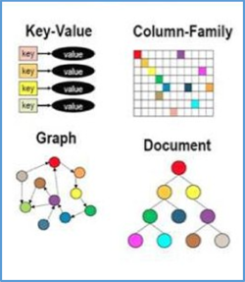
Figure 1 - Different types of NoSQL Database Designs[8]

NoSQL Database Solutions
Like SQL, there are NoSQL solutions that are available for database administrators to use, below is a list of different database solutions.

MongoDB
MongoDB uses the Document database design to store data[9], the data is saved in files that are similar to JSON and can be scaled heavily and is flexible. It has support for over 10 programming languages including C#, PHP and Java.
The database solution is one of the more popular NoSQL solutions and is used by popular such as Facebook, Google, eBay, EA and GOV.UK[9].

DynamoDB
DynamoDB is a NoSQL database which was created by Amazon, it uses the key-value database design and can deliver low latency performance[5]. DynamoDB can be installed on AWS (Amazon Web Services) which allows the database to be in cloud computing. This is a big advantage over the other database solutions as it means it is less hassle for database administrators.
The database solution is designed for companies offering Ad Tech, Gaming, Retail and Banking products with customers including Nike, Netflix, Samsung and Snapchat.

Cassandra
Apache Cassandra was originally designed by Facebook to be used as the inbox system, since then the NoSQL database has been taken over by Apache. Cassandra is popular for its speed and having a similar SQL-like query language[4].
Compared to other NoSQL database solutions, there is a short learning curve for Cassandra. An example of inserting to a Cassandra database is[10]:
INSERT INTO NerdMovies (movie, director, main_actor, year)
VALUES ('Serenity', 'Joss Whedon', 'Nathan Fillion', 2005)
USING TTL 86400;

INSERT INTO NerdMovies JSON '{"movie": "Serenity",
"director": "Joss Whedon",
"year": 2005}';
Code
The code above, taken from the Cassandra documentation is an example of using CQL which stands for Cassandra Query Language to insert data to a NoSQL database. This is helpful for database administrators wanting to use the technology as it means there is not of adjusting needed.

NoSQL vs SQL
With the rise of Cloud Computing, NoSQL databases have become popular with influential companies such as Amazon, Apache and Google all investing in NoSQL technology. For example, DynamoDB works best with AWS which is a Cloud Computing service.
One of the main differences between NoSQL and SQL is the properties of transactions.

ACID vs BASE
In SQL databases, there are four properties for the processing of transactions. They are known as ACID[3]:
- Atomicity – The transaction either takes place or it does not.
- Consistency – The data must be consistent before and after the transaction. This is typically handled by the database engine.
- Isolation – Multiple transactions can happen without a failed transaction interfering with other transactions.
- Durability – Once the data has been successfully committed, it must be written to disk instead of being placed in volatile memory.
In NoSQL databases, instead of the ACID properties of transactions being used. An acronym called BASE is used[11]:
- Basic Availability – The database will work most of the time.
- Soft-state – Different replicas of the database do not have to be consistent all the time.
- Eventual consistency – The database will lazily read different replicas and will eventually merge all the database together.

Comparison of SQL and NoSQL
Below is a comparison of SQL and NoSQL.
 | SQL Databases | NoSQL Databases
Design Type | Relational | Non-relational
Data Storage | Stored in tables | Stored in XML and JSON documents
Schema | Built before the database is created | Can be changed dynamically
Language | SQL (DDL and DML) | SQL is not used. Each database has its own language
Joins | Required to link data together | Not required
Support | Support available as used heavily | Less support available, but most are open source
Transaction Principles | ACID | BASE
Table of SQL Databases vs NoSQL Databases (Adapted from Database Zone[12]).

What should ABargain use as a Database System
As ABargain is a small company, it would be best for them to follow a traditional relational database design. This is because it may be expensive for the database administrator to learn how to use a NoSQL database engine.
But as the company expands and has a lot of records, the limitations of a large SQL database may cause a problem. Before this happens, it would be best if the database was converted to a NoSQL database which can handle a large amount of data.

ABargain Database
The ABargain database is built up of seventeen tables, the database is built to follow the rules of the third normal form (3NF). This means that there is not any data replication throughout the database.
Below is a schema of the Database.
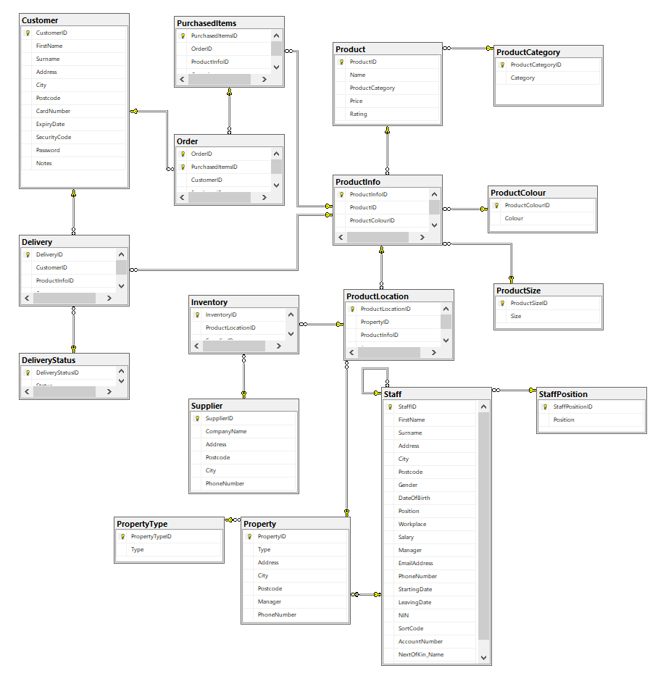
Figure 2 - ABargain Database Schema

Primary and Foreign Keys
Each table has a primary key, this is so the tables can relate to each other using foreign keys. It also ensures the database is kept integral. Some tables have a composite primary key, where two columns make up a primary key. The table containing a composite primary key is:
- Order Table – The composite primary key is made up of OrderID and PurchasedItemsID, this is so a single order can contain many different purchased items.

Check Constraints
The ABargain database has multiple check constraints, this is to ensure the data integrity is kept. Where data is required, the column has a constraint of not accepting null values. In other columns, there are further check constraints to allow specific values.
Primary Keys throughout the Database
The primary keys throughout the database are set to follow a certain format. This is to make it easier to reference in foreign keys or when inserting new data, for example, the Staff table primary key is in a format of S0001.
Postcode Checks
Throughout the database, the Postcode is required, as Postcodes are between 6-8 characters the check constraint requires the Postcode to be greater than or equal to six characters.
Staff being over 18 years old
In the Staff table, the employee’s must be over 18 years of age. There is a check constraint that uses a date difference function to compare now and then inserted date. If the year is under 18 then the check constraint fails.
Phone Number Checks
Throughout the database, the phone numbers are inserted in the following format “00000 000000”. If it is inserted any other way the check constraint will fail.
National Insurance Number
The national insurance number is in a format of “AA 00 00 00 A”, the check constraint follows the standard set by the UK Government and if it is anything else it will fail.
Sort Code Checks
The sort code throughout the database is stored in a format of “00-00-00”, this keeps the data consistent.
Account Number Checks
The account number is checked to be eight numbers which follow the format of British banks.
Leaving Date
In the Staff table, there is a leaving date, there is a check constraint added to ensure the leaving date is after the starting date of the employee.
Password Length
In the Customer table, there is a check constraint to ensure the Password is greater than or equal to 8 characters.

Indexes
Indexes are special tables that have been defined by the database administrator, the database system stores the tables in a cache which can be accessed quickly when needed. An index is like an index of a book, where the reader can quickly find a page they are looking for[3].
In the ABargain database, seven indexes have been created to speed up the database. The tables chosen to be indexed are Customer, Inventory, Order, Product, Product Info, Staff and Supplier.

Transactions
Transactions allow database administrators to control whether a query is executed. Transactions can be cancelled mid-execution when a condition is met, this is done by using the rollback keyword[3]. Inside a transaction block a try and catch block can be used, when using try and catch blocks the database engine will try to perform a query but if it fails, it will revert to the catch block. Inside the catch block, the database administrator can insert an error message and the statement to roll back the transaction[3].
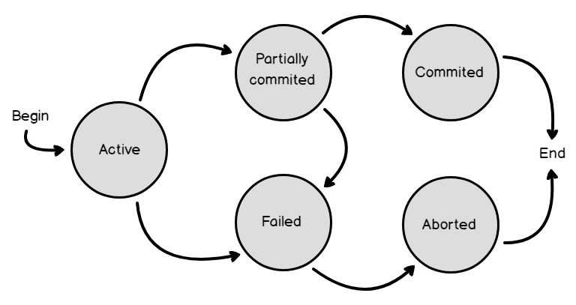
Figure 3 - Database transactions[13]
The image above shows the potential routes a database transaction. It shows a transaction can be partially committed then failed when this happens the database will revert itself and not execute the queries.

Transaction Problem One
For the first transaction, the database could record orders but not the products purchased. To solve this, a try and catch blocks were implemented.
The database attempts to execute a query with an invalid ProductInfoID but when that happens, the query fails because the foreign key is invalid. This is because it has not been created yet.
Inside the catch block, the database performs a rollback on the transaction then displays an error message to the database administrator.

Transaction Problem Two
This problem is more complex, as the system was originally allowing customers to order products that were not in stock.
The problem with this transaction was that there are multiple products attached to an order, this means a counting loop would have to be created to find the number of stock available. Another problem is that a product can be stored at multiple warehouses.
To find the number of products in an order, a count function was performed. This returned a number that could later be used in a loop. Counting (for) loops are not possible in SQL Server, so a while loop had to be created mimicking a counting loop. The loop would then cycle through each item comparing it to the warehouses, it would then use a sum function to return the total amount across all three warehouses.
If there was a product with zero stock, the database would roll back the transaction allowing it not to execute. It would then display an error message to the database administrator. If the products were in stock, the database would print a message displaying how many are left in stock across all three warehouses then the database would commit the transaction.
A setback with this solution is that it is not possible to test queries, to overcome this the data would have to be placed in a temporary table then the data would have to loop through. It was not possible to follow this approach due to lack of knowledge and time constraints although, the solution created could be expanded on to add the temporary table check later.

Distributed Database Solution
A distributed database allows the database to split up into fragments and split across servers in different locations. The database administrator must decide which method the database is fragmented[3]:
- Horizontal – The table is fragmented by rows.
- Vertical – The table is fragmented by columns.
- Horizontal Derived – The table is fragmented based on a horizontal parent table using a join.
- Mixed – A mixture of horizontal and vertical fragmentation.
- None – Fragmentation is decided against due to the table size or it is not possible to fragment.
When a table is not fragmented, it is replicated at every site so the database can still use that table. Tables that are fragmented must be reconstructed, when a table is horizontally fragmented the union statement is used which merges tables together. Tables that are vertically fragmented are combined using joins.

Customer Table
This table was fragmented using a vertical fragmentation, this is so that HR (Human Resources) can see the payment details of staff and customers for processing.
C₁: ΠCustomerID, FirstName, Surname, Address, City, Postcode, Notes (Customer).
C₂: ΠCustomerID, FirstName, Surname, CardNumber, ExpiryDate, Security Code (Customer).
The table would then be reconstructed by joining C₁ and C₂:
C₁ ⋈ C₂ = Customer

Delivery
This table uses a derived horizontal fragmentation, it uses the ProductInfoID to join to the ProductInfo table then the ProductLocation table to divide each fragment by warehouse. The fragments would then be stored at each of the relevant ABargain warehouses.
D₁: Delivery ⊳ _{ProductInfoID}, ProductInfo ⊳_{ProductLocationID} PL₁
D₂: Delivery ⊳ _{ProductInfoID}, ProductInfo ⊳_{ProductLocationID} PL₂
D₃: Delivery ⊳ _{ProductInfoID}, ProductInfo ⊳_{ProductLocationID} PL₃
To reconstruct this table the union keyword would be used on D₁, D₂ and D₃.
D₁ ∪ D₂ ∪ D₃

Delivery Status
This table is too small to be fragmented.

Inventory
The Inventory table is divided using a horizontal fragmentation, it is done using the PropertyID.
I₁: σProductLocationID = P0002 (PropertyID)
I₂: σProductLocationID = P0003 (ProprertyID)
I₃: σProductLocationID = P0004 (PropertyID)
To reconstruct this table the union keyword would be used on I₁, I₂ and I₃.
I₁ ∪ I₂ ∪ I₃

Order
This table could not be fragmented as there is no suitable way to do it.

Product
This table uses a horizontal fragmentation on the ProductCategory table.
P₁: σProductCategory = PC0001 (ProductCategory)
P₂: σ ProductCategory = PC0001 (ProductCategory)
P₃: σ ProductCategory = PC0001 (ProductCategory)
P₄: σ ProductCategory = PC0004 (ProductCategory)
To reconstruct this table the union keyword would be used on P₁, P₂, P₃ and P₄.
P₁ ∪ P₂ ∪ P₃∪ P₄

Product Category
This table would not have been fragmented as it is a small table.

Product Colour
This table would not have been fragmented as it is a small table.

Product Info
The Product Info table would use a derived horizontal fragment using the PropertyID from the ProductInfo table.
PI₁: ProductInfo ⊳ _{ProductLocationID} PL₁
PI₂: ProductInfo ⊳ _{ProductLocationID} PL₂
PI₃: ProductInfo ⊳ _{ProductLocationID} PL₃
To reconstruct this table the union keyword would be used on PI₁, PI₂ and PI₃.
PI₁ ∪ PI₂ ∪ PI₃

Product Location
The product location table would have been fragmented using a horizontal fragmentation on the PropertyID column.
PL₁: σProductLocationID = P0002 (PropertyID)
PL₂: σProductLocationID = P0003 (ProprertyID)
PL₃: σProductLocationID = P0004 (PropertyID)
To reconstruct this table the union keyword would be used on PL₁, PL₂ and PL₃.
PL₁ ∪ PL₂ ∪ PL₃

Product Size, Property and Product Type
These tables would not have been fragmented as they are small tables.

Purchased Items
A derived horizontal fragmentation would be used to divide the table based on the ProductLocationID. The reason this fragmentation was called PuI was that it would have conflicted with the Purchased Items fragmentation.
PuI₁: PurchasedItems ⊳ _{ProductLocationID} PL₁
PuI₂: PurchasedItems ⊳ _{ProductLocationID} PL₂
PuI₃: PurchasedItems ⊳ _{ProductLocationID} PL₃
To reconstruct this table the union keyword would be used on PuI₁, PuI₂ and PuI₃.
PuI₁ ∪ PuI₂ ∪ PuI₃

Staff
A vertical fragment is used as Human Resources (HR) need to see payment information for each staff member for monthly wage payments.
S₁: ΠStaffID, FirstName, Surname, Address, City, Postcode, Gender, DateOfBirth, Position, Workplace, Manager, EmailAddress, StartingDate, LeavingDate, NextOfKin_Name, NextofKin_PhoneNumber(Staff).
S₂: Π StaffID, FirstName, Surname, Address, City, Postcode, Gender, DateOfBirth, Position, Workplace, EmailAddress, NIN, SortCode, AccountNumber(Staff).
To reconstruct the table, a join is used
S₁ ⋈ S₂ = Staff

Staff Position and Supplier
This table was not fragmented as they are both small tables.

References

[1] “IBM100 - Relational Database,” 07-Mar-2012. [Online]. Available: http://www-03.ibm.com/ibm/history/ibm100/us/en/icons/reldb/. [Accessed: 10-Dec-2019].
[2] “ISO 8601 Date and time format,” ISO. [Online]. Available: http://www.iso.org/cms/render/live/en/sites/isoorg/home/standards/popular-standards/iso-8601-date-and-time-format.html. [Accessed: 10-Dec-2019].
[3] T. Connolly and C. Begg, Database Systems: A Practical Approach to Design, Implementation, and Management, Global Edition. Pearson, 2014.
[4] A. Fowler, NoSQL For Dummies: Real-Time Big Data Management for the Enterprise, 1st ed. 2015.
[5] “Amazon DynamoDB - Overview.” [Online]. Available: https://aws.amazon.com/dynamodb/. [Accessed: 11-Dec-2019].
[6] “AWS | Amazon SimpleDB – Simple Database Service.” [Online]. Available: https://aws.amazon.com/simpledb/. [Accessed: 11-Dec-2019].
[7] “Cloud Bigtable | Google Cloud.” [Online]. Available: https://cloud.google.com/bigtable/. [Accessed: 11-Dec-2019].
[8] “6433.SQL-vs-NoSQL.jpg (1183×427).” [Online]. Available: https://social.technet.microsoft.com/wiki/cfs-filesystemfile.ashx/__key/communityserver-wikis-components-files/00-00-00-00-05/6433.SQL-vs-NoSQL.jpg. [Accessed: 11-Dec-2019].
[9] “What Is MongoDB?,” MongoDB. [Online]. Available: https://www.mongodb.com/what-is-mongodb. [Accessed: 11-Dec-2019].
[10] “Documentation.” [Online]. Available: https://cassandra.apache.org/doc/latest/cql/dml.html#insert. [Accessed: 11-Dec-2019].
[11] “Graph Databases for Beginners: ACID vs. BASE Explained,” Neo4j Graph Database Platform, 13-Nov-2018. .
[12] “SQL vs. NoSQL - DZone Database,” dzone.com. [Online]. Available: https://dzone.com/articles/sql-vs-nosql. [Accessed: 11-Dec-2019].
[13] “word-image-65b.png (768×407).” [Online]. Available: https://www.sqlshack.com/wp-content/uploads/2019/01/word-image-65b.png. [Accessed: 11-Dec-2019].

