

Video Games as Art: Questioning Culture.
  - Dissertation
Adam Head | Creative Computer Games Design – Level 6 | 5459 Words

Submitted in partial fulfillment of the requirements for the degree of BA (Hons) University of Wales Trinity Saint David, Swansea on 11th December 2018.

Table of Contents
Introduction 2
Case Study: Robert Ebert 3
Case Study: Thibault Brunet and Marcel Duchamp – A Comparison 7
Case Study: Interactive Art 12
Case Study: Tetris 14
Conclusion 16
Bibliography 17
List of Images 18

List of Images
Figure 1 – p7: Vice City – Brunet, T., 2012.
Figure 2 – p8: First Person Shooter – Brunet, T., 2012.
Figure 3 – p9: Fountain – Duchamp, M., 1917.
Figure 4 – p10: Light Fall Development Still. - Robillard, M., 2016.
Figure 5 – p11: Still from Django Unchained. - Tarantino, Q., 2013.
Figure 6 – p12: Contest between Zeuxis and Parrhasius. - Merian, M., 1630.
Figure 7 – p13: Google Tilt Brush – Google, 2016.
Figure 8 – p14: Tetris 1984 vs. Tetris 2018 - Louis, A., 2018.

Introduction
It can be argued that throughout history, art has been used as a tool to bridge cultures and communicate emotions. The integral requirement for a piece of art is that it has been created with the purpose of making the viewer feel or perceive in a certain way and in some occasions; artists can aim to influence points of view with their work in an attempt to bring enlightenment to a particular topic or issue.
This essay aims to argue that video game experiences could be considered an art form by using literature and opinions of both leading critics and influential artists; along with case studies of comparative examples to expose the cultural significance of video games and identify their place in society among more classical, established art forms.
This paper will look to explore the place of Video Games as an established art form by:
- Analysing and deconstructing the opinion of an authority on digital media; “Roger Ebert”, to establish a narrative that exposes opposing sentiments on the cultural significance of video games in order to bring context to the case studies explored in this essay.
- Identifying individuals currently using video games as a means to produce more conventional pieces of art through mediums such as in-game renders/screenshots; paying special attention to the work of Thibault Brunet.
- Examining any implications of considering video games on an equal cultural footing to more established art forms (e.g. classical painting, film, photography.) and whether this would have a positive or negative effect on the games industry as a whole.
As well as exploring the topics outlined above, overall discussions will be formed regarding video games’ role as both an entertainment platform and a commentary on modern society as a whole; much in the same way as more conventional mediums. In order to reflect and in turn analyse the possible artistic future of video games, it must be remembered that the original intention of these interactive, playable creations is to entertain. With this in mind, a clear distinction will be drawn between the original intention of games designers; whether it be to create an artistic statement, or to merely create an object of entertainment that also possesses artistic qualities as a byproduct of the creative process.
“Video games are the quintessential social texts of our present cultural moment.” Jones, (2008)

Case Study: Robert Ebert
Roger Ebert (1942-2013) was an American film critic and is widely regarded as being a figure of authority in the field of digital media. With a career spanning 46 years, Ebert developed many practices for both criticizing and praising most digital media platforms, with a focus primarily on film; creating a reputation for being an advocate for the recognition of film as an established art form on equal cultural footing with classical forms of art (e.g. Painting, Sculpture, Music etc.) whilst creating an honest, in-depth review platform that would go on to gather many followers not only in his home city of Chicago, but all over the world.
“It would not be a stretch to say that Mr. Ebert was the best-known film reviewer of his generation, and one of the most trusted.” Martin, (2013)
Ebert became well known for his method of listing films into compilations and lists, with both a greatest, along with most hated list of films in which he deconstructed and analysed various aspects of the subject’s creative decisions in order to further justify his view point that digital media (especially film) is capable of being art. Roger Ebert also gained popularity with his televised film critique show; “At the Movies” (broadcast nationwide by ABC Domestic Television in the USA), in which Ebert and fellow film critic Gene Siskel discussed and criticized contemporary movies; concluding each review with a thumbs up or thumbs down rating. This simple method for rating films quickly made their critiques nationally recognized as being a go-to method for moviegoers to determine a films worthiness.
On April 16th, 2010, Roger Ebert published an article titled; “Video Games Can Never Be Art”. From this piece, Ebert illustrates his authoritative opinion that video games are inherently incapable of an artistic portrayal; introducing the article with an elaboration on its title, Ebert proposes that no comparisons have ever been drawn between that of any video game or the work of history’s great poets, writers, sculptors or film makers etc., from either the critiquing or artistic professional community as a whole; thus presenting his viewpoint that no video game has ever been deemed worthy of even being classed as art at the very beginning of the article. This shows any reader his staunch, erudite predetermination before any evidence for his opinion has either been displayed or analysed, possibly using his position as an authority in the field of digital media to create a bias in his readers’ minds before they can formulate a considered opinion. [Ebert, 2010]
In the main body of the article, Ebert uses varied examples of video games released at the time of publication that had been either put forward as art or critically acclaimed by the public, in order to deconstruct them and dismiss them as being mere examples of Ludology and nothing more. Ebert also focuses on a TED talk given by Kellee Sangtiago (a producer from the games industry) in the University of Southern California and uses the provided exampled in argument against Sangtiago’s proposals, along with her definition of art. In the talk, Sangtiago draws a comparison between both cave paintings and video games’ place in artistic culture; suggesting that while culturally similar in equivalence to the cave paintings, video games will eventually evolve the same way that speech and writing both evolved into methods of story telling from being used solely for the purpose of basic communication. This comparison is particularly telling, as it makes clear that while video games are far more technologically sophisticated in relation to cave paintings; they are both equally culturally restrained, suggesting that both technology and art may not be a historically natural pairing. [Ebert, 2012]
Ebert goes on to propose that there is one obvious difference between video games and art; that you can win a game. He suggests that the rules, objectives and outcomes within constrain video games from being artistic and are purely ludological constructs with the sole purpose of presenting the viewer with a task or challenge that must be completed as a form of entertainment. This is a comparison he draws to chess, a game which Sangtiago herself concedes (along with football, baseball, mahjong etc.) are not art “no matter how elegant their rules”. While this may be an interesting argument by Ebert, the same can be applied to almost any known form of art; for example, there are a form of rules in painting with the concepts of colour and light theory; in storytelling with basic conventions of the beginning, middle and end or even movies with the widely used “heroes arc”. The use of these rules/frameworks are largely the decision of the creator themselves; or in this case, the player of the video game and by classifying such rules as being absolute, Ebert has implied that all games are linear in nature and allow gamers no freedom. [Ebert, 2012]
Ebert then explains both Plato and Cicero’s view/definition of art; that it should be defined as an imitation of nature. He goes on to argue that while it can be said there are “immersive games that don’t use points or rules”, the very removal of these qualities makes it no longer a game but an experience or simply a portrayal/representation of something artistic. While this point is valid in a literal sense, it could be argued that the act of interacting with something towards a goal is one of the most natural processes performed by humanity, many times on a daily basis and could even be compared to the work of history’s great artists that Ebert referenced earlier in the article; the very act of creating a piece of art (of the classical forms) can be deconstructed to the point in which it resembles a game/ludology; e.g. Painting; - The painter assigns themselves the goal of completing a portrait. There are a number of tasks, requirements and challenges the painter must overcome/face in order to reach their end goal, much in the same way video game players perform a certain number of tasks in order to finish the game. These comparative deconstructions support the view point that there are more comparisons than contrasts when viewing ludology (specifically video games) as a possible art form. Ebert (2012) proposes,
Why aren't gamers content to play their games and simply enjoy themselves? They have my blessing, not that they care. Do they require validation? In defending their gaming against parents, spouses, children, partners, co-workers or other critics, do they want to be able to look up from the screen and explain, "I'm studying a great form of art?" Then let them say it, if it makes them happy.
In the year preceding the article written by Ebert, a decision had been made by the supreme court of the United States of America ruling that video games should be considered an art form and “therefore should be protected under the first amendment which guarantees free speech.” This ruling came in response to a law enforced in the state of California that would allow the regulation and censorship by the state, of the purchasing/rental of video games which was deemed unlawful by the Supreme Court; as this contravened the verdict that even though medium of video games was relatively new, games themselves should not be treated differently to other forms of entertainment and art; e.g. plays, movies, books etc. [Brown v. Entertainment Merchants Assn., United States Supreme Court, 2011]
The significance of this ruling gives substantial power to the argument for Video Games as art and is a stark contrast to the aforementioned quote by Ebert, as the actions undertaken by the United States Supreme Court grant games a legal equivalency to the established art forms with their status in society being as protected in United States law as the very right to free speech and expression which Ebert has used to argue his point of view in his article. Video Games’ place as an art form is as legally recognized as Ebert’s right to say they’re not.
While the Supreme Court’s ruling was by no means a cultural one, the creation of the first Video Game based exhibition at the Smithsonian American Art Museum on the 16th of March 2012, a full month before the publication of Ebert’s article, could be construed as the cultural recognition required to be used as evidence in argument against such a significant authority as Roger Ebert. The guest curator of the exhibition, Chris Melissinos, proposes that the trinity between game, artist and player is critical for the understanding of Video Games’ transcendence to art and when done correctly presents the player with more than a mere form of entertainment, but an interaction of cultural significance. This is in direct contradiction to the quoted passage above as it presents the players as not just being mere viewers of entertainment/art, but an integral component in its transcendence to becoming an established art form through the medium of play and interaction. [O’Brien, 2012]
Ebert (2012) goes on to summarize,
I allow Sangtiago the last word. Toward the end of her presentation, she shows a visual with six circles, which represent, I gather, the components now forming for her brave new world of video games as art. The circles are labeled: Development, Finance, Publishing, Marketing, Education, and Executive Management. I rest my case.
For Ebert to suggest video games are unique in the respect of trying to make money, or marketing is debatable when looking also at the film industry (in which Ebert focuses the majority of his critiquing work) for example. Between January 1st and June 30th, 2015, Warner Brothers Studios and Universal Pictures spent an estimated $456 million and $296 million respectively on television advertisements for those six months alone. This is a stark comparison to the entire games industry’s television advertising/marketing spending, with $629.2 million spent in total for the year of 2015 as opposed to the earlier six month figure provided for only two of the major Hollywood film studios. This comparison could imply a massive disparity in spending between the industries, but it must also be taken into account that the majority of the games industry’s advertising and marketing takes place on online/social media platforms; with a focus on approaching potential customers on their chosen console as opposed to more conventional methods, i.e. television. [iSpot.tv, 2015] [Servideo, 2016]
Traditional art is not immune to the need to make money or even to marketing practices, as even artists and creators need to develop portfolios, followers and eventually patrons in order to creating their works; much in the same way marketing departments of both Video Game and film companies use advertising to network their new creations to potential customers. Ebert’s criticism that the video game industries main focus is on marketing and is thus not an art form is questionable, as the great artists of history that were referenced earlier in the article, such as painters or sculptors, have also been recorded to have accepted commissions and sold works in order to support themselves. There is an implication by Ebert that the act of trying to sell, or profit from a piece/work somehow strips them of their right to be classed as art. As Valjak (2017) explains regarding Michelangelo,
For painting the ceiling of the Sistine Chapel, he was paid 3000 ducats, which would amount to approximately 78 000 dollars in today’s terms, which at the time was a stellar amount of money. For the tomb of Pope Julius II, he was reportedly paid 10,000 ducats, an astronomical sum.
While the deconstruction and analysis of Ebert’s article presents many points to consider on the prospect of video games being considered as art, compared with the more established/traditional forms – specifically the implication of the introduction of another recognized art medium in the already vastly populated artistic world; there are more comparisons that can be drawn upon by exposing examples of video game based work crossing barriers into potentially being inclusive of certain art movements, with the aim to further reinforce the image of video games as an academically viable and equal companion to the classical forms.

Case Study: Thibault Brunet and Marcel Duchamp – A Comparison
Thibault Brunet (b. 1982) is a French photographer who uses video game environments and characters in order to create snapshots of a virtual world which are used for exhibitions. Much of his work focuses on lesser seen aspects of video games such as rarely used side roads, non-playable characters and general objects in the game environment. By using these virtual elements in familiar formats (e.g. Landscape, Portraiture) Brunet is able to create a visual narrative that is easily accessible to any viewer and expose the previously unknown artistic qualities of a video games world even to an audience who have never before been exposed to the medium.

Fig. 1: Vice City - Thibault Brunet, 2012
These creations bridge the gap between art forms with a unison of both landscape photography and video games design. Such a unison of art forms can also be seen in video game concept art; where classically trained painters and artists create fantastical approaches to reality in order to inform the design of a game environment. This brand of “virtual photography” is an example of how video games can evolve further as an art form, adapting to cohesively merge with other more established/traditional mediums in order to create works from the genuinely unique perspective of a group of artists virtual presentation of the world around them; further reinforcing Sangtiago’s statement analysed by Ebert; that like cave paintings, video games will continue to evolve to resemble the established forms of art accepted by society today, thus making them more accessible to a wider audience.
Brunet’s work: “First Person Shooter” is a collection of stills and renders taken directly from a video game world by the artist. The collection contains stills and landscapes of barren, war torn cities that are implied to be in the Middle East, along with portraits of the characters that inhabit this virtual world. The emotionally ambiguous expressions of the soldiers taken in Brunet’s portrait stills are particularly telling, as it makes it clear to the viewer that these are in fact virtual photographs of characters, taken not from a real world war/battle but from a realistically created virtual environment, designed by a number of individual artists. This realization arguably promotes the place of video games as not only an art form in itself; but a social commentary on the world around us and a reflection on society as a whole.

Fig. 2: First Person Shooter - Thibault Brunet, 2011
Fountain (by Duchamp) is a sculpture piece consisting of a urinal originally created for a men’s public toilet, turned on its side and signed. At the time this caused an outrage in the art community as it called into question “what makes something a work of art?”, and “what is the role of art institutions in evaluating and qualifying art?” The very proposal that this piece would be exhibited at the time was rejected by an art society of which Duchamp was a member. These questions have shaped art in modern society and led to Marcel Duchamp being considered a founding member of the “Readymade” movement, in which manufactured objects are manipulated or simply just designated as being art. [Artland, 2017]

Fig. 3: Fountain – Marcel Duchamp, 1917
This also calls to question whether all art created using video games is in fact part of the “Readymade” movement, as the art, assets and worlds were originally created by teams of developers with their own unique vision and disciplines; comparable to the designers, sculptors and workers who created the original “Fountain”. This comparison and classification of Brunet’s video game based work into a specific art form (Readymade) exposes and promotes the clear synergy between mediums; contrary to the belief that virtual pieces are a separate entity from already established art forms/conventions.
Brunet and arguably Duchamp take this one step further by not only using their work as a means of creating aesthetically pleasing pieces, but pieces that evoke specific feelings and provoke deep philosophical questions upon their consideration with each artist using the same methods to tap into specific opinions or view-points. Brunet’s vividly realistic capturing of a video games worlds is arguably a surrealist statement on society’s increasingly computerized presence by using his brand of “visual photography” as a medium with which to showcase cultural questions and concerns; as shown in his “First Person Shooter” collection.
Classifications of game based art into artistic movements is just one method that can be used to justify the video games as an equally viable art form. Further justifications can be explored when also comparing games industry developers use of established artistic principles and approaches; such as colour and light theory – paying special attention to the similarities specifically with the film industry.

Fig. 4: Development Still from Light Fall – Robillard, 2018
“Light Fall” is a side scrolling adventure game released in 2018 by Bishop Games, that has players jump, roll and dive in order to navigate a hazardous and often fantastical environment in order to progress the narrative in the form of a story of a hero on a quest to liberate the world from a dark evil. “Light Fall” is a clear example of video games developers’ use of colour theory; with many uses and references to the conventional cold/warm style colour schemes throughout the experience. The player is introduced straight away to the games colour palette, with each area/zone in the virtual world having a clear, strict pattern of colouration. This is used by the developer to create objects or characters with the appearance of being a completely alien presence in the world by using a colour contrasting the original scheme; instantly signaling any major threats or changes to the player in abrupt shifts in tones.

Fig. 5: Still from Django: Unchained – Quentin Tarantino, 2013
While colour theory has been in artistic practice for centuries, there are clear comparisons to be drawn between its use in both the video game and film industries. Using the above still from “Django: Unchained”, released in 2013; a clear comparison can be illustrated on both mediums similar use of colour theory; with the cold blue palette of the snow and lead characters in the foreground showing a stark contrast to the heavily heat based colouration on the underlying valley and mountain peaks. This is identical to the development still of “Light Fall”, in which the bluish, cold and bleak undergrowth is warmly lit by the warm, contrasting shades of fuchsia and blinding white from above.
By identifying the similarities between mediums and their combined use of recognised artistic principles, it is clear that video games are subject to the same conventions and are viewed with a similar perception the universal language of colour. This similarity means that video games could be equally as deconstructed in an aesthetic sense, further reinforcing the connection between video games and the conventional, established art forms.

Case Study: Interactive Art
Developments in technology have not only changed society as a whole but have also consequentially adapted societies perception of what makes something artistic/cultural. These developments have been defined as “Interactive Art.” This form of art relies on the relationship between artist and spectator to develop unique experiences, often utilizing electronic means such as; computers, sensors and interfaces to create an immersive atmosphere that further reinforces the message that the artist wants to convey.
While it could be easily assumed that interactive art is a fairly modern invention due to its often computerized/electronic appearance; the act of creating interactive art that requires the participation or involvement of spectator’s dates back to the times of Ancient Greece, with the work of Parrhasius. Maurice Benayoun, an authority and theorist of the New Media/Interactive Art movement, considers the work of Parrhasius to be the first example of interactive art. During a contest with Zeuxis (a friend of Parrhasius) in the 5th century B.C., Parrhasius had Zeuxis attempt to open a set of curtains in order to reveal a piece of his work, only to discover that they were in fact only realistic, painted depictions of curtains. [Benayoun, 2008]
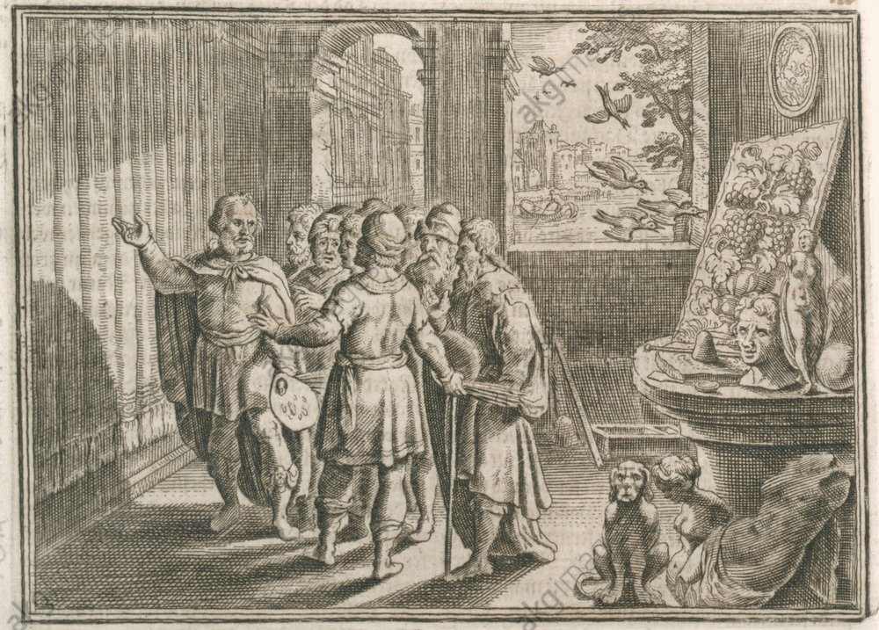
Fig. 6: Contest between Zeuxis and Parrhasius – Matthäus Merian, 1630
On analysis, this event can be seen as the definition of what classifies a piece of interactive art; as in the example of Parrhasius, the painting of the curtains ascended to an interactive level upon the actions (under the artists instruction in this case) of Zeuxis. This simplified explanation is also in direct correlation with video games as objects themselves; as without the invitation of interactivity to the player/viewer, or the framework with which to grant them any form of usability; they are merely a collection of hidden works, much like an art gallery closed to the public, only to be opened when interacted with. Video games’ artistic potential is directly dependent on the participation of a spectator in a modem form of Parrhasius’ ancient contest, repeating the same principles every time a video game is launched and thus played. [Benayoun, 2008]
It can be conceded that the next natural step in which the interactive art movement will advance is physically influenced virtual reality. This is a significant evolution when viewed in a video game-based context, as the technology making such advancements possible would never have been created or even conceived if not for the games industry. This is promoted furthermore with the now wide spread use of “Touch Controllers” allowing users/players to introduce their hands into the virtual space, transcending the experience from passivity into a platform within which the spectator becomes the participant. [Benayoun, 2008]
Inherently, video games and virtual reality are part of the interactive art movement and should be treated as such. Although, the cultural and artistic implications of this focus on technology not only benefits the games industry, but the art world as a whole. Video games and virtual reality peripherals not only increase the accessibility to other more contemporary art forms via. Virtual reality experiences allowing the user to visit art galleries from the comfort of their home; but also present themselves as tools to create new pieces of art using applications such as “Tilt Brush” created by Google for use on Virtual Reality gaming set ups allowing users to create three dimensional art work using their touch controllers/peripherals. This shows that not only can games be a source of entertainment and a form of interactive art in principle; but can also become a new medium which enables that allows artistic expression for the masses.
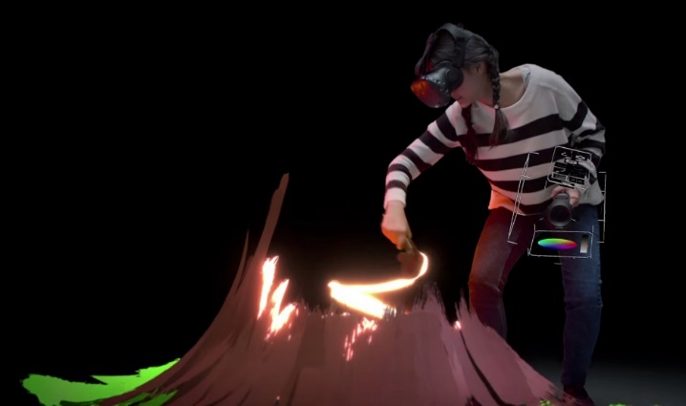
Fig. 7: Tilt Brush – Google, 2016

Case Study: Tetris
While hailing video games’ ability to not only be classified in principle as interactive art and its ability to thus aid in the creation of further pieces; considerations must be drawn for video games’ power to convey a particular social narrative or cultural message and sometimes bring to light a particular issue/topic. There is a prime example of both seen in effect when analysing the ludological classic: Tetris.
Tetris is a two dimensional puzzle game created in 1984 by the Russian video games developer Alexey Pajitnov. It is widely regarded by many in the gaming world as being a pioneer of the puzzle/casual gaming genre, with its easy to learn – hard to master gameplay relying on the users ability to deal with an ever increasing swathe of bricks that must be neatly stacked and aligned in order to clear the shapes row by row, never allowing them to reach the top, as when that occurs – the game is over. Tetris has been adapted and changed over the years to match with changes in technology and demographic, but its core principles, rules and gameplay remain completely intact, remaining as one of the widely played casual games still available today. [Plank-Blasko, 2015]

Fig.8: Left: Tetris, 1984. – Right: Tetris Effect, 2018.
On the surface, Tetris seems to be a simplistic, casual puzzle game with the sole purpose of being an entertaining time waster with no further story or deeper meaning. It is not until the history of its creator and origin is analysed that a true underlying narrative may be discovered and elaborated on. It is worth remembering that Tetris was created during the height of the cold war in 1984, a tumultuous time for the Union of Soviet Socialist Republics (U.S.S.R) and a perfect catalyst for the social idea that would become Pajitnov’s creation. Tetris can be (or was arguably intended to be) seen as a representation of Soviet, Communist society; in which national production and infrastructure is key, with responsibility for not only the future prosperity of the nation resting on the shoulders of the workers, but it’s political and social ideologies as well. [Plank-Blasko, 2015]
Tetris’ core gameplay ideas and mechanics are thus which reinforce this idea/principle. The blocks can arguably be seen to represent the multifaceted national identity of Soviet life; with sections of Soviet society, Political Blocs and the workers themselves having to work together in cadenced unison in order for the nation to function and prosper. When the player completes a fully aligned, horizontal section of blocks; they vanish only to be recycled through the gameplay process once more – akin to a factory or assembly line, constantly working in a rhythmic manner. But if one of the blocks should be misplaced, the entire game is jeopardized; much in the same way that when viewed in the context of its origin in Russia at the height of the cold war, it symbolizes how all aspects of Soviet society must work hand in hand; otherwise resulting in hardships and eventually catastrophic failure. [Plank-Blasko, 2015]
This analysis further promotes the concept of video games as an art form, as it is possible to portray a message or narrative through a ludological construct as evidenced by this case study. By exposing video games to an academic, deconstructive review it can be clear that philosophical assumptions can be drawn from this medium much in the same way a painting could be analysed, finding that no matter how simple the idea or concept may first appear to be (whether intentional or not) there can be a deeper meaning to be discovered which may not have originally been clear. It is this element of mystery that makes art such a focal point in humanities history; presenting video games as the next natural piece of the artistic puzzle which has inspired humankind since the creation of the very first cave paintings millennia ago.

Conclusion
As with any question of culture, there are far reaching implications not just for the art world but society itself. While giving video games an equal cultural pedestal as the other established or more classical art forms would give the creators the credit afforded of their efforts and discipline, it is possible that such a classification could cause pressure on the games industry to be forever forced to justify and explain the work they create. By making the games design process more academic and less dynamic in its approach it is a further possibility that the creative freedoms it possesses currently may be stifled when the looming presence of the artistic community is taken into account in the creation phase.
There would be a question of the individual artist’s recognition in this potentially new cultural milestone, as the games industry has been known to often employ hundreds, sometimes even thousands of people to work on one video game, all of which specialize in many different disciplines. While crediting artists individual contributions is a possibility in terms of noting each persons contribution to a project, on a scale as large as the average games development process such an action may prove exhaustive; while video games have almost always used credit rolls/sequences much akin to the film industry, they differ in the fact that they are often able to be skipped or closed by the touch of a button as opposed to the passive, immovable listings provided at the end of a movie or the signature of the painter in the corner of the canvas. This is one of many possible ways that the games industry could look to learn from its new artistic counterparts; paying special attention to the very similar evolution of the film industry into a now established medium.
As noted in his article analysed above, Roger Ebert inquires; “Do gamers require validation?” In conclusion and retrospect, it is possible that video games being validated as art may be a question that doesn’t cross the mind of the average gamer, much in the same way the average movie goer does not automatically assume their experience from an artistic angle; video games main purpose is that of entertainment and it is possible that marketing them as art, or any such label other than for entertainment could irreparably damage the image of video games, the games industry and gamers in general as it is primarily the desire to be entertained that first motivates the average gamer to participate in a video game experience and not it’s potentially deeper artistic meaning. While artistic validation is a major concern when considering video games as pieces of art, nothing can reinforce the mediums place in culture and society more than the ability to study for degree in video game design at a vastly growing number of universities and colleges of art around the world.

Bibliography
ARTLAND. (2018). Top 10 most controversial artworks that shook the art world. [Online] Available at: https://artlandapp.com/10-controversial-artworks-changed-art-history/ [Accessed 13 Oct. 2018].
Gee, J. (2006). Why Game Studies Now? Video Games: A New Art Form. Games and Culture, 1(1), pp.58-61.
Jones, S. (2008). The meaning of video games. New York: Routledge.
Walker, J. (1999). Art and outrage. London: Pluto Press.
O'Brien, J. (2012). Are video games art? [Online] BBC News. Available at: https://www.bbc.co.uk/news/magazine-17373879 [Accessed 15 Nov. 2018].
Rainey, J. (2016). The Perils of Promotion: Pricey TV Campaigns, Fear of Change Shackles Movie Spending. [Online] Variety. Available at: https://variety.com/2016/film/features/movie-marketing-advertising-tv-campaigns-1201724468/ [Accessed 20 Nov. 2018].
Variety. (2015). Mid-Year Movie Report: Warner Bros. Dominates Top TV Ad Budgets. [Online] Available at: https://variety.com/2015/film/news/mid-year-movie-report-warner-bros-dominates-top-tv-ad-budgets-1201539126/ [Accessed 20 Nov. 2018].
Ebert, R. (2012). Video games can never be art | Roger Ebert's Journal | Roger Ebert. [Online] Rogerebert.com. Available at: https://www.rogerebert.com/rogers-journal/video-games-can-never-be-art [Accessed 22 Oct. 2018].
Martin, D. (2013). Roger Ebert Dies at 70; a Critic for the Common Man. [online] Nytimes.com. Available at: https://www.nytimes.com/2013/04/05/movies/roger-ebert-film-critic-dies.html [Accessed 24 Oct. 2018].
Supremecourt.gov. (2011). Brown v. Entertainment Merchants Association, 564 U.S. 786 (2011). [Online] Available at: https://www.supremecourt.gov/opinions/10pdf/08-1448.pdf [Accessed 29 Oct. 2018].
de Nijs, P., (2016). Duchamp Biography. RELIEF - Revue Électronique de Littérature Française, 10(1), pp.8–9. DOI: http://doi.org/10.18352/relief.921
Plank-Blasko, D. (2015). ‘From Russia with Fun!’ Tetris, Korobeiniki and the ludic Soviet. The Soundtrack, 8(1), pp.7-24.
Zach Servideo, i. (2018). Gamemakers spent nearly $630M on TV ads in 2015. [online] VentureBeat. Available at: https://venturebeat.com/2016/01/11/gamemakers-spent-nearly-630m-on-tv-ads-in-2015/ [Accessed 3 Dec. 2018].

Image References
Figure 1 – p7: Brunet, T. (2012). Vice City. [image] Available at: http://thibaultbrunet.fr/wp-content/uploads/2016/03/ThibaultBrunet_Site_Sauvv-960x728.jpg [Accessed 18 Nov. 2018].
Figure 2 – p8: Brunet, T. (2011). First Person Shooter. [image] Available at: http://thibaultbrunet.fr/wp-content/uploads/2016/03/ThibaultBrunet_Site_Sauv6-960x728.jpg [Accessed 19 Nov. 2018].
Figure 3 – p9: Duchamp, M. (1917). Fountain. [image] Available at: https://d7hftxdivxxvm.cloudfront.net/?resize_to=width&src=https%3A%2F%2Fartsy-media-uploads.s3.amazonaws.com%2Fi-8Le397-h2ZTgLM1iMegw%252FMarcel_Duchamp.jpg&width=1200&quality=80 [Accessed 19 Nov. 2018].
Figure 4 – p10: Robillard, M. (2016). Light Fall Development Still. [image] Available at: https://d1jmp7so7ezzp3.cloudfront.net/bishop-content/uploads/2016/10/LF1-700x332.jpeg [Accessed 10 Dec. 2018].
Figure 5 – p11: Tarantino, Q. (2013). Still from Django Unchained. [image] Available at: https://digitalsynopsis.com/wp-content/uploads/2016/05/cinema-palettes-famous-movie-colors-django-unchained.jpg [Accessed 10 Dec. 2018].
Figure 6 – p12: Merian, M. (1630). Contest between Zeuxis and Parrhasius. [Etching] Berlin: Joh. Lud. Gottfried, Historische Chronica.
Figure 7 – p13: Google (2016). Google Tilt Brush. [image] Available at: https://cdn-images-1.medium.com/max/2000/1*2F4CK-jv40UnvYDCAQxL7g.jpeg [Accessed 4 Dec. 2018].
Figure 8 – p14: Louis, A. (2018). Tetris 1984 vs. Tetris 2018. [image] Available at: https://i.ytimg.com/vi/_4rc8b7d5AA/maxresdefault.jpg [Accessed 9 Dec. 2018].

