Change makers: Creativity and Value Creation
Assignment 2

Karen Windsor (1918576)
1918576@student.uwtsd.ac.uk

Table of Contents
1 Link to e-portfolio 2
2 Task 1 2
2.1 Quantitative analysis methods 2
2.1.1 Descriptive Statistics 2
2.1.2 Inferential Statistics 2
2.1.3 Regression Statistics 2
2.1.4 Time Series Analysis 2
2.1.5 Data Mining 2
2.2 The Organisation of Qualitative Data 3
2.2.1 The right equipment for the job 3
2.2.2 Creating initial codes and recognising themes 4
2.2.3 Storage of Research Documents 5
3 Task 2 Poster 5
3.1 Link to Poster in CANVA 5
3.2 Scope 7
3.3 Objectives 7
3.4 Proposed Solution 7
3.5 Project Management 7
4 Task 3 8
4.1 Q1 Developing new skills 8
4.2 Q2 Positive impact 8
4.3 Q3 Potential Risks and Challenges 8
5 E-Portfolio Screenshots 9
6 Engagement with literature screenshots 13
7 References for Task 1 Q1 and Q2 15
8 References for Task 2 Poster 16
9 References for Task 3 16

Screenshot 1 Assignment 2 10
Screenshot 2 Quantitative Data 10
Screenshot 3 Quantitative Data 2 10
Screenshot 4 Chart 1 10
Screenshot 5 Chart 2 11
Screenshot 6 Chart 3 11
Screenshot 7 Qualitative Data 11
Screenshot 8 Qualitative Data 2 12
Screenshot 9 Theme flowchart 12
Screenshot 10 Cloud Storage 12
Screenshot 11 Task 3 13
Screenshot 12 Task 3 page 2 13
Screenshot 13 References task 3 13
Screenshot 14 Unit 4 Topic 1 Section 1 14
Screenshot 15 Unit 1 Topic 1 Section 2 14
Screenshot 16 Unit 4 Topic 1 Section 3 14
Screenshot 17 Unit 4 Topic 2 Section 1 15
Screenshot 18 Unit 4 Topic 2 Section 2 15
Screenshot 19 Unit 4 Topic 3 Section 1 15
Screenshot 20 Unit 4 Topic 3 Section 2 16
Screenshot 21 Unit 4 Topic 3 Section 3 16

Figure 1 Bar chart 3
Figure 2 ED waiting times bar chart. 3
Figure 3 Line time chart 4
Figure 4 Flow chart 6
Figure 5 Cloud Storage 6
Figure 6 Poster 7
Figure 7 Gantt Chart 8

Table 1 of Interview Questions 5

Link to e-portfolio
https://1918576.wixsite.com/website

Task 1

Quantitative analysis methods

Descriptive Statistics
The methodology for this branch of statistics is one of summarising the data using a predefined set of controlled measures and analysis practices. According to Mendenhall et al [1] descriptive statistics uses standard deviation and frequencies to calculate how the data is positioned around the mean, looking for trends and patterns that the data demonstrates. Visualisations in the form of bar charts, histograms and scatter plots are often used in descriptive statistics to facilitate and better express the trends and patterns in a format that is easier to understand.

Inferential Statistics
Is a methodology that makes ‘inferences or suppositions and uses those deductions to conclude either a cohort of the population or a sample using methods like hypothesis testing and/or confidence intervals.
In a recent article Amrhein, Trafiomox and Greenland [2]document that inferential statistics are unpredictable descriptions of the relationship that exists between the assumptions and the data. And that any results gained from using this type of statistical analysis should be treated as being underdeveloped and not showing a conclusive result.

Regression Statistics
Kranzler [3] states that Regression Analysis is used to examine if a relationship between a dependent variable and one or more independent variables to predict or explain outcomes.
Quantitative analysis is a vital aspect of research and decision-making in various fields. It involves the use of mathematical and statistical methods to gather, analyse, and interpret numerical data. This summary provides an overview of different types of quantitative analysis. This project could use this method for modelling and forecasting to predict future numbers of patients that will need Unscheduled care through the winter months.

Time Series Analysis
Again, this method of analysis can be used to identify patterns and trends, and predict future service requirements, by studying data points collected over a period of time. Chatfield [4] indicates that the autoregressive integrated moving average (ARIMA) and moving averages methods are used in Times Series Analysis.

Data Mining
Refers to the method of extracting information, trends and patterns from large datasets, where methodologies are used to highlight previously unknown relationships, that will prove in the case of this project Welsh Government with the information they need to be able to make informed decisions on how to allocate funds and how to support those Health Boards that are not performing to the required standard.
Figure 1 Bar chart
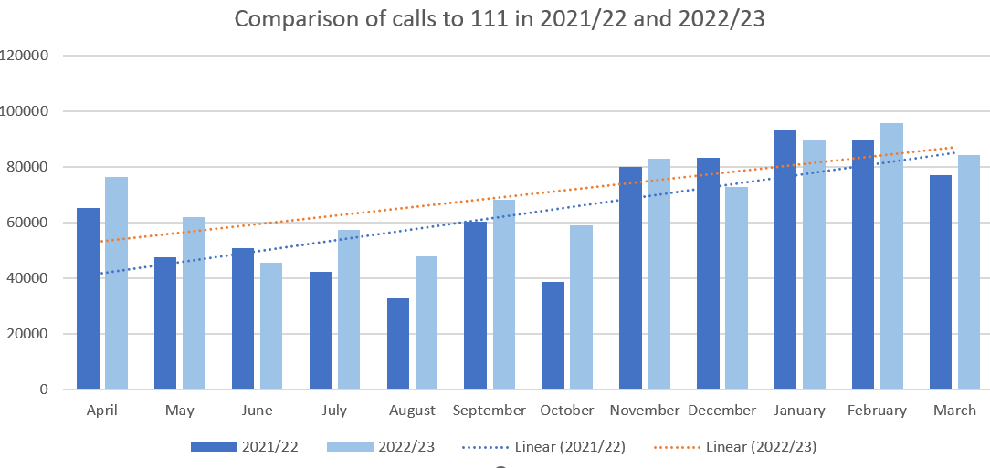
Figure 2 ED waiting times bar chart.
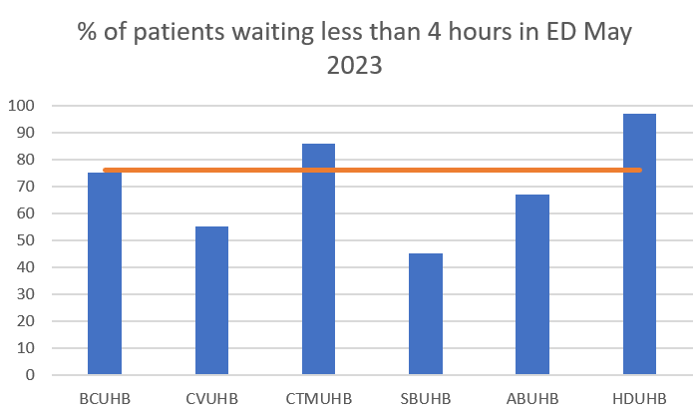
Figure 3 Line time chart
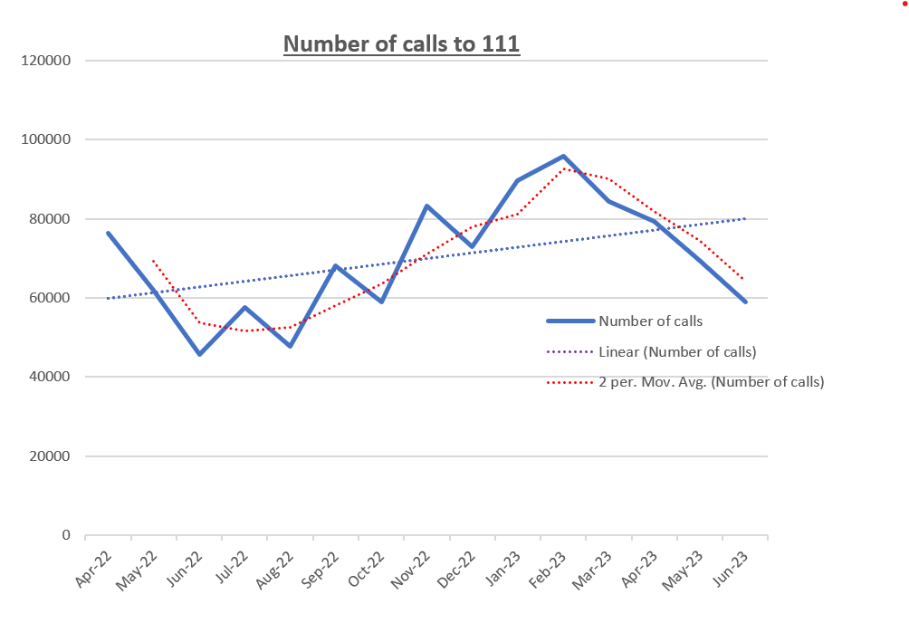

The Organisation of Qualitative Data
The organisation of times and dates for meetings/appointments is vital when conducting qualitative research for several reasons. However, the main one according to Miles et al [5] is that it causes the researcher to take into consideration just how much time they will need to allocate, in order for them to be able to set up and participate in the meetings that will need to take place, to ensure the engagement of the stakeholders and to guarantee the comprehensiveness and relevance of the data collected.
To assist with the scheduling and recording of the meetings I have created an Excel spreadsheet to facilitate the rescheduling of meetings should it be necessary. However, even though this can promote higher attendance, it will never ensure 100% attendance, and sometimes the project will need to proceed without input from those stakeholders who will not engage.

The right equipment for the job
Once the meetings have been set up, the researcher will need to ensure that a process for recording and transcribing the conversations is agreed and applied. My organisation uses TEAMS to carry out meetings and to record and transcribe the discussion, once agreement has been sort from all those attending the meeting. The meetings for the project will be held entirely on TEAMs as my organisation is still working from home, the same as many of the Information and data staff within the Health Boards, and due to the geographical spread of the Health Boards in Wales.
Even though the meetings will be recorded Saldana [6] advises that it is best practice to structure the meetings, using a set of defined questions so that the data that is collected can be categorised into themes and assigned codes for analysis.
Table 1 of Interview Questions
Question | Response | Health Board/Respondent | Code
Do you know where the data will be sourced from?
What is the level of data quality?
What is the current data collection system – WPAS/WPC?
Are you currently collecting all of the data elements?
How are you going to be submitting the dataset?
What impact if any do you see this having on your data warehouse and information teams?
Can you see any issues with sending data to Data Platform?
Are you able to make the implementation date?
Will you be able to submit the data set every 4 hours?
Any further comments

Creating initial codes and recognising themes
Once all the meetings have been completed, then the hard work of understanding the data and formatting it into information can begin. One method of doing this is to code similar answers to create themes.
The method that I will use to create the initial codes and recognise themes is the Hierarchical Coding Frame. Dr Medelyan [7] PhD describes this method as optimal for discovering previously unseen relationships between data elements.
The flowchart below includes some of the themes that I could see being an integral part of the project.
There would need to be research on where the data is collected, and which systems will be affected by the collection of this data. Is the data already been recorded or will there need to be a new collection method created so this data can be gathered? What additional resources will the health boards need to meet this new requirement? What changes will my organisation need to make to meet the prerequisite of receiving this data set first every 4 hours and then in real-time when statuses change? Will the proposed Google Cloud Platform (GCP) reach the required data storage and extraction times, and will it be able to cope with the number of data sets being submitted to it? What new skills will staff have to learn to be able to submit and extract data from the GCP?
Figure 4 Flow chart
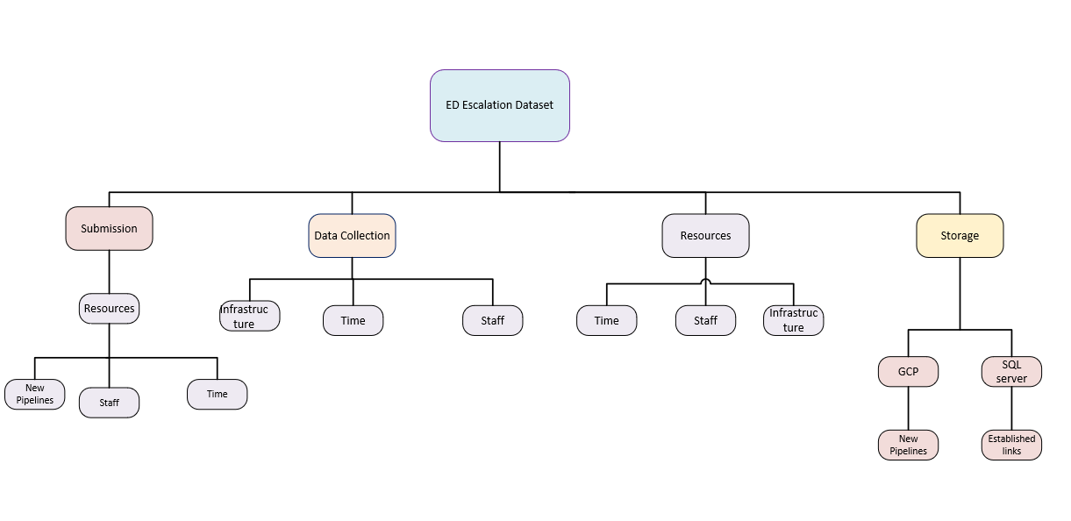

Storage of Research Documents
Using the right type of storage method for all the research documents generated for a project is vital, and one of the priorities for my project would be security, though the data and the research only contain aggregate healthcare data and no Patient Identifiable Information (PII), the security question cannot be ignored. Research completed by Hassan et al [8] states that by using a cloud system for storage you can ensure the security of your data, whilst having the option of sharing your documents, which can help encourage engagement.
For my project I will be using Micro Softs OneDrive to store my documents, creating folders for each Theme.

Figure 5 Cloud Storage
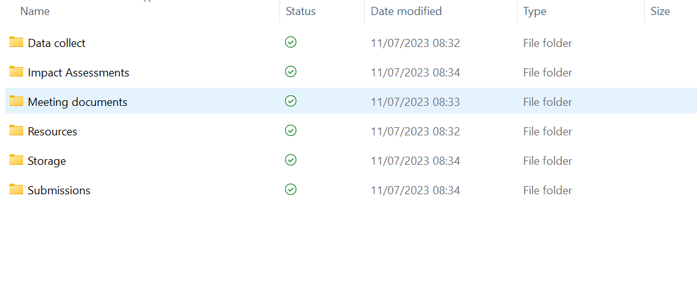

Task 2 Poster

Link to Poster in CANVA
https://www.canva.com/design/DAFoT0A2MKk/40rQ8l8LiVkz5YXwhNOw9w/edit?utm_content=DAFoT0A2MKk&utm_campaign=designshare&utm_medium=link2&utm_source=sharebutton

Figure 6 Poster
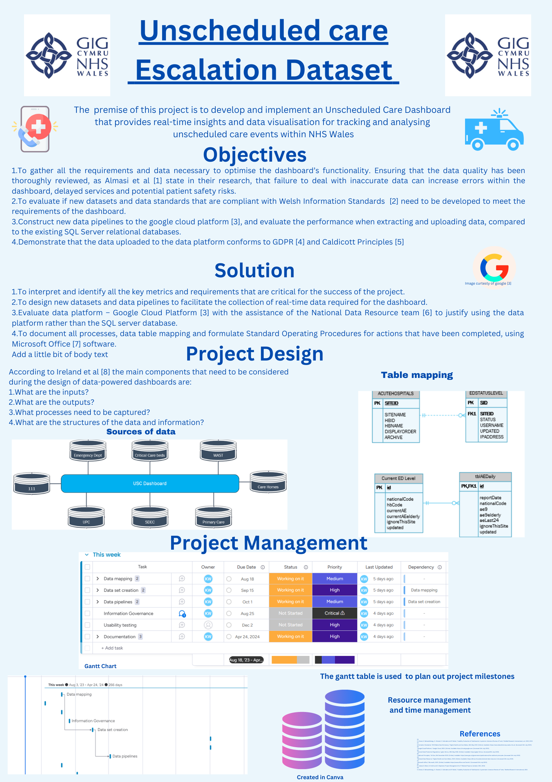

Scope
The premise of this project is to develop and implement an Unscheduled Care Dashboard that provides real-time insights and data visualisation for tracking and analysing unscheduled care events within NHS Wales

Objectives
- To gather all the requirements and data necessary to optimise the dashboard’s functionality. Ensuring that the data quality has been thoroughly reviewed, as Almasi et al [1] state in their research, that failure to deal with inaccurate data can increase errors within the dashboard, delayed services and potential patient safety risks.
- To evaluate if new datasets and data standards that are compliant with Welsh Information Standards [2] need to be developed to meet the requirements of the dashboard.
- Construct new data pipelines to the google cloud platform [3], and evaluate the performance when extracting and uploading data, compared to the existing SQL Server relational databases.
- Demonstrate that the data uploaded to the data platform conforms to GDPR [4] and Caldicott Principles [5]

Proposed Solution
- To interpret and identify all the key metrics and requirements that are critical for the success of the project.
- To design new datasets and data pipelines to facilitate the collection of real-time data required for the dashboard.
- Evaluate data platform – Google Cloud Platform [3] with the assistance of the National Data Resource team [6] to justify using the data platform rather than the SQL server database.
- To document all processes, data table mapping and formulate Standard Operating Procedures for actions that have been completed, using Microsoft Office [7] software.

Project Management
Figure 7 Gantt Chart
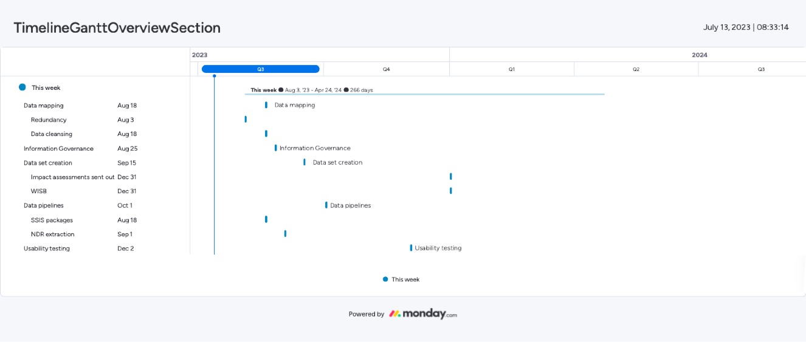

Task 3

Q1 Developing new skills
Even though the project is at its inception, I have already started to develop new skills to support the design and creation of new data pipelines for the Unscheduled Care dashboard. Categorising the data that powers the visualisation, where are the source tables, investigating the current quality of the data and the displayed data, as this affects decision-making and reputation of those involved in the creation of the visualisation and stakeholders utilising the dashboard [1].
To be able to create the data pipelines I have been tasked with learning SQL Server Integration Services [2], which is powered generated using Visual Studio [3], which permits the transfer of tables between the organisation’s servers.
As one of the project’s objectives is to have all the data that is required to power the dashboard stored on the organisation’s data platform, this necessitates understanding how queries are constructed in Google’s Big Query [4]. Although Big Query uses SQL its format differs from Microsoft’s SQL Server Management Studio [5] and learning these variances will take time.

Q2 Positive impact
While the National Data Resource team in Digital Health and Care Wales, have been researching the data platform, they have not loaded any live data onto the system. The Unscheduled Care Dashboard’s data will be the first live data to be loaded. Being part of this initial step is not only exciting but will provide us with real-time examples so that the data platform’s performance can be compared and measured against those of the organisations’ SQL Server databases. Once operational, the dashboard will provide Welsh Government with the information they need to evaluate whether their Six Goals initiative to improve the Urgent and Unscheduled Emergency Care [6] is delivering the expected outcomes and measures.

Q3 Potential Risks and Challenges
One of the major risks is that the dashboard will not meet the expectations of the Welsh Government, which could result in the tarnishing of Digital Health and Care Wales’s reputation as a leader in digital innovations. That is why the planning and development of the dashboard is such a major part of delivering a successful end project. A recent study performed by the Project Management Institute (PMI) [7], stated that implementing a robust planning stage mitigates the risk of potential issues by identifying them at an early stage in the project lifecycle.
Another potential risk would be that the data that is necessary to power the dashboard, could be missing, out of date or inaccurate. That is why ensuring that all the data submitting stakeholders are fully engaged and are appraised on how vital complete, timely and accurate data is to the success of the project and the usability and functionality of the dashboard. A recent report by Mckinsey [8] backs up this conjecture by stressing that if an organisation is using analytics to aid effective decision making then accurate real-time data is imperative.

E-Portfolio Screenshots
Screenshot 1 Assignment 2
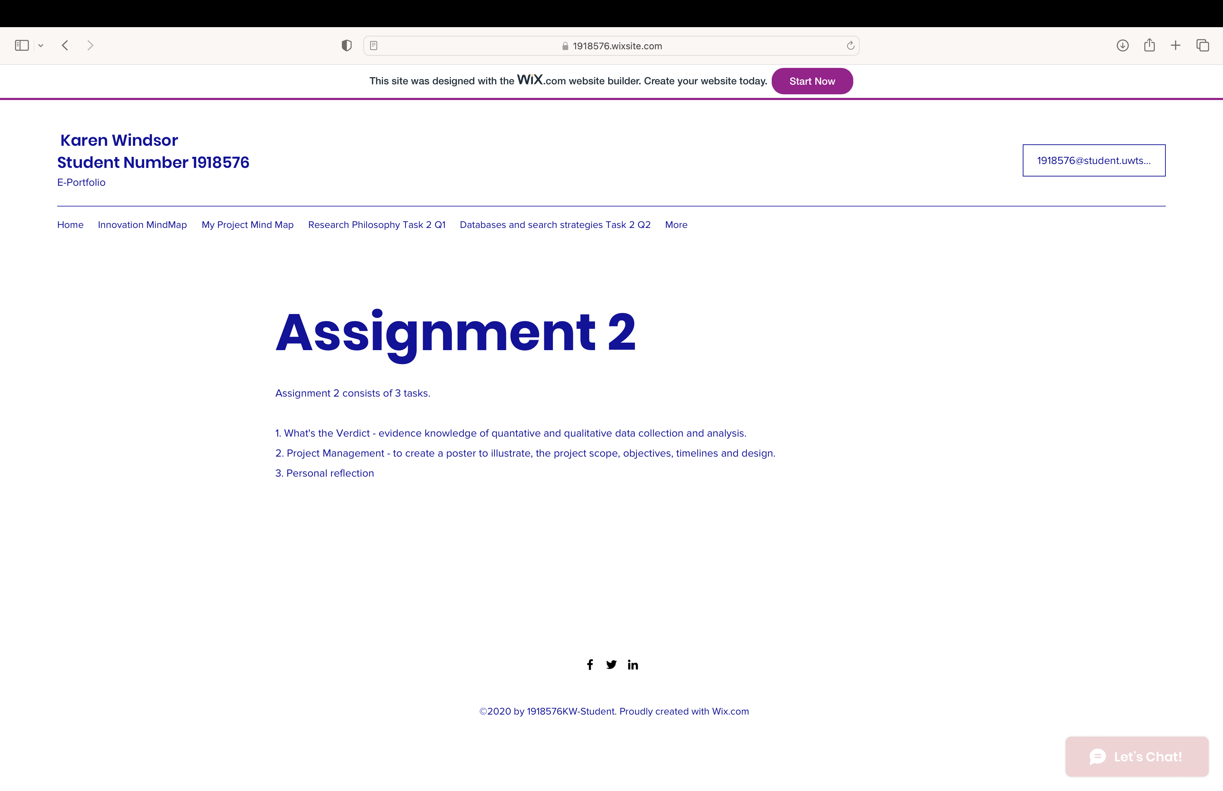
Screenshot 2 Quantitative Data
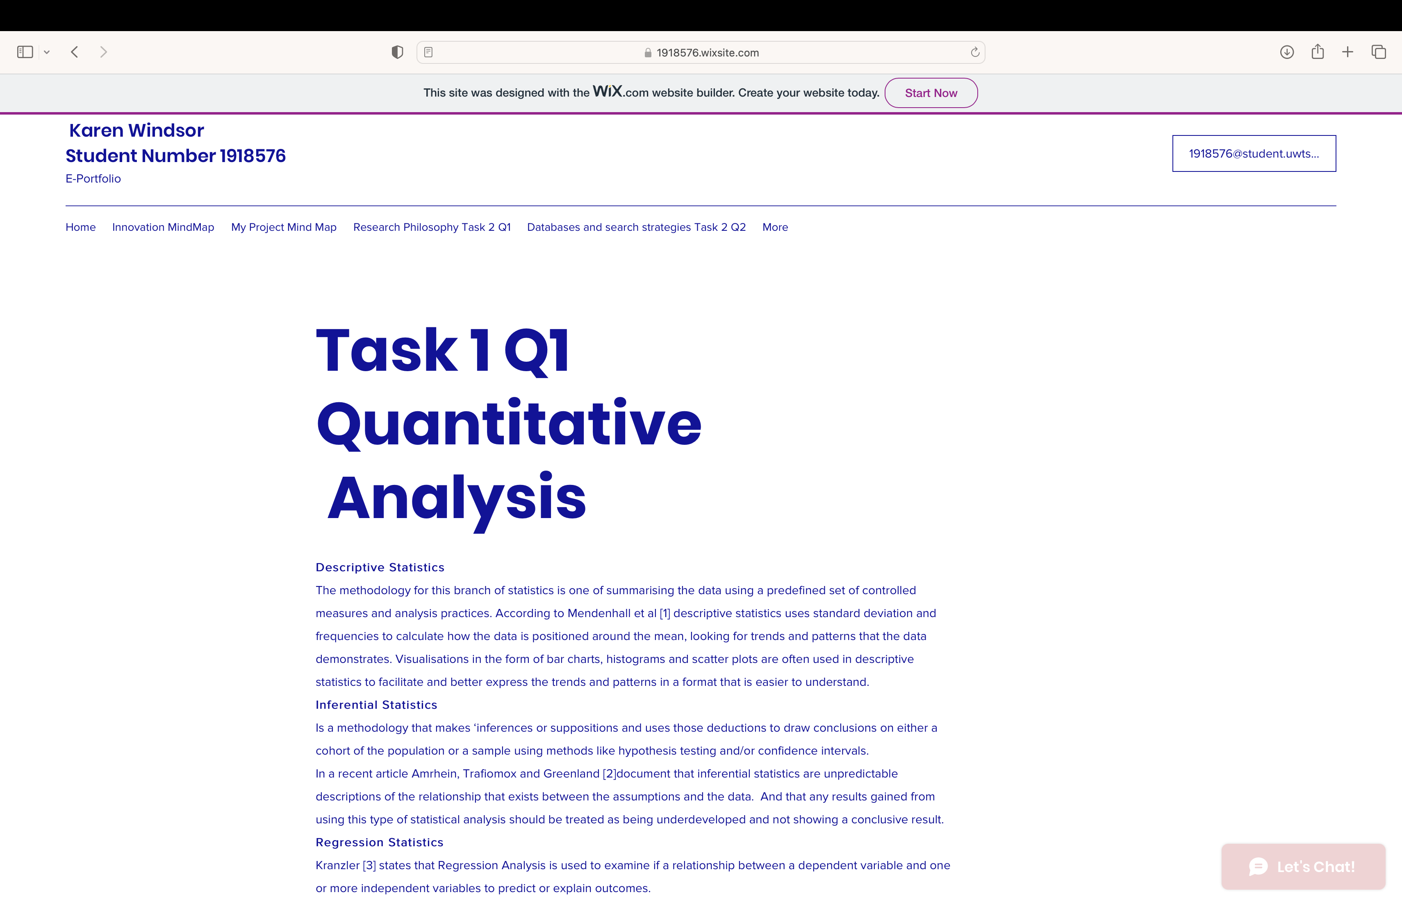
Screenshot 3 Quantitative Data 2
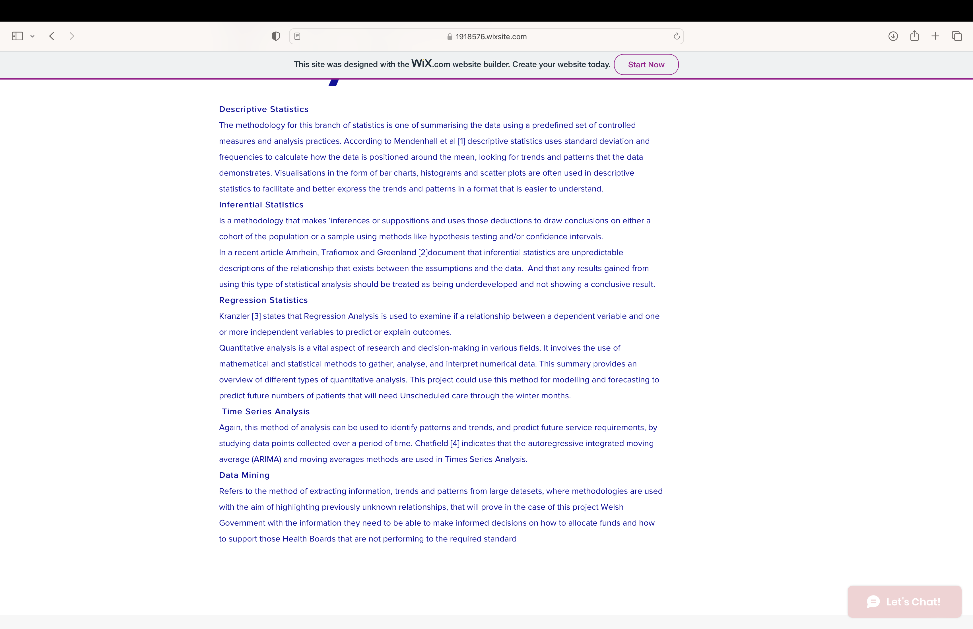

Screenshot 4 Chart 1
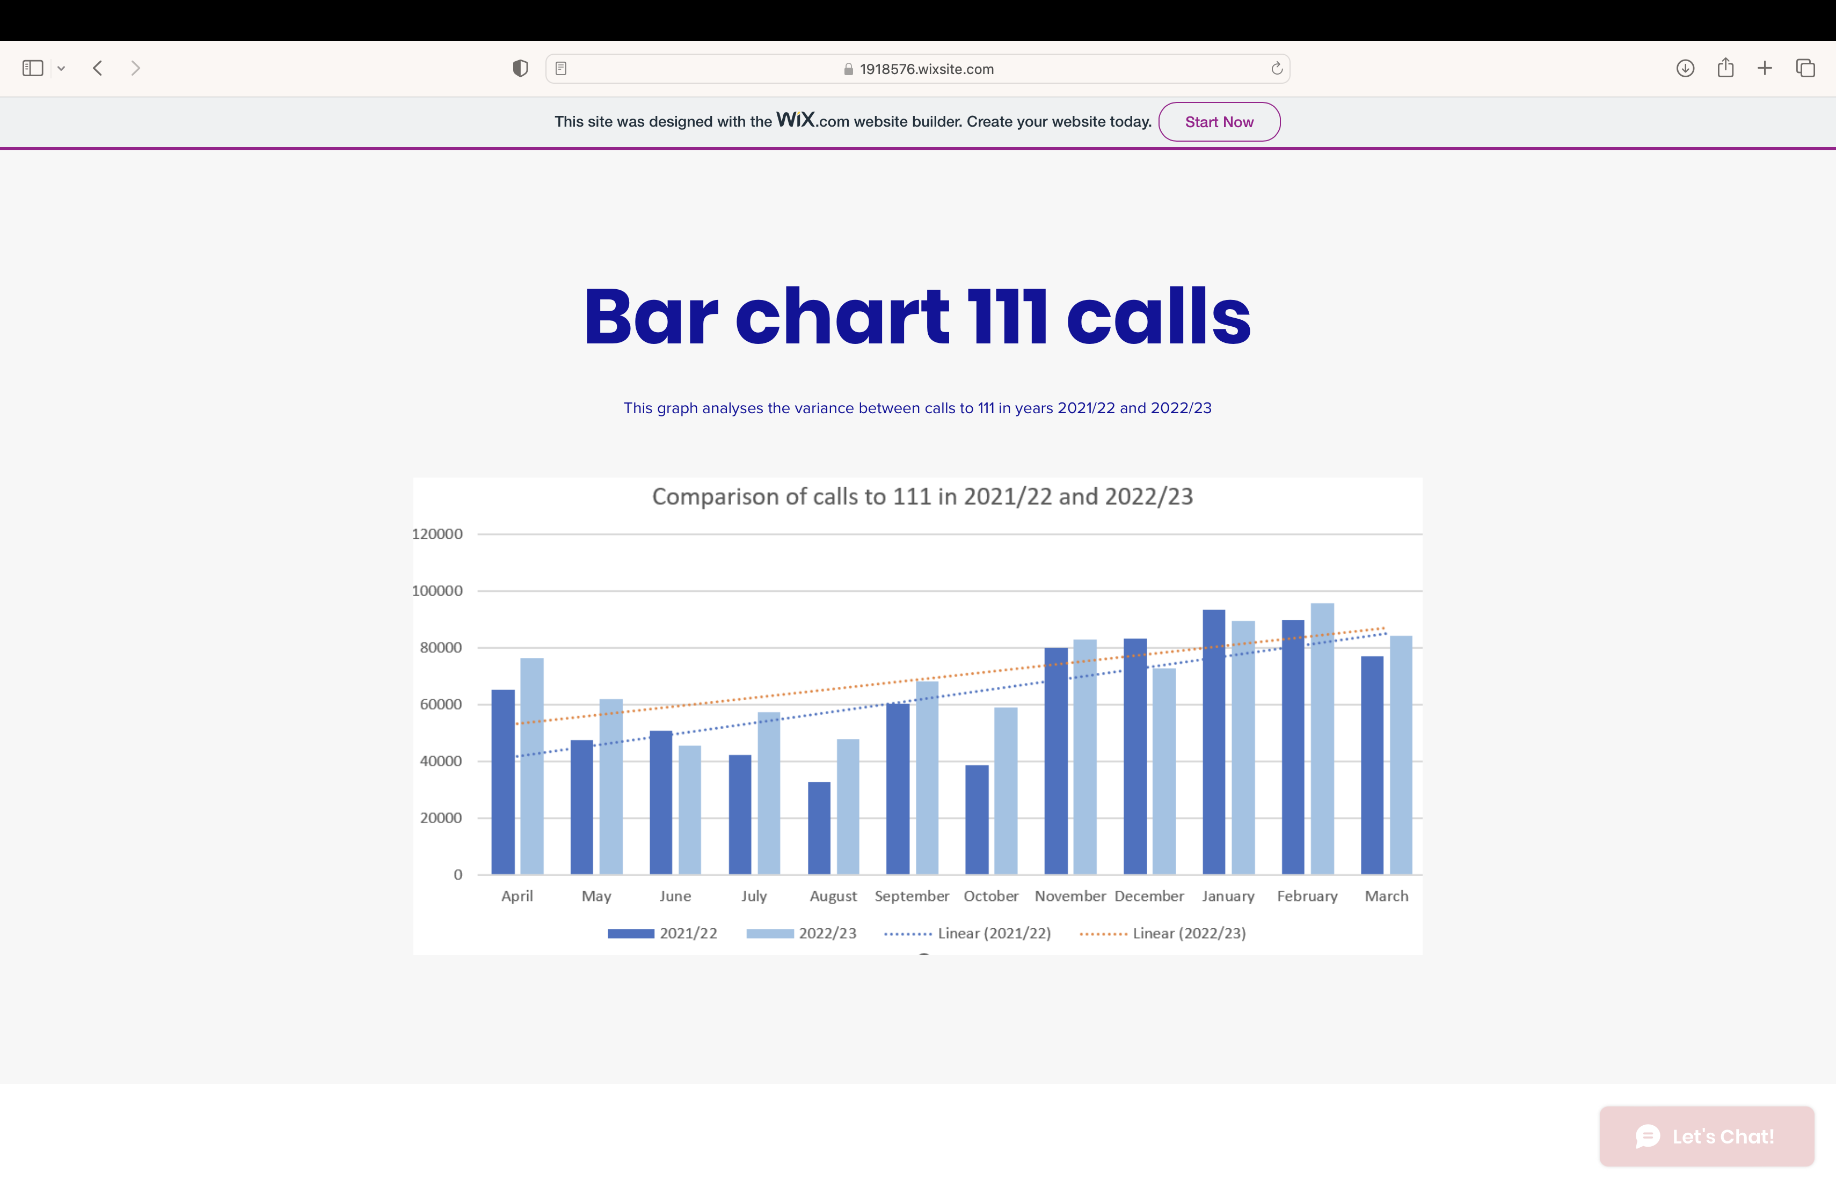

Screenshot 5 Chart 2
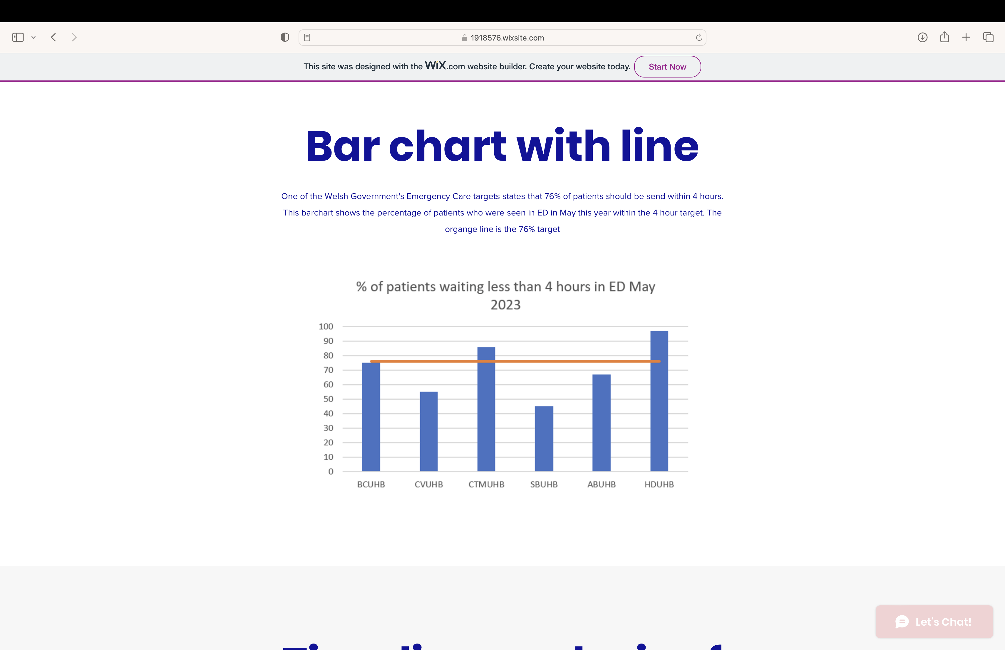
Screenshot 6 Chart 3
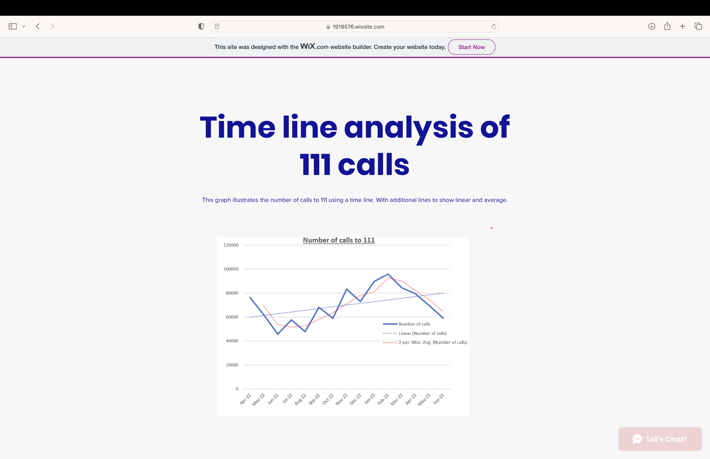
Screenshot 7 Qualitative Data
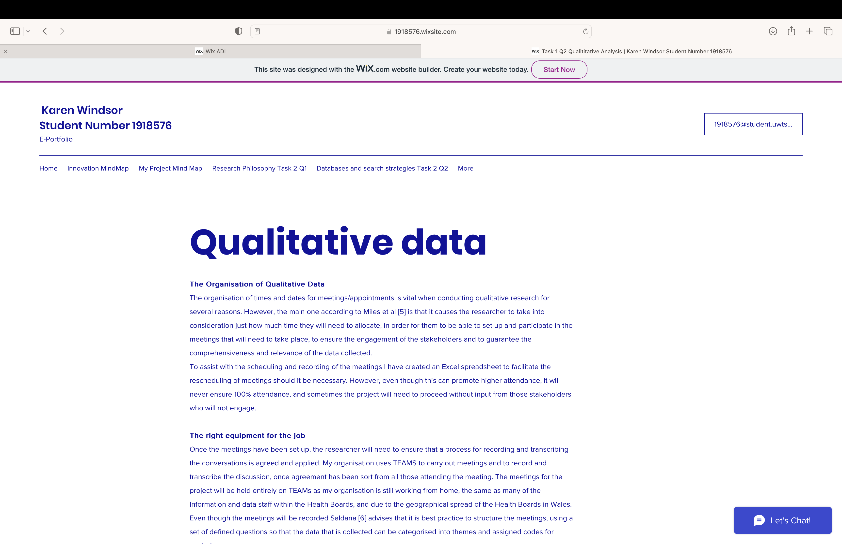

Screenshot 8 Qualitative Data 2

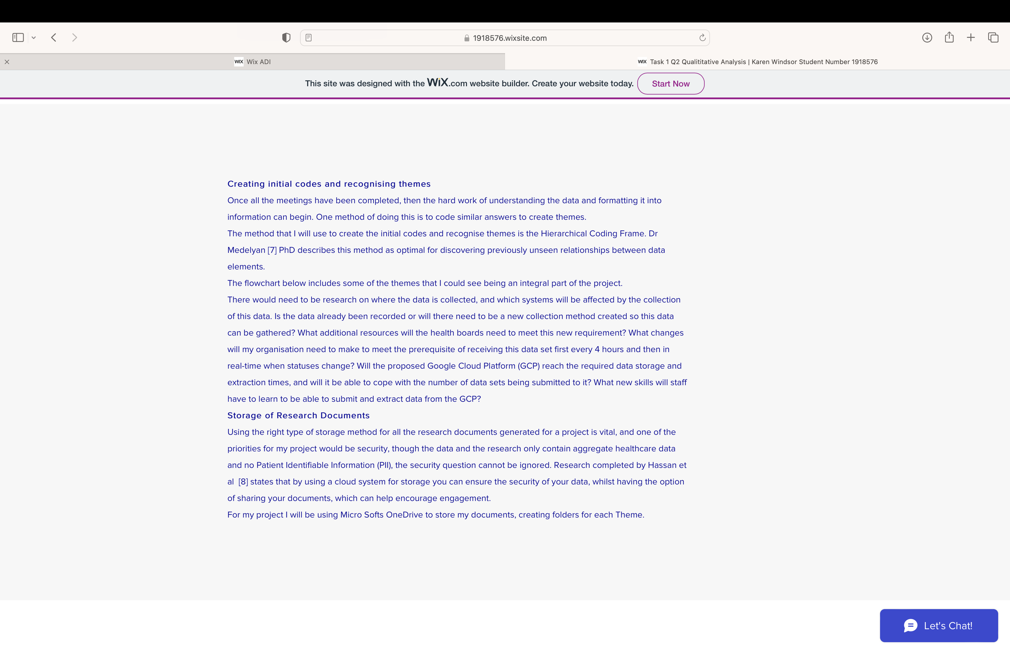

Screenshot 9 Theme flowchart
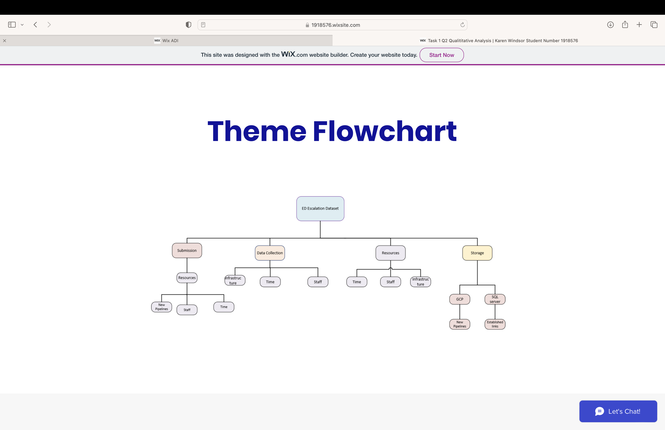

Screenshot 10 Cloud Storage
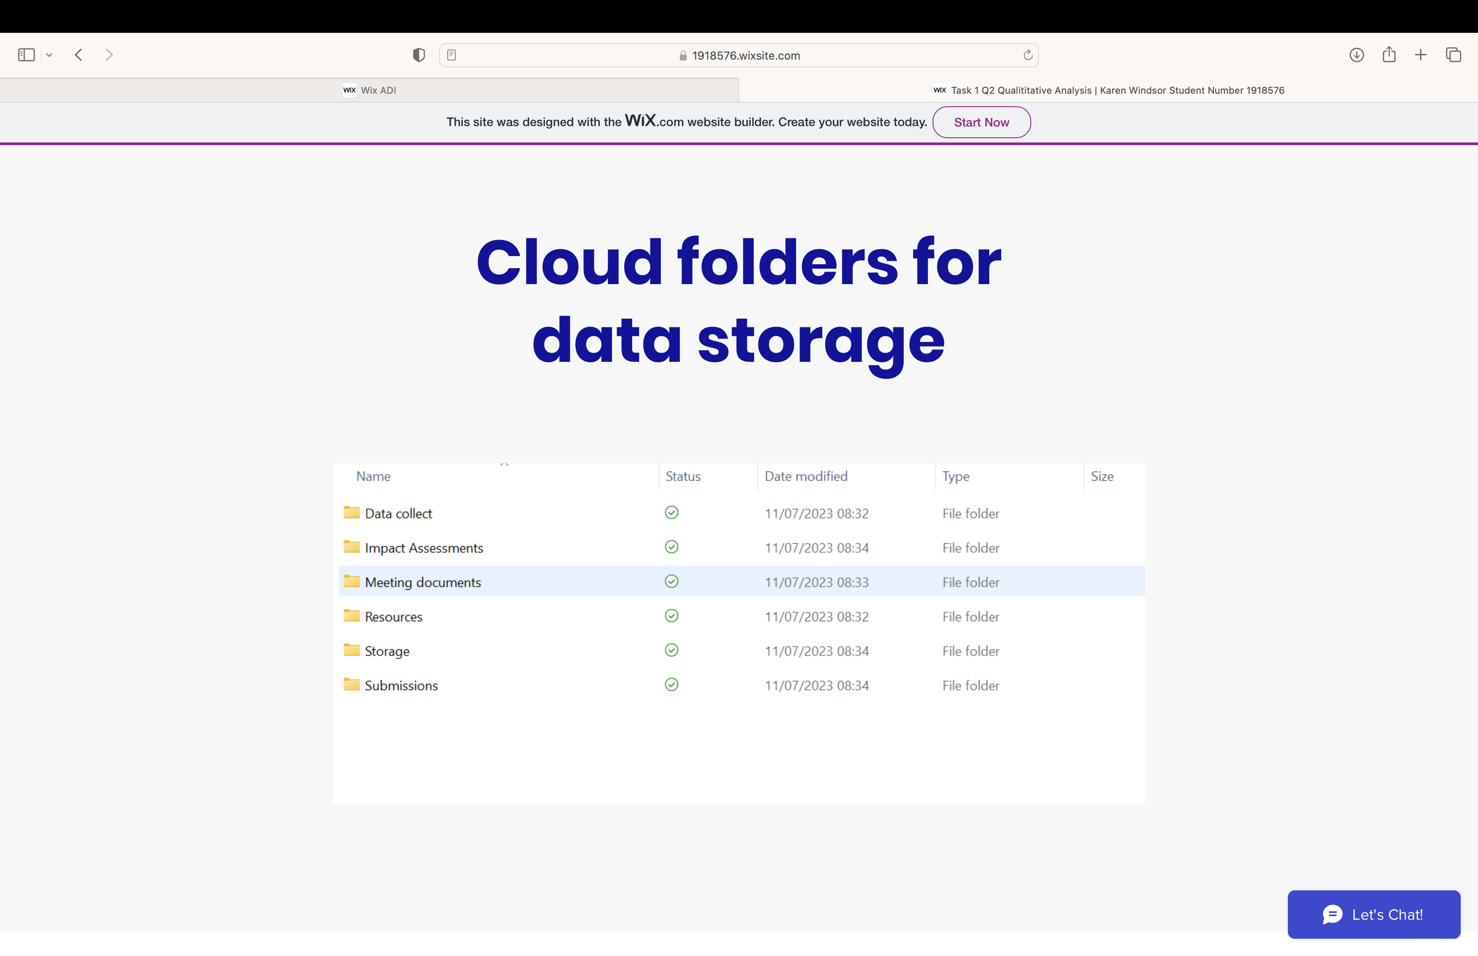

Screenshot 11 Task 3
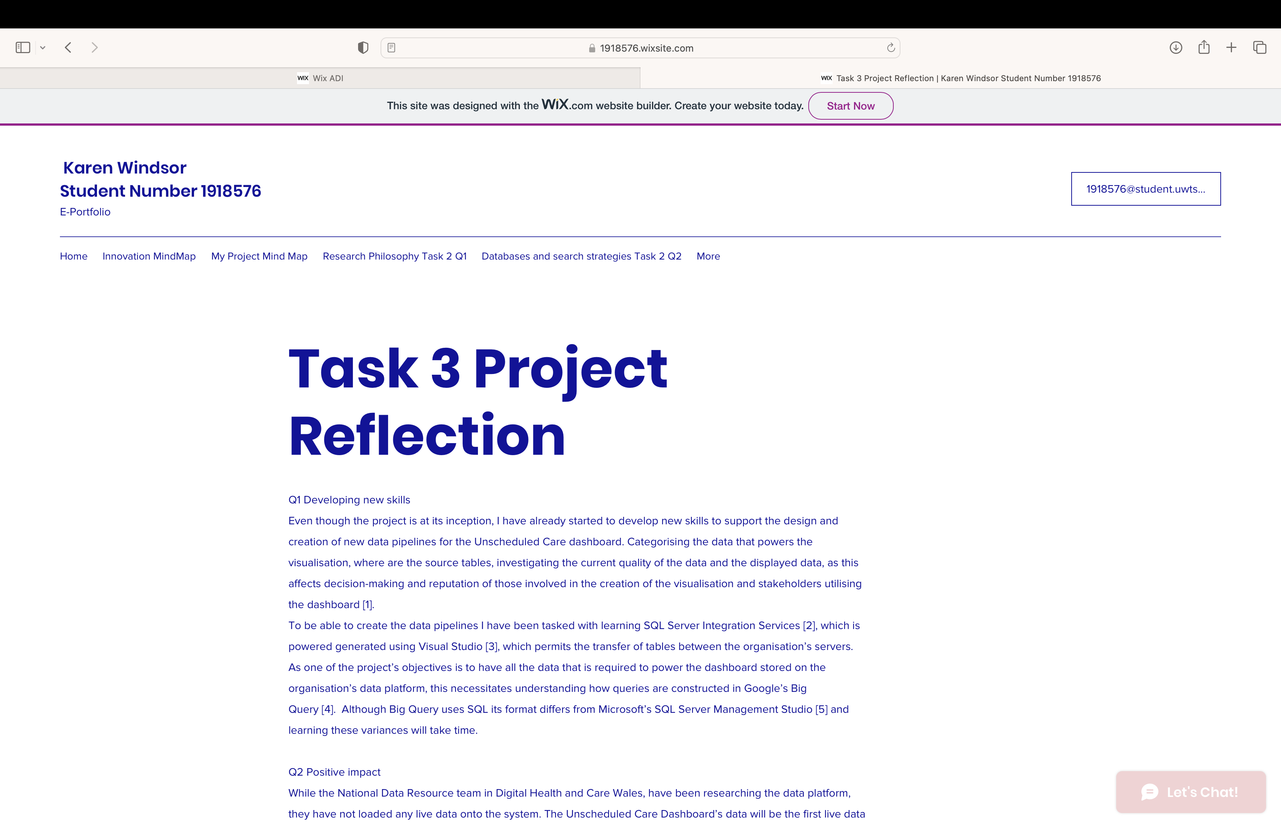

Screenshot 12 Task 3 page 2
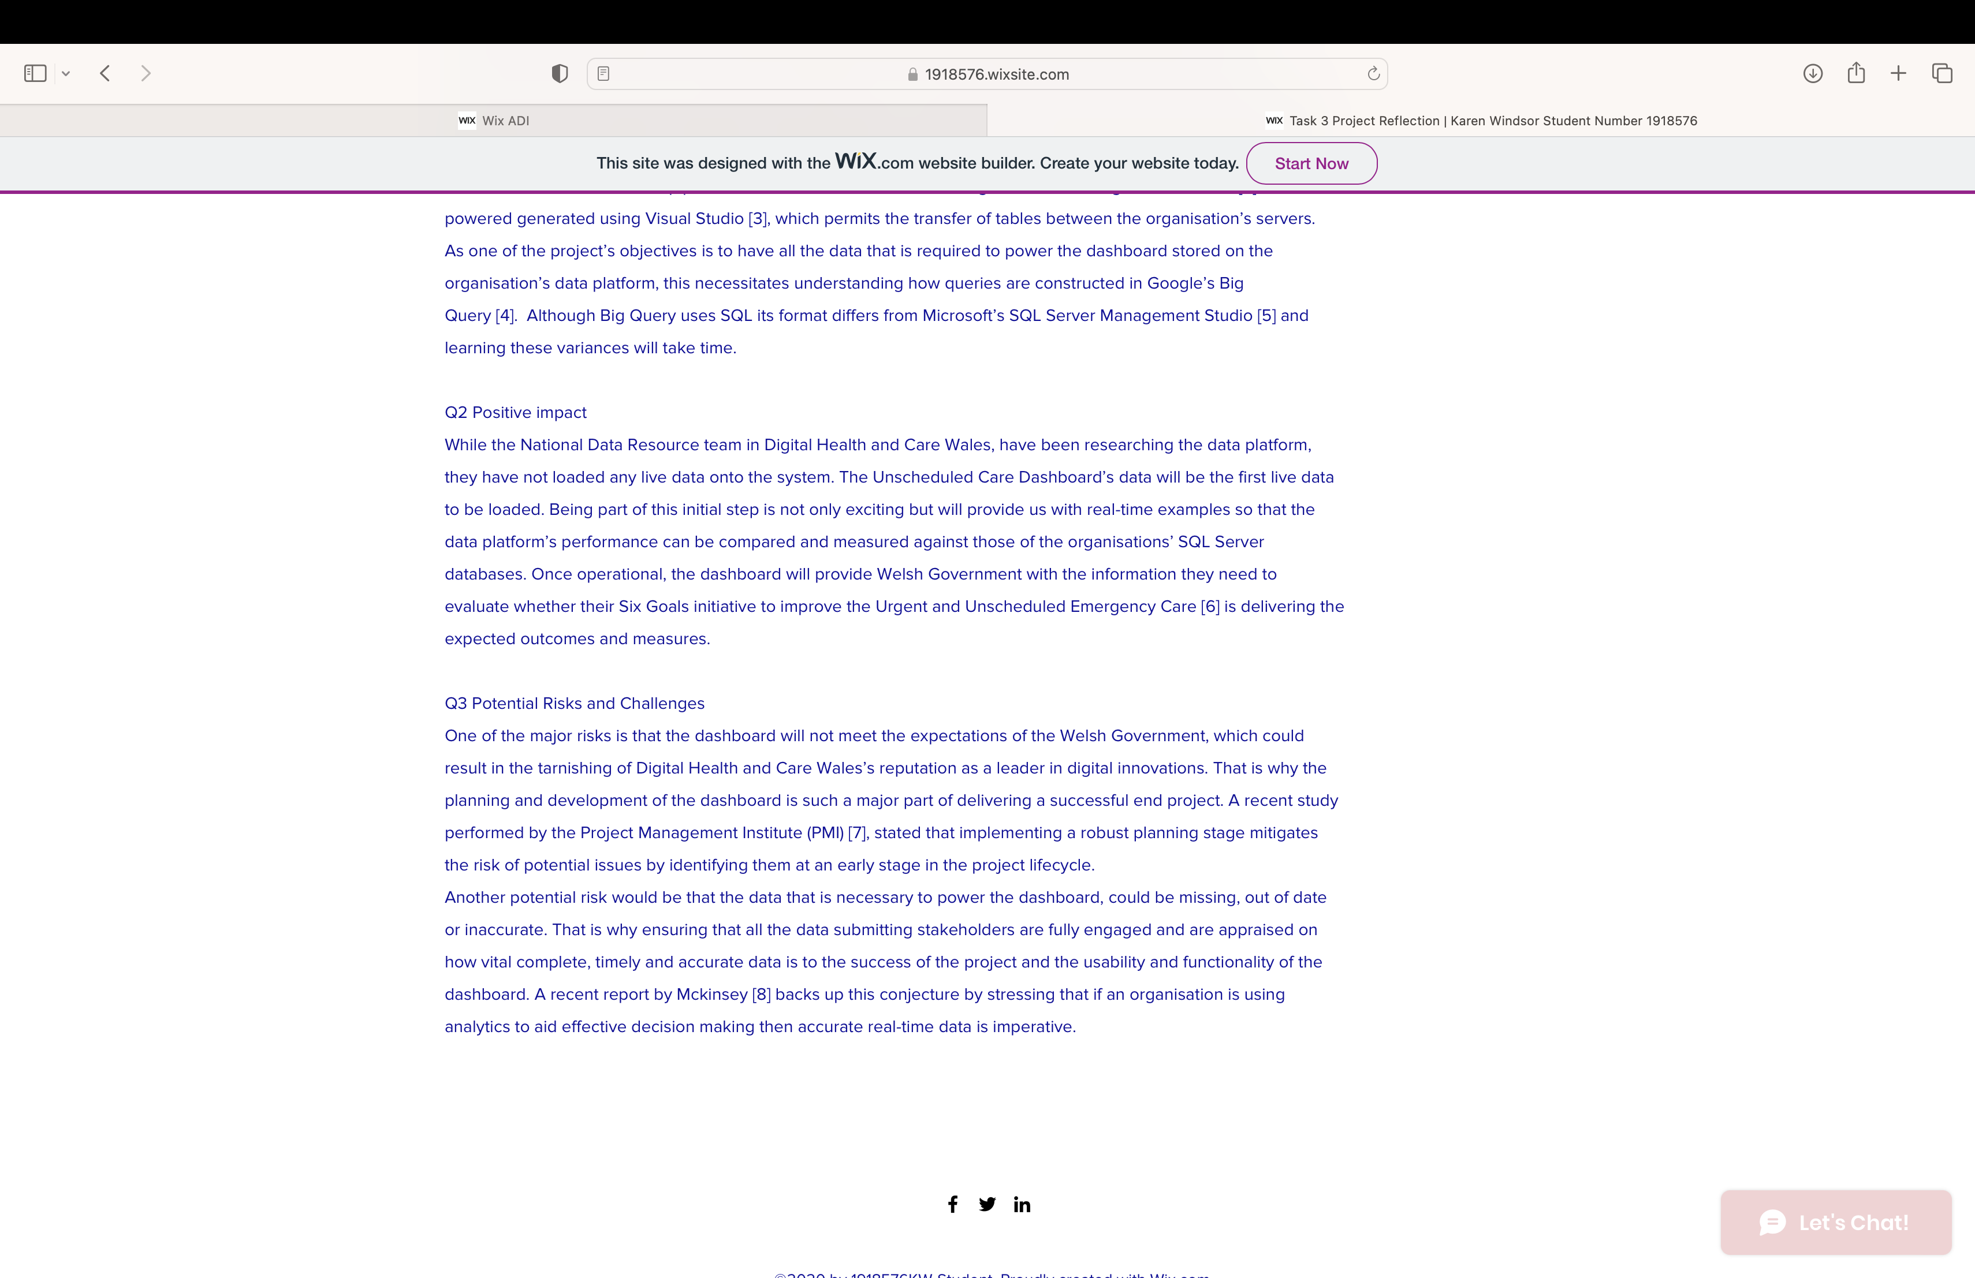

Screenshot 13 References task 3
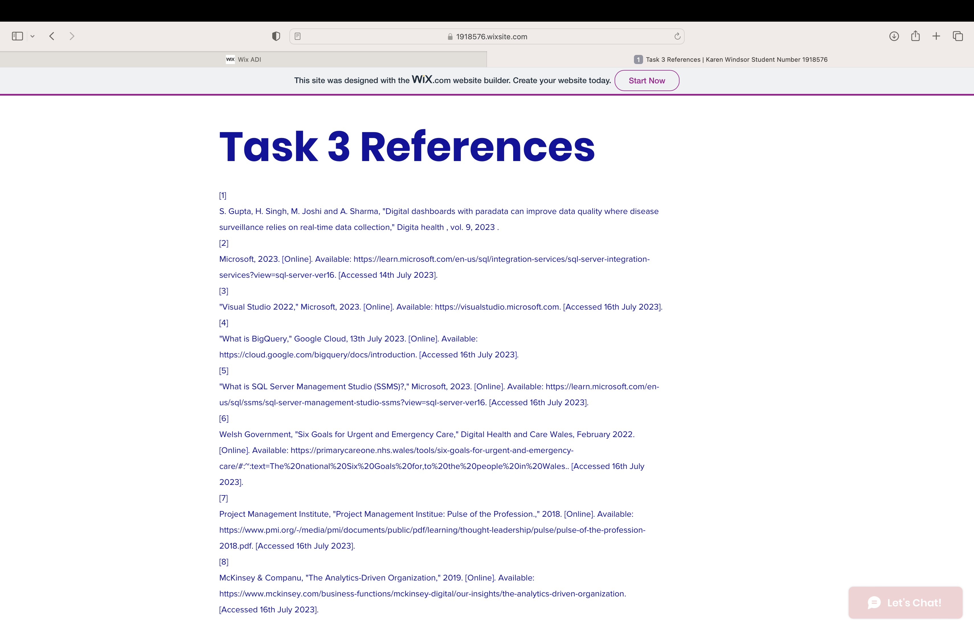

Engagement with literature screenshots

Screenshot 14 Unit 4 Topic 1 Section 1
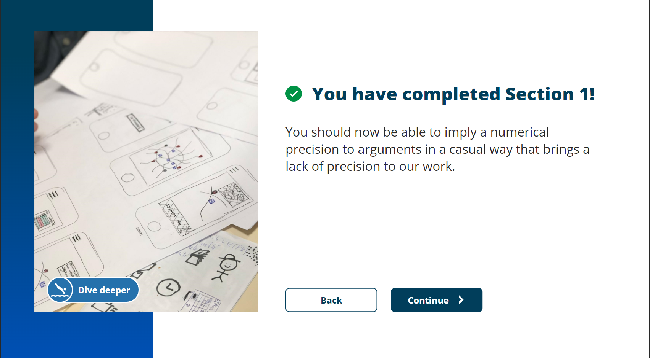

Screenshot 15 Unit 1 Topic 1 Section 2
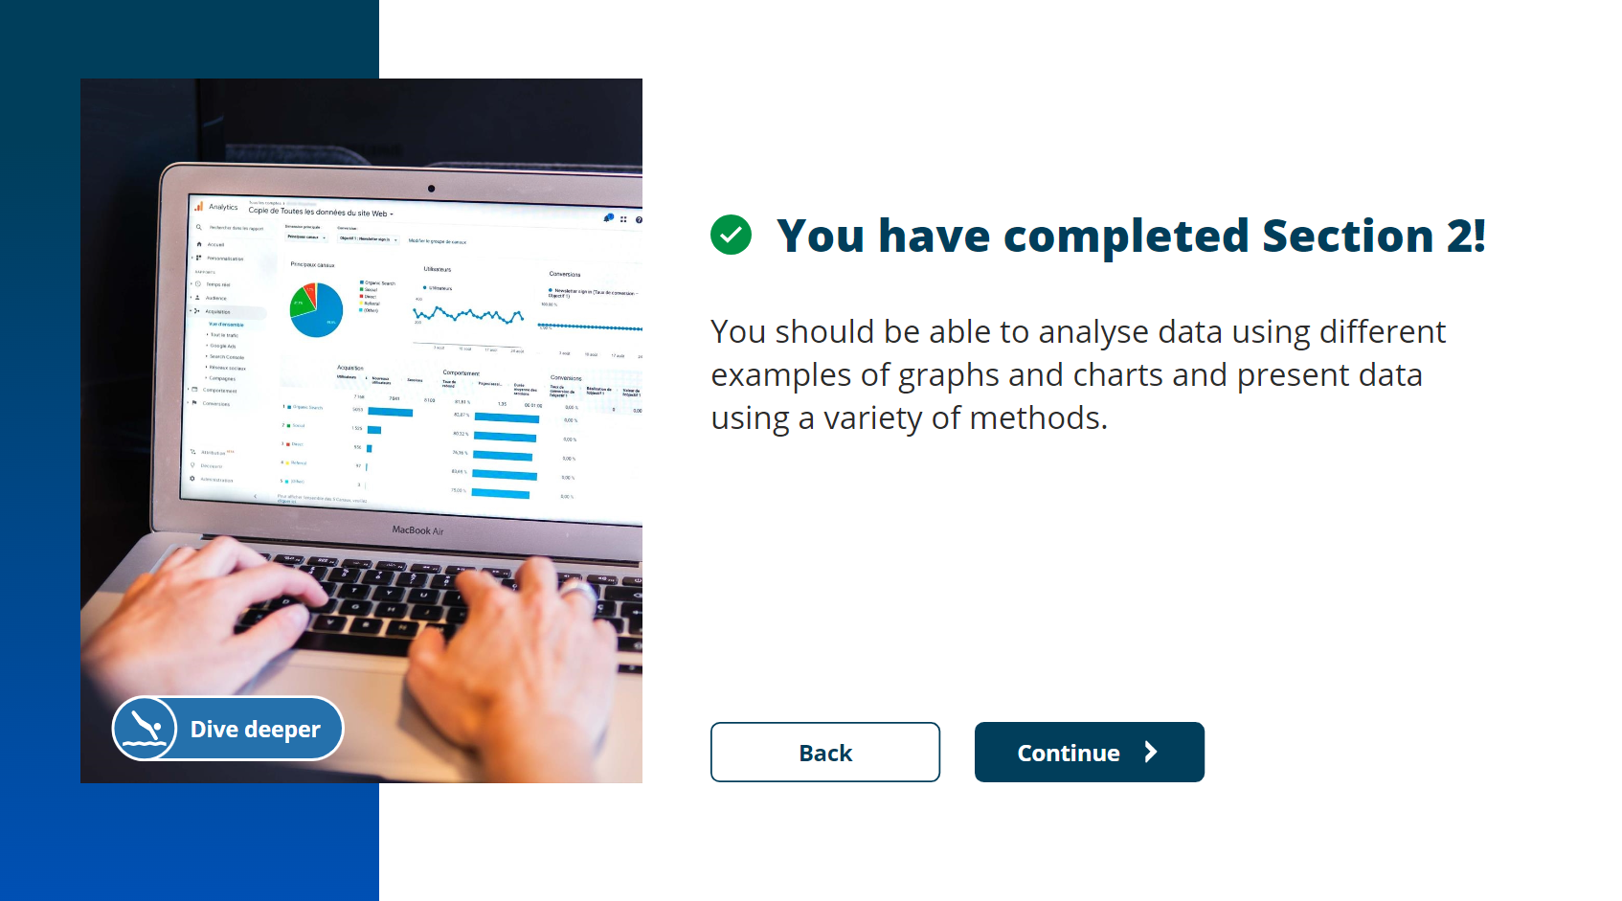

Screenshot 16 Unit 4 Topic 1 Section 3
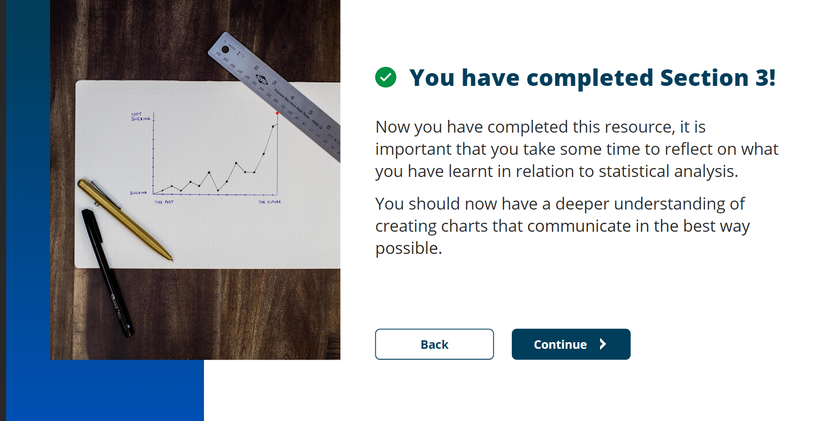

Screenshot 17 Unit 4 Topic 2 Section 1
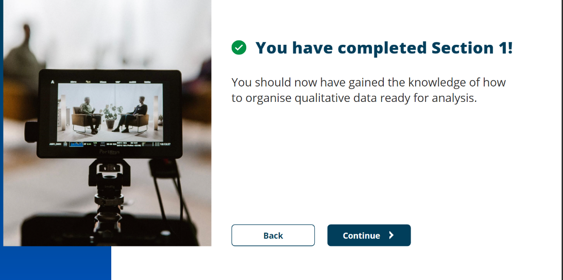
Screenshot 18 Unit 4 Topic 2 Section 2
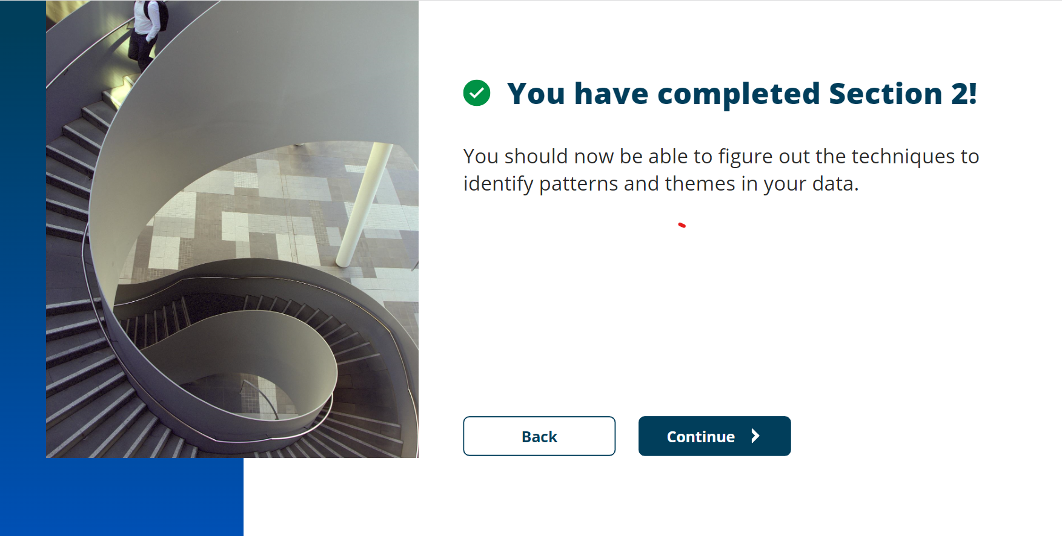

Screenshot 19 Unit 4 Topic 3 Section 1


Screenshot 20 Unit 4 Topic 3 Section 2
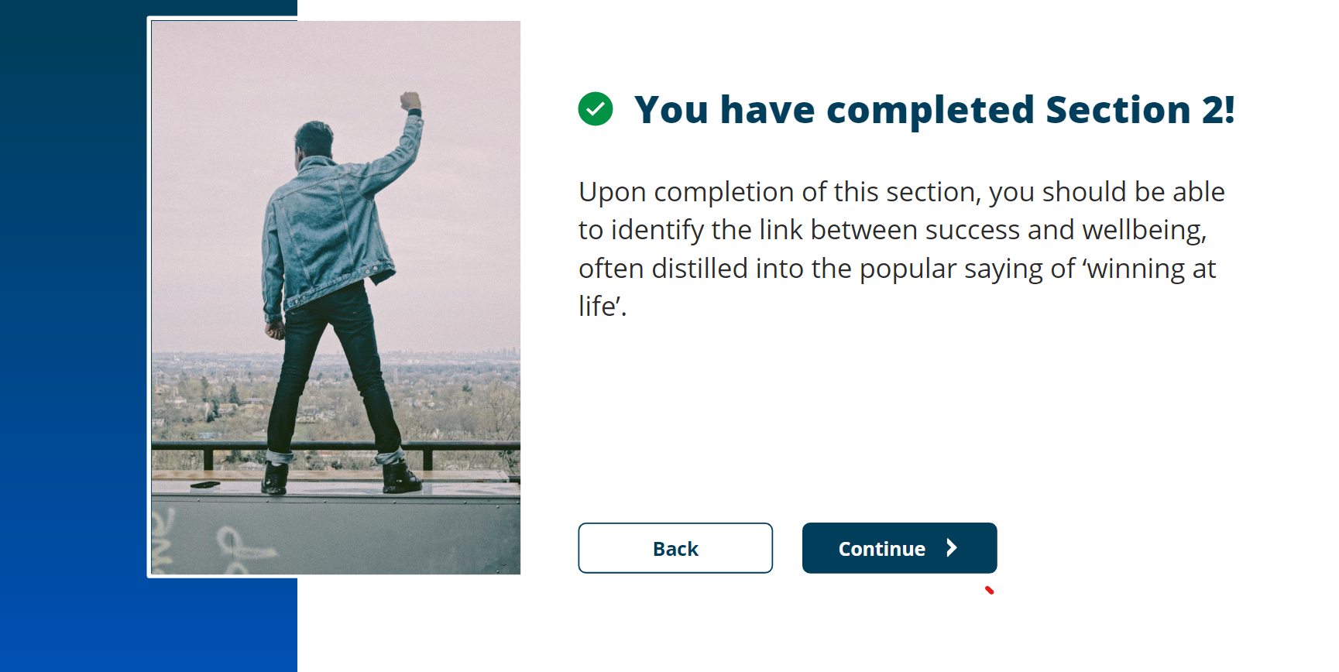

Screenshot 21 Unit 4 Topic 3 Section 3
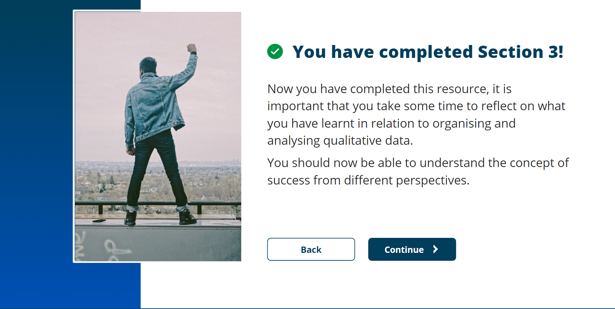

References for Task 1 Q1 and Q2

[1] | W. Mendenhall, R. Ott and K. Beard, Introduction to Probability and Statistics, 15th ed., Boston: Cengage Learning, 2016.
[2] | V. Amrhein, D. Traflmow and S. Greenland, "Inferential statistics as descriptive statistics: There is no replication crisis if we dont expect replication'," The American Statistician, vol. 73, no. 1, pp. 262-270, 2019.
[3] | J. Kranzler, Statistics for the terrified, 6th ed., New Jersey: Prentice-Hall, 2017.
[4] | C. Chatfield and H. Xing, The Analysis of Time Series: Introduction with R, 7th ed., London: CRC Press, 2019.
[5] | M. B. Miles, M. A. Huberman and J. Saldana, Qualitative Data Analysis: A methods Sourcebook, 3rd ed., vol. London, Sage Publications, 2013.
[6] | J. Saldana, The Coding Manual for Qualitative Researchers, 2nd ed., London: SAGE, 2013.
[7] | A. Medelyan, "Coding Qualitative Data: How to Code Qualitative Research," thematic, [Online]. Available: https://getthematic.com/insights/coding-qualitative-data/. [Accessed 10th July 2023].
[8] | J. Hassan, D. Shehzad, U. Habib, M. Aftab, M. Ahmad, R. Kuleev and M. Mazzara, "The Rise of Cloud Computing: Data Protection, Privacy and Open Research Challenges - A Systematic Literature Review," Comput Intell Neurosci, vol. 2022, 2022.
[9] | J. Kranzler, Statistics for the Terrified, 6th ed., New Jersey: Prentice-Hall, 2017.
[10] | K. Liu and L.-j. Dong, "Research on Cloud Data Storage Technology and Its Architecture Implementation," Procedia Engineering, vol. 29, pp. 133-137, 2012.

References for Task 2 Poster

[1] | S. Almasi, K. Bahaadinbeigy, H. Ahmadi, S. Sohrabei and R. Rabiei, "Usability Evaluation of Dashboards: A systemic Literature Review of Tools," BioMed Research International, vol. 2023, 2023.
[2] | Information Standards, "NHS Wales Data Dictionary," Digital Health and Care Wales, 16th May 2023. [Online]. Available: https://www.datadictionary.wales.nhs.uk. [Accessed 11th July 2023].
[3] | "Google Cloud Platform," Google Cloud, 2023. [Online]. Available: https://cloud.google.com. [Accessed 11th July 2023].
[4] | "General Data Protection Regulations," gdpr-info eu, 25th May 2018. [Online]. Available: https://gdpr-info.eu. [Accessed 9th July 2023].
[5] | "Caldicott Principles," UK Gov, 8th December 2020. [Online]. Available: https://www.gov.uk/government/publications/the-caldicott-principles. [Accessed 11th July 2023].
[6] | "National Data Resource," Digital Health and Care Wales, 2023. [Online]. Available: https://dhcw.nhs.wales/national-data-resource/. [Accessed 13th July 2023].
[7] | "Microsoft office," Microsoft, 2023. [Online]. Available: https://www.office.com/?auth=2. [Accessed 13th July 2023].
[8] | R. Ireland, B. West, N. Smith and D. Shepherd, Project Management for IT-Related Projects, Swindon: BSC, 2004.
[9] | S. Almasi, K. Bahaadinbeigy, H. Ahamdi, S. Sohrabei and R. Rabiei, "Usability Evaluation of Dashboards: A systematic Literature Review of Tools," BioMed Research International, 2023.

References for Task 3
[1] | S. Gupta, H. Singh, M. Joshi and A. Sharma, "Digital dashboards with paradata can improve data quality where disease surveillance relies on real-time data collection," Digita health , vol. 9, 2023 .
[2] | Microsoft, 2023. [Online]. Available: https://learn.microsoft.com/en-us/sql/integration-services/sql-server-integration-services?view=sql-server-ver16. [Accessed 14th July 2023].
[3] | "Visual Studio 2022," Microsoft, 2023. [Online]. Available: https://visualstudio.microsoft.com. [Accessed 16th July 2023].
[4] | "What is BigQuery," Google Cloud, 13th July 2023. [Online]. Available: https://cloud.google.com/bigquery/docs/introduction. [Accessed 16th July 2023].
[5] | "What is SQL Server Management Studio (SSMS)?," Microsoft, 2023. [Online]. Available: https://learn.microsoft.com/en-us/sql/ssms/sql-server-management-studio-ssms?view=sql-server-ver16. [Accessed 16th July 2023].
[6] | Welsh Government, "Six Goals for Urgent and Emergency Care," Digital Health and Care Wales, February 2022. [Online]. Available: https://primarycareone.nhs.wales/tools/six-goals-for-urgent-and-emergency-care/#:~:text=The%20national%20Six%20Goals%20for,to%20the%20people%20in%20Wales.. [Accessed 16th July 2023].
[7] | Project Management Institute, "Project Management Institue: Pulse of the Profession.," 2018. [Online]. Available: https://www.pmi.org/-/media/pmi/documents/public/pdf/learning/thought-leadership/pulse/pulse-of-the-profession-2018.pdf. [Accessed 16th July 2023].
[8] | McKinsey & Companu, "The Analytics-Driven Organization," 2019. [Online]. Available: https://www.mckinsey.com/business-functions/mckinsey-digital/our-insights/the-analytics-driven-organization. [Accessed 16th July 2023].

