2
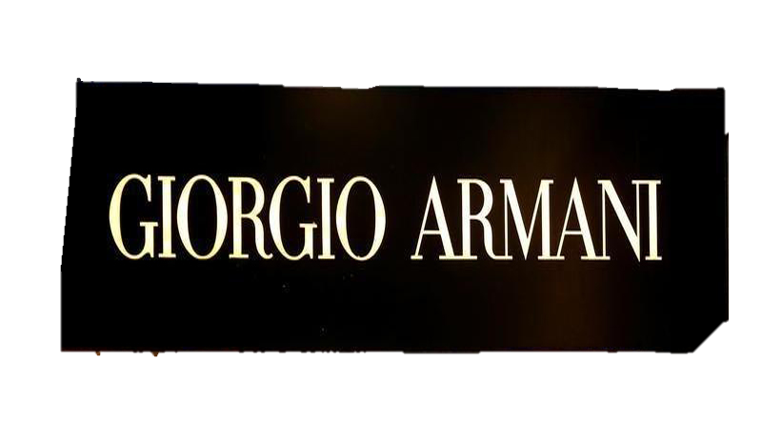

Marketing foundamentals
Assigment 1 (30%)

Noemi Bregolin

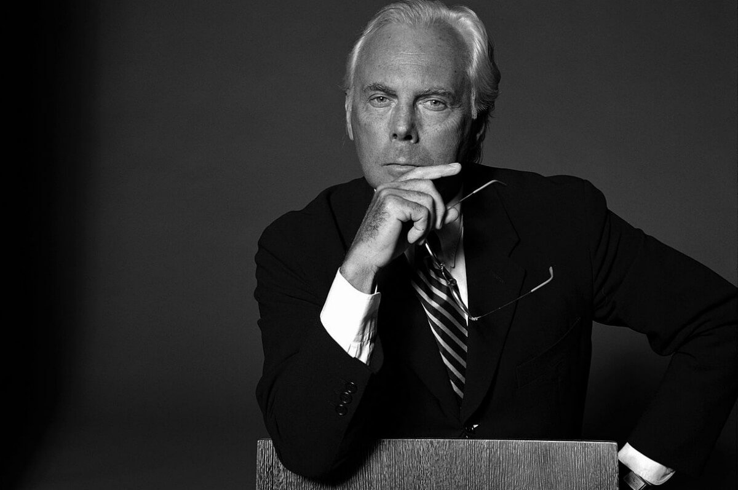
‘Elegance is not about being noticed, is about being remembered’
(Goodreads, 2022)
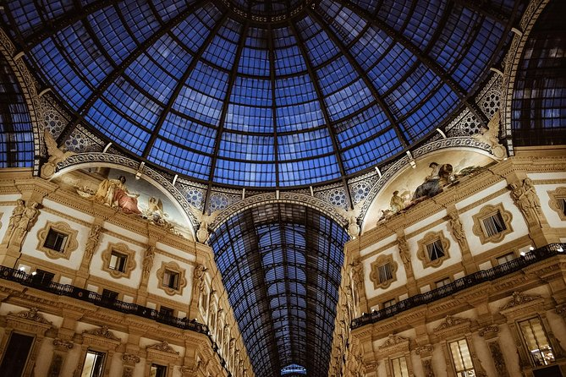
HISTORY OF THE BRAND

Armani was born on 11 July 1934 in Piacenza from a humble family (Editorial Team, 2021). Fashion was not in the programs of the famous designer; in fact, he approached fashion by chance when he moved to Milan to study medicine, which he later left. Life often surprises us, leading us to choose unexpected paths; Giorgio Armani starts working as a window dresser in the Rinascente department stores. Here he learned to put his creativity into play and discover his propensity for aesthetics. Armani's first experience in the fashion world comes with Nino Cerruti in the 1960s (Editorial Team, 2021). This was the first experience with clothing design, which built the pillars of the Giorgio Armani brand. After that, King Giorgio became an assistant for the new Hitman fashion line that Armani ran until 1970 (Editorial Team, 2021).
Sergio Galeotti, Giorgio's life partner, subsequently pushed Armani to create his own fashion line. Thus, the prestigious brand emblem of the style of elegance worldwide was born.

One year after the birth of the Armani brand, the production also began for women's clothing; later in 1978, Armani was worn by Diane Keaton at the Oscars and by Richard Gere in American Gigolo in 1980 (Editorial Team, 2021. The Italian designer revolutionized the way women dressed by making elegant coloured pantsuits instead of floral skirts. From here begins the real Armani empire, and starts dressing celebrities including Leonardo di Caprio, Laura Pausini, Lady Gaga, Madonna, Cate Blanchett, etcetera (Editorial Team, 2021).

Armani had decided to open Emporio Armani to gain access to a different aesthetic and to gain entrance in the world of youth cultures. Success was immediate and worldwide. Initially, it was considered a risky choice. However, this intuition led the designer to sell the refined Armani garments at affordable prices to the youngest. As Armani says, 'I liked the idea of a place where you could find everything at a fair price. That idea still applies today: for me, Emporio is a collection of garments, accessories and ideas aimed at a broad, cosmopolitan and urban audience.' (Editorial Team, 2021)


PRODUCT
Armani produces and markets a wide range of products: clothing and accessories, eyewear, watches and jewellery, cosmetics and perfumes, and furniture and home accessories. To Giorgio Armani S.p.A., all the brands founded by the famous stylist belong to them.
As Armani says in this interview on YouTube (The Business of Fashion, 2015), the label depends on a few sub-brands. King George doesn’t want to collaborate much with other brands as it might change the style without maintaining the same product line and character. Simple and elegant lines characterize its unmistakable style without neglecting comfort; the lines are classic, and vivid colours create a stunning effect.
These characteristics are present in all the Armani brands, which differ for the function, the target, and the budget. The listed below are some examples of typical products of the Armani brand.

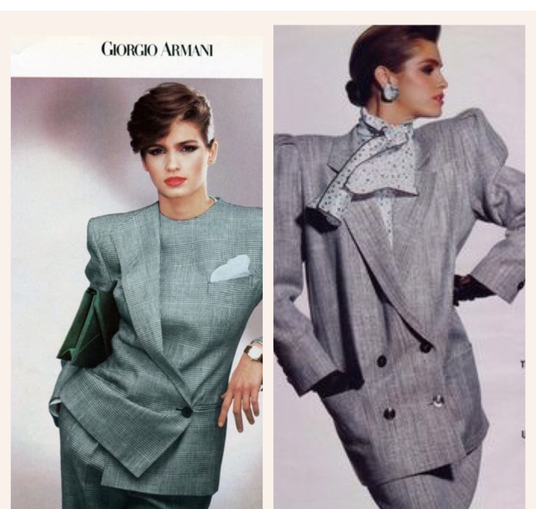

Deconstructed jacket (Favolo C, 2021)
Customize one of the most classic garments in the male wardrobe, making it suitable for the wearer. How to turn the jacket into a second skin? Simple: Armani takes it apart. And then he puts it back together. Deconstructed precisely because it has no structure, no padding and interlining, with buttons positioned elsewhere in the fabric and completely renewed proportions. This gives a sense of naturalness that satisfies the psychological and emotional demands of women, no longer attributed to the concept of femininity but of emancipation.
The purpose is to build stronger women and kinder men, dressed in simple, sober, and calm elegance..

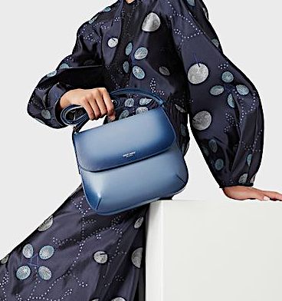
Large, gradient palmellato leather la Prima bag (Giorgio Armani, 2021)

How can it better represent the Armani style than the ‘Prima Bag’? This simple bag of solid colour is suitable for any occasion and responds to requests for elegance but at the same time for functionality

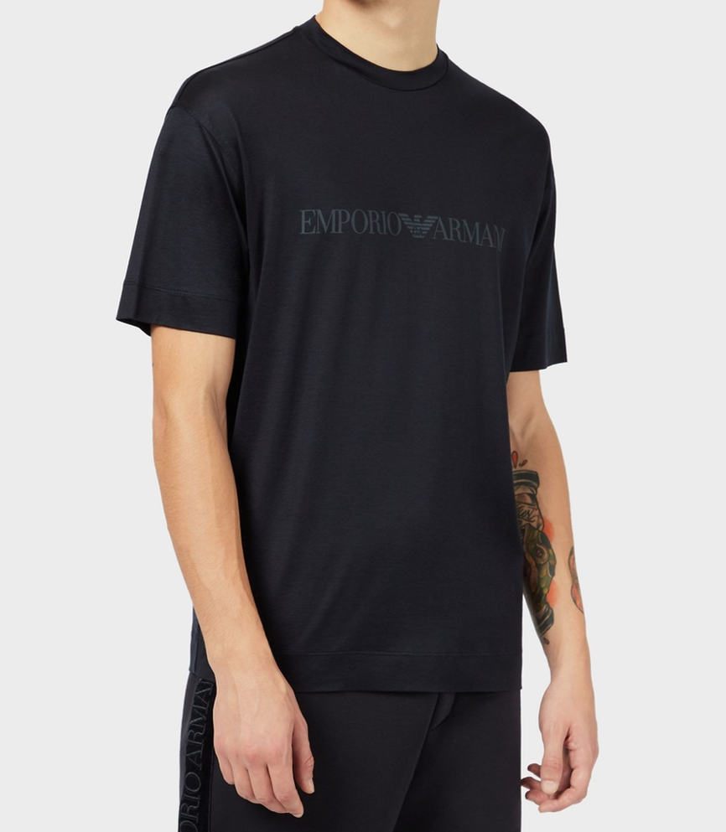

Lustrous jersey T-shirt with logo print (ref

This grace is also found in a sports T-shirt. Jersey T-shirt is part of the Emporio Armani brand characterized by a more modern and Cosmopolitan appeal, suitable for a younger audience.

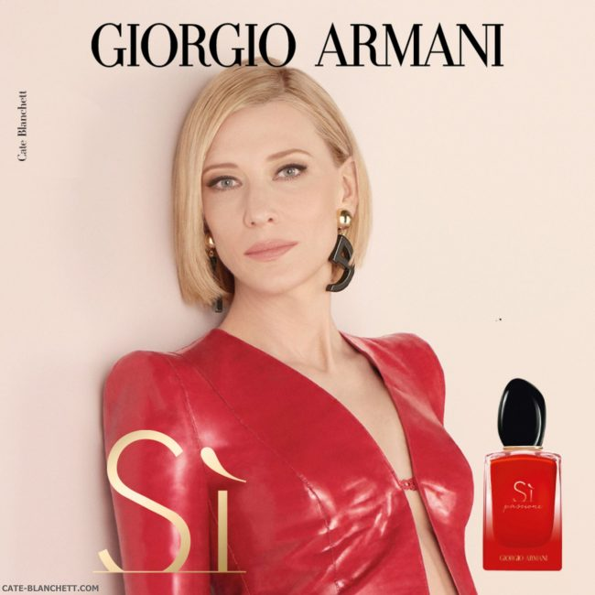
SI PASSIONE (Armani Beauty, 2021)

One of the sub brand s or Armani is ‘Armani Beauty’
With Cate Blanchett as a testimonial, Armani targets a defined audience between 25 and 55 years old. Armani define Sì Eau de Parfum as a modern fruity perfume, vibrant and captivating.
The floral base (rose) is solid but not as strong as the fruity top notes of blackcurrant and jasmine. Less recognizable only the white wood and patchouli seem to have the sole task of trying everything together.
Everything is finished with a note of vanilla, which gives energy and femininity to the fragrance.
As Giorgio affirms: "Intensity doesn't need to be dark. Intensity is a movement in the making, a continuous vibration."
As someone wearing the fragrance, I can prove Si Passione is a perfect combination of passion and brightness.

Sub brands of Giorgio Armani

EMPORIO ARMANI
The Emporio Armani is one of the longest-running brands of the fashion group and it’s still very popular thanks to a modern and cosmopolitan appeal, characterized by old-time tailoring. The Emporio Armani women's and men's clothing collections include comfortable and at the same time trendy garments: men's jackets and trousers, women's dresses, shirts and t-shirts and target professionals between 35 to 50 years old. (MartinRoll, 2021)

EA7
EA7 represents the sporting soul of Armani. A complete line of sportswear, which includes tracksuits, sweatshirts, t-shirts, shorts, shoes made with technical fabrics and offered in captivating and trendy colours. Andriy Shevchenko, a footballer who played for A.C. Milan at the period was wearing the number 7 and became the inspiration for the EA7 line (MartinRoll, 2021)

AX
Armani Exchange
Armani Exchange is the group's fast-fashion line and outlets (MartinRoll, 2021). It offers an accessible and versatile line of men's and women's clothing, dedicated to the world of young people. Jackets, sweaters and sweatshirts, t-shirts, polo shirts and jeans with a fresh and casual style.

PACKAGING
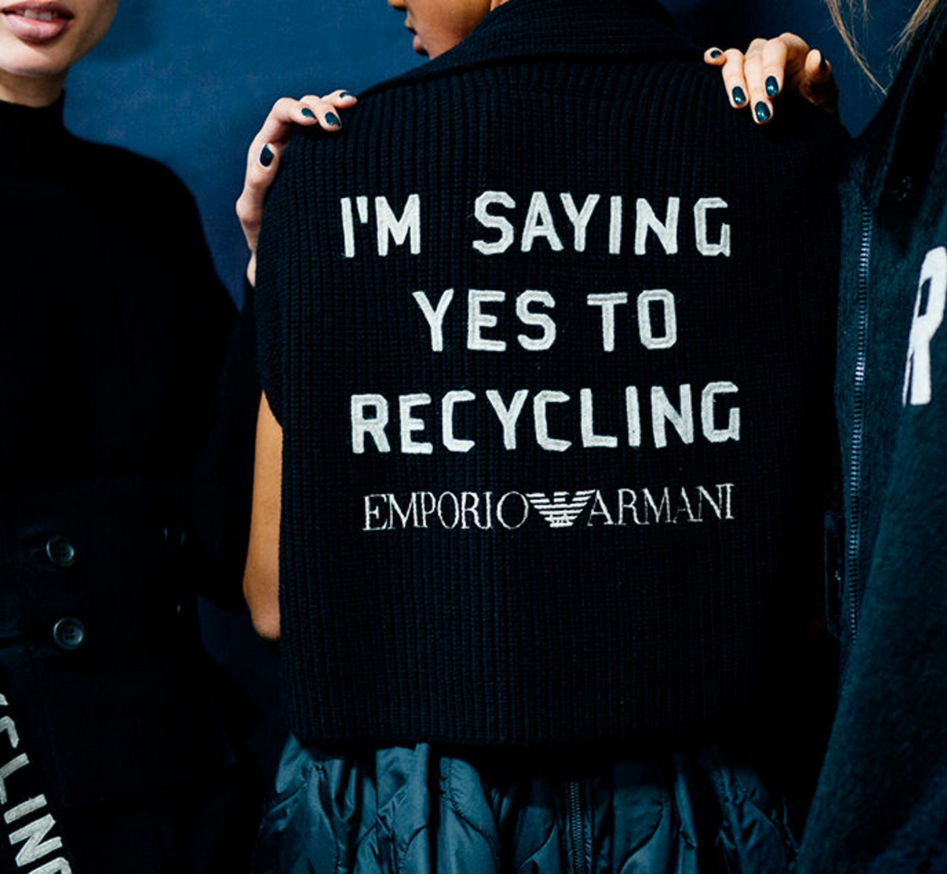

The Armani Group is committed to safeguarding the environment by controlling the production of packages.
They are produced from recyclable materials and adhere to the Forest Stewardship Council's criteria, which guarantee that the materials are sourced from ethically managed environments.
The bags have no plastic elements and are made of recycled paper, including the handles of the paper bags, making them completely recyclable.
Even the stickers on the Giorgio Armani and Emporio Armani brands are recycled paper like the boxes used for shoes.

Instead, recycled polyester is used for ribbons and covers.
.


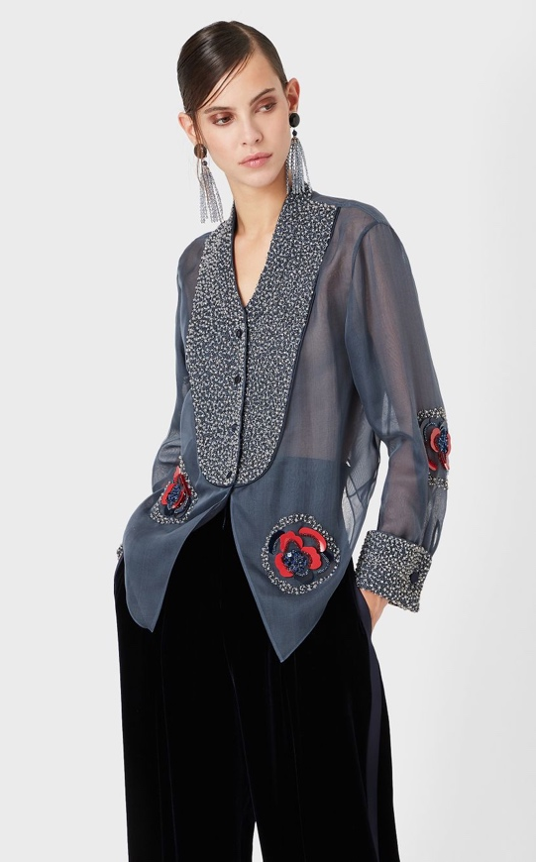
PRICES
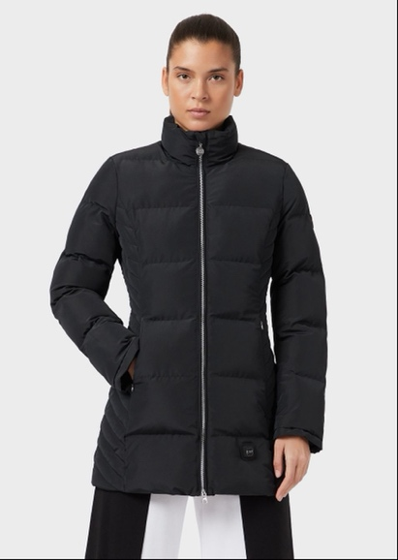
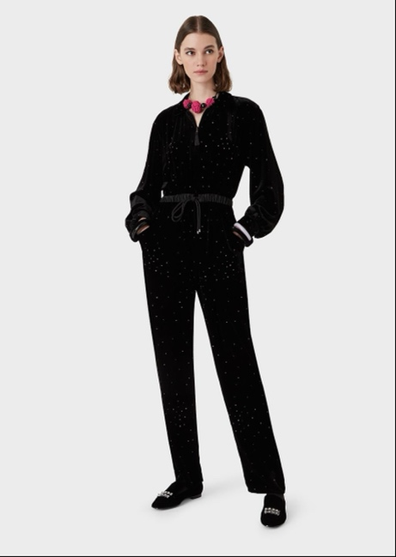
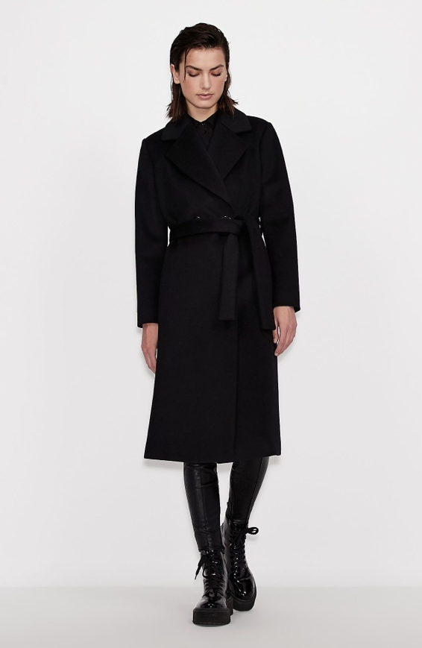

Organza shirt with sequin embroidery (Giorgio Armani a, 2021)
Giorgio Armani
$ 11,695
Zipped velvet jumpsuit with all-over rhinestones (Emporio Armani, 2021) Emporio Armani
$3695
Puffer Jackets (EA7, 2021)
EA7
$575
Coat (Armani Exchange, 2021)
A|X
£350
PLACE
As we have mentioned above, Giorgio aims to keep the exclusivity of his brand without looking at it in his style. However, having previously created several lines under the parent company, he had undoubtedly broadened the target that the designer could aim for at the expense of quality and elegance.
Because of this, Armani has decided to refocus on a type of exclusive distribution, consolidating the leading brands such as Masterbrand.
Armani thus changed the distribution in retail stores focusing on what was originally the Emporio. (Zargani L, 2017)
In this way, Armani eliminates the confusion between the different lines and encloses the entire line in retail, avoiding dispersion.

The retailers are present in several countries worldwide (on the Armani main website, we can count 50).
However, distribution takes place through other channels, such as the official website, allowing you to find the closest retailers in the area. (Sandeep D, 2017)
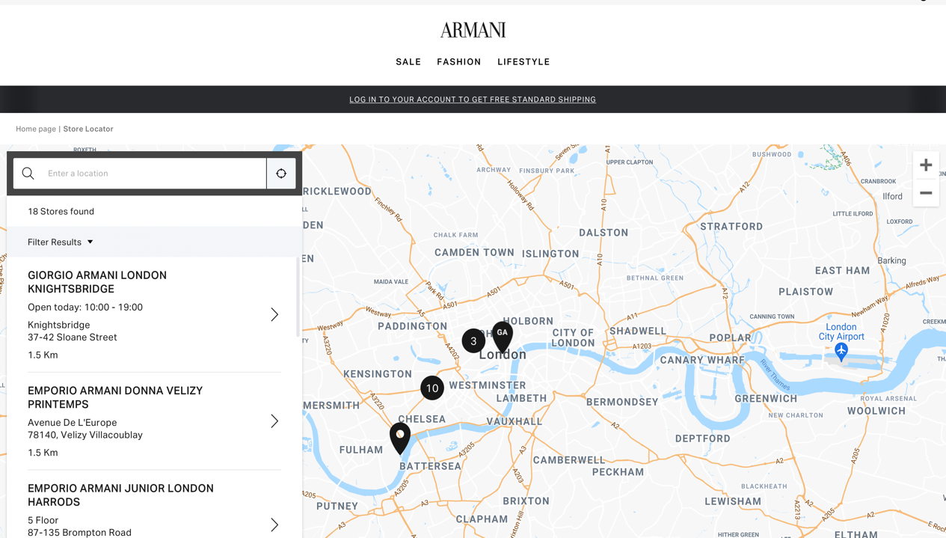

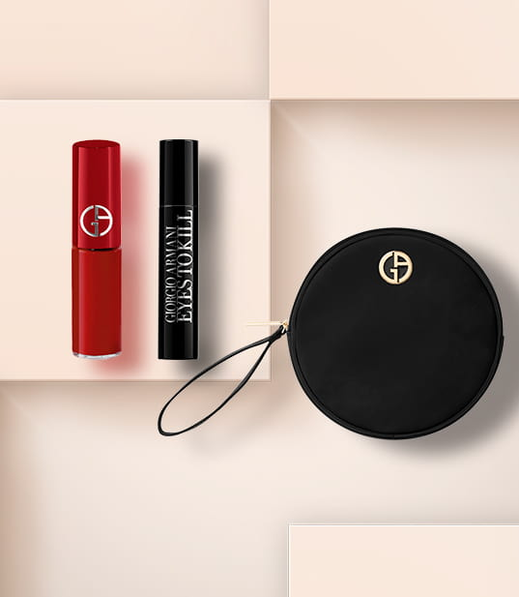
PROMOTION
Armani provides a wide range of promotions regarding the beauty line.

There are offers such as a free Black beauty pouch mini if you pay over £80, a Privé Sample Set if you buy 200 or more, a congratulatory ‘ Blue Pouch, My Way EDP 15ml, and Mini Lip Power 400’ (Armani Beauty a ,2021) when you buy any ‘My Way EDP 50ml + or My Way Intense EDP 50ml +’ (Armani Beauty a ,2021), and a complimentary ‘Blue Pouch, My Way EDP 15ml, and Mini Lip Power 400’ (Armani Beauty a ,2021)when you decide to buy any ‘My Way EDP 50ml + ‘(Armani Beauty a ,2021)

If you buy the last chance to purchase products, you can receive 30% savings. (Armani Beauty a , 2021)

Moreover, if you sign up with the newsletter, you get 15% off the next purchase (Armani Beauty a , 2021).

Sign up for the email to get 15% off your next purchase, two samples with every transaction, and free UK standard shipping. (Armani Beauty a , 2021)

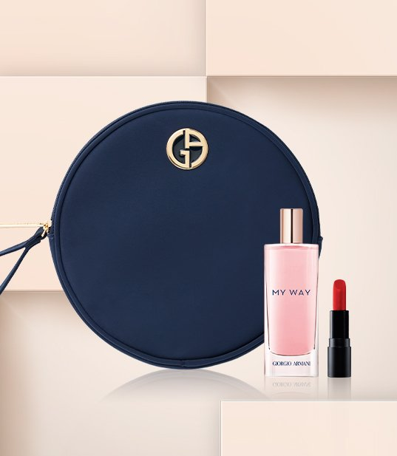

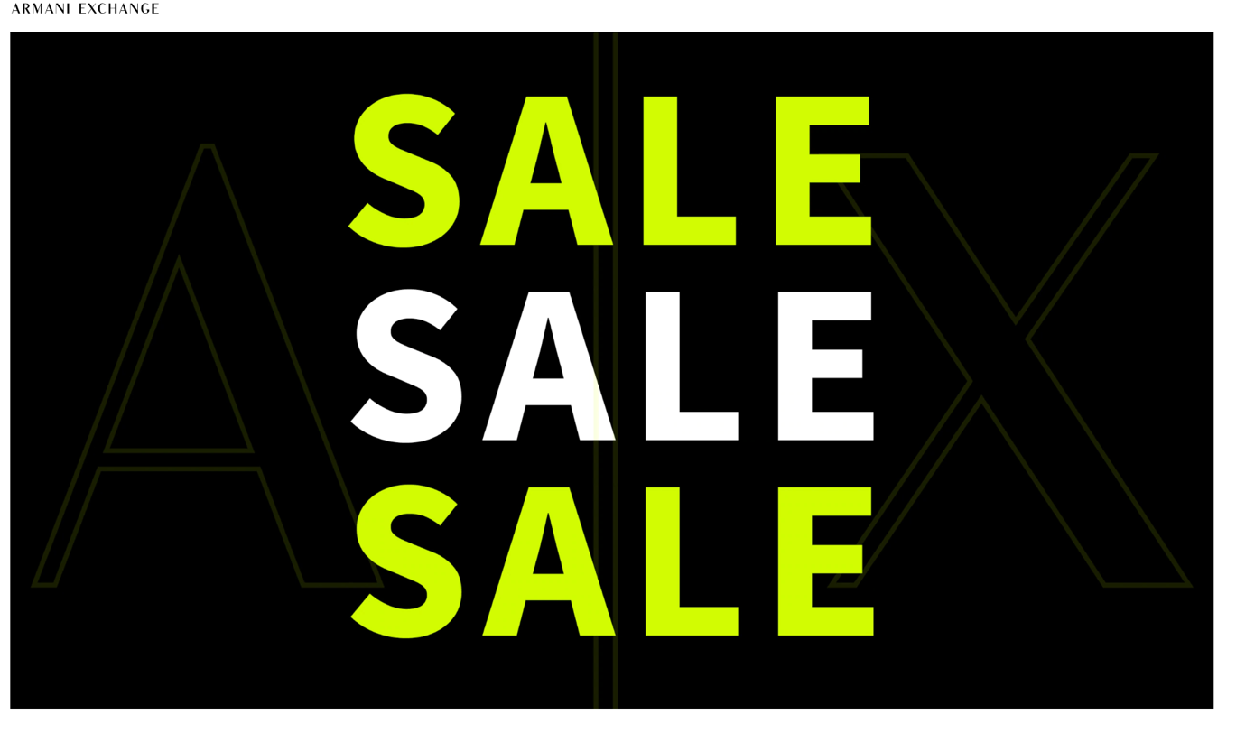

For Armani exchange, there is always a wide range of sales, such as fall winter 2021, thus concluding the end-of-season deals with discounted items. (Armani Exchange a, 2021)

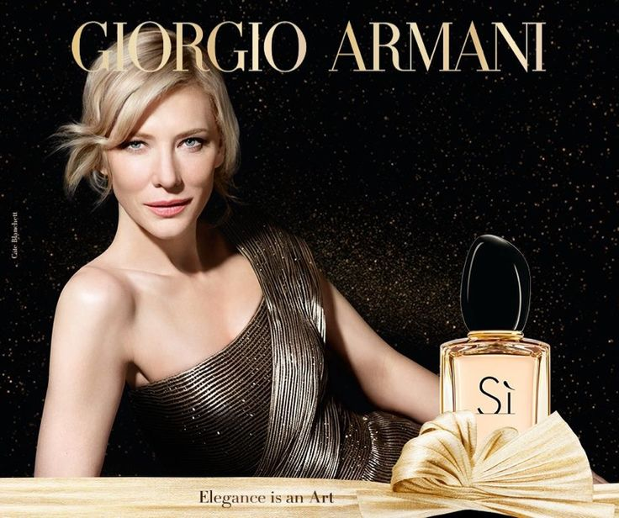

As far as Giorgio Armani and Emporio Armani are concerned, television advertisements are not very widespread. However, elite garments and accessories are advertised through fashion shows and magazines.
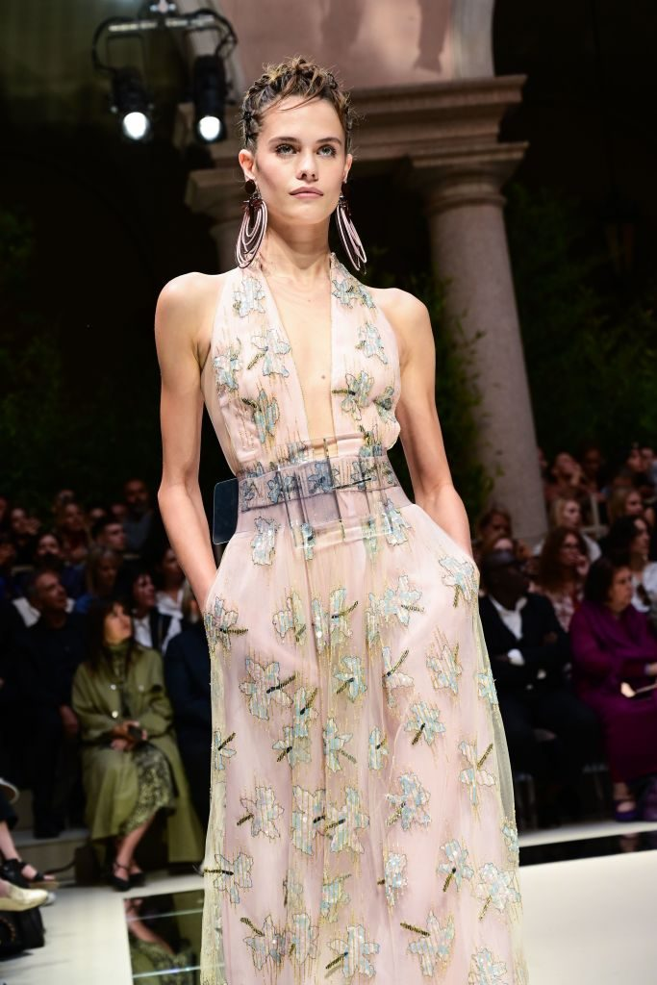
Great celebrities often await the fashion shows, giving a sense of exclusivity, which is precisely contained in his garments.

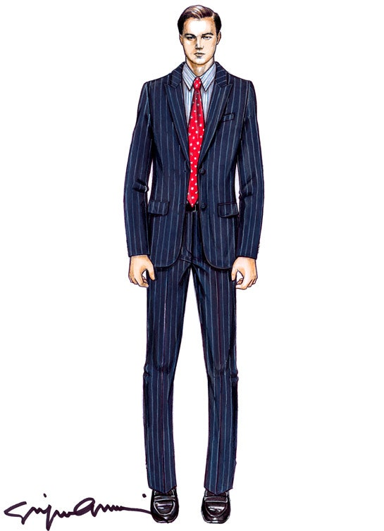

For Armani beauty, especially on perfumes, television advertising is much sought after and often resorts to celebrity endorsements, such as the one seen previously with Cate Blachett.
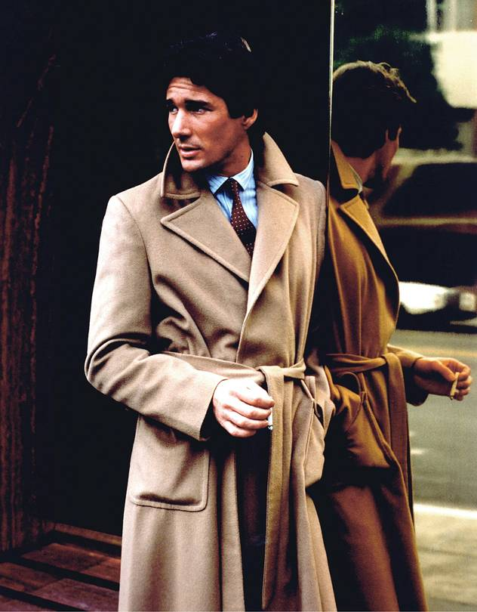
The film is a way for Armani to sponsor his clothes for example with Richard Gere in American Gigolo, and with Leonardo di Caprio in the Wolf of Wall Street. (Solomon M, 2015)

REFERENCES
Armani (2021), ENVIRONMENTAL PROTECTION AND THE EFFICIENT USE OF RESOURCES, available at:<https://www.armani.com/en-us/experience/corporate/social-responsibility/social-responsibility-environment>

Armani Beauty, (2021), SÌ PASSIONE EDP INTENSE, available at: <https://www.giorgioarmanibeauty-usa.com/fragrances/womens-fragrances-perfume/si/si-passione-edp-intense/A2261.html#start=6&cgid=F3_FRAGRANCES_HER_SI>
Armany Beauty a , (2021), Exclusive Offers, available at: <https://www.armanibeauty.co.uk/exclusive-offers>

Armani Exchange, (2021), Coat, available at: <https://www.armaniexchange.com/gb/coat_cod15145883rs.html>

Armani Exchange a, (2021), Public Sale Section, available at: <https://www.armaniexchange.com/gb/unisex/publicsale_section>

EA7 (2021), Puffer Jackets, available at: < https://www.armani.com/en-us/item_cod32027475399650779.html>

Emporio Armani, (2021), Zipped velvet jumpsuit with all-over rhinestones, available at: <https://www.armani.com/en-us/zipped-velvet-jumpsuit-with-all-over-rhinestones_cod27086482323941791.html>

Favolo C, (2021) Fashion history to report the present: the 70’s social crises are still contemporary, Lampoon, available at: <https://lampoonmagazine.com/blog/2021/04/01/emporio-armani-fashion-show/>

Giorgio Armani, (2021), La Prima Bag, available at: <https://www.armani.com/en-gb/experience/giorgio-armani/la-prima>
Giorgio Armani a, (2021) Organza shirt with sequin embroidery, available at:<https://www.armani.com/en-us/organza-shirt-with-sequin-embroidery_cod17411127376184113.html>
Goodreads (2022), Giorgio Armani quotes, available at: <https://www.goodreads.com/quotes/766192-elegance-is-not-about-being-noticed-it-s-about-being-remembered>
Editorial Team, (2021), Emporio Armani: the history behind the Logo, Pixartprinting, available at: <https://www.pixartprinting.co.uk/blog/emporio-armani-logo/>

MartinRoll (2021),Giorgio Armani – The Iconic Global Fashion Brand, , Available at <https://martinroll.com/resources/articles/branding/giorgio-armani-the-iconic-fashion-brand/>

Sandeep D, (2017) Distribution - The 'uncool' element of brand success, LinkedIn, available at: <https://www.linkedin.com/pulse/distribution-uncool-element-brand-success-sandeep-das\>

Solomon M, (2015), Luxury Lineage: A Brief History of the Armani Suit, Forbes, available at: <https://www.forbes.com/sites/msolomon/2015/05/06/luxury-lineage-a-brief-history-of-the-armani-suit-armani-40th-anniversary/?sh=624152e36138>

The Business of Fashion, (2015), Inside Giorgio Armani's Fashion Legacy | The Business of Fashion, [online video] available at: <https://www.youtube.com/watch?v=x6zd18LUxp4>
Zargani L, (2017) Giorgio Armani Restructures Brands, Rethinks Distribution, WWD, available at: <https://wwd.com/fashion-news/designer-luxury/giorgio-armani-restructures-brands-10822285/>

