

Assessment 1 – Reading Task Template
PART 1: Upload your photo of your A3 in-class notes here:
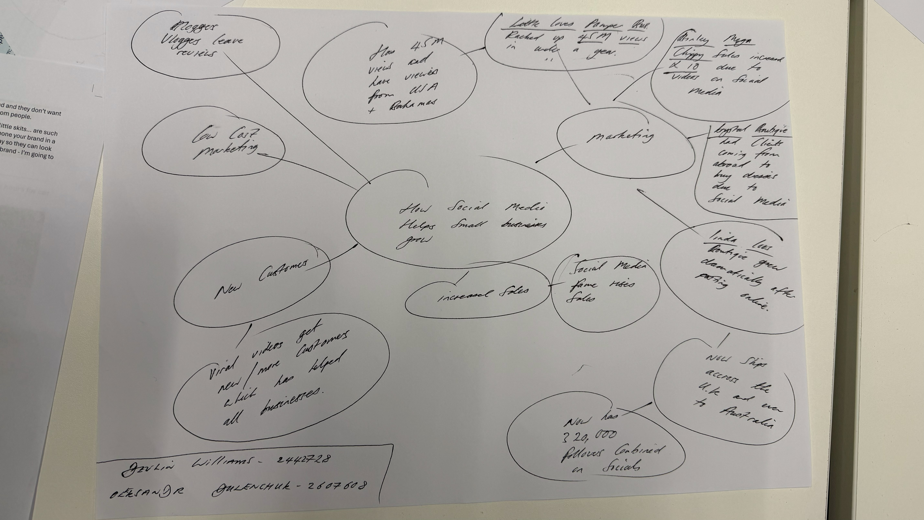

PART 2:
- Answer every question below in 1-3 full sentences.
- Use your own words. Do not use generative AI to answer these questions.
- Include a specific detail from the text when asked.
REMINDER
- The main idea is the overall message of the whole text.
- A key point helps to explain the main idea.
- A specific detail or example from the text shows that the key point is true.

- What is the main idea of the whole text?
The main idea of this text is that social media has made marketing easier, cheaper, and more popular. It is now possible to grow a business without spending a lot of money on advertising and marketing. Today, businesses can grow quickly and reach many people. Sometimes, customers promote a business themselves by sharing reviews on their social media pages. This is a type of word-of-mouth marketing that can help build trust between customers and sellers. On the other hand, people have become more careful when buying things and choosing products.

- What is one key point that supports the main idea, and which specific example from the text shows this?

One of the key points of this text is that social media helps businesses attract new customers through authentic content and word-of-mouth marketing. Faye Martin, a marketing expert, explains that people prefer content they can relate to and understand rather than traditional adverts where it is clear that someone is trying to sell them a product. At the same time, the example of Honywood Sandwich Shop shows how videos made by customers can attract new visitors, even from far away.

- What is a different key point that supports the main idea, and which specific example from the text shows this?
Social media allows businesses to reach not only local customers but also people in other cities and even other countries. For example, Lindy Loo’s Boutique, owned by Linda Hunter, has moved fully online and started delivering its products across the UK and to Australia.
- Which part of the text do you think is most important, and why?
I do not want to focus on one specific part of the text, as each section includes different examples or data. However, the part where TikTok shared data showing that around 1.5 million British businesses use its platform, and the data from the government’s Business Academy programme stating that over 200 million businesses worldwide use Instagram to find customers, clearly shows that social media is an important part of marketing today and will continue to be so in the future.
Reflection:
- What did you find difficult in this task (including in-class components), and why was it difficult?

For this task, it was important to understand the main idea of the text first and then, after reading it several times, identify the key points that support the main idea. The most difficult part was connecting all the examples and finding links between them, as the businesses described operate in different areas and grow in different ways. Overall, based on this analysis, it can be said that social media is an essential part of modern business marketing.

- What helped you with this difficulty, and how did it help you?

First, reading helped me understand the overall picture of the text. Then, by scanning, I identified the main ideas that were repeated, focusing on what actions helped each business grow. After that, by filtering the information, I selected important details based on specific criteria and removed unnecessary information, focusing on how social media helped businesses grow, attract customers, and reach a wider audience.

