My Digital Life

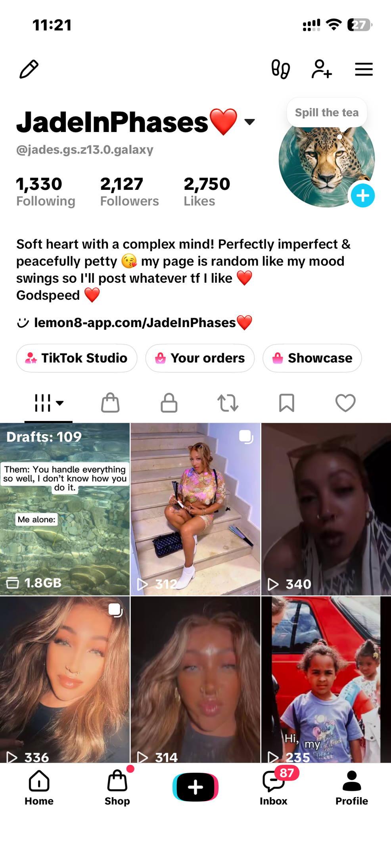

I use TikTok often and my profile displays my personal digital presence, the things I enjoy, and how I interact with content and creators. I use TikTok almost daily mainly for entertainment purposes but also to interact and occasionally promote items I’ve purchased.

Screenshot/Photo 2
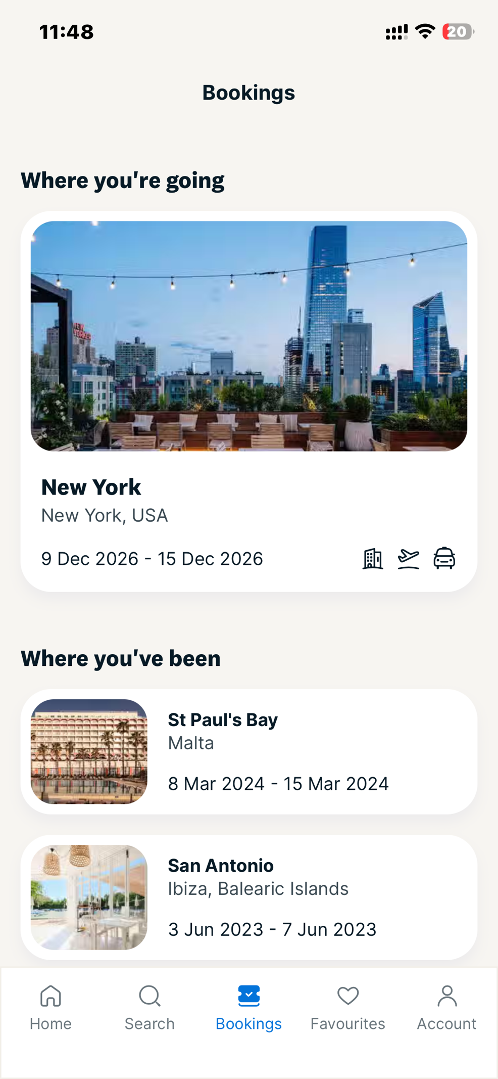
I feel confident using online holiday booking platforms. This screenshot shows my Love Holidays booking It demonstrates my ability to plan and book trips which is something I thoroughly enjoy .It’s how I look forward to future experiences and stay organised with my travel plans.

Screenshot/Photo 3
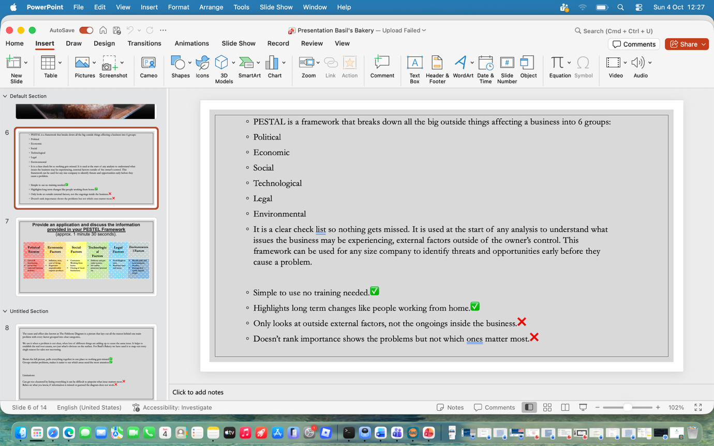
I want to improve on my ability to use PowerPoint confidently. The screenshot above shows me working on my current university assignment using PowerPoint. It is the main digital tool I’m using right now to research, structure and create my presentation it shows how I build and organise my coursework digitally.

Screenshot/Photo 4
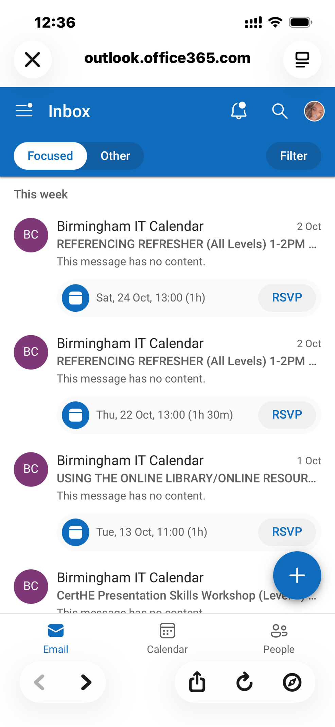
This is my university email inbox. It’s how I stay connected, receive important information and keep on top of my studies and communications it is an essential part of my digital life as a student.

Screenshot/Photo 5
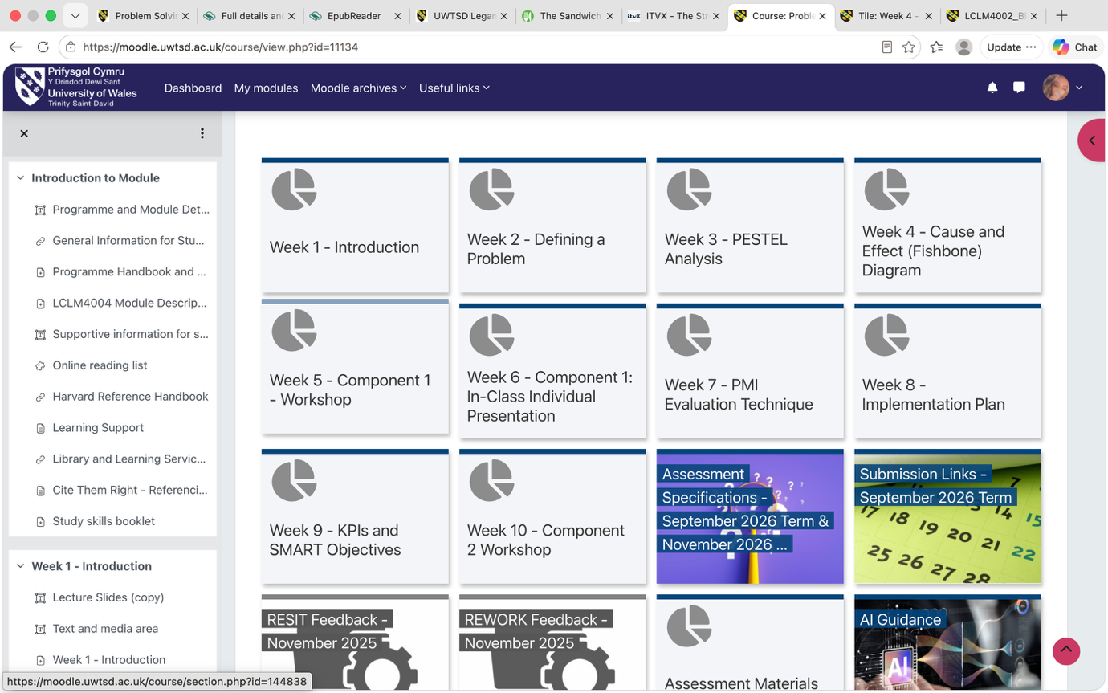
I feel confident using Moodle, my university’s online learning platform. I use it every week to access my modules, see the essential reading lists, download materials and to keep track of what I need to do. It is how I navigate and manage my studies digitally.

Screenshot/Photo 6

My Short Reflection
- Write 5–8 simple sentences about your digital life.
- You can use the sentence starters below if helpful.
My Digital Life Reflection
Digital technology is part of almost everything I do. For university, Moodle, email and PowerPoint help me learn, stay informed and create work. Outside of study TikTok and YouTube is where I relax and enjoy myself and Love Holidays helps me plan for future enjoyment. My digital life balances my studies with who I am as a person, keeps me connected, organises and inspired.

Sentence starters
- I use digital tools to …
- I feel confident when I …
- I want to improve …
- I often use these tools: …
- I sometimes feel nervous about …
- I hope this module will help me …
- Digital skills are important for me because …
You can write more if you want.

Submission Checklist
Before you submit, please check:
​​​ ☒ I added 4–6 screenshots
☒ I wrote short sentences for each screenshot
☒ I wrote my short reflection
☒ My work is my own
☒ My file opens correctly
​​☒ My file opens correctly

