Database Management Systems
ACCA5014
Connor Ellement 1803452
Web Development

Contents
1) Introduction 3
2) Performance Tuning 3
2.1) Data Query Requirements 3
2.2) Indexes 4
3) Distributed Database Solution 4
3.1) Fragmentation 4
3.1.1) Advantages of Fragmentation 5
3.2) Allocation 5
3.3) Replication 5
3.4) Recommendations for each table 6
3.4.1) Region Table 6
3.4.2) City Table 6
3.4.3) Gym Table 7
3.4.5) MembershipType Table 7
3.4.6) GymMembershipPrice Table 8
3.4.7) Customer Table 8
*Note* As it is being vertically fragmented, both table Customer1 and Customer2 can have the CustomerID in them. 9
3.4.8) MembershipPurchase Table 9
3.5) Reconstruction 10
4) Conclusion 10
5) References 11

Introduction
The task set in this assignment was to assist Shape Up Gyms by helping them solve their issues with their database. In this report you will read about the results from the created database using the Shape Up Gyms case study as well as a proposed database distribution system. You will also see the recommendations of data queries and indexes that will help improve the query performance.

Performance Tuning
When creating a database, it is to be expected that the database and the data inside it will at some point be queried to find specific parts of the entered data. To do this, data queries are used as they are transactions that allow the database to be queried efficiently [1].

2.1) Data Query Requirements
When looking at the Shape Up Gym case study, quite a few queries pop into mind that would be searched for frequently.
1) Firstly, all gyms in a specific city is very likely to be queried a lot as people would prefer to search for gyms that are close to them and in and possibly around their area.
2) Another query likely to be popular and quite important is searching for a gym’s contact details, and querying for a gym’s name, address and phone number.
3) Searching for customers using their names is a query likely to be used by the Shape Up staff a lot as they will be checking to see if a customer already exists when they enter a gym.
4) Staff checking memberships of customers is a very important query that will be used frequently to make sure no one is using the gym for free.
5) Customers would search what membership packages Shape Up offers so they can check what suits them more.

2.2) Indexes
Looking at the suggested data queries above, there have been four indexes created from what have been judged to be the most important out of the five data queries.
The first index created was idx_Gym_GymCity. This index helps query gym names and their city code so users can see the name of the gym and which city it is in faster.
The next one created was idx_Gym_GymContact. This index was chosen as it was seen as important for customers to be able to search contact details efficiently.
The penultimate index created was idx_Customer_CustomerNames. This was created to allow efficient querying to check if a customer already exists.
The last index created was idx_MembershipPurchase_MembershipCheck. It was created as staff members need to be able to check memberships quickly and efficiently to make sure no one is using gym for free.

Distributed Database Solution
Shape Up Gyms is rapidly growing in popularity and customers, to the point where they decided to expand the business into all the regions in wales by physically distributing gyms across the regions. It is a recommendation that they improve their database, by distributing their database physically across a computer network, controlled by a single database management system (DBMS) [2]. As it would be controlled by a singular DBMS, it makes the database Homogeneous, and this is good because homogeneous databases are easier to design and manage. The way to achieve this distribution is by using the selective replication data allocation strategy due to the database being physically distributed. This will be done by using three factors, fragmentation, allocation, and replication.

3.1) Fragmentation
Fragmentation, also sometimes referred to as data partitioning according to the book Advances in Computers vol. 27 [3], it’s the method of splitting up data in a table that can then be allocated elsewhere in a computer network.
There are 4 methods of fragmentation that the Shape Up Gyms database could use:
Horizontal – Data in a table is split up by the rows (or tuples) into smaller tables, and each of those smaller tables contains unique rows from the original table [4].
Vertical – Data in a table is divided by the columns (or attributes) into smaller tables, and those smaller tables contain unique columns from the original table [4].
Mixed – Also referred to as Hybrid fragmentation, is a mixture of Vertical and Horizontal fragmentation when they are used together and is used to split rows and columns.
Derived – A method of horizontal fragmentation that is used when a child table is linked to a parent child and they need to be fragmented in the same way.

3.1.1) Advantages of Fragmentation
- As the data that results from fragmentation is kept close to the site that would use the resulted data the most, it increases the efficiency of the DBMS. [5]
- As there will be no data at the sites that isn’t needed, it allows the privacy and security of the DBMS to be maintained. [5]
- “Local query optimization techniques are sufficient for most queries since data is locally available.” [5]
- Typically, with databases, views are used more that the entire solutions, so it is fitting to use subsets of the relations

3.2) Allocation
After Fragmentation, the fragments created need to be allocated somewhere. This is where allocation comes in to play. The fragments of data should be stored at the point of most importance and most likely to be searched [6].

3.3) Replication
Replication is used for certain tables or fragments to be replicated across all sites so that all of the sites can access the tables/fragments and see the data inside them.

3.4) Recommendations for each table

3.4.1) Region Table
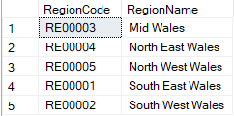
For the region table, there will be no fragmentation performed, and the table will be replicated across the network as all sites will need access to the region codes.

3.4.2) City Table
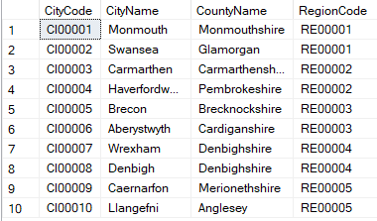
The city table is recommended to be horizontally fragmented, as each gym needs to be in its region, and by horizontally fragmenting it, the resulted fragments will clearly show which gyms are in what regions, as you can see below:
City5
City4
City3
City2
City1

3.4.3) Gym Table
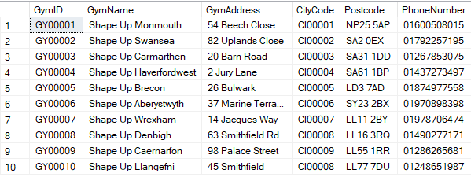

The gym table, like the city table should be horizontally fragmented. The reasoning is because each gym needs to be displayed in it’s correct region, and despite RegionCode not being in the gym table, it is still linked to the region codes through the CityCodes.

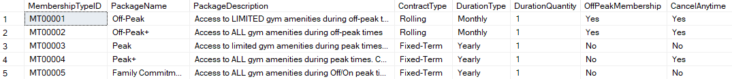
3.4.5) MembershipType Table

The MembershipType table is recommended to be replicated across the network so that all sites can access all of the different membership types. This is important, so that more membership types might be added, and then all the gyms would be able to see the changes and add the updates to the gym if required.

3.4.6) GymMembershipPrice Table
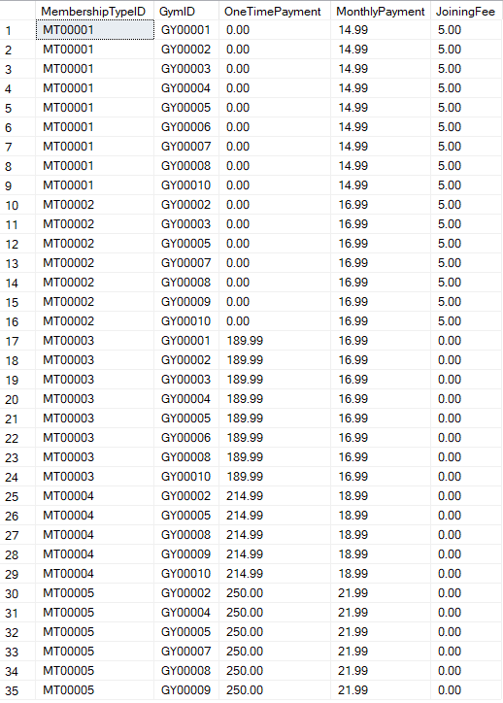
The GymMembershipPrice table will also be replicated so that all sites have access to the prices if they update or change as the price structure is the same.

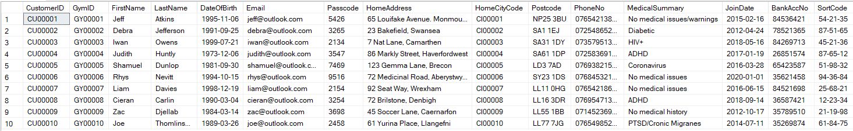
3.4.7) Customer Table

The customer table should used mixed fragmentation. The table would first be vertically fragmented by splitting up the customers personal information (Customer1) from the financial information (Customer2), then the Customer2 table would be horizontally fragmented using the home city code to identify which region the customer lives in. The results of the vertical fragmentation can be seen below:
Customer1
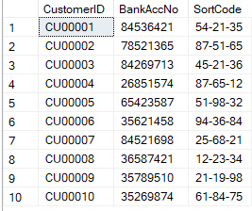
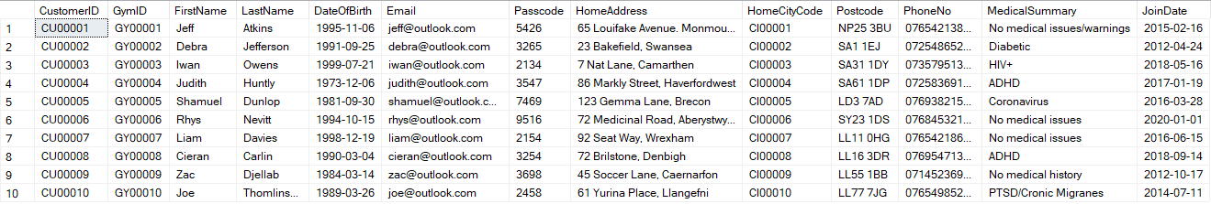
Customer2

*Note* As it is being vertically fragmented, both table Customer1 and Customer2 can have the CustomerID in them.

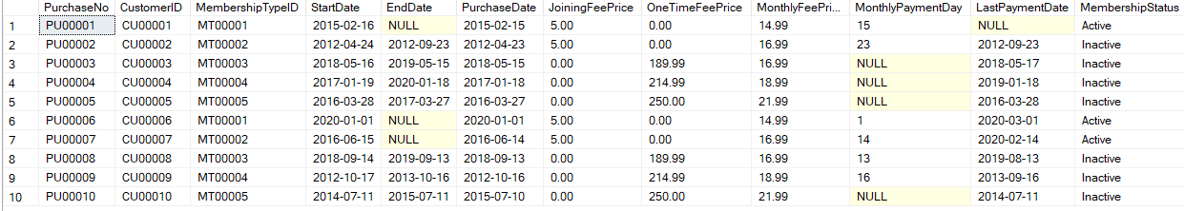
3.4.8) MembershipPurchase Table

The MembershipPurchase table with not be fragmented and will be centralised at the finance department in the head offices in Swansea. The reasoning behind this is because all the sites do not need access to all the information provided in the MembershipPurchase table. If a customer whose membership has expired tried returning to a gym, it would be up to the finance department to cut that customer off so that he cannot use his expired membership.

3.5) Reconstruction
As some of the tables have been fragmented, they need to be reconstructed to be able to be viewed as whole again. The city table was horizontally fragmented, so it would use UNION to reconstruct using the regional code. The gym table was also horizontally fragmented, and it would also use a UNION to reconstruct using the city code which would translate up to the region code. For the customer table as mixed fragmentation was used, a combination of a JOIN and UNION are required to reconstruct. As the vertical fragmentation was done first, a Natural JOIN is required and can be done using the Customer ID, then followed by a UNION on the home city code, which would again translate to the region code.

Conclusion
The task was set out to aid Shape Up Gyms in the overhaul of their database and making it more efficient, as well as propose a way the database could be distributing by using a DDBMS and a fragmentation schema.
The database has been created and works with full functioning capability and is efficient. There are many check constraints to allow the data to check for any incorrect or unwanted data. The transaction has also been created and does not allow any overlapping of an existing customers memberships.
A proposal of a DDBMS has been given and goes into depth on how and why it will be distributed in the suggested way. An accurate fragmentation schema has also been provided, as well as the reasoning behind the suggestions.
With all that being said, the task set out is believed to have been met.

References

[1] | “What Is Performance Tuning? Why Should You Do It?,” Technology Partners, [Online]. Available: https://technologypartners.net/blog/2016/06/performance-tuning-why-do-it-st-louis-information-technology-recruiters/. [Accessed 12 March 2020].
[2] | “Fragment Allocation In Distributed Database Design,” UKEssays, November 2018. [Online]. Available: https://www.ukessays.com/essays/information-technology/fragment-allocation-in-distributed-database-design-information-technology-essay.php?vref=1. [Accessed 12 March 2020].
[3] | M. C. Yovits, Advances in Computers vol. 27, 1988.
[4] | “What is horizontal and vertical fragmentation? What are the types of horizontal fragmentation?,” Ques10, May 2016. [Online]. Available: https://www.ques10.com/p/19583/what-is-horizontal-and-vertical-fragmentation-what/. [Accessed 12 March 2020].
[5] | “Distributed DBMS - Design Strategies,” tutorialspoint, [Online]. Available: https://www.tutorialspoint.com/distributed_dbms/distributed_dbms_design_strategies.htm. [Accessed 12 March 2020].
[6] | “Fragment Allocation in Distributed Database Design,” 2001.

marking criteria and Student FEEDBACK

This section details the extent to which the assessment criteria are demonstrated by you, which in turn determines your mark. The marks available for each category of skill are shown. Lecturers will use the space provided to comment on the achievement of the task(s), including those areas in which you have performed well and areas that would benefit from development/improvement.

Common Assessment Criteria Applied (Assignment 1) | Marks available | Marks  awarded
1. Engagement with Literature Skills

2. Knowledge and Understanding Skills

A very good range of queries to create sample data for the database has been provided with additional, appropriate queries to test the constraints added to the tables. A good attempt at the required transaction to purchase a new membership but there is room for improvement in the logic and avoid hard-coding values you know already exist. The logic for the IF condition is not quite correct. Also not sure why you were adding DDL ALTER statements to the transaction. The transaction should be made up of DML statements only. (Grade mark: 76.00%) | 25 | 19
3. Cognitive and Intellectual Skills

A good analysis of the case study, but there is room for improvement. The data queries discussed to select your indexes are good choices, but the chosen columns to index could be better. Although you have explained the purpose of indexes well and demonstrated the use of multi-column indexes, a few of your chosen indexes include too many columns. This will make the size of the indexes large and also inefficient. Also note that with multi-column indexes, the order of the columns is important. Generally, a very good distributed database design solution has been proposed, but there is also room for improvement. See your report for additional comments. (Grade mark: 70.00%) | 30 | 21
4. Practical Application Skills

A very good attempt. Just a few minor things to note. You changed the name of the PK column in the Gym table. Note that that FKs do not have to have the same name as PKs and your understanding of this was being assessed. For the OffPeakMembership and Cancel Anytime columns, use the BIT type which is used to store Boolean data (True/False or Yes/No). This will also eliminate the need for the check constraint. You may want to consider allowing some flexibility in some of your check constraint formats. The phone number for example, if you ask a number of people to write a telephone number down, chances are you will get a few different formats. For your monthly payment day constraint, it would have been better to use BETWEEN or instead of LIKE i.e. CHECK(MonthlyPaymentDay BETWEEN 1 AND 31) or CHECK(MonthlyPaymentDay >= 1 AND MonthlyPaymentDay <= 28). (Grade mark: 77.50%) | 40 | 31
5. Transferable Skills for Life and Professional Practice

The report is well-written and presented. (Grade mark: 80.00%) | 5 | 4

Assignment Mark (Assessment marks are subject to ratification at the Exam Board. These comments and marks are to give feedback on module work and are for guidance only until they are confirmed. ) | Late Submission Penalties (tick if appropriate) |  | 75%
 | Up to 1 week late (40% Max) |  | 75%
 | Over 1 week late (0%) |  | 75%

