Portfolio (Poster + Essay)
Introduction to Health and Social Care
Module Code: LCHS4003
Lecturer: Dr Helen Parsons

Student Name: Syed Faisal Nadeem
Student Number:2313914
Date:19-06-2026

Task 1: Poster
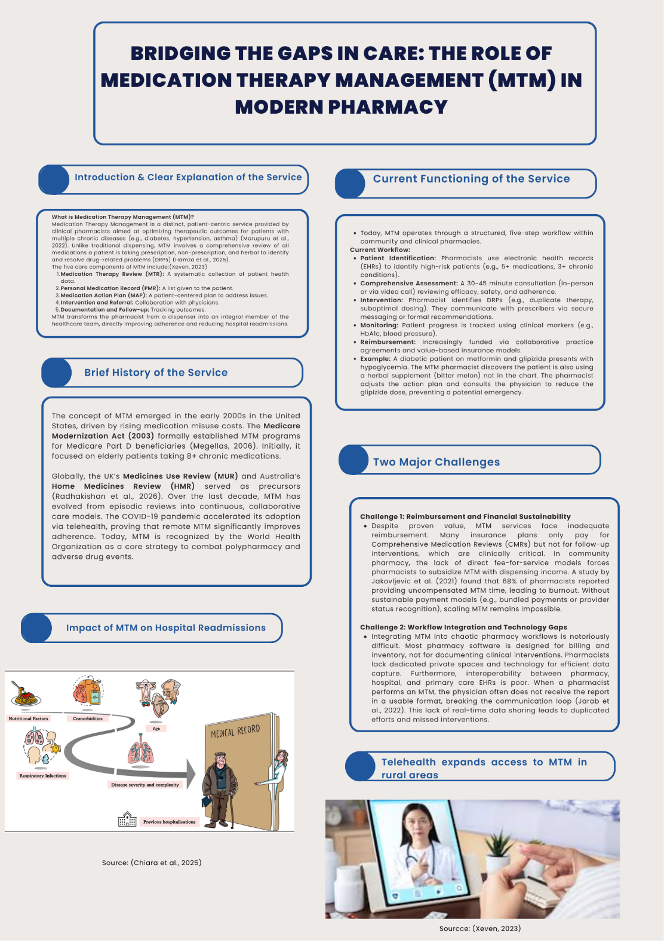
Essay: Community Mental Health Services
Title:
From Asylums to Inclusion: The Evolution and Impact of Community Mental Health Services

Table of Contents
Essay: Community Mental Health Services 1
Introduction 3
Origins and Historical Context 3
Current Functioning of Community Mental Health Services 3
Significance Of Improving a Person's Quality Of Life 4
Conclusion 5
Reference List 6

Introduction
For much of modern history, individuals with severe mental illness were confined to large, remote asylums, often deprived of dignity and autonomy. There has been one of the biggest shifts in the paradigm of healthcare, namely, the development of community mental health services such as residential care homes and community disability services. This essay critically assesses the evolution, operation, and value to quality of life of these services, concluding that although the deinstitutionalization movement has mostly succeeded, there are continuing problems of funding and integration.

Origins and Historical Context
Mental health care in the United Kingdom and elsewhere was Victorian until the 1950s. These institutions were famously referred to as ‘total institutions' by Goffman (1961) because they involved ‘mortification of the self' by way of rigid routines, no privacy, and institutionalized behaviors. But there were three forces that brought change. First, the introduction of psychotropic drugs (chlorpromazine in 1952) enabled symptoms to be controlled in the community (Thornicroft & Tansella, 2013). Secondly, the anti-psychiatry movement, led by anti-psychiatrists such as R.D. Laing, brought to light the dehumanizing conditions found in mental hospitals. Third, the fiscal constraints could not justify mass institutionalization. The Mental Health Act 1959 (amended in 1983) introduced the concept of compulsory community treatment, and the National Health Service and Community Care Act 1990 stated that care should be provided ‘in the least restrictive setting’ (Department of Health, 1990).

Current Functioning of Community Mental Health Services
Residential care homes and community disability services are no longer medical-custodial services but run on a recovery-oriented, person-centered model. Most residential care homes house 6-12 service users and have 24/7 staff available to help them with medication and daily activities (cooking, cleaning, budgeting, and emotional support) (Aspire Life Care, 2026). Residents are provided with their own lockable room and have opportunities to plan their daily activities and engage in house meetings, unlike the old asylums. Community disability services, on the other hand, are services that offer outreach in a person's home or family environment. These are assertive outreach teams (for hard-to-reach clients), crisis resolution and home treatment teams (to prevent hospital admission), and early intervention in psychosis services (EIPs) (Slade et al., 2017). One of the innovations is the multidisciplinary team (MDT) approach for formulating a care plan for the person, involving psychiatrists, community psychiatric nurses (CPNs), occupational therapists, social workers, and peer support workers.

Significance Of Improving a Person's Quality Of Life
In several respects, the transition to a community-based system of services has been shown to have a positive impact on the life of service users. First, autonomy and choice are truly strengthened. In an asylum setting there would be none of these choices for a service user residing in a residential care home to make. Community services actively promote recovery outcomes identified by Leamy et al. (2011) as core to recovery: connectedness, hope, identity, meaning, and empowerment (the CHIME framework). Second, there is less stigma when people are socially integrated. Instead of being out of view, service users become 'visible neighbors' shopping in a local shop, attending local churches, and attending local colleges. Thirdly, objective outcomes are enhanced. In terms of care costs, a systematic review by Slade et al. (2017) demonstrated that community-based care can lower hospital readmission rates by about 40% compared to institutional care and that costs for health care services are also lower. However, some observers question the effectiveness of ‘community care' as 'dumping,' where the number of clients on which CMHTs rely is far too high for one practitioner and the care is therefore not adequately resourced with caseloads of over 40 clients per practitioner often leading to practitioner burnout and neglect (Thornicroft & Tansella, 2013). Notwithstanding these limitations, evidence shows that adequately resourced community mental health services are effective in improving people's functional independence, subjective well-being, and social belonging.

Conclusion
Community mental health services have been able to challenge the 'asylum' model and focus on recovery, autonomy, and social inclusion. Their trajectory through history, starting back in the 1950s to today, highlights a significant change in attitude towards the rights and dignity of persons with mental illness. But their ability to operate is limited by their long-standing underfunding and high case loads.

Reference List
Aspire Life Care (2026). Home Nursing Service in Karachi – Trusted, Affordable & 24/7 Professional Care at Your Doorstep. [online] aspire life care. Available at: https://aspirelifecare.com.pk/home-nursing-service-in-karachi-trusted-affordable-24-7-professional-care-at-your-doorstep/ [Accessed 11 Jun. 2026].
Department of Health (1990). National Health Service and Community Care Act 1990. London: HMSO.
Goffman, E. (1961). Asylums: Essays on the Social Situation of Mental Patients and Other Inmates. New York: Anchor Books.
Leamy, M., Bird, V., Le Boutillier, C., Williams, J. and Slade, M. (2011). Conceptual framework for personal recovery in mental health: Systematic review and narrative synthesis. British Journal of Psychiatry, 199(6), pp.445-452.
Slade, M., Oades, L. and Jarden, A. (2017). Wellbeing, Recovery and Mental Health. Cambridge: Cambridge University Press.
Thornicroft, G. and Tansella, M. (2013). The balanced care model for global mental health. Psychological Medicine, 43(4), pp.849-863.

Poster Reference list
Chiara, C.D., Sartori, G., Fantin, A., Castaldo, N. and Crisafulli, E. (2025). Reducing Hospital Readmissions in Chronic Obstructive Pulmonary Disease Patients: Current Treatments and Preventive Strategies. Medicina, [online] 61(1), pp.97–97. doi:https://doi.org/10.3390/medicina61010097.
Hamza, M.A., Imran, F., Ahmed, A., Ali, W., Siddique, H., Ahsan, H., Murtaza, B., Babar, Z.-U.-D. and Ahmed, A. (2025). Medication therapy management in Pakistan: a cross-sectional evaluation of pharmacists’ knowledge, attitudes, practices, and barriers. Journal of Pharmaceutical Health Care and Sciences, 11(1). doi:https://doi.org/10.1186/s40780-025-00493-8.
Jakovljevic, B., Stojanovic, K., Nikolic Turnic, T. and Jakovljevic, V.Lj. (2021). Burnout of Physicians, Pharmacists and Nurses in the Course of the COVID-19 Pandemic: A Serbian Cross-Sectional Questionnaire Study. International Journal of Environmental Research and Public Health, 18(16), p.8728. doi:https://doi.org/10.3390/ijerph18168728.
Jarab, A.S., Al-Qerem, W., Mukattash, T.L., Abuhishmah, S.R. and Alkhdour, S. (2022). Pharmacists’ knowledge and attitudes toward Medication Therapy Management service and the associated challenges and barriers for its implementation. Saudi Pharmaceutical Journal. doi:https://doi.org/10.1016/j.jsps.2022.03.008.
Marupuru, S., Roether, A., Guimond, A.J., Stanley, C., Pesqueira, T. and Axon, D.R. (2022). A Systematic Review of Clinical Outcomes from Pharmacist Provided Medication Therapy Management (MTM) among Patients with Diabetes, Hypertension, or Dyslipidemia. Healthcare, 10(7), p.1207. doi:https://doi.org/10.3390/healthcare10071207.
Megellas, M.M. (2006). Medicare Modernization: The New Prescription Drug Benefit and Redesigned Part B and Part C. Baylor University Medical Center Proceedings, 19(1), pp.21–23. doi:https://doi.org/10.1080/08998280.2006.11928119.
Radhakishan, M., Sashindran, V.K., Kellarai, A., Joel, J.J., Nanjesh Kumar, S., Ananthesh, L., Alex, A. and Mateti, U.V. (2026). The home medication review (HMR) checklist: development, validation, and feasibility study. Frontiers in Pharmacology, 17. doi:https://doi.org/10.3389/fphar.2026.1792080.
Xeven (2023). The 5 Pros Of Telepharmacy In The Digital Age. [online] xeven SOLUTIONS. Available at: https://www.xevensolutions.com/blog/the-5-pros-of-telepharmacy-in-the-digital-age/ [Accessed 8 Jun. 2026].

