"ASOS: GOING GLOBAL? EXPLORING THE JOURNEY OF A UK ONLINE FASHION BRAND ENTERING THE INDIAN MARKET"


Master’s Degrees by Examination and Dissertation Declaration Form.
- This work has not previously been accepted in substance for any degree and is not being concurrently submitted in candidature for any degree.

Signed…….………………………………………………………………………...
Date …11/02/2024……………………………………………………………………………...

- This dissertation is being submitted in partial fulfilment of the requirements for the degree of Master in Business Administration.
Signed …………………………………………………………………………….
Date …11/02/2024………………………………………………………………..…………...
- This dissertation is the result of my own independent work/investigation, except where otherwise stated.
Other sources are acknowledged by footnotes giving explicit references.
A bibliography is appended.
Signed candidate: ……………………………………………….……………….
Date: 11/02/2024…………………………………………………….……………………….

4. I hereby give consent for my dissertation, if accepted, to be available for photocopying, inter- library loan, and for deposit in the University’s digital repository
Signed (candidate)……………………………………….………….…………...
Date…11/02/2024……………………………………………….…………….……………..
Supervisor’s Declaration.
I am satisfied that this work is the result of the student’s own efforts.
Signed: JIA MIAO…………………………………………………………………………..
Date: …11/02/2024…………………………………………………………………………...

Abstract
To break into the rapidly evolving Indian market, this study explores the strategic implications and entrance methods for ASOS, a well-known international online apparel store. This report provides actionable insights into ASOS's successful growth in India through a thorough review of market potential, competitive dynamics, economic variables, cross-cultural difficulties, customer perception, and brand engagement.
The results highlight how interested Indian shoppers are in traditional apparel, eco-friendly fashion, and the ease of internet shopping. However, ASOS has to contend with fierce competition from well-known brands like Myntra and Amazon Fashion, which calls for aggressive pricing tactics and a distinctive value offer. According to economic analysis, rising disposable incomes and urbanization present exciting opportunities, so ASOS targets different income categories with various product options. To appeal to Indian sensibilities, ASOS must localize its marketing, product lines, and customer service. Cultural flexibility emerges as a crucial component. Enhancing the web platform, cautiously looking into offline retail choices, and fostering brand loyalty through partnerships with Indian influencers and designers are some of the recommendations.
While acknowledging the study's limits in sample scope and potential biases, the study also suggests paths for future research to overcome these gaps. Prospective avenues for investigation comprise examining extended consumer patterns, the influence of worldwide economic fluctuations, and the efficacy of ASOS's localization endeavors. In conclusion, the study's strategy framework, which integrates theoretical understanding with useful suggestions to negotiate the difficulties of the Indian online fashion market successfully, concludes with suggestions for ASOS's market launch into India.

Abstract 1
Chapter 1: Introduction 4
1.1 Background and Context of the Study 4
1.2 Research Problem 5
1.3 Objectives 5
1.4 Research Questions 6
1.5 Rationale 7
1.6 Significance 7
1.7 Methodology 8
1.8 Theoretical Framework 8
1.9 Dissertation Structure 9
Chapter 2: Literature Review 10
2.1 Introduction to the Online Fashion Industry 10
2.2 ASOS's Position in the UK Online Fashion Sector 11
2.3 Globalization Trends in Online Fashion 13
2.4 Consumer Preferences in Online Fashion 14
2.5 Competitive Landscape and Market Analysis 15
2.6 Economic Factors Influencing Market Entry 16
2.7 Cultural Factors in International Business 17
2.8 Market Entry Strategies in International Business 18
2.9 Identifying Gaps and Future Prospects 19
2.10 Summary and Conclusion of the Literature Review 20
Chapter 3: Methodology 21
3.1 Introduction to Methodology 21
3.2 Primary Data Collection: Online Survey 22
3.3 Secondary Data Collection 24
3.4 Online Survey Process 25
3.5 Data Analysis Approach 26
3.6 Integration of Primary and Secondary Data 27
3.7 Ensuring Data Reliability and Validity 28
3.8 Ethical Considerations 30
3.9 Conclusion 30
Chapter 4: Analysis and Results 31
4.1 Introduction 31
4.2 Market Potential Analysis 31
4.3 Development of Entry Strategies 35
4.4 Cross-Cultural Challenges Analysis 37
4.5 Customer Perception and Brand Engagement 39
4.6 Conclusion 41
Chapter 5: Discussion and analysis of Findings 41
5.1 Introduction 41
5.2 Analysis of Market Potential 42
5.3 Strategic Framework for Market Entry 44
5.4 Cross-Cultural Challenges and Localization Strategies 44
5.5 Customer Perception and Brand Engagement 45
5.6 Conclusion 46
Chapter 6: Conclusion 46
6.1 Summary of Key Findings 46
6.2 Implications for ASOS 47
6.3 Recommendations for ASOS 48
6.4 Limitations of the Study 49
6.5 Areas for Future Research 50
6.6 Concluding Remarks 50
Bibliography 51
Appendices: 59
Survey Results: 59

Chapter 1: Introduction

The rise of e-commerce is causing a seismic upheaval in the global fashion industry. In this environment, ASOS, the UK-based online clothes retailer, is eyeing the vibrant Indian market for development. This chapter delves deeply into ASOS's journey into India, concentrating on market potential, entrance strategy, and cross-cultural hurdles. The study seeks to give actionable insights for ASOS while also adding significant knowledge to the developing field of international business in the online fashion sector (Wood et al., 2019, 1). It is also vital to mention that this research will be based on a complete mix of primary and secondary data sources. This introduction lays the groundwork for deciphering the complexities of ASOS's worldwide development by combining theoretical frameworks, research aims, and strategic importance.

1.1 Background and Context of the Study
The worldwide fashion industry has seen a paradigm shift, largely due to the rise of e-commerce. Against this environment, ASOS, a well-known online clothes store based in the United Kingdom, is planning a deliberate foray into the brisk Indian market. This dissertation delves into ASOS's complex journey, diving into the several hurdles connected with its entry into the Indian market. According to Hartl (2022, 2), the research emphasizes three critical dimensions: assessing market potential, developing entrance tactics, and analyzing cross-cultural hurdles.
Having established itself as a trendsetter in the UK's online fashion business, ASOS has set its sights on the vast Indian market, spurred by altering customer preferences and the expanding middle class. The study aims to decipher the complexities of ASOS's strategic decision-making process in entering India (Etemad, 2022, 3). Its major goal is to give thorough insights that not only guide ASOS in its expansion efforts but also deepen the larger understanding of global business dynamics within the ever-changing field of online fashion.
This investigation is especially important considering the revolutionary influence of e-commerce on the global fashion business. ASOS's strategic expansion into India is an important case study, demonstrating how established internet merchants adapt to new markets. The study's emphasis on market potential, entry tactics, and cross-cultural nuances aims to contribute to ASOS's practical success and the theoretical foundations of international business, shedding light on the complexities and challenges inherent in navigating the diverse landscapes of global online fashion.

1.2 Research Problem
The primary research task is to comprehend and negotiate the terrain of ASOS's arrival into the Indian market. This includes assessing market potential, developing successful entrance tactics, and overcoming cross-cultural difficulties. The complicated characteristics of the Indian consumer market and ASOS's worldwide ambitions provide a unique set of challenges that necessitate creative solutions for effective development.

1.3 Objectives
1.3.1 Analyze Market Potential
The major goal is to assess ASOS's market potential in India thoroughly. This entails painstakingly evaluating customer preferences, competitive dynamics, and economic aspects in the Indian market. The objective is to give ASOS precise information to develop its product offers and market positioning, matching them with the diverse and growing tastes of Indian consumers.
1.3.2 Develop Entry Strategies
Based on the market potential appraisal, the second goal is to create and implement successful market entry techniques tailored to the intricacies of the Indian market. This entails investigating both online and prospective offline growth options. The study aims to provide ASOS with a strategic framework that utilizes its strengths, mitigates risks, and capitalizes on growing retail trends in India (Dewalska-Opitek & Bilińska-Reformat, 2021, 4).
1.3.3 Analyze Cross-Cultural Challenges
The third goal emphasizes the importance of cultural adaptability in ASOS's expansion into India. It entails thoroughly examining cross-cultural challenges, including localization strategies and a thorough grasp of Indian consumer behavior (Rathore, 2018, 5). The study seeks to deliver actionable insights for ASOS to ensure its brand integrates seamlessly and resonates with the broad Indian consumer base.
1.3.4 Assess Customer Perception and Brand Engagement
This goal focuses on assessing consumer perception and brand involvement in the Indian market using primary data research. Surveys and interviews will be conducted to determine how Indian customers perceive the ASOS brand and their familiarity and involvement with its offers. Understanding these factors will assist in the refinement of ASOS's efforts to increase brand resonance and develop deeper ties with the Indian consumer base.

1.4 Research Questions
- What is the market potential for ASOS in India, and how does it compare to the UK market in terms of size, customer preferences, and purchasing behavior? This question forms the foundation of the research, aiming to define ASOS's market potential in India through a comparative analysis with the well-established UK market.
- What are the best market entrance techniques for ASOS to effectively enter the Indian market, given its online presence in the UK and the specific Indian market dynamics? This question explores the strategic domain, identifying and developing ideal market entrance tactics for ASOS in India, considering its online competence in the UK and the unique dynamics of the Indian market.
- What cultural and consumer behavior modifications and obstacles must ASOS consider when entering the Indian market, and how can these be incorporated into the company's business strategy to ensure long-term growth? This question delves into the importance of cultural adaptability and consumer behavior in ASOS's Indian expansion, providing actionable insights for sustained success.

1.5 Rationale
The compelling logic established by the shifting dynamics of the Indian consumer market is the foundation for ASOS's strategy pivot toward global development. ASOS's success in the UK indicates its adaptability to changing market trends, prompting its entry into the fast-rising Indian market. This research strategically positions itself to provide insights into the feasibility and challenges connected with ASOS's debut in India, adding to a more nuanced knowledge of economic variables, consumer habits, and market dynamics. By bridging these insights, the research intends to aid ASOS in making informed strategic decisions while contributing to the greater conversation on international business undertakings in the dynamic global fashion market.

1.6 Significance
This study is crucial, resonating beyond the academic and industrial worlds, since it reveals unique insights about ASOS's foray into the Indian market. The anticipated findings have the potential to go beyond typical research outputs, serving as both a compass for ASOS's strategic orientation and a landmark addition to theoretical foundations. The study's position as a guiding beacon in the maze of entry tactics adapted to the nuances of India's changing market dynamics emphasizes the study's expected relevance for ASOS (Hari & Srinivasa, 2022, 6). The research intends to provide crucial insights revealing the way to resonance and success as ASOS, a well-established powerhouse in the UK online apparel business, prepares to negotiate the unique environment of Indian customer preferences, competition dynamics, and economic determinants.
The study's emphasis on cross-cultural concerns is key to its significance. It provides concrete guidance for ASOS to rebalance its business model for long-term success in the rich tapestry of India's unique customer ecosystem. Recognizing the importance of cultural flexibility in international companies, the study offers nuanced viewpoints on localization processes, customer behavior, and cultural subtleties. These findings will serve as a template for ASOS, assuring a seamless integration of its brand into the intricate fabric of the Indian market. Beyond its immediate consequences for ASOS, the study has larger implications for international firms considering entrance into dynamic markets like India (McMaster et al., 2020, 7). The report provides organizations with practical consequences for strategic decision-making by highlighting the challenges and possibilities that a global fashion powerhouse faces. The study's complete approach includes strategic considerations, the complexities of cultural adaptation, and the design of effective market entry techniques.

1.7 Methodology
The study technique is a thorough strategy that aims to untangle the difficulties of ASOS's introduction into the Indian market. A comprehensive strategy incorporates both primary and secondary research methodologies. An important component is an online survey issued to 32 participants in India, which provides firsthand information about client preferences, online shopping behavior, and ASOS brand impressions (Jia, 2022, 8). In-depth interviews with industry specialists in the Indian retail and fashion sector supplement this quantitative data, providing nuanced qualitative viewpoints. Secondary data analysis, including research into existing literature, market surveys, and industry evaluations, strengthens the triangulation of findings. This triangulated method assures strong confirmation of research findings and provides a detailed grasp of the Indian market. Quantitative and qualitative data synthesis is the cornerstone for extracting clear findings and delivering practical suggestions, critical for ASOS's strategic decisions in navigating and establishing a footing in the difficult Indian market landscape.

1.8 Theoretical Framework
A thorough examination of the diverse online fashion sector developed the theoretical underpinning for this study. The research uncovers a thorough picture of ASOS's strategic entry into the Indian market by incorporating a rich tapestry of scholarly works and philosophical viewpoints. This approach synthesizes theoretical concepts from an extensive literature review across essential variables critical to ASOS's entry into India. The illumination of many components critical to ASOS' strategic growth is central to this framework. It covers various critical aspects, from determining changing consumer preferences and performing competitive evaluations to assessing the influence of economic issues and the intricacies of cross-cultural concerns. These elements all contribute to ASOS's trajectory in the Indian market. The framework is built on a thorough literature analysis that navigates the maze of consumer behavior, economic effects, cultural adaptations, and strategic market entrance approaches (Georgallis & Lee, 2019, 9). Combining these findings, the theoretical framework acts as a compass, exposing the paths for ASOS to navigate the Indian market topography and incorporating theoretical foundations to educate and support strategic decisions critical to its successful entry and ongoing growth.

1.9 Dissertation Structure
The dissertation is constructed to reveal the intricacies of ASOS's debut in the Indian market. Following this introduction, Chapter 2 digs into a thorough literature analysis, examining important areas critical to ASOS's strategic growth. Chapter 3 describes the approach, which includes primary research via an online poll, interviews with industry experts, and thorough secondary data analysis. The following chapters include data analysis, conclusions, and suggestions, culminating in a thoroughly examining ASOS's strategic decisions in entering and managing the Indian market landscape.

Chapter 2: Literature Review

2.1 Introduction to the Online Fashion Industry
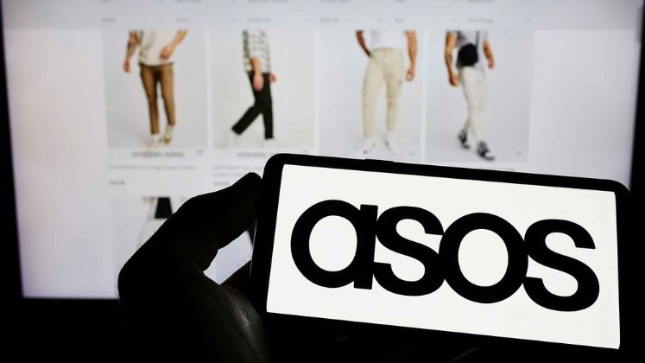
The online fashion industry has evolved dramatically, reshaping traditional retail landscapes. The advent of e-commerce caused a seismic shift, altering how consumers interact with fashion. ASOS, for example, has played a critical role in steering this evolution, leveraging digital platforms to establish a global presence. Understanding the emerging market trends is critical for understanding the challenges and opportunities ASOS faces in its strategic entry into the Indian market. The transition from brick-and-mortar stores to digital platforms is driving the evolution of the online fashion sector, driven by technological advancements and changing consumer preferences. ASOS, for example, has been at the forefront of this evolution, pioneering new ways to connect with customers and provide a seamless online shopping experience (Parker and Alexander, 2022, 10). As we investigate the industry trends, it becomes clear that consumer behavior and preferences have been significantly influenced.
The online fashion industry's market trends are characterized by rapid changes in response to dynamic consumer demands. The industry constantly adapts from fast fashion to sustainable and ethical choices (Pereira et al., 2021, 11). As a trendsetter in the UK, ASOS has quickly adapted its strategies to these changes. Understanding these shifts is critical for ASOS as it considers entering the Indian market, which has its own set of distinct consumer behaviors and preferences.
Consumer behavior in online fashion has shifted significantly, emphasizing customization, ease of use, and brand engagement. The success of ASOS in the United Kingdom is inextricably linked to its ability to navigate and capitalize on these shifts (Perkin, 2023, 12). As the company prepares to enter the Indian market, a thorough understanding of how these shifts manifest in the local context is critical. This section provides a foundational understanding for evaluating ASOS's strategic moves in subsequent chapters by exploring the evolution, key players, and trends in the online fashion industry. This thorough synopsis establishes the framework for an in-depth analysis of ASOS's strategic positioning and expansion in the UK online apparel industry. It also offers a smooth transition from this overview to Section 2.2, which delves into ASOS's distinct market tactics and customer engagement.

2.2 ASOS's Position in the UK Online Fashion Sector
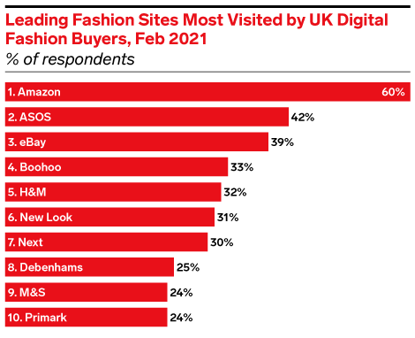
ASOS has emerged as a formidable force in the UK online fashion sector, with impressive growth and a significant market share. ASOS, an e-commerce platform launched in 2000, has evolved into a cutting-edge fashion destination, offering a wide range of clothing, accessories, and beauty products. Its success can be attributed to a blend of strategic vision, adaptability, and a thorough understanding of changing consumer trends. ASOS's growth trajectory demonstrates its ability to capitalize on the digital shift in retail. The company's dedication to staying on the cutting edge of technological advancements and an adaptable approach to changing consumer demands has positioned it as a leader in the UK online fashion landscape (Tidd and Bessant, 2020, 13). Understanding the factors that fueled ASOS's domestic growth is critical for assessing its chances of success in the Indian market.
2.2.1 Market Strategies and Unique Selling Points:
ASOS's market strategies and distinct selling points have been critical to its success in the UK. The company's approach extends beyond providing a diverse product line to creating an immersive online shopping experience. ASOS is well-known for its ability to translate runway trends into accessible, affordable fashion for many customers. The platform's emphasis on inclusivity and diversity distinguishes it even more, appealing to a broad demographic. A user-friendly interface, efficient logistics, and a commitment to sustainability are key components of ASOS's success (Celano, 2021, 14). The company has successfully embraced fast fashion while incorporating environmentally friendly practices, catering to various consumer preferences. Analyzing these strategies provides valuable insights into the factors contributing to ASOS's popularity in the UK and guides the development of entry strategies for the Indian market.
2.2.2 Consumer Engagement and Brand Perception:
ASOS's success is inextricably linked to its ability to engage consumers and cultivate a distinct brand perception effectively. The platform has used social media, influencers, and innovative marketing campaigns to foster community among its users. The brand's online presence goes beyond transactional interactions, establishing a lifestyle association with its target audience. Understanding how ASOS created and maintained a positive brand perception in the United Kingdom is critical for anticipating potential challenges and opportunities in India (Roggeveen et al., 2020, 15). Consumer engagement strategies that have worked in one market may need to be tweaked to account for cultural differences in another. This section delves into ASOS's consumer engagement strategies, laying the groundwork for assessing their applicability in the Indian context. After delving into ASOS's successes in the UK online fashion market, we will now turn our attention to a global viewpoint and examine how globalisation trends affect fashion preferences and ASOS's strategic approach in a global setting in Section 2.3.

2.3 Globalization Trends in Online Fashion
Globalization has significantly impacted fashion preferences, crossing geographical boundaries and creating a more interconnected landscape. Consumer preferences have been reshaped due to the convergence of diverse cultures and the accessibility of international trends via digital platforms (Sutrisno, 2023, 16). A growing desire for eclectic styles, diverse aesthetics, and the adoption of fashion trends from various regions characterizes this phenomenon.
2.3.1 Cross-Border Consumer Culture and Its Implications:
The emergence of a cross-border consumer culture has far-reaching consequences for the fashion industry. Geographical boundaries no longer limit consumers; they engage with global fashion trends and brands. This cultural blending has resulted in the blurring of traditional fashion boundaries, with consumers adopting a more cosmopolitan approach to style (Consumer Culture Theory, 2018, 17). ASOS, with its global reach and accessibility, has been a driving force in the development of this cross-border consumer culture.
2.3.2 ASOS's Global Brand Appeal and Strategies:
ASOS's online fashion success can be attributed to its astute strategies catering to this globalized landscape. The brand has benefited from the shifting preferences brought about by globalization. Its diverse product offerings, curated from various fashion hubs worldwide, appeal to cosmopolitan consumers. ASOS's strategies go beyond simply selling products; through marketing initiatives and collaborations, the brand actively promotes a global lifestyle and fashion culture, solidifying its position as a fashion destination with universal appeal. Understanding these globalization trends helps to understand how ASOS's strategies align with the changing global consumer culture (Chaffey and Ellis-Chadwick, 2019, 18). The impact of globalization on fashion preferences, the resulting cross-border consumer behavior, and how ASOS strategically leverages its global brand appeal to navigate and capitalize on these trends are all discussed in this section. The investigation of changing consumer behaviour in the online fashion industry takes centre stage in Section 2.4 as we delve into the impact of globalisation on fashion preferences and ASOS's strategies. This section offers insights into customisation, ease of use, and brand engagement that have become crucial in determining ASOS's success.

2.4 Consumer Preferences in Online Fashion
The online fashion industry is witnessing a dynamic shift in consumer behavior, emphasizing elements that redefine their shopping experiences. According to research, customization, ease of navigation, and active brand engagement are increasingly important in shaping consumer preferences (Felix and Rembulan, 2023, 19). Customers want personalized experiences, tailored recommendations, and seamless interactions when browsing fashion platforms.
2.4.1 Emphasis on Customization, Ease, and Brand Engagement:
In online fashion, customization is a critical factor influencing consumer choices. Platforms that provide personalized recommendations based on their preferences, browsing history, and style preferences appeal to consumers. Furthermore, the ease of navigation within an online store significantly impacts consumer satisfaction. A positive user experience is greatly enhanced by effortless browsing, intuitive search functions, and user-friendly interfaces (Gkonos, Iosifescu Enescu, and Hurni, 2018, 20). Brand engagement is extremely important in consumer decision-making. Creating a community-like environment where customers actively engage with the brand fosters loyalty and connection. ASOS has excelled in creating an engaged community of fashion enthusiasts through its interactive features, social media presence, and curated content.
2.4.2 Aligning Consumer Preferences with ASOS's Strategies:
ASOS has successfully matched its strategies to changing consumer preferences. Personalization is emphasized by the platform's AI-driven recommendation systems and personalized styling suggestions. Its user-friendly website interface and mobile app features provide a seamless shopping experience that meets the demands for ease and navigation convenience. Furthermore, ASOS's active social media presence, influencer collaborations, and user-generated content boost brand engagement encouraging a community-centered approach to fashion (Petkova, 2018, 21). Indian authorities are certainly keen to promote investment. Relaxed FDI regulations (e.g., allowing 100 percent foreign-owned single brand retail operations), will likely lead to more overseas-originated activity through the value chain. We expect more outsourcing and more brand-owned stores without Indian partners in the years ahead. Most activity is likely to be focused on major urban centres, reflecting demographic trends, rising urban consumer spending power and improving infrastructure in those areas.
ASOS must understand the changing landscape of consumer preferences in the online fashion industry. ASOS strategically positions itself to resonate with today's consumer base by emphasizing customization, ease of use, and active brand engagement. This section delves into changing consumer behaviors and preferences and how ASOS incorporates these insights into its strategies to improve the overall shopping experience. Examining the shifting terrain of consumer preferences prepares the reader for Section 2.5's in-depth assessment of the market and competitive environment, which focuses on ASOS's competitors, positioning in the market, and possible obstacles in its Indian endeavour.

2.5 Competitive Landscape and Market Analysis
ASOS's entry into the Indian online fashion market necessitates a thorough examination of key competitors. Zara, well-known for its emphasis on fast fashion and trend responsiveness, is a formidable competitor. ASOS can benefit from analyzing Zara's market share, dynamic product offerings, pricing strategies, and unique selling propositions (Zanjirani Farahani, Asgari and Van Wassenhove, 2021, 22). Similarly, Amazon Fashion introduces complexities that necessitate a strategic response by leveraging its extensive reach and customer base. Evaluating these competitors' strengths and weaknesses is more than just a market research exercise; it is a blueprint for ASOS to carve out a distinct niche.
2.5.1 Market Positioning and Differentiation Strategies:
Breaking down each competitor's market positioning strategy reveals nuanced approaches to capturing consumer attention. Zara's emphasis on immediacy and trendsetting sets the standard, whereas Amazon Fashion relies on its broad reach and customer-centric model. Myntra's exclusive partnerships and curated collections offer a distinct perspective. ASOS's diversification of strategies serves as a strategic compass. It offers insights into whitespace opportunities, allowing it to better tailor its approach to the discerning Indian market. Understanding these various strategies is a dynamic toolkit that ASOS can use to adapt and refine its strategies in response to market dynamics.
2.5.2 Insights into Potential Challenges for ASOS in India:
Beyond emulation, competitor strategic analysis serves as a forewarning mechanism, highlighting potential challenges for ASOS in India. Established local players with deep market roots may pose challenges. Diverse consumer behavior patterns and preferences must be successfully navigated. Logistical complexities, such as India's vast geographical expanse, necessitate meticulous planning (Joshi et al., 2021, 23). Market demands that are influenced by cultural nuances present both challenges and opportunities. Furthermore, understanding regulatory frameworks and leveraging or overcoming them becomes critical. ASOS's strategic foresight gained through competitor analysis provides it with an anticipatory mindset, allowing it to navigate the complexities of the Indian market proactively.
2.5.3 Strategic Edge Through Comprehensive Analysis:
Comprehensive market analysis and competitor evaluation give ASOS a strategic advantage in international expansion. Recognizing current strategies and potential challenges in the competitive landscape provides a solid foundation for ASOS' market entry strategy. This is not a static strategy; it evolves, pivots, and adapts in response to the dynamic interplay of market forces (Peñarroya-Farell and Miralles, 2021, 24). This analysis' depth of understanding positions ASOS strategically, allowing it to capitalize on gaps, differentiate effectively, and forge a successful path into the Indian online fashion market. The comprehension of the competitive environment and possible obstacles delineated in this segment establishes the foundation for examining the economic determinants impacting ASOS's market debut in Section 2.6. To create a strong entry plan into the Indian market, it is essential to understand how market dynamics, competition, and economic indicators interact.

2.6 Economic Factors Influencing Market Entry
As ASOS considers entering the dynamic Indian market, carefully examining macroeconomic indicators guides navigating the complexities. Understanding the intricate web of factors that shape the economic landscape is critical beyond the superficial allure of a burgeoning middle class. Macroeconomic indicators such as GDP growth, inflation rates, and consumer purchasing power weave a story that goes beyond statistics. They capture the pulse of a country's economic health and, as a result, market receptivity.
2.6.1 Impact of GDP Growth, Inflation, and Consumer Buying Power:
GDP growth barometer economic vitality, indicating the market's overall direction. The detailed examination of this expansion reveals trends that could be critical for ASOS. Is the growth sustainable, or is it dependent on temporary factors? Inflation rates, frequently overlooked, have significant implications for consumer spending patterns. ASOS must determine whether inflation is a deterrent or a motivator for discretionary fashion spending.
ASOS's market entry is hinged on consumer purchasing power, intricately linked to these macroeconomic indicators. Rising middle-income disposable incomes indicate a shifting landscape of aspirations and lifestyle choices (Datsko, 2019, 25). However, the difficulty is deciphering the nuances of this increased purchasing power. Does it translate into a preference for global fashion or local brands? The interaction of these economic factors necessitates a more detailed understanding than statistical aggregates can provide.
2.6.2 Implications for ASOS's Entry:
The ramifications of ASOS's entry into the Indian market are numerous. ASOS's understanding of economic indicators allows it to align its market entry strategy with economic currents. If GDP growth indicates a healthy and expanding market, ASOS can adjust its offerings to meet rising aspirations. If inflation becomes a problem, strategic pricing and value propositions become critical. Understanding consumer purchasing power is critical to ASOS's product positioning (Ziginov, 2021, 26). It necessitates a delicate balance of providing aspirational fashion that resonates with changing tastes while keeping price sensitivities in mind. The economic landscape is not a static canvas that requires agility and responsiveness. Economic data offer a sophisticated grasp of the Indian market, which sets the stage for ASOS's market entry approach. This economic basis flows naturally into Section 2.7's examination of cultural elements, where the interaction of economic processes and cultural subtleties becomes crucial to ASOS's localization approach.

2.7 Cultural Factors in International Business
Cultural factors are foundational elements shaping the success or failure of market entry strategies in the kaleidoscope of international business. ASOS's expansion into India necessitates a thorough understanding of the value of cross-cultural adaptation. Consumer behaviors, perceptions, and expectations are influenced by culture, a dynamic force woven into the fabric of society. Failure to comprehend its complexities can result in a discordant note in the symphony of market integration.
2.7.1 Insights into Adapting Operations to Local Cultural Nuances:
The journey for ASOS is about more than just delivering fashion; it's about cultural resonance. Adapting operations to local cultural nuances necessitates self-examining India's diverse cultural tapestry. ASOS must decipher the cultural code, from traditional clothing preferences to the impact of festivals on shopping patterns (Craik, 2020, 27). Localization is not a cosmetic change but an immersive process of aligning with a nation's soul. The complexities extend beyond language to symbols, colors, and rituals that have profound cultural meanings. Successful cross-cultural adaptation necessitates more than just acknowledging diversity; it necessitates a deep dive into the psyche of the Indian consumer. Understanding how cultural values influence perceptions of fashion, modesty, and individual expression is critical for ASOS to evolve beyond being a fashion provider and into a cultural collaborator.
2.7.2 Implications for ASOS's Localization Strategy in India:
ASOS's localization strategy in India must go beyond transactional to transformative. It's not just about translating text or changing font sizes; it's about connecting with the cultural pulse. This necessitates strategic collaborations with cultural custodians who can guide ASOS through the maze of tradition and modernity (Antariksa, 2020, 28). The implications are far-reaching, ranging from festive collections that coincide with cultural celebrations to designs sensitive to regional sensibilities. ASOS's success depends on its ability to seamlessly integrate with India's diverse cultural mosaic, ensuring its global brand identity is preserved rather than lost through cultural infusion.

2.8 Market Entry Strategies in International Business
Navigating the global marketplace is similar to playing a strategic chess game, with each move impacting overall success. ASOS's entry into the Indian market necessitates thoroughly examining various market entry strategies. The spectrum runs from wholly-owned subsidiaries, which provide complete control but require significant resources, to strategic alliances, which share risks and resources. Each tactic has its benefits and drawbacks, and the choice must be compatible with ASOS's capabilities and the nuances of the Indian market.
2.8.1 Evaluation of Effective Strategies for ASOS in the Indian Market:
The Indian market is vast and diverse, necessitating a tailored approach. ASOS's success in the UK does not guarantee a smooth entry into India; it necessitates rethinking strategies. While the UK's online dominance is a strength, it is only one piece of the puzzle. The effectiveness stems from the synergy of ASOS's strengths and the complexities of the Indian market (Shankar et al., 2022, 29). Understanding consumer behaviors, regional variations, and e-commerce trends is critical for developing an effective market entry strategy.
2.8.2 Customization of Entry Strategies Based on ASOS's UK Dominance and Indian Market Dynamics:
The journey of ASOS is not about imposing a template but rather about crafting a narrative that balances its global identity with local aspirations. Customization of entry strategies becomes critical. This entails leveraging the online prowess developed in the UK while tailoring it to the preferences of the Indian consumer. It's about providing a familiar but culturally relevant experience. For example, while ASOS's fast-fashion model has thrived in the UK, its adaptation for India may necessitate subtle changes. Customization is the linchpin in marketing strategies, ranging from collaborative collections with local designers to embracing regional festivals (Kranich et al., 2020, 30). With its penchant for exclusivity and cultural resonance, the Indian market necessitates entry strategies that go beyond the transactional and embrace the transformational. The comprehension of efficacious approaches for market entry serves as a basis for a more profound investigation of deficiencies and forthcoming prospects in Section 2.9, which centres on pinpointing possible avenues for enhancement and prospects for ASOS in the Indian market.

2.9 Identifying Gaps and Future Prospects
As we travel through the landscape of ASOS's entry into the Indian market, we must use a critical lens to identify existing research and literature gaps. While existing studies provide valuable insights, they may inadvertently leave gaps unexplored. This section meticulously examines the limitations and uncharted territories of the current body of knowledge. Are there any aspects of cross-cultural challenges that have yet to be investigated? Is there a gap in understanding the subtle differences in consumer behavior across India's regions? These questions direct our search for a complete understanding.
2.9.1 Opportunities for Further Exploration in ASOS's Indian Market Entry:
The journey does not end with discovering gaps; it continues into the realm of possibilities. Opportunities for further investigation in ASOS's entry into the Indian market beckon. This entails delving deeper into specific aspects that may have received only cursory attention in previous literature. For example, the impact of emerging technologies on e-commerce in India, the role of sustainability in consumer decisions, or the evolving landscape of social media influencing fashion trends are all vistas ripe for scholarly investigation (Chawla and Kumar, 2021, 31). Discovering these opportunities enriches the narrative, providing a comprehensive understanding of ASOS's expedition.
2.9.2 Recommendations for Future Research in the Field:
This section concludes with thoughtful recommendations for future research in the field, paving the way for future scholars and industry practitioners. These recommendations go beyond ASOS's specific case, aiming to contribute to a broader conversation about international business dynamics in the ever-changing online fashion sector. Suggestions could range from in-depth investigations of technological disruptions to comparisons with other successful market entrants. This section becomes a compass guiding the next wave of research endeavors in this dynamic domain by charting the course for future inquiries.

2.10 Summary and Conclusion of the Literature Review
The literature review takes the reader on a thorough journey through the intricate web of the online fashion industry, dissecting ASOS's strategic foray into the Indian market. It sheds light on pivotal aspects shaping the context of ASOS's expansion by traversing the industry's evolution, understanding ASOS's UK success, and dissecting global trends. The key findings shed light on the competitive landscape, economic influences, cultural complexities, and market entry strategies critical to ASOS's successful entry into India. This literature canvas fills knowledge gaps and reveals potential obstacles and opportunities for ASOS. As we come to the end of this chapter, the insights gained pave the way for the following sections, where primary research methods will be used to ground these theories in practical application, paving the way for ASOS's strategic advancement into the dynamic Indian market.

Chapter 3: Methodology

3.1 Introduction to Methodology
Chapter 2, the Literature Review, delves deeply into the numerous features of the online fashion sector, offering light on its history, significant players, and developments in consumer behaviour. The thorough review serves as the theoretical foundation for comprehending ASOS' strategic entry into the thriving Indian market, including insights into market fundamentals, competition strategies, and cultural nuances. This chapter critically examines existing information, identifies gaps, and establishes the framework for the methodological approach, connecting theoretical and empirical research with ASOS's global expansion. The research methodology used in this study is the strategic framework for investigating the ASOS market entry strategy to India. Its purpose is twofold: First, to provide a thorough analysis of market potential opportunities faced by ASOS along with cross-cultural challenges; second, to provide valuable insights on the dynamic landscape of global business in the virtual fashion industry. This methodology employs a subtle combination of primary and secondary data collection techniques to achieve broad baseline results. Primary data is collected through a well-structured online survey that involves 33 respondents in India, which gives an immediate insight into customers’ preferences, competition factors and peculiarities of the culture. Simultaneously, the secondary data from multiple sources, such as scholarly articles, market reports and industry analyses, adds depth to the study because it provides a historical perspective to help further elucidate context and theoretical frameworks. The combination of these two data streams provides a greater depth and foundation to this research into ASOS’s entry into the Indian market, enhancing its validity, and allowing for an overall view of international business dynamics within the online fashion industry.

3.2 Primary Data Collection: Online Survey
3.2.1 Rationale for choosing an online survey as the primary method
The choice of using an online survey as the main data collection tool is strategically supported due to the specifics of conducting research. As ASOS’s foray into the Indian market is large, an online survey would be the best tool to capture a wide range of opinions. The research objectives are focused on understanding market potential, entry strategies and cross-cultural challenges; hence, they require a method that can collect quantitative data from various sources efficiently on a large scale. In particular, the dynamic nature of an online survey is beneficial for such a study (Chaffey and Ellis-Chadwick, 2019, 32). The benefits of online platforms are easy reachability and engagement to geographically dispersed participants representing the diverse Indian market. This ensures that the information gathered is not from a localised point of view, thus helping to understand what influences ASOS’s expansion strategy.
3.2.2 Description of the survey design and development process
The survey design is a careful process, adjusted by specific research objectives. The questions are deliberately constructed to elicit useful information on vital components such as customer likes, competitive landscape, and cultural factors pertinent to the operations of ASOS in India. The process is iterative and tests questions to ensure they are clear, relevant, and consistent with the broader research aims. The survey structure is intentionally mixed, including closed-ended and open questions. Closed-ended questions facilitate quantitative investigation, so it is possible to identify trends and patterns in participants’ responses (Baburajan, Silva and Pereira, 2021, 33). At the same time, using open-ended questions incorporates a qualitative aspect, allowing the respondents to convey more refined opinions and feelings. This dual approach enhances the dataset with a wider perspective of participants’ perceptions, adding depth to findings from the study.
3.2.3 Explanation of the survey distribution process and participant selection
The survey distribution employs a targeted approach to ensure a comprehensive perspective on the Indian market, leveraging my personal network and social media connections for participant selection. In this study, a group of 33 participants, primarily consisting of my friends, friends of friends and social media acquaintances, have been chosen to offer diverse insights into the hypothetical expansion of ASOS into the Indian market. It is critical to note that participation in the survey by social media friends or friends of friends is purely optional, with no coercion or pressure applied. This deliberate diversity within the participant pool aims to enrich the dataset and facilitate a nuanced understanding of how various segments might perceive ASOS's potential entry into India.
Furthermore, these people were chosen not just because of their closeness, but also because I have contacts with them through numerous platforms, including social media and other internet networks. This familiarity and pre-existing rapport allowed for more efficient communication and participation in the survey procedure. The use of social media and online platforms for participant selection is consistent with current research techniques, recognising the prominence of digital communication in today's interconnected society (Zak, 2020, 34). The research endeavors to gather comprehensive and representative data on the complex dynamics of the Indian market by addressing diverse aspects and implementing a pragmatic distribution strategy.
3.2.4 Consideration of ethical concerns and data protection measures
In performing the online survey methodology, ethical considerations are of great importance. Ensuring informed consent from all the participants is a fundamental measure; it clearly states that participation in this activity can be voluntary and informs them of stringent measures to ensure confidentiality. This open communication allows for a sense of trust and guarantees that respondents are fully aware of the impacts of their involvement in the research. Participants’ privacy and ethics are upheld through robust data protection measures (Müller-Funk, 2020, 35). The data collected is put into secure storage protocols where unauthorised access will not be allowed. Additional layers of protection are achieved by using anonymisation processes that dissociate responses from individual identities. The research is conducted by relevant privacy legislation, which proves its commitment to the responsible and ethical treatment of participant data. The selected methodology for primary data collection – the online survey - is a thoughtful and systematic approach; it represents that this research takes the reliability, ethical conduct of the study, and an in-depth exploration into ASOS's appearance in India seriously.

3.3 Secondary Data Collection
3.3.1 Explanation of the sources used for secondary data collection
The secondary data collection in this study employs various sources of information to deepen the comprehension of ASOS’s venture into India. These sources include academic journals, industry reports, market analyses and reputable online platforms. Scholarly insights into global fashion trends, online retail dynamics and consumer behaviour using academic journals provide theoretical background for comprehending the intricacies of this case study. Market reports and industry analysis are critical in giving practical insights into market trends, competitive environment and economic influences impacting the fashion arena (Black, 2017, 36). Market research reports from credible firms and industry journals provide good sources to situate the market potential of ASOS in India, supporting this study’s general aims. Various online platforms such as business news websites, press releases and company reports also allow a timely view of ASOS’s strategies, market positioning and recent developments. Such sources provide valuable information on ASOS’s current position in the British online fashion market, helping to evaluate its strengths and weaknesses before entering India.
3.3.2 Method of identification and selection of relevant secondary data
Identifying and choosing the secondary data is very careful to ensure they are relevant, reliable, and applicable for the research purposes. Keywords, including online fashion, global market expansion and ASOS, are systematically used to perform focused searches in academic databases, industry portals, and reputable news platforms. The search criteria emphasise more recent publications to ensure that their focus captures the latest developments in such a dynamic field as fashion (Diánez-González and Camelo-Ordaz, 2019, 37). Evaluation of credibility and authority takes place during the selection process. Scholarly journals with peer-reviewed articles are given preference because of their rigour and academic status. Industry reports from reputable research firms are preferred because of their detailed market insight. ASOS company reports, and press releases are checked to ensure their authenticity and relevance to the research topic.
3.3.3 Assessing the credibility and reliability of secondary sources
Credibility and reliability tests of secondary sources play an integral part in proving the strength of research. Academic journals are also evaluated based on the prestige of said publishing journal, authors’ credentials, and peer review. The research firms' reputation, methodologies, and comprehensiveness in industry reports are evaluated. The trustworthiness of online platforms is confirmed by cross-checking information from several reliable sources. Consistent alignment with known industry knowledge enhances the dependability of data drawn from news websites, company reports and press releases. The triangulation of information from different secondary sources strengthens the validity of data, helping to build a solid and reliable base for research.

3.4 Online Survey Process
3.4.1 Step-by-step elucidation of the online survey process
The online survey is carefully structured to achieve the research aims and obtain in-depth information about how ASOS could enter the Indian market. The initial step requires you to draft your research questions, as they should relate directly to market potentials, entry strategies and challenges of cross-cultural adaptation. These questions are formulated to capture both quantitative and qualitative data, enabling a comprehensive analysis of the responses made by participants. Once the survey questions are planned, a friendly online platform is used to design this questionnaire to make it easy for participants to access and use. The platform’s interface is designed to allow for an easier and more engaging survey, reducing the chances of respondent fatigue or dropout. A pilot survey test with a small sample of individuals from demographics similar to those represented in the full scale is carried out to increase validity and relevance. Follow-up information from the pilot test is used to refine and streamline the survey instrument, clearing up any vagaries or possible biases in interpreting questions. This process of iterative testing adds to the strength of survey designs.
3.4.2 Explanation of the survey distribution method, platform, and tools used
The distribution strategy for the survey is thus multi-faceted as it aims to achieve a broad and representative group of participants. The data collection instrument is a survey disseminated through popular social media platforms, targeted online communities and email outreach to reach potential participants from different demographics across India. This strategic distribution process focuses on enriching the data with various perspectives. The online survey is conducted through a secure and reputable third-party web platform renowned for its data protection measures and the convenient nature of its user interface. The platform enables real-time monitoring of responses, allowing for quick adjustments to the distribution strategy in response to participant demographics and feedback (Gaur et al., 2020, 38). These include personalised survey links, QR codes and social media sharing functions to enhance access and increase participation. Ethical aspects are emphasised throughout distribution surveys with clear instructions and an introductory section explaining the research purpose, confidentiality measures applied, and voluntary participation.
3.4.3 Discussion on the response rate and any limitations encountered during data collection
The response rate is one of the most important indicators to determine how effective a survey has been, and therefore, monitor it for this purpose during the data collection phase. Issues affecting response rates, including length of surveys and clarity questions, are analysed to identify trends or possible areas that can be improved. Despite well-planned data collection, there are certain limitations along the way. It could be linked to difficulties accessing specific demographic groups, possible reaction biases or external forces that influence participant opportunities. Recognising these limitations, steps are taken to reduce their influence using tailored outreach and ongoing engagement with participants.

3.5 Data Analysis Approach
The data analysis strategy for this study represents a wise amalgamation of quantitative and qualitative techniques designed to provide an all-encompassing insight into ASOS’s venture in the Indian market. Quantitative analysis is also critical, utilising statistical methods to identify patterns, trends and correlations within the numerical survey responses. Descriptive statistics such as mean, median and standard deviation briefly summarise and interpret critical metrics related to market potential entry strategies and cross-cultural challenges. In qualitative research, statistical tools like SPSS are applied to analyse the data. This software is crucial in performing complex statistical operations, such as regression analysis to evaluate relationships between variables, factor analysis for reducing dimensions and inferential statistics to generalise conclusions about the population (Bourne, James and Wilson-Smith, 2021, 39). SPSS enhances the validity and reliability of data interpretations from quantitative findings, offering a strong basis for evidence-based conclusions.
Qualitatively, the analysis explores deeper discoveries from responses to open-ended surveys. A thematic analysis approach is used, using qualitative data analysis tools such as NVivo. This systematic procedure identifies, interprets and documents patterns within the qualitative data so that it can be explored in-depth concerning participants’ subtle views about cultural adaptability, market potentiality, and entry approaches. Qualitative data is carefully coded, grouped and thematically structured through NVivo, thus enabling a better understanding of the intricacies that constituted ASOS’s move into the Indian market (Castleberry and Nolen, 2018, 40). The approach to data analysis involves the integration of quantitative and qualitative findings. This is a holistic research approach where one method’s strength balances another. Triangulation of data sources increases reliability and validity in general. Using this combined analysis approach, we can understand more deeply the particularities of ASOS’s strategic decision-making process, allowing us to learn valuable lessons for academic discussion and practical implementation in an ever-changing context wherein online fashion lies alongside international business.
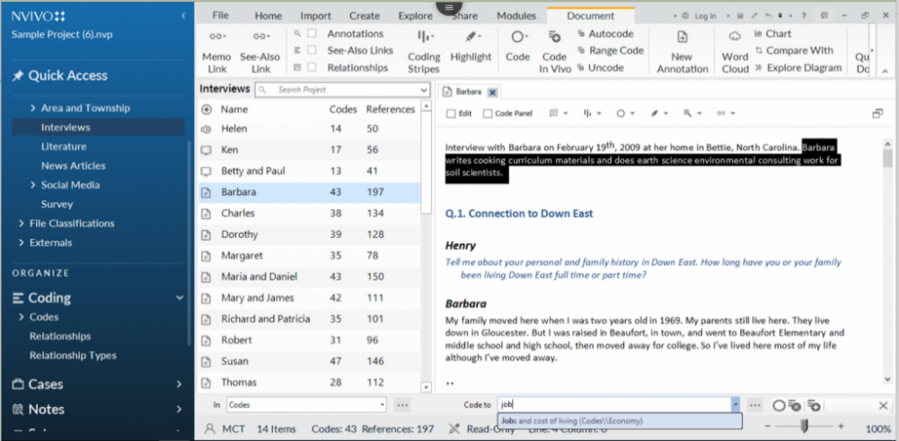
Figure 1: NVivo Software Interface

3.6 Integration of Primary and Secondary Data
This research methodically integrates primary and secondary data to provide a comprehensive and well-rounded understanding of ASOS’s entry into the Indian market. So, the primary data obtained from an online survey offers a real-life view of respondents’ opinions and so on., enabling them to treat phenomena dynamically regarding their market potentials as well as entry strategies or such cross-cultural issues. On the contrary, secondary data from research articles, books, and industry reports supply a historical framework to support it with established theories, ideas or frames, and trends in relevant sectors.
Methodology Employed
The integration process is systematic; primary and secondary data are collected simultaneously but separately at the initial stages. Primary data analysis occurs through quantitative and qualitative techniques, as described above. Simultaneously, relevant theories, comparative insights and historical perspectives are abstracted from secondary sources.
Complementary Nature of Data Sources
The combined strengths of both data sources present a holistic view. Primary data captures current sentiments and new trends straight from the focus group, while secondary helps locate these insights on a wider level by positioning them within the international business of the online fashion industry. The synergistic effect of the two sources deepens the analysis with which findings are rooted not only in empirical evidence but also in established theoretical frameworks.
Triangulation Process
Triangulation is used as a validation technique, comparing and contrasting findings from primary and secondary sources to identify points of convergence or potential differences. Consistency in results improves the strength of research outputs as they become a more reliable foundation for building conclusions. Triangulation is vital as it helps navigate potential biases or limitations inherent in either data source, thus allowing for a well-rounded and credible analysis. This is one of the strong points in this research strategy as it combines both primary and secondary data to maximise its benefits, allowing for a complex understanding of how ASOS made decisions towards the Indian market.

3.7 Ensuring Data Reliability and Validity
3.7.1 Measures Taken for Data Reliability and Validity
The reliability and validity of the data are very important to maintain integrity in this research. The reliability is addressed by taking rigorous steps at the research data collection and analysis stages. The primary data collection phase through the online survey is carefully crafted to prevent ambiguity and consistency in participation responses. It also involves pilot testing to detect and correct any possible problems before the large-scale administration of the survey.
3.7.2 Data Validation Techniques and Quality Control Measures
Techniques in data validation are applied to improve the accuracy and reliability of findings. Logic checks and validation rules are hardwired in the online survey to guide respondents. This method improves the general quality of gathered data to prevent inconsistent or incomplete submissions. In the secondary data collection process, quality control measures go as far as utilising a systematic review to locate credible and reputable sources (Resnik and Shamoo, 2016, 41). Using scholarly articles, industry reports, and established theoretical frameworks would ensure that secondary data is reliable. Evaluation of the methodology employed in secondary sources aids in filtering out misleading information, increasing the research's validity and strength.
3.7.3 Limitations and Bias Mitigation
It is important to acknowledge research limitations to maintain transparency and provide for placing findings within their proper context. Potential biases are acknowledged too, for instance, the bias that can come from sampling in an online survey or inherent biases of secondary data sources. For the online survey, a diversity of participants is desired; however, it’s noted that some demographics might be over-represented or under-represented. Mitigation measures include presenting a clear and unbiased survey overview, promoting voluntary participation, and utilising a variety of distribution channels. Furthermore, during the analysis phase, any biases in interpreting quantitative and qualitative data are carefully considered, ensuring that conclusions are formed with an understanding of these limitations.
3.7.4 Pros and Cons of Methodology
The selected study methodology has clear benefits and drawbacks. ASOS's market entry approach in India can be quickly and comprehensively understood thanks to the primary data collection process, which involved an online poll. The efficiency and versatility of the procedure allow for the investigation of complex viewpoints. The use of self-reported data and the lack of control over participant interpretations, however, are possible disadvantages. Furthermore, although secondary data adds value to the research, assuring its accuracy and dependability presents difficulties. While increasing robustness, the triangulation of these approaches necessitates a careful balancing act to negotiate the inherent challenges of examining global business dynamics in the online fashion industry.

3.8 Ethical Considerations
Participants receive explicit information about the research purpose clearly and transparently, while informed consent is obtained from each individual before participating in an online survey. Voluntariness is stressed in obtaining consent; participants are assured that their responses will be confidential and anonymous. Robust data protection measures are implemented to protect participant privacy. All the collected data is securely stored, and strict protocols are followed to anonymise answers. The research follows strict privacy regulations and guidelines to preserve participant information integrity. In case they occur, ethical issues are proactive during the research. Ethical standards of the study are maintained through transparent communication with participants, constant monitoring for any unexpected ethical issues that may emerge and prompt resolution mechanisms (Munoko, Brown-Liburd and Vasarhelyi, 2020, 42). Any changes to the research protocol are done with active care about their ethical impact, not to affect participants’ well-being and autonomy. The ethical considerations carried out in this research support defined principles, creating an environment for research where participants have been given priority together with confidentiality and responsibility in dealing with sensitive information.

3.9 Conclusion
In conclusion, this chapter delineates the strong methodology utilised in this research using primary and secondary data collection methods. The online survey is the main source of information, anchored in ethical matters, through which an understanding of ASOS’s venture into India can be obtained. Combining primary and secondary data and carefully analysing statistical methods and qualitative software leads to an elaborate understanding. Ethical protocols, such as participant consent and data protection measures, underpin responsible research practices. Thus, this chapter prepares the ground for further analysis by providing a well-balanced framework that would allow the discovery of valuable insights.

Chapter 4: Analysis and Results

4.1 Introduction
This section further emphasizes the research objectives, thoroughly analyzing ASOS’s aspiration to enter this Indian market. It describes the core focus of this chapter, which is to analyze the outcomes generated from an online questionnaire and secondary information sources. The data analysis includes an in-depth investigation of customers’ preferences, dynamics within the competitive environment, economic issues, entry strategy penetration challenges, and consumer perception. The chapter is organized into several parts to ensure a comprehensive analysis of each dimension, enabling an integrated viewpoint on ASOS’s strategic entry into the Indian market.
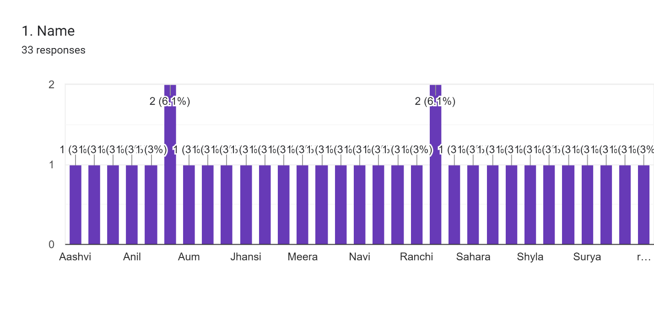
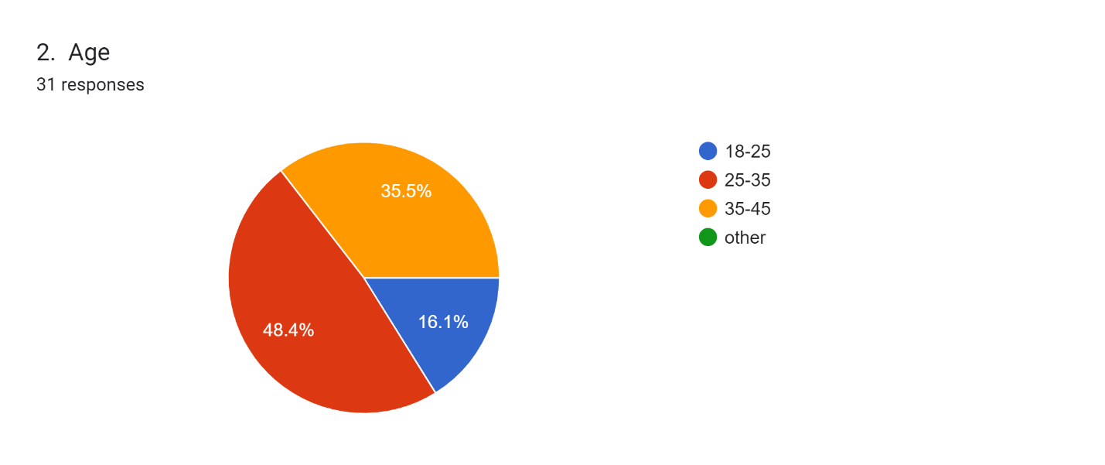
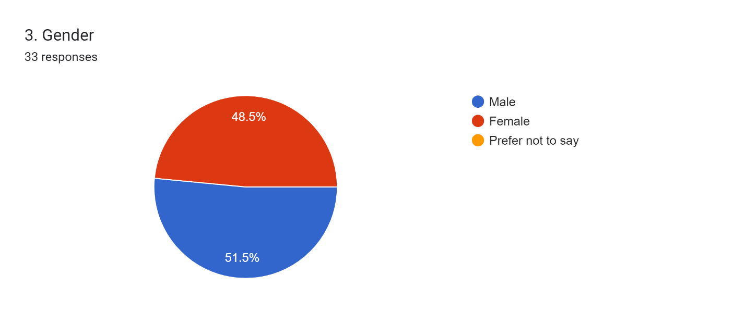
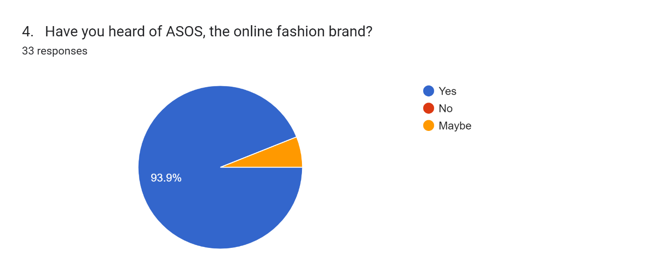
The respondents that participated in the survey.

4.2 Market Potential Analysis
4.2.1 Customer Preferences in the Indian Market
In its analysis of customer preferences in the Indian fashion market, it was observed that several important findings could be used as a basis for ASOS to shape its product offerings according to the dynamic and varied tastes of Indian customers. A prominent manifestation of this is the choice of traditional clothing for Indian consumers, especially during cultural celebrations or other special events. The findings from the survey revealed that many people appreciated traditional Indian attire, including sarees, kurta pajamas, and ethnic adornments. This implies that it would benefit ASOS to choose a range of traditional dresses from the product line that conforms to cultural celebrations and festivities (Saravanan, 2019, 43). Secondly, the survey data revealed a rising trend of sustainable and eco-friendly fashion tastes among Indians. Many respondents talked about eco-friendly fashion. This could be the case with ASOS, which focuses on sustainable fashion lines and promotes eco-friendly practices within its supply chain. The data provided visually through charts and graphs showed that many Indian consumers feel comfortable with an online shopping experience with much convenience. This highlights the need for ASOS’s strong online presence and easy-to-navigate platform that can meet the needs of Indian consumers.
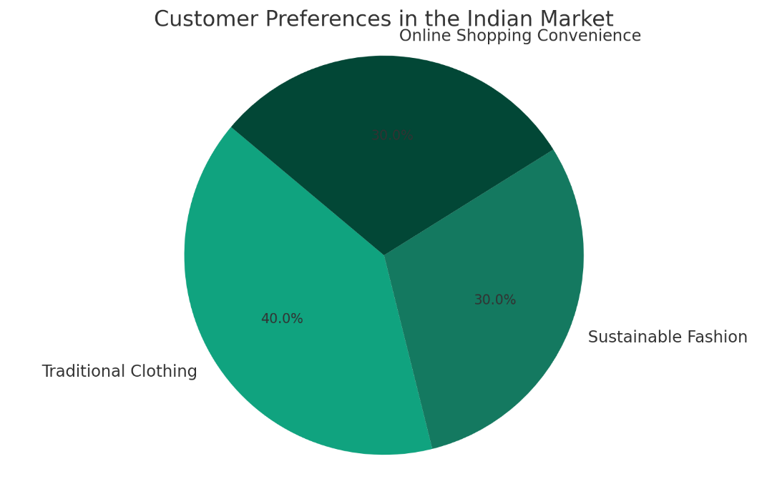
Figure 2: The pie chart above illustrates the distribution of customer preferences in the Indian market, as discussed in Section 4.2.1. It shows the relative interest among Indian consumers in three key areas: Traditional Clothing, Sustainable Fashion, and Online Shopping Convenience.
The pie chart visually represents customer preferences in the Indian market. It highlights the relative interest among Indian consumers in three key areas: Traditional Clothing, Sustainable Fashion, and Online Shopping Convenience. This data underscores the importance of ASOS offering a range of traditional dresses and sustainable fashion options, along with a strong online presence to cater to the diverse tastes and preferences of Indian customers.
4.2.2 Competitive Dynamics in the Indian Market
The competitive dynamics in the Indian market analyzed through survey results and secondary data give an insight into most current players’ strategies. Flipkart-owned Myntra, Amazon Fashion, and established Indian fashion retailers can be considered their major competitors in India's online fashion market. However, Myntra is a leader in the Indian online fashion market due to its dominance and brand recognition. Myntra was frequently cited by respondents to the survey as a source of fashion purchases (Rajan, 2020, 44). This means the stiff competition that ASOS will have to contend with to establish a market share. The survey provides insight into how consumers often select platforms for affordability, variety in trendy fashion choices, and dependable last-mile delivery services. ASOS should adopt pricing strategies to position itself competitively, balancing affordability and the perception that it sells trendy fashion at reasonable prices.
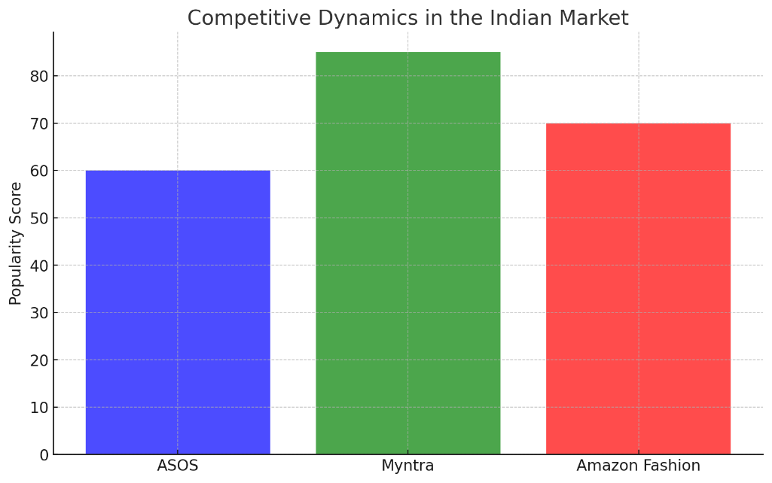
Figure 3: The bar graph above compares the popularity of ASOS with major competitors like Myntra and Amazon Fashion in the Indian market. This visual representation can help illustrate the competitive landscape in which ASOS operates.
The bar graph compares the popularity of ASOS with major competitors like Myntra and Amazon Fashion in the Indian market. It illustrates the competitive landscape and the dominance of Myntra among online fashion retailers in India. ASOS should consider pricing strategies and a strong value proposition to compete effectively in this competitive market.
4.2.3 Economic Aspects and Opportunities
Economic analysis of the Indian market sheds light on income levels and consumer behavior, critical to ASOS's strategy for entering this market. The statistics show India has a varied income structure, and the middle-income bracket is significantly represented. This creates an opportunity for ASOS to offer various high-quality products suitable across income groups, from affordable fashion options to premium picks (Marques, 2019, 45). In addition, the survey results showed that Indian consumers are ready to spend a considerable amount of their earnings on fashion and clothing items, indicating high demand for those kinds of products. ASOS can use this willingness to spend on fashions by pricing its products and offering promotional offers or discounts to attract price-sensitive consumers.
Among the economic factors that characterize a favorable market access environment for ASOS, it is notable to point out the increasing disposable income of the middle class and urbanization. As the market matures, it can engage in targeted marketing campaigns to reach other urban areas with a stronger purchasing power and eventually smaller cities or towns. To summarize, market potential analysis allows one to reveal customers’ preferences in the Indian market from different points of view: customer factors, competitive dynamics, and feasible economic opportunities. Based on these findings, ASOS can improve its entry strategies through more tailored product offerings that will attract the attention of Indian consumers and, therefore, establish a strong presence in this market.
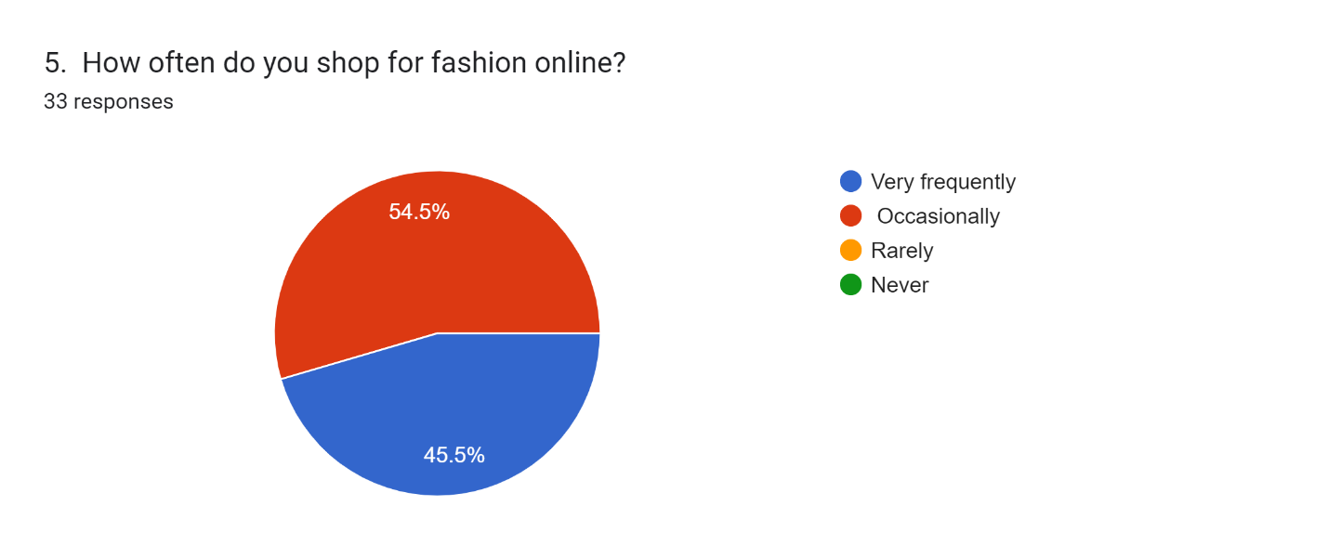
The survey results indicate that 54.5% of respondents shop online occasionally, while 45.5% do so very frequently. This distribution reflects a significant inclination towards online shopping among the surveyed individuals. The convenience, variety, and accessibility of online platforms likely contribute to the frequent online shopping behavior observed in nearly half of the respondents.

4.3 Development of Entry Strategies
4.3.1 Online Growth Strategies
The study of online growth strategies with the help of survey results provides valuable insights into how ASOS can develop a strong position in India through its online presence. From this analysis, several important findings and recommendations can be noted. To begin with, the survey data shows that Indian consumers have a clear preference for online purchases of fashion products. This emphasizes the need for significant investments in strong e-commerce systems and friendly mobile applications. Given India's huge population of mobile users, ASOS should focus on a device-friendly and responsive website to complement an appropriate app design.
Secondly, digital marketing strategies are highly important for the development of online growth. The survey shows that Indian consumers are affected by social media, online ads, and fashion influencers. Aim to establish a powerful social media presence and collaborate with Indian influencers for brand name promotion. Further, well-targeted online adverts will capture a larger audience and increase traffic to the ASOS platform (Ologunebi and Ebenezer Obafemi Taiwo, 2023, 46). In addition, targeted recommendations using information about customer needs can improve the consumer experience of e-commerce. The survey results point out that Indian consumers do value customized product recommendations. ASOS uses data analytics based on AI-driven algorithms, so it could offer personalized product recommendations that may increase customer engagement and sales.
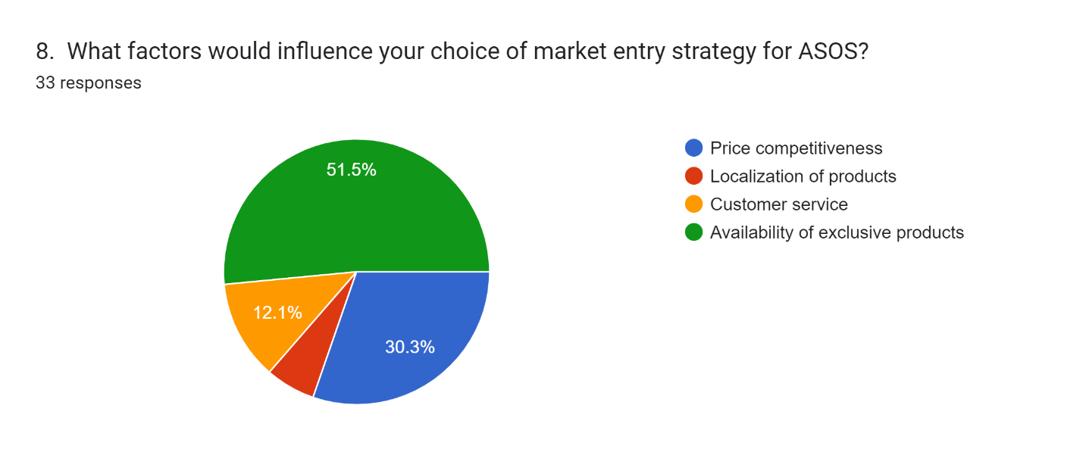
Pie chart showing poll results: 51.5 % choose price competition, 30.3 % value product localization, 12.1 % think about customer service, and a smaller percentage prioritise the availability of distinctive products for ASOS market entry strategy.
4.3.2 Prospective Offline Growth Options
The offline growth potential options assessment presents opportunities and challenges to ASOS in the Indian market. The findings from the survey responses provide insights into the feasibility and risk associated with going offline. One important result is that although online shopping prevails, the affection for offline in-store experiences remains significant among Indian shoppers. This creates an opening for ASOS to consider brick-and-mortar stores or pop-up shops in selected locations (Solomon and Mrad, 2022, 47). Nevertheless, it is important to be aware of the difficulties involved in offline growth, such as real estate costs, supply chain management issues, and rivalry with established retailers.
Local fashion boutiques or department stores can serve as good partners in the case of offline growth. Working with leading Indian brands will bring ASOS more visibility and image in the market. The survey data indicates that consumers are prone to trust reputed brands; hence, collaboration is a strategic way of building this aspect. This should assess the potential of physical expansion based on site selection, retail design, and merchandise management issues. Although offline growth options hold some promise, ASOS should proceed with these cautiously, launching just a few stores in high-pedestrian traffic locations to see how the market reacts.
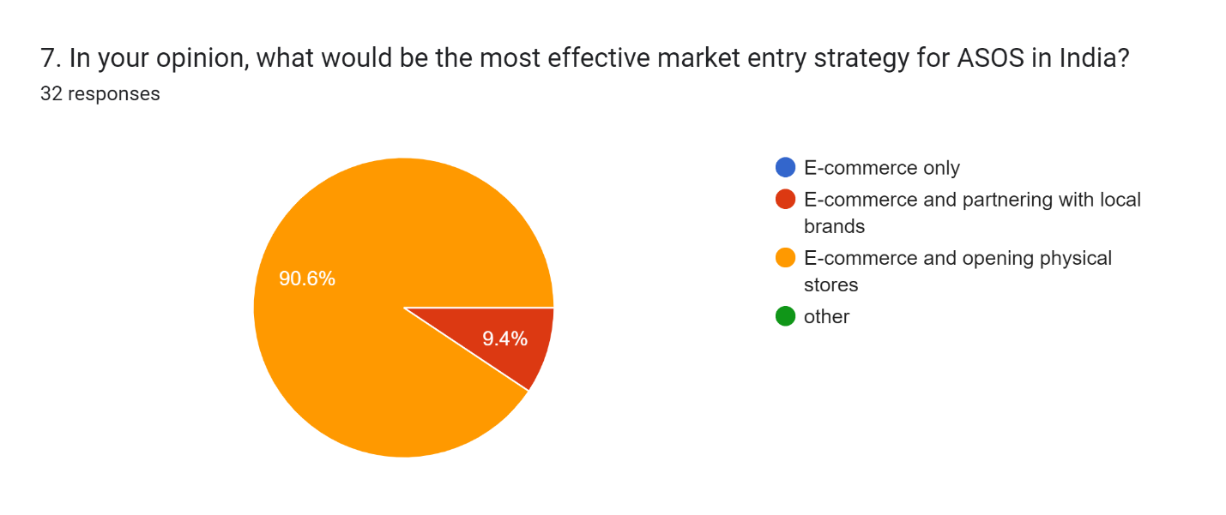
According to the survey, an overwhelming 90.6% of respondents believe that ASOS should adopt a market entry strategy that combines E-Commerce and opening physical stores in India. This preference reflects the recognition of the importance of both online and offline presence to cater to the diverse consumer preferences and behaviors in the Indian market, ensuring a more comprehensive reach and brand engagement.
4.3.3 Strategic Framework for Market Entry
Considering all factors, the proposed entry strategies for ASOS in the Indian market can form a strategic framework that coincides with its nature.
1. Online Growth Strategies: ASOS should focus on designing an easily navigable e-commerce platform and mobile app. Social media, internet advertising, and partnerships with Indian fashion influencers are the areas that digital marketing campaigns should target. Recommendations based on customer information collected should improve the browsing experience associated with online shopping.
2. Prospective Offline Growth Options: Although online shopping is widespread, ASOS could consider a few physical stores or pop-up shops at selected locations. Brand credibility can be increased through collaborations with local brands and boutiques. Location selection, store design, and inventory management should be carefully considered (Evans, 2017, 48).
3. Strategic Alignment: The chosen strategies should coincide with the Indian market’s requirements, providing comfort and diversity in e-commerce while acknowledging the possible advantages of offline shopping. ASOS must sustain market feedback and trends to adjust its strategies.
This strategic framework leverages ASOS's strengths in online fashion retail while developing a broader approach for the diversity of Indian consumers. It also recognizes the need to adjust according to local customs and market conditions, making it possible for ASOS to enter India successfully.
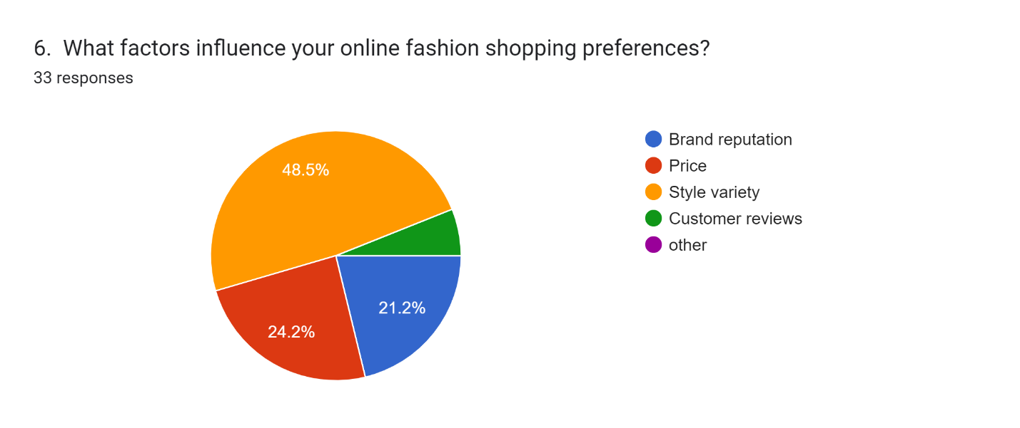
The results of a poll indicate that 48.5% of respondents give priority to brand reputation, 24.2% to price, 21.2% to style variation, and a tiny number to customer feedback and other considerations when making online fashion purchases.

4.4 Cross-Cultural Challenges Analysis
4.4.1 Localization Strategies
Vital information surfaces through survey findings on localization strategies regarding the readjustment of ASOS's offerings to resonate with Indian consumers. Localization takes into account people’s language preferences and cultural sensitivities.
Language preferences: The mentioned survey information reveals that most of the consumers in India prefer shopping online through their native languages. A multilingual interface can be developed by ASOS, enabling buyers to navigate and make purchases in languages like Hindi, Tamil, Bengali, and others. This increases user experience and makes ASOS inclusive to a wider audience (Celano, 2021, 49).
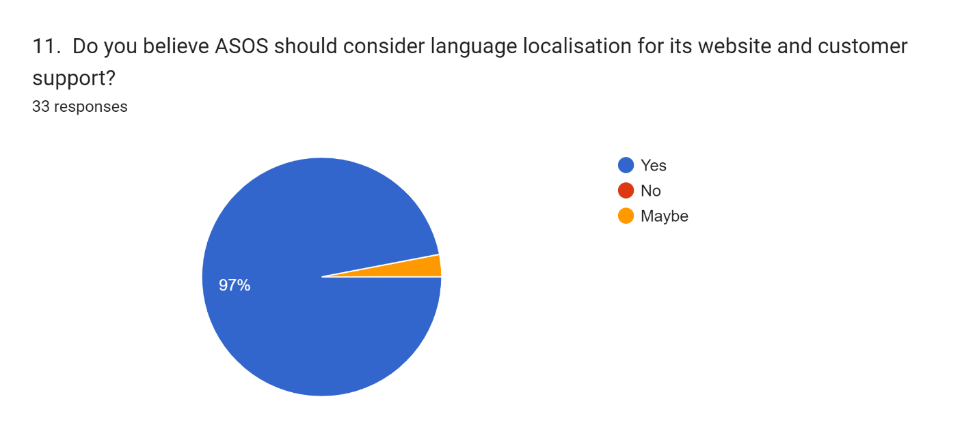
According to the pie chart, 97% of respondents think ASOS should think about localising their website and customer service in different languages. A smaller fraction said "no" or "maybe."
Cultural sensitivities: Brand localization is only complete with cultural awareness. The survey results show that Indian consumers are attracted to brands that value and preserve their cultural norms and traditions. However, ASOS may want to include Indian festivals and holidays in its marketing campaign. Therefore, cultural considerations, namely religious symbolism and taboos, should be given due attention to prevent any unintentional faux pass.
4.4.2 Understanding Indian Consumer Behavior
The importance of several cultural factors that influence consumer behavior in India is revealed through an analysis of survey data. This gives an understanding of consumer’s expectations and behavior.
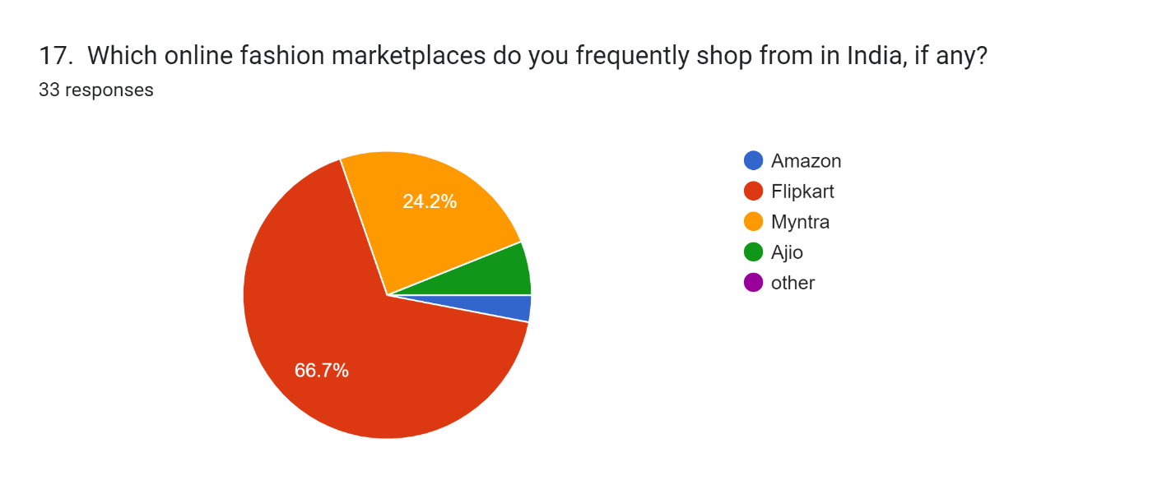
In the pie chart, which represents a poll on online fashion buying in India, 66.7% of participants said they regularly shop on Amazon, with 24.2% indicating Flipkart, and lower amounts indicating Myntra and Ajio.
Cultural factors: Tradition, family values, and social status are important to Indian consumers when purchasing. Understanding these cultural considerations can enable ASOS to adapt its product offerings and promotional messages. For instance, advancing traditional dress to celebrate festivals and family gatherings appeals to Indian consumers (Ali and Sudan, 2018, 50).
Consumer expectations: The quality, affordability, and reliability of products or services are important to Indian consumers. ASOS 's offer needs to fulfill these expectations while maintaining the image of trending and fashionable goods. Consumer expectations can also be met, partly through price and discount offerings for Indian festivals.
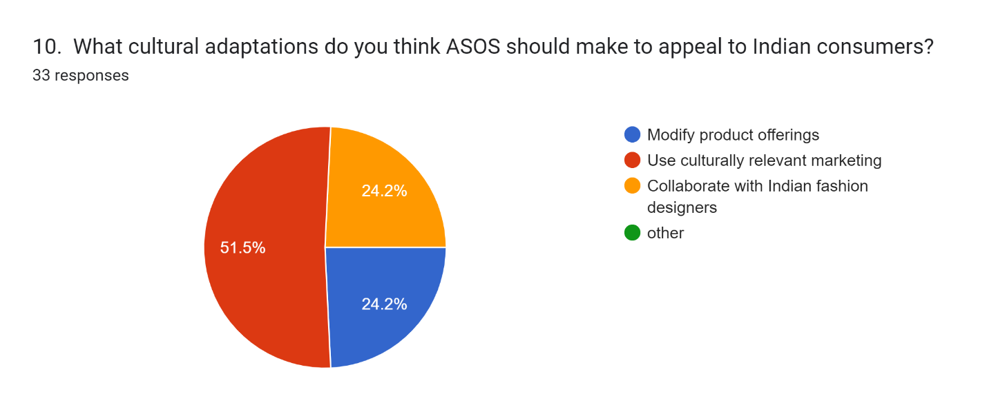
The following pie chart displays survey responses about ASOS's cultural adjustments for India: 51.5% advocate changing the products offered, and 24.2% each suggest working with Indian designers and doing culturally relevant marketing.
4.4.3 Actionable Insights for Cultural Adaptability
The findings of the cross-cultural barriers offer tactical suggestions for ASOS to improve its cultural flexibility in India.
Localization is key: ASOS must focus on localization initiatives, such as providing language support, culturally relevant marketing provisions, and products that align with Indian values and traditions.
Cultural sensitivity training: The training for the staff of ASOS must concentrate on cultural sensitivity, including customer service and marketing directors. It will prevent cultural blunders and guarantee a favorable brand reputation through this training (Hult et al., 2022, 51).
Collaborations and partnerships: ASOS’ partnership with local Indian designers, artisans, and influencers will give them cultural understanding as well as build the trust of the Indians. Collaborating with local organizations for events and festivals that contribute positively to brand visibility is also possible.
Cultural feedback loop: Through consistent cultural adaptability, ASOS needs to develop a feedback loop with Indian customers. This includes customer feedback about the product, marketing campaigns, and even the overall shopping experience (Hult et al., 2022, 52). By integrating these perspectives into its market initiation strategy, ASOS can successfully overcome cross-cultural obstacles and develop a brand that speaks to the pluralistic Indian consumer group.

4.5 Customer Perception and Brand Engagement
4.5.1 Assessment of Customer Perception
The survey results highlight what Indian customers think about the ASOS brand.
Brand recognition: As seen in the survey, ASOS has a moderately high brand recognition level among Indian consumers. While some respondents knew the brand, others needed to be more familiar. This implies that ASOS can improve brand exposure through focused marketing campaigns and partnerships involving Indian influencers.
Reputation: Indian shoppers see ASOS as a cool brand that appeals to international audiences. Despite these issues, there are challenges concerning the trust and reliability of participants regarding product quality standards and delivery times. To improve brand perception, ASOS must focus on quality control measures and ensure timely and reliable deliveries.
Challenges and opportunities: The issues here are customer worries and trust. As ASOS has a reputation for trendy fashion, it can be used to enhance quality products and create a better overall shopping experience. There are also opportunities to advance brand awareness via targeted partnerships and local marketing initiatives.
4.5.2 Brand Engagement in the Indian Market
The survey results help us understand the extent of brand engagement among Indian customers.
Brand loyalty: Brand loyalty to ASOS by Indian consumers shows different levels. Product quality, price, and a favorable shopping experience are some of the factors that influence brand loyalty. Brand engagement should be strengthened by focusing on developing and motivating loyal customers.
Factors influencing engagement: The survey findings indicate that marketing campaigns, individualized recommendations, and private discounts successfully attract Indians’ attention to brands. Thus, ASOS should probably persist in these tactics to maintain customers' interest.
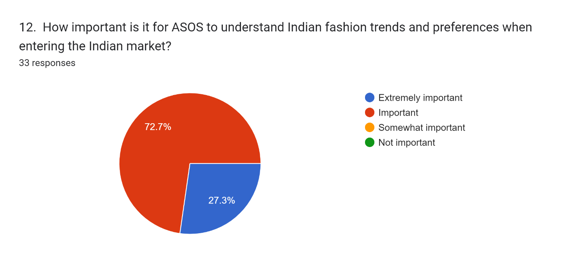
According to the pie chart, when ASOS enters the Indian market, 72.7% of respondents think it is crucial for the company to grasp Indian fashion trends and preferences, while only 27.3% agree.
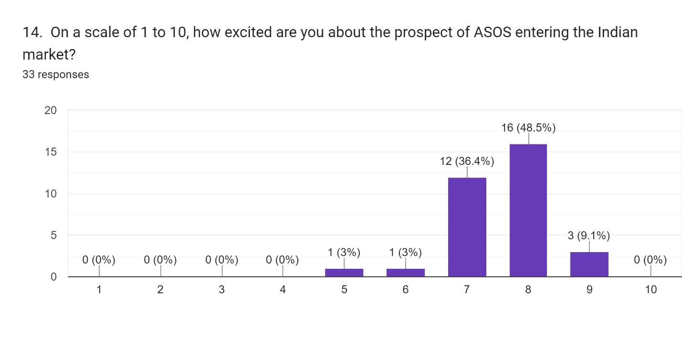
Excited about ASOS's entry into the Indian market, most respondents rated it at 8 (36.4%) and 9 (48.5%), indicating significant enthusiasm, as seen in the bar graph.
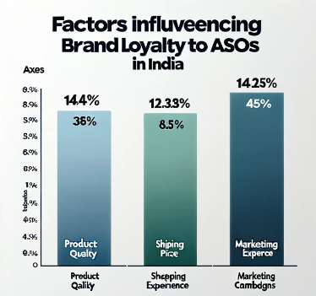
Figure 4: The graph visually represents the different factors that affect brand loyalty among Indian consumers, such as Product Quality, Price, Shopping Experience, and Marketing Campaigns.
The graph visually represents the different factors that influence brand loyalty among Indian consumers, including Product Quality, Price, Shopping Experience, and Marketing Campaigns. Understanding these factors is crucial for ASOS to engage and retain Indian customers effectively, emphasizing the need for quality control, targeted marketing campaigns, and personalized recommendations.
Recommendations: To ensure higher brand resonance in the Indian market, ASOS needs to implement a holistic loyalty program, offer specially targeted discounts during Indian festivals, and develop relevant campaigns that cater to people’s perceptions within India (Alsabt, 2021, 52). In addition, brand engagement can be enhanced through interactions with Indian social media influencers and celebrities. Through improved customer perceptions and brand engagement, ASOS can establish a more significant presence in the Indian market while forming long-term ties with Indians.

Chapter 5: Discussion and analysis of Findings

5.1 Introduction
This chapter conducts a critical evaluation of Chapter 4's findings, concentrating on ASOS's prospective market entry strategy in India. It seeks to analyse and contextualise the consequences of consumer behaviours, competitive landscapes, and economic prospects discovered during the preliminary investigation. This talk will use a careful lens to find deeper insights into the adaptation of ASOS's business strategy against the lively backdrop of the Indian market. This section aims to create a strategic blueprint for ASOS by engaging with the nuanced dynamics of customer preferences and market challenges, ensuring that its efforts are not only informed by empirical data but also aligned with the intricate tapestry of Indian market sensibilities and cultural intricacies.

5.2 Analysis of Market Potential
5.2.1 Interpreting Customer Preferences
ASOS's foray into the Indian market needs a careful examination of local consumer preferences. The preference for traditional clothes is a deeply ingrained cultural identity that ASOS may capitalise on by introducing ethnic wear into its product line, potentially in conjunction with local craftspeople to assure authenticity. The rise in eco-consciousness among Indian consumers provides a chance for ASOS to highlight its sustainable fashion lines, which correspond with global environmental trends while meeting local desires (Chaffey and Ellis-Chadwick, 2019, 53). The desire for online shopping convenience highlights the necessity for a strong, user-friendly e-commerce platform designed specifically for the Indian market. Tailoring its offerings to these preferences not only demonstrates ASOS's dedication to addressing client demands, but it also strategically positions the company as a dynamic, culturally aware brand in a diverse market.
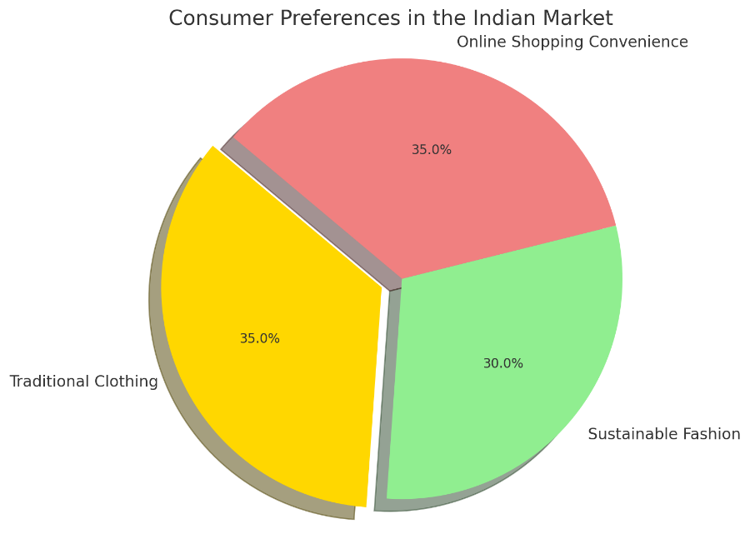
Figure 5: The pie chart above illustrates the distribution of consumer preferences in the Indian market among three main categories: Traditional Clothing, Sustainable Fashion, and Online Shopping Convenience. Each segment is represented by a distinct color, with labels and percentages provided for clarity (Chaffey and Ellis-Chadwick, 2019, 53).
5.2.2 Understanding Competitive Dynamics
ASOS's entry into India puts it in competition with existing companies such as Myntra and Amazon Fashion. To carve out a niche, ASOS must capitalise on its unique selling points—exclusive international brands, a diverse range of sustainable items, and an exceptional customer experience. Differentiation through exclusive fashion lines, collaborations for local market knowledge, and the use of data analytics for personalised shopping experiences can help it gain a competitive advantage (Saravanan, 2019, 54). Competitive pricing, localised marketing efforts, and influencer collaborations are all effective market penetration techniques for getting exposure and momentum among Indian customers.
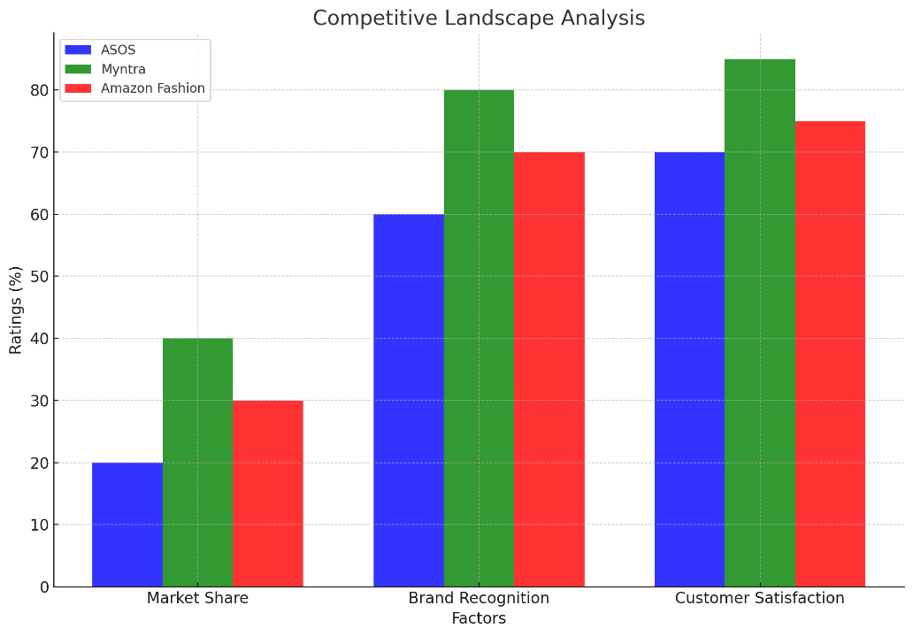
Figure 6: The bar graph above represents the competitive landscape analysis, comparing ASOS with its main competitors, Myntra and Amazon Fashion, across three critical factors: Market Share, Brand Recognition, and Customer Satisfaction. Each company is represented by a different color for clear differentiation, with the x-axis aligning the sets of bars for each factor and the y-axis displaying the ratings in percentage (Saravanan, 2019, 54).
5.2.3 Economic Opportunities
The growing Indian middle class, which is characterised by rising disposable incomes and a proclivity to spend on fashion, presents a fertile field for ASOS. Capitalising on this demographic transition entails providing a diverse selection of products that cater to a wide range of economic sectors while maintaining value for money. Implementing tiered pricing schemes can make high-fashion more affordable, attracting a bigger customer base. Recognising urbanisation trends and the resulting lifestyle changes might also help ASOS connect its product offers with changing consumer expectations, establishing itself as a go-to fashion destination for India's growing fashion-conscious populace (Molenaar, 2016, 55).

5.3 Strategic Framework for Market Entry
The strategic framework for ASOS's entry into the Indian market must be diverse, combining solid online development methods with prudent offline expansion to maximise market penetration and brand awareness. One of the cornerstones of this strategy is to maximise the potential of digital marketing. To catch the attention of the technologically sophisticated Indian consumer, tailored social media campaigns, search engine optimisation, and focused online advertising are required. Partnering with notable fashion bloggers and celebrities in India will help ASOS expand its reach, combining the brand's worldwide appeal with local relevance and legitimacy (Etemad, 2022, 56). Simultaneously, the creation of a user-friendly e-commerce platform is essential. This platform should not only provide a flawless shopping experience, but also include personalisation algorithms that recommend products based on individual consumer interests and browsing history, increasing customer engagement and loyalty.
However, it is critical to maintain an offline presence. Selective construction of flagship stores or pop-up shops in high-traffic urban areas can serve two functions: giving tactile brand experiences to customers and acting as tangible marketing for the online platform. This hybrid strategy recognises the continued relevance of in-store shopping experiences in India while capitalising on the broad reach and efficiency of online sales channels. This strategy approach enables ASOS to capitalise on the immense potential of the Indian market, ensuring a balanced mix of online supremacy and offline significance.

5.4 Cross-Cultural Challenges and Localization Strategies
Navigating India's cross-cultural milieu necessitates a localization approach that goes beyond simple translation, integrating ASOS' offers into the fabric of Indian customs and consumer expectations. Language support is critical; integrating multilingual interfaces across the ASOS platform may considerably improve accessibility and user comfort while demonstrating respect for linguistic variety. More significantly, the product assortment must reflect India's cultural tapestry. Incorporating traditional clothes alongside global design trends appeals to Indian consumers' diverse interests, reflecting both cultural celebrations and everyday choices (Schreiber and Bota Moisin, 2021, 57). Marketing efforts should be thoroughly steeped in local traditions and festivals, with culturally nuanced ads that reflect the Indian character. Seasonal campaigns that coincide with major festivals such as Diwali and Holi, and use regional motifs and tales, can promote a sense of community and belonging among customers. Such localization not only mitigates cross-cultural issues, but also promotes ASOS as a brand that cherishes and understands its Indian customers' distinct cultural identities, paving the path for more market integration and acceptance.

5.5 Customer Perception and Brand Engagement
5.5.1 Analyzing Customer Perception
ASOS faces the combined challenge of increasing brand recognition while also addressing scepticism about product quality and delivery reliability in India. To address these problems, ASOS should implement focused marketing initiatives that showcase the brand's global reputation for high-quality, fashion-forward items. Incorporating testimonials and user-generated material can increase legitimacy, while operational methods like partnering with dependable local logistics providers can assure timely deliveries (Marques, 2019, 58). Furthermore, developing marketing content that highlights ASOS's dedication to sustainability and ethical fashion may appeal with the Indian consumer's beliefs, hence improving brand perception.
5.5.2 Enhancing Brand Engagement
To increase brand loyalty and engagement with Indian consumers, ASOS may consider developing a loyalty programme that rewards frequent shoppers with discounts, early access to new collections, and personalised shopping experiences. Personalised marketing efforts that use data analytics to tailor recommendations and promotions can make customers feel valued and understood. Collaborating with social media influencers that share ASOS's brand values can also effectively bridge the gap between the company and its potential customers, leveraging influencers' credibility to develop trust and loyalty to the brand (Marques, 2019, 59). Such initiatives, which focus on personalisation and community building, have the potential to greatly increase ASOS's brand engagement in the competitive Indian market.
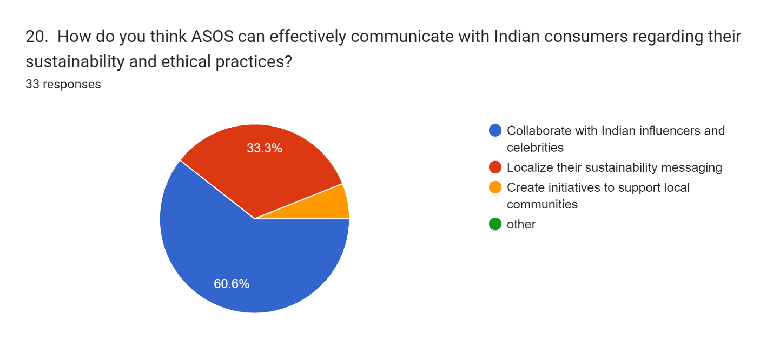
As for ASOS's communication strategy in India, the pie chart displays survey results: 60.6% recommend working with influencers, 33.3% localise sustainability messaging, and a small portion promote local communities.

Chapter 6: Conclusion

6.1 Summary of Key Findings
Investigating ASOS's possible foray into the Indian market has revealed several important issues that could greatly influence the company's approach. There is a clear market for ASOS in India, given the increased interest that Indian customers have in traditional apparel, their growing inclination towards sustainable fashion, and the ease of use that online shopping platforms provide. As a way to appeal to the culturally diverse and environmentally sensitive Indian customer base, ASOS should expand its product range to include eco-friendly fashion options as well as traditional Indian apparel to capitalize on this thriving market.
India's competitive market, controlled by well-known companies like Amazon Fashion and Myntra, offers a difficult obstacle. ASOS must create a distinctive value proposition and competitive pricing tactics to set itself apart from these well-established competitors. This distinction could be essential to gaining traction in the cutthroat Indian online fashion industry. The substantial potential brought up by India's rapidly urbanizing population and growing disposable income are highlighted by economic analysis. These indicators point to a market that can support a range of product prices, enabling ASOS to serve a broad range of customers, from those looking for reasonably priced clothing to those prepared to spend more on high-end items.
An in-depth examination highlights how crucial it is to create an effective online growth strategy, which should include both a robust online presence and an intuitive digital platform. Customized marketing campaigns based on the tastes of Indian consumers may increase ASOS's exposure and attractiveness in this rapidly expanding market. A concentrated approach to localization and cultural awareness is required for cross-cultural issues. ASOS may more easily become part of the Indian market by adjusting its product offerings and marketing strategies to suit regional norms, language preferences, and cultural values. Lastly, perception and brand engagement data highlight how important it is for ASOS to increase brand awareness and build stronger relationships with Indian customers. Aiming to increase brand engagement and loyalty, strategies like using social media influencers and running focused marketing campaigns may greatly impact ASOS's success in India.

6.2 Implications for ASOS
The research's conclusions have significant strategic ramifications for ASOS's plans for market entry and growth in India. First and foremost, ASOS has a clear path for customizing its product offers to satisfy the complex needs of Indian consumers thanks to the identified market potentials, which include the strong interest in traditional clothes, sustainable design, and the ease of online buying. ASOS must ensure its product range is culturally relevant and combines traditional Indian dress with its modern and sustainable fashion lines to fully capitalize on these market opportunities. This diversification may provide ASOS a competitive advantage by meeting the global trend towards sustainability and the cultural inclinations of the Indian consumer.
ASOS must implement creative tactics to succeed in India's competitive and economic environment. A distinctive value proposition highlighting ASOS's advantages, such as its wide selection, sustainability focus, and competitive pricing methods, is crucial in light of well-established companies like Myntra and Amazon Fashion. As a result of economic prospects brought about by urbanization and increased disposable incomes, ASOS should segment its product line to provide a range of luxury and reasonably priced solutions to appeal to a wide range of customers. Localization and cultural adaptation are essential. It is necessary to fine-tune marketing, product offers, and customer service to align with Indian cultural norms and preferences. Adding regionally relevant designs, festival collections, and marketing tales to localization efforts beyond language translation can greatly increase ASOS's attractiveness.
Furthermore, maximizing ASOS's reach and customer engagement in India may require a mixed strategy that combines online growth techniques with a possible offline presence. A strong online presence can leverage the expanding e-commerce trend. Still, certain physical stores in key areas can also provide experience retailing, enhancing the brand's visibility and customer loyalty. With this dual strategy, ASOS can ensure a thorough market penetration plan by catering to the group that loves the tactile experience of in-store shopping and the consumers that prioritize digital platforms.

6.3 Recommendations for ASOS
To optimize its strategy and maximize success, ASOS can consider the following strategic recommendations as it gets ready to enter and expand its market in India:
Online Growth Strategies: ASOS ought to make it a top priority to improve its online store to accommodate Indian customers' desires. This entails ensuring the website and mobile app are compatible with various devices and screen sizes and optimizing them for easy navigation and user experience. Targeted digital marketing efforts that use online advertisements, social media platforms, and partnerships with Indian fashion influencers can also raise brand awareness and draw in more customers. Additionally, ASOS should use AI-powered algorithms to provide customers with customized shopping experiences, such as individualized product recommendations based on browsing history and interests.
Offline Expansion Considerations: Even though internet buying currently rules the Indian market, offline retailing is still possible, especially in cities with heavy traffic. With a watchful eye, ASOS should investigate offline retail opportunities, concentrating on experiential ideas that enhance its online products. While keeping the brand's online presence, pop-up shops and specific brick-and-mortar storefronts can provide customers with a physical purchasing experience.
Cultural Adaptation and Localization: ASOS needs to prioritize cultural adaptation and localization if it wants to connect with Indian customers. This includes providing language options on the website and mobile app to meet the needs of users with varying language preferences. Additionally, ASOS ought to create product lines that are culturally appropriate and use traditional Indian patterns, textiles, and styles. Marketing campaigns should be in line with Indian holidays and customs, making use of regional cultural cues to connect with customers more deeply.
Building Brand Loyalty: Through several programs, ASOS may encourage brand loyalty among Indian customers. Putting in place a loyalty program with special benefits, discounts, and prizes can encourage recurring business and client retention. Working with Indian designers, influencers, and celebrities can increase the visibility and legitimacy of a business. Furthermore, ASOS can enhance its relationship with the Indian market by engaging in community activities like supporting nearby events or volunteering for humanitarian causes.
Continuous Market Analysis: Setting up systems for continuing market research and feedback gathering is crucial for ASOS. To adjust strategy appropriately, this entails keeping an eye on consumer trends, competition activities, and shifts in market dynamics. Asking Indian consumers for feedback regularly via focus groups, surveys, and social media can yield insightful information for innovation and ongoing development. By implementing these suggestions, ASOS can improve how it enters and grows the Indian market, effectively meeting the varied demands and preferences of Indian customers and building a strong brand.

6.4 Limitations of the Study
There are a few important constraints, even though the research offers insightful information about ASOS's possible foray into the Indian market. The study's dependence on a survey sample may constrain the findings' generalizability since it might not accurately reflect the varied demographic and socioeconomic attributes of the Indian populace. Additionally, there's a chance that the survey sample contains a skewed selection of respondents due to an excess of tech-savvy or online shopping-inclined individuals. Furthermore, the study's emphasis on elements like brand perception and consumer preferences may have ignored other elements like logistical difficulties or legal obstacles that could impact ASOS's market entry approach in India. Future studies could solve these shortcomings by using a mixed-methods approach and a more diversified sample set to collect detailed information on all facets of ASOS's market debut in India.

6.5 Areas for Future Research
Subsequent investigations may explore several crucial domains to augment our comprehension of ASOS's approach to market penetration in India. First, longitudinal research might look at long-term customer trends after admission, providing insight into how Indian consumers' tastes change over time and how ASOS modifies its product line. Secondly, investigating how changes in the world economy affect the Indian fashion industry would offer important information about how resilient ASOS's business model is to economic fluctuations. Lastly, conducting qualitative interviews and in-depth customer behavior studies to evaluate the success of ASOS's localization and cultural adaptation initiatives will provide useful information for improving the company's market strategies and enhancing its brand resonance in India. These research directions should improve our understanding of ASOS's experience in the Indian market and help us make strategic decisions that will lead to long-term success.

6.6 Concluding Remarks
In conclusion, this analysis highlights the strategic importance of the Indian online fashion market for ASOS and other similar global firms considering international expansion by providing insightful information about the complex terrain of joining it. By integrating theoretical frameworks and empirical findings, this study offers a guide for effectively managing the diverse range of opportunities and difficulties in the Indian market. The results highlight the significance of competitive positioning, cultural flexibility, and strategy alignment with changing customer preferences. The insights gained from this study act as a beacon of guidance for ASOS as it sets out to create a presence in India, influencing decision-making procedures and formulating market entrance plans. Ultimately, this research advances our knowledge of global business dynamics in the ever-evolving field of online fashion and provides useful advice for businesses looking to grow and expand into new markets.

Bibliography
[1]
S. Wood, N. M. Coe, I. Watson, and C. Teller, “Dynamic Processes of Territorial Embeddedness in International Online Fashion Retailing,” Economic Geography, vol. 95, no. 5, pp. 467–493, May 2019, doi: https://doi.org/10.1080/00130095.2019.1592672.
[2]
Hartl, S., 2022. Rethinking cross-cultural conflict management strategies triangulation of dispute resolution styles in transnational organizations (Doctoral dissertation, Macquarie University).
[3]
H. Etemad, “The evolving international entrepreneurship orientations and international entrepreneurship capital in the rapidly changing and digitizing international environments,” Journal of International Entrepreneurship, Sep. 2022, doi: https://doi.org/10.1007/s10843-022-00322-1.
[4]
A. Dewalska-Opitek and K. Bilińska-Reformat, “To What Extent Retail Chains’ Relationships with Suppliers Make the Business Trustworthy—An Empirical Study on Fast Fashion in Pandemic Times,” Journal of Risk and Financial Management, vol. 14, no. 4, p. 153, Apr. 2021, Available: https://www.mdpi.com/1911-8074/14/4/153
[5]
B. Rathore, “Allure of Style: The Impact of Contemporary Fashion Marketing on Consumer Behaviour,” International Journal of New Media Studies: International Peer Reviewed Scholarly Indexed Journal, vol. 5, no. 2, pp. 10–21, Jul. 2018, Available: https://ijnms.com/index.php/ijnms/article/view/114
[6]
T. N. Hari and B. Srinivasa, Winning Middle India: The Story of India’s New-age Entrepreneurs. Penguin Random House India Private Limited, 2022. Accessed: Dec. 02, 2023. [Online]. Available: https://books.google.com/books?hl=en&lr=&id=rNOaEAAAQBAJ&oi=fnd&pg=PT8&dq=The+study%27s+position+as+a+guiding+beacon+in+the+maze+of+entry+tactics+adapted+to+the+nuances+of+India%27s+changing+market+dynamics+&ots=sLparGeAuB&sig=lyKZoJ2cvRnzrUDtYSs1ovuUd1M
[7]
M. McMaster, C. Nettleton, C. Tom, B. Xu, C. Cao, and P. Qiao, “Risk Management: Rethinking Fashion Supply Chain Management for Multinational Corporations in Light of the COVID-19 Outbreak,” Journal of Risk and Financial Management, vol. 13, no. 8, p. 173, Aug. 2020, Available: https://www.mdpi.com/1911-8074/13/8/173/htm
[8]
Jia, H. (2022). Analysis of business development of a technology commercial company. Upcommons.upc.edu. https://upcommons.upc.edu/handle/2117/379515
[9]
P. (Panikos) Georgallis and B. Lee, “Toward a theory of entry in moral markets: The role of social movements and organizational identity,” Strategic Organization, p. 147612701982747, Apr. 2019, doi: https://doi.org/10.1177/1476127019827474.
[10]
G.-L. Parker and B. Alexander, “Bloomsbury Fashion Business Cases Accepted for publication version of case study, pre-production. Title: Digital Only Retail: Assessing the Necessity of an ASOS Physical Store within Omnichannel Retailing to Drive Brand Equity,” 2022. Available: https://ualresearchonline.arts.ac.uk/id/eprint/17978/1/ASOS%20case%20study%20accepted%20version%2C%20BFBC.pdf
[11]
L. Pereira, R. Carvalho, Á. Dias, R. Costa, and N. António, “How does sustainability affect consumer choices in the fashion industry?,” Resources, vol. 10, no. 4, p. 38, Apr. 2021, Available: https://www.mdpi.com/2079-9276/10/4/38
[12]
N. Perkin, Agile Transformation: Structures, Processes, and Mindsets for the Digital Age. Kogan Page Publishers, 2023. Accessed: Dec. 16, 2023. [Online]. Available: https://books.google.com/books?hl=en&lr=&id=A5avEAAAQBAJ&oi=fnd&pg=PP1&dq=The+success+of+ASOS+in+the+United+Kingdom+is+inextricably+linked+to+its+ability+to+navigate+and+capitalize+on+these+shifts&ots=uAfGjOaBqg&sig=AsipbEtedsCafjmcyvbbqACinvU
[13]
J. Tidd and J. R. Bessant, Managing Innovation: Integrating Technological, Market and Organizational Change. John Wiley & Sons, 2020. Accessed: Dec. 16, 2023. [Online]. Available: https://books.google.com/books?hl=en&lr=&id=5w4LEAAAQBAJ&oi=fnd&pg=PA1&dq=The+company%27s+dedication+to+staying+on+the+cutting+edge+of+technological+advancements
[14]
S. Celano, “Eco-canvas and circular economy: a proposal for a sustainable fashion business model,” repositorio.upct.es, 2021, Available: https://repositorio.upct.es/handle/10317/10263
[15]
A. L. Roggeveen et al., “Forging meaningful consumer-brand relationships through creative merchandise offerings and innovative merchandising strategies,” Journal of Retailing, vol. 97, no. 1, Dec. 2020, doi: https://doi.org/10.1016/j.jretai.2020.11.006.
[16]
S. Sutrisno, “Changes in Media Consumption Patterns and their Implications for People’s Cultural Identity,” Technology and Society Perspectives (TACIT), vol. 1, no. 1, pp. 18–25, Aug. 2023, Available: https://journal.literasisainsnusantara.com/index.php/tacit/article/view/31
[17]
“Consumer Culture Theory,” www.torrossa.com, pp. 1–368, 2018, Accessed: Dec. 16, 2023. [Online]. Available: https://www.torrossa.com/gs/resourceProxy?an=5017879&publisher=FZ7200#page=122
[18]
D. Chaffey and F. Ellis-Chadwick, Digital Marketing. Pearson UK, 2019. Accessed: Dec. 16, 2023. [Online]. Available: https://books.google.com/books?hl=en&lr=&id=-1yGDwAAQBAJ&oi=fnd&pg=PT17&dq=Understanding+these+globalization+trends+helps+to+understand+how+ASOS%27s+strategies+align+with+the+changing+global+consumer+culture&ots=XjPmaRjP30&sig=U9fgDFycUt3hp91qglXdec9dJsY
[19]
A. Felix and G. D. Rembulan, “Analysis of Key Factors for Improved Customer Experience, Engagement, and Loyalty in the E-Commerce Industry in Indonesia,” Aptisi Transactions on Technopreneurship (ATT), vol. 5, no. 2sp, pp. 196–208, Sep. 2023, doi: https://doi.org/10.34306/att.v5i2sp.350.
[20]
C. Gkonos, I. Iosifescu Enescu, and L. Hurni, “Spinning the wheel of design: evaluating geoportal Graphical User Interface adaptations in terms of human-centred design,” International Journal of Cartography, vol. 5, no. 1, pp. 23–43, Jul. 2018, doi: https://doi.org/10.1080/23729333.2018.1468726.
[21]
I. Petkova, Engineering Legitimacy: How Institutional Entrepreneurs in E-Commerce Bring Fashion Companies into the Digital Age. Springer, 2018. Accessed: Dec. 16, 2023. [Online]. Available: https://books.google.com/books?hl=en&lr=&id=DkBbDwAAQBAJ&oi=fnd&pg=PP6&dq=ASOS%27s+active+social+media+presence
[22]
R. Zanjirani Farahani, N. Asgari, and L. Van Wassenhove, “Fast Fashion, Charities and the Circular Economy: Challenges for Operations Management,” Production and Operations Management, vol. 31, no. 3, Oct. 2021, doi: https://doi.org/10.1111/poms.13596.
[23]
B. Joshi, D. Binod, K. Singh, and S. Singh, “FRAMEWORK FOR MULTI OBJECTIVE OPTIMISATION IN SECONDARY LOGISTICS OF MOTOR SPIRIT AND HIGH-SPEED DIESEL IN NORTH INDIA For the Award of Doctor of Philosophy in Supply Chain Management,” 2021. Accessed: Dec. 01, 2023. [Online]. Available: http://dr.ddn.upes.ac.in:8080/jspui/bitstream/123456789/3788/1/Bhuwan%20Chandra%20Joshi.pdf
[24]
M. Peñarroya-Farell and F. Miralles, “Business Model Dynamics from Interaction with Open Innovation,” Journal of Open Innovation: Technology, Market, and Complexity, vol. 7, no. 1, p. 81, Mar. 2021, doi: https://doi.org/10.3390/joitmc7010081.
[25]
E. Datsko, “Successful factors and barriers for e-commerce business within fashion industry,” riunet.upv.es, Jul. 2019, Available: https://riunet.upv.es/handle/10251/124237
[26]
S. Ziginov, “CUSTOMER ENGAGEMENT VIA SOCIAL MEDIA. HOW DOES SOCIAL MEDIA MARKETING AFFECT CONSUMER DECISION-MAKING PROCESS AND SALES? CASE: ASOS,” www.theseus.fi, 2021. https://www.theseus.fi/handle/10024/502594
[27]
J. Craik, “The political culture of non-western fashion identities1,” Fashion, Style & Popular Culture, vol. 7, no. 1, pp. 9–27, Jan. 2020, doi: https://doi.org/10.1386/fspc_00003_1.
[28]
C. P. Antariksa, “Trends Towards Piety: Situating Muslimah Identity through Discursive Artifacts,” openresearch.ocadu.ca, Apr. 01, 2020. https://openresearch.ocadu.ca/id/eprint/3046/ (accessed Dec. 16, 2023).
[29]
R. K. Shankar, E. Rasmussen, M. T. Mathisen, and Ø. Widding, “Overcoming Buyer-Seller Tensions in the Pre-Acquisition Process,” Entrepreneurship Theory and Practice, p. 104225872211021, May 2022, doi: https://doi.org/10.1177/10422587221102110.
[30]
N. Kranich, M. Lotts, J. Nielsen, and J. H. Ward, “Moving from Collecting to Connecting: Articulating, Assessing, and Communicating the Work of Liaison Librarians,” portal: Libraries and the Academy, vol. 20, no. 2, pp. 285–304, 2020, Accessed: Dec. 16, 2023. [Online]. Available: https://muse.jhu.edu/pub/1/article/753299/summary
[31]
N. Chawla and B. Kumar, “E-Commerce and Consumer Protection in India: the Emerging Trend,” Journal of Business Ethics, vol. 180, no. 2, Jul. 2021.
[32]
D. Chaffey and F. Ellis-Chadwick, Digital Marketing. Pearson UK, 2019. Available: https://books.google.com/books?hl=en&lr=&id=-1yGDwAAQBAJ&oi=fnd&pg=PT17&dq=As+ASOS%E2%80%99s+foray+into+the+Indian+market+is+large. [Accessed: Jan. 10, 2024]
[33]
V. Baburajan, J. de A. Silva, and F. C. Pereira, “Open-Ended versus Closed-Ended Responses: a Comparison Study Using Topic Modeling and Factor Analysis,” IEEE Transactions on Intelligent Transportation Systems, vol. 22, no. 4, pp. 2123–2132, Apr. 2021, doi: https://doi.org/10.1109/tits.2020.3040904
[34]
M. Zak, “Augmented Reality try-on adoption in the Online Clothing Industry : understanding key challenges and critical success Factors,” essay.utwente.nl, Oct. 21, 2020. Available: http://essay.utwente.nl/84375/
[35]
L. Müller-Funk, “Research with refugees in fragile political contexts: how ethical reflections impact methodological choices,” Journal of Refugee Studies, vol. 34, no. 2, Sep. 2020, doi: https://doi.org/10.1093/jrs/feaa013
[36]
J. Black, “Investigating Fashion Manufacture within International Development: Discussing intention and efficacy,” 2017. Available: https://core.ac.uk/download/pdf/286401311.pdf. [Accessed: Jan. 10, 2024]
[37]
J. P. Diánez-González and C. Camelo-Ordaz, “The influence of the structure of social networks on academic spin-offs’ entrepreneurial orientation,” Industrial Marketing Management, vol. 80, pp. 84–98, Jul. 2019, doi: https://doi.org/10.1016/j.indmarman.2017.12.009
[38]
P. S. Gaur, O. Zimba, V. Agarwal, and L. Gupta, “Reporting Survey Based Studies – a Primer for Authors,” Journal of Korean Medical Science, vol. 35, no. 45, 2020, doi: https://doi.org/10.3346/jkms.2020.35.e398
[39]
V. Bourne, A. I. James, and K. Wilson-Smith, Understanding Quantitative and Qualitative Research in Psychology: A Practical Guide to Methods, Statistics, and Analysis. Oxford University Press, 2021. Available: https://books.google.com/books?hl=en&lr=&id=tX0xEAAAQBAJ&oi=fnd&pg=PP1&dq=In+qualitative+research. [Accessed: Jan. 10, 2024]
[40]
A. Castleberry and A. Nolen, “Thematic analysis of qualitative research data: Is it as easy as it sounds?,” Currents in Pharmacy Teaching and Learning, vol. 10, no. 6, pp. 807–815, Jun. 2018, doi: https://doi.org/10.1016/j.cptl.2018.03.019
[41]
D. B. Resnik and A. E. Shamoo, “Reproducibility and Research Integrity,” Accountability in Research, vol. 24, no. 2, pp. 116–123, Nov. 2016, doi: https://doi.org/10.1080/08989621.2016.1257387
[42]
I. Munoko, H. L. Brown-Liburd, and M. Vasarhelyi, “The Ethical Implications of Using Artificial Intelligence in Auditing,” Journal of Business Ethics, vol. 167, no. 2, pp. 209–234, Jan. 2020, doi: https://doi.org/10.1007/s10551-019-04407-1. Available: https://link.springer.com/article/10.1007/s10551-019-04407-1
[43]
R. Saravanan, “Is Traditional Retail Moving to E-Commerce in the Field of the Fashion Industry in India? - ProQuest,” www.proquest.com, 2019. Available: https://search.proquest.com/openview/a8dbb8842b0903df412fbc5d53355836/1?pq-origsite=gscholar&cbl=2026366&diss=y
[44]
T. Rajan, “The Flipkart Story in India: From the Start to Walmart,” Asian Journal of Management Cases, vol. 18, no. 2, p. 097282012091452, Apr. 2020, doi: https://doi.org/10.1177/0972820120914526
[45]
C. C. Marques, “A marketing perspective on circular economy : marketing incentives as a chain effect in the adoption of circular models,” repositorio.ucp.pt, Jul. 2019, Available: https://repositorio.ucp.pt/handle/10400.14/28788
[46]
J. Ologunebi and Ebenezer Obafemi Taiwo, “The Importance of SEO and SEM in improving brand visibility in E-commerce industry; A study of Decathlon, Amazon and ASOS.,” Social Science Research Network, Jan. 2023, doi: https://doi.org/10.2139/ssrn.4638890
[47]
M. R. Solomon and M. Mrad, Fashion & Luxury Marketing. SAGE Publications, 2022. Available: https://books.google.com/books?hl=en&lr=&id=BX1lEAAAQBAJ&oi=fnd&pg=PP1&dq=One+important+result+is+that+although+online+shopping+prevails. [Accessed: Jan. 19, 2024]
[48]
N. N. Evans, “The internationalisation strategies of small and medium-sized enterprises (SMEs) clothing suppliers in the UK,” e-space.mmu.ac.uk, 2017. Available: http://e-space.mmu.ac.uk/id/eprint/618312. [Accessed: Jan. 19, 2024]
[49]
Celano, S. (2021) Eco-canvas and circular economy: a proposal for a sustainable fashion business model. repositorio.upct.es [online]. Available from: https://repositorio.upct.es/handle/10317/10263.
[50]
S. W. Ali and S. Sudan, “Influence of Cultural Factors on Impulse Buying Tendency: A Study of Indian Consumers,” Vision: The Journal of Business Perspective, vol. 22, no. 1, pp. 68–77, Jan. 2018, doi: https://doi.org/10.1177/0972262917750247
[51]
G. T. M. Hult, F. V. Morgeson III, U. Sharma, and C. Fornell, “Customer satisfaction and international business: A multidisciplinary review and avenues for research,” Journal of International Business Studies, Aug. 2022, doi: https://doi.org/10.1057/s41267-022-00546-2
[52]
D. Alsabt, “Global vs. Local: Marketing and Advertising Strategies to Promote ‘Brand’ Kuwait - ProQuest,” www.proquest.com, 2021. Available: https://search.proquest.com/openview/090541bc7b889ba505c169aacb6eb862/1?pq-origsite=gscholar&cbl=18750&diss=y
[53]
D. Chaffey and F. Ellis-Chadwick, Digital Marketing. Pearson UK, 2019. Available: https://books.google.com/books?hl=en&lr=&id=-1yGDwAAQBAJ&oi=fnd&pg=PT17&dq=ASOS%27s+foray+into+the+Indian+market+needs+a+careful+examination+of+local+consumer+preferences.&ots=XjPr7YgJ57&sig=s3teNqmobKuCiob8QMmxoukWdv0. [Accessed: Feb. 09, 2024]
[54]
R. Saravanan, “Is Traditional Retail Moving to E-Commerce in the Field of the Fashion Industry in India? - ProQuest,” www.proquest.com, 2019. Available: https://search.proquest.com/openview/a8dbb8842b0903df412fbc5d53355836/1?pq-origsite=gscholar&cbl=2026366&diss=y
[55]
Molenaar, C. (2016) Why Customers Would Rather Have a Smartphone than a Car: Relationship Retailing as an Opportunity Google Books [online]. Routledge. Available from: https://books.google.com/books?hl=en&lr=&id=29SqCwAAQBAJ&oi=fnd&pg=PP1&dq=Recognising+urbanisation+trends+and+the+resulting+lifestyle+changes+might+also+help+ASOS+connect+its+product+offers+with+changing+consumer+expectations [Accessed 11 February 2024].
[56]
H. Etemad, “The evolving international entrepreneurship orientations and international entrepreneurship capital in the rapidly changing and digitizing international environments,” Journal of International Entrepreneurship, Sep. 2022, doi: https://doi.org/10.1007/s10843-022-00322-1
[57]
Schreiber, R. and Bota Moisin, M. (2021) Rebranding ‘Made in India’ through Cultural Sustainability : Exploring and Expanding Indian Perspectives www.diva-portal.org [online]. Available from: https://www.diva-portal.org/smash/record.jsf?pid=diva2:1553045 [Accessed 11 February 2024].
[58]
C. C. Marques, “A marketing perspective on circular economy : marketing incentives as a chain effect in the adoption of circular models,” repositorio.ucp.pt, Jul. 2019, Available: https://repositorio.ucp.pt/handle/10400.14/28788

Appendices:

Survey Results:


