Name: Madeleine Povey
Module Code & Title: Creative Practice 1 (M4X01557)
Group Number/Name: Clockwork
Project Title: Clockwork
The finalised game concept is for a single-player survival horror, including some mechanics inspired by the game Dead by Daylight with enemy designs inspired by the Clockwork Droids from the Doctor Who episode The Girl in the Fireplace.
The player is required to search for and retrieve the required parts to fix a wind-up clockwork doll in order to receive a key to unlock the door and progress to the next room, which is an exact replica of the first, however this time containing a slightly different enemy. After repeating this process three times, upon repairing the clockwork doll in the third room and receiving the key from it, all of the dolls activate and actively pursue the player as they work to find the fourth and final key (which will allow them to unlock the final door) hidden somewhere in that room, and unlock the door to the fourth and final room. They then progress into the final area, a long corridor which they must walk down to reach the exit door, however as they do so, at three separate intervals along the corridor, the clockwork dolls approach the player’s character one-by-one and attack them / injure them grievously, their wounds eventually killing them just before they reach the exit doors.
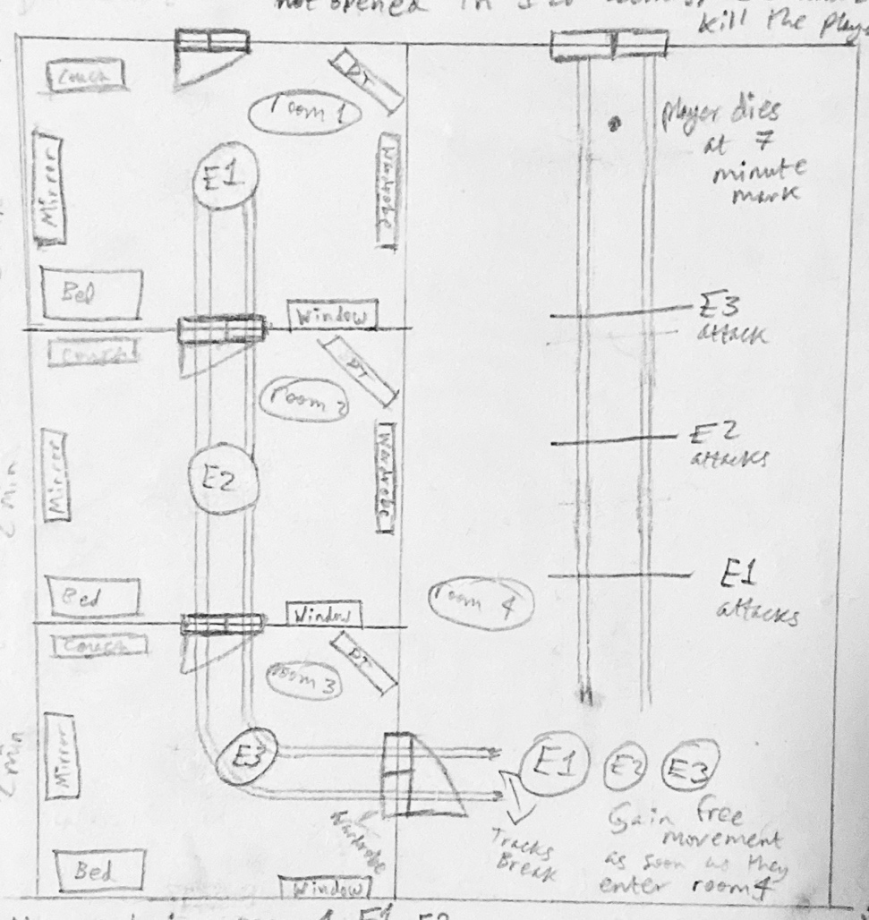
Figure 1; bird’s eye view of my initial concept for the game’s map
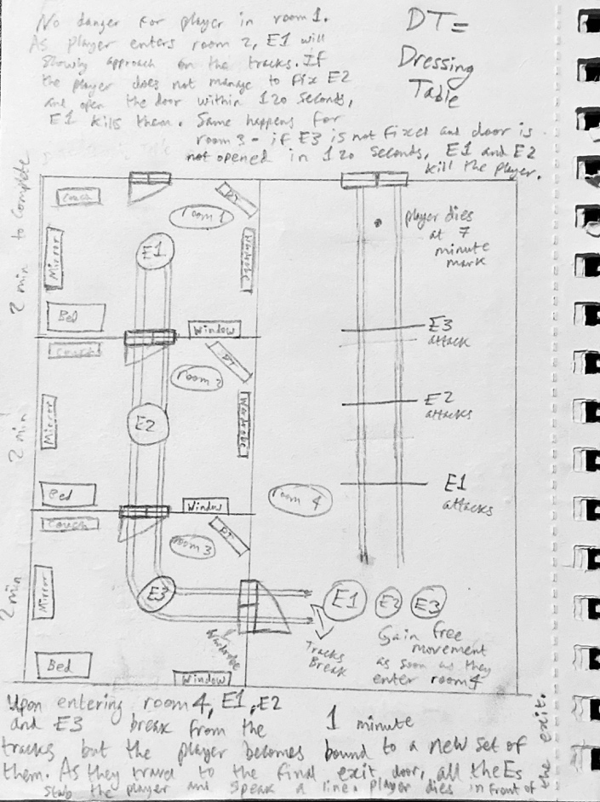
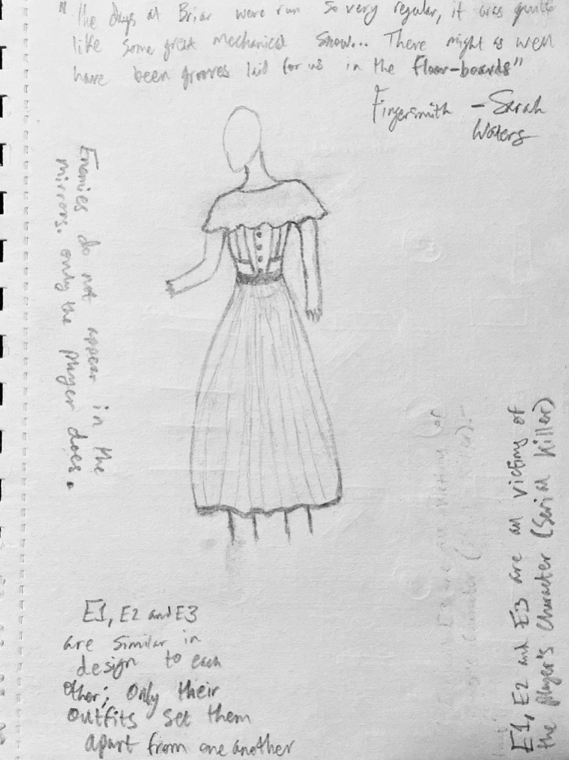
(Bottom Right)
Figure 4; bird’s eye view of the map including handwritten notes
(Bottom Left)
Figure 3; handwritten notes on my initial concept for the gameplay
(Left)
Figure 2; initial concept art for the enemies / clockwork dolls, including some notes
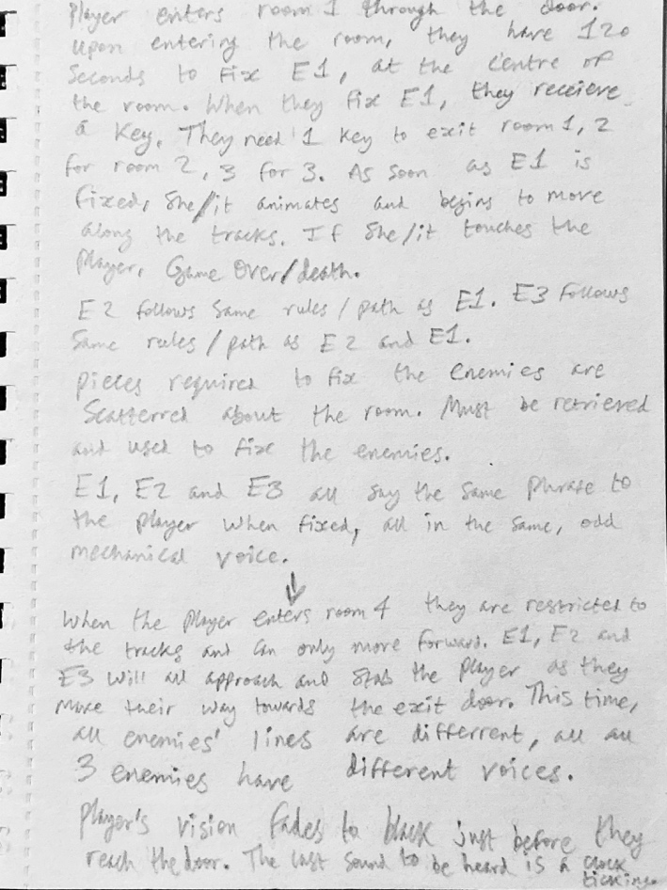
Introduction
The brief for the module was to create a game in the survival horror genre provided that we abide by certain restrictions, primarily that the gameplay last for 7 minutes, concluding with the death of the player’s character, and that said game have no more than one level.
The initial game idea was mine, as the other group members joined with me at later dates in the production process.
As at first I was working alone, I came up with the initial concept for the game; I created the initial concept art for the game’s enemies, a bird’s eye view of the level’s layout, as well as the game’s story and basic concept. However, as others joined the production process, I focused more on overseeing the project and working on the game’s story and creating a prototype for the game’s map, which Bethany then took and refined. I oversaw the process of creating the game’s assets / models and thus gained a better understanding of the fundamentals of 3D modelling and the primary software used, which was Blender.
Technical Research
Much of what I’ve learnt over the duration of this project has been from overseeing Bethany model assets for the game, and as such I’ve grown more familiar with Blender and now have a better grasp of the software. I have also been watching through and following tutorials by the YouTuber Blender Guru, primarily the Blender 2.8 Beginner Tutorial Series.
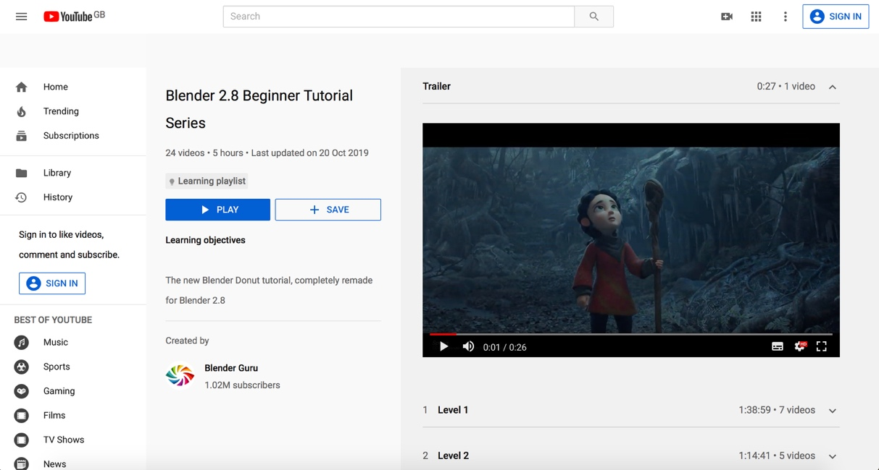
Figure 5; screenshot of Blender 2.8 Beginner Tutorial Series playlist on YouTube; YouTube
Game Research
The main game I drew inspiration from was Dead by Daylight and its primary mechanic, which requires the player to repair generators in order to power the exit gates to escape. However, the passive noise the generators make as the player repairs them (and, upon completing the repair process, the visual and audial noise alert the killer receives, informing them of the player’s location) alert the killer to where they are, thus making repairing the generators a dangerous task.
Using the premise (that the very thing you are required to repair is one of the things that can lead to your death), I came up with the idea of the main mechanic of the game: repairing the enemies, which will eventually activate and hunt / kill the player.
Other mechanics (searching for the required parts, unlocking doors, etc) are relatively common within the survival horror genre.
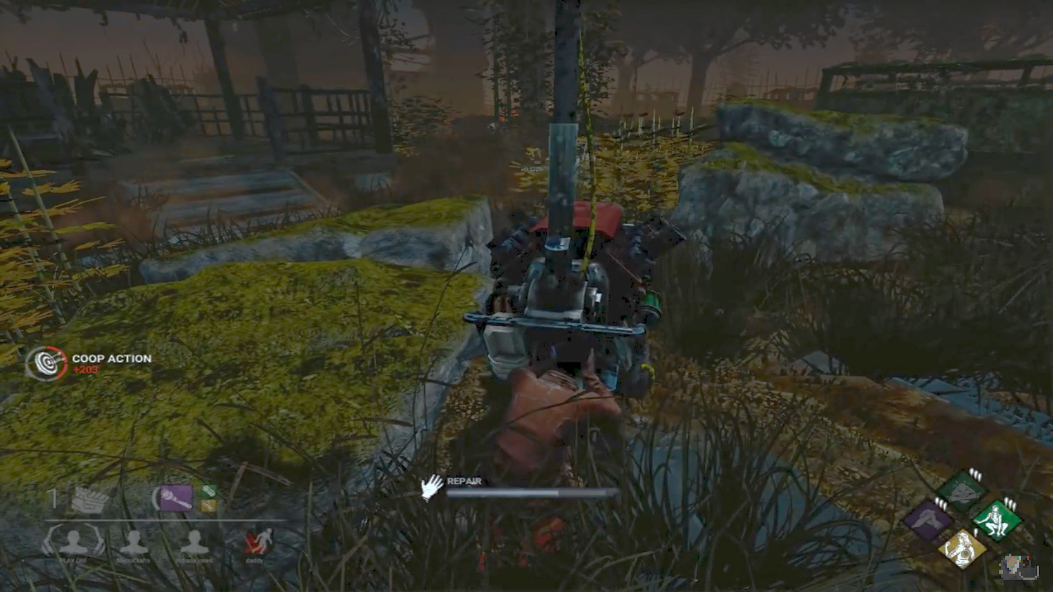
Figure 6; screenshot of Dead by Daylight gameplay footage; YouTube
The primary inspiration source for the game’s enemies was the Doctor Who episode, The Girl in the Fireplace, and the Clockwork Droids featured as the antagonists of that episode.
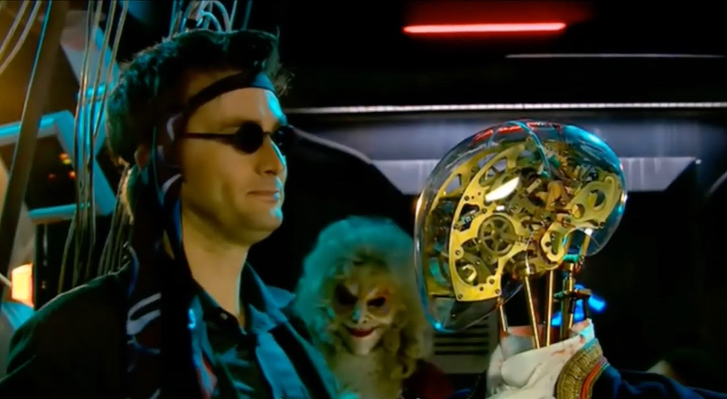
Figure 7; screenshot from Doctor Who, episode The Girl in the Fireplace; YouTube
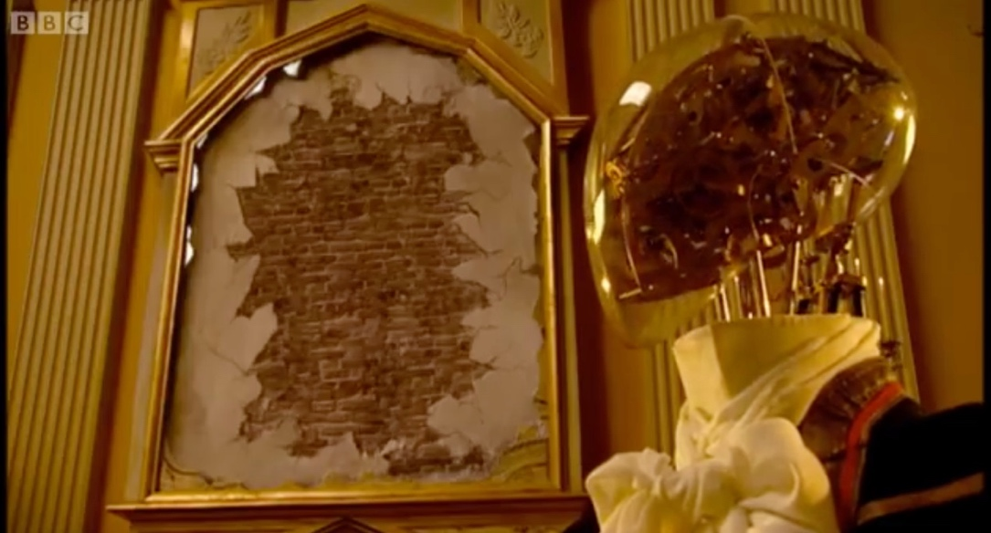
Figure 8; screenshot from Doctor Who, episode The Girl in the Fireplace; YouTube
Technique Evaluation & Identification & Suitability of Production Methods
As I had never used any of the software before, there was a steep learning curve, which meant for the most part, as there was a limited time-frame in which to complete the task, most of my time spent using the software was spent simply learning the basics. However, having used Maya for the majority of the time and struggling, I discovered a couple of weeks before the conclusion of the project that as a beginner I found Blender significantly easier to use. As a result, though I will try and learn how to use Maya for future projects, I will familiarise myself with 3D modelling using Blender first.
Development of Techniques & Skills
Aside from creating the basic outline of the map in the Unreal Engine and assisting with some modelling work in Blender, the bulk of what I learnt was from watching other members of my group, though I believe it has helped me familiarise myself with the software we used. I do believe I could have made better use of my time by experimenting with the software more, but regardless, I am more familiar with the software now and plan to dedicate much more time to learning how to use the software proficiently.
Iterative Design Practice
The initial concept of the game saw that the clockwork dolls would activate and begin to hunt the player immediately upon relinquishing the key, however this was changed relatively late into the design process after a group discussion and a suggestion by Jo (Joanna) that the dolls only activate when the player has repaired the third. We thought this would work better as it builds suspense more and makes the game less complicated and difficult (and thus a less frustrating experience) for the player.
Development Conclusion
Initially we were all working on separate projects, however with the time constraints we quickly realised it would be more time-effective to form a group. However, despite this, our time management skills were not as good as we would have hoped, primarily because of all the changes our groups underwent (going from a one-person team to two, then to four), which caused some disruption. As a result, we did not complete everything we would have liked to have done for the prototype. In future, I will attempt to better manage my time and plan ahead in order to ensure I waste no time on projects, especially those with tight deadlines.
References
Figure 5; screenshot of Blender 2.8 Beginner Tutorial Series playlist on YouTube; YouTube
Blender Guru. 2019. Blender 2.8 Beginner Tutorial Series (playlist)
Accessible at:
https://www.youtube.com/playlist?list=PLjEaoINr3zgEq0u2MzVgAaHEBt--xLB6U
Last accessed 8th December

Figure 6; screenshot of Dead by Daylight gameplay footage; YouTube
Ussylis. 2019. Trying Out "Any Means Necessary" - Dead By Daylight (Gameplay)Accessible at:
https://www.youtube.com/watch?v=fHfAtGtPfIU
Accessed 7th December, 2019

Figure 7; screenshot from Doctor Who, episode The Girl in the Fireplace; YouTube
Doctor Who. 2013. The Doctor Smashes Through The Time Window | The Girl In The Fireplace | Doctor Who
Accessible at:
https://www.youtube.com/watch?v=MSecHsvREd0
Accessed 7th December, 2019

Figure 8; screenshot from Doctor Who, episode The Girl in the Fireplace; YouTube
TheOncomingStorm. 2016. Doctor Who - The Girl in the Fireplace - A glass of wine
Accessible at:
https://www.youtube.com/watch?v=NfdAcVRLLdI
Accessed 7th December, 2019

