Name | Student Number | Date | Lecturer’s Name | Your score
Dennis Brown | 2026661 | 30/06/2025 | E R | To be filled by the marker  ___/40
You will have 90 minutes to complete this assessment. It is divided into three sections: note-taking, paraphrasing and writing a paragraph.
---------------------------------------------------------------------------------------------------------------------
1. Take diagrammatic notes from the passage below using the space provided:

The university experience is not just about subject knowledge, but also about developing skills that will equip you for your future life. For starters, it's impossible to graduate without a range of people skills under your belt. You'll meet new people from different backgrounds. You'll also interact with lecturers, tutors and university staff almost daily. Another life lesson that university teaches you is taking responsibility for yourself, your own schedule and learning. A lot of university study is self-directed - it's up to you to plan and organise your work, juggle multiple projects and manage deadlines – you will need to develop self-motivation if you want to succeed. Let’s not forget learning how to overcome obstacles; whether academic, work-related or personal, you'll face your fair share of hurdles as a student, but you will develop resourcefulness and resilience in the process. If you were a bit unorganised before you went to university, you won't be by the time you leave. To successfully navigate student life you'll need to handle a variety of study, work, social and personal commitments and the only way to do this is with organisation and time management. Finally, university provides plenty of opportunities to work on and boost your confidence: you'll work in groups, deliver presentations, complete assessments and maybe even become a class representative.
Adapted from: https://www.prospects.ac.uk/applying-for-university/university-life/7-life-skills-youll-learn-at-university

Space for your notes (max 12 marks):
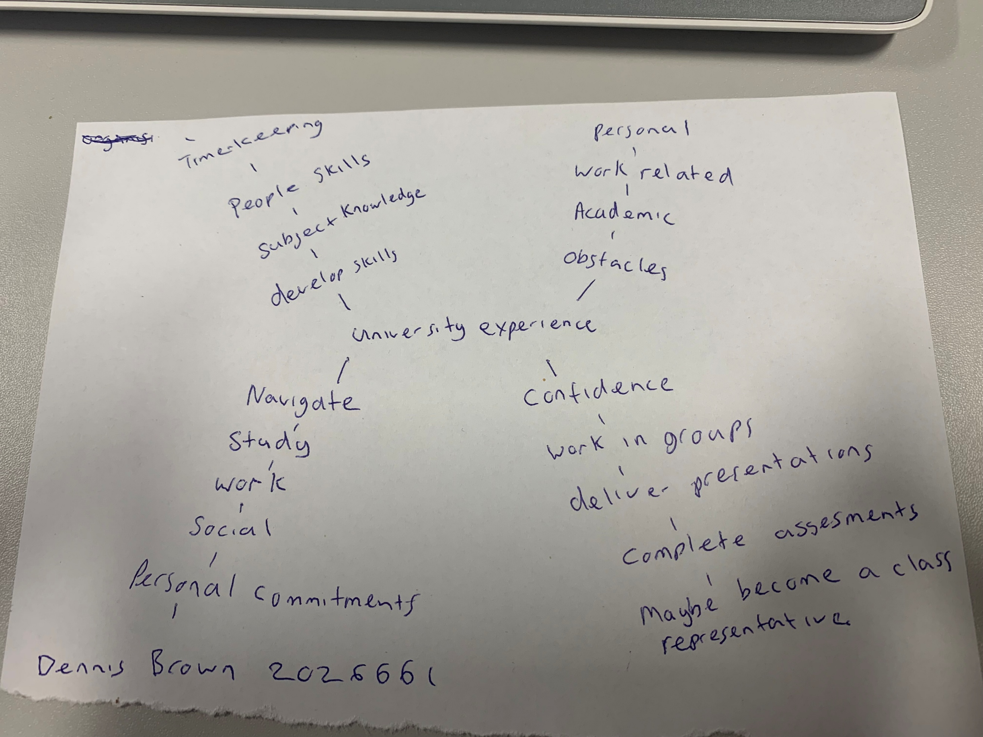

2. Paraphrase the following sentences (max 3 marks for each, max 12 marks in total):

a) To successfully navigate student life you will need to handle a variety commitments.
In order to be Successful in navigating student life you must be willing to adapt and make dedicate yourself to take on a variety of commitments.

b) You will need to develop self-motivation if you want to succeed at university. ___________
Self-motivation will be a key skill that would need to be developed to succeed at university

c) Many students find it challenging to manage stress during assessment periods. ___________________
It can be very challenging to manage stress at university especially during assessment periods.

d) Frequent reading can help you become a more effective communicator.

Reading as often as possible can really help you to become a much more effective communicator.

3. Write a well-structured paragraph (8 sentences) on the following topic:

Effective time management techniques for university students

Your paragraph must be written in full sentences (no bullet points) and in an academic style.

(max 16 marks in total)

During my time at university, I have gained some effective time management skills that will also help in the real world and not just at my time as a student. I have found that prioritising tasks into most to least important helps a lot and saves wasting valuable time. The process of planning how much time I can spend on tasks helps me to assure I can get everything I need done on time affectively. Managing time affectively can really help to reduce stress, save time and get everything done that is needed on time. It is important to always plan, if you plan your time for each task and prioritise, sometimes even remove tasks that are less important, this can really be useful in getting important tasks done first. It is also very important to take breaks in between tasks to avoid rushing or making silly mistakes. Poor time management can result in wasting time and not getting done what is needed .it is important to use your time effectively and the best way to do this is to always plan ahead .

