Agonistic and Antagonistic Drug Effects

Agonistic is defined as:

Antagonistic is defined as:

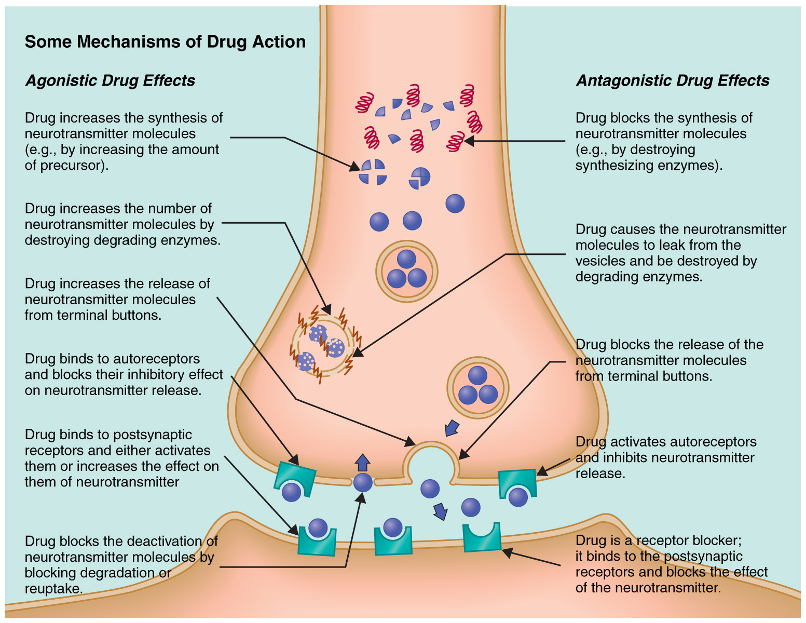

5.
6.
4.
3.
2.

