Student name: Patricia Menendez Hernandez
Student number: 2111630

Module name: Sustainable Hospitality & Tourism Management (BMIH5006)
Lecturer name: Kathryn Roberts

Future of Hospitality and Is it Profitable to be Green?

Table of Contents
Introduction 1
Global Hospitality Industry and Environmental Emissions 1
Theoretical Framework 2
Profitability and CSR 4
Financial Resilience and Environmental Sustainability Tourism 5
Is Green Profitable in the Tourism Industry? 6
Conclusion 6
References 8

Introduction
This report is based on the analysis of social responsibility in the hospitality industry. The report has highlighted whether it is profitable to be green or not. The report is based on the analysis of the argument of Milton Friedman, who stated that the social responsibility of an organisation is to increase profits. This report aims to determine if the argument is still relevant today. It also aims to cover whether Corporate Social Responsibility (CSR) is business or customer-driven.

Global Hospitality Industry and Environmental Emissions
Hospitality Industry enables consumers to participate in different leisure activities. In 2023, the hospitality industry reached 4.7 trillion U.S. dollars. It is expected that the industry will grow to 5.8 trillion U.S. dollars in 2027. The expected growth rate of the industry is CAGR of 5.5%. The leading businesses in the hospitality industry include Hilton, Marriott, and Holiday Inn. In 2021, the sales revenue of Hilton was 5.8 billion U.S. dollars. The Revenue per Available Room (REVPAR) is higher in Europe.
According to FoE (2023), the typical emission by one cruise ship is 421.43kg of CO2 each day. On the other side, the average emissions by an individual staying in a high-end hotel is 81.33 kg of CO2. The average carbon footprint of a vacationer is 51.88kg. This is one-eight times lesser than the average emission by cruisegoers. This shows that environmental emissions from the cruise are significant. The report by Friends of Earth has shown that environmental emissions by cruisegoers are higher than those by land-based vacationers. Hence, there is a need to take measures in order to reduce emissions from cruises (FoE, 2023). Cruises use heavy fuel oils and chemicals, which leak into the ocean. The emission of sulphur and heavy materials threatens marine life.
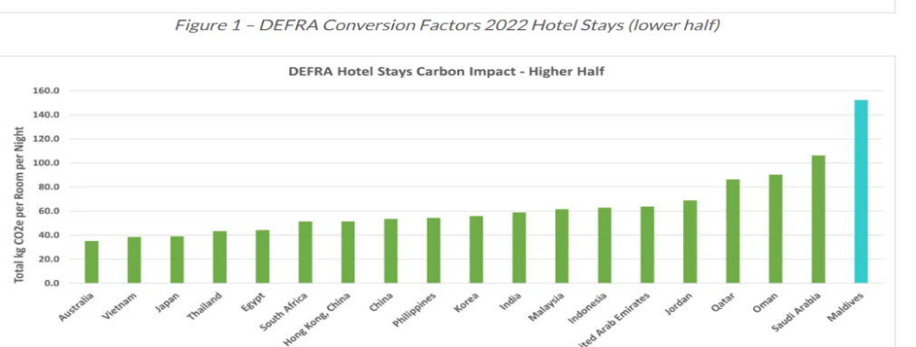
Figure 1: Carbon Impact from Hotel Stays in Different Countries (Circular Ecology, 2023).
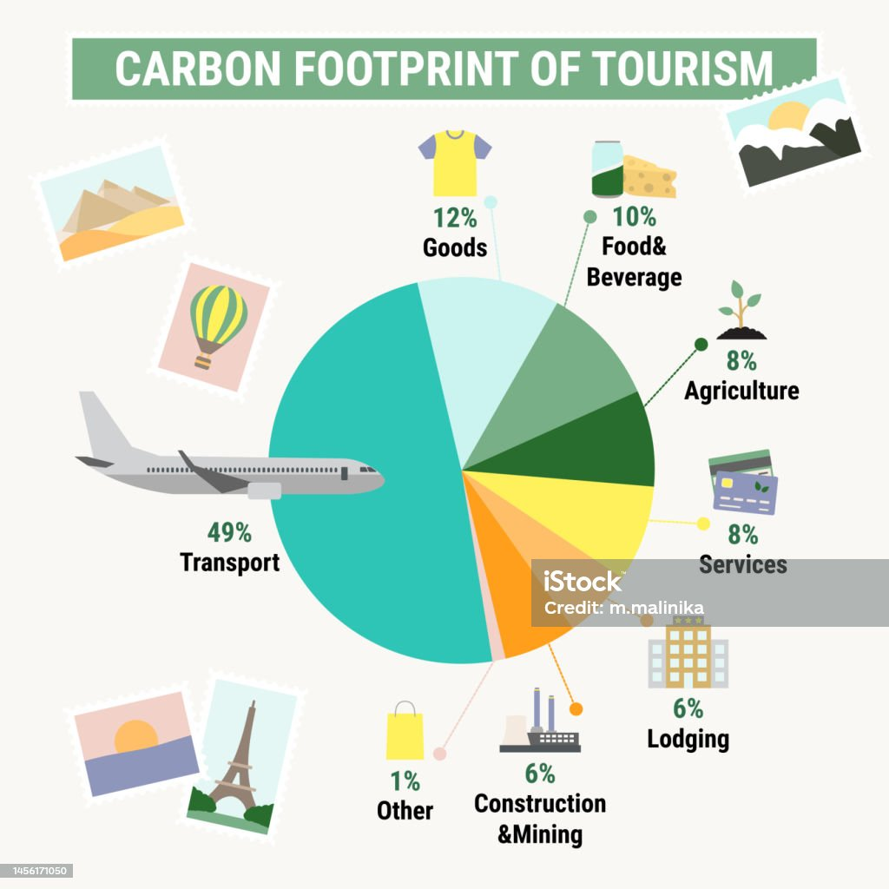
Carbon Footprint of Tourism (iStock, 2023).
The highest emission from the hospitality industry is from transportation, which accounts for 49% of emissions. After this, food & beverage and goods account for the highest emissions of greenhouse gases.

Theoretical Framework
The Triple Bottom Line model can be used to conceptualise environmental sustainability and corporate social responsibility in the tourism industry. According to this model, the three P's include Profit, People, and the Planet. These categories can be used in order to determine the negative impact on the environment. This model can be applied in order to explain tourism development and environmental sustainability. According to this model, organisations can develop sustainability strategies.
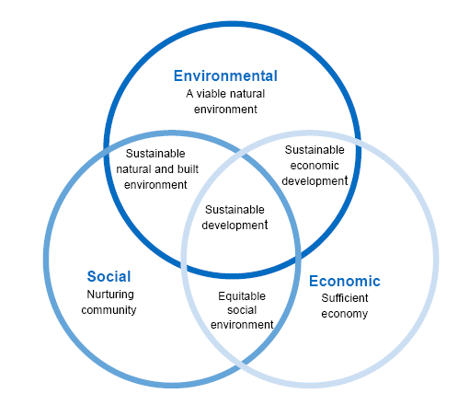
Triple Bottom Line
The focus on tourism activities is on income generation and economic growth. The incorporation of the Triple Bottom Line (TBL) into the development of goals and objectives in the tourism sector results in the development of long-term goals which reduce environmental emissions. The Global Tourism Industry has set a target of net zero by 2050. In order to achieve this goal, it is important for tourism organisations to make commitments towards reporting, measuring, and planning.
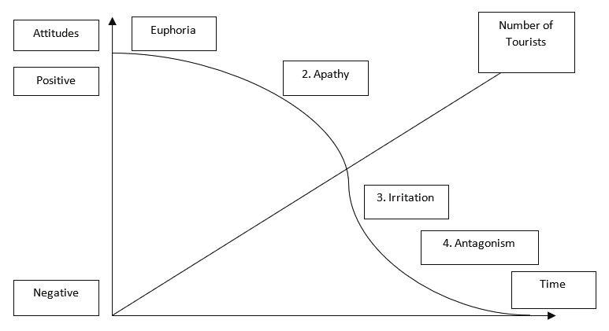
Doxey's Irridex Model (1975)
Another key model is Doxey's Irridex Model (1975), which has highlighted that the attitudes of people towards tourism involves a series of stages, including euphoria, apathy, irritation, and antagonism. The stages are based on perceived costs and expected benefits. The model has highlighted that the attitudes of residents become negative after reaching the threshold (Line, Hanks, & Miao, 2018). The attitudes of residents towards tourism change with the passage of time. When the expected benefits are higher than the cost, people develop a positive attitude. The higher environmental emission from the tourism industry has created a lack of balance in the exchange. The exchange of resources is low in the tourism industry. There has been an increase in environmental damage in terms of noise, air, and marine pollution. As a result of this, people have started to develop negative attitudes towards tourism.
Butler's Lifecycle Model is also relevant in terms of explaining environmental emissions in the tourism industry. According to Butler, tourist locations evolve through various stages, including exploration, involvement, development, consolidation, stagnation, and rejuvenation or decline. The model has highlighted the need for environmental sustainability in the tourism industry. Moreover, in order to make a tourist destination attractive, it is important to conserve resources. With the help of environmental sustainability and conservation of resources, it is possible to increase the length of time a tourist location remains a viable location. Moreover, the model has also highlighted the need for collaboration and integration in the tourism industry. There is a need to shield the local community from exploitation in order to ensure that a tourist destination remains attractive.

Profitability and CSR
One of the central arguments related to CSR in the tourism industry is related to profitability. There has been an increase in the number of tourism companies which are adopting environmental friendly and green strategies to promote sustainable travel and tourism. Although the tourism industry is an engine of economic growth, it is causing a threat to society and the environment (Marsiglio, 2015). Hence, in order to mitigate harmful impacts on the environment, there is a need to adopt corporate social responsibility strategies. In order to minimise harm to the environment and promote environmental sustainability, it is essential that the industry adopts practices that focus on improving the lives of employees, communities, and the overall environment. The use of these practices is positively associated with profitability because these strategies ensure that resources are utilised in a sustainable manner. In this way, companies avoid the waste of resources.
There are different studies which have highlighted a positive link between environmental sustainability initiatives and profitability. The role of CSR is critical in the profitability of the business in the short term because of a decline in cost. In 2011, a study by Inoue and Lee revealed that CSR and financial performance are related. The studies based on the financial aspect of CSR have revealed that the implementation of CSR causes an increase in the profit and sales of tourism companies. The strategic implementation of environmentally friendly strategies can cause a decline in cost. For instance, the switch to alternative modes of electricity generation and fuel reduce the overall cost. In this way, the overall cost of operations is reduced, and competitiveness is increased. Moreover, the investment in CSR results in an increase in customer satisfaction and retention. In this way, customers do not switch to the alternative.
The global economy has become interconnected. Organisations have started to recognise the need to improve the efficiency of supply chain operations. There is an increase in the need for environmentally friendly options. It is important for businesses to ensure that tourism businesses contribute positively to sustainability initiatives. The sustainable initiatives are in the form of efficient utilisation of resources. In this way, it is possible for businesses to reduce the cost of operations.

Financial Resilience and Environmental Sustainability Tourism
The COVID-19 pandemic had a significant impact on the tourism sector because of restrictions on the mobility of people. The countries and regions heavily dependent on tourism, such as the European Union and Latina America, were heavily affected. The negative impacts of the pandemic created the need for developing financial resilience in the industry (Bagheri et al., 2020). The challenges faced by the industry created the need for diverse and inclusive tourism development programs. In order to improve the resilience of the sector, there is a need to introduce structural reforms. At the same time, it is also important to ensure that the tourism sector is able to adapt according to the shock and disasters.

The sustainable development initiatives in the tourism industry can help in improving the profitability of the industry without compromising the ability of future generations to meet their needs. Currently, the tourism industry requires the harmonisation of inclusion, environmental protection, and economic growth. There are different initiatives which can be undertaken in order to achieve this goal, including curricular economy. Without financial resilience, it is not possible for tourism businesses to maintain their CSR.

The role of sustainable tourism is significant in terms of building the financial resilience of tourism companies. With the help of sustainable business solutions, it is possible to control costs and improve the efficiency of operations. In addition, environmental sustainability helps in attracting and retaining customers in the long run. Moreover, the lack of investment in sustainable business solutions can cause a decline in the competitiveness of tourism businesses (Dodds & Joppe, 2001).

Is Green Profitable in the Tourism Industry?
According to UNWTO, the investment in green and sustainable solutions causes an increase in profitability. With the help of green investment, the profit margin is increased because of savings in utility. The investment in sustainable solutions is also profitable because it increases revenue by satisfying customer needs. Green tourism is also profitable because, in the current environment, travellers have started to reconsider the way they travel. The travellers have become conscious of the environmental impact of their activities. According to the United Nations, the transition to a sustainable tourism model would increase the number of jobs by 10.5% by 2030.
According to the United Nations, Sustainable Development Goals can be achieved by 2030. It is possible to achieve Net Zero Target by 2050. The investment in sustainable technology can improve the profitability of travel and tours. The report by Research Analysis and Insights has revealed that the worth of sustainable tourism is US$242.54 billion. The growth rate of the industry is CAGR of 6.2%. By 2029, sustainable tourism is expected to reach US$369.54. The growth of the global economy has created the need for ensuring that supply chain operations are environmentally friendly and sustainable. In order to ensure this, it is important to formulate strategies which ensure that all aspects of supply chain operations contribute to sustainable development. The report by Mint has also revealed that there are 81% of travellers who have highlighted that sustainable tourism and travel are important for them. The customers are now aware of the climate change and its impact. Hence, they are motivated to make sustainable choices. Hence, it can be confirmed that investment in sustainable tourism is profitable and can improve the profitability of tourism businesses.

Conclusion
The report is based on the analysis of sustainable tourism and its financial implications. The environmental emissions from the tourism industry are significant. The analysis of emissions has revealed that cruise emissions contribute significantly towards environmental emissions. The emissions from cruise vacations are higher than those from land vacations. The statement of Friedman revealed that the responsibility of businesses is to increase profit. However, in the current era, the environmental and social responsibility of businesses has been increased. The TBL model has highlighted the need for focusing on the planet, profit, and people. The analysis of the financial implications of CSR has revealed that investment in green tourism is profitable. It is because of an increase in the demand of customers for sustainable business solutions. Hence, it can be agreed that the investment in CSR is customer-driven. The switch to environmentally friendly alternatives also causes cost savings and increases in efficiency. Hence, being environmentally friendly is profitable for tourism businesses. The report has also highlighted the need for financial resilience of tourism businesses. The COVID-19 pandemic has highlighted the need for resilience in order to deal with challenges. It is possible to build resilience through cost-efficiency and collaboration. The analysis of green tourism has revealed that it is profitable to be green because the lack of investment in green solutions results in the loss of customers.

References
Bagheri, M., Shojaei, P., Jahromi, S. A., & Kiani, M. (2020). Proposing a model for assessing green hotels based on ecological indicators. Tourism and Hospitality Research, 20(4), 406-422.
Circular Ecology (2023). The Carbon Emissions of Staying in a Hotel. [Accessed: 8.11.2023] From https://circularecology.com/news/the-carbon-emissions-of-staying-in-a-hotel
Dodds, R., & Joppe, M. (2001). Promoting urban green tourism: The development of the other map of Toronto. Journal of Vacation Marketing, 7(3), 261-267.
Doxey, G. (1975). A causation theory of visitor-resident irritants: methodology and research inferences in the impact of tourism. In: Sixth Annual Conference Proceedings of the Travel Research Association. San Diego, California, (September): 195.
Ferronato N, Mertenat, A, Zurbrügg, C, Torretta, V. (2023). Can tourism support resource circularity in small islands? On-field analysis and intervention proposals in Madagascar. Waste Management & Research, 0(0).
FoE (2023). Analysis: Vacationers Generate 8 Times More Carbon on a Cruise Ship than on Land. [Accessed: 11.8.2023] From https://foe.org/news/cruise-passengers-carbon/#:~:text=According%20to%20the%20analysis%2C%20one,kg%20of%20CO%C2%B2%20per%20day.
He, Y., He, P., Xu, F., & Shi, C. (Victor). (2019). Sustainable tourism modelling: Pricing decisions and evolutionarily stable strategies for competitive tour operators. Tourism Economics, 25(5), 779-799.
Hwang, L. (2017). Butler’s Tourism Area Life Cycle and Its Expansion to the Creative Economy. The SAGE International Encyclopaedia of Travel and Tourism. ed. Linda L. Lowry, SAGE Publications, Inc.
Inoue, Y., & Lee, S. (2011). Effects of different dimensions of corporate social responsibility on corporate financial performance in tourism-related industries. Tourism Management, 32(4), 790–804.
iStock (2023). Carbon Emission Tourism. [Accessed: 8.11.2023] From https://www.istockphoto.com/vector/carbon-footprint-of-tourism-sector-carbon-footprint-infographic-greenhouse-gas-gm1456171050-491285099
Kim, Y. J., Kim, W. G., Choi, H. M., & Phetvaroon, K. (2018). The effect of green human resource management on hotel employees' eco-friendly behaviour and environmental performance. International Journal of Hospitality Management, 76, 83–93.
Li, X., Wang, Y., Zhang, Y., & Cao, Y. (2019). Examining the role of corporate social responsibility in resident attitude formation: A missing link? Journal of Travel Research, 58(7), 1105–1122.
Line, N. D., Hanks, L., & Miao, L. (2018). Image Matters: Incentivizing Green Tourism Behaviour. Journal of Travel Research, 57(3), 296-309
Marsiglio, S. (2015). Economic Growth and Environment: Tourism as a Trigger for Green Growth. Tourism Economics, 21(1), 183-204.
Mint (2023). Sustainable-tourism-industry-set-for-profitable-growth-say-experts-at-dubai-session. [Accessed: 8.11.2023] From https://www.livemint.com/news/sustainable-tourism-industry-set-for-profitable-growth-say-experts-at-dubai-session-11684133773360.html
Moneva, J. M., Bonilla-Priego, M. J., & Ortas, E. (2020). Corporate social responsibility and organisational performance in the tourism sector. Journal of Sustainable Tourism, 28(6), 853–872
OECD (2022). OECD Tourism Trends and Policies 2022, [Accessed: 8.111.2023] From https://www.oecd-ilibrary.org/sites/efa87744-en/index.html?itemId=/content/component/efa87744-en
Somilar International (2023). Green Investments in Tourism: Unlocking Opportunities and Experiences for Sustainable Growth (World Tourism Day 2023). [Accessed: 8.11.2023] From https://www.solimarinternational.com/green-investments-in-tourism-unlocking-opportunities-and-experiences-for-sustainable-growth-world-tourism-day-2023/
Statista (2023). Market size of the hospitality industry worldwide in 2023, with a forecast for 2027. [Accessed: 8.11.2023] From https://www.statista.com/statistics/1247012/global-market-size-of-the-hospitality-industry/
UNWTO (2023). Transforming Tourism for Climate Action. [Accessed: 8.11.2023] From https://www.unwto.org/sustainable-development/climate-action#:~:text=It%20proposes%20a%20coordinated%20plan,around%20planning%2C%20measuring%20and%20reporting.
Wise, N. (2016). Outlining triple bottom line contexts in urban tourism regeneration, Cities, 53, pp. 30-34
Yfantidou, G., Spyridopoulou, E., Kouthouris, C., Balaska, P., Matarazzo, M., & Costa, G. (2017). The future of sustainable tourism development for the Greek enterprises that provide sport tourism. Tourism Economics, 23(5), 1155-1162

