

ACCA4026
CERTHE Computing Skills for the Workplace

Software Solutions for Business

Student Name:
Student ID:
Date:
Table of Contents
Introduction 2
Task 1: e-Commerce Website builders or software solutions 3
1.1 Shopify 3
1.2 Wix 4
Task 2. Mind-map of contemporary software applications 6
a. Mind mapping and explaining the benefits of using mind mapping in business operations 6
b. Create a mind map of contemporary software applications 6
Task 3. Office Applications 8
a. Four office software solutions for business operations 8
MS Word 8
MS PowerPoint 9
MS Excel 11
MS Access 12
b. Practical demonstration of Two Office Features 14
Mail Merge 14
If Statement 15
Task 4. Communication and Collaboration applications 16
a. One contemporary Communication and one Online Collaboration application/tool 16
MS Outlook 16
MS Teams 17
b. One feature of a freely available Communication (1) and one feature of a Collaboration (1) application 19
MS Outlook 19
Ms Teams 20
Conclusion 21
References 22

List of figures
Figure 1. Shopify 3
Figure 2. Shopify Dashboard 4
Figure 3. Wix 4
Figure 4. Wix Sites 5
Figure 5. Mind-map 7
Figure 6. Ms Word 8
Figure 7. Ms Word Home 9
Figure 8. Ms PowerPoint 10
Figure 9. PowerPoint 11
Figure 10. MS Excel 11
Figure 11. Excel Sheet 12
Figure 12. MS Access 13
Figure 13. Database 14
Figure 14. Mail Merge 15
Figure 15. Mail Details 15
Figure 16. IF Statement 15
Figure 17. Outlook 16
Figure 18. Outlook Mails 17
Figure 19. MS Teams 18
Figure 20. Selecting File Sharing 19
Figure 21. Mail Scheduling on Outlook 19
Figure 22. Creating Meeting Channel on Teams 20

Introduction
The efficiency, improved decision-making, and the facilitation of its operations in day-to-day operations are all aspects that modern businesses are turning to digital tools or software applications. With organisations changing in the technology-driven world, it has been critical to understand how various software solutions are useful in the organisation as regards productivity, communication, data management and online presence. This portfolio takes a different look at various modern software applications that are critical in work practices, such as e-commerce site constructors to office packages and coordination software. It evaluates the main specifics, advantages, and feasible applications of each of the tools backed by scientific knowledge and examples of houses of the chosen functions. Studying the example of Shopify, Wix, Microsoft Office applications and communication platforms, the portfolio underscores the role of software solutions in hastening the workflow and strengthening professional duties. This work gives a clear solution to the way technology can effectively support the present-day business operations through written analysis and real-life examples.

Task 1: e-Commerce Website builders or software solutions

1.1 Shopify
Shopify is a very popular e-commerce website construction tool that is developed to assist corporations of any scale to create, operate, and expand Web-based stores without much technical skills. Being a Software-as-a-Service (SaaS) service that is fully hosted, Shopify is an integrated platform where its users have access to creating their web pages, accepting payments, controlling stock, and studying their sales performance in a single location. The user-friendly interface of Shopify is one of its greatest advantages, as it allows practically anyone with no knowledge of coding to establish an online store in no time with the help of customisable themes and drag-and-drop design apps. Besides, Shopify also offers its own payment systems, such as Shopify Payments and third-party gateways, so businesses can receive payments anywhere in the world [1].
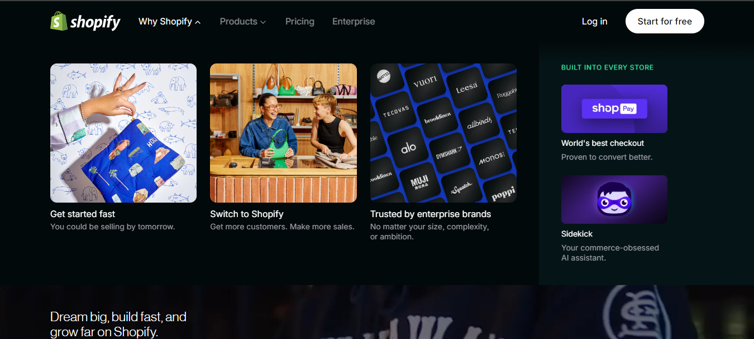
Figure 1. Shopify
The other major benefit of Shopify is its rich App Store, which provides thousands of plug-ins to enhance its features, such as marketing automation, customer reviews, social commerce, and inventory control. Shopify is able to be scaled due to this flexible ecosystem, which handles small start-ups and large companies alike. Inbuilt security, hosting and 24/7 support are also features in the platform, and these features minimise the burden of business operations of businesses. Shopify possesses some weaknesses, such as requiring an external payment gateway, which attracts additional costs and the fact that it requires paid apps to achieve higher levels of customisation. Irrespective of these constraints, Shopify is an influential option that can be used by companies interested in a profitable and efficient e-commerce model [2].
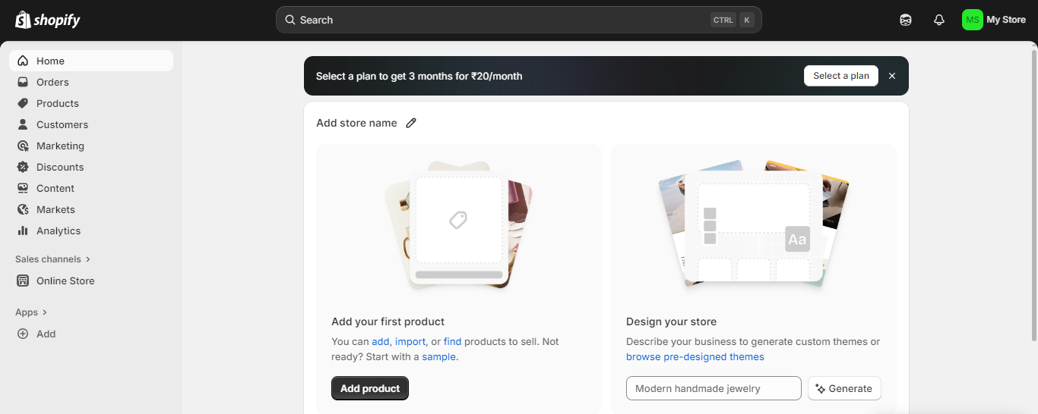
Figure 2. Shopify Dashboard

1.2 Wix
Another modern e-commerce site making tool is Wix, which has good adaptability, ease of use and good design features. In contrast to Shopify, which is also very much oriented on full-fledged online stores, Wix offers a malleable website-creating platform that is suitable for small ventures, freelancers, and entrepreneurs who would desire an appealing website with built-in e-commerce capabilities. Under a very user-friendly drag-and-drop editor, Wix provides the user with full visual opportunities to create an online store without the need to code anything. It offers hundreds of commercial-designed templates, tailored animations, and layout options that enable companies to develop graphical attractive storefronts.
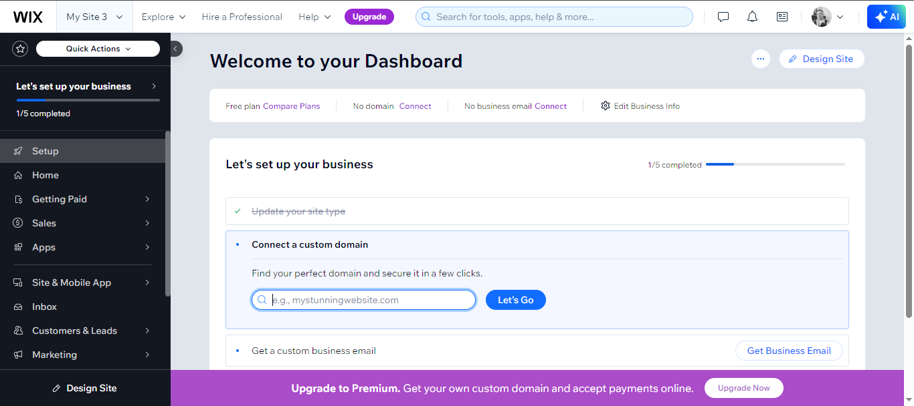
Figure 3. Wix
Other built-in e-commerce services that are available in Wix are product catalogue, secure checkout, lost cart recovery, offer creation, and inventory management. Also, Wix has numerous payment methods: credit cards, PayPal and local gateways. Its in-built marketing, like email campaigns, optimisation of search engines and social media interconnections, can assist companies to gain prominence and draw the customer base. One of Wix's strong points is its AI-powered Wix ADI (Artificial Design Intelligence) that can be used to create websites depending on the preferences of its users, which is why it is the best option for beginners.
The Pros and Cons related to Wix are limited, such as a smaller number of sophisticated e-commerce options than Shopify, less scalability with very large stores, and being restricted to changing templates after a site is launched. Wix is a great choice when companies of small to medium size are willing to pay less, have artistic freedom and are easy to use [3].
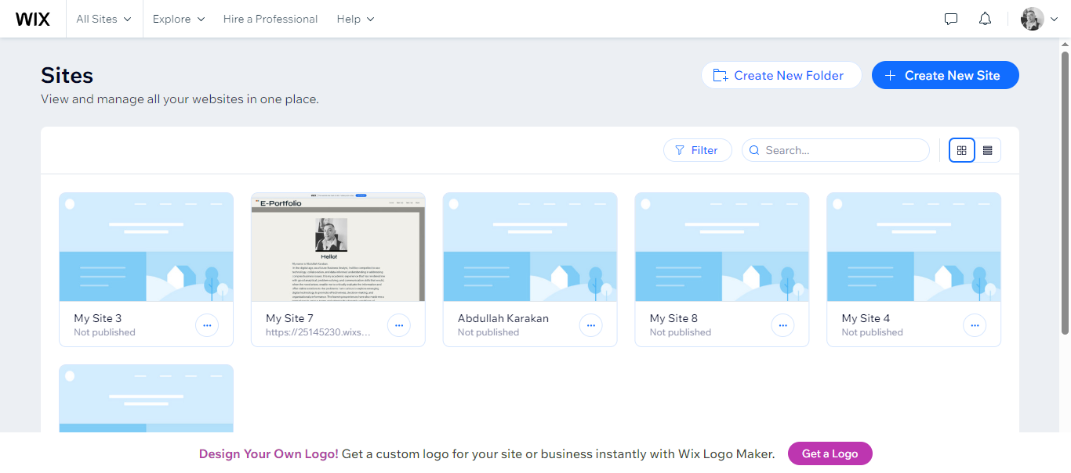
Figure 4. Wix Sites

Task 2. Mind-map of contemporary software applications

Mind mapping and explaining the benefits of using mind mapping in business operations
Mind mapping is a graphical method for arranging ideas, tasks and information around a main idea in the form of a branch and sub-branch. It assists personalities and groups of people to organise the information in an orderly manner, divide complicated issues and determine the connection among various factors. A mind map normally starts with a central theme, and then connected nodes comprise other categories, concepts and actions. Such visual depiction facilitates easier comprehension of information as well as its memorisation, contributing to the creativity of the idea and the logical organisation of plans. Mind mapping is significant in planning, problem-solving solving and decision-making in business activity. A clear advantage of it is enhanced clarity. Presenting ideas graphically allows business firms to make faster decisions on what is important to attend to, gaps in operations, as well as get a better insight into what is being undertaken. It is particularly helpful when one plans the project, works out the workflow, or draws customer routes in mind.
The collaboration is also improved by mind mapping. Visual diagrams are also used during team meetings, whereby employees are able to contribute to branches and sub-branches in real-time. This enhances the comprehensibility and minimises misunderstanding, especially during the implementation of new steps or ideal idea generation. Other important advantages are enhanced creativity. Mind maps are useful in encouraging free-flow thinking, as personnel can consider various ideas or ways of approaching their work without being limited by the linear process of taking notes. This can be deployed to develop a product, do a marketing campaign, and do some strategic planning and innovation tasks [4].
Report outlining reports, presentation planning, task management or documentation of business needs can be done using them. Mind mapping is also widely applicable in learning and training activities as it allows employees to learn complex software systems, the organisation's structure or business processes in a better manner.

Create a mind map of contemporary software applications
The mind map depicts the key types of modern-day software applications applicable in carrying out business. The theme of the Business Software Tools is in the centre, with the branches encompassing the e-commerce platforms, office applications, communication tools, collaboration tools, productivity software, and cloud storage services. E-commerce services like Shopify and Wix are easily used by businesses to create web pages and handle sales on the Internet. Applications in the office, such as Word, Excel, PowerPoint and Access, help in creating documents, analysing data, presentations and updating databases. Outlook can also be used to communicate effectively, and Microsoft Teams can be used to facilitate teamwork and work remotely. Trello and Notion are productivity tools that allow you to plan the work, whereas shops like OneDrive and Google Drive provide safe cloud storage of files [5].
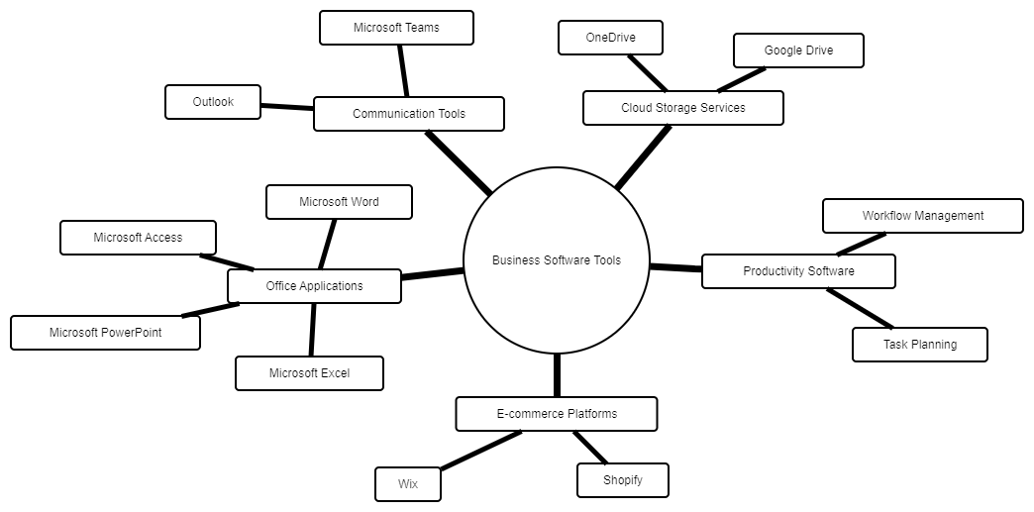
Figure 5. Mind-map

Task 3. Office Applications
The office applications are important in making sure that the business operations are well-ordered, efficient and smooth. They are applied every day to develop documents, analyse data, create presentations and store information, as well as facilitate effective communication in any organisation. Some of the popular office software tools in use are Microsoft Word, Microsoft PowerPoint, Microsoft Excel and Microsoft Access, each with a certain purpose in assisting administrative, analytical, operational and reporting functions. This part examines the key features, advantages, and restrictions of these four vital software solutions and how they will lead to increased productivity, an improved decision-making process, and more organised business operations [6].

Four office software solutions for business operations

MS Word
One of the word-processing programs, which has a high number of applications in the work and educational sphere, is Microsoft Word. Its main idea is to develop, revise, and design written documents, and it is one of the fundamental tools of running a business. Firms use Word to prepare reports, letters, proposals, meeting minutes, policy documents and most other types of written communication. A high level of formatting is one of the biggest characteristics of Microsoft Word. It is possible to use various fonts, colours, styles and paragraphs to enhance the look and readability of the documents. Word allows the use of tables, borders, page layouts, templates and graphical objects like images, shapes, and SmartArt. The functions allow companies to design high-quality, attractive business documents with a consistent corporate image [7].
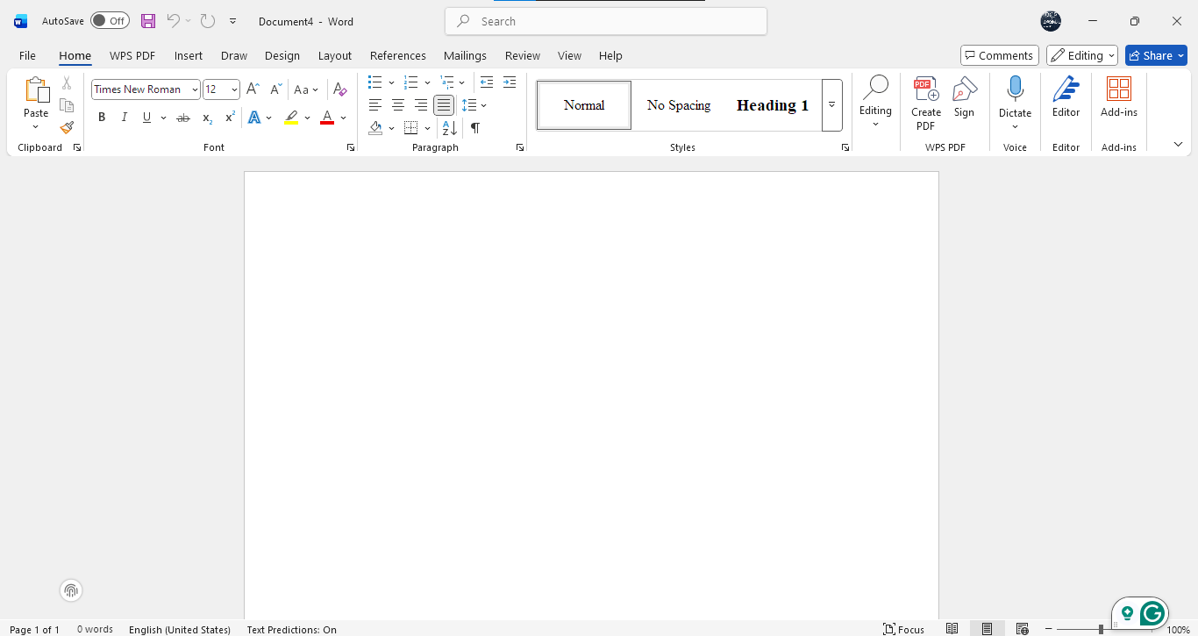
Figure 6. Ms Word
The use of templates is also another important feature. Word offers resume templates, invoice templates, business letter templates, report templates and brochure templates, which are effective as they save the user time and ensure uniformity. Templates really come in handy in large organisations where the documents need to be standardised in format. There are also spelling and grammar inspection devices in Microsoft Word. These roles enhance precision and professionalism through the detection of errors and propose corrections. The Editor tool has a clever language detector so that it offers suggestions on clarity, brevity and tone to make sure that documents are well written according to the standards of business writing [8].
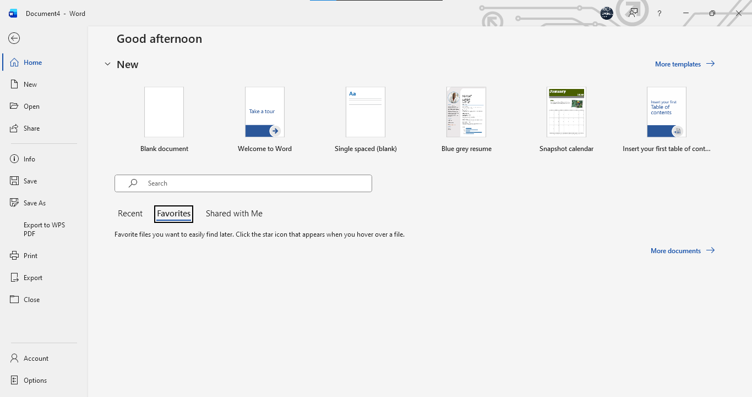
Figure 7. Ms Word Home
The other benefit is collaboration. As a part of Microsoft 365 integration, several users can collaborate on a document in real time through cloud computing, either by using OneDrive or SharePoint. Track changes, version history and comments enable teams to go through, edit, and approve documents with ease. There are limitations of the word Microsoft Word. The complicated texts that have numerous pictures or tables can be slow or erratic. Also, Word files may become problematic when exchanged with older versions or even other office programs. Microsoft Word can still be used in documentation, communications and administration in business despite these shortcomings.

MS PowerPoint
The main software that is employed in the presentation of the business is Microsoft PowerPoint. PowerPoint gives the means to present information visually and enough, whether it is at a conference, a meeting, training, or a market presentation. The major characteristic of PowerPoint is the use of slides. Users are able to make several slides with each slide having text, charts, images, videos, shapes and animation. This is a structure that enables the presentation of information in small, manageable parts and therefore making it easy to follow and comprehend by the audience [9].
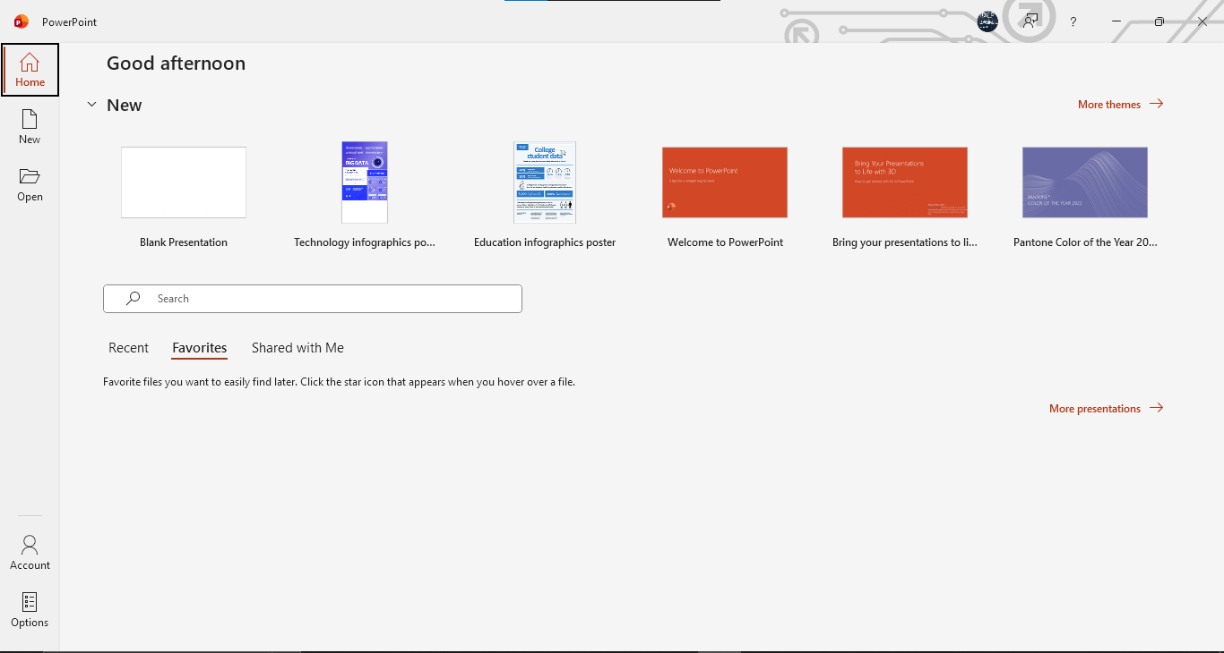
Figure 8. Ms PowerPoint
The themes and PowerPoint design options are very useful to the business. The software includes different settings of predefined themes that automatically form fonts, colours and layouts to generate consistent and professional presentations. The templates can also be customised according to the company users have to brand as it is a necessity in the workplace. There is multimedia also in PowerPoint. Animations, audio clips, videos, and screen records could be included in the slides to make it more interactive. Charts and graphics of SmartArt may assist in the description of processes, data and organisational structures through graphics.
Presenter View, slide notes, timers, and laser pointers represent presenter tools that would be extremely helpful when providing live presentations. The tools will assist presenters to talk in an assertive manner and to keep the audience interested. PowerPoint presentations can also be well shared in virtual meetings, with Microsoft Teams integration.
The next limitation of PowerPoint is that there can be an information overload. Users can overload their text or use too many animations and rendering the presentation useless. The next drawback is that PowerPoint is a visually based presenter; this means that presentations might not be well presented in case of a lack of design skills. Also, PowerPoint files with huge images or videos can easily get huge and hard to transfer. These difficulties do not undermine the importance of PowerPoint in business as the program is versatile for training, making decisions, promoting and communicating because of the features of the visual aids.
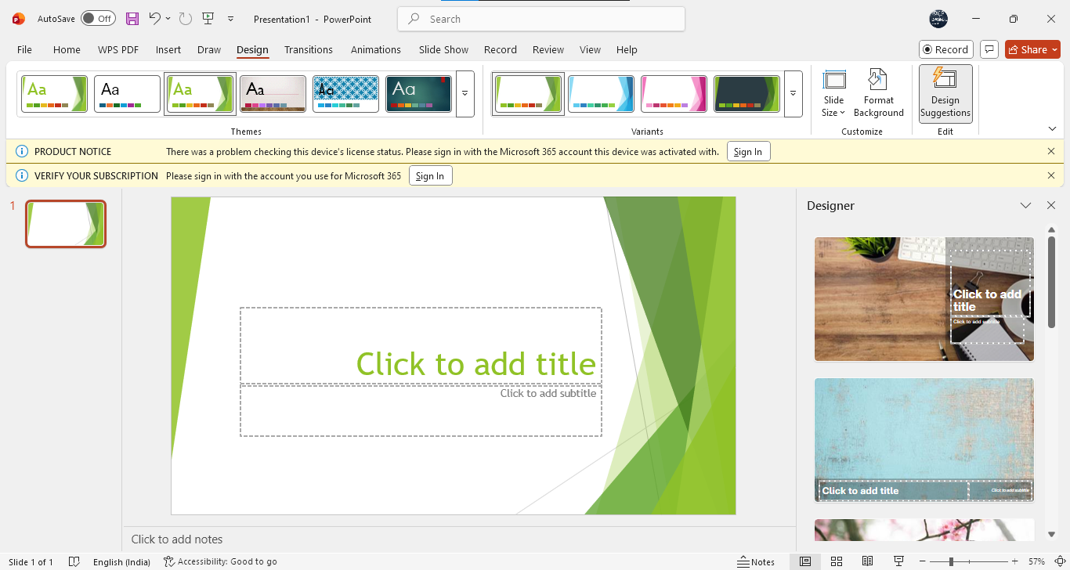
Figure 9. PowerPoint

MS Excel
Microsoft Excel is one of the strongest and most universal instruments of the data analysis multitude, calculation of finances, and organisation of information. All companies in every industry are relying on Excel in budgeting, forecasting, reporting, statistical analysis, inventory control, and tracking their performance. The spreadsheet is probably one of the most significant features of Excel, which has cells [10]. Users are able to add, tabulate and manipulate data in rows and columns. Excel accommodates text, numbers, dates and formulas, and graphs, among other structured information.
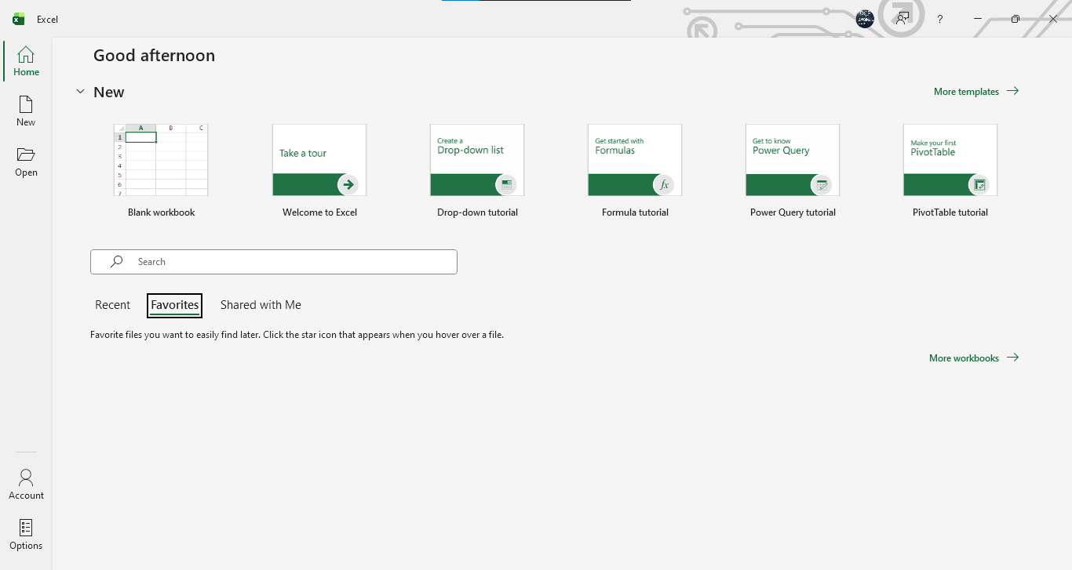
Figure 10. MS Excel
Excel is especially useful with the help of formulas and functions. Such examples are SUM, AVERAGE, COUNT, IF statements, VLOOKUP, INDEXmatch and hundreds more. These functions enable the businesses to automate calculations and minimise the chances of human error. Conditional analysis and data lookup procedures require such functions as IF and VLOOKUP. Excel has features that are used in data visualisation, including charts, graphs, pivot charts, and conditional formatting. The tools help users to find patterns, trends and insights briefly. One of the strongest features that Excel has is PivotTables. They present big data in a concise and understandable format, which is most suitable for business reporting.
Data validation, data goal seeks, data what-if and data solver are some additional tools that enrich the features of Excel in data analysis. These are tools that assist the companies to understand the situation, optimise results and make sound decisions. The fact that Excel can relate to other sources of data like databases, cloud platforms or CSV files is also an advantage. Excel can be used in accounting, human resources, finance, logistics, and sales as it can easily import and export data related to a business.
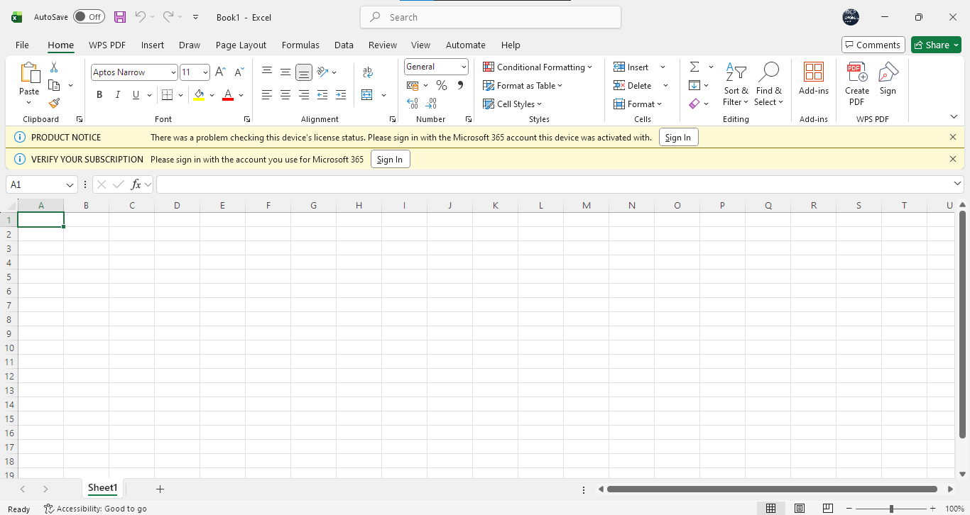
Figure 11. Excel Sheet
Excel also has limitations. Data sets of very large size can either slow down or lead to errors. Entering data by hand subjects it to error, and users who do not excel in Excel will not find complex functions simple to use. Also, Excel is not necessarily applicable in a multi-user environment where real-time editing features are necessary, whereas Microsoft 365 has enhanced collaboration features.

MS Access
Microsoft Access is a database management system that is utilised to store, arrange and manipulate huge amounts of structured data. Access can also be used to handle complex datasets, unlike Excel, which is aimed at spreadsheet and calculation functionality. The key characteristic of Access is that it allows the creation of a database table to store the information in a structured format. Fields and records are contained in each table, with more control and scaling, as was the case with a spreadsheet. It has access that enables relations among the tables so that users can be able to link data between various categories [11].
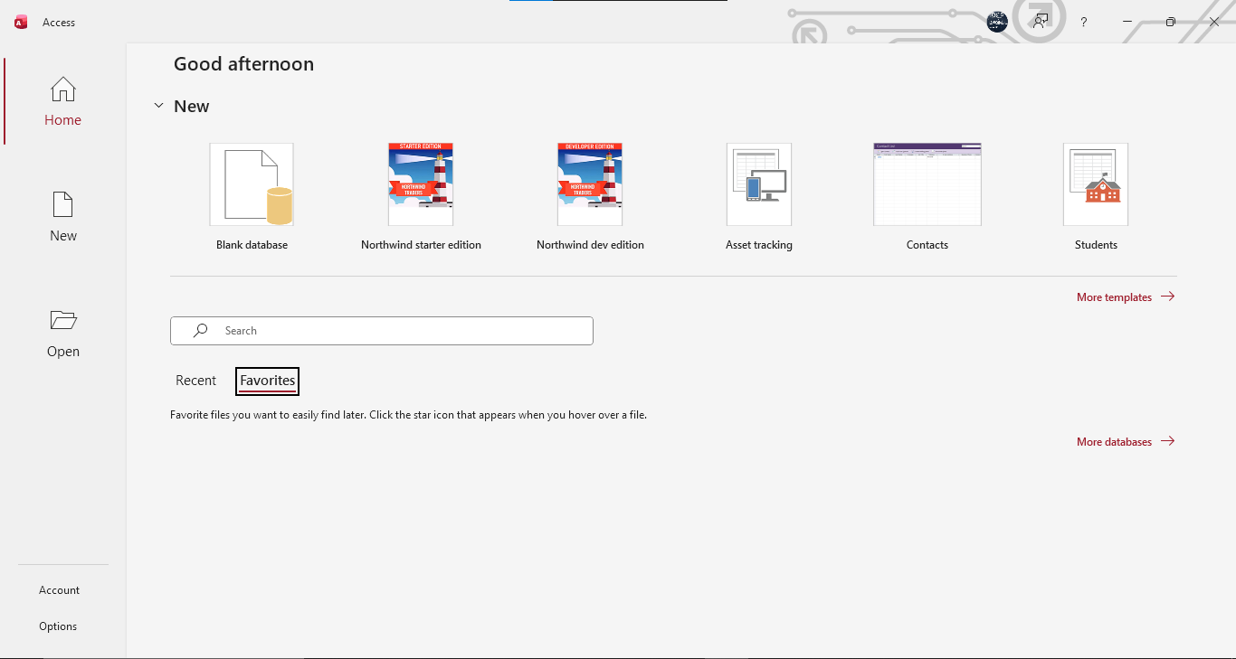
Figure 12. MS Access
Another significant characteristic is forms. Making forms that will be used to enter the data is something that can be done by the access user, optimising the fidelity of the process and making it more intuitive. It is also applicable, especially in organisations where customer information, sales information, and inventory information are keyed in by multiple employees. One of the strongest tools used in access is queries. They enable users to access certain information in large datasets based on criteria. As an illustration, a company can seek customers within a specific area, sales within a given time, or goods lower price than the current inventory. Access also tolerates reports that enable users to come up with formatted summaries of data. Such reports are either printable or can be stored in a computer and are significant in terms of performance monitoring and reporting for business. Among the advantages of Access is the fact that it is automatable using macros and integrates with SQL (Structured Query Language). This enables the development of a more sophisticated database system without requiring a lot of programming elements.
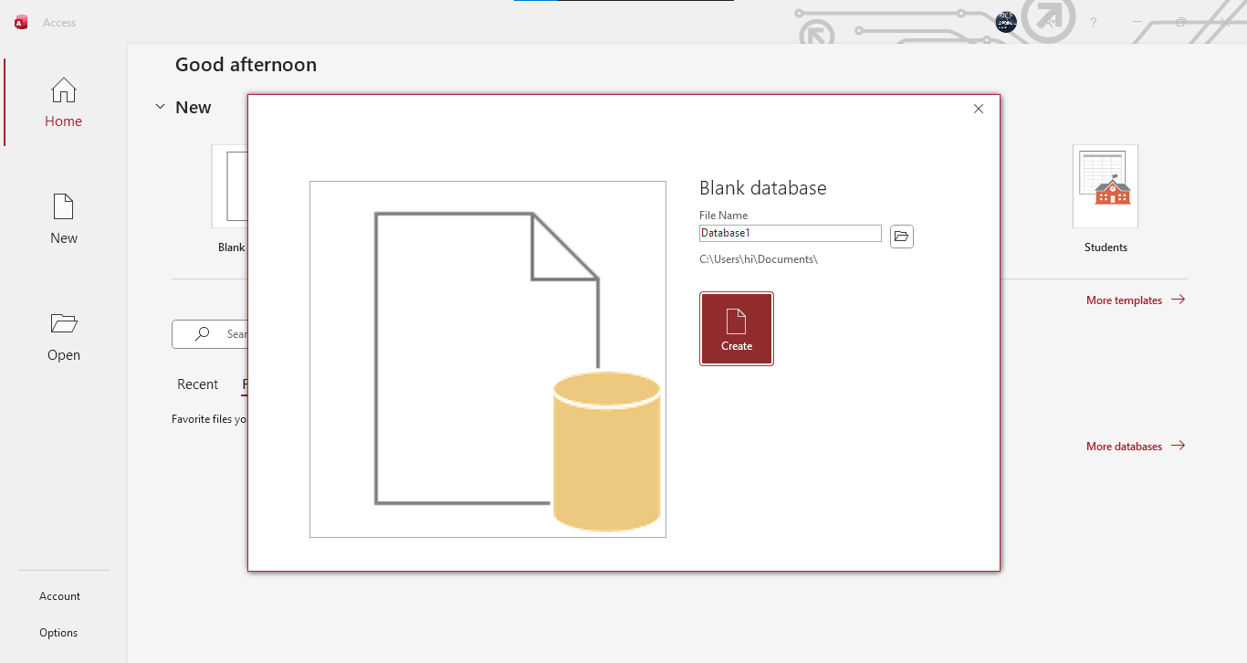
Figure 13. Database
There are weaknesses to Access. It is not as scalable as enterprise-level database systems such as SQL Server or Oracle, and it cannot be used with very large or highly complex databases. Access also suits well in small to medium-sized organisations compared to large corporations. Also, users need to be trained to design relational databases, which may become difficult for newcomers. Access is good to handle structured information where the company is needless of investing in a highly developed system since the company needs to have a customised database solution.

Practical demonstration of Two Office Features

Mail Merge
Mail Merge is a feature of Microsoft Word, which enables one to send personalised messages to many recipients simultaneously. It is very popular in businesses to mail marketing messages, event advertising, newsletters, announcements, and to communicate with customers. Rather than manually typing the individual email, Mail Merge automatically puts the personalised content in terms of the name, email address, company name or reference number. This saves time, minimises errors and ensures uniformity of communication among the recipients.
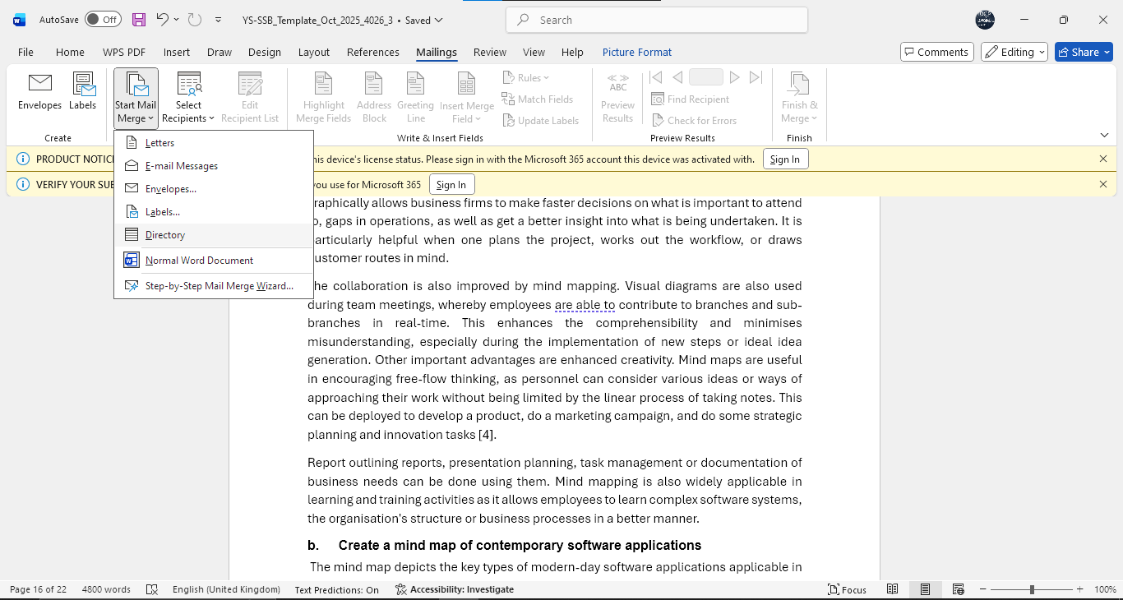
Figure 14. Mail Merge
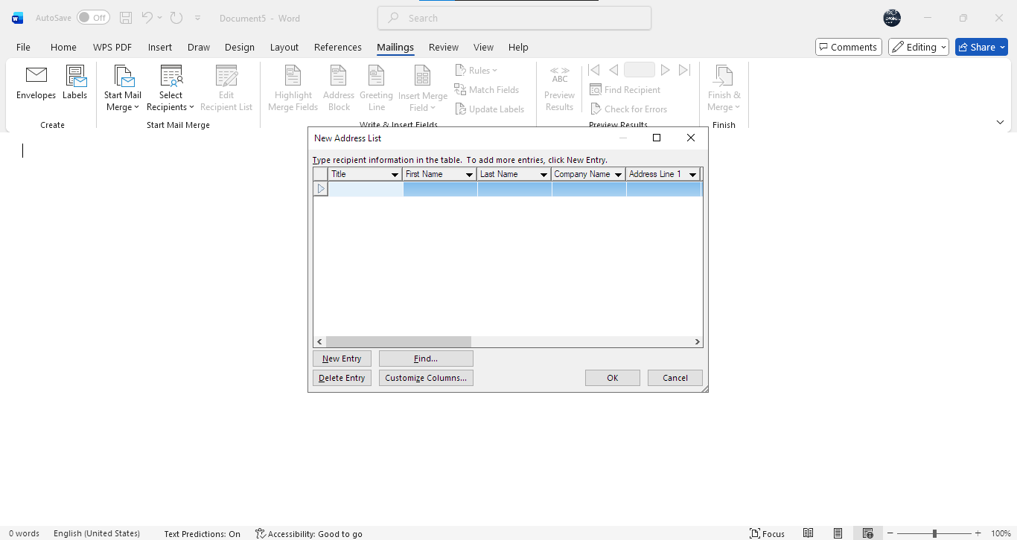
Figure 15. Mail Details

If Statement
The IF function in Microsoft Excel is a logical function that is used to make comparisons and give out varied results if a condition is true or false. Some of the tasks that the IF function is used a lot by businesses involve performance assessment, making decisions on finances, sales and inventory checks.
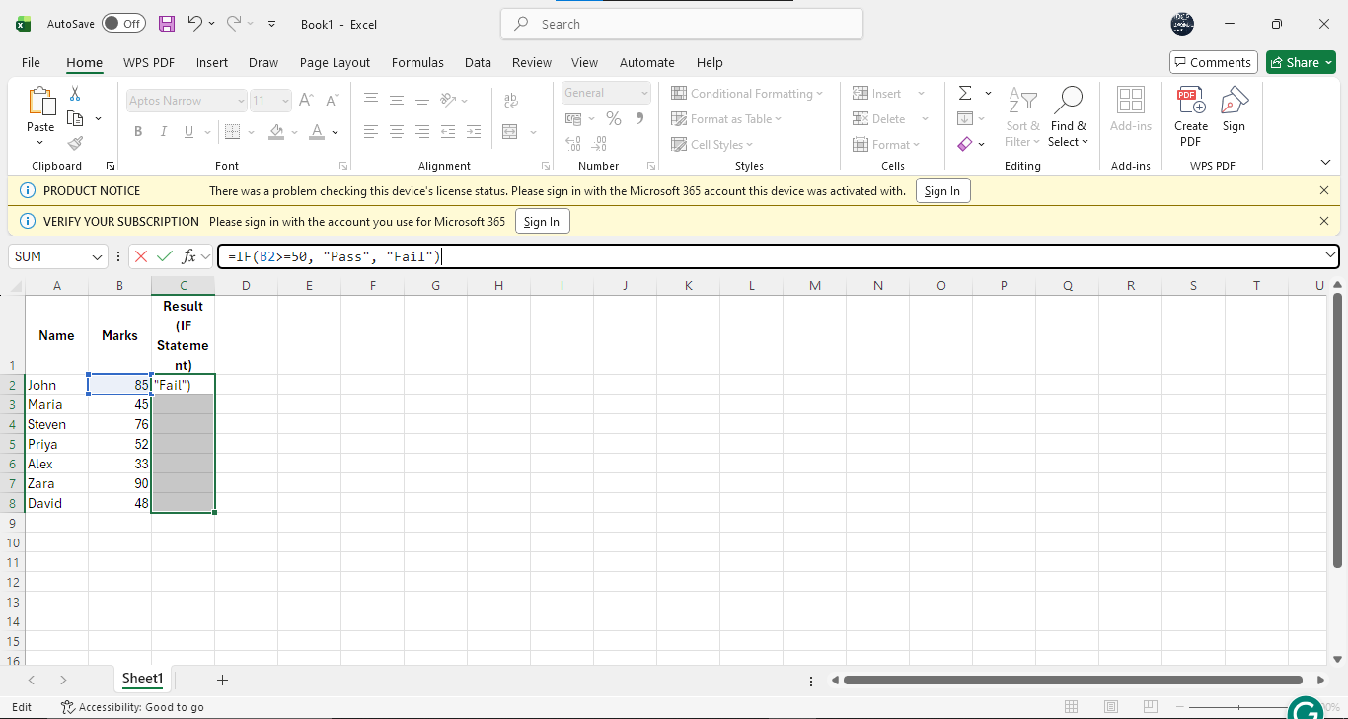
Figure 16. IF Statement

Task 4. Communication and Collaboration applications
Digital tools are also essential because underpinned by modern organisations to facilitate communication, coordinating teamwork and workflow. Communication and collaboration applications have become crucial as workplace environments become more hybrid and decentralised, so that information can be communicated efficiently and employees can keep in touch. Microsoft Outlook, a communication application, and Microsoft Teams, which is a collaboration tool, are two of the most common applications in businesses. The two tools aid the day-to-day working, improve the workflow and organisational productivity. This section gives a detailed analysis of their major features, advantages and drawbacks.

One contemporary Communication and one Online Collaboration application/tool

MS Outlook
Microsoft Outlook is among the most widely used communication tools in workplaces. It is mainly used as an email client but also features a calendar, task manager, contact directory, a scheduling assistant and notes. These combined features make Outlook an all exchange communication and organisational tool for businesses. Outlook has a great email management system as one of its key assets. Outlook enables users to send emails, receive, and also store emails in folders, categories, rules and flags. This assists in processing huge amounts of emails used by employees. Stringent rules may also be developed that automatically determine what messages to sort out and what not; this saves more information and time, which would be spent sorting out messages. Search is also a facility that allows users to find their previous emails, attachments or contacts fast [12].
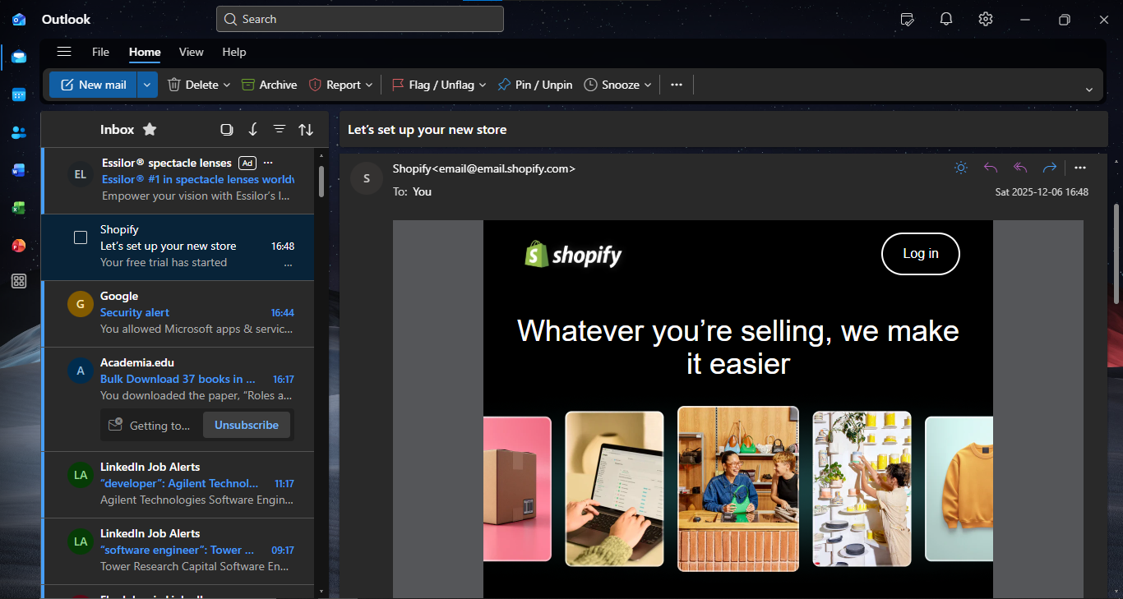
Figure 17. Outlook
The next important feature is a calendar feature. The calendar of Outlook will enable the user to set meetings, reminders, recurrence and availability of events. The Scheduling Assistant indicates the availability of the colleagues (free or busy), and it can be said that it is much easier to contact them and make an appointment than to send a long chain of emails. With busy schedules of organisations, this enhances planning and time-saving. Microsoft 365 is also integrated with Outlook, and people can use their emails and calendars using any device. This cloud-based connectivity will enhance flexibility since the staff will be able to work remotely and keep up with the situation. The Teams connection allows one to participate in virtual meetings directly through calendar appointments. Contact management facility enables a business to archive personalities of clients and suppliers in addition to their associates. This facilitates real-time interaction, and the information on contacts is also always available.
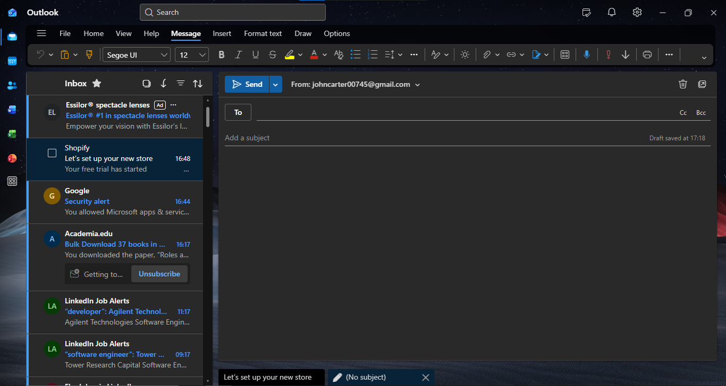
Figure 18. Outlook Mails
Although this is so, there are limitations to Outlook. It is not user-friendly because it has numerous features that are not easily comprehended by new users. In the case of big inboxes, the performance can decrease unless the old emails are deleted and archived. Dealing with several email accounts may be perplexing to users who do not know how to use them. Dependence on a constant internet is also a big problem, to which the existence of an offline mode is irrelevant, since several features are only found online [13].
In summary, Microsoft Outlook is an important communication tool for business establishments. Its capacity in combining email, scheduling and contacts into a single system enhances productivity, besides facilitating fluency within the departments. It facilitates external and internal communication and is a necessity in contemporary workplaces.

MS Teams
Microsoft Teams refers to a popular collaboration tool, which is aimed at facilitating teamwork, remote communication and project coordination. It incorporates video meetings, file sharing, and chat in a single platform that makes it a hub of collaboration at the workplace. Real-time chat is one of the fundamental capabilities of Teams since it enables employees to instantly engage in communication. There is the ability to form an individual chat, a group chat or a team channel. The channels may be arranged according to the department, project, or topic, enabling the teams to maintain the discussions focused and organised. This saves time on long e-mail discussions that are time-consuming and enhances the speed of communication [14].
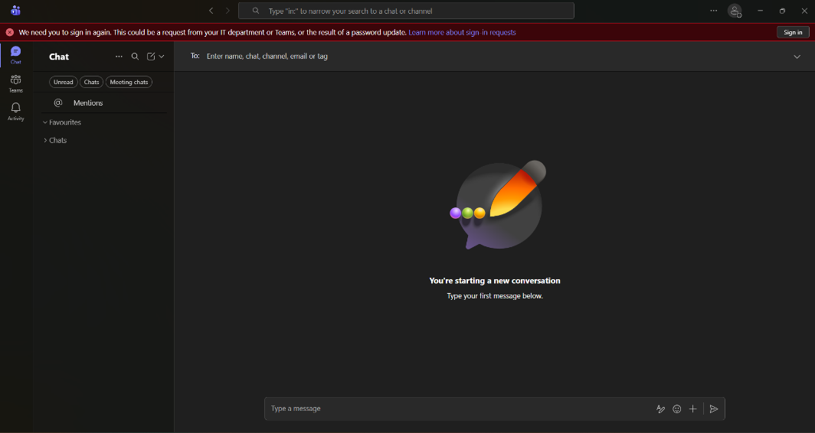
Figure 19. MS Teams
Teams also facilitates video conferences and audio calls, which are important in both hybrid and remote working environments. Screen sharing, breakout rooms, recording, background effects, live captions and presentation mode can be utilised in meetings. The tools render virtual communication interesting and effective so that the teams can communicate with each other irrespective of geographical location. File sharing and cloud storage happen to be another feature. Team is a direct integration of SharePoint and OneDrive and enables the user to co-edit and share documents in real time. Documents like Word, Excel sheets and PowerPoint presentations could be opened and edited in Teams without the need to switch between them. This increases the efficiency of the workflow and minimises version-control problems.
There is also app and tool integration on the platform (Planner, Forms, Excel, Asana and third-party apps like Trello or Zoom are all supported). This enables organisations to tailor their Teams environment to suit their requirements to aid project management, reporting and communication activities. Team strengthens the productivity with functions such as notifications, assigning tasks and tags, as well as activity feeds, which keep the employees informed of what happens at the workplace. In the case of training and onboarding, Teams has hosted features like recording of meetings and location libraries of shared resources. Teams does have limitations, though. The application can be resource-consuming to the system and lead to performance problems on older computers. The interface is overwhelming, and sometimes new users get confused by the numerous features of the interface. Alerts aimed at managing computer distraction would become overwhelming without proper control. Also, Teams is strongly dependent on the internet connectivity, and a weak network connection may impact the call quality and access to files [15].
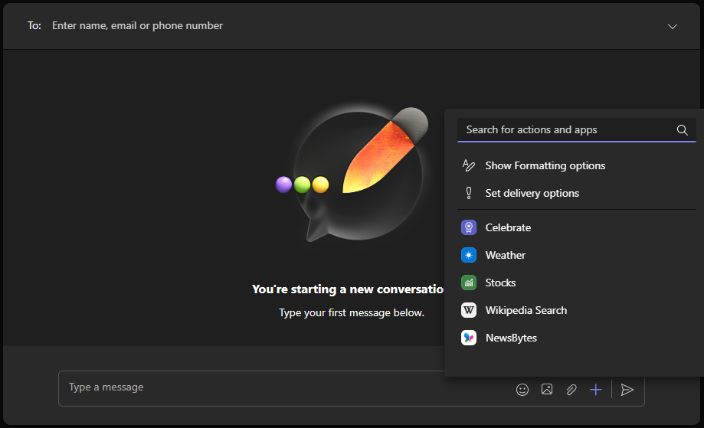
Figure 20. Selecting File Sharing
Microsoft Teams still happens to be one of the most efficient collaboration tools utilised worldwide despite these circumstances. It is also important in the modern-day operation of a business through its capability to integrate communication, file sharing, task coordination and virtual meetings in one platform. The teams improve organisational cooperation, sustain distant working patterns, and encourage a high degree of productivity.

One feature of a freely available Communication (1) and one feature of a Collaboration (1) application

MS Outlook
Activity Demonstrated: Creation and Scheduling of an email.
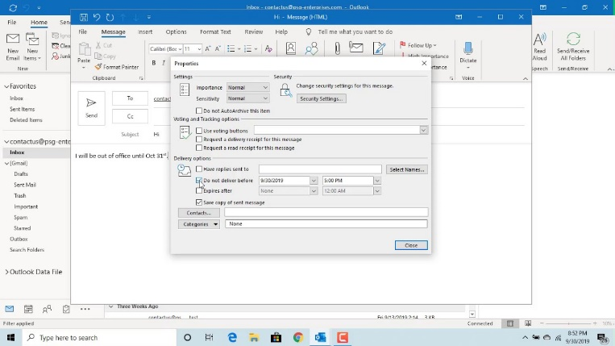
Figure 21. Mail Scheduling on Outlook
Scheduling an email is a significant part of Microsoft Outlook communication, enabling an individual to send messages in the future and at a given date and time. The tool has the greatest utility in business activities, particularly the communication with clients located in varying time zones, planning announcements beforehand or ensuring that messages are delivered at the best time. The timing of emails allows the workers to control the workload better and also lets the communication be timely, arranged and formal.

Ms Teams
Activity Demonstrated: Creating a Meeting Channel on Teams
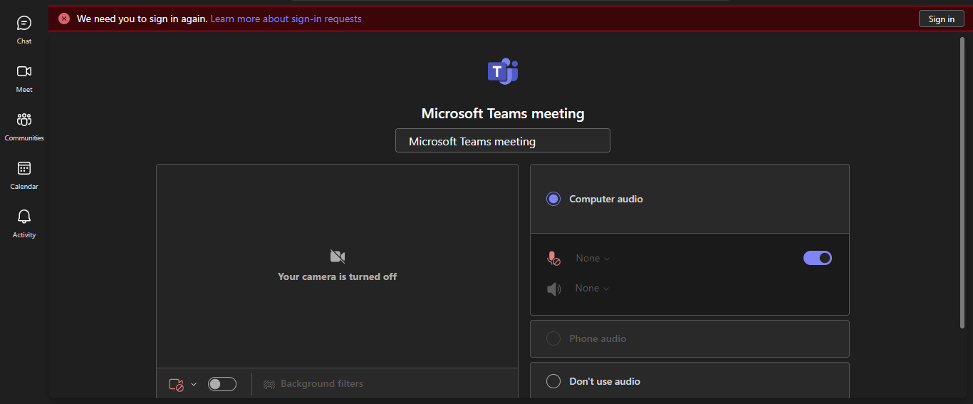
Figure 22. Creating Meeting Channel on Teams
Microsoft Teams has channels that enable the organisation of a space where members can cooperate, share files and discuss certain projects or subjects. This is a feature that facilitates teamwork, ensuring the conversations and other documents are in one place, increasing transparency and efficiency in workflow.

Conclusion
This portfolio has shown that a modern software solution is a critical component in facilitating modern business operations. The application of tools like Shopify, Wix is aimed at allowing organisations to create a decent online presence, and the mind mapping aids in the organisation of ideas, as well as better decision-making. Documentation, data analysis, presentations and database management are some of the things that were identified by analysis of office applications such as Microsoft Word, Excel, PowerPoint and Access. Hands-on examples on functionalities like the Mail Merge, IF function, e-mail scheduling and creation of collaboration channels were also used to further demonstrate the effectiveness and accuracy of the tools in day-to-day activities. Communication and collaboration tools such as Microsoft Outlook and Microsoft Teams are still undergoing changes that have reshaped the interaction in the workplace in terms of providing smooth connectivity, organised teamwork work and productivity. In general, the application of these software solutions helps to enhance the management of working processes, improve interaction and provides organisations with the digital resources to work in a successful environment of the modern world of technologies.

References
[1] M. Rukki, Design and Implementation of a Shopify Online Store, 2025. https://www.theseus.fi/bitstream/handle/10024/895718/Rukki_Maarika.pdf.pdf?sequence=2
[2] S. Bang, Top E-Commerce CMS Platforms (Shopify/WordPress/BigCommerce), 2023. https://www.theseus.fi/bitstream/handle/10024/797028/Bang_Seunghun.pdf?sequence=2
[3] L. Sandbrook, Digitalization – How to Design a WIX Website, a Modern-Effective Platform with SEO and Keyword Consideration, 2024. https://www.theseus.fi/bitstream/handle/10024/860979/Sandbrook_Lewis.pdf?sequence=4
[4] T. Buzan, Mind Map Mastery: The Complete Guide to Learning and Using the Most Powerful Thinking Tool in the Universe. Jaico Publishing House, 2024. https://books.google.com/books?hl=en&lr=&id=5VUWEQAAQBAJ
[5] R. Sari, S. Sumarmi, I. Astina, D. Utomo, and R. Ridhwan, “Increasing students’ critical thinking skills and learning motivation using inquiry mind map,” Int. J. Emerg. Technol. Learn. (iJET), vol. 16, no. 3, pp. 4–19, 2021. https://www.learntechlib.org/p/219033/article_219033.pdf
[6] J. Jamiludin, D. Darnawati, S. Linta, A. Muhammad, and W. Uke, “Microsoft Office 365 on learning history subject,” J. Educ., Teaching Learn., vol. 6, no. 2, pp. 181–185, 2021. https://www.learntechlib.org/d/219942/
[7] O. Kruse and C. Rapp, “Word processing software: The rise of MS Word,” in Digital Writing Technologies in Higher Education: Theory, Research, and Practice. Cham: Springer, 2023, pp. 15–32. https://link.springer.com/content/pdf/10.1007/978-3-031-36033-6_2.pdf
[8] C. Rapp, T. Heilmann, and O. Kruse, “Beyond MS Word: Alternatives and developments,” in Digital Writing Technologies in Higher Education: Theory, Research, and Practice. Cham: Springer, 2023, pp. 33–47. https://link.springer.com/content/pdf/10.1007/978-3-031-36033-6_3.pdf
[9] E. Sulasmi, “Primary school teachers’ digital literacy: An analysis on teachers’ skills in using technological devices,” J. Innov. Educ. Cultural Res., vol. 3, no. 2, pp. 140–145, 2022. https://www.jiecr.org/index.php/jiecr/article/viewFile/81/38
[10] D. Narayana, S. Ranjan, and N. Tyagi, Basic Computational Techniques for Data Analysis: An Exploration in MS Excel. Routledge India, 2023. [Online]. Available: https://www.researchgate.net/.../Basic-Computational-Techniques-for-Data-Analysis
[11] K. Suwannahong et al., “Evaluation of the Microsoft Excel Solver spreadsheet-based program for nonlinear expressions of adsorption isotherm models onto magnetic nanosorbent,” Applied Sciences, vol. 11, no. 16, p. 7432, 2021. https://www.mdpi.com/2076-3417/11/16/7432
[12] J. Sequeira, R. Navas, and R. B. Francisco, The Organization of Information in Databases: Using MS Access. 2022. https://books.google.com/books?hl=en&id=7gJaEAAAQBAJ
[13] F. Wempen, Outlook for Dummies. John Wiley & Sons, 2021. https://books.google.com/books?hl=en&id=So1SEAAAQBAJ
[14] A. E. E. Sobaih, A. E. Salem, A. M. Hasanein, and A. E. A. Elnasr, “Responses to COVID-19 in higher education: Students’ learning experience using Microsoft Teams versus social network sites,” Sustainability, vol. 13, no. 18, p. 10036, 2021. https://www.mdpi.com/2071-1050/13/18/10036
[15] M. L. B. M. Khidir, S. N. B. Sa’ari, and A. S. B. Mohammad, “Effectiveness of online learning with Microsoft Teams applications in Polimas,” EPRA Int. J. Environ. Econ., Commerce Educ. Manage., vol. 9, no. 5, pp. 29–33, 2022. https://www.academia.edu/download/86953481/5.EPRA_JOURNALS_10260.pdf

