Student Name: Kiran Naz
Student Number: 2319990
Module Code and Title: LCHS4003 – Introduction to Health and Social Care
Assignment Title: Ambulance Services: Challenges and Solutions
Date: Monday 20th October 2025 10AM
.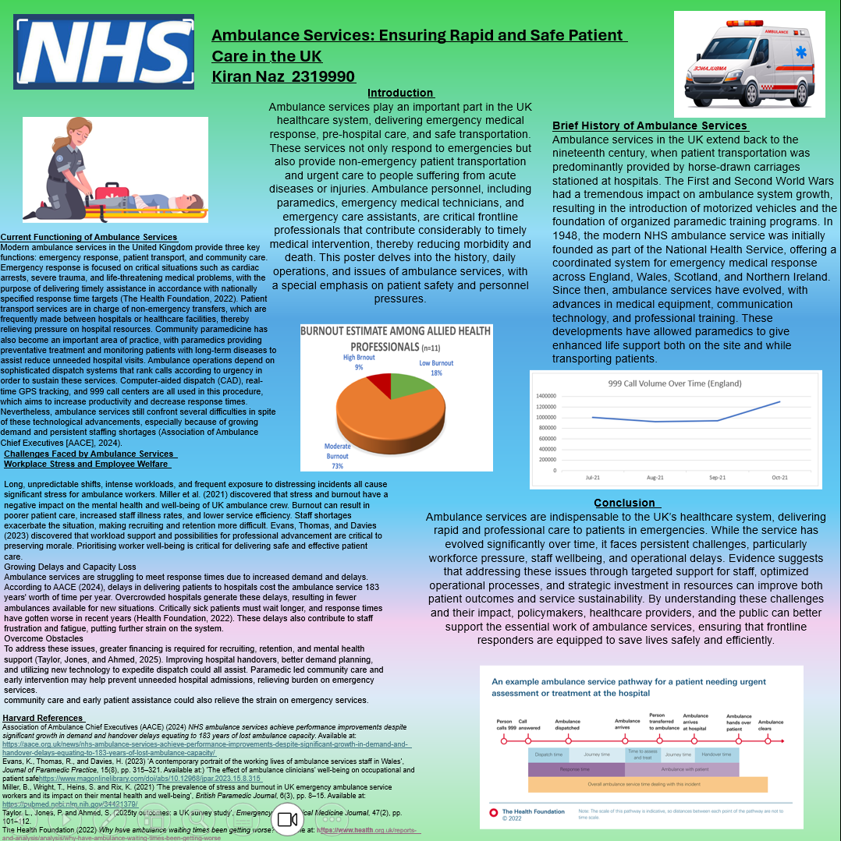

Problems with Ambulance Services and Their Solutions;
Emergency care is provided throughout the United Kingdom via ambulance services, a vital part of the NHS. These agencies have recently had to cope with significant problems that impact both patient safety and staff welfare. The stress ambulance workers experience on the job and the growing delays caused by hospital handovers are the two main issues this essay discusses and provides evidence-based solutions for. Long shifts, heavy workloads, and regular exposure to horrifying events cause a great deal of stress for ambulance workers. Miller et al. (2021) found that 53.8% of UK ambulance workers reported work-related burnout, whereas more than half (48.7%) experienced personal burnout. In addition, patient care burnout was reported at 37.1%. st vulnerable. Burnout can affect the quality of patient treatment, reduce employee effectiveness, and raise absenteeism. absenteeism. Workforce shortages make it harder to retain employees and deliver high-quality services, which further exacerbates these issues. Stress and burnout can also lead to increased turnover rates, which further strains the existing staff and creates a vicious cycle. Ambulance services are facing more operational delays in addition to staffing issues. The NHS ambulance services in England lost the equivalent of 183 years of ambulance availability between 2023 and 2024 due to hospital handover delays, according to the Association of Ambulance Chief Executives (AACE, 2024).These occur when ambulance personnel must wait longer before transferring patients due to overcrowded emergency departments that are unable to admit patients promptly. As a result, there are fewer ambulances available for emergencies in the future, which could compromise patient outcomes and lengthen response times. Similarly, the Nuffield Trust (2024) found that about 30% of ambulance handovers were delayed by more than 30 minutes, exceeding the NHS goal of less than 5%. These delays increase the workload and stress levels of ambulance staff, who must remain with patients during waiting periods, which can result in burnout. A multifaceted approach is required to address these problems. Funding for worker well-being programs and mental health services is essential to reducing burnout and raising morale (Miller et al., 2021). Retaining skilled workers may also be facilitated by providing flexible work arrangements and opportunities for career progression. Increasing hospital capacity and streamlining patient handovers are important systemic considerations. The AACE (2024) recommends enhanced collaboration between ambulance services and hospitals to reduce delays. Additionally, expanding access to community-based urgent care services can lessen the strain on ERs and prevent unnecessary hospital admissions.
In conclusion, staff stress and growing operating delays are causing major problems for the UK's ambulance services right now. These issues are intimately linked because hospital handover delays increase the workload and stress levels of ambulance crews, and high staff burnout and stress further reduce the efficiency and capacity of emergency services. These interdependencies make it necessary to address these problems with multifaceted, coordinated solutions that prioritize employee wellbeing and system efficacy. Ensuring ambulance crews have access to adequate mental health care and professional development opportunities is essential to sustaining employee morale and retention. In addition to funding community-based treatment to reduce unnecessary hospitalizations, better coordination between hospitals and ambulance services is necessary to reduce hospital handover delays. The only way ambulance services can successfully satisfy the increasing demand for treatment while maintaining high quality emergency care is by finding a balance between these demands.
References
AACE (2024) NHS ambulance services achieve performance improvements despite significant growth in demand and handover delays equating to 183 years of lost ambulance capacity. Association of Ambulance Chief Executives. Available at: https://aace.org.uk/news/nhs-ambulance-services-achieve-performance-improvements-despite-significant-growth-in-demand-and-handover-delays-equating-to-183-years-of-lost-ambulance-capacity/
Miller, J., Teeling, M. and Talbot, L. (2021) ‘The prevalence of stress and burnout in UK emergency ambulance service workers and its impact on their mental health and well-being’, British Paramedic Journal, 6(3), pp. 8–15. Available at: https://pubmed.ncbi.nlm.nih.gov/34421379/
Nuffield Trust (2024) Ambulance handover delays. Available at: https://www.nuffieldtrust.org.uk/resource/ambulance-handover-delays

