Module: Digital Skills and Research Methods
Module code: BMSW4003
Individual Report on
The Impact of Virtual Learning Environment
Student Name: Cezar Stroescu
Student ID: 2123047
Lecturer Name: Amitave Banik

Contents
Introduction 3
Overview OF Virtual Learning Environment 3
Background 4
Literature Review – Virtual Learning Environment 4
Aims and Objectives of this research 4
Research Method 5
Ethical Consideration 7
Research Result 8
Discussion 10
Conclusion 12
References 13

Introduction

Overview OF Virtual Learning Environment
A virtual learning environment is a web-based educational technology that is used for enhancing the traditional way of learning and teaching in the classroom. It provides the tools for structuring the educational materials in a logical flow (Chou and Liu, 2005). It can provide several media types for one course so that the students don't have to face any difficulty in getting access to the content. This learning environment supports setting up the assessment components for the students which makes the task easier for the course teacher for assessing his students (Clarke, 2013). Unlike the traditional way of communication, it allows the students and the teachers to communicate among themselves in real-time and also when they are available online. This incredible technology was first introduced by British engineer Tim-Berners Lee in 1989 (Tan and Waugh, 2016). At that time only document sharing feature was available in the technology. Since then, it continuously improved and now not only the students in the university level studies use it but also all type of students and learners use it. Particularly home-based education, charter schools and distance learning-based programs are suitable for the technology. This topic has become very significant for research for understanding the problems that need to be solved and avail the opportunities from it (Firefly, 2022).

Background

Literature Review – Virtual Learning Environment
VLE technology is providing various types of services for enhancing teaching and learning strategies (Efiloğlu Kurt, 2017). These services can be used for content management, curriculum and assessment, learner engagement, communication, collaboration, and real-time learning opportunity (Halvoník, 2021). Content Management helps to organize the study materials like pdfs, PowerPoint presentations, ebooks, documents etc. So, the right group of people can access it when necessary and the study and learning approach becomes easier (Herrera, 2017). Lessons outlines, assessments and progress reports all are available in the VLE which ensures the staff and the students’ easy access to their needed information. They can personalize the learning experience. VLE is for engaging the students while they are outside the classroom. Tools like quizzes and multimedia resources encourage them to visit the study contents and learn them effectively (Ismail, 2019). The teachers provide study materials there in the form of documents or multimedia linked to YouTube or self-made. Such an opportunity helps to enhance the learning experience. The VLE has the tools for communicating forms of 1:1 and 1: many. It provides a messaging system like email but is different because it serves within the system only. There are options for live chats and forums which allow the students to discuss with their teachers for educational purposes (Keppell, 2014). It is very convenient for group collaboration because the documents have the option to work together by different people from different places. Real-time teaching has the feature of live video, screen sharing, and a virtual whiteboard by which students can take part in the virtual classroom and the teachers can continue their classes.

Aims and Objectives of this research
Aims
The aim of this research is to understand the impact of VLE (Virtual Learning Environment) on students learning.
Objectives
- To find the positive and negative impact of VLE on the educational establishments in the UK.
- To find the problems of VLE that students face while using the platform.
- To understand how students are benefitting from using VLE.

Research Method
The research was mainly conducted by the qualitative research method. Qualitative research depends on the information that is gathered by the researchers from primary sources like questionnaires, surveys, interviews etc. This research method is very effective for analyzing the relationship between two or more variables (Shandilay,2018). The primary objective of this research is to identify the impact of the virtual learning environment on educational institutions in the UK. Therefore, to accomplish the objective the author splits his research approach into two-part. One is secondary research and the second one is primary research.
The secondary research is based on various journals published by other authors on this topic, books and various literary articles written to explain the VLE and its positive and negative impact on the educational institutions and the benefits and drawbacks of using it.
Primary Research
The primary research was conducted by the survey and in that survey, eight questionnaires were provided to the participants via email. The participants were to choose one option from the alternatives which portray their opinions. They were chosen for the research randomly. At first, an email was sent to some students at local universities to know if they were interested in participating in the research questionnaires. Only a few of them responded and so twenty participants were given the questionnaires to collect the data regarding the research purpose. They submitted their response to these questionnaires that were further used in the analysis of the study. Moreover, random students were interviewed for receiving their responses which helped in analyzing the questionnaires’ results. The interview was very effective in the sense that it allowed the researcher to get to know the details of the topic. The questionnaires that were used in the research are provided below:
Q1. Do you prefer VLE for your studies?
- Yes
- No
- Not sure
Q2. Do you have basic knowledge of using VLE?
- Yes
- No
- Not sure
Q3. VLE platforms help to continue the studies on the covid-19 pandemic
- Strongly Agree
- Agree
- Not sure
- Disagree
- Strongly Disagree
Q4. Do you face any difficulty in using the VLE platform for your studies?
- Yes
- No
- Not sure
Q5. Should Universities continue to use the VLE platform after the pandemic?
- Yes
- No
- Not sure
Q6. You are comfortable communicating with your teachers and friends via VLE
- Strongly Agree
- Agree
- Not sure
- Disagree
- Strongly Disagree
Q7. VLE platforms are very effective for quick learning
- Strongly Agree
- Agree
- Not sure
- Disagree
- Strongly Disagree
Q8. VLE has improved your exam results
- Strongly Agree
- Agree
- Not Sure
- Disagree
- Strongly Disagree

Ethical Consideration
In every research work, there are guidelines that all researchers should follow. If there were no guidelines, the researchers would influence the outcome of the research which can be said as a biased result. This research was conducted by keeping the confidentiality of the participants as the first priority. Those who participated in the survey only gave their responses and there was no requirement for their details. Their responses were also secret, and nobody had the access to them except the researcher. Before involving the participants in the research process, they all were informed of the objectives and aim of the research and therefore no misleading info was present in any stage of the data collection. The participants were also chosen randomly, and the researcher focused only on the relevant group for keeping the research unbiased.

Research Result
The data were collected from 20 participants by questionnaires where they answered 8 questions. From their responses, various type of data was collected. These data are shown in the bar charts, line bar charts and the table.
18 participants from the 20 prefer VLE for their studies and only 2 of them don’t like it. This means 90℅ of the students are positive about accepting VLE for their education and only 10℅ don’t like it. The second question is constructed to know how many students the skills have for using VLE. From the information table, it is exhibited that 17 students from 20 have the skills and only 3 of them do not have the skill. In question 3, 17 students admit that VLE platforms help to continue the studies on the covid-19 pandemic. 2 students are not sure whether VLE is useful and only 1 student disagrees with the statement. The majority of the students believe that VLE is useful in circumstances like pandemics when the world reaches a standstill. Regardless of VLE being very effective, 4 out of 20 students face difficulties using it. Despite difficulties, 18 students want the universities to use the VLE platform after the pandemic and continue their education using the platform. VLE platforms can be used for communicating with teachers and students. 65% of the students are confident in using such technology and 30% of the students are not confident. When it comes to the question of how effective it is, 70% of the students believe VLE is very much effective for quick learning and 25% of them believe it is ineffective. Surprisingly, 60% of students think their results have improvements after using VLE platforms and 15% are not sure whereas 25 are sure it has not improved their results. Previously 70% considered it to be effective but in the last response, 10% of them have lost their confidence that it really improves their exam results.
Questions | Responses (Yes) | Responses (No) | Not Sure
Q1 | 18 | 2 | 0
Q2 | 17 | 3 | 0
Q4 | 4 | 15 | 1
Q5 | 18 | 2 | 0

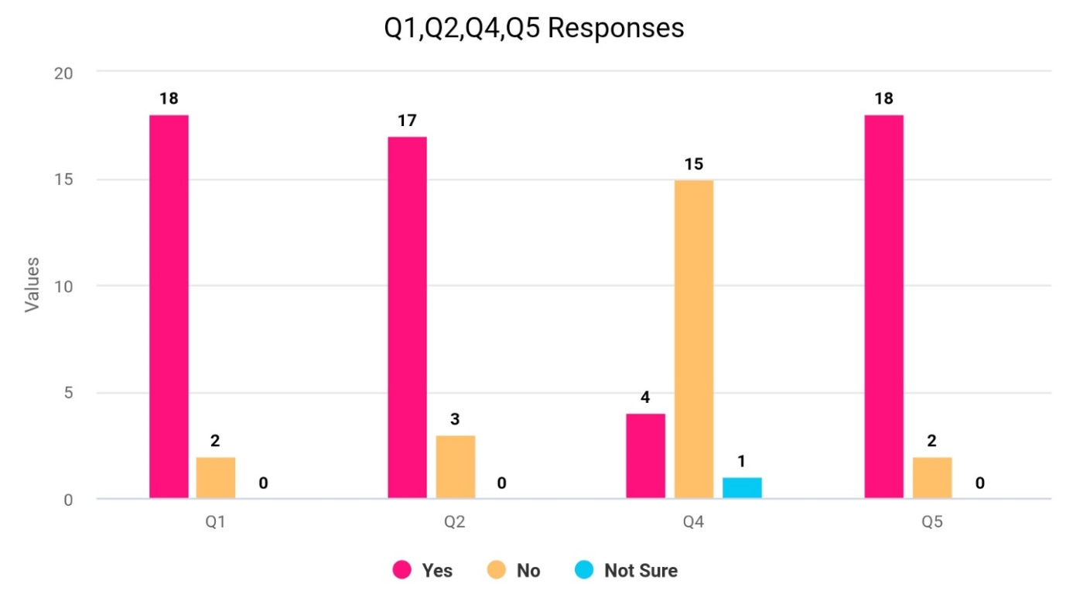

Questions | Strongly Agree | Agree | Not sure | Disagree | Strongly Disagree
Q3 | 9 | 8 | 2 | 1 | 0
Q6 | 6 | 7 | 1 | 5 | 1
Q7 | 4 | 10 | 1 | 3 | 2
Q8 | 4 | 8 | 3 | 3 | 2

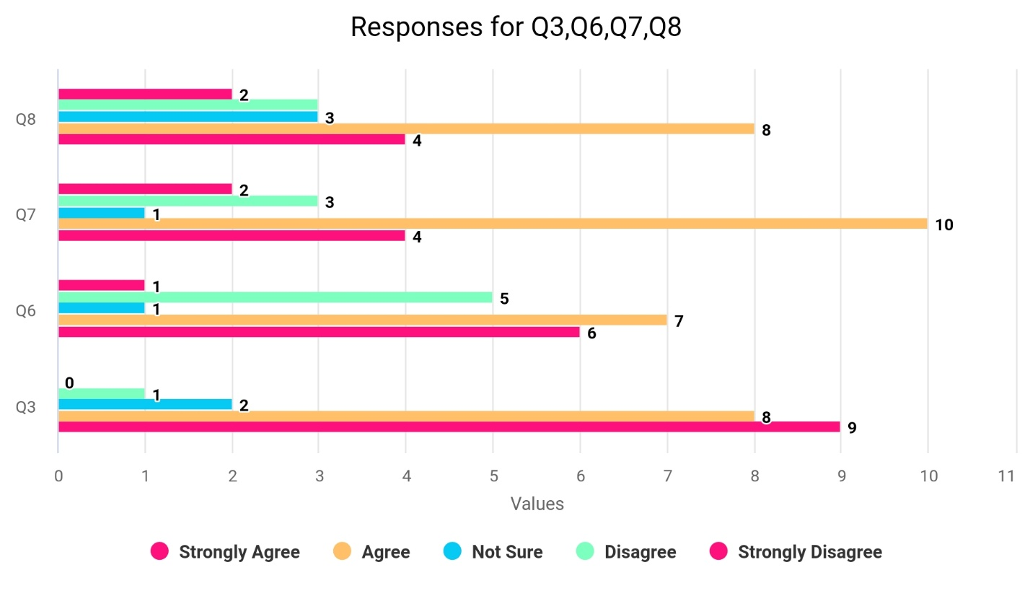

Discussion
After analysing the above primary data, it can be said that most of the students prefer a virtual learning environment, and they want the technology to continue after the pandemic. The universities using the VLE platform get the most efficient result in the completion of their course, students’ assessments, and academic tasks. Most of the students are confident in using different tools of VLE and therefore such confidence can boost the learning experience. The result from the analysis is very helpful to obtain insight into the VLE in the current scenario of utilizing it in education (Shandilay, 2018). Most of the participants have positive thoughts about the VLE and some conceive negative aspects of this technology. To explore the reasons behind it, the researcher interviewed some of the students, and they explained some facts for which reason they prefer VLE, and for which reason some students had opposite opinions. These are explained below:
Most of the students preferred VLE because it is very convenient for them for continuing their studies. As VLE does not require them to be in any specific places or any specific times, they can join the learning program while staying in their homes (Chou and Liu, 2005). During the pandemic situation when all the educational institutions were shut down, the learning process came to a halt. If there was no VLE technology, universities could not continue their schooling without organizing the physical classes. With the help of VLE, they were able to remove the barrier between the classroom and the home. Students enjoyed their learning experience as they did not have to go to physical classes. Enhancement in the study approach helped them to do better results which can be noted as another reason why most of them preferred VLE.
There were some students who had different views about the VLE. The reasons can be pointed out that they were not comfortable with using the technology. They encountered fear or lack of confidence while having a conversation online or in collaboration with the other students. Some students had no previous experience in using the technology that's why they didn’t know how to use various tools of VLE.
After comprehending the above situations some recommendations are given below:
- The universities should use the VLE for continuing their education after the pandemic which will create many opportunities for the students.
- Everyone should accept the technology so that all the limitations in the way of learning and teaching can be eliminated.
- Those who do not have the skill and hence are afraid of using the technology should be given proper training and motivation.

Conclusion
Throughout the report, various aspects of the virtual learning environment used by the universities have been analyzed from the primary data collected from the surveys and the secondary data collected from different sources. The outcome of the research is that students are very positive about using the virtual learning environment. It has a significant impact on educational institutions. The form of teaching and learning has been shifted to a new dimension by introducing the VLE technology. The benefits of this technology create the opportunity for the students and teachers for making the best use of the technology in developing their careers and increasing the efficiency of the people. There might be some issues with this technology, but such drawbacks are possible to overcome and eventually everyone will be better off by accepting the technology and by making improvements to it.

References
Chou, S. and Liu, C., 2005. Learning effectiveness in a Web-based virtual learning environment: a learner control perspective. Journal of Computer Assisted Learning, 21(1).
Clarke, L., 2013. Virtual Learning Environments in teacher education: A journal, a journey. Technology Pedagogy and Education.
Efiloğlu Kurt, Ö. T. Ö., 2017. The acceptance and use of a virtual learning environment in higher education: an empirical study in Turkey, and the UK. Int J Educ Technol High Educ.
Firefly. 2022. What is a Virtual Learning Environment (VLE)?. [online] Available at: https://www.fireflylearning.com/what-is-a-virtual-learning-environment-vle [Accessed 8 April 2022].
Halvoník, D. and Psenak, P., 2021. Design of an Educational Virtual Assistant Software. International Journal of Emerging Technologies in Learning (iJET), 16(11).
Herrera Mosquera, L., 2017. Impact of Implementing a Virtual Learning Environment (VLE) in the EFL Classroom. Íkala, Revista de Lenguaje y Cultura, 22(3).
Ismail, S., 2019. Using a Virtual Learning Environment for Problem Based Learning (P.B.L). SSRN Electronic Journal.
Keppell, M., Souter, K., Riddle, M. and Tynan, B., 2014. Physical and Virtual Learning Spaces in Higher Education. Hershey: IGI Global.
Shandilay, D., 2018. Virtual Learning Environment Scenario in Higher Education (Web-based Learning). International Journal Of Management And Economics Invention, 04(05).
Tan, S. and Waugh, R., 2016. Virtual learning environments.

