Information Engineering Exam
Test 14th Jan 2020

Mark L. E. Vaughan 1909160
1909160@student.uwtsd.ac.uk

Context Diagram
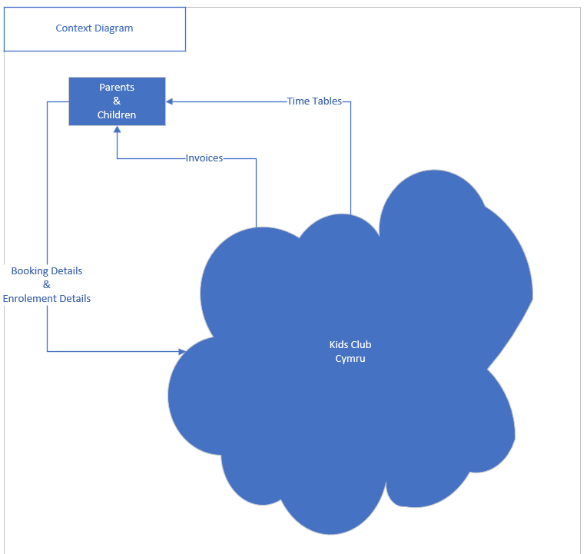

Level 0 DFD
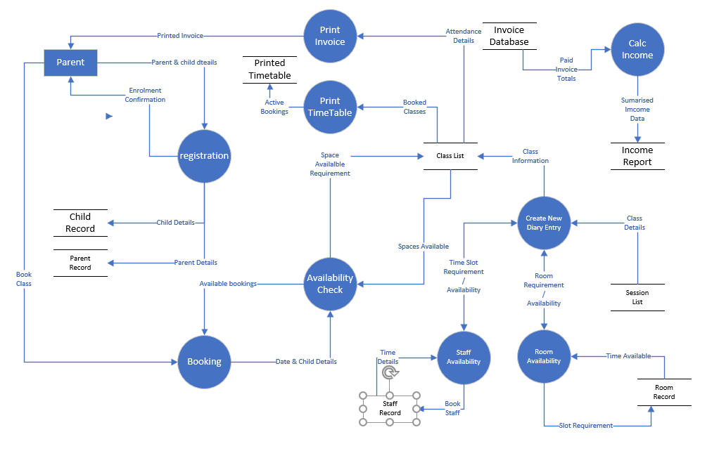

Level 1 DFD – Enrolment Process.
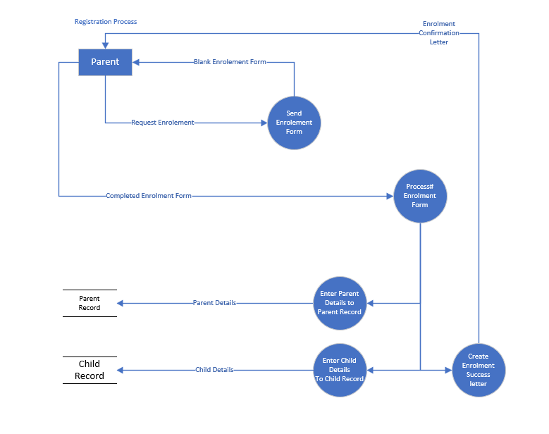

Level 1 DFD – Booking Process
note: Lunch time and Afternoon bookings are treated as Classes.
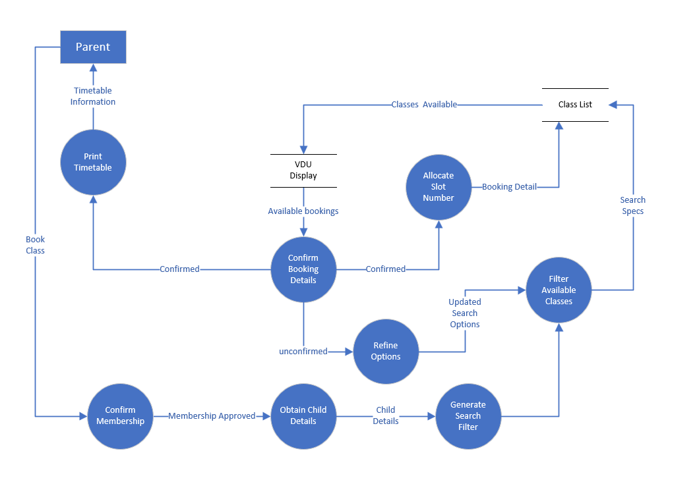

DFD Level 1 - Invoicing

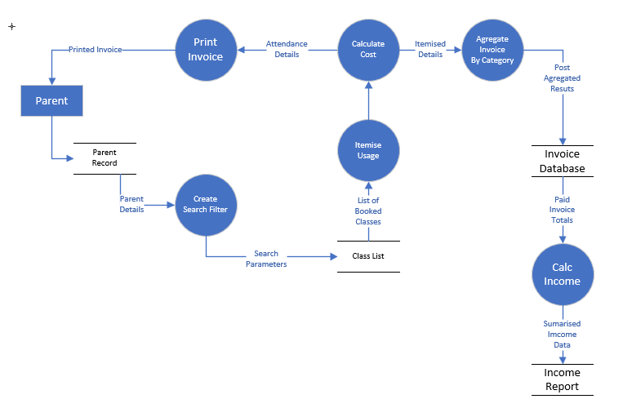

DFD Level 1 – Session Management
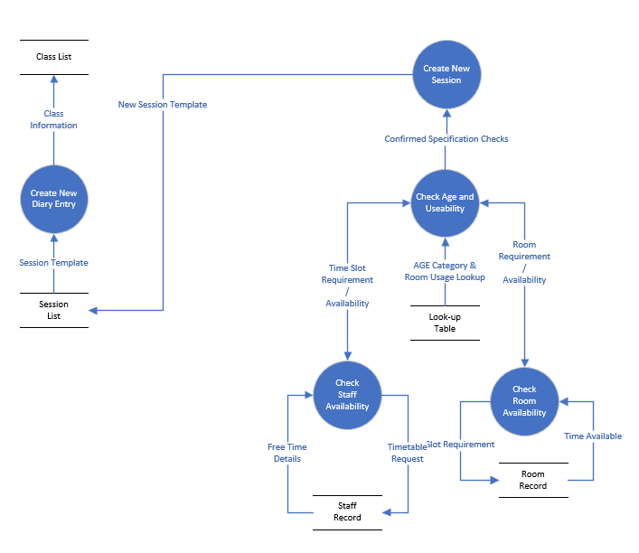

Entity Diagram – Basic

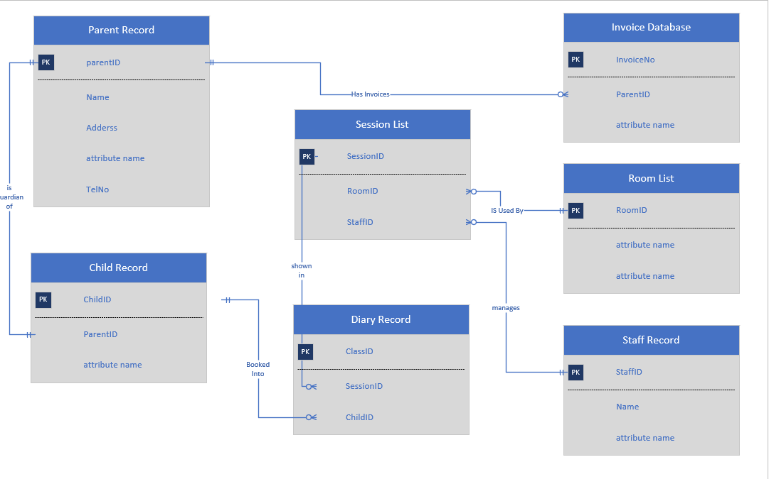

Entity Diagram – Staff Extended

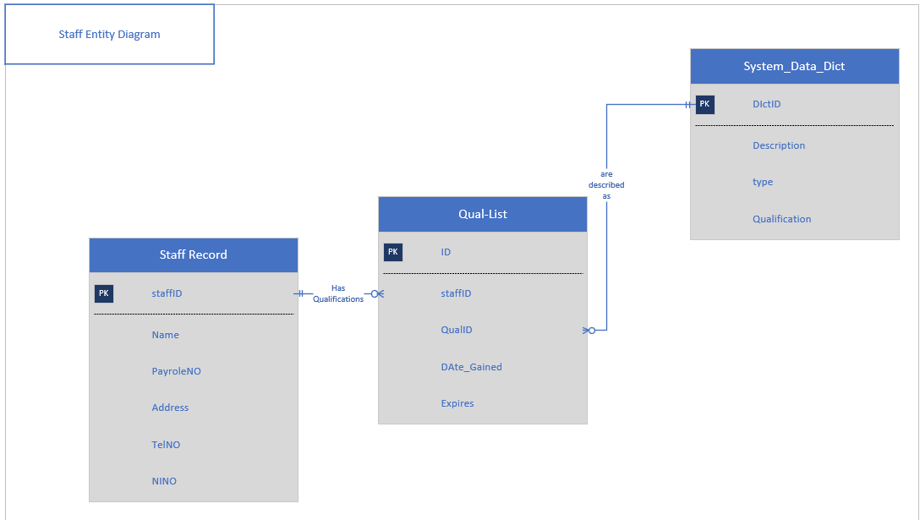

Entity Tables Outline
Parent
Key | Description | Type
PK | ParentID | Int Unique
 | Name | Varchar(40)
 | TelNo | Varchar(11)

Child Record
Key | Description | Type
PK | ChildID | Int Unique
FK | ParentID | int
 | Name | Varcghar(40)
 | Age_Grp | int
 | Status | Bool
Session List
Key | Description | Type
PK | SessionID | Int Unique
FK | Class Description | Varchar(20)
 | Day | Date
FK | Age_Grp | Int | Link to Datadict / Look up
FK | Room |  | Link to room Table
FK | Staff Member | int | Link to Staff Table

