Professional skills and health and safety assignment

Daniel Jac Beynon
Student Number-2116579
Email-2116579@student.uwtsd.ac.uk

Contents Page
- Page 3- Introduction
- Page 4,5- Types of professional bodies
- Page 6- Importance of joining a professional body
- Page 7- Personal Development Plan
- Page 8- Reference list

Introduction
In this assignment, I will be writing a report to the managing director of my company based in the construction industry on why it is important for me to join a professional body and how it could benefit to me and the company, especially with health and safety records.
I will also be explaining different types of professional bodies and what benefits each have and which ones a company should sign up for but in this instance, I will be explaining to a managing director of a company.
The key points I will be talking about are,
- Types of professional bodies
- Advantages and disadvantages of joining professional bodies
- How it can benefit your company
- Health & Safety benefits

Types of professional bodies
One main professional body is RICS (Royal Institution of chartered surveyors) which enforces the highest professional qualifications and standards in construction for development and management. (Rics.org, 2019) being a part of a professional body such as RICS will develop expertise and earning potential, it will also give insight into ethical guidance for your business (Rics.org, 2020). From my experience in business being more ethical can also improve revenue, it also improves brand and business awareness and recognition. Another benefit of being more ethical can be your staff are more motivated, this could improve the amount of work that gets done especially by staff and if I were to be apart of a professional body then I could forward what I have learned to my co-workers.
With RICS a professional statement is provided with a document that recommends an approach to good practice in Health & Safety. Having this against your name or company’s name provides your company with a very good reputation which influences firms to use your business over others as you are a registered business with RICS which shows them that you are a qualified business.
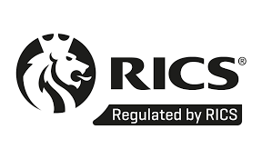

When registered you also get this logo which can be used on any vehicles or documents created for the business. It also shows the professionalism of a company which persuades people to use your company as they know they are getting a top-class service. This next to my name will show that the company is registered and goes by the book.

RICS is a very good professional body in the construction and built environment, but it doesn’t concentrate on the health and safety aspect, however, IOSH is the institution of occupational safety and health is more centered around safety on-site with all employers (HSE NETWORK, 2020). This qualification is very respected in the field of health and safety and any company or managing director would benefit from getting this qualification completed.
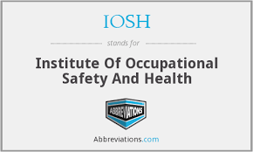
Once you are qualified in this all that’s needed is 24 hours of training every year to keep up to date with new legislation and relevant topics in health and safety to ensure that a construction company can be as safe as possible on-site and off it. I got this information from talking to our Health and Safety Director and his views are that this would be very beneficial to the company to most of its staff, but I think it would be very important for me to get it done as I am new to the industry and I need to learn as much about everything in a short space of time.

Being an IOSH member also brings benefits such as professional indemnity insurance which is only offered in the UK alone (IOSH, n.d). This is an insurance for businesses, self-employed and freelancers which protect them a client tries to claim service is inadequate, meaning if a client does not believe the service you have provided has been done properly this insurance can help business against being sued and losing money.
Being a part of a professional body has huge benefits to a business as it helps get their business out there which therefore would increase revenue and profit, but it also has its benefits when it comes to its employees as being a part of a professional body which is centered around health and safety, helps increase morale for its staff as it would set out rules for a company or a managing director to follow for the business which would not let its employees get injured or become ill in the workplace.

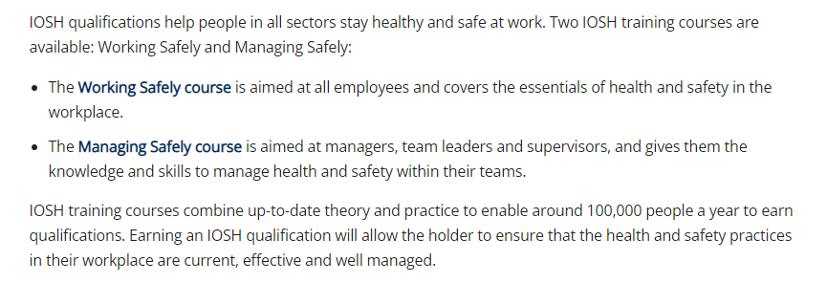
(British safety council, n.d)
As you can see here there are 2 types of training available, I would be more suited to the working safely course as it’s the basics I need to know and its something that would help me when visiting sites and the workplace on essential things I should and should not do.
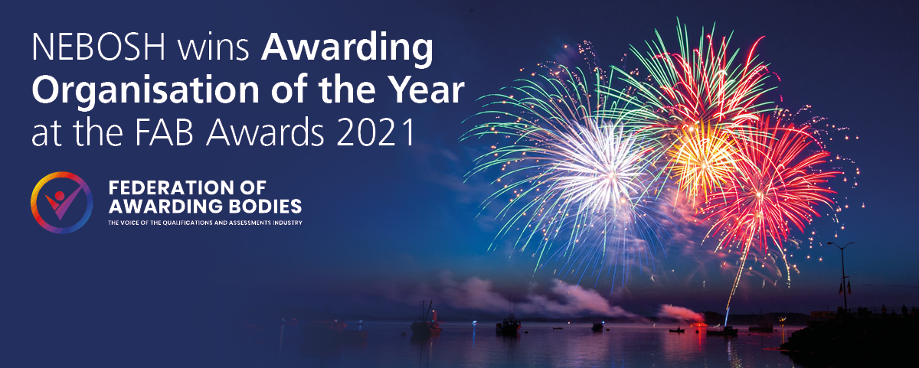
Another professional body that would be of use is NEBOSH, this professional body is centered around health and safety and offers qualifications to stay up to date with the most up-to-date rules in the workplace. It offers courses that cover health and safety and also well-being management, which our health and safety manager is also signed up to which suggests it is a reliable source for all thing’s health and safety, this is another one I believe would be hugely beneficial to me as it will give me the knowledge in health and safety that a newbie in the industry needs.
(NEBOSH, 2020)
As you can see from this image they are a very credible organization as they were awarded the organization of the year by the federation of awarding bodies. They are also British-based so all information or examinations would be useful to us. They would also like IOSH to keep you up to date with the newest most useful information regarding health and safety.

Importance of joining a professional body
Having a membership in a professional body shows that you have reached a certain level in your profession (CTP, 2015). This would then suggest adding to your credibility as it shows you are serious about your career and professional development and want to improve your business and yourself.
Joining a professional body also keep you current and up to date within the industry and especially with us in the construction industry this is very important as not staying up to date with prices of materials, labour costs, or new health and safety rules (www.neoibn.org, 2017) could have a bad effect on the business, which could lead to having a bad reputation in the industry. From speaking again to our health and safety Director joining a professional body could also be beneficial for the reasons that being a part of a professional body also offers career opportunities such as business gatherings which could lead to getting new contacts in different fields and expanding the business to therefore being more successful in the long term, this again is essential to me as I am new in the industry and learning from people with experience is the best way of gaining useful knowledge.
It also helps with staying on top of current issues the industry might be facing, this meaning that we could get ahead of the issues instead of thinking what to do when the issue hits us, this would mean we are well prepared and not at a disadvantage compared to other firms that don’t have a member of staff in a professional body, this will also aid my personal development which meaning i could gain more experience in different areas of business which haven’t been explored yet and maybe meaning I could get ahead of other people in the industry and share my knowledge with my co-workers.
To conclude joining any professional body would be hugely beneficial not only to a company but also to individuals like myself as getting personal gain can motivate people and make them work harder and be more successful in the long term. For a business, it has the advantages of keeping up to date with any changes in the industry let it be material costs or health and safety rules, which in our day and age with COVID would be a huge boost as being COVID friendly can not only keep everyone at the company safe but it’ll also show people that the company goes by the book and does everything right, which could lead to being a registered company and acknowledged by bigger firms to use us for work.
Out of these professional bodies, the one I would join would be either IOSH or NEBOSH as it will give a newbie like me very useful information into health and safety on-site and in the workplace. RICS would also be good in terms of learning things to do with construction but I can learn that from working, but with health and safety you cannot wait for something to happen then deal with it, I need to know how to deal with issues that happen before they happen. Also having a new member of staff like me undertaking health and safety qualifications like the above shows that the company takes every step to make sure everyone is safe when they are on-site and in hazardous environments.

Personal Development Plan
Name | Daniel Jac Beynon
Job Role | Junior Quantity Surveyor
 | Review of learning needs |  |  | Development plan
Reference | In what area do I need to improve my performance? | What do I need to learn to achieve this? | What will I do to achieve this? | What are the likely resources and support that I will need? | How will I evaluate a successful outcome?
Literacy skills | I believe one of my weaknesses is not using enough of my vocabulary, as I think I use the same words over and over which makes my work seem boring and not interesting. | I should learn new worlds which make my work stand out over others and seem more interesting and it won’t bore the readers of my work. | To achieve this, I could read past essays and coursework and see the sort of language they have used and take some pointers of words and phrases I could use on my next essay/course work. | I could use Moodle to find old coursework/papers which would help broaden my vocabulary.  I could also go through the thesauruses to see different words I commonly use such as ‘because’. | I could tell I have been successful when I get better marks on my coursework for my literacy skills. This will also help with my written work in my job role when sending out tenders to subcontractors as I have to make sure I am wording everything correctly.
Digital Skills | I need to improve my excel and drawing skills on the computer. This is a very important part of my job and role as a quantity surveyor. | I will have to learn to use different tools on both platforms to ensure I have enough knowledge to use them when I am asked to do so. | I will watch my piers such as senior surveyors and my commercial manager to see how they use these platforms and take tips, this will help me get an understanding of how to use each of the tools and options of the platforms. | I would need support from work, college, and university and maybe resources such as the library so I can give my spare time to using these platforms and learning by getting used to them. | I would count it as a successful outcome when I am able to use all the tools and options of the platforms without the help of others.
Health and safety skills | I need to improve my skills in areas such as what PPE and rules apply to me when I am on-site and, in the workplace, so I do not put myself or others in danger. | I need to learn essential things I should and should not do when on-site, therefore learning what PPE to wear when I am on-site, things to do and not to do, and having site inductions. | I could join a professional body that would give me guidance on specific rules that apply when I am on-site and in my workplace. | I would use professional bodies, gain knowledge from others, and being on-site to learn about specific rules and procedures that apply to me when on site. | I will evaluate it a successful when I can pass a health and safety exam with little to no mistakes, or by doing a professional body qualification as it would show I am qualified in Health and safety and know the right rules about being on site.

Reference list
- British Safety Council (n.d.). What Is IOSH? | British Safety Council. [online] www.britsafe.org. Available at: https://www.britsafe.org/training-and-learning/find-the-right-course-for-you/what-is-iosh/.
- CTP (2015). Benefits of Joining a Professional Body. [online] Ctp.org.uk. Available at: https://www.ctp.org.uk/resettlement-guide-article/benefits-of-joining-a-399704.
- HSE NETWORK (2020). What is the difference between IOSH and NEBOSH? [online] HSE Network. Available at: https://www.hse-network.com/what-are-the-options-when-it-comes-to-online-health-and-safety-training/ [Accessed 11 Jan. 2022].
- IOSH (n.d.). IOSH Extras. [online] IOSH. Available at: https://iosh.com/my-iosh/iosh-extras/.
- NEBOSH. (2020). Home. [online] Available at: https://www.nebosh.org.uk/home/.
- Rics.org. (2019). About RICS. [online] Available at: https://www.rics.org/uk/about-rics/.
- Rics.org. (2020). Benefits of RICS membership. [online] Available at: https://www.rics.org/uk/surveying-profession/join-rics/benefits-of-rics-membership/.
- www.neoibn.org. (2017). 3 Reasons to Join a Professional Organization | International Business Network. [online] Available at: https://www.neoibn.org/top-three-reasons-to-join-a-professional-organization/.

