

Global Business Environment

Name- Utsav Kakadiya
Student ID- 2240174
Module code- LCBB4005
Module Name- Global Business Environment
Lecturer- Hoang Nguyen

Table of Contents

Introduction 3
Selected Country Introduction 4
PESTLE Analysis 5
Porter’s Five Forces 7
Hofstede Framework 9
Opportunities 10
Challenges 10
Barriers in Developing Country 11
Recommendations 13
Conclusion 14
References 15

Introduction
The report will identify, depict, and analyze the different business environmental factors and their impact on the company Lister which manufactures cars and is planning to move its production facilities to another developing country, India. The report will portray the opportunities, challenges, and barriers that the company may face in the scope and development of the international business environment. The social and economic risks, the technological and other factors that the company might face would be listed in various analyses like PESTLE analysis, Porter’s Five Forces, and Hofstede framework. The company has to see and think of the economic stability, currency exchange rates, and trade barriers. Key factors like political stability, the geography of the developing country, and technology play an important role in the strategies made by the company to grow its business and production facilities in the developing country and international market. Expanding the business will expand the brand visibility of the company all over the world.

Selected Country Introduction
India is growing at a faster rate in the field of the automobile industry. It could be beneficial and challenging both for the company to start the business and grow its production facilities in India. India is a developing country and holds the third position in the automobile market or it can be said that India has the third largest automobile market in the world. A lot of multinational companies are surviving and in fact, ruling the market of India. These companies are also contributing varieties and much more to the Indian market and they mostly benefit because many legislations in India support the international market in the country (Mathivathanan, et al., 2018).

PESTLE Analysis
Political Factors: India offers stability to foreign businesses politically. The country is termed the world's biggest democracy, but then the company has to face corruption, sales tax, labor law, income tax and service tax, and a lot of trade and tax policies, then only its economic growth can take place. India has reduced a lot of rules and government interference in the operations of international business. India will help the Lister cars to grow independently (Mattioli, et al., 2020).
Economic Factors: These factors could be said to determine the profits of Lister. The increasing growth in the GDP of India promises opportunities for the company to grow. The country’s economy is also increasing because of the liberal industrial policies imposed by India that encourage increased foreign investment. For the company Lister, it would be beneficial to grow business in India because of the favorable taxation policies of the Indian government (Kushwaha & Sharma, 2016).
Social Factors: Social factors include the behaviors of the customers norms of the country, values, beliefs, traditions, population, lifestyle, and much more. Lister can only run the production facilities and its business in India if it will be aware of the local culture and acceptability. The company could easily get the local workforce or the labor at affordable labor rates. The massive domestic market of the country is also one of the reasons Lister wants to grow its business here. The people of India are changing their lifestyle and standard of living, on which the company must concentrate (Mani, et al., 2018).
Technological Factors: The business operations of Lister would be highly impacted by the innovations and automation of India because the technology industry of the country is regularly growing. The IT sector of the country is constantly working on the upgradation of software and technology. It will influence the company’s communication with customers, production, and also distribution. A lot of investments are being done in the tech market of India (Llopis-Albert, et al., 2021).
Legal Factors: The Constitution of India provides or gives equal opportunities to all, including copyright laws, discrimination laws, advertising laws, and consumer rights. These options can benefit the company for trading automobiles in India. Just the company has to follow the rule and laws of the country. These legal factors can affect the labor cost and pricing of the company. The foreign trade regulations of India offer growth opportunities to the company, Lister (Kyriakidis, et al., 2015).
Environmental Factors: Environmental factors like climate change, carbon footprint, and raw materials can give growth opportunities to Lister. But, as the company Lister is an automobile company, it may face environmental issues in India as a part of ongoing issues regarding the ecological crisis. Company has to deal with it or bring up some innovations to combat these ecological crises. The demand for eco-friendly products is rising and because of this, the company might need to change its strategies and demand-supply model to meet the changes required.

Porter’s Five Forces
Competitive Rivalry: The automotive industry is very big in India having a lot of competitors. A rapidly growing market of automobiles has been encountered in India. The companies like Jaguar, Audi, Volkswagen, and many other companies can give direct competition to Lister in the Indian market. Competition can result in distributed audience and lower costs (Bhatia, 2016).
Supplier Power: There is a large number of raw material suppliers in the automotive industry, so this can result in low and weak bargaining power. The raw material does not require more resources, and because of this plenty of raw materials are needed. The companies switch suppliers because of their inadequate supplies of the material. (Digalwar & Giridhar, 2015)
Buyer Power: India possesses a high bargaining power with consumers. Because of a lot of options, the buyers get this advantage to bargain with the companies. The customers need high reductions in prices or they switch to another company or brand or model of automobiles. Buyers’ power and their bargaining power can result in a threat and loss to the economy of the company.
Threat of Substitution: There can be many substitutions to the Lister cars, but nothing can match the convenience, flexibility, and accessibility that is received by owning a car or an automobile. There is an increase in demand because people in India are demanding personal cars and this has led to an increase in manufacturing and usage of the cars.
Threat of New Entry: There could be a high threat of new brands and entries in the field or industry of automobiles and the company may have to face this. Influencing Lister Car on the audience over other automobiles will not be easy, as it will require a lot of brand advertising and recognition (Yang, et al., 2019).

Hofstede Framework
Power Distance Index (PDI) – India has a much higher power distance index of 77, which is very much higher as compared to the average PDI of the world, which is 59. This thing will impact the growth of the company to a higher extent.
Individualism vs. Collectivism Index (IDV) – While the native country of Lister cars relies on individualism, but Indian government and policies highly prefer group over individual rights. India believes in Collectivism more.
Masculinity vs. Femininity Index (MAS) – India has a more ratio of masculinity, that is, it has high masculinity. This will favor the company with assertiveness with a sort of emphasis on competition in the automotive industry.
Uncertainty Avoidance Index (UAI) – This leads to the extent of Indians and the society who feels threatened by unknown and new businesses, its ambiguity, and uncertainty of foreign business in the country.
Long- vs. Short-Term Orientation Index (LTO) – The company has to promote its persistence and virtue and also has to focus on its future goals including long-term and short-term goals and objectives in the automotive industry of India.

Opportunities
The automotive industry of the developing country, India is expected to grow four times by 2050. It can be a plus point for Lister Cars to enter the market of India and target the audience from India as people are changing their standards and lifestyles and with this, they are demanding a personal car for almost every earning or employed person. It can be cost-efficient for Lister Cars to move their production facilities to the developing country, India because wages for the labor are low here as compared to other developed countries. There will be a low manufacturing infrastructure needed in moving the production facilities to India. The company can open a medium-sized enterprise here. It can be a huge benefit and opportunity for Lister Cars as it will get a lot of skilled engineers, workers, and software developers to fill up the jobs in the industry or the company (Kamble, et al., 2023). The company can get a healthy work-life balance as the government tries to create a fair, safe, and happy environment for the workforce, which will make the workers and employees happy and as a result, this will benefit the company. The company has to spend less on housing facilities for the workers as they have to provide in their own countries. Also, they have to provide lower safety measures to the workers as they have to give in their native countries. Their production and tooling costs will also be reduced in India (Jain, et al., 2018).

Challenges
The company may face cultural differences between Indian and Western cultures and also the local regions or domestic regions of the country. This can be quite challenging for Lister Cars to set up production facilities in India. The company and the administration have to keep the workplace harmony and cultural diversity of India in mind before jumping to this decision of setting up production facilities or manufacturing plants in India. The company will need to understand the culture of the employees and build up a team with them, then only it will be able to succeed and rule over the automotive industry of the country (Gupta, et al., 2019). Lister Cars have to think of the varied demographics and significantly the preferences of the customers that vary from region to region in the same country. Before setting up, the company needs to gather a lot of information and data. The other challenge that the company might face is to choose a location and the right infrastructure that can benefit them with everything. Though Indians prefer quality over price, still it has to be kept in mind that the price-centric mentality of Indians is very unique. Recruitment becomes another challenge that could be faced by Lister Cars (Gupta & Vardhan, 2016).

Barriers in Developing Country
The barriers that Lister can face in India could be the high levels of import duties and the taxes that they have to pay to the Indian government. The company, Lister has to make modifications to the product for the poor road conditions, high levels of dust, and heat in India. Many multinational automotive companies like Mercedes-Benz, BMW Group, Audi, Skoda Auto Volkswagen, and Porsche can also be a barrier to the growth and overall economy of the company. These companies can give good competition related to price and models. People will switch to better models of cars that will be offered to them at low prices. Before entering the market, the company has to think about and compare the models and the prices on which they are offering their products to these listed companies (Mangla, et al., 2018). The company has to keep a bit low or the same range to sustain itself in the market initially. The safety and restraints, fuel efficiency, the high sunk costs of the technology development, and bargaining power of the suppliers and buyers can also be stated or listed as one of the barriers to moving the production facilities to the developing country India (Goel, et al., 2021).
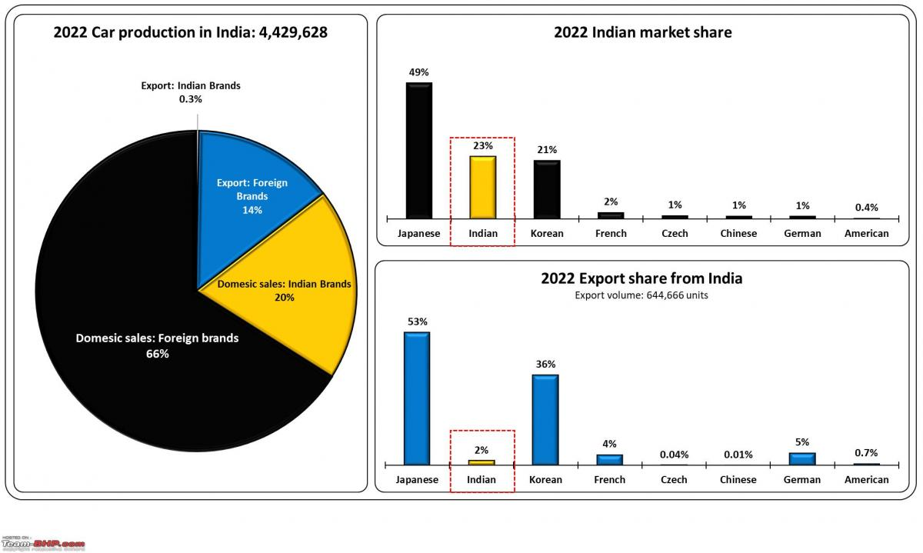
(Source: TeamBHP, 2023)

Recommendations
The company Lister will be needed to be registered and establish a branch office in India. The company has to follow some norms like it has to be a private limited company as per the legislations and acts of India. The company, Lister can either be established by a strategic partnership with the business entities in India. It could be helped by opting for investments that are relatively lower in risk as compared to other options. This can benefit the company from the market or consumers and distributed channels of already established Indian companies. The company before getting into the Indian market may first gather information about the developing country India because in Western countries there are different cultural diversity and economic factors, and legal factors. They may face difficulties in running the business and production facilities in India. But, at the same time, India is the fastest-growing economy in the world so it can be a better opportunity for Lister Cars to capture its market.
For setting up in India, the company must understand the legal and regulatory framework. People in India need a lot of variety in everything, so the company needs to think of increasing the number of models and variants as per the needs of the Indian market otherwise it will not be able to survive in India for a long time. It will be needed to create a quality culture to gain the attention of the audience and other companies and give them tough competition. The company should work with such strategies with which it gets the least number of warranty claims and this can only be done by incorporating manufacturing intelligence in the production processes.

Conclusion
The report portrays a study of the international business environment and organizational strategies that are to be followed and fulfilled by Lister to enter the developing country India and set up its production facilities here. The company could get good competition in India because India has one of the most competitive automotive industries in the world. As India is gradually shifting to electronic cars, the company will have to manufacture such cars that are in demand in India. The report concludes that there are various factors like political, social, cultural, and economic factors that will impact and influence the growth of the company. Lister Cars will have to focus on the challenges and barriers and most of all the cultural diversities that it may have to face. The company will have to follow some standards and regulations in order to sustain itself in the market of India.

References
Bhatia, J., 2016. Porter's Five Forces Industry Analysis of Indian Passenger Car Industry. Pacific Business Review International, 8(7), pp.113-123. Link: http://www.pbr.co.in/2016/2016_month/January/13.pdf
Digalwar, A.K. and Giridhar, G., 2015. Interpretive structural modeling approach for development of electric vehicle market in India. Procedia Cirp, 26, pp.40-45. Link: https://www.sciencedirect.com/science/article/pii/S221282711400938X
Goel, S., Sharma, R. and Rathore, A.K., 2021. A review on barrier and challenges of electric vehicle in India and vehicle to grid optimisation. Transportation engineering, 4, p.100057. Link: https://www.sciencedirect.com/science/article/pii/S2666691X21000130
Gupta, P. and Vardhan, S., 2016. Optimizing OEE, productivity and production cost for improving sales volume in an automobile industry through TPM: a case study. International Journal of Production Research, 54(10), pp.2976-2988. Link: https://www.tandfonline.com/doi/abs/10.1080/00207543.2016.1145817
Gupta, S., Soni, U. and Kumar, G., 2019. Green supplier selection using multi-criterion decision making under fuzzy environment: A case study in automotive industry. Computers & Industrial Engineering, 136, pp.663-680. Link: https://www.sciencedirect.com/science/article/abs/pii/S0360835219304292
Jain, V., Sangaiah, A.K., Sakhuja, S., Thoduka, N. and Aggarwal, R., 2018. Supplier selection using fuzzy AHP and TOPSIS: a case study in the Indian automotive industry. Neural computing and applications, 29, pp.555-564. Link: https://d1wqtxts1xzle7.cloudfront.net/88368793/s00521-016-2533-z20220708-1-khmy3r-libre.pdf?1657338762=&response-content-disposition=inline%3B+filename%3DSupplier_selection_using_fuzzy_AHP_and_T.pdf&Expires=1692724314&Signature=Jez7gho2DWcJ3edWyPM98PM0q-HSFToMBrVG6AizIbKyybctRWMtNiQji-6hY5ZCPzkQRpYCDkyxDa7QE9bd9x7hvZMSa00CAljGUkRHU7DPpES3UO1snWpiCdMkgnAc2FxeCqpbrZspw5oAvF8cJ-xHu4wNRzXmLcBCaz4aHSbk2Xz0UdlKvg1XyZstjQHzS8XmOTWWQ0GoXKAJw2Dcc38jklR-k69FxfNkbvZphVva-inPmQ4fF3EO83AKooDjUoiEnjbKkCHMZEd0S3SyYCd5Auqn2Hr1DFYHfYdsunPpyTv3M5KJeqJwiQdRr72n3hzMKQDw17LqNrv1Chrrgw__&Key-Pair-Id=APKAJLOHF5GGSLRBV4ZA
Kamble, S.S., Gunasekaran, A., Subramanian, N., Ghadge, A., Belhadi, A. and Venkatesh, M., 2023. Blockchain technology’s impact on supply chain integration and sustainable supply chain performance: Evidence from the automotive industry. Annals of Operations Research, 327(1), pp.575-600. Link: https://link.springer.com/article/10.1007/s10479-021-04129-6
Kushwaha, G.S. and Sharma, N.K., 2016. Green initiatives: a step towards sustainable development and firm's performance in the automobile industry. Journal of cleaner production, 121, pp.116-129. Link: https://www.sciencedirect.com/science/article/abs/pii/S0959652615010008
Kyriakidis, M., Happee, R. and de Winter, J.C., 2015. Public opinion on automated driving: Results of an international questionnaire among 5000 respondents. Transportation research part F: traffic psychology and behaviour, 32, pp.127-140. Link: https://www.sciencedirect.com/science/article/abs/pii/S1369847815000777
Llopis-Albert, C., Rubio, F. and Valero, F., 2021. Impact of digital transformation on the automotive industry. Technological forecasting and social change, 162, p.120343. Link: https://www.ncbi.nlm.nih.gov/pmc/articles/PMC7543716/
Mangla, S.K., Luthra, S., Mishra, N., Singh, A., Rana, N.P., Dora, M. and Dwivedi, Y., 2018. Barriers to effective circular supply chain management in a developing country context. Production Planning & Control, 29(6), pp.551-569. Link: https://www.tandfonline.com/doi/abs/10.1080/09537287.2018.1449265
Mani, V., Gunasekaran, A. and Delgado, C., 2018. Enhancing supply chain performance through supplier social sustainability: An emerging economy perspective. International Journal of Production Economics, 195, pp.259-272. Link: https://www.sciencedirect.com/science/article/abs/pii/S0925527317303407
Mathivathanan, D., Kannan, D. and Haq, A.N., 2018. Sustainable supply chain management practices in Indian automotive industry: A multi-stakeholder view. Resources, Conservation and Recycling, 128, pp.284-305. Link: https://www.sciencedirect.com/science/article/abs/pii/S0921344917300034
Mattioli, G., Roberts, C., Steinberger, J.K. and Brown, A., 2020. The political economy of car dependence: A systems of provision approach. Energy Research & Social Science, 66, p.101486. Link: https://www.sciencedirect.com/science/article/pii/S2214629620300633
TeamBHP., 2023. Sales performance foreign car companies India. [Online]. Available at: https://www.team-bhp.com/news/sales-performance-foreign-car-companies-india-2022 [Accessed on 23rd August, 2023].
Yang, D.X., Qiu, L.S., Yan, J.J., Chen, Z.Y. and Jiang, M., 2019. The government regulation and market behavior of the new energy automotive industry. Journal of cleaner production, 210, pp.1281-1288. Link: https://www.sciencedirect.com/science/article/abs/pii/S0959652618335273

