Workplace Culture and its Impacts on Organisation Efficiency
(BMSW5105)
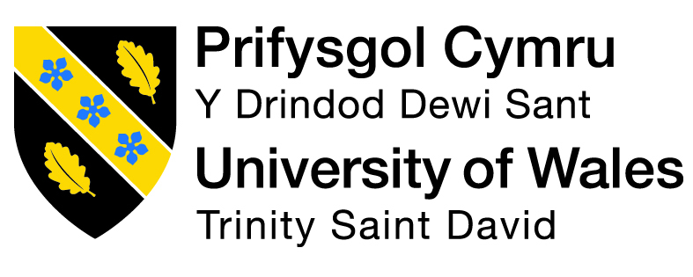

Lecturer; Brynnach Hefferenan

By Badsa Miah ID:1815821 Date:25/03/2022

EXECUTIVE SUMMARY 3
INTRODUCTION 4
2.0 FINDINGS 5
CONCLUSION 14
BIBLIOGRAPHY 17

EXECUTIVE SUMMARY
This report has highlighted that culture plays a considerable role when Organisation wants to succeed and need to understand the culture it wants to portray internally as well as externally and how its brand image plays a significant role also its internal culture could be seen and how good ethical behaviour can influence its future, harmful exposure would lesson brand image and how employees expected to act or do being part of a successful company.

INTRODUCTION
On 10/01/22 the CEO asked the researcher for a report to be compiled on British airway's culture and the two most critical external factors affecting the Organisation. To be submitted on 25/03/22
A detailed critical analysis of the workplace culture using the cultural web model.
Critical analysis of the positive cultural values contributed to its success and measures during the Pandemic.
Also, the stance on ethical and unethical behaviour in the Organisation.
British airway’s strong culture stems from the top of the hierarchy and its values and attitude, British airway's set the company apart from other airlines. Its brand image and excellent customer service, and high standard approach have led to its success.
This has contributed to its success globally, where other organisations look at cheap flights such as Ryan air more focused on low-cost flights quick revenue and seasonal, with poor customer relationship, hence poor management.
Other models can also analyse cultures, such as Charles’s handy model and Edger Schein’s model.
The researcher has complied the report using websites, journals and articles. Culture is a broad and somewhat ambiguous concept. According to some, it is "what happens while no one is watching."
In truth, the situation is even more complicated. Your Organisation's culture comprises a collection of behaviours, values, artefacts, incentive systems, and rituals. When you visit a firm, you can "feel" the culture since it is frequently visible in the employees' conduct, excitement, and physical environment. (Bersin, 2022)

2.0 FINDINGS
2.1 Definition of cultures
Organisational culture shapes the Organisation's surroundings and the long-term strategies that help it achieve its goals. Organizational rules and procedures are also influenced by the organization's culture.. (Buchanan, D. & Huczynski, A. 1997).
One of the most important functions of human resources is to organise and coordinate the workforce in order to produce value and success. HR systems and procedures are a component of this, but they are not sufficient in and of themselves.
Enough for an organisation to make significant strides forward. Assuming that inclusion and diversity are important,
In the case of a company that fails to recognise and appreciate distinctions, for example, research has shown that
Despite the existence of policies, it is doubtful that meaningful change will occur if just some groups are allowed to advance while others are barred from doing so. Workplace standards, beliefs, and behaviours, as well as cultural custom individuals’ perspectives and opinions, are also important considerations. It is these features that are shared. People inside the same organisation who work together to shape the organization's culture are known as organisational culture builders. (Armstrong, M. 2012)
"The way we do things around here" by Balogun and Johnson and "the pattern of shared basic assumption - formed, found or evolved by one particular group as it learns to cope with" by Schein are two examples of organisational culture definition.
It has worked effectively in terms of adapting outside and internally
sufficient to be accepted as true and, as a result, to be taught to new members as the proper
There is a way to approach these issues. An example of this is Denison's.
what are the core values that underpin an organization's mission?'
both the management system and the collection of management practises of an organisation, and
People who demonstrate and reinforce these fundamental ideas. To learn more, click here
Using these resources,. (Denison, 2022)
Culture is important it allows employees to understand the way an organisation expects to behave to make connections and develop a common relation and purpose it is equally important to always assess its culture from time to time it also shows which values are being held and what employees are passionate and value, the effects of a good standard practices will help retention and influence the engagement of its employees. (Hofstede, G. 2001)
Hofstede's technique helps leaders and managers understand cross-cultural interactions and their behavioural differences. These principles show that different sets of principles and structures are applicable. Quantitative studies of employees helped Hofstede establish his cultural elements hypothesis. "Collective programming of the mind that differentiates members of one group or category from another" (Hofstede, "National Culture"). His investigation yielded five dimensions. Individualism-collectivism, power disparity, aversion to ambiguity, and individualism-collectivism. (Leibensperger, 2022)
These days you find culture affects organisational performance and some.
organisations have put much effort into changing their culture and structure to improve
This. However, while managing Organisational culture is increasingly seen as a necessary
part of governance and management practice, research evidence on the link between
Organisational culture and performance are weak. In order to establish correlations between organisational culture and beneficial outcomes such as organisational performance, more study is required. Additionally, more research is required in order to identify accurate measurements of organisational culture. (CIPD, 2022).
Numerous models have been presented to explain the organisational culture to date, one of which is the Charles Handy model. And Schein’s model, Each firm has distinct principles and adheres to specific rules and methods that set it apart from the competition. Moreover, an organisation’s culture is defined by its ideals and beliefs. The organisational culture shapes how employees engage with external parties. No two organizations have the same culture; therefore, it is critical for employees to successfully adapt to their organisation’s culture to enjoy work and avoid stress. (Charles Handy Model of Organization Culture, 2022).

Cultural web
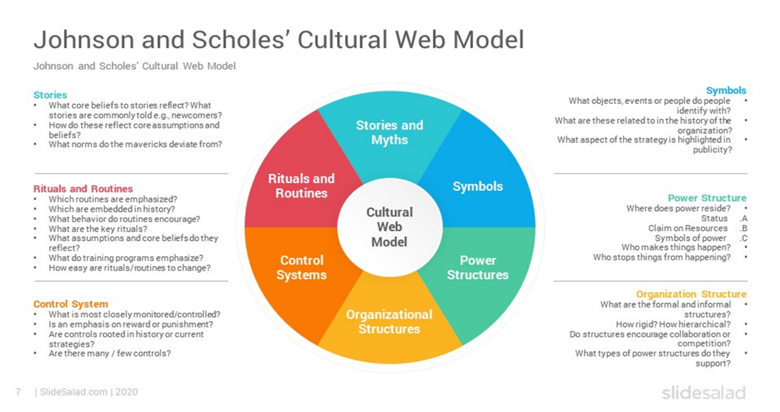
The Cultural Web is a tool used to map an organisation's culture and is a
way of understanding the different influences that affect Organisational
culture. It can also be used to map existing culture, and it can also map the future.
(Johnson, G & Scholes, K. 1999).

Artefacts
The union is a notable British Airways artefact. Jack inspired their logo, a speed bird echoed.
British Airways also values its brand since it represents it. "To Fly. To Serve" is their tagline. It reflects the Coat of Arms and what they guarantee to their consumers.
British Airways also has around 300 outfits from 1980.
Employees at British Airways are expected to dress professionally and follow rigorous regulations. Among British Airways' rigorous uniform policies, Osborn (2014) lists:
Hair must be tidy and neatly cut back (food handlers)!
A nice, tidy worn-up hairdo is required.
No cracked nail polish, red or natural pastel hues only, no blacks or blues.
Lipstick in the same hues.
No emblems on clothes or baggage (only name badges or luggage labels).
Only black (snag-free) tights, always spares.
Male and female polished black shoes, no buckles. Ladies' shoes have a heel no higher than 2 inches.
Bags and suitcases no stickers, only black or navy (wheelie bags to fit in the overhead locker).
Jackets must be worn at all times.
To be worn during serving on board.
Hats to wear in the airport and in public.
On or off uniform coats as a crew in hot weather.
Always wear ties and cravats.
Never roll up a Sleeve.
A skirt no higher than the knee.
Unaltered trousers (no narrowing).
Name badges with wings on lapel.
Never chew gum.
Unless there is a major delay or incident on board, there is no public dining.
Use your phone while strolling through the airport or boarding the plane.
No backpacks or bags.

Never criticise the airline.Value
British Airways values its employees because they play a significant role in deciding its culture. The employee's attitudes have a significant impact on the culture at British Airways. The mindset of employees influences the culture at BA. British Airways' vision and mission statement are "To be the most exclusive and first choice airline for all airline travellers" and "One destination seeks to ensure our customers fly with confidence that, together, we are acting responsibly to take care of the world we live in". with these British Airways are telling their employees and customers that they are safe on the ground or in the air. They also want employees and customers to feel safe and confident when flying with British Airways. (British Airways,2022)

Customers adore us when we remain genuine to ourselves. They come to us seeking a distinctive British Airways experience, imbued with the flair and charm for which our country is renowned across the world (if you believe a globe can have corners). You'll feel at ease here if you accept both traditional British values and modern Britain's strengths: know-how, creativity, energy, variety, and open-mindedness – as well as a sense of respect, responsibility, fair play, and an understanding of who gets to make the tea. (British Airways,2022)

How you would expect to behave in British airways
Each of us must speak out if we witness or suspect a violation of the Code. This should be accomplished with caution and sensitivity. Each employee is expected to address an issue when they become aware of a scenario in which the Code's standards and behaviours are not being followed. You can submit a concern in a variety of ways. The best course of action is to speak with your boss, but if that is not feasible, there are other options accessible. (British, 2022)
Performing tasks in the British Airways manner necessitates a specific mindset. It is irrelevant where you come from. It's all about how you’ve constructed. We honour serving consumers from various ethnicities, backgrounds, and cultures. We're delighted to hire a diverse workforce that reflects that diversity in all its manifestations. Learn more about our inclusive, inviting business and how we're establishing a staff that embodies all that's great about modern Britain. (British Airways,2022)

Assumption
British Airways cultural characteristics are implicitly assumed to exist in everyday interactions amongst employees, at the most fundamental level. These topics are considered taboo by British Airways employees since they are part of the company's culture. There are several tacit norms at British Airways that have evolved through time. As a result, they rely on surveys and informal conversations with workers to get information, but they aren't very effective. For British Airways, it's important to understand that organisational behaviourists typically overlook the importance of culture at this level.
PESTEL is a tool to analyse external factors of an Organisation. It allows forming an impression of the factors that impact the industry.
Pestle analysis shows British airways.
Political factors
Politics is becoming important in aviation. Political issues are becoming increasingly important in generating growth, market attractiveness and establishing a business-friendly climate, and the impact of government monitoring and regulation on the total impact of the aviation sector in an area. Government policies in major aviation markets like the UK and the US considerably impact the airline business. Moreover, the political climate in the UK and the amount of political stability affect the airline brands' profitability. The EU significantly controlled the UK aviation sector, affecting issues like as operator licencing, traffic rights, safety rules, and staff licencing. The Civil Aviation Authority is the UK's principal regulator of the aviation sector. The CAA also controls consumer rights in addition to safety and security regulations. (British Airways SWOT & PESTLE Analysis | SWOT & PESTLE, 2022)

Aside from the government's control of the aviation sector and other political issues, Brexit has had a significant influence on airline branding. Border, customs, and immigration restrictions are among the major Brexit challenges that will impact air travel. Things won't change overnight, but the UK and the EU are striving to resolve all difficulties by the end of 2020. Travel from major markets like the US and other Western countries has been made easier by the UK government. When the UK was part of the EU, there were no barriers to cross-border travel. No customs or passport issues. This will change after the Brexit on January 31, 2020. To overcome the short-term and long-term consequences of Brexit, the aviation industry would need to consider various factors. Airline companies must work on several parts of their company to overcome Brexit's challenges: economics, regulation, corporate governance and strategy, operations, and consumer and customer relations. British Airways has previously confirmed to its passengers that post Brexit, its flights will fly on their normal timetable.. (British Airways SWOT & PESTLE Analysis | SWOT & PESTLE, 2022)
Economic factors
Economic issues and developments directly effect the airline sectors in the UK. Country or region's financial-economic status significantly effects airline brand profitability. Economic stability, unemployment, and GDP all impact air travel and aircraft operators. The slowing economy harms airline profits and sales. However, the UK economy has been increasingly unpredictable since the 2016 Brexit declaration. Since then, Brexit-related uncertainty has harmed the UK economy.. (British Airways SWOT & PESTLE Analysis | SWOT & PESTLE, 2022)
The UK's economy slowed after Brexit. While the UK economy weakened, several major companies relocated their headquarters to the EU. Despite declining confidence and sluggish development, the UK jobless rate remained low. Increasing strategic investments, increasing customer focus, and the capacity to adjust business and operating models to shifting economic conditions have all helped British Airways maintain its growth rate and profitability. Despite Brexit's economic uncertainties, the company's sales has soared. British Airways' overall income increased 6.1 percent in 2018 to £13,021 million from £12,271 million in 2017. During the same time, operational profit increased 10.3% to £1,952 million from £1,769 million. (British Airways SWOT & PESTLE Analysis | SWOT & PESTLE, 2022)

British Airways responded to the pandemic by leveraging technology to bring new goods and services to customers, enhancing its offering, reducing costs, and mitigating infection risk.
Tom Stevens, the airline's director of brand and customer experience, stated during the AIX online event on 13 September that the objective was to "bolt new technology onto our existing infrastructure" to innovate. (British Airways sees Covid as a catalyst for service innovation, 2022)
The Pandemic also caused issues at British airways such as restrictions and new measures that had to be adopted urgently to felicitate passengers and adhere to government guidelines, which imposed more significant stress on the Organisation facing many obstacles. All aspects of the industry were suffering. Certain companies struggled to stay afloat had to go into administration. (British Airways sees Covid as a catalyst for service innovation, 2022)
He highlights a new project that enables travellers in the Greater London region to check in their luggage the day before their trip and retrieve it before departure. This allows them to bypass security, hence minimising line-ups.
Similarly, the airline now allows travellers taking the Heathrow Express rail service from Paddington to dump their luggage on the station platform, saving them time in the terminal.
Onboard, customers may now order food and beverages to their seats via the in-flight wi-fi, which assists the carrier in transitioning away from its usual trolley service. (​British Airways sees Covid as a catalyst for service innovation, 2022)
Similarly, enabling passengers to pre-order products before the trip expands their options and provides an opportunity to avoid food waste.
According to Stevens, such changes are motivated by "consumer choice, flexibility, and a persistent adaptation effort." The response, he says, is to "set new records for consumer satisfaction."
BA, he continues, has worked hard to instil trust in passengers and is also taking measures to protect its premium brand position, such as by providing complimentary snacks and beverages in its "Euro traveller" economy cabin. (British Airways sees Covid as a catalyst for service innovation, 2022)
Stevens emphasises that the carrier is experiencing "significant pent-up demand for flying again," particularly for leisure and visiting friends and family, even in premium cabins.
"We’re seeing that once clients have flown once and get accustomed to the additional processes, they realise it's not that difficult and are willing to fly again and again," he adds. (British Airways sees Covid as a catalyst for service innovation, 2022)
Unethical stance
Contracts for longer-serving crew members at BA are rather substantial by current standards. They originated when the airline industry was less fiercely competitive before budget carriers such as Ryanair and EasyJet drove established airlines to slash costs and restructure their business models. (British Airways: A breakdown in trust? 2022)
BA was embroiled in a protracted battle with Unite in 2010 over proposals to restructure cabin staff contracts. The dispute lasted two years and resulted in 22 days of strike action. Finally, an agreement was struck in which current employees kept most of their privileges while new hires were placed on inferior contracts with reduced compensation.
Unite alleges that BA is now using the Covid-19 situation to justify "permanent, draconian cutbacks to employment, salaries, and working conditions" when industrial action is impossible. The union is conducting a high-profile campaign against what it refers to be the company's "betrayal" of its employees.
The effort has attracted the backing of several prominent politicians. However, Huw Merriman, Conservative MP and chair of the transport select committee is one of BA's harshest critics.
He describes the company's treatment of employees as "appalling." "It's akin to holding a pistol to someone's head," he explains. "It's heart breaking to witness a renowned company being pulled down by its administration." (British Airways: A breakdown in trust? 2022)
Balpa approached the negotiation table when the redundancy measures were initially publicised. At first, the corporation made no threat of "firing and rehiring" pilots who refused to accept new conditions. However, everything changed at the end of last week when pilots were handed the same request as other staff. According to Brian Strutton, Balpa's general secretary, that move "felt like a kick in the teeth to those who had been negotiating in good faith." The union is still in negotiations with BA, but he claims the talks are "hanging by a thread" and might collapse at any time. A British Airways check-in counter area at a deserted Gatwick airport.
Meanwhile, many pilots have responded furiously. One BA captain told the BBC, "I wouldn't say there were many trusts beforehand. There's even less now". Another described the mood within the company as "terrible”. (British Airways: A breakdown in trust? 2022)
Ethical behaviour
At British Airways, the code of ethics is applied on various levels. At the executive level, codes of conduct are employed to assist in containing, limiting, and preventing corruption. According to the corporation, corruption is defined as the taking or offering bribes and gifts to influence business decisions. According to the company's ethics code, all managers are prohibited from accepting or giving gifts or favours from customers, agents, suppliers, or any other party to obtain a commercial or personal benefit. All managers are shielded against exploitation by astute business colleagues. If the firm incurs losses as a result of managers adhering to the zero-tolerance policy, the managers are not accountable for such losses.
Local management is accountable for training and monitoring the compliance of all managers and business leaders at all levels. If management violates any requirement of this code, the Director of Safety, Security, and the Environment is responsible for taking appropriate disciplinary action (British Airways, 2002).
British Airways' code of ethics is applied to its workers for two primary reasons. It is committed to ensuring that employees are treated fairly, and their rights are upheld. This is done to incentivise staff to perform at their best for the organisation.
Additionally, the code of ethics states that employees must follow the highest ethical standards. To guarantee that employees experience a sense of belonging, the organisation has developed new and effective methods of communication with employees.
Additionally, the corporation has established many channels for employees to report instances of ethics violations. Employees have a responsibility to report any ethical violations to appropriate authorities. If they believe their rights as British Airways employees have been jeopardised, they may do so through a third party (British Airways, 2000).
According to the company's social and environmental report from 2000, the Board of Directors is directly accountable for the company's social, corporate, and environmental ethics.
This will be accomplished by ensuring that the firm maintains a positive cooperative image while also being socially responsible in its community contribution. However, the report does not mention the consequences if a member of the board of directors violates any provision of the company's code of ethics (British Airways, 2000).

CONCLUSION
This report says that British Airway has a strong hierarchy and that they have both a role and a task culture at the company.
This report says that BA should have a culture that shows how each department works together and how communication is passed up and down the company. Also, BA needs to show their customers that they care about them by giving them the best customer service possible.
Changes in the new regulation, the competition, or the company environment may require a new way of doing things. It's possible that they'll learn that a whole set of organisational values and assumptions may need to be changed. So, the business can grow and last. To make sure the employees understand how important the company is, the executive should keep up with that. Employees are happy to be part of BA. As well as customers and employees, they have a value that goes well with each other.From this report, we can say culture is how we do things. Culture is how we judge people's beliefs and behaviours in this context. Culture also influences human behaviour, behaviours, and human performance at work. Other models can be used to assess an organisation’s culture mentioned briefly.
Demonstrating good ethical behaviour would help employees feel they are a part of the company and valued employees, if the Company values set out are being practised and not just preached company culture also would improve, fewer negative stories would arise, and its Brand will not face headlines.

BIBLIOGRAPHY

Armstrong, M. (2012) Armstrong's handbook of human resource management practice.12th ED. London: Kogan Page
Bersin, J., 2022. Culture: Why It's The Hottest Topic In Business Today. Forbes. Available at: https://www.forbes.com/sites/joshbersin/2015/03/13/culture-why-its-the-hottest-topic-in-business-today/?sh=1093a1bf627f [Accessed 23 March 2022].
British Airways 2022. Available at: https://www.britishairways.com/en-gb/information/about-ba/history-and-heritage Accessed 7 March 2022.
British Airways 2022.] Available at: https://careers.ba.com/working-with-us#:~:text=You'll%20feel%20at%20home,is%20to%20make%20the%20tea. [Accessed 9 March 2022.
British Airways. 2022. Available at: https://www.britishairways.com/cms/global/pdfs/corporate_responsibility_report_2006/the_BA_way_in_the_workplace.pdf [Accessed 10 March 2022].
British Airways. 2022. Available at: https://www.britishairways.com/travel/home/public/en_gb/ [Accessed 9 March 2022].
British, a., 2022. Before you continue to Google Search. Google.com. Available at: https://www.google.com/search?q=British+Airways+employees+expected+to+behave&client [Accessed 23 March 2022].
Buchanan, D. & Huczynski, A. (1997). Organisational Behaviour: An Introductory Text. (3rd ed). Prentice-Hall.
CIPD. 2022. Organisational Culture and Cultural Change | Factsheets | CIPD. Available at: https://www.cipd.co.uk/knowledge/culture/working-environment/organisation-culture-change-factsheet#gref [Accessed 3 March 2022].
Denisonconsulting.com. 2022. Available at: https://www.denisonconsulting.com/wp-content/uploads/2019/08/introduction-to-the-denison-model.pdf[Accessed 9 March 2022].
Flight Global. 2022. ​British Airways sees Covid as catalyst for service innovation. Available at: https://www.flightglobal.com/systems-and-interiors/british-airways-sees-covid-as-catalyst-for-service-innovation/145461.article [Accessed 9 March 2022].
Hofstede, G. (2001) Cultures Consequences: International Differences in work-related values. London: Sage Publications, (2nd Edition).
Johnson, G & Scholes, K. (1999). Exploring Corporate Strategy. (5th ed). Prentice-Hall
Managementstudyguide.com. 2022. Charles Handy Model of Organization Culture. Available at: https://www.managementstudyguide.com/charles-handy-model.htm [Accessed 17 March 2022].
Managementstudyguide.com. 2022. Edgar Schein Model of Organization Culture. Available at: https://www.managementstudyguide.com/edgar-schein-model.htm [Accessed 17 March 2022].
SWOT & PESTLE.com. 2022. British Airways SWOT & PESTLE Analysis | SWOT & PESTLE. Available at: https://www.swotandpestle.com/british-airways/ Accessed 7 March 2022]. Leibensperger, M., 2022. Hofstede’s Cultural Dimensions Theory & Employee Behavior.Sites.psu.edu. Available at: https://sites.psu.edu/leadership/2015/11/28/hofstedes-cultural-dimensions-theory-employee-behavior/ [Accessed 24 March 2022].

