Student name:

Student ID number:

Module code: ECPS4018

Lecturer: Karen Eaton-Thomas Internal
Verifier: Dr Stuart Jones

Assignment Title: Component ONE:
E-Portfolio (3 elements)

Word count (or equivalent): 1,610 words

- TASK 1: Summary Article
- TASK 2: Infographic from Study Skill
- TASK 3: Essay Outline/Plan

Task 1:

Journal Article/ How to succeed in your degree, with psychology…

Dr. Paul Penn, in “ The Psychology of Effective studying: How to succeed in Your degree,”talks about research-based methods to enhance study habits and academic performance. Ineffective strategies like rereading, which is common but less effective than retrieval practice, are employed by many students, according to Penn (Karpicke, 2017). By exposing knowledge gaps, retrieval practice helps students build accurate self- assessment (cognition), which is essential for effective studying (Kruger & Dunning, 1999).

Page 1

Penn proposes “implementation intentions, “a method that has been demonstrated to reduce procrastination by linking particular cues with actions, as a way to better time management (Gollwitzer et al, 2008). With the goal to increase engagement with the material, he also suggests that reading and taking notes should entail actively developing one’s own expertise rather than rote copying. That is achieved by elaborative research (Pressley et al, 1987; Ozgungor & Guthrie 2004).

Penn suggests improving translation skills using methods like “ Read, Recite, Review” (McDaniel et, al 2009) to reduce reliance on direct copying in order to keep academic integrity. Overly complex vocabulary often hides understanding and can have a negative influence on assessments, hence writing should be clear and straightforward (Oppenheimer, 2006).

To enable accountability and decrease social loafing, Penn discusses team work and recommends peer evaluations (Latane et al, 1979). To keep presentation slides informative and focused, he suggests implying the Assertion/ Evidence method (Alley et al, 2006) Finally, he advises for spaced retrieval practice to ensure long-term retention and discourages exam cramming (Bjork & Bjork, 2011; Soderstorm & Bjork, 2015.

Overall, the guidance provided by Penn promotes research- based study techniques that enhance learning, reduce stress, and enable students to get the most out of their stay at campus.

Word count- 279

Reference List: https://www.bps.org.uk/psychologist/how-succeed-your-degree-psychology

Alley, M, Nielsen, L.A & O’Bryan, A. (2006) The assertion evidence approach to effective presentation slides. Communication Design Quarterly, 4(1), 26-31.

Bjork, RA, & Bjork, E.L. (2011). Making things hard to learn improves long- term retention. Psychological Science, 22(1), 58- 64.

Goltwizer, P.M, Sheeran, P & Schaal, B. (2008). The influence of implementation intentions on the goal behaviour relation. Personality and Social Psychology Bulletin, 34(5), 1388- 1399.

Page 2
Karpicke, J.D. (2017). Retrieval based learning; Active retrieval promotes meaningful learning. Current Directions in Psychological Science, 26(6), 451-455.

Kruger, J, & Dunning, D. (1999). Unskilled and unaware of it: How difficulties in recognising one’s own incompetence lead to inflated self- assessments. Journal of Personality and Social Psychology, 77(6), 1121-1134

Latane, B, Williams, K, & Harkins, S. (1979). Many hands make light the work: The causes and consequences of social loafing. Journal of Personality and Social Psychology, 37(6), 822, 832.

McDaniel, M. A, Howard, D. C & Einstein, G. O. (2009). The read- recite- review study strategy: Effective and efficient to promote learning. Perspectives on Psychological Science, 4(3), 290- 298.

Oppenheimer, D. M, (2006). Consequences of erudite vernacular utilised irrespective of necessity: Problems with using long words needlessly. Applied Cognitive Psychology, 20(2), 139-156.

Ozgungor, S, & Guthrie, J. T. (2004). Interactions among elaborative interrogation, knowledge, and interest in the process of constructing knowledge from text. Journal of Educational Psychology, 96(3), 437- 433.

Pressley, M, & McDaniel, M. A. (1987). The cognitive psychology of school learning. Harper and Row.

Sodestorm, N. C, & Bjork, R. A. (2015). Learning versus performance: An integrative review of the effects of study and test events on long- term retention. Psychonomic Bulletin & Review, 22(3), 1395-1414.

I confirm that I have not used any AI tools in the research and creation of this assignment. I confirm that I have not presented any AI generated materials as my own work. I can confirm I have copies of my drafts, notes, and other resources I used, which I may be asked to provide in evidence.

Page 3

Task 2:

Infographic Study Skills: How to use Library System

https://www.canva.com/design/DAGWR4HJEHc/wQ_uUxbIkf3izOmedgGvtQ/edit?utm_content=DAGWR4HJEHc&utm_campaign=designshare&utm_medium=link2&utm_source=sharebutton

Word count- 162

Page 4

Page 5

Task 3:

Essay Plan: Describe and discuss the psychological, social and physical benefits of owning a pet.

Introduction

- Introduce the idea that having a pet has several benefits on a social, psychological, and physical level of life.

- History and Frameworks: Mention ideas which demonstrate the connection between the health and welfare of humans and animals, like “One Health”, and “One Welfare”.

- Thesis: Emphasise that this essay will look at the key benefits of having a pet, highlighting its benefits for development, social life, mental health, and physical health of individuals of all ages, as well as important factors and challenges.

Paragraph 1:
Benefits to Physical Health

- Main Point: Explain the ways in which pets (particularly dogs) have been linked to improvements in physical health.
Page 6

- Argument to support: Increased Physical Activity- Playing & walking outdoors are two ways that owning a dog enhances outside time.
- Daily or regular walks can increase physical activity, decrease body mass index (BMI), and reduce the risk of obesity. (Christian et al., 2013) (Curl, Bibbo, & Johnson, 2017)
- Improved Cardiovascular Health: There is evidence suggesting that owning a dog lowers blood pressure, cholesterol, and heart rates, which reduces the risk of cardiovascular illness and death. (Kramer, Mehmood, & Suen, 2019)

- Exercise with Non- dog pets: Although thoroughly researched, routine care duties (e.g. feeding & cleaning) which include other pets may encourage physical exercise.

- Counterpoint: The cardiovascular benefits associated with pet ownership have been the focus of contradictory or inconsistent research, indicating that it is not an effective approach for preventing heart diseases. (Wells, 2019)

- Conclusion: Despite contrary evidence, pets (especially dogs) frequently promote exercise and may help people have healthier bodies.

Paragraph 2:
Mental Health Benefits

- Main Point: Explain the advantages pets can provide for mental health, ranging from lowering stress to promoting resilience and routine. (Bennetts et al., 2022)
Page 7

- Argument to support: Comfort & Stress Relief: Interaction with pets can enhance oxytocin and decrease cortisol levels, which reduces stress and provides emotional comfort. Pets can help people maintain their mental health by providing company and routine, which helps decrease feelings of loneliness and isolation. The benefits of animal- assisted therapy (ATT) for people with mental illnesses, autism, or developmental issues include practical help (e.g. distraction from symptoms) and emotional work (e.g. reducing anxiety). (Cherniack & Cherniack, 2015)

- Identity & Self- worth: Non- judgemental support from pets can boost self- esteem and give owners a feeling of focus. (Brooks et al., 2018)

- Consideration: Emphasise the need of recognising the challenges and welfare standards of assistant animals, who receive specific training and face particular demands at work.

- Conclusion: As they provide comfort, support, and companionship, all of which are critical for managing mental health and maintaining emotional stability, pets have a significant impact on mental health.

Paragraph 3:
Social Benefits

- Main Point: The primary idea is to highlight how pets improve social contact, decrease feelings of loneliness and promote social support.
Page 8

- Argument to support: Reduces Isolation: Pets can be dependable companions for those with limited social ties, helping them feel less alone. (Kramer, Mehmood, & Suen, 2019)

- Social Facilitation & “Social Lubricants”: In public areas like parks or neighbourhoods, dogs in particular help people engage with another, creating social relationships for their owners. (Wells, 2019)

- Confidence and Emotional Support: Even while living alone many people see pets as confidants who may help them feel supported and handle stress. Example: According to research, having a pet can help those who are socially isolated, particularly those who are old or live alone. (Hughes, Verreynne, Harpur, & Pachana, 2020) (Headey, 2003)

- Conclusion: Pets are beneficial social companions because they build connections and reduce loneliness, especially for people who might not have as many social outlets.

Paragraph 4: Benefits Across Age Groups:

- Main Point: Explain the beneficial effects pets can have on people of all ages, including adults, children, and senior citizens.

- Argument to support: Children and adolescents can help lower anxiety, encourage social and emotional growth, and teach empathy.(Purewal et al., 2017) By fostering non- judgemental company, animals encourage learning and growth, which can increase language and learning abilities.
Page 9
(Matheson et al., 2011)
- Early animal exposure has been associated with a decreased change of developing allergies later in life. (Chan, Schonert-Reichl, & Binfet, 2022)

- Adults & Families: Having a pet provides adults with emotional stability, habit and extra social connections; this is especially helpful for those without children.

- Older Adults: Pets make elderly feel less depressed, promotes mobility and physical activity, and offers companionship. However, there are risks for older people, such as the possibility of falls, and the vulnerability to zoonotic illnesses. (Hughes et al., 2020) (Zoanetti, Young, & Nielsen, 2024)

- Conclusion: At different stages of life, pets can benefit people by stimulating social and emotional growth, offering routine, and providing company.

Paragraph 5:
Public Health Implications

- Main Point: Research the wider health impacts of pet keeping, such as lower medical expenses and requirements.

Page 10
- Argument to support: Decreased doctors appointments: Families and pets regularly report fewer doctor visits, especially those who have had pets for a long time, which may indicate resilience and health gains. (Headey, Grabka, Kelley, Reddy, & Tseng, 2002)

- The financial benefits of pet ownership are highlighted by the possibility that fewer medical visits could lower healthcare costs and ease some public health strains.

- Conclusion: Pet ownership may improve public health by reducing medical visits and related expenses, while results may vary depending on the specific situation.

Paragraph 6:
Important Considerations & Limitations

- Main Point: Acknowledge that although having a pet has many benefits, there are certain practical and health- related issues that need to be taken into account. (Lima, Mateus, & Silva, 2022) (Rault, Waiblinger, Boivin, & Hemsworth, 2020)

- Argument to support: Diverse impacts on Human Health: Depending on the kind of pet, the characteristics of the owner and the strength of the human- animal link, pet ownership can have many consequences on human health. (Matheson et al., 2011)

- Contradictory Research Results: Some studies show no obvious health benefits or even possible hazards (Mueller, King, Halbreich, & Callina, 2022) (Batty, Zaninotto, Watt, & Bell, 2017) (e.g. an investigation relating shared lifestyle patterns to diabetes risk among dog owners). (Delicano et al., 2020)

Page 11
- Challenges of pet ownership: Having a pet comes with hazards (such as accidents, allergies, and zoonotic diseases) and demands a financial, practical, and emotional commitment. (Brooks et al., 2018) (Lima, Mateus, & Silva, 2022) (Bennetts et al., 2022) (Wells et al., 2022)

- Survey results: The importance of good pet care is highlighted by the findings of a 2022 poll conducted in Australia, which revealed that over 85% of pet owners experienced positive life impacts from their animals. (Animal Medicines Australia, 2022)

- Conclusion: Pet ownership offers numerous benefits, but maximising these benefits depends on personal health considerations and responsible ownership.

Conclusion:

- Summary: Reaffirm that having a pet has several advantages for one’s social, mental, and physical well-being.

- Conclusion: In order to assure benefits for all parties, emphasise the significance of taking into account the welfare of both people and animals as well as ethical pet ownership practices.

- Conclude by highlighting the significance of human- animal connections and the benefits of pet ownership for both individuals and society’s well-being, in keeping with the “One Health” concepts.
Page 12
Word count- 1,169

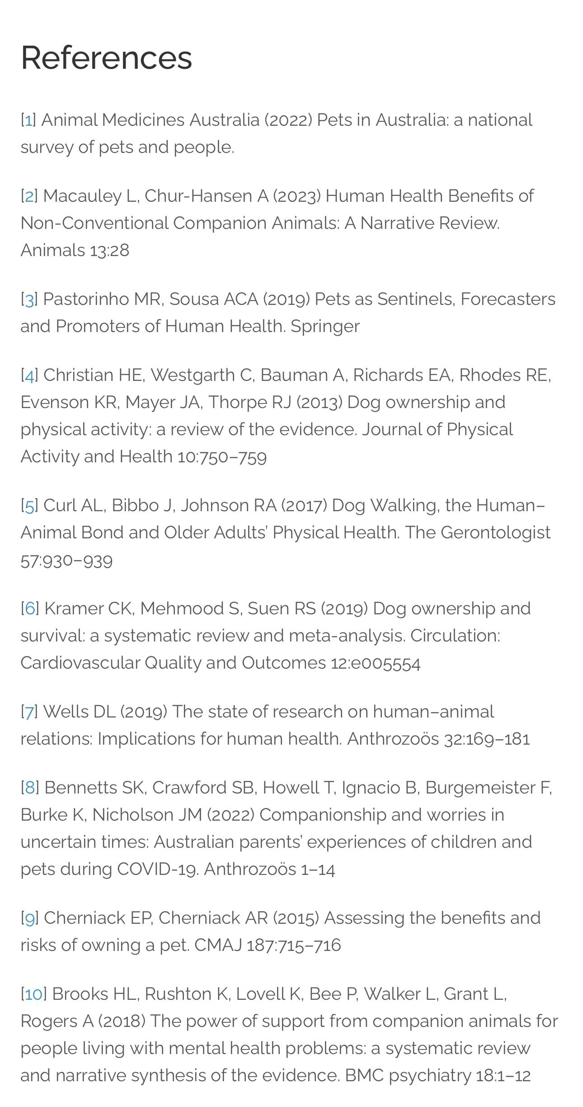
Researching Evidence

Page 13

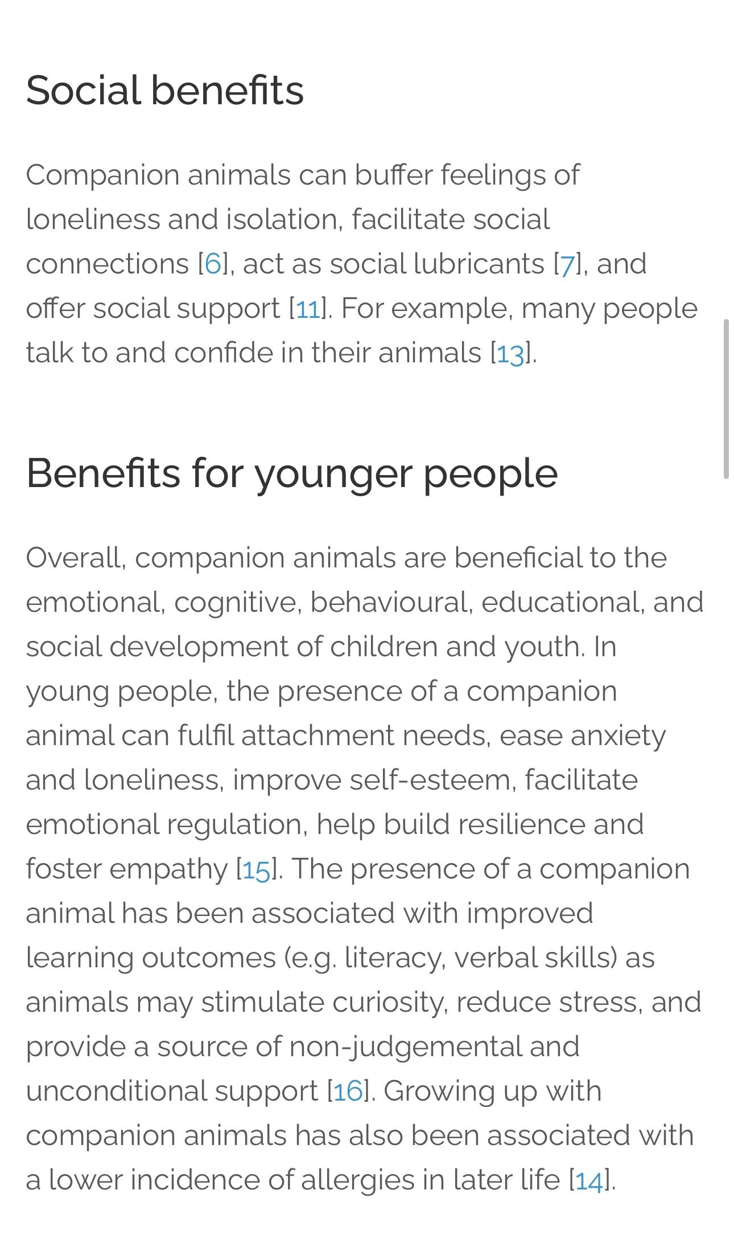
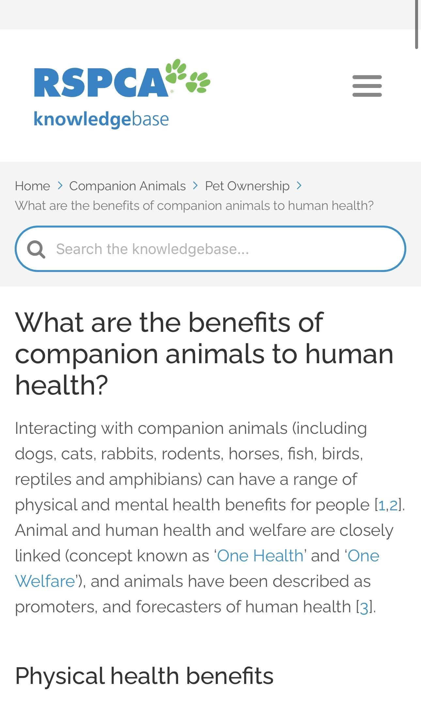

Page 14
Reference List: https://kb.rspca.org.au/knowledge-base/what-are-the-benefits-of-companion-animals-to-human-health/
- [4] Christian HE, Westgarth C, Bauman A, Richards EA, Rhodes RE, Evenson KR, Mayer JA, Thorpe RJ (2013) Dog ownership and physical activity: a review of the evidence. Journal of Physical Activity and Health 10:750–759
- [5] Curl AL, Bibbo J, Johnson RA (2017) Dog Walking, the Human–Animal Bond and Older Adults’ Physical Health. The Gerontologist 57:930–939
- [6] Kramer CK, Mehmood S, Suen RS (2019) Dog ownership and survival: a systematic review and meta-analysis. Circulation: Cardiovascular Quality and Outcomes 12:e005554
- [7] Wells DL (2019) The state of research on human–animal relations: Implications for human health. Anthrozoös 32:169–181
- [8] Bennetts SK, Crawford SB, Howell T, Ignacio B, Burgemeister F, Burke K, Nicholson JM (2022) Companionship and worries in uncertain times: Australian parents’ experiences of children and pets during COVID-19. Anthrozoös 1–14
- [9] Cherniack EP, Cherniack AR (2015) Assessing the benefits and risks of owning a pet. CMAJ 187:715–716
- [10] Brooks HL, Rushton K, Lovell K, Bee P, Walker L, Grant L, Rogers A (2018) The power of support from companion animals for people living with mental health problems: a systematic review and narrative synthesis of the evidence. BMC psychiatry 18:1–12
- [11] Hughes MJ, Verreynne M-L, Harpur P, Pachana NA (2020) Companion animals and health in older populations: A systematic review. Clinical Gerontologist 43:365–377
- [12] Zoanetti J, Young Y, Nielsen,TD (2024). A Scoping Review of the Risks Posed by Companion Animals to Older Adults. Anthrozoös, 1–17.
- [13] Headey B (2003) Pet ownership: good for health? Medical Journal of Australia 179:460–460
- [14] Chan MC-H, Schonert-Reichl KA, Binfet J-T (2022) Human–Animal Interactions and the Promotion of Social and Emotional Competencies: A Scoping Review. Anthrozoös 1–46
- [15] Purewal R, Christley R, Kordas K, Joinson C, Meints K, Gee N, Westgarth C (2017) Companion animals and child/adolescent development: A systematic review of the evidence. International journal of environmental research and public health 14:234
- [16] Matheson MC, Dharmage SC, Abramson MJ, Walters EH, Sunyer J, de Marco R, Leynaert B, Heinrich J, Jarvis D, Norbäck D (2011) Early-life risk factors and incidence of rhinitis: results from the European Community Respiratory Health Study—an international population-based cohort study. Journal of allergy and clinical immunology 128:816–823
- [17] Headey B, Grabka M, Kelley J, Reddy P, Tseng Y-P (2002) Pet ownership is good for your health and saves public expenditure too: Australian and German longitudinal evidence. Australian Social Monitor 5:93–99
- [18] Lima M, Mateus TL, Silva K (2022) With or Without You: Beneficial and Detrimental Associations Between Companion Dogs and Human Psychological Adjustment During a COVID-19 Lockdown Phase. Anthrozoös 1–20

Page 15
- [19] Rault J-L, Waiblinger S, Boivin X, Hemsworth P (2020) The power of a positive human–animal relationship for animal welfare. Frontiers in Veterinary Science 7:590867
- [20] Mueller MK, King EK, Halbreich ED, Callina KS (2022) Companion Animals and Adolescent Stress and Adaptive Coping During the COVID-19 Pandemic. Anthrozoös 1–20
- [21] Oliva JL, Johnston KL (2021) Puppy love in the time of Corona: Dog ownership protects against loneliness for those living alone during the COVID-19 lockdown. International Journal of Social Psychiatry 67:232–242
- [22] Batty GD, Zaninotto P, Watt RG, Bell S (2017) Associations of pet ownership with biomarkers of ageing: population based cohort study. bmj 359:
- [23] Delicano RA, Hammar U, Egenvall A, Westgarth C, Mubanga M, Byberg L, Fall T, Kennedy B (2020) The shared risk of diabetes between dog and cat owners and their pets: register based cohort study. BMJ 371:m4337
- [24] Bennetts SK, Crawford SB, Howell TJ, Burgemeister F, Chamberlain C, Burke K, Nicholson JM (2022) Parent and child mental health during COVID-19 in Australia: The role of pet attachment. PLoS One 17:e0271687
- [25] Wells DL, Clements MA, Elliott LJ, Meehan ES, Montgomery CJ, Williams GA (2022) Quality of the Human–Animal Bond and Mental Wellbeing During a COVID-19 Lockdown. Anthrozoös 1–20

Page 16

