A Guidance Handbook for Early Years keyworkers during Childhood Transitions.
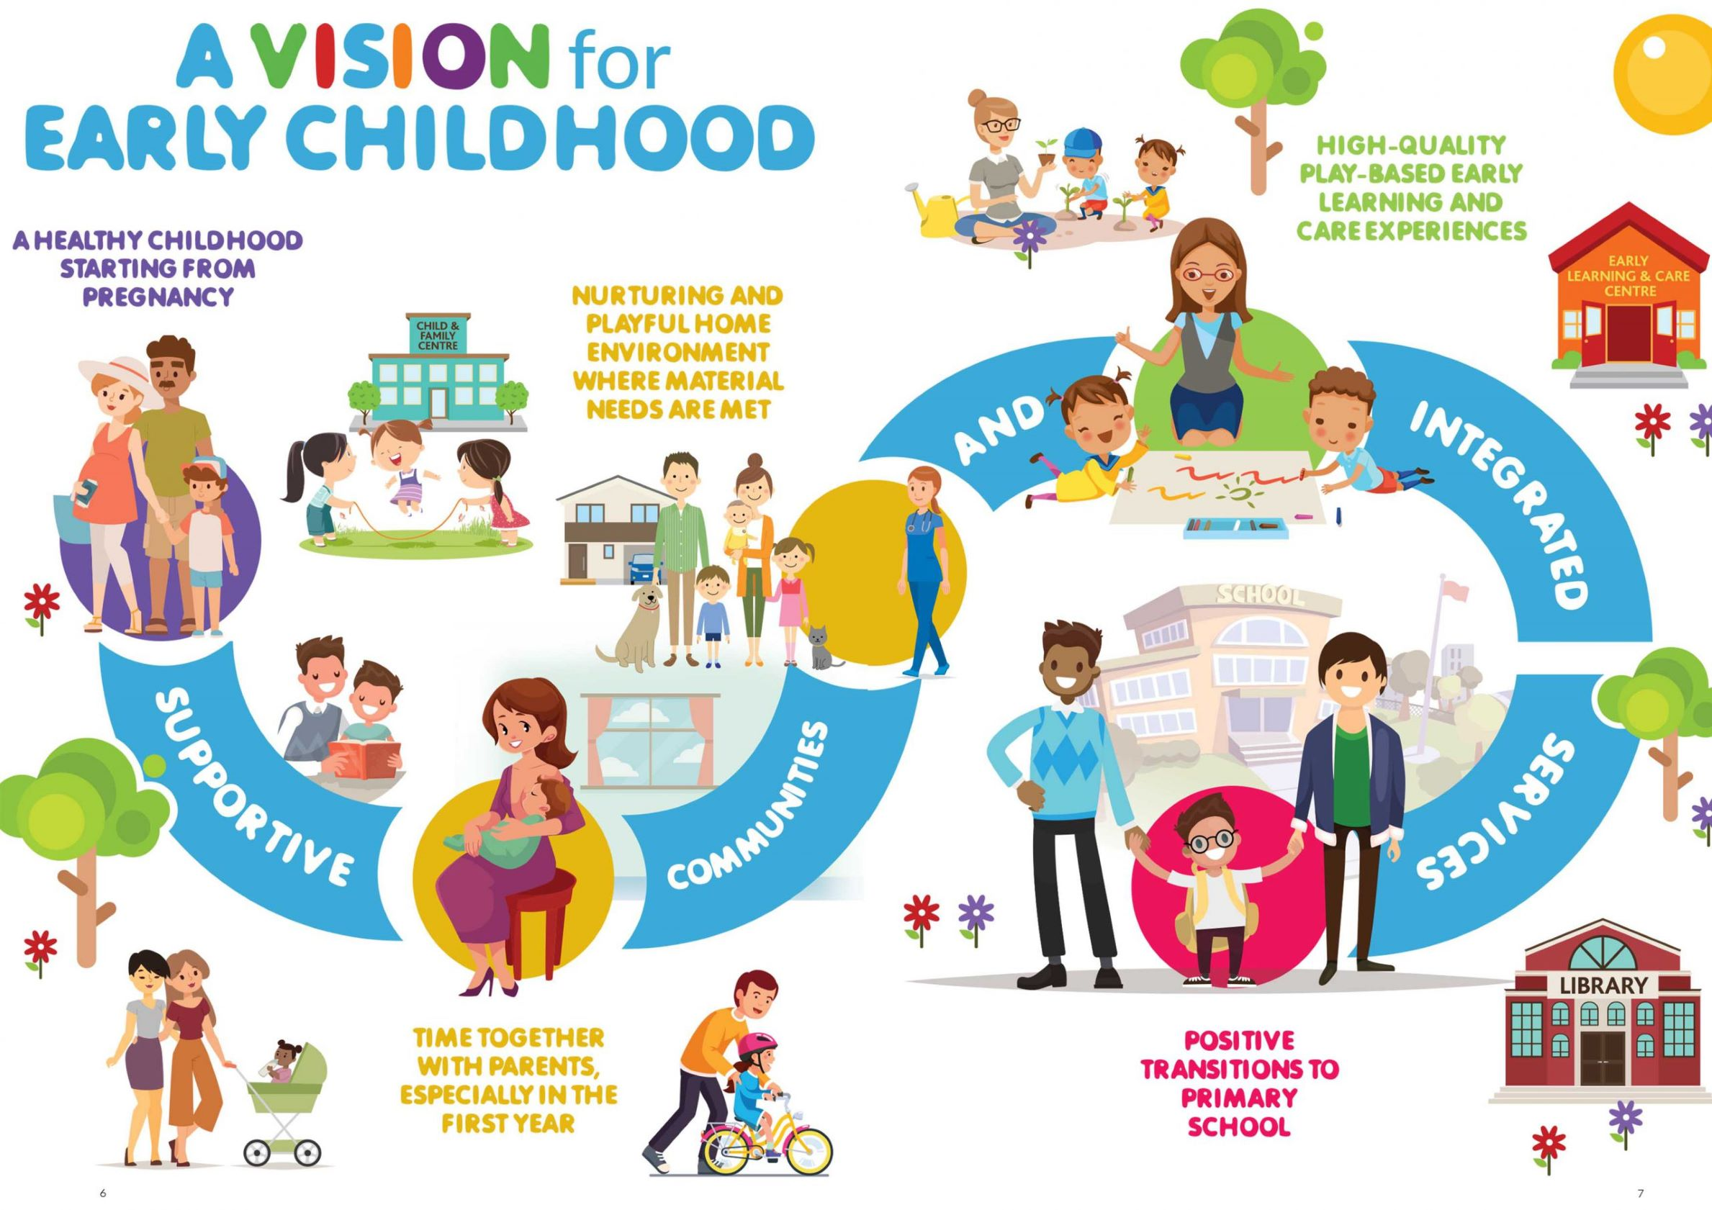
(Image A) A Whole-of-Government Strategy for Babies, Young Children and their Families 2019-2028

Sarah Powell
Human Development
2012735

Transition
Change or passage from one state or stage to another. The period during which something changes. (Collins English Dictionary & Thesaurus).

Contents Page
1. Introduction: 3
2. Quality Transition in Early Years 4-5
3. Roll of the Adult 5-7
4. The needs of the child 7-11
5. Partnerships 11-14
6. Interventions 15-16
8. Proposed outcomes 16
9. Reference list 17

2

Theorists in early years education
i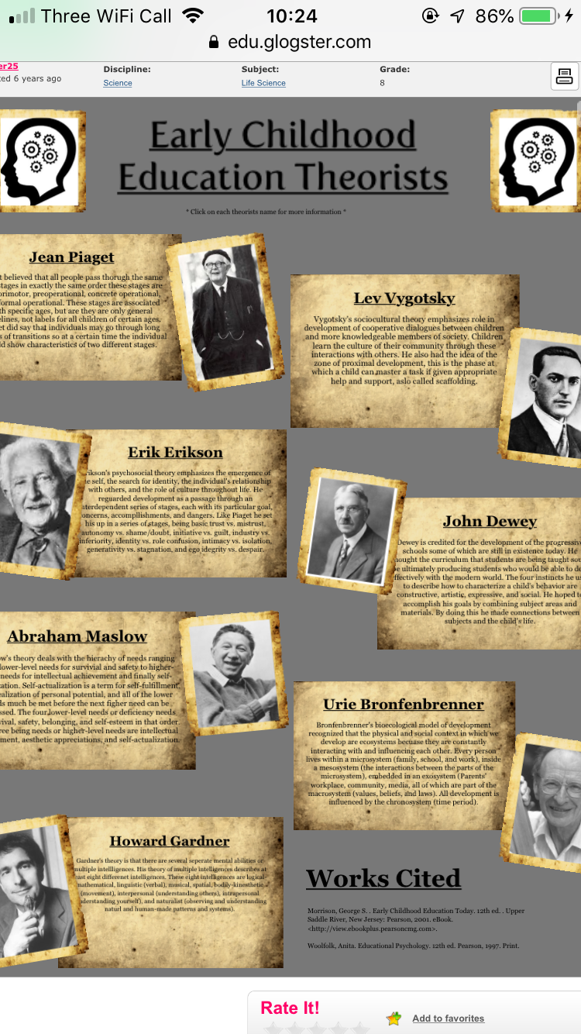
Source: Pinterest

Introduction
The transition period in Early Years is a significant change for the whole family. it can be very stressful and an unsettling time for both primary care giver and child. However, it is important that the first transition goes as positive and as smooth as possible as this can benefit further transitions in a child's life. Therefore, it is important that both home and schools work together in the best interest of the child. If the partnership between primary care giver and the keyworker is both frequented and of high quality then this will have a direct impact on the development of the child (Foley and Leverett, 2008). Children will experience many transitioning periods right through from babies to toddlers, teenage years and right through to Adulthood.
3

How to use the Handbook
This handbook is designed for keyworkers, working with children aged 0-3 years the aim of this handbook is to provide guidance for all early year's keyworkers based on research and Knowledge. Many schools and settings are working in partnership with parents to ensure a smooth and positive transition. There are many different stages of development that a child goes through when transitioning into Early Years environment. There is a significant amount of information that needs to be obtained and recorded. There are lots of ways that information can be retained and shared with both primary care giver, key worker, and or significant agencies. Example All about me sheets, parents' questioners and parent partnership forms. It is good practice for settings to have a Transition policy that can be redeemed from the schools. It is both primary care giver and keyworker to ensure and the responsibility in helping the child have a smooth and easy Transition.

“This first experience children have of school has a great impact on their progress and future schooling “(Margetts, K. 2007). “For many children the change of setting and sense of moving on acts as a stimulus for development but if they find this change too abrupt there is a risk that the child will regress” (Bennett, J 2007)

Quality transition in early Years
Quality Transition is paramount when moving into a new environment and is a process that lots of children go through. It is a period that is filled with a range of mixed emotions for both the child and primary caregiver. “It is generally viewed as an expected stage in every child’s life and many children see the challenge of starting school a positive experience” (Fabian, H 2007 and Moss, P 2007) But research also shows that “too many children experience starting school as a culture shock” (Brostrom, S 2007).

4

For many children the change of environment or setting acts as a stimulus for development. Brostrom stated that any transition process should be that it supports the child and family to feel welcomed and valued in the new environment. This in turn will help the child to feel safe, secure, confident and competent to face the challenges ahead. It needs to be considered as a happy and adventurous transition and not a rushed process. The effectiveness and quality of the Transitioning period depends largely on communication between parents, keyworks and other agencies involved. Such as the child referral scheme co coordinators, and any other relevant agency workers involved.

The role of the adult

It is all keyworkers and primary caregivers to ensure the safety, welfare and wellbeing to all children in their settings. You must enable the safe, secure, warm, stimulating and warm loving environment in all aspects of the child development and growth throughout their child transitioning period.
Children have the right to be protected and kept safe from harm (Article 19 – UN convention ‘Rights of a Child’.
“Every person in contact with or working with children, young people and their families; Should understand their roll and responsibilities to safeguard and promote the welfare of children”. (all Wales Child protection procedures 2008 pg. 4).
All keyworkers should be familiar with and follow their organisations procedures, policies and protocol for safeguarding and promoting the welfare of the children. All keyworkers should receive the appropriate child protection training. Therefore, should have access to: The Wales Child Protection Procedures.
The welsh Government committed to using the United Nations Convention on the rights of the child (UNCRC) for its policies for children and young people (2004.) In January 2011, the National Assembly for wales approved a new law - the rights of Children and young persons (Wales) measure 2011. This received

5

Creating a warm and stimulating, loving and safe environment enhances the child's ability to settle in whilst going through their transitioning period. A child-centred approach to education instead of the teacher's approach was the work that Montessori was the key driver of establishing, The Unique Child and was acknowledged by Montessori and that it was best practice in the early years work for children and was based around the child's unique abilities. Play-based approaches used to extend thinking and develop ideas. Adults as co-thinkers and partners in play provide the support, confidence, capability and challenges children need to initiate their own learning. However, as children transition through the Foundation Stage and into school, there can often be a move towards more adult-directed activity. Core skills are taught in fun ways, play is how children learn and develop their skills and mastered their existing skills. children are active, and play can be spontaneous with little or no planning you will be helping them to grow and to develop in every way. artwork and role play are recognised as fundamental to deeper understanding of the world and self-awareness. Role play, outdoors, sand, water play and play dough are used. Therefore, if inspiring stimulus is used to help them to be active participants in leading their own learning, we don’t have to control their experience with a desire for them to ‘sit still and listen’. Everyone should be able to play regardless of any additional needs.

The German educator Fredrich Froebel (1782-1852) set up a Kindergarten (nursery) in Germany where he was able to test his ideas about play. He believed in outdoor and indoor play, and is recognised as inventing finger play, and many songs and rhymes. Many of Froebel's ideas still influence modern thinking about play. (Home based childcare Pg. 151)

6

Postnatal factors that can affect development
Diet, Food allergies, Accident, Health issues, Sensory Impairment, Learning difficulties, Lack of stimulation, Breakdown of relationships, Loss and Bereavement, Environment and poverty, Culture.
All aspects of child's Physical development can be met through adequate activities and experiences. As mention that all children are unique and develop at different stages. Therefore, to promote the health, wellbeing and physical development of the children in your care., you must take all these aspects into consideration when planning daily activities, outings and tasks. Consider before planning, it must be right for you and the children in your care.
The five stages of development are: -
- Physical
- Intellectual or cognitive
- Language
- Emotional
- Social

There are things you will do every day as a keyworker in your setting and this is automatic you will be watching and observing the children in your care, observing is a key factor of good practice. Observing children is very valuable and important

Why you need to observe
- To provide parents information and other professionals.
- To check the child's development and growth
- To learn more about the individual child's need
- To help identify any problems
- To check that planned activities are appropriate to that child
- To help plan activities
7

The needs of the child
All Childrens needs should to be met and cared for in a loving, caring, warm, happy, welcoming and stimulating environments. No child should be excluded or disadvantaged because of race, colour, Ethnic or national origin, gender, religion beliefs, marital status, age, social class, employment status, sexual orientation and special educational needs and or disability. Children need to be able to form secure attachments with their keyworker, as some children may be experiencing a sense of loss when leaving their primary care giver. Experiences within the childcare setting should be based upon what the child's development stage. along with information from the child's primary caregiver, on what their likes and dislikes; to ensure that the transition goes as smoothly as possible for them. “Relevant and appropriate activities need to match the level of the child’s needs and provide them with the best possible, enjoyable experiences as this can have an adverse impact on their well-being, as well as their development”. (Smidt, 1998)
The holistic approach and a child centred approach within the setting will enable all the practitioners, especially the key worker, to observe and plan for the children needs and development stage. Supporting children to learn at their own pace to developed encourage to explore their own interests in a warm comfortable natural environment. The holistic approach in early years development is recognised throughout early childhood development and a ‘hand-on-approach for key workers and early childhood educators. Keyworkers can support and encourage the holistic development; by asking open end questions, build a stong trusting bond, create a stimulating warm and friendly environment.

Therefore, the keyworkers should Focus on and consider the child’s interests, likes and dislikes and incorporating these into the child's learning portfolios.

Piaget centred on how children think and learn. He proposed that the human mind contains structures. Piaget believed that babies are born with innate schemas. The more a child develops the more schemas they construct. The stage of intellectual growth constantly modified as new experiences happen.

What Are Schemas?
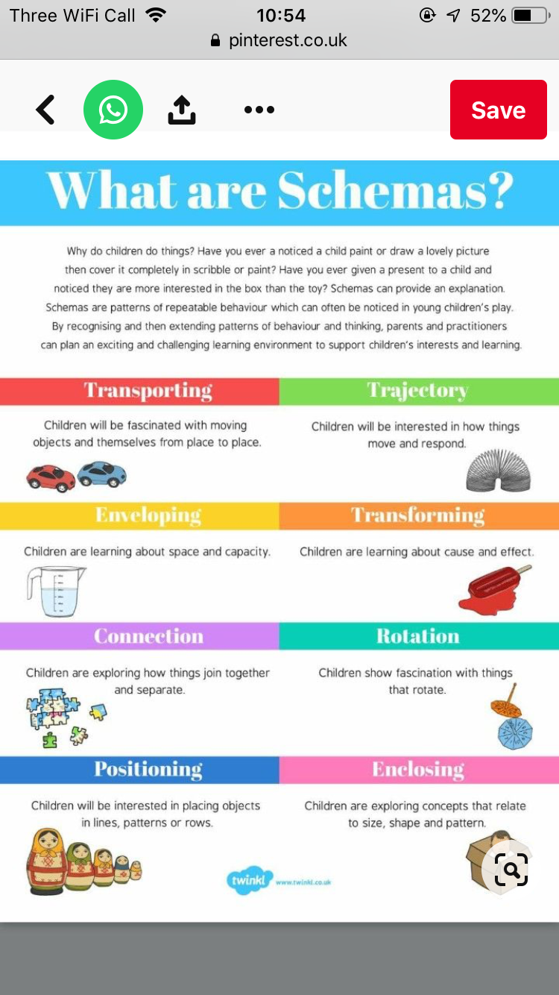
Image (Pinterest: accessed on 24/11/2020)

9

In 2011 the welsh government made the UNCRC law in Wales, with the rights of children and young persons (Wales) measure 2011. There are 54 articles in the convention.
The United Nations Convention on the rights of the child (UNCRC) Article 3: All organisations concerned with children should work towards what is best for the child. Article 12: Children have the right to say what they think should happen, when adults are making decisions that affect them, and to have their opinions considered.
‘Play’ is a very important part of the transition process, the child has a ‘right to play,’ as governed by the United Nations Convention on the rights of the child. Play can be both child and adult initiated, where interaction between both child and keyworker can be displayed in a positive manner”. Piaget (1951), Vygotsky (1978) and Bruner (1974) have all played pivotal roles in shaping the educational practices of today. (Maynard and Thomas, 2004).

The Foundation Phase Framework places emphasis on the seven learning outcomes for children. The child needs a variety of play opportunities to enable them to achieve such outcomes in the following areas: (Pacey).
- Personal and Social Development
- Well-Being and Cultural Diversity
10

- Language, Literacy and Communication
- Mathematical Development
- Welsh Language Development,
- Knowledge and Understanding of the World,
- Creative Development.

Abraham Maslow hierarchy of needs shows the needs of the child and what is needed for the child to Develop onto the next stage.

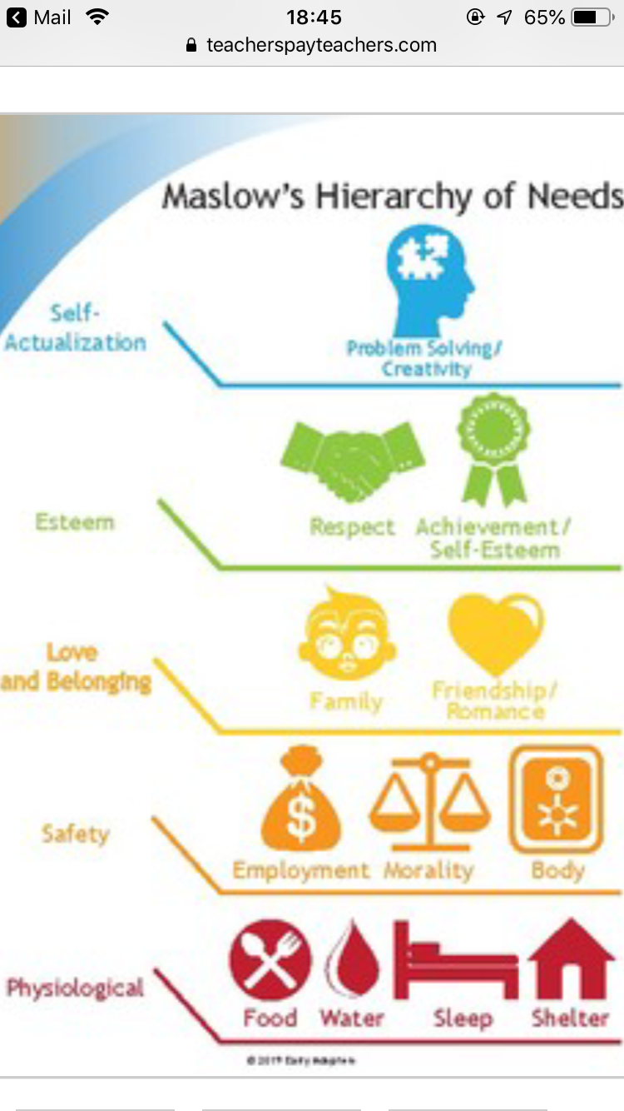
Image [ teacherpayteach.com]
11

Partnerships
As a keyworker, it is your duty that parents are involved from day one in the transition process. It is important that they continue to be involved and informed daily on the progress of their child's development. Two-way communication Daily chats, open door policy and continuous communication is vital and a great way to interact and a way of communicating to build relationships as well as sharing of resources, events and information sessions. Communication requires time and effort from all parties involved in the child's day to day life. Lack of communication can lead to misunderstanding and misinformation; it is important to discuss the planning of all routines with parents and or Primary caregiver to ensure both child and parents needs are met.
“Communications with the parents need to be flexible and you need to be mindful of adapting to different situations where English is an additional language, or the parent may have a specific learning need” (Pacey, 2018).

Individual Assessment and Planning Sheet.
Example:
My Name Is:

I can do:

My Next steps are:

Key worker/primary care giver are going to help me by:

(source:

12

For us to continue to provide a good quality childcare service that benefits all the children and their parents we would be much obliged if you would kindly take the time to complete this short questionnaire and return to the setting as soon as possible
Example

NAME: ___________________________DATE_____________________________
- Are you happy with the overall childcare that is provided for your child?
_______________________________________________________________
- Are there any improvements you feel the setting could make that would benefit you, if so what would these be?
________________________________________________________________
- Are you happy with the environment and play provisions that are provided?

________________________________________________________________
- Are you happy with the activities, games and learning resources that are available for your child?

________________________________________________________________
- Do you consider your child happy, settled and confident in the setting?

________________________________________________________________
- Are you happy with all the information that is provided to you regarding your child’s daily routine?

_________________________________________________________________
- Any further comments you would like to make to which could help to improve the setting in order that all the children in our care remain happy/cared for in their own unique way?
13

Thank you for taking the time to answer this questionnaire

Parental permission must always be received when working with any multiagency, such as: Health visitors, Local authority, this multiagency approach is important to be proactive and all those involved with the child must come together to communicate in partnership to improve the child’s life and development chances. Strong links need to be made between the child and keyworker, for the child to build a secure and happy attachment to enable them to settle into their new routine smoothly and confidently. “Communication is paramount through verbal and non-verbal strategies as well as responding appropriately and showing a genuine interest in what the child has to say or are doing”. (Daly, Byers, Taylor, 2004)

14

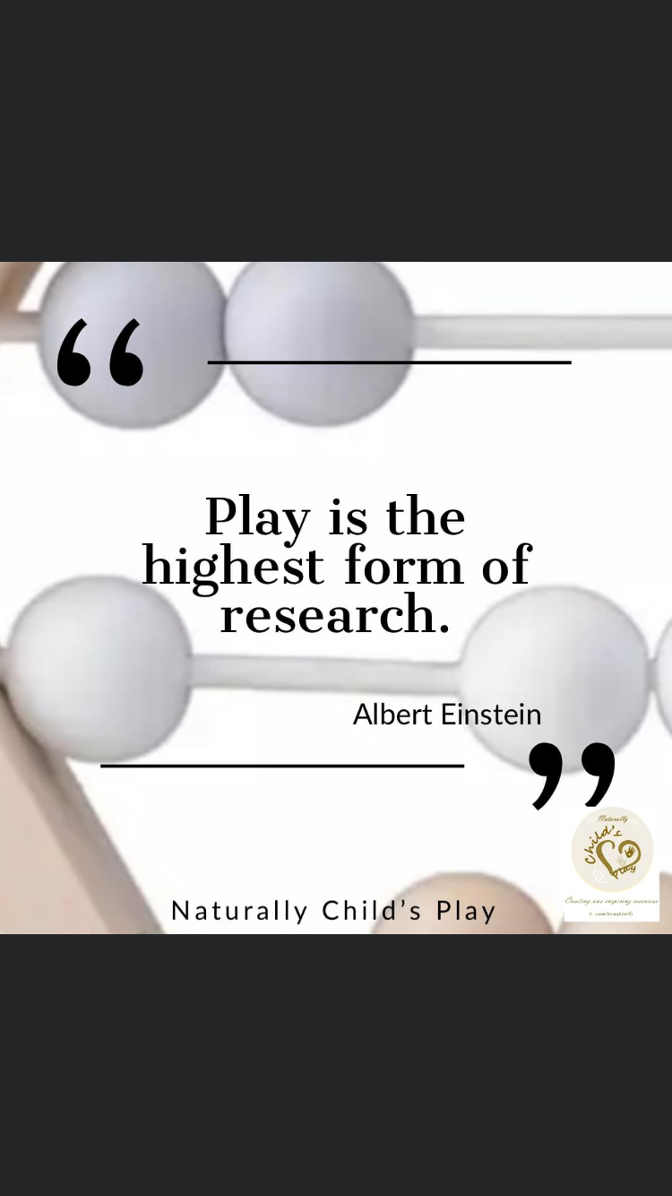
Interventions
All Children need to receive high quality childcare and support during their transitioning period. Children need to feel safe, comfortable, respected, welcomed and secure in their environment. Full Commitment is needed from all professionals and primary care givers, keyworkers, manager and other staff to develop positive links and have a shared approach in early intervention. Early intervention identifies any problems or risk to a child and their families. Therefore, this approach can provide a good start for the child. The child centred focus can prevent any serious issues arising. Prevention services are based on the safety and wellbeing for all children and their families
“In the affluent area of Reggio Emilia, Italy, the provision of high-quality childcare and education has been a priority of all the local people since the end of the Second World War. Reggio Emilia’s educational philosophy and network was founded by Loris Malaguzzi. He participated in the birth and building of the municipal preschools, for children and 3-6 years and the infant-toddler centres, birth to three years. The philosophy of the nurseries is that childhood is important and that the children should encounter a range of meaningful experiences and activities to enable them to represent what they have seen, heard and learned. Children’s work here is very impressive and their concentration in the different areas of learning are outstanding. Parents and other people in the community are involved in the “
15

Key Words: -
Safeguarding – look after, protect and maintain the wellbeing of children.
Respect – show consideration for and recognise individuals' opinions, needs and values.
Effective communication - Is one of the core key skills in early years.
Valued - Given importance, appreciated.
Inclusion - The process of recognising, understanding and overcoming obstructions.
Confidentiality - Discretion, privacy, keeping information secret.
Attachment – A unique emotional bond between a child and an adult.
Prejudice - Discrimination, narrow mindedness, unfairness, bigotry.

Proposed outcome

Quality transitioning is paramount for the development and confidence for the child, primary care giver and the keyworker. The child should feel welcomed, happy, safe and their rights are respected. (National minimum standards). Therefore, all keyworkers should have adequate training and are up to date with all policies and procedures in their setting. Keyworkers also have a duty to treat each child as a unique child and care for the child according to their values and practices. Therefore, you should provide equal chances for every child to develop to their full potential taking in to account the child's, stage of development, ethnicity, gender, ability and language. Keyworkers should be working towards the foundation phase in wales for children to learn through play and experiences.

“We know now that play- in the sense of ‘messing about’ either with material objects or with other children, and of creating fantasies – is vital to children's learning and therefore vital in school.” (1976: 193)

16

References

Aubrey, K. and Riley, A. (2019) Understanding and using Educational Theories. 2nd Ed. London: Sage.

Extract from the All-Wales Child Protection procedures (2008). Part 2 Roles and Responsibilities. NCMA Cymru. Available at: http://www.allwalesunit.gov.uk

Riddall-Leech, S. (2013) Home-based Childcare. 2nd Ed. Essex: Pearson Education Limited.

Teacherpayteacher (2020) [ Pinterest] 19th November. Available at: https://www.teacherspayteachers.com (Accessed 20th November 2020).

Welsh Assembly Government (2011). National Minimum Standards for Regulated Child Care. Available at: http://www.cymru.gov.uk

Welsh Government ( 2011). A Summary of The United Nations Convention on the rights of the child. Available at: http://www.unicef.org.uk/Documents/Publications-pdfs/UNCRC_PRESS200910web.pdf

17

