Human Progress

Myth or Monster?


Economic Anthropology
BY: Natasha Graham
SN: 1810918
Tutor: Andy Bevan




From the point of view of economic anthropology, is it meaningful to speak of human progress through the ages? Is there a useful distinction to be made regarding technological, cultural and moral progress?

Throughout this assignment I will use world leading oil and gas suppliers BP, as an example to demonstrate the problematic task of defining human progress. These complexities are increased from an anthropological standpoint. The essay is structured to reflect both the Oxford English Dictionary’s definition of corporate growth as an example of human progress, and human progress from the point of view of economic anthropology.

Initially the focus will be on the economic progress of BP. I will clearly show that in terms of financial success, and in keeping with O.E.D.s definition these humans are progressing economically as corporate giants. However, when anthropological methods of research are applied, we see very little of that progression benefitting humans, the animal kingdom or our environment.

The 2010 Deepwater Horizon Oil spill on the Gulf of Mexico (E.P.A. 2023) will be used as an anthropological case study to expose the progression of immorality and the unethical practices that are needed to maximize profit margins. Government reports will be examined from an anthropological frame of reference. An analysis of the true cost of BPs worldwide economic success has been conducted to assess the consequences of this ‘progress.’ This piece explores how changing cultural and moral values fused with technological advancements have, in some cases, led to the retrogression of human progress. Some of the most vulnerable communities in society are being displaced and burdened with debt, and our environment is continually recovering from biological disasters. My findings demonstrate that attempts to define human progress in compliance with economic progress is meaningless, because economic growth in neo capitalist societies benefits so very few humans and dramatically reduces biodiversity. From an anthropological point of view how can it possibly be considered human progress?

What is progress?

“The process of improving or developing, or of getting nearer to achieving or completing something” (Oxford English Dictionary 2023).

The Oxford English Dictionaries definition indicates that progress is relative to the achiever’s aims and objectives. Within this essay I will demonstrate the need for context, both historically and culturally. Fuel providers, such as world leading oil and gas suppliers BP, have made great progress in terms of economic growth. However, their reputation for ecological disasters (E.P.A. 2023) and record profit margins (B.P. 2023) whilst thousands die each year from fuel poverty (gov.com et al 2023) indicates the word progress is in fact relative to the achiever as OED suggests. In Eurocentric neo capitalist societies the development and improvement aspect of the Oxford English dictionary’s definition is often overlooked, unless it is relative to developing and improving profit margins. As Clarke and young remind us, ‘given human arrogance and the prevalence of progressivist ideology, it is commonly presumed that the emergence of Homo sapiens is the inevitable apex of evolutionary processes’ (Clarke and Young 2011). Corporate giants have no need to consider the ‘small people’ unless good public relations are needed to increase profit margins (msnbc.com 2010). Most humans don’t contemplate the considerable damage to aquatic life from many washing up detergents, simply because it cost fifty pence extra. Everyday costs are cut, and lives are destroyed on many levels if we look at human progress through the ages. I am not arrogantly, suggesting I am a beacon of morality; I am also guilty of this casual disregard to anything I fail to consider kin.

Donna Haraway’s plea that we ‘make kin not babies,’ (Haraway 2016) becomes more relevant today as humanity faces the reverberations of an unsustainable future in a technocratic world of cultural amalgamation and predictive programing. Virtual worlds are continuously being created enabling anxious humans to escape their unsustainable reality, however media violence has been proven to modify the behavior of young people by several contemporary scholars (Anderson. C et al 2003).

Who stands to gain from this unsustainable consumerism and cognitive dissonance of both young and old in many of the poorest communities? Profit becomes a priority in societies that surrender all hope of a more empathic future that is not reliant on the othering process. Neo capitalism depends upon the othering process as its contingency plan to maintain corporate prestige. If we have no one to look up to how will we learn to aspire or compete. If there are no others we could push the new materialist agenda, enabling water, land and air to become our kin.

As I previously discussed humans are perfectly capable of nurturing and protecting their kin. A change in our mindset would allow for a fresh more sustainable perspective.

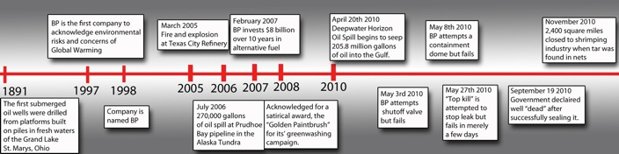

Figure 1: BP History;1891 launch – 2010 Deepwater Horizon Oil Spill (https://teachers.henrico.k12.va.us/elko/stacy_j/1501/TSA2011/TSA2011/BP_Timeline.html)

The timeline in figure 1 charts the success and disasters since BP were established in 1891. Initially BP were the first oil and gas company to acknowledge global warming concerns and environmental risks in1997. The company did not officially name themselves BP until 1998. Although eight billion was invested in alternative fuel over a period of ten years, it is clearly a pittance when we factor in the £695 billion profit BP made over that ten-year period (figure 3). As BP C.E.O Bernard Looney (you could not make this up!) announced last week BP had record profits in over 8 years despite thousands still suffering or dying from fuel poverty related deaths.

Below is a graph detailing BPs share prices from 2000 to 2018.

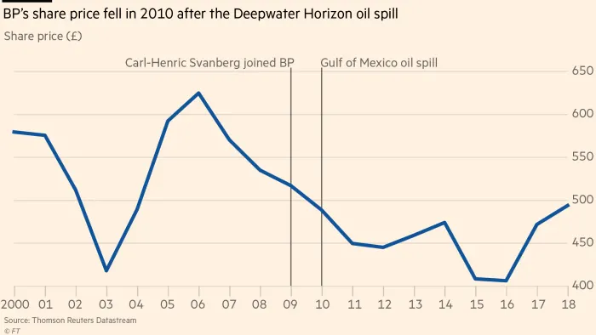

Figure 2: Source; Thomson Reuters Data Stream (Financial Times 2018)

The graph in Figure 2 clearly shows a continuous slump in share prices after the 2010 Deepwater Horizon oil spill. The CEO at the time created a media frenzy when he stated, “I hear comments sometimes that large oil companies are greedy companies or don’t care. But that is not the case in BP. We care about the little people,” (nbcnews.com 2010) in reference to the villagers along the Gulf of Mexico, whose livelihoods had been destroyed by BPs ecological disaster. BP in the past have avoided reducing carbon emission, perhaps in fear of losing profit and popularity within the corporate world. Further investigations from an economical anthropologist perspective of their rising profit margins also leads one to speculate their lack of accountability for carbon emissions was a deliberate attempt to increase BPs economic progress.

Peer reviewed studies indicate that over a decade later the repercussions of the Deepwater Horizon oil spill are still manifesting and impacting on deep sea eco systems (Fisher et al., 2016). These ‘side effects’ of BP’s profit margins are also outlined by criminology lecturer Vicky Cooper, and Socio-legal studies professor David Whyte. Their thesis lambasted ‘the violence of austerity’ created by fuel poverty (Cooper. V. et al 2017).

Below is a graph of UK BP gas prices compared with US Henry Hub since 2008

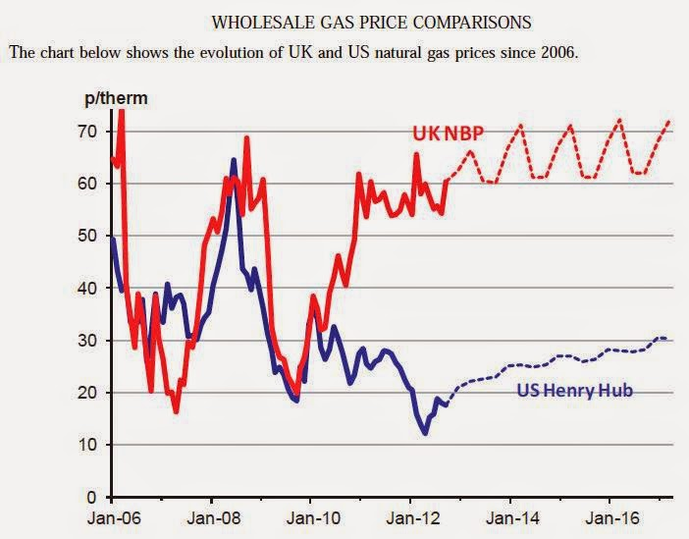

Figure 3 (Source unknown)

Although the graph in figure 3 displays gas prices up to 2016, it reveals ongoing escalating gas prices from BP in comparison with the US owned Henry Hub. This trend has continued as austerity measures also increased amongst the most vulnerable in society. Vulnerable both financially and physically.

This rise occurs after 2010, which is the same year as the Deepwater Horizon oil spill. Once again this would suggest an avoidance of financial responsibility for their negligence, a negligence that resulted in eleven human deaths, irreparable damage to the local community’s livelihoods, ocean and wildlife. Whilst billionaires avoided a reduction in healthy profit margins, prices were increased. Their profit margins were lower than previous years, as many non-influential figures turned away from the unethical practices of BP. The Royal Opera House recently rejected BP’s sponsorship, which prompted tenor Mark Padmore, to state, ‘we in the cultural sector need to ask difficult questions and encourage better practices. We must put sustainability, fairness, inclusivity and generosity at the heart of all we do,’ much to Daily Mail interviewer and former Tory, David Mellor’s dismay. He considers BPs latest promise to reducing carbon emissions is a ‘victory for the ‘wokery’ that is sweeping the nation and controlling our way of life’ (Mellor. D. Daily Mail 2023). I am assuming ‘our way of life’ does not refer to the ‘small people’ BP CEO, Carl-Henric Svanberg, claimed to care about (nbcnews.com 2010).

In February 2001 the UK government announced fresh plans to end fuel poverty by 2010 (et al 2001). Clearly no remarkable progress has been made according to the governments fuel poverty fact sheet 2022 (gov.com 2023), however it is presented in such a way that it appears progress is being made. Upon further inspection it offers proof that this is not entirely the case. The progress refers to efficiency ratings, however no matter how efficient a building is at retaining heat if the tenant cannot afford to switch the heating it is useless.

I have displayed BPs meteoric rise to the top of the oil and gas industry on clear timelines to enable comparisons to be drawn between the economic progress of one corporate fuel provider and the devastating effects of rising fuel costs, despite energy prices lifting BP profits to its highest in eight years (Bousso 2022). Perhaps a correlation exists between the poor moral progression and ethical practice of the company and its growing profit margin and increasing fuel poverty deaths. Robert Tressell’s, The Ragged Trousered Philanthropist, is an unequivocal political work detailing the impact of economic growth on working class lives that fail to progress under capitalist regimes. Tressell’s work is even more relevant today as we face an unsustainable future that considers heating a luxury item. Tressell reminds us “There is no such thing as being neutral: we must either help or hinder.” (Tressell. R. 1914)

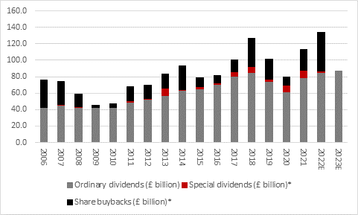

Figure 4 – BP bumper profits (tradingadmin.youinvest.co.uk 2023)

The bar chart in figure 4 calls attention to the notable decline in profit during 2009 and 2010, supporting evidence suggests this was due to poor ethical practice and ecological disasters. The waning profits of 2020 are during the covid crisis that left many small businesses bankrupt. However, BP are not a small business and even during the profit margin slump of 2010 over 40-billion-pound profit was still accumulated and 80 billion profit was made during Covid. This mounting evidence would suggest very little human progress in terms of culture and morality.

From an anthropological viewpoint, it is impossible to define human progress through the ages because it is relative to the achiever and requires context. A distinct lack of human progression is evident when we look at the degradation of the environment since the beginning of the industrial revolution and the erosion of culture and morality during the technocratic revolution we are witnessing within our lifetime. The technocratic amalgamation of cultures via algorithms and the desensitization of sensationalized violence requires a more detailed study that I am unable to conduct within this short piece.

It is with great hope that David Mellor’s prediction was indeed correct when he claimed, victory for the ‘wokery’ is sweeping the nation and controlling the corporate way of life. Heating is not a luxury item it is a necessity.

Bibliography

Anderson, Craig A., et al. “The Influence of Media Violence on Youth.” Psychological Science in the Public Interest, vol. 4, no. 3, 2003, pp. 81–110.JSTOR, http://www.jstor.org/stable/40059680. Accessed 6 Feb. 2023.

“An End to Fuel Poverty in the UK?” Energy Exploration & Exploitation, vol. 19, no. 1, 2001, pp. 88–90. JSTOR, http://www.jstor.org/stable/43754193. Accessed 3 Feb. 2023.

Boussou.R “Energy prices lift BP profits to 8 year high” https://www.reuters.com/business/energy/bp-records-highest-profit-eight-years-2021-2022-02-08/#:~:text=For%20the%20year%2C%20BP%27s%20%2412.85%20billion%20profit%20compared,year%2C%20down%20%248.3%20billion%20from%20a%20year%20earlier.

Fisher, C., Montagna, P. and Sutton, T. (2016) “How did the Deepwater Horizon Oil Spill Impact Deep-sea eco systems?” Oceanography, 29(3), pp. 182–195. Available at: https://doi.org/10.5670/oceanog.2016.82.

Haraway. D., “staying with the trouble: making kin in the chthulucene” Duke University press, Durham and London. 2016

Moore, Anne. “Ending Child Poverty.” Fortnight, no. 465, 2009, pp. 11–12. JSTOR, http://www.jstor.org/stable/25704271. Accessed 3 Feb. 2023.

nbc news: “BP boss ‘sorry’ about ‘small people’ remark: BP Chairman Carl-Henric Svanberg apologizes for 'clumsily' referring to oil-spill victims as “the small people,” a remark that drew strong reactions.2010 https://www.nbcnews.com/id/wbna37739658

Tressell.r. “The Ragged Trousered philanthropist” Grant richards ltd 1914

united states environmental protection agency – EPA “deepwater horizon –gulf of mexico oil spill” https://www.epa.gov/enforcement/deepwater-horizon-bp-gulf-mexico-oil-spill

York, Richard, & Clark, Brett. (2011). “Stephen Jay Gould’s Critique of Progress”. Monthly Review, February 1.

