

LEVEL/LEFEL 4

Module Code: BMSW4002

Academic and Employability Skills

Name: Alexandra Dunai
Student Number: 1917409
Module Title: Academic and Employability Skills
Assignment Title: My Academic and Employability Skills
Name of the Lecturer: Joanna Walsh

Academic and employment skills are skills that play an important role in personal development as well as in professional development. These qualities can be acquired through exercise, through repeated practice. In this paper I will highlight the scientific notions related to the development of these abilities, using numerous examples from real life. Each notion will be defined and followed by an example from everyday life. In this paper I will try to exemplify my own communication skills, teamwork. A swot analysis will be performed and a personal development plan will be developed. The importance of these qualities and the way in which we can perfect and apply them in daily life. The term aptitude has its roots in Latin, which means "capable of". Skills is a set of mental and physical characteristics that are only individual, and stable of a person. Skills are characteristics that can evolve. In the situation in which they are adequate, they can be used, implemented in certain daily situations, having an efficient result, they can be called people's capacities. Skills are influenced by nature and on the other hand are influenced by humanity. Negative influences and facts stop the evolution of skills. Talent is also part of the skills branch. Also, skills can be classified according to certain criteria: sensory skills, psycho-motor skills and intellectual skills. Sensory skills define a person's ability to see, hear or smell. Psycho-motor skills define the ability to perform physical movements that combine physical qualities with those of thinking. Intellectual skills are manifested to a higher degree as an example when we try to memorize a poem. Also, skills can be classified in general as intelligence and special ones such as artistic, sports, scientific skills.
We can define academic skills as characteristics of care for students' behavior during the teaching-learning process. Practicing these skills stimulates the appearance of graduates' attributes, such as problem solving, efficient communication, innovation and creativity. Academic skills are based on academic writing, the ability to present, which are also based on more complex skills such as critical thinking. Therefore we can understand the importance of these academic skills in finishing an institution and also after finishing an educational institution and looking for a job. These basic skills include: independent learning, writing or written communication, presentation or spoken communication, research and referencing. These skills are the foundation of other more developed and more complex skills. It has been shown that these skills are much more difficult to develop, they include: criticality, academic writing, reflective writing, information management, understanding evaluation and also the production of dissertations.An example can be when students have the obligation to write essays, papers, case studies in almost all subjects. In order to improve these academic skills, students can seek the help of teachers and can also benefit from the help of specialists. Enployability skills are so caring skill can be transferable and are useful for every job. These skills involve the ability to create more attractive to the employer. They are employable skills are common and there are numerous attitudes of training in work. These skills increase performance improvement, promote teamwork, and allow you to be more efficient at work. Employability skills may not be present in the job description, the most important must be present those that will make you more attractive to the employer. Possessing these traits puts you in front of other candidates who are competing for the same job. Hiring skills differ by industry, in order to compete for a job one needs a resume. Hard skills are the skills developed through exercise, education. They are particularly important because they increase employee productivity and efficiency and subsequently improve employee satisfaction. These tough skills are hard to learn because they are related to personality. These skills can be proven by obtaining a certificate or experience in the field. Employers look for personal skills in personal resumes. Employers often look for job candidates with soft skills rather than tough skills. These tough affiliates are based on rules that remain unchanged regardless of the field in which you apply them. in fact, hard skills can be acquired from books or in schools. For example, a person can take basic and advanced accounting courses, gain work experience and pass the accounting exam. Hard skills are personality traits and communication skills are essential in the evolution at work. These skills characterize the way you interact with those around you. Soft skills are rather emotions that are much harder to master and evaluate. The greatest importance of these skills lies in the fact that they are not limited only in a certain field. Software skills make people flexible in a world that continues to change. Numerous research has found that software skills are essential to work at work. Communication skills are essential in terms of work, friends, family and superiors. Look for information about the workers of the company must have a transmission station and receive a message. These skills will be able to develop in the dedicated career. Being a good listener is one of the best ways a communicator can be. Thus, you can better understand what you want to convey the other problem, and will give an answer about the corrector. Body language, gestures and tone of voice also accompany the message for care. Look for transmission. Many clues can tell you how the person really feels. It is good to remember that the message must be as few words as possible. It is very important to be political in all conversations to give back, face to face as well as in writing. Another important characteristic is trust, it is very important to believe what you say. Equally active listening can be given to what the partner of the paper feels and thinks. It matters a lot to interact with people's care and different opinions. Simple actions are needed to be able to name people, make eye contact, and listen to the activity when they can be reduced or spoken face to face. The most important thing is this feedback, it enables the importance of communication. Teams are deliberately and carefully trained for a satisfying need for work to care for an individual or a group of individuals can not meet more effectively. In a work group, performance is a function of what members face avoid as individuals. Divided teams are characteristic, including a clear and clear goal. No commitment to teams, it is demonstrated by which they can apply the rules and rules of the team of desire and pay attention to the group process and the sense of mutual responsibility, both to team members and people as well as the team in whole. Project teams are the time team for limited formats for a completion or a specific task. When the team is performing the task, it is disbanded. When a team works well, each member feels that he or she is part of something bigger. Communication is open, members may feel opinions that are different from opinions are appreciated. Successful teams meet their work, deadlines and goals. Managing time well can help you improve your career. Having strong time management skills can ultimately lead to achieving key goals and flowing into your position. Time management skills include a variety of skills. You need to stay organized and keep a clear picture of what you need to complete and when. Assessing each responsibility for priority is essential to being a good time manager. Setting goals is the first step to becoming a good time manager. Developing strong communication skills can allow you to clarify your plans and goals for the people you work with. A fundamental part of time management is planning, be efficient in planning the day. When practicing good time management, you should also pay attention to your mental health. Taking the time to develop each of these skills will help you organize your daily work, whether you are in a job, looking for a job or trying to develop a new skill. swot represents the strengths, weaknesses, opportunities, therefore or analysis, swot is the technique for evaluating these four aspects of your business. For starters you need to make a swot matrix. This is a 2/2 grid, with a square for each of the four.
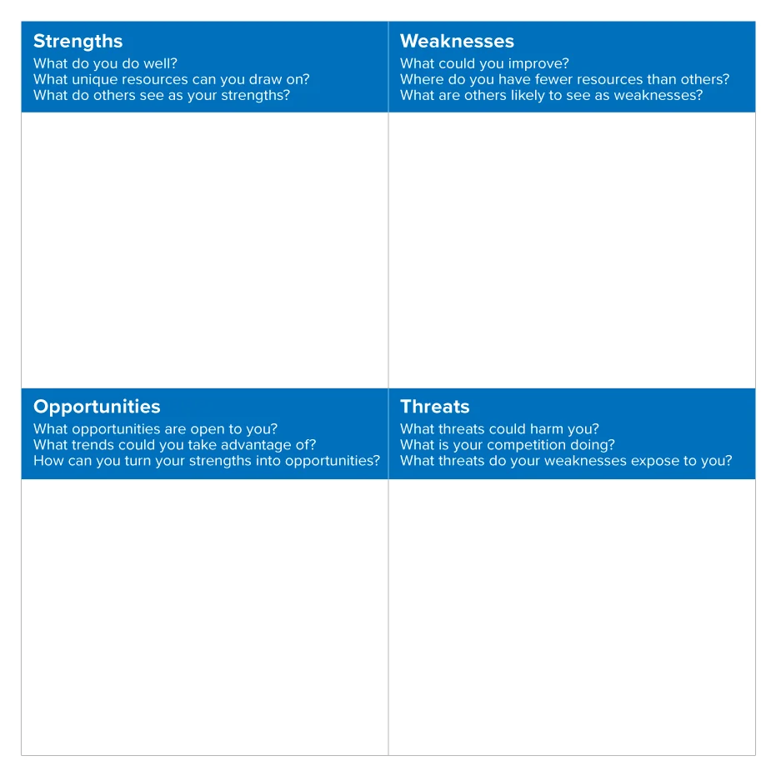
Taking notes involves recording key information points. The notes taken during the lectures can serve as study aids. Taking these notes implies a certain cognitive behavior. Taking notes can lead to more learning than mastering the course content. Taking notes will force you to engage your brain while you identify what is important in terms of what you are talking about and begin to organize the information into an intelligible format to describe later. This process, which is much more than just a joke from what you hear, involves some complex brain work. Academic writing is clear, structured and supported by evidence. Its purpose is to help the reader's understanding. Each discipline has certain vocabulary and types of discourse that they become familiar with along the way. Planning and concentration demonstrate an understanding of the subject, the structure demonstrates logical order and brings together related points and materials. The evidence demonstrates the knowledge of the thematic field is supported by arguments, opinions and evidence. Uses appropriate language and timing and is clear, concise and balanced. The purpose of academic writing is to communicate complex ideas in a way that makes them the least likely to be challenged. So it is important to avoid any ambiguity. The reference is made when you recognize the work of other people and allow the reader to locate the sources you have used. You should always refer to the materials of your mode to check what reference he knows to use for your mission or to seek the advice of your tutor. It is important to make absolutely clear where each idea or information comes from by referring to it in your own work. Plagiarism is an incorrect academic form. It can be deliberate or unintentional, so it is important to learn how to make the right reference. Plagiarism is when students knowingly present another person's language or ideas (or paper) as if it were their own work. Plagiarism includes the use of another writer's words, ideas, answers, or works without providing a clear acknowledgment of the original author and an accurate quote. When researching online electronic sources and / or using information from published or unpublished papers, students must fully and clearly recognize the original writer and use correct citation methods. Plagiarism in the classroom results in a failure of the plagiarized pregnancy and can lead to course failure. Students should feel comfortable browsing the internet looking for information related to their essay topic. It's always helpful to go to a topic on Google and find out what kind of information is being shared about it. It is also an excellent brainstorming tool. It is also useful to use reference books such as dictionaries and encyclopedias to learn about new ideas. However, every time you consult a paper and use their ideas, you should quote them as well. Listening and communication skills not only mean spreading your ideas, but also actively listening to other people's thoughts and taking them on board. People are more likely to listen to you if you show them the same kindness. Presentation skills, in order to communicate effectively in the workplace, you need to be able to present your information clearly. Presentation skills not only mean knowing how to pull off a good set of powerpoint slides, but it also means getting involved and connecting with an audience to get your message across. Adapting information to suit the public, as well as being able to decide what information is important and how to present it, a good communicator is able to adapt the information to suit their audience. You would not use the same language in an informal meeting with close colleagues to present the same information to a group of external customers, for example. Presenting information clearly and effectively is an essential skill in conveying the message. Today, presentation skills are needed in almost every field, and most of us need to give presentations on occasion. While some people take this step, others find it much more difficult. Employers are increasingly aware of the importance of investing in their staff and often have structures and processes in place to provide training and development opportunities for their employees.
However, managers must also take personal responsibility for renewing and updating their skills and knowledge throughout their professional lives. Personal development is a continuous process of training, improvement and improvement of skills and knowledge to ensure maximum efficiency and continuous employability.

Personal development does not necessarily involve upward movement; rather, it is about enabling people to improve their performance and reach their full potential at every stage of their careers.
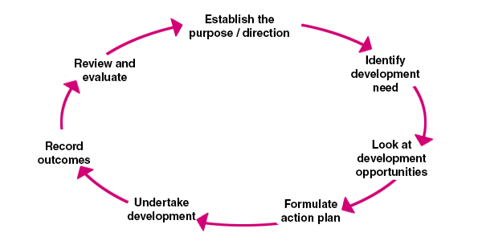
A personal development plan (or PDP) is not just a mandatory thing that managers make you do before an annual evaluation; they are also that firm stone that helps your dreams and desires stay in sight.A good plan provides concentration; it helps you plan a path to your successful version; it allows you to make better decisions and prevents you from taking steps back. A good plan also allows you to strategize and get back on track when things don't go well. A clear plan is also good for your mental health, as a sense of purpose can often help reduce stress and anxiety. Like twenty-something, you are in one of the most frightening phases of life. Everything feels chaotic and there are many frustrations. Realizing what you want is not only the first step in planning, but also the hardest. Once you realize what you want to do, that dream acts as an emotional anchor; provides stability and structure in a time of chaos. Next, you need to consider all the small steps that will help you achieve your big goals. And you will have to prioritize these short-term goals. Remember that you cannot do everything at once and try to fail. Knowing when you want to reach a goal is crucial and presenting your future is an important source of motivation and inspiration. There are certain things - these could be external things or an element of yours - that, if you let them go, will prevent you from reaching your goals or delaying your path. As soon as you have an idea of ​​what you are -It could also hinder what could help you, when you can capitalize on those opportunities that you have recognized. Make an action plan on how you will do this. In your PDP, list the people who can help you. He could be a financial advisor, a friend, a colleague. People are often so happy to help you, more than you can accomplish. Whether it's big or small, after you've made some progress, you need to think about how far you've come. In conclusion, I could say that in this assessment I tried to highlight all the skills necessary to be able to evolve in the workplace, as well as the realization of a personal development plan. All these skills can be educated and developed through repeated exercise. As they can be applied in everyday life and in the field in which you work.

REFERENCES:
https://www.indeed.com/career-advice/finding-a-job/employability-skills
https://www.investopedia.com/terms/h/hard-skills.asp
https://en.wikipedia.org/wiki/Soft_skills
https://www.thebalancecareers.com/communication-skills-list-2063779
https://hr.mit.edu/learning-topics/teams/articles/basics
https://www.indeed.com/career-advice/career-development/time-management-skills
https://www.mindtools.com/media/Diagrams/SWOT_Analysis_New_Figure_1.jpg
https://www.mindtools.com/pages/article/newTMC_05.htm
https://www.thoughtco.com/note-taking-research-1691352
https://study.cardiffmet.ac.uk/AcSkills/Pages/About.aspx
https://library.leeds.ac.uk/info/14011/writing/106/academic_writing
https://www.open.ac.uk/library/help-and-support/referencing-and-plagiarism
https://www.ed.ac.uk/institute-academic-development/undergraduate/good-practice/referencing
https://www.mesacc.edu/~paoih30491/ArgumentsQuoteSummarizeParaphr.html
https://www.bradford.ac.uk/careers/develop-skills/communication/
https://www.skillsyouneed.com/presentation-skills.html
https://www.managers.org.uk/knowledge-bank/personal-development-planning
https://www.highspeedtraining.co.uk/hub/personal-development-plan-template/



