3/24/2025
University of Wales Trinity Saint David
London campus
E-Portfolio Link: https://2544806-my-site-3.editor.wix.com/edit/od/933eddf3-8ef5-4c67-81e4-8d2b8b161146?metaSiteId=7fd06508-5308-41a2-bb9f-4e92dc5bc7d5&editorSessionId=2b0d49f2-4a51-4b61-b82f-cd3cfb4a5dc0&http_referrer=https%3A%2F%2Fwww.wix.com%2F

Module Name: Learning In the Digital Era
Module Code: ACCA 4025

Student Name:
Student ID:
Group: 1

Lecturer’s Name: Koushik Modak

LDE Assignment 1
E-Portfolio
Table of Contents
Introduction 2
Main Body 2
Task 1: Essential Academic and Employment Skills for the future career Path 2
Task 1 (a): Report on Essential Academic and Employment Skills 2
Task 1 (b): Evaluation of Task 1 (a) based on Similarity report 2
Task 2: Collaborative Mind Map and Individual Poster 2
Mind Map (Collaborative) 2
Poster (Individual) 2
Task 3: Virtual Collaboration and RefWorks 2
Report on Virtual Collaboration 2
Step-by-step process of using RefWorks with visuals 2
Task 4: E-Portfolio Creation and Evaluation 2
Task 4 (a): E-Portfolio Creation 2
Task 4 (b): Illustrative Review of E-Portfolio tool Selection 2
Conclusion 2
References 2
Task 1 References: 2
Task 3 References: 2

Introduction
Communication, data management, and service provision are based on digital technology. In Great Britain, 28% of employees’ hybrid-worked at the beginning of 2025, and 43% of the UK businesses had suffered a cyber breach or assault. In addition, employers anticipate 39 percent of the skills of workers to be transformed by 2030. Hence, workers require communication, computer security, teamwork, and problem-solving skills, which are more than a mere operation of a computer. An IT Support Specialist is one who provides help to users and can diagnose hardware and software, as well as network problems, maintain accounts and security, and liaise with technical staff. These competencies are portrayed in the e-portfolio using Mind Meister, RefWorks and Wix.

Main Body

Task 1: Essential Academic and Employment Skills for the future career Path

Task 1 (a): Report on Essential Academic and Employment Skills
1. Introduction to the IT Support Specialist Career
IT support specialists identify hardware, software, and network errors, support users, document cases, administer accounts and permissions, escalate cases and protect operations. These roles are indicative of organisational reliance on trusted technology [9].
2. Research and Information-Evaluation Skills
They consult technical reports, knowledge bases and security guidance and pseudo-code; assess the undeadness and timeliness of the source; contrast alternative remedies; employ indicators rather than untrustworthy or out-of-date web advice [14].
3. Critical Thinking and Problem-Solving
Critical troubleshooting sees a distinction between the symptoms and root cause, systematically evaluates solutions, keeps records, validates recovery, and escalates unmanageable phenomena. Access failures, such as failed access to the workplace, can involve the verification of credentials, permissions, multifactor authentication and service status [9].
4. Academic Communication and Referencing
Through academic communication, reports, technical documentation, presentations, and evidence-based recommendations, it is possible. Proper recognition by having the IEEE referencing can safeguard academic integrity and enhance professional credibility.
5. Professional Communication and Customer Service
Active listening, diagnostic questions, explanations made in plain language, patience, explicit instructions and progress updates are needed in the context of professional support [4]. A review found communication, teamwork, adaptability, problem-solving and willingness to learn to be long-lasting employability skills [13].
6. Cybersecurity and Responsible Digital Practice
Strong passwords, phishing awareness, multi-factor authentication, secure handling of personal data, as well as access control, confidentiality, and restrained administrator privileges are a part of cybersecurity practice. In 2025, 43 percent of the businesses in the UK indicated that they had suffered a breach or an attack [10]; the NCSC advises that sensitive services need a robust MFA [14].
7. Teamwork, Time Management and Adaptability
IT support employees work in collaboration with network engineers, administrators and managers, prioritize urgent tickets, achieve service levels and adjust to new systems. In the UK in 2024, there were 27 percent skill-shortage vacancies [16].
8. Career Development
Ongoing learning enhances the level of employability, performance, confidence, promotion and advancement into IT positions; 39% of core skills are expected to evolve by 2030 [2].

Task 1 (b): Evaluation of Task 1 (a) based on Similarity report
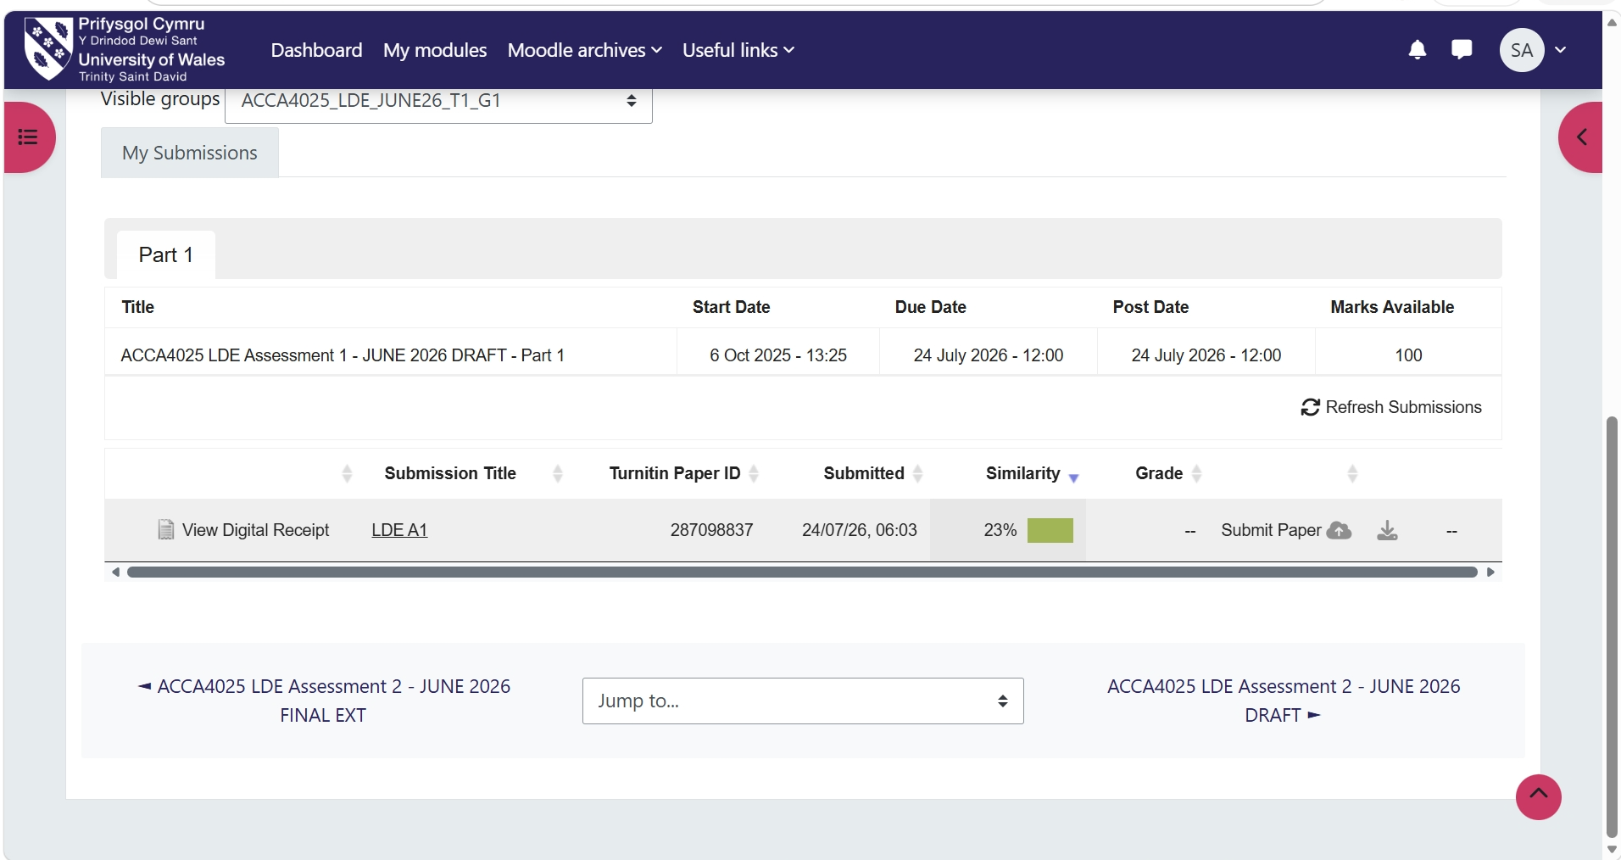

Reflection on the similarity report
The Turnitin estimate of similarity in the report was 23%, principally due to reference information, technical vocabulary and standard academic expressions. These similarities were deemed to be acceptable, as any external ideas were backed up with citations. Any similarity to such an extent would be edited by more vigorous paraphrasing, vigorous explanation and a blend of several textual materials.

Task 2: Collaborative Mind Map and Individual Poster

Mind Map (Collaborative)
Mind Map Link: https://mm.tt/map/4046791868?t=jKaZnKKx6M

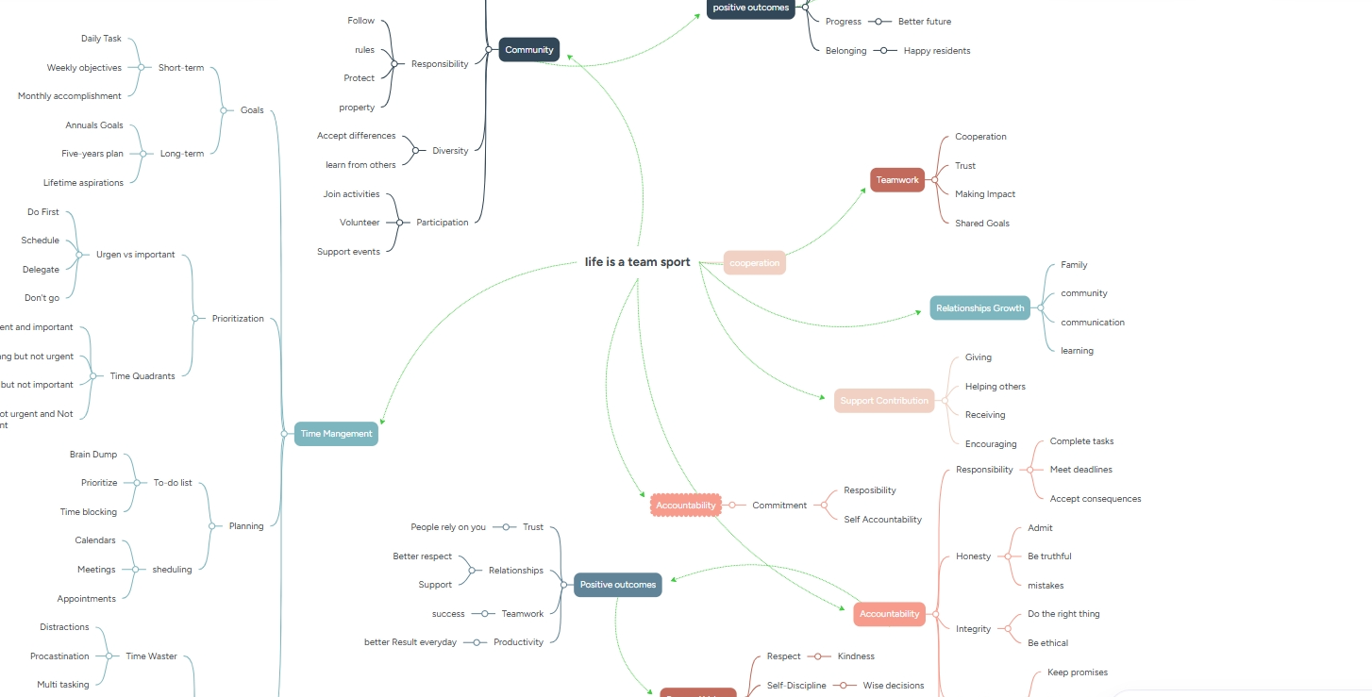

Poster (Individual)
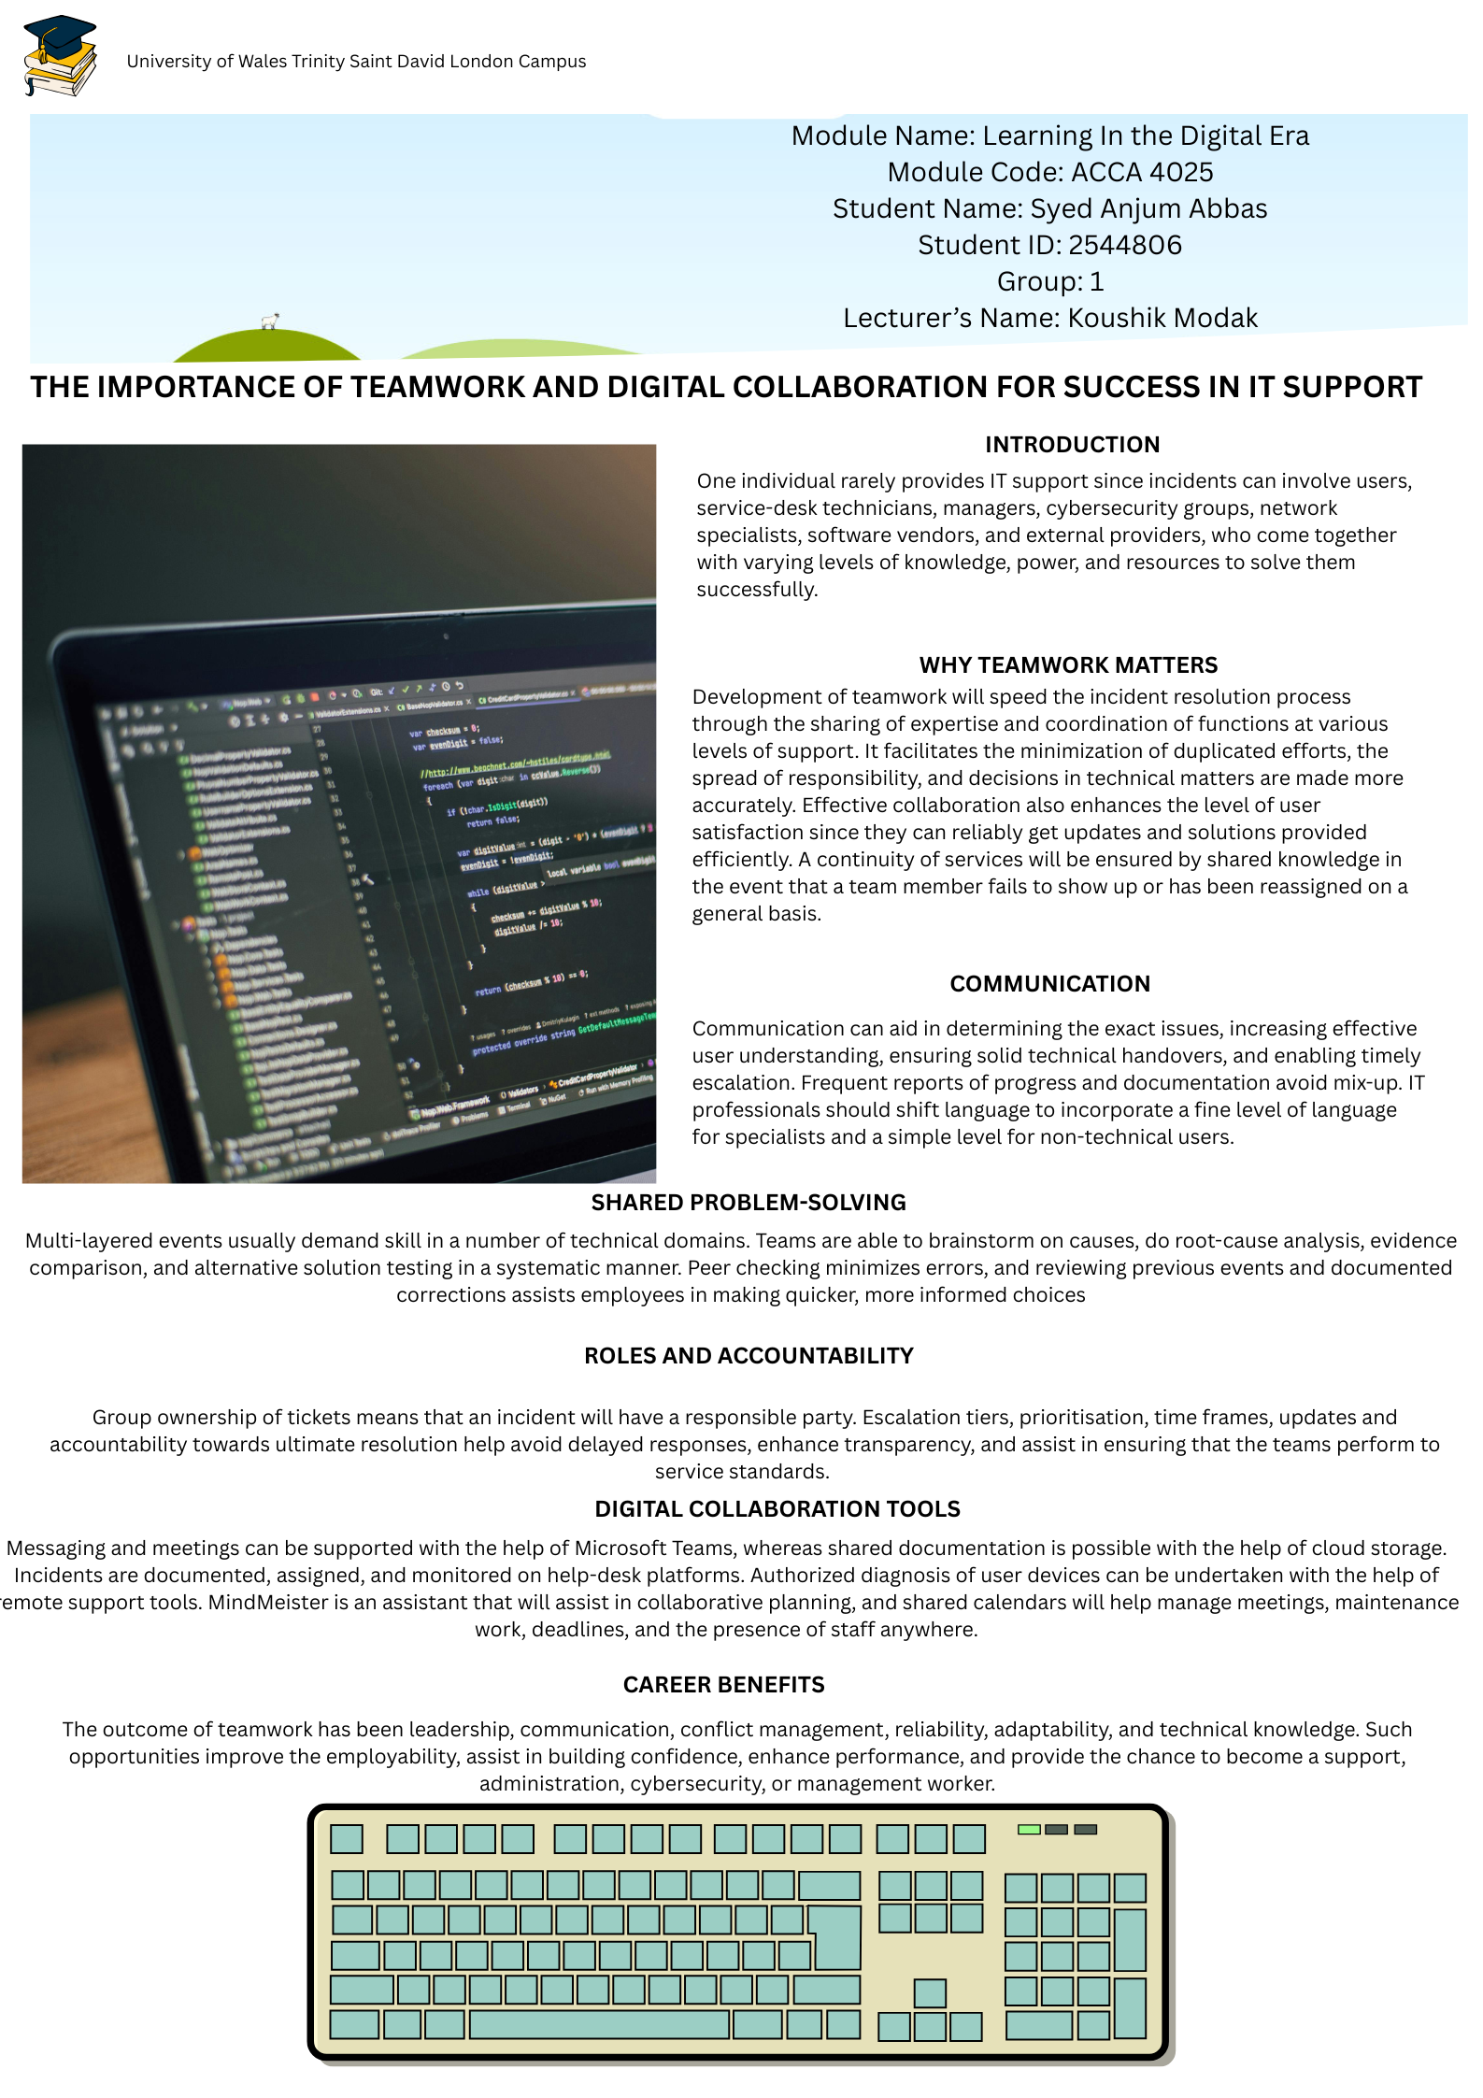
Poster Link: https://canva.link/1jhloixufu1ib5v

Task 3: Virtual Collaboration and RefWorks

Report on Virtual Collaboration
The Role of Virtual Collaboration Tools in Supporting Remote IT Support Teams
Introduction
Virtual collaboration involves the use of digital technologies in order to assist the geographically dispersed employees in communicating, sharing information, and performing tasks [8]. It applies to remote and hybrid IT support since 28% of working adults in Great Britain hybrid-worked in January-March 2025, which continues to keep location-independent support needed [6].
Virtual Collaboration Tools
● Microsoft Teams facilitates meetings, messaging, channels, screen and file sharing, along with discussions [7].
● Google Meet allows remote meetings and demonstrations, as well as training and troubleshooting by using a screen share [15] [17].
● Help desks also document, allocate, prioritize, and escalate an incident, provide tracking, and record solutions [16].
● Remote-support software allows viewing of screens, fault diagnostics, and approved fixes; the cloud knowledge base contains guides, cases, and procedures [15].
Benefits of Virtual Collaboration
These tools enhance the extent of service coverage, remote work and hybrid work, restrict movement, and enable faster access to knowledge. Using shared tickets and knowledge articles enhances the flow of knowledge, troubleshooting, and escalation. These maintain business continuity in the face of disruption and enable technicians to provide service to users in more than one site. A study conducted with 26 software professionals who worked in eight companies revealed that interaction, belonging and organisational support are key elements in increasing hybrid team resilience [16] [18].
Challenges and Risks
Due to poor connection, software failures, and slow responses, diagnosis and quality of service delivery. Not using face-to-face interaction/poor communication, time differences, digital burnout, and user lack of confidence slow down the process of resolution. Unsecure file sharing, the absence of privacy, and unauthorized access may result in the compromise of data. A survey conducted in the UK revealed that 43 percent of the businesses reported to have encountered a cyber-breach or cyber-attack, which is equivalent to 612, 000 businesses; 69 percent of large-scale businesses were hit [10].
Cybersecurity and Confidentiality
Remote assistance will require secure logins, multifactor authentication, encryption of communications, approved access devices, and role-based access controls. Technicians are to check identities, seek online consent to screen sharing, limit privileges, guard confidential data and adhere to organisational regulations. The NCSC also suggests the use of robust MFA to all users who use sensitive data [12].
Recommendations
Organisations ought to come up with communication guidelines, responsibilities, an escalation process, and frequent virtual conferences. Actions, ownership, and progress must be recorded on every ticket. Safety platforms, personnel planning, authentication measures, and alternative communication tools are necessary. Regularly, teams must assess tools in terms of reliability, usability, security, integration, and suitability [18].

Step-by-step process of using RefWorks with visuals

Task 4: E-Portfolio Creation and Evaluation

Task 4 (a): E-Portfolio Creation
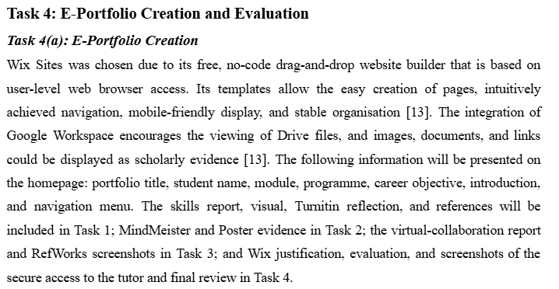
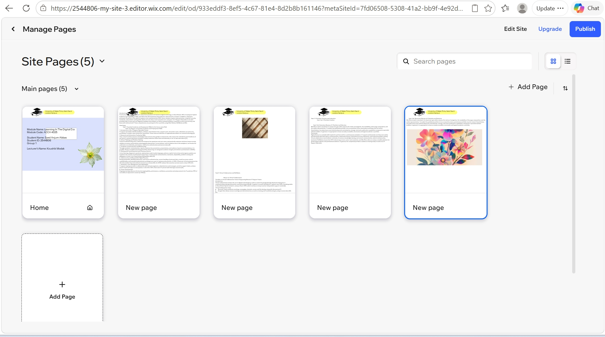

Task 4 (b): Illustrative Review of E-Portfolio tool Selection
Wix Sites is quite convenient; its visual next-gen editor ensures the clarity of navigation, the readability of the page composition, and the stable representation. To enable the published portfolio to be accessed by tutors, permissions and links must be tested. Nevertheless, free plans have more limited advanced customisation, storage, and some publication capabilities compared to specialist website builders. In general, it is appropriate to have an easily accessible, structured, and logical academic e-portfolio.

Conclusion
Digital literacy is a valuable skill required to perform well in a contemporary workplace. IT support professionals can help users safely and efficiently with their help in communication, information literacy, information security awareness, and technical problem-solving. Virtual collaboration tools facilitate continuity of services, knowledge sharing, and remote communication, which is enhanced by teamwork. RefWorks ensures that IEEE referencing is more correct and consistent, and Wix Sites offers an easily accessible platform for showcasing academic and professional evidence. In general, the completed portfolio is evidence of being ready to work as an IT Support Specialist.

References

[1] GOV.UK, '"Occupations in demand, Calendar year 2024,".

[2] World Economic Forum, '"The Future of Jobs Report 2025,".

[3] I.&.T. Department for Science, '"Department for Science, Innovation and Technology," GOV.UK.

[4] H. Phan, I. Kuzminykh, and B. Ghita, '"Understanding the Skills Gap between Higher Education Institutions and the Software Engineering Industry,".

[5] Department for Education, '"Employer Skills Survey 2024,".

[6] Public Policy and Economic Insights team, '"Who has access to hybrid work in Great Britain?" Ons.gov.uk.

[7] Microsoft, '"What is Microsoft Teams?".

[8] R. M. Hussein and B. A. Hassan, '"Collaboration Tools and their Role in Agile Software Projects,".

[9] National Careers Service, '"It Support Technician | Explore Careers,".

[10] Government of the UK, '"Cyber Security Breaches Survey 2025,".

[11] MeisterLabs, '"MindMeister,".

[12] NCSC, '"Multi-Factor Authentication for Your Corporate Online Services,".

[13] H. Tushar and N. Sooraksa, '"Global employability skills in the 21st century workplace: A semi-systematic literature review," Heliyon, vol. 9, no. 11, Nov 1, pp. e21023.

[14] DfE, '"Employer Skills Survey , Calendar Year 2024,".

[15] Google Meet, '"Present During a Video Meeting - Computer - Google Meet Help,".

[16] Atlassian, '"Learn How to Manage Incidents in Jira Service Management,".

[17] TeamViewer, '"TeamViewer,".

[18] R. de S. Santos,, G. Adisaputri, and P. Ralph, '"Post-Pandemic Resilience of Hybrid Software Teams (Chase 2023 - Research Track) - Chase 2023,".

[19] NCSC GOV.UK, '"Principle B2 Identity and Access Control,".

