BSC HEALTH AND SOCIAL CARE
Module: Changemakers: Building your Personal Brand for Sustainable Employment
Module Code: BMHP5015
Name of student: Sharon Akhigbe
Student Number: 2334467
Lecture: Olufemi Oluranti

Component 2: Assignment (Report): Developing Employability Skills and Career Strategy for Entry into Adult Social Care in the UK

Introduction
The United Kingdom adult social care system is one of the major elements of the UK health and care system‚ providing essential care services for older people and for people with complex physical‚ emotional and social needs․ Demographic change has driven some of the demand‚ with population ageing and rising numbers of people living with long-term conditions (Office for National Statistics‚ 2024; King's Fund‚ 2023). The sector still suffers from long-term recruitment and retention issues, with high vacancy rates and an inability to recruit staff with the appropriate skills affecting service delivery (Skills for Care, 2024).
Employability in roles in adult social care is not only a function of having educational qualifications‚ but also the development of transferable skills‚ emotional intelligence, and experience (Health Education England‚ 2022). Potential employers seek those who can articulate their understanding of care, along with their ability to apply their knowledge in practice (Health Education England, 2022). Personal branding also enables individuals to create their own professional identity by aligning their values with those of the organisation they work for (Gorbatov, Khapova and Lysova, 2019).

Job role description․
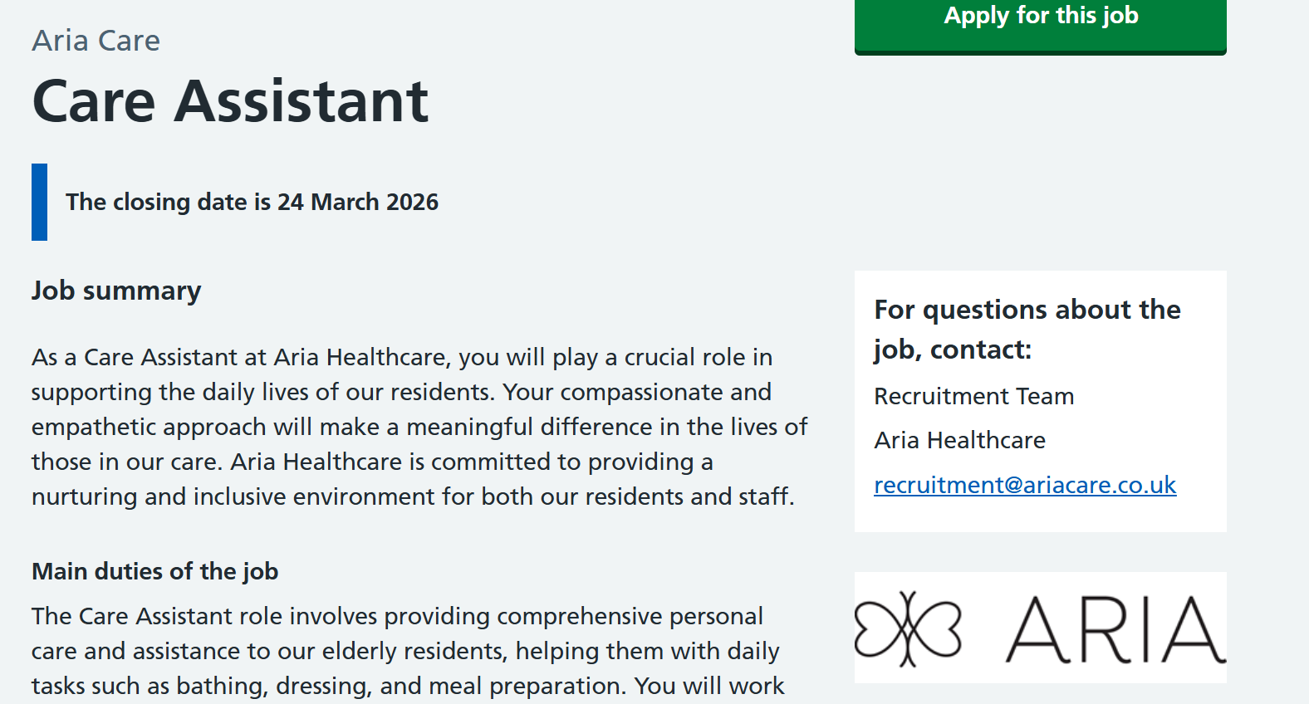
Figure 1: Care Assistant Job Advert
As shown in figure 1, the Care Assistant role is considered entry level as it relates to adult social care within a residential care home where individuals reside and are required to provide care with daily living․ The job description of the chosen post mainly involved helping residents with bathing‚ dressing and other tasks‚ promoting dignity‚ independence and wellbeing (NHS Jobs‚ 2026).
Analytically‚ care work is seen as having two dimensions: the physical dimension consists of physically doing the activities involved in the work‚ whereas the relational dimension involves emotional support‚ empathy‚ as well as (non-verbal and verbal) communication with persons receiving care․ This is in line with person-centred care approaches which value seeing people as active partners in their care and respecting their preferences and autonomy (McCormack and McCance‚ 2021).
This key role is often set against a context of structural problems with the adult social care sector‚ which has been heavily criticised for low pay‚ low opportunities for progression, and high staff turnover (King's Fund‚ 2023), all of which create an unstable workforce which may affect staff wellbeing and the quality of the care provided․

Employability Skills Required
Care Assistant competencies and skills include not just the practical skills‚ but also interpersonal and ethical skills that are needed to provide safe‚ effective, and compassionate care to individuals․

Communication Skills
Communication is considered a core skill of the adult social care worker‚ being used to communicate and converse with not only those being supported‚ but also their families and other professionals working alongside them as part of the multi-disciplinary team․ In practice‚ this will require adaptation to the individual needs of the service user (Arnold and Boggs‚ 2020).
In critical accounts of caring‚ communication covers more than simple information exchange․ It includes listening‚ showing empathy, and understanding non-verbal communication and its meanings․ Failures in care and safeguarding have been identified as a consequence of communication failure‚ with effective communication seen as being central to the provision of quality care (Care Quality Commission‚ 2023).
I can show that communication is a strength for me‚ but I need to work out how I can use this strength in practice so that I can develop my skills further․

Compassion‚ Empathy, and Emotional Intelligence
Compassion and empathy are important values in adult social care and were part of the job advert examined in this article. Care workers need to empathise with service users' feelings to provide adequate care and support and enable person-centred care. Empathy is also associated with improved outcomes‚ including patient satisfaction and emotional wellbeing (Moudatsou et al․‚ 2020). Emotional intelligence‚ or the ability to recognise and understand the emotions of oneself and others‚ is associated with improved interactions with others and workplace relationships (Cherry‚ 2023).
The expectation that care workers assign compassion to everything that they do‚ however‚ raises questions of emotional labour․ The care sector can impose high levels of emotional labour on staff‚ which can lead to stress‚ burnout‚ and even dehumanisation if care workers do not have sufficient resources (Tronto‚ 2020). Therefore‚ though empathy is very important‚ it needs to be supplemented with resilience and wellbeing strategies․

Safeguarding and Ethical Responsibility
Safeguarding is a framework in adult social care for protecting adults from abuse‚ neglect‚ and other forms of harm․ Care assistants must be able to identify‚ and report‚ any potential safeguarding concerns‚ and work within procedures and legislation․ In addition to procedural knowledge‚ safeguarding is also linked to moral knowledge (see ethics). Care workers should also follow the principles of dignity‚ autonomy and respect by treating service users fairly‚ respectfully, and compassionately․ The Care Quality Commission (2023) expects safe‚ effective, and compassionate care to support the delivery of all services․
From the perspective of critical safeguarding‚ safeguarding is not just about following policies and procedures but also about ethical commitment and professional judgement‚ for example, in complex and uncertain situations․ Knowledge and ethics are both considered to be important elements of being a good safeguarding practitioner․

Resilience and Workforce Pressures
Resilience as a skill is increasingly recognised to be core to the adult social care workforce‚ who are often exposed to difficult working conditions concerning staffing resources‚ high turnover rates‚ and rising demand (Skills for Care‚ 2024). Resilience enables care workers to cope with emotional and physical demands․ Resilience is largely taken for granted‚ but needs to be critically considered․ Structural issues such as under-resourcing‚ low pay, and limited career prospects should not be overshadowed by a focus on individual resilience (Tronto‚ 2020).

Review of my personal skills
On reviewing my own skills‚ I believe that I possess several that make me ideally suited to the role of Care Assistant ․ Probably the most important skill I have to offer is my ability to empathise with others, which drives my desire to care for and maintain dignity and independence․
Secondly‚ I have developed my communication and teamwork skills academically and socially and am confident in my ability to engage with and add value in collaborative group environments․ I have learned the value of patience, particularly when working with individuals with diverse and complex needs․
Despite these strengths‚ I recognise that there are barriers to my employability as well‚ the most meaningful of which is my lack of direct experience within an adult social care setting․ Theoretical knowledge is not a substitute for the practice-based experience and skills gained from being in the role‚ which may affect my confidence and competence in practice (Benner‚ 1984).

Personal Brand and Professional Identity
Perhaps no concept is more relevant to modern employment than personal branding‚ which seeks to distinguish the employee from others in a highly competitive market Building on Peters' (1997) initial reviews of self-marketing‚ personal branding has been described as the process of presenting a coherent professional identity that reflects values and competencies of members of the organisation (Gorbatov‚ Khapova and Lysova‚ 2019).
In the context of adult social care‚ personal branding is closely associated with professional identity․ Adult social care also attaches great importance to values such as kindness‚ dignity‚ respect‚ and person-centred care․ My own personal brand includes being an empathetic‚ patient and trustworthy individual․ I support vulnerable adults to live an independent and dignified life․ These personal values reflect those in the job advert‚ which closely matched expectations in this sector (Care Quality Commission‚ 2023).
More negatively‚ while it is important to communicate personal values and personality strengths for employability purposes‚ personal branding may promote professional self-advertisement and exaggeration‚ while failing to recognise or acknowledge profession-specific challenges․ For example‚ in high-risk areas of practice‚ such as adult social care‚ personal branding should focus on competencies‚ ethical practice‚ and professional accountability․ The process of professional identity formation takes place when personal values are integrated with professional knowledge‚ skills and behaviours (Cruess‚ Cruess and Steinert‚ 2019). I see professional identity development as an active process․

Networking and Social Capital
Networking is key to employability‚ providing access to information‚ opportunities and professional support․ Social capital is widely used to explain how networks support career development (Bourdieu‚ 1986; Putnam‚ 2000). Bonding social capital‚ bridging social capital‚ and linking social capital are related to my job․ Bonding social capital is the close relationship with family and friends that I can turn to for emotional support․ Bridging capital is a network of connections with people who are not part of your social group‚ while linking capital is a network with people in power․
Should I reflect on my network today‚ I would say that I have high bonding capital‚ as I rely a lot on family and friends for support and advice․ This is good for my wellbeing‚ but does not provide opportunities professionally․ In contrast‚ my bridging and linking capital has not developed to the same extent in adult social care․ A further disadvantage is that weak ties‚ i․e․ work acquaintances‚ are thought to be better able to provide access to job opportunities than strong ties (Granovetter‚ 1973). If I cannot interact with professional networks‚ I will be unable to find opportunities and will lack perception into how things work in the sector․

‘
Career Development Action Plan
Table 1: Career Development and Action Plan (January 2026 – December 2027)
Timeframe | Career Objective | Action/Activity | Skills Developed | Expected Outcome | Evaluation Method
Jan 2026 – Mar 2026 | Strengthen academic foundation | Continue Health and Social Care degree modules | Theoretical knowledge, critical thinking | Improved academic performance | Assignment grades and feedback
Apr 2026 – Jun 2026 | Develop a professional identity | Create and optimise LinkedIn profile; begin reflective journaling | Personal branding, self-awareness | Clear professional profile | Profile completion and engagement
Jul 2026 – Sep 2026 | Gain sector awareness | Research adult social care providers and job requirements | Industry knowledge, analytical skills | Better understanding of employer expectations | Documented research notes
Oct 2026 – Dec 2026 | Build initial experience | Apply for volunteering roles in care homes/community settings | Communication, empathy, teamwork | Practical exposure to the care environment | Supervisor feedback and reflection
Jan 2027 – Mar 2027 | Develop safeguarding competence | Complete safeguarding and care-related training courses | Safeguarding knowledge, ethical awareness | Certification achieved | Training certificates
Apr 2027 – Jun 2027 | Strengthen professional network | Attend career fairs; connect with professionals; seek mentorship | Networking, professional communication | Expanded bridging and linking social capital | Number of contacts and interactions
Jul 2027 – Sep 2027 | Prepare for employment | Develop CV and cover letter; practice interviews | Self-presentation, confidence | Job-ready application materials | Mock interview feedback
Oct 2027 – Dec 2027 | Secure employment | Apply for Care Assistant roles | Employability, adaptability | Job offer secured | Interview outcomes
Ongoing (2026–2027) | Continuous development | Engage in CPD, reflective practice and skills improvement | Lifelong learning, resilience | Sustained professional growth | Reflective journal and CPD records

As shown in Table 1, employability skills are developed through a structured process and theories of career development stress goal-setting and lifelong learning (Bridgstock‚ 2009). My short-term goal is to complete my Health and Social Care degree from January 2026 to January 2027‚ and to gain the theoretical knowledge and understanding to start working in this area․ During this period, I will also develop my professional identity‚ for example‚ creating a LinkedIn profile‚ and researching potential employers within adult social care․
In the medium term I will gain experience working in the caring sector‚ such as through volunteering in institutions such as residential homes‚ or working with community groups․ This will allow me to develop my understanding practically‚ improve my communication skills and increase my confidence․ Evidence suggests that work-place learning is correlated with improved employability in the health and social care sector (Health Education England‚ 2022).
I will also engage in training, such as safeguarding and care-related courses. CPD is essential to maintain and improve performance and to meet the demands of a changing workplace (NHS England, 2023). My career objective is to find work as a Care Assistant. Working as a Care Assistant would provide me with valuable experience and enable me to develop my career with numerous opportunities for advancement․ They will require motivation and application throughout my learning and practicing․

Communicating Employability to Employers
To be considered for paid employment in adult social care‚ individuals need to show their employability skills․ Employers will assess an individual's ability to show skills and attitudes which fit the organisation's culture․ A CV should present the skills and experiences that I possess․ I will show my communication skills‚ empathy‚ teamwork ability‚ and practical experience from my volunteering work and training․
In addition, social media platforms such as LinkedIn can increase visibility and lead to connections and interactions among similar individuals (Treem and Leonardi, 2013).

Conclusion
The report has also critically analysed the employability standards for entering the adult social care profession and working in the role of Care Assistant․ It has highlighted that the role requires a combination of interpersonal skills‚ emotional intelligence‚ ethical awareness and resilience․ On a personal level‚ I identified my own strengths in personality as empathy‚ communication and teamwork‚ which are all essential skills for the role‚ but I identified several serious gaps‚ in particular practical experience and professional networking․ I plan to volunteer‚ train and network to plug the gaps and improve employability․

References
Arnold, E. and Boggs, K. (2020). Interpersonal Relationships: Professional Communication Skills for Nurses. Elsevier.
Benner, P. (1984). From Novice to Expert. Addison-Wesley.
Bourdieu, P. (1986) ‘The forms of capital’, in Richardson, J. (ed.) Handbook of Theory and Research for the Sociology of Education. New York: Greenwood.
Bridgstock, R. (2009) ‘The graduate attributes we’ve overlooked’, Higher Education Research & Development, 28(1), pp. 31–44.
Care Quality Commission (CQC) (2023) Fundamental standards. London: CQC.
Cherry, K. (2023). Emotional Intelligence. Verywell Mind.
Cruess, R., Cruess, S. and Steinert, Y. (2019). Teaching Medical Professionalism. Cambridge University Press.
Gorbatov, S., Khapova, S. and Lysova, E. (2019) ‘Personal branding’, Frontiers in Psychology, 10.
Granovetter, M. (1973) ‘The strength of weak ties’, American Journal of Sociology, 78(6), pp. 1360–1380.
Health Education England (2022) Workforce Strategy. London: HEE.
King’s Fund (2023) Social Care Workforce Report. London: King’s Fund.
McCormack, B. and McCance, T. (2021) Person-Centred Practice in Nursing and Health Care. Wiley.
Moudatsou, M. et al. (2020) ‘The role of empathy in health and social care’, Healthcare, 8(1), pp. 1–12.
NHS England (2023) Workforce Development Framework. London: NHS England.
Office for National Statistics (2024) Population ageing in the UK. London: ONS.
Peters, T. (1997) ‘The brand called you’, Fast Company, 10.
Putnam, R. (2000). Bowling Alone. New York: Simon & Schuster.
Skills for Care (2024) State of the Adult Social Care Workforce. Leeds: Skills for Care.
Treem, J. and Leonardi, P. (2013) ‘Social media use in organisations’, Communication Yearbook, 36.
Tronto, J. (2020). Caring Democracy. NYU Press.
West, M. et al. (2022) Compassionate Leadership in Healthcare. King’s Fund.

