LCBB5000 Data Handling and Business Intelligence Component 2
Student Name: Tankitsa Yankova
Student ID: 2130469
:

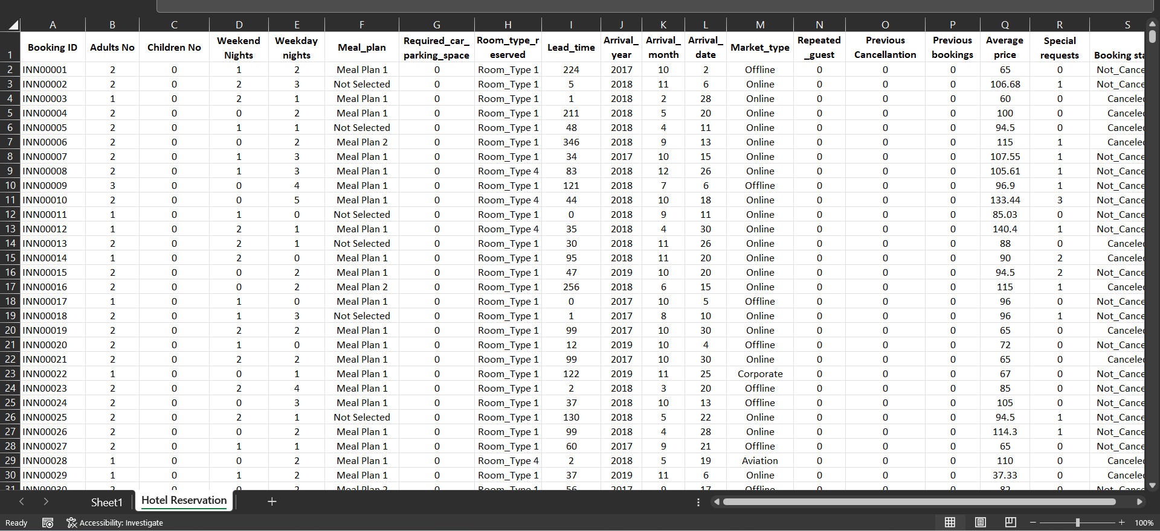
This is the file that is provided with the hotel reservation data which needs to be utilized to find out various values and trends regarding the increase or decline of the average price that the customers have to pay on the hotel. There are manual ways of finding the average price, but the dataset that is provided for this task is significantly large which makes it difficult to analyse and find the relevant results. So, Microsoft Excel will be used, and the year range of data that are provided in this file are spread from 2017 to 2021.
The data that are given here have been checked, and found that, all the data are provided in the required format, so no changes in the data is required. Directly applying PivotChart and PivotTable will be sufficient to get the required value (Walkenbach, 2010). In the picture, another sheet named Sheet1 can be seen which contains the PivotTable and PivotChart, so instead of creating a new sheet, the existing sheet will be utilized (‌Dalgleish, 2006).
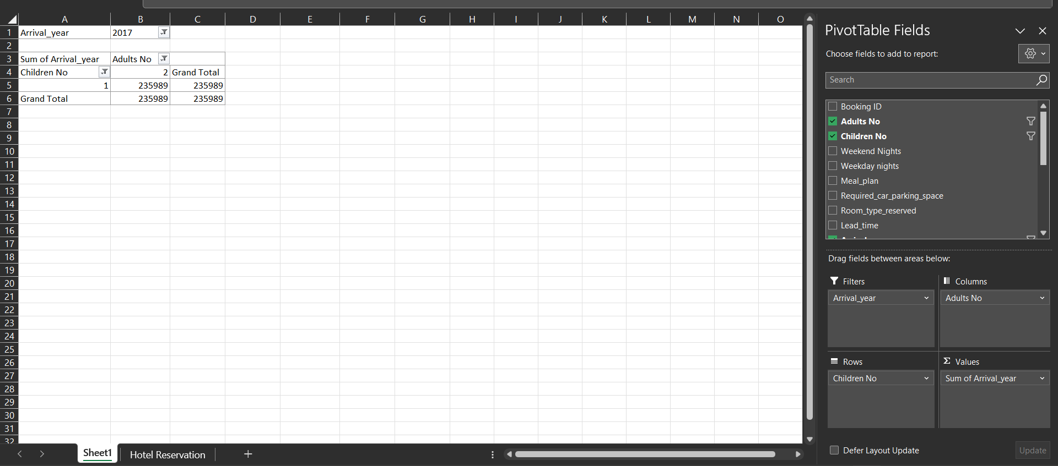
This is the existing sheet where already two variables are chosen, and the corresponding values are shown on the page. However, these values are not relevant to these task, so these values will be removed, and required values will be inputted (Walkenbach, 2010).
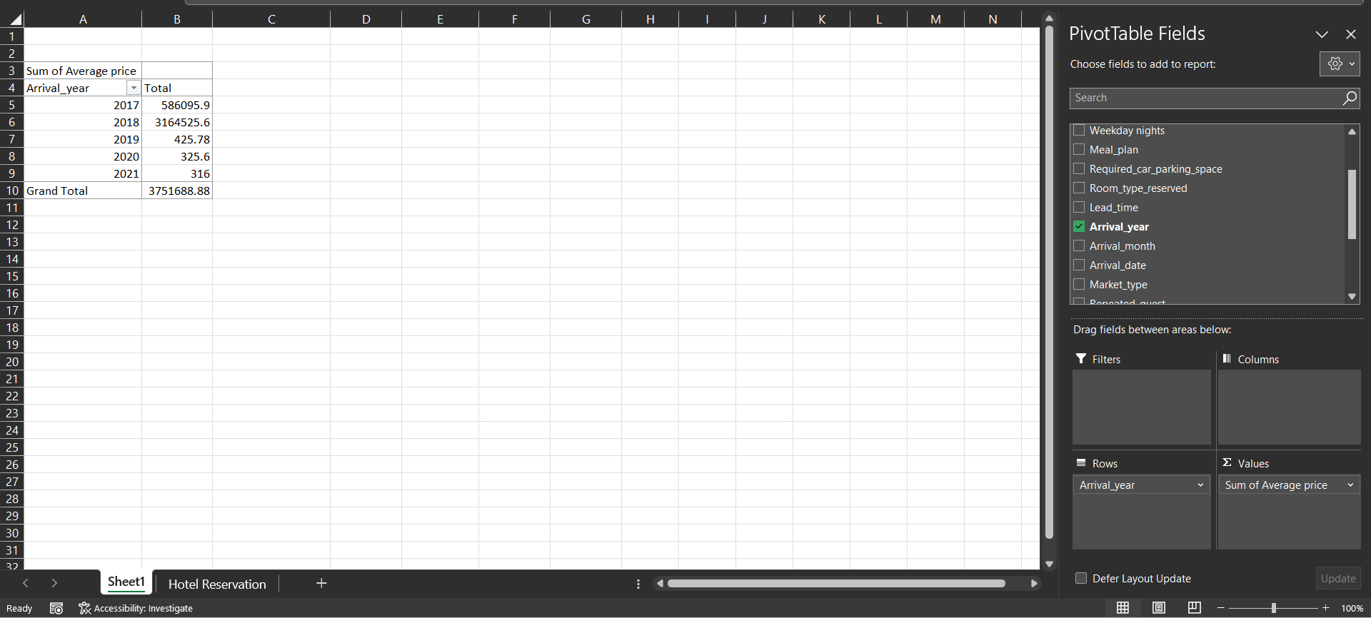
To calculate the average price per year, it is evident that the price and year data needs to be included in the PivotTable. By ticking on the Average Price and Arrival year boxes, these two values has been assigned to the four fields that are shown on the bottom right. Both the values has been included on the Values field, but the Arrival year value needs to be on Row field, so the Arrival Year value has been dragged from Values cell to Rows cell so that the expected output can be obtained (‌Dalgleish, 2006). The values for the arrival year and total price can be seen on the left of the screen where the prices are separated based on the arrival year. However, the prices have been calculated by adding the price for the whole year, and it is found that inputted values related to arrival year 2021 is significantly low that means the days of 2021 taken into account is lower than the other years. So, adding up all the values will not provide a correct answer, instead the result will be a false one (Guerrero et al., 2019). To avoid that issue, the price values can be turned to average so that the values can be compared with each other regardless the number of days inputted.
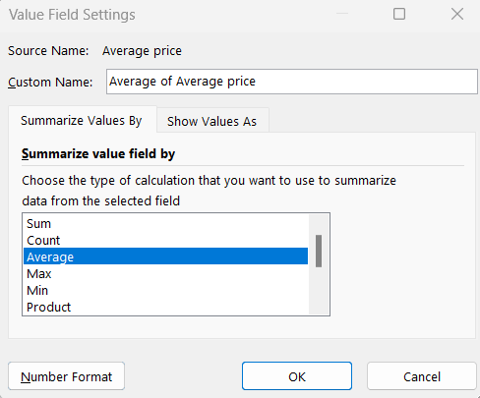
By clicking on the Sum of Arrival Year on the Values field and choosing Value field setting provides a new tab where there are a number of options available to choose from (Guerrero et al., 2019). From these options, average has been selected which will guide Excel to calculate the average price for each year, and show it on the sheet.
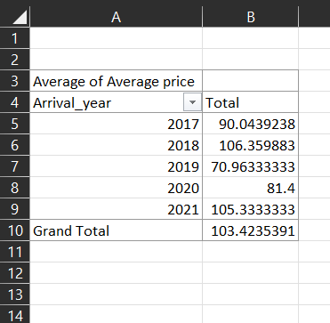
By considering the average price for each year, these are the values that has been found from the dataset which can now be utilized to find the necessary values from the dataset (Guerrero et al., 2019). It can be seen that the values of each year are different, but they are close to each other which shows that the average price changes each year.
To ensure if the data is correct and all the cells from the mainsheet has been considered, Data option available on Riboon was chosen, and from there, Refresh all was clicked which have updated all the data, and it is found that there are values for year 2022 as well (Microsoft.com, 2021b).
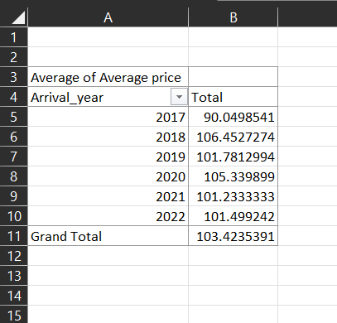
The updated values are shown here which better shows the price and change of average price per year. It can be noted that the highest price of all was active during year 2018 when the average price was over 106, and the lowest price of all was active during the year 2017, and the average price rest of the years have been located in between these values.

To better understand the data, a PivotChart has been included in this file where all the years are shown. It can be clearly seen that the price raised more than 106 which occurred during 2018 (Microsoft.com, 2023). A huge spike on the line can be seen from year 2017 to 2018, and such jump can never be found on the later years. From there, the curve dropped and raised minorly each year, and the average price can be found to be over 100 on any year (Microsoft.com, 2023). Another significant trend that can be noted is the price raises and drops by some margin each year up until the end of the recorded price data.
To calculate the Average Price of the hotel per year, IF formula can be utilized at Excel because IF is a multifunctional formula which can included several other formulas inside it. It provides the opportunity to get several types of values using the IF formula, even nested IF where several IF formula is used at the same cell can be very valuable (Microsoft.com, 2023).
First of all, it is important that the years are separated in a new column which can be utilized in the LookUP function to obtain the required results. So, a new cell is created called Year 2017 where 2017 will be the only input but it will be inputted multiple times. The value will be inputted on each cell on this column if the J cell has 2017 input, otherwise the cell on the new column will be left blank.
To achieve that, IF formula can be utilized, and the formula written in this case is =IF(J2=2017,J2,"")
This formula states that, if there is 2017 value inputted at J2 cell, then write 2017 at the new cell or else leave the cell blank (Microsoft.com, 2023a). This formula has been copied until the last cell of the column with the command Ctrl+D to obtain the new values.
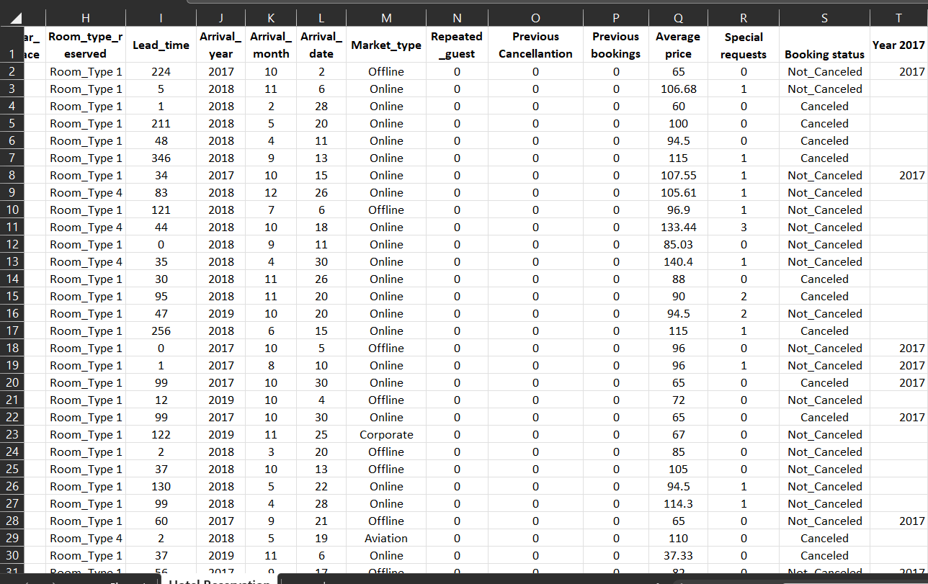
By applying the formula, multiple cell inputs has been found which contains the value 2017, but there are multiple cells that are left empty, and the reason behind it is that the J column did not contain the value 2017, thus the cell has been left blank.
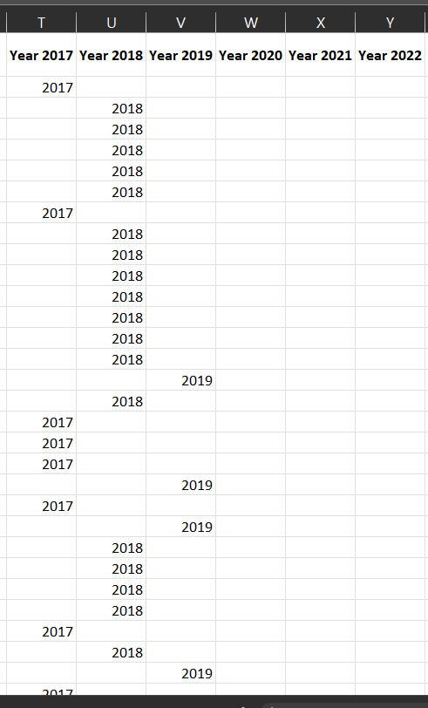
The same method has been applied on the later columns up until the column named year 2022, so that the same results can be obtained on each column (Guerrero et al., 2019). Here, each column contains the values as mentioned by the column heading such as the column called Average Price of Year 2019 contains only the year 2019 if 2019 is mentioned at column J.

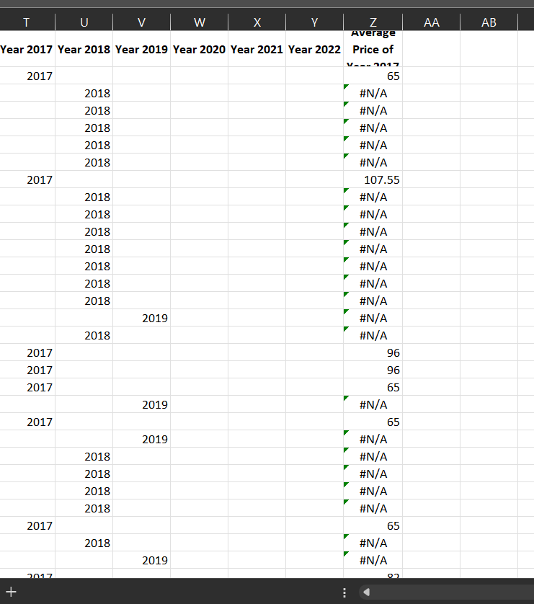
The next step of the task is to input the value of 2017 in a new column so that the values related to 2017 can be easily averaged. However, an issue as been observed that then blank cell says #N/A that is basically error. It is not desired, so changes need to be made here.
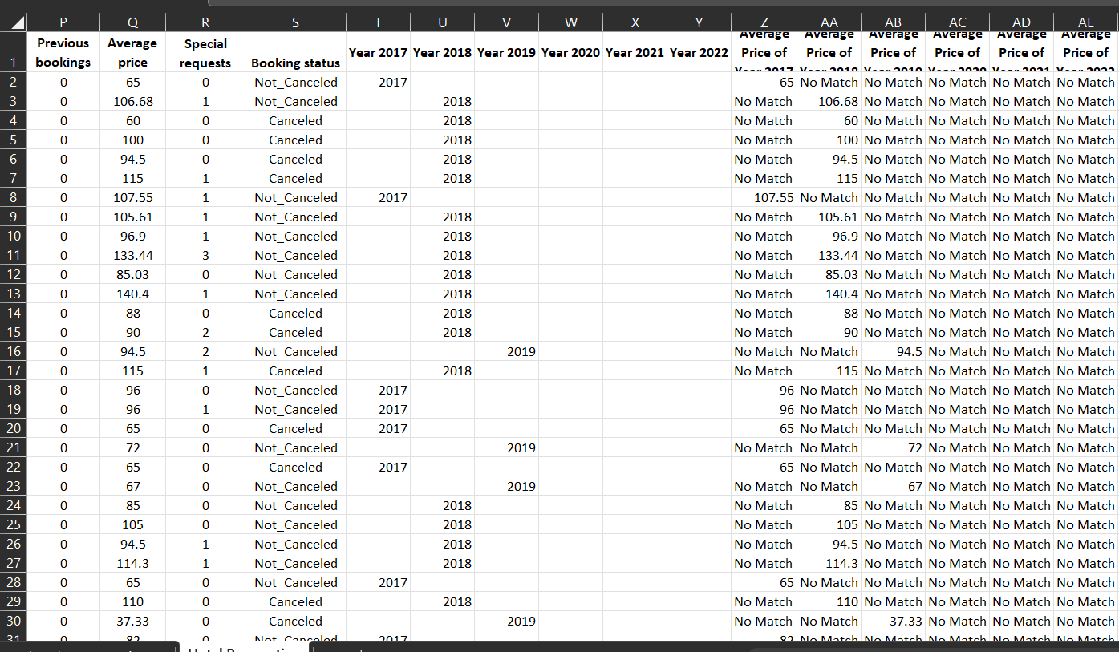
To change it, IFERROR formula was used instead of IF formula which writes No Match on the blank cells (EDUCBA, 2023). It makes it easier to navigate the data as the written part contains two words and the values only contain number.
=IFERROR(LOOKUP(2017,T2,Q2),"No Match")
This is the formula that has helped ton obtain the values for year 2017, and the formula has been copied downward. The similar formula has been used on the next few columns which has provided the values for other years (EDUCBA, 2023). By doing so, the values has been separated easily, and now the steps to find the average can easily be found (Microsoft.com, 2021).
=AVERAGE(Z:Z)
This is the formula used to find the average of year 2017, and the similar formula has been applied on each cell from here (Microsoft.com, 2021). By applying the formula, the average value for each year has been found separately which have helped to obtain the values.
Average 2017 | Average 2018 | Average 2019 | Average 2020 | Average 2021 | Average 2022
90.04985 | 106.4527 | 101.7813 | 105.3399 | 101.2333 | 101.4992
After completing the required steps, these are the values for each year found which is the desired result.

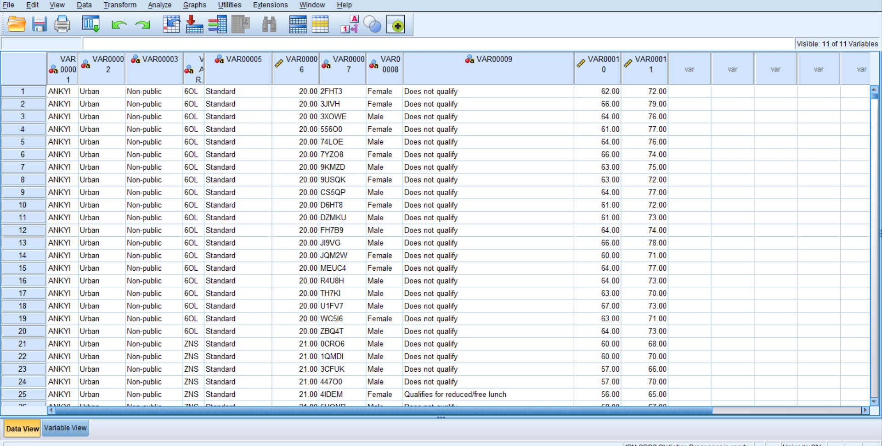
The student data that is provided on the Students Score file has been copied and inputted in the SPSS software so that the data can be analysed using SPSS (George, 2011). Also, the name of the variable present here are the ones that SPSS provides by default which can make it challenging to understand while working on the project, so the names need to be changed.
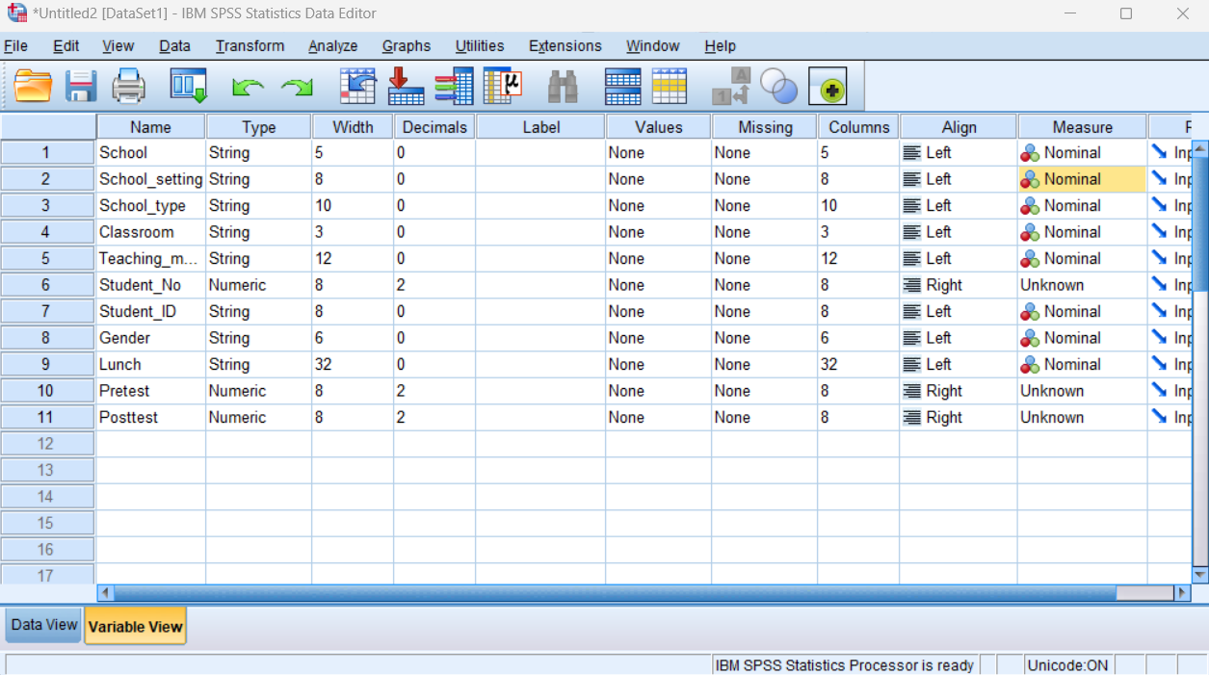
To change the name of the variables, there is a different sheet available at the SPSS, and this sheet has been utilized to change the name of the variables. By coping the name of each variable from the Excel file, the value has been copied to SPSS as shown in the above picture (George, 2011). An issue remains as the measure of variables are either set as Nominal or unknown, so SPSS will not be able to identify the variable type while calculating.
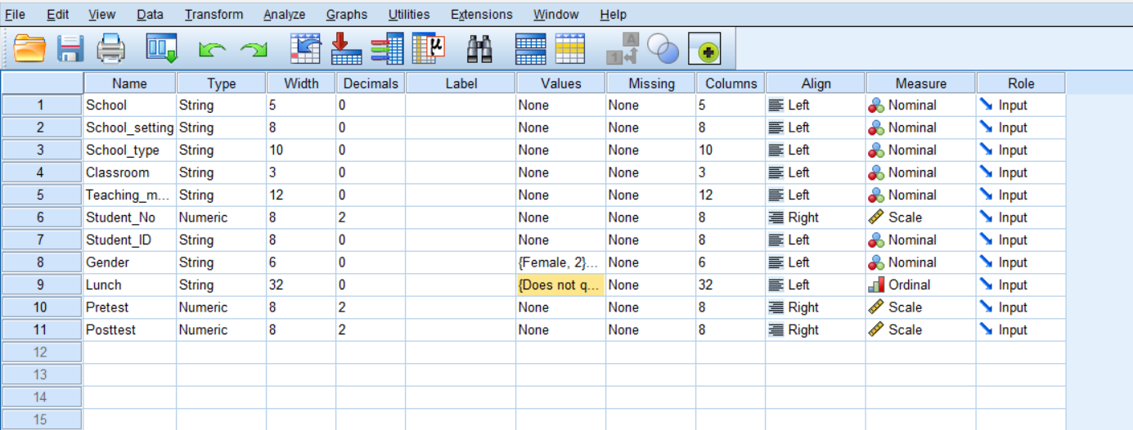
This is the final outcome of the variable after making the required changes. The key changes made here are the measure of the variable where the text or non important numbers has been left as nominal. However, the significant numbers such as number of student, pretest, protest numbers require changes as they will be counted or be present during numerical calculations (George, 2011). The values which are numeric has been presented as scale so that it can be measured from 1 to 100 or so on. The students will get free lunch or not is significant in case of this project as the students who get free lunch will be priviliedged and to mention that, SPSS provides a measure option called Ordinal. Gender data will be significant but has been left as nominal because being male or female is equal and none of them are larger or more previledged than the other.
To calculate, the gender data and lunch data will come into play, but those are presented as text which can not be calculated. To allow SPSS to calculate those values, a valu need to be assigned to those. So, for the people who gets free lunch, 1 and people who do not get free lunch 0 has been inputted. Same for gender, but the values inputted are 1 for male and 2 for female (George, 2011).
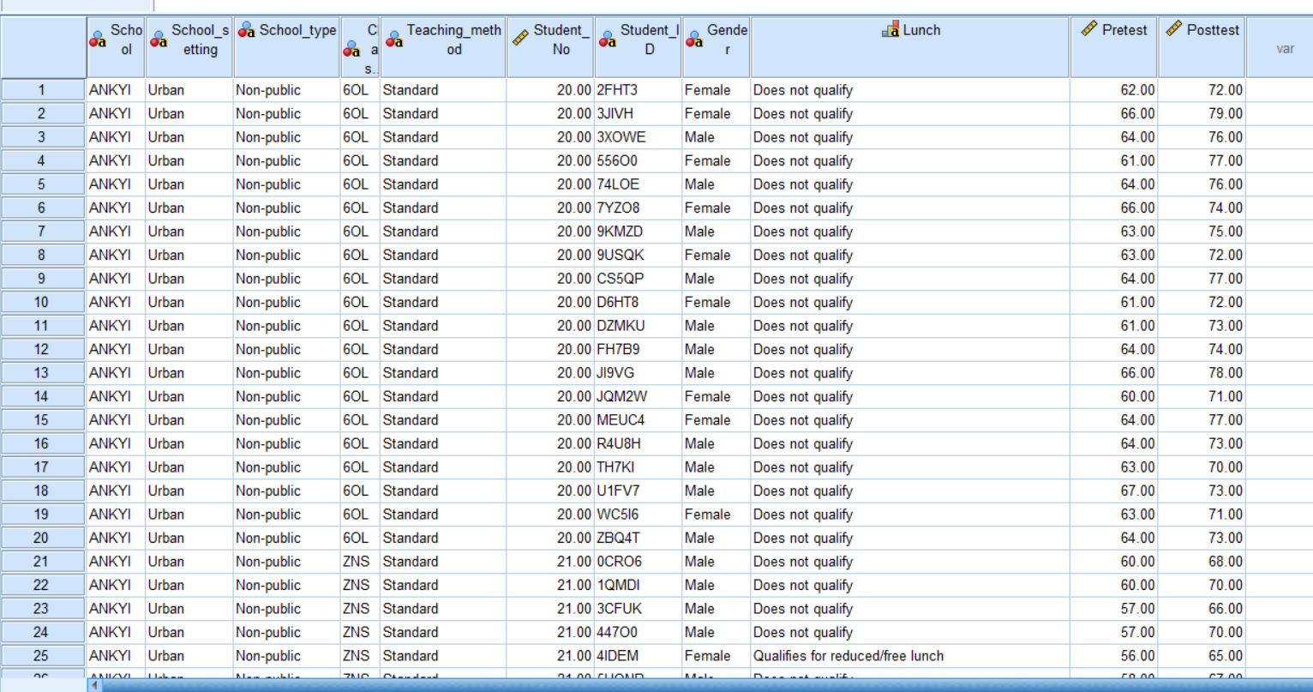
The assigned values for Lunch and Gender are not shown here which can be achived by turning on value lebels.
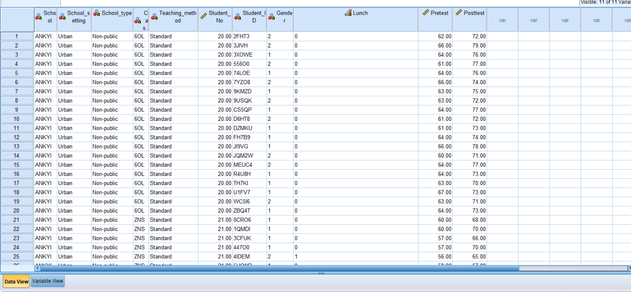
This is the final outcome of the SPSS file, and it is now ready for the required analysis using SPSS.
Analyze is an option that is available in SPSS and is used for any kind of analysis that needs to be done usisng SPSS. The first task is to find out the number of male and female, so Descriptive analysis under Analyze will be utilized. There are several option available, and frequency is the one chosen from there (George, 2011).
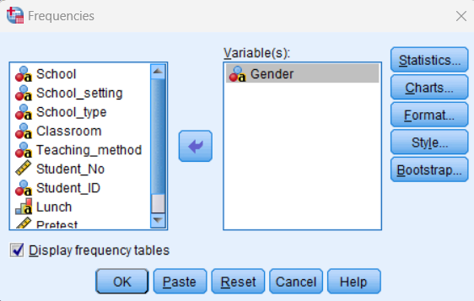
This is the new tab that is obtained by clicking the Frequency option, and from this option, Gender is selected as a variable that needs to be analyzed in this part.
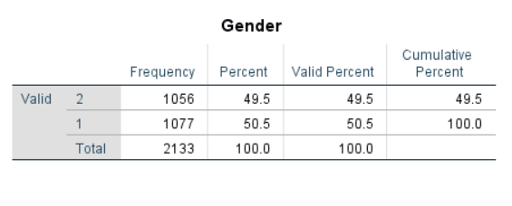
Here, the number of male and female data has been obtained that shows there are 1056 female in the class, and the number of male is greater which is 1077. Additional data such as percent, valid percent, cumulative percent are provided as well which are not needed for this task.
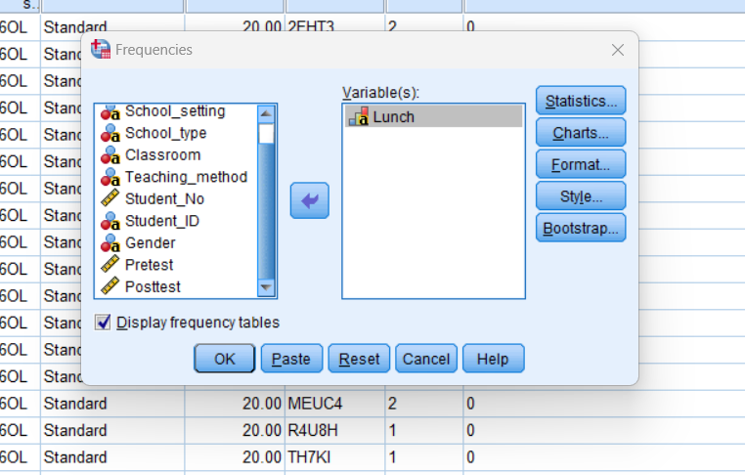
To find out the number of student who gets or does not get free lunch, the frequency option will come into play again (George, 2011). From this tab, Lunch data is set under variables to instruct SPSS that Lunch data is the one that needs to be evaluated.
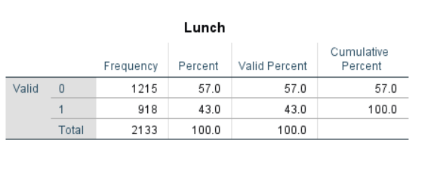
It is found through SPSS calculation that there are 1215 students who are not getting free lunch, but there are 918 students who are priviledged to obtain free lunch (‌Hinton et al., 2014).
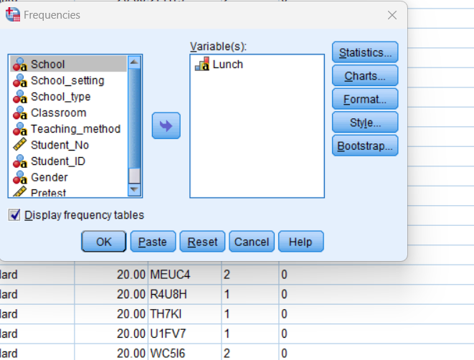
Finding mean and median will again bring to this tab, but a new step will be included. An option called Statistics can be found in this tab which needs to be utilized at this stage.
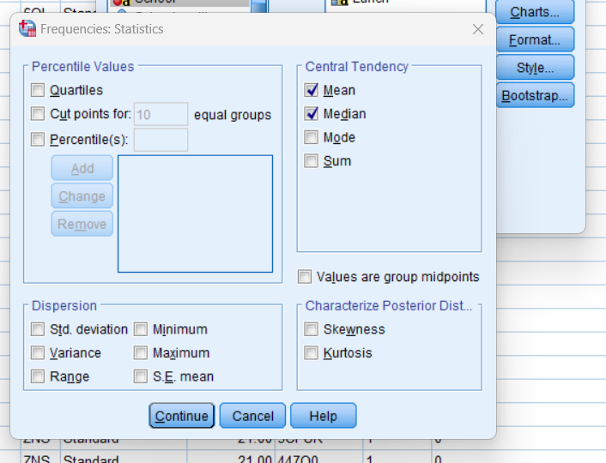
By clicking statistics, this is the new tab that comes up where there are several options to instruct SPSS to find several statistics related terms. Among them, the central tendency related data which are Mean and Median needs to be calculated for this task (‌Hinton et al., 2014). However, it is found that, the variable value is not working as the mean and median values are not being calculated properly. So, a new approach has been taken where the values will be transformed. From Transform option available at SPSS, Automatic Recode has been chosen which provided with a new tab.
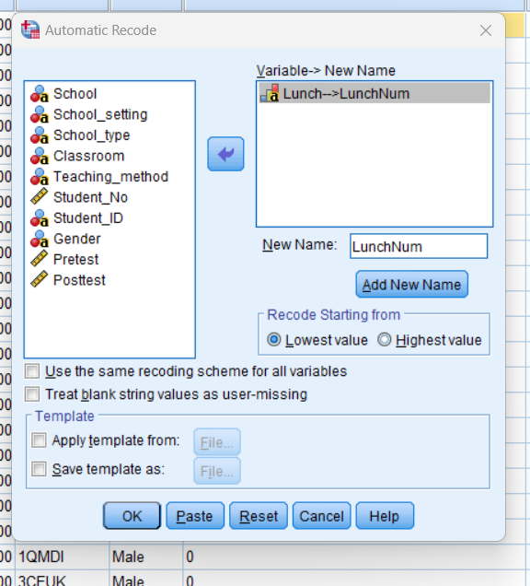
From here, lunch was chosen as string variable because the lunch data are being considered as text (Kent.edu, 2018). From add new name, LunchNum has been chosen so that a new column is created with this name which contains the required values (Field, 2009).
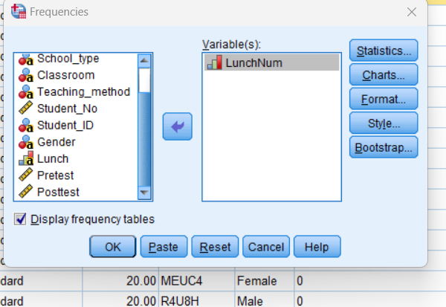
By choosing LunchNum for frequency data, the mean and median values has been calculated now which shows that the Lunch values has been successfully transformed into numeric values (Field, 2009).
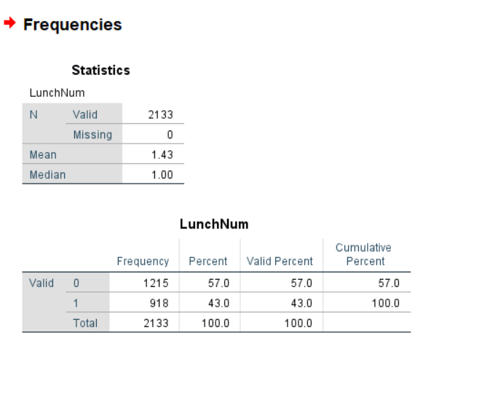
This picture shows the Mean and Median values along with several other values. The mean is found to be 1.43 which is calculated through SPSS, and the media value has been calculated to be 1.
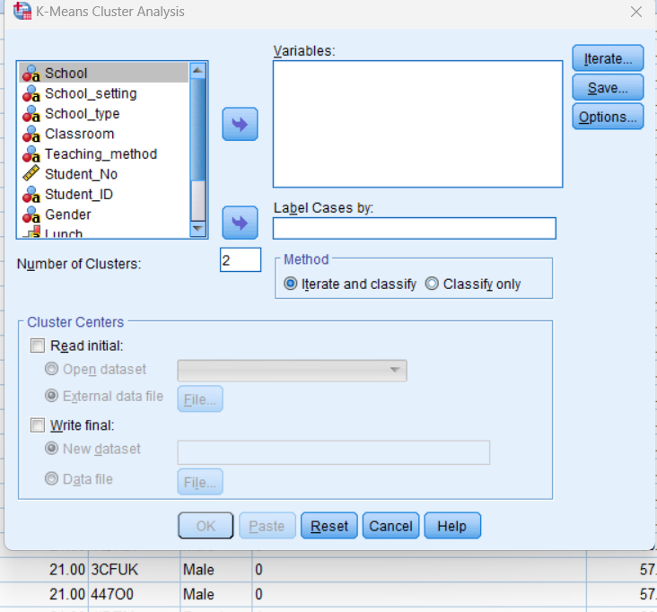
Clustering is also analysis, thus the option is available under Analyze at SPSS. From there, classify has been chosen which has provided with the option called K means clustering that needs to be utilized here (‌Hinton et al., 2014).
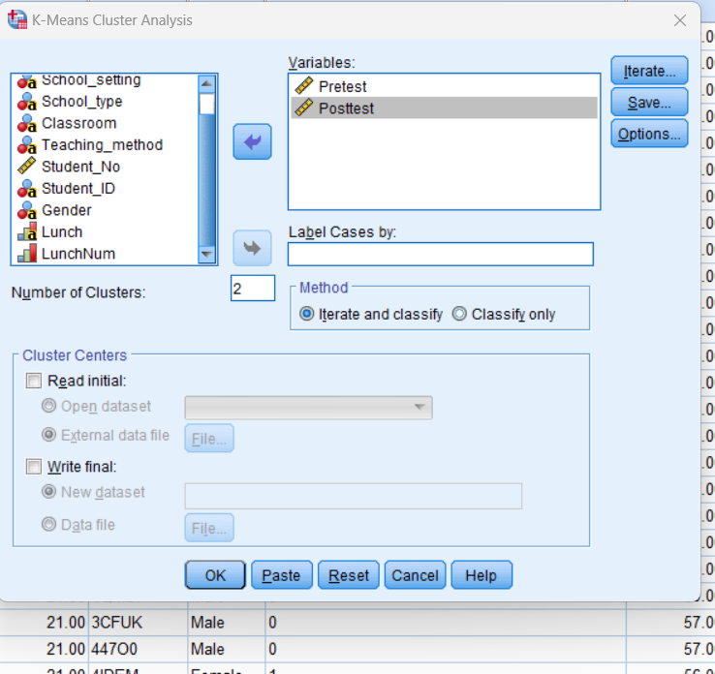
For clustering, numerical data is desired, and the two major numerical data provided in the dataset as Protest and Posttest. These data has been utilized at this stage to cluster the values (‌Hinton et al., 2014). By clicking iterate, the default iteration has been set to be 10 which has been left unchanged.
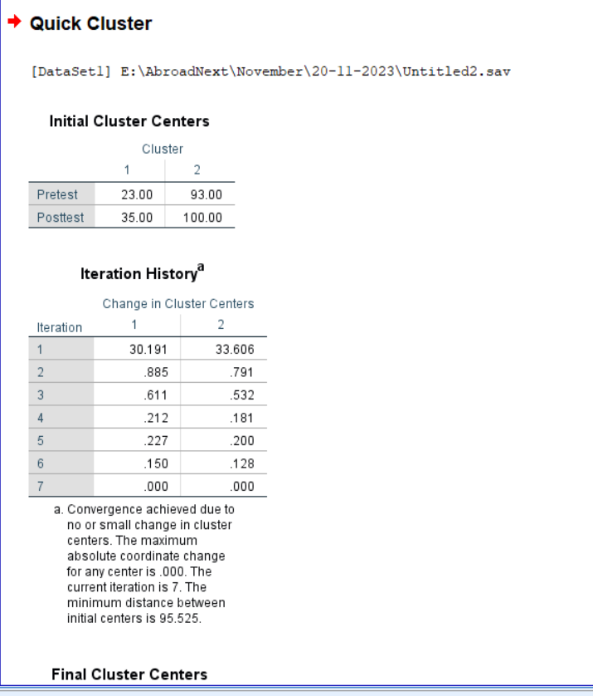
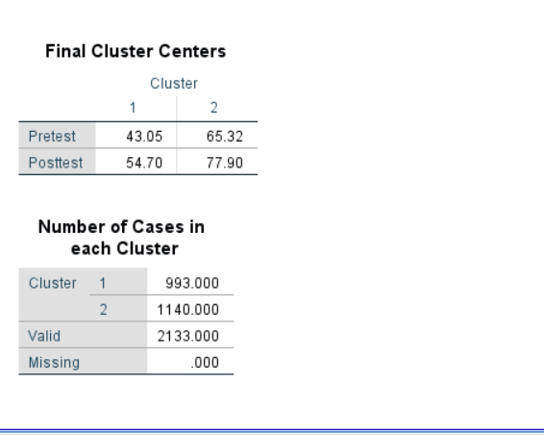
These are the results found through K clustering the data using SPSS.
There are several data mining methods that are usually used for various implications. Classification is the name of one of the data mining method where the students are differentiated by making different classes for the customer bases. If the customer base is kept together, then it becomes difficult for companies to design their product to cater the customers (Kantardzic, 2011). The marketing agencies use several classification of the customer and apply different strategies to attract different customer bases. The clustering is making similar groups of something so that various benefits can be achieved through it. The e-commerce business utilizes clustering so that if a customer buys a product, the company can recommend an additional product that the customer may get interested in (Kantardzic, 2011). The company identify the third product based on the other customers purchase behavior. Regression analysis is basically predicting the future which provides several benefits. By predicting the sales of a company in the upcoming season, they can decide on whether to increase or decrease their spending (Kantardzic, 2011). Anomaly detection is another data mining process which provides important information to ensure that the unusual patterns can be detected before a major security threat comes up. Time series analysing is another data mining methoid where the historical sales data are studied extensively so that the future sales can be forecasted for a specific period.
Regarding text mining, sentiment analysis is a widely used on as it helps to understand the opinion of the custoemers regarding a product or service. The ecommerce utilize it to find out customer opinion based on their reviews to decide whether the product need changes. Named Entity Recognition basically is identifying names of person or places from a large dataset to ensure efficiency (Berry and Kogan, 2010). The news companies usually take advantage of it to find out the important names or important video footages to break the new first. Topic modelling is another method which finds common theme from a large group of data (Berry and Kogan, 2010). For example, based on customer tickets, a common theme related to their issue can be identified to improve their service. Text classification is another method where customers are categorized based on their emails into predefined categories (Berry and Kogan, 2010). Finally, text summarization is another method where the long documents are transformed into summary to get the main idea of the articles. It is used for lengthy legal documents to capture the key idea of the documents.
Criteria | SPSS | Excel
Ease of Use | SPSS is designed for statistical analysis, making it more user-friendly for complex analyses. | Excel is user-friendly for basic tasks but may be less intuitive for advanced statistical analyses.
Statistical Capabilities | Offers a wide range of advanced statistical tests and analyses. | Limited statistical functions compared to SPSS (Abbott, 2014).
Data Handling | Handles larger datasets efficiently and supports various data types (Abbott, 2014). | Limited capacity for handling large datasets and may become slow with extensive data.
Graphics and Visualization | Provides advanced visualization options for statistical graphs and charts. | Excel is good for basic charts, but SPSS excels in creating complex statistical visualizations (Abbott, 2014).
Automation and Macros | Supports scripting and automation for repetitive tasks (Abbott, 2014). | Limited support for automation and scripting, but can be enhanced with VBA in some cases.
Cost | Generally more expensive, especially for advanced versions. | Comes bundled with Microsoft Office, making it more cost-effective for basic data analysis.

References
Abbott, M.L., 2014. Understanding educational statistics using Microsoft Excel and SPSS. John Wiley & Sons.
Berry, M.W. and Kogan, J. eds., 2010. Text mining: applications and theory. John Wiley & Sons.
‌Dalgleish, D., 2006. Excel pivot tables recipe book: a problem-solution approach. Apress.
‌EDUCBA. (2023). IFERROR with VLOOKUP (Formula, Examples) | How to Use? [online] Available at: https://www.educba.com/iferror-with-vlookup/ [Accessed 20 Nov. 2023].
Field, A., 2009. Discovering statistics using SPSS: Book plus code for E version of text (Vol. 896). London, UK: SAGE Publications Limited.
George, D., 2011. SPSS for windows step by step: A simple study guide and reference, 17.0 update, 10/e. Pearson Education India.
Guerrero, H., Guerrero, R. and Rauscher, 2019. Excel data analysis. Springer International Publishing.
‌Hinton, P.R., McMurray, I. and Brownlow, C., 2014. SPSS explained. Routledge.
Kantardzic, M., 2011. Data mining: concepts, models, methods, and algorithms. John Wiley & Sons.
Kent.edu. (2018). LibGuides: SPSS Tutorials: Recoding String Variables (Automatic Recode). [online] Available at: https://libguides.library.kent.edu/SPSS/AutomaticRecode [Accessed 20 Nov. 2023].
Microsoft.com. (2021). AVERAGE function - Microsoft Support. [online] Available at: https://support.microsoft.com/en-au/office/average-function-047bac88-d466-426c-a32b-8f33eb960cf6 [Accessed 20 Nov. 2023].
‌Microsoft.com. (2021b). Refresh PivotTable data - Microsoft Support. [online] Available at: https://support.microsoft.com/en-us/office/refresh-pivottable-data-6d24cece-a038-468a-8176-8b6568ca9be2#:~:text=Click%20Analyze%20%3E%20Refresh%2C%20or%20press,%3E%20Refresh%20arrow%20%3E%20Refresh%20All. [Accessed 20 Nov. 2023].
Microsoft.com. (2023). Create a PivotChart - Microsoft Support. [online] Available at: https://support.microsoft.com/en-us/office/create-a-pivotchart-c1b1e057-6990-4c38-b52b-8255538e7b1c [Accessed 20 Nov. 2023].
‌Microsoft.com. (2023a). IF function - Microsoft Support. [online] Available at: https://support.microsoft.com/en-us/office/if-function-69aed7c9-4e8a-4755-a9bc-aa8bbff73be2#:~:text=Use%20the%20IF%20function%2C%20one,another%20value%20if%20it's%20false.&text=For%20example%3A,Budget%22%2C%22OK%22) [Accessed 20 Nov. 2023].
Walkenbach, J., 2010. Excel 2010 bible (Vol. 593). John Wiley & Sons.

‌

