Student name – Owen Evans
Student number – 2121421

Introduction to Web and Database Concepts

Database Analysis and Design

Contents
1. Introduction 3
2. Database requirements 3
2.1. Functional requirements 3
2.2. Non-functional requirements 3
3. Design 3
3.1 Context Diagram 4
3.2 Level 0 DFD 4
3.3 Entity Relationship Diagram 5
4. Implementation 6
4.1 Forms 6
4.1.1 Main Menu 6
4.1.1 Books 7
4.1.2 Customers 8
4.1.3 Suppliers 9
4.1.4 Orders 9
4.1.5 Sales Query 10
4.1.6 Staff 10
5. SQL 11
5.1 QuerySales SQL 11
5.2 SupplyQuantity SQL 11
5.3 StockUpdate SQL 11
6. User guide 12
6.1 Main Menu Navigation 12
6.2 Form Navigation 12
6.3 Add New Button 13
6.4 Delete Button 13
6.5 Save Button 13
6.6 Editing Data 13
6.7 Running Reports 13
6.7.1 Book Search Button 14
6.7.2 Invoice Button 15
7. References 15

Introduction

This report will provide analysis of ‘Dylan’s Book Stores’ new database system. There will be information regarding the requirements of the database and implementation of an Entity Relationship Diagram (ERD). The report will also include information on the forms used, evidence of SQL and then a user guide that gives a brief overview of the full database system.

Database requirements

Functional requirements are specific demands that the end user requires the system to offer. These functionalities should be incorporated into the system itself. Non-functional requirements act more as quality constraints and have no impact on the actual system itself. For example, a functional requirement would define a system or part of it and what it should do. The non-functional comparison would define the quality attribute of a system or part of it and how the system should fulfil the functional requirements [1]. Below are the requirements of Dylan’s Book Store.

Functional requirements

The list below shows ‘Dylan’s Book Stores’ functional requirements for the database system that was created. The database must:

- Have the ability to add and delete information from any table.
- Have the ability to view book stock, orders and customer details on screen.
- Have the ability to view ongoing customer orders.
- Have the ability to query the system and print out reports.

Non-functional requirements

The list below shows the non-functional requirements for the database system. ‘Dylan’s Book Stores’ database system would benefit from:

- Add or delete information within 2 minutes
- Search individual books within 1 minute
- Access customers order history in less than 1 minute
- Print any report in less than 3 minutes

Design

Context Diagram

A context diagram represents the external entities that can interact with a system. The system itself appears in the middle, with no details shown of the structure inside. The external entities that interact with the system are surrounding it with links explaining the interactions that take place [2]. Below is an example of a context diagram for ‘Dylan’s Book Store’:

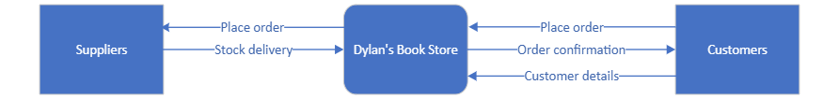

Level 0 DFD

In a system development life cycle (SDLC), process modelling is covered in the analysis phase. Process modelling is important as it defines the requirements of a system in a graphical format. A data flow diagram (DFD) specifies, constructs, and visualises the system model. A DFD is split into multiple levels, for this report a level 0 DFD is provided. This level of DFD represents a system’s major processes, data flows and data stores [3]. Below is an example of a level 0 DFD for ‘Dylan’s Book Store’:

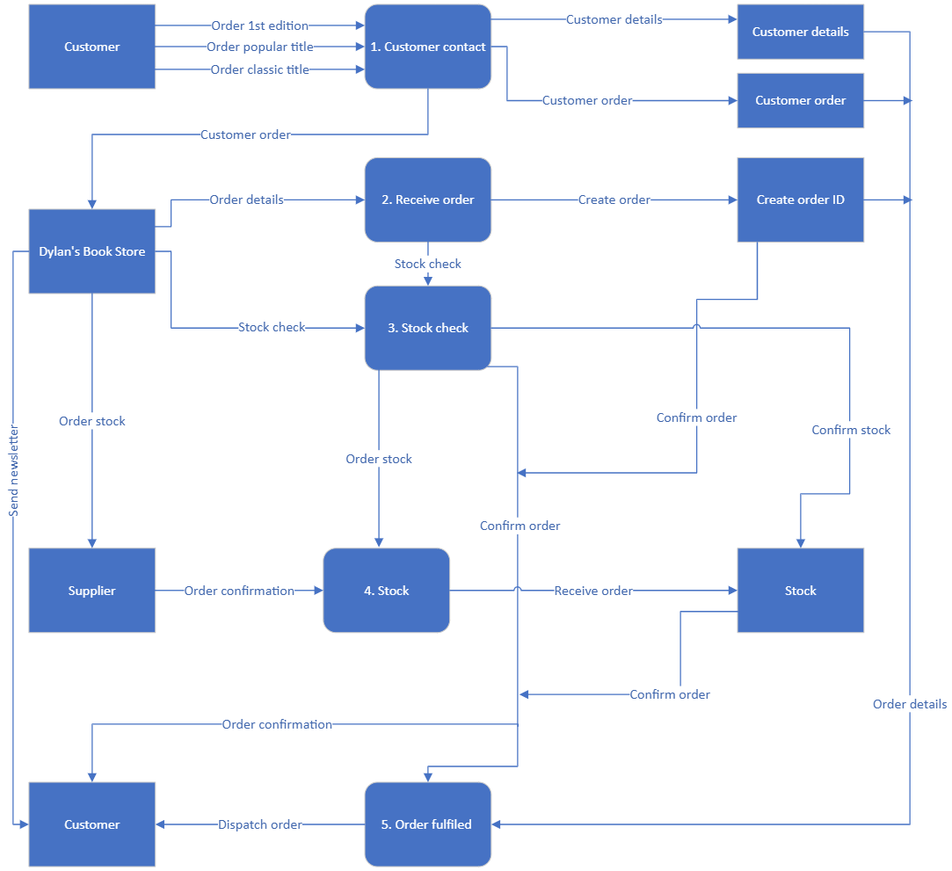

Entity Relationship Diagram

An entity relationship diagram (ERD) is a flowchart that shows how entities relate to each other within a system. In a database, an ERD will show the important entities and how they link together. They use defined sets of symbols and lines to connect each entity [4]. The lines create the relationships, these are one-to-one, one-to-many and many-to-many. One-to-many is the most common relationship and, for example, in this kind, a row in table 1 can have many matching rows in table 2, but rows in table 2 can only have one matching row in table 1 [5]. Below is a relationship diagram for Dylan’s Book Store:

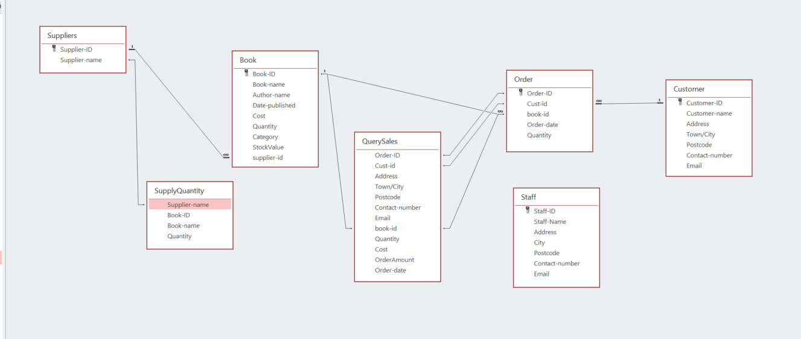

Starting with the suppliers. The primary key, Supplier-ID has a one-to-many relationship with the supplier-id within the Book table. This is due to there being one supplier, to multiple books. The Supplier-name key also has a relationship with the Supplier-name key in the SupplyQuantity table as the tables use the same data. The Book table has a one-to-many relationship with the book-id key in the Order table because there are many orders for the same book ID. The QuerySales table has a relationship with the book-id keys in both the Book and Order table as they use the same data throughout. QuerySales has other relationships with the Order table, including the Order-ID and the Cust-id keys, this is again due to both tables using the same data. The final one-to-many relationship is between the primary key in the Customer table, Customer-ID and the Cust-id key in the Order table, this relationship shows that one customer can make many orders.

Implementation

Forms

Main Menu

The main menu is the initial form that will be seen when a staff member opens the database. This menu shows 6 buttons that allows staff to access different areas of the business by simply clicking the relevant button.

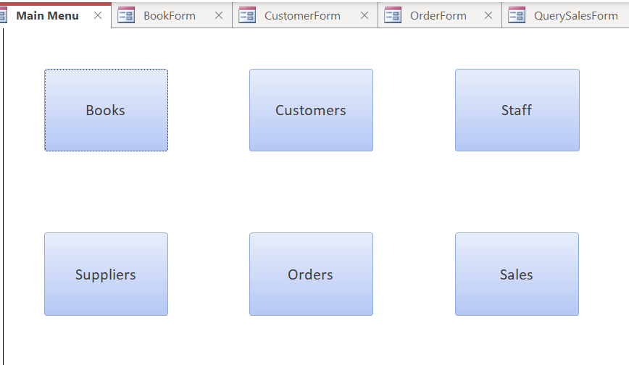

Books

The books form shows all the books available in the store, with the option to edit the details, add new books and delete any records. The form also contains a table that shows the name of the person that ordered, and the quantity ordered. The sales form is linked to the quantity numbers as when a sale is made or a current one is edited, then the database will use a macro to call upon a query that updates the quantity levels of that specific book. There is a second macro that is in use for the book search button.

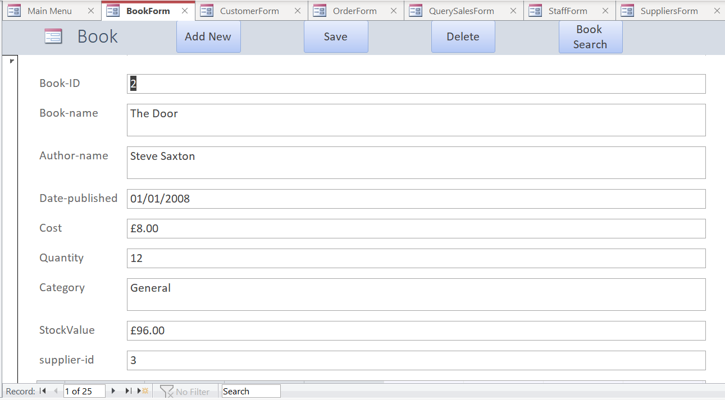
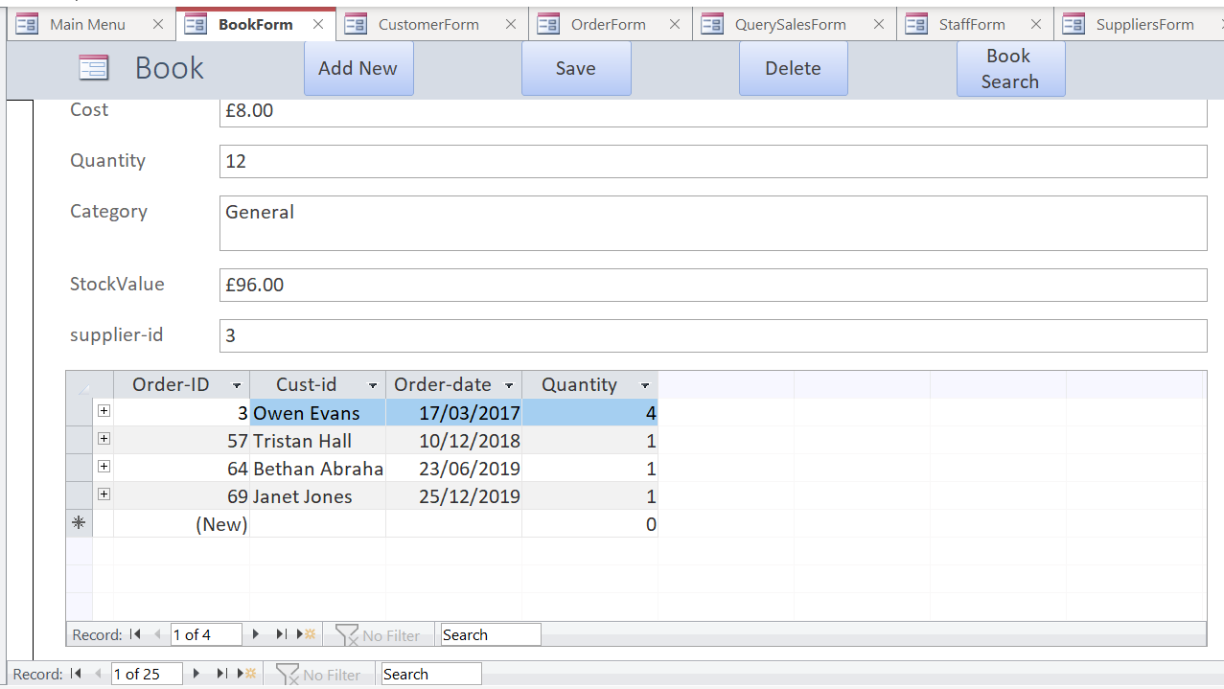

Customers

The customers form allows staff to view customer details and their previous purchases. The form allows you to edit records and has buttons that allow you to add a new customer, delete a current record and save any changes.

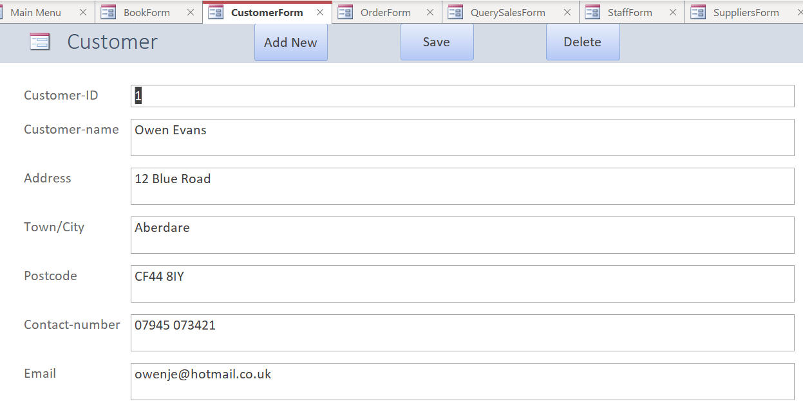
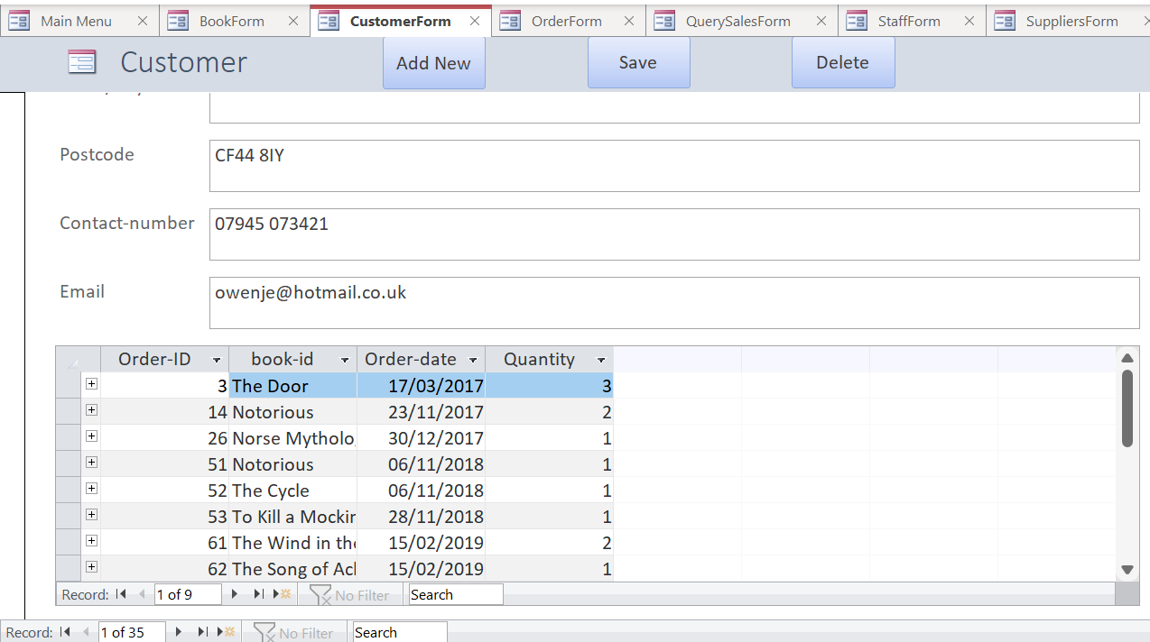

Suppliers

The suppliers form shows the suppliers name and then a table view of supplied books and related details, the current stock, the value, and category of each. Buttons included to add new, save any changes and deleted the current record.

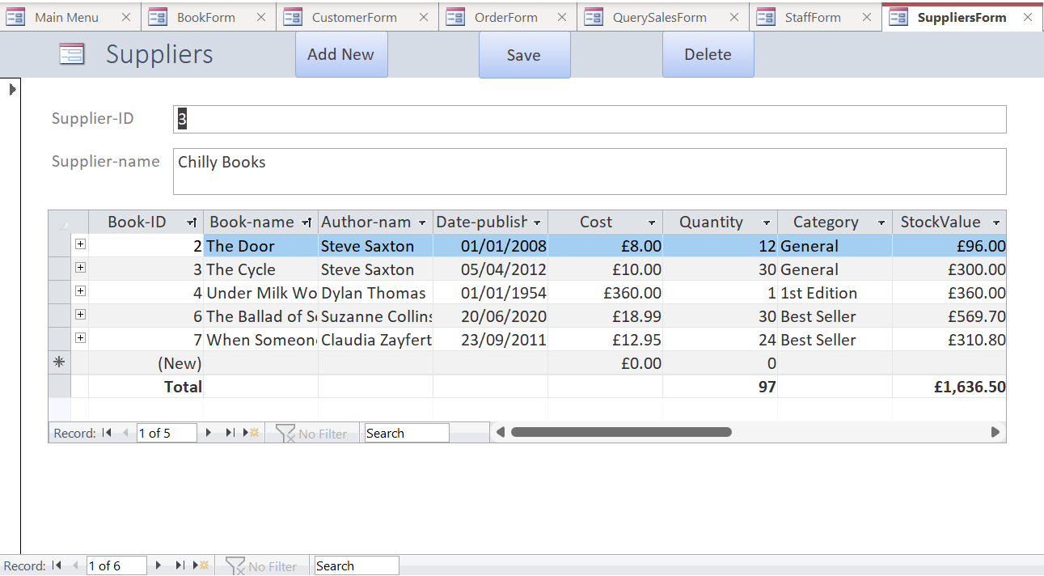

Orders

The orders form shows a briefer view of a sale compared to the sales form below but does includes the order date. The buttons are included on this page; however, it is recommended to use the sales form to enter most of the details and then come back and enter the order date.

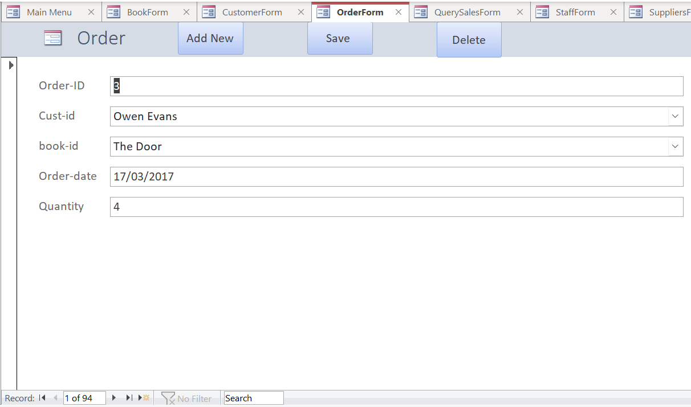

Sales Query

The Sales form shows a slightly more in-depth view of the order form containing the details of the customer and the order amount. Here you can edit, add new orders, save the changes, delete any records, and search for a specific order with the invoice button. The invoice button is created through a macro.

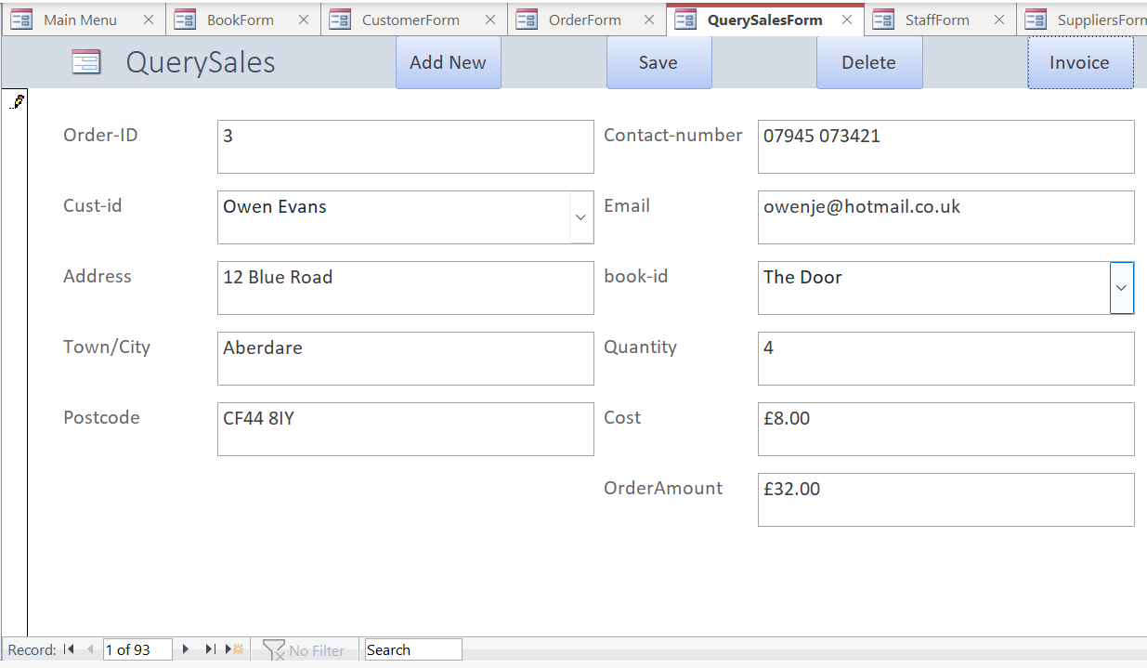

Staff

The staff form shows the details of all the current staff members. The details can be edited and there are buttons to add new members of staff or delete current members.

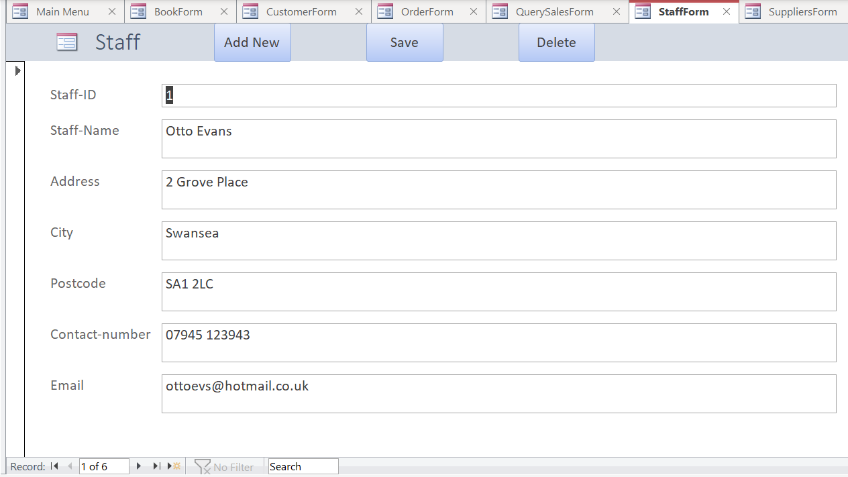

SQL

SQL stands for Structured Query Language and become a standard in 1987 with the International Organisation for Standardisation (ISO). SQL is a standard language that is used for accessing and manipulating databases. SQL can be used to execute queries, retrieve data, insert, update, or delete records [6]. It is useful when selecting rows and columns from different tables and placing them in a new table, so that certain information can be displayed.

QuerySales SQL

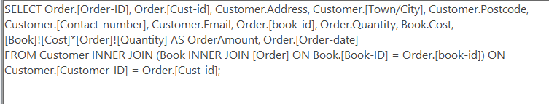

SupplyQuantity SQL

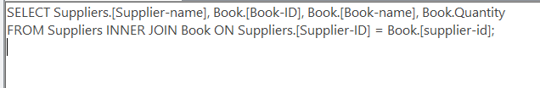

StockUpdate SQL

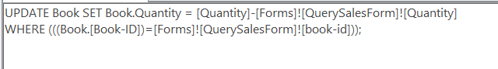

User guide

Main Menu Navigation

Click the button that is relevant to the form that you are wishing to view. For example, if you click the books button (circled below) then the database will bring up the books form.

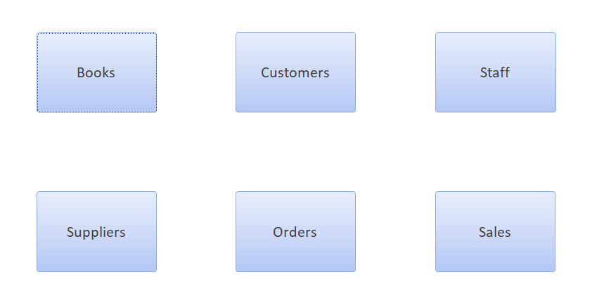

Form Navigation

Each form has a similar layout, just showing different information. Each form opens to a relevant record and can be edited from there. The forms also contain multiple buttons that can be used to add a new record, save a current record that has been edited or newly created and delete the current record. The buttons are shown below.

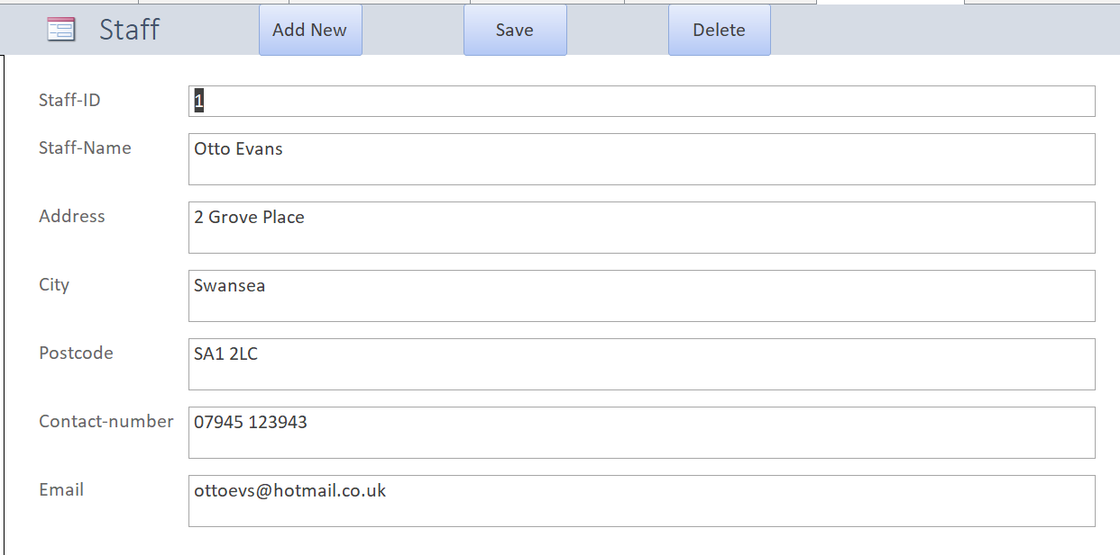

Add New Button

The add new button on each form lets you add a new record to the end of the relevant form. So, if you are on the book form, then clicking add new will take you to an empty record that you are able to fill in with the relevant details. You can add a new record for all the forms.

Delete Button

The delete button lets you delete the current record that you are viewing. This is available on all forms.

Save Button

The save button lets you save a current record after you have edited it in some way.

Editing Data

If you want to edit data on a record then this can simply be done by first accessing the relevant form and record, and then just clicking on the relevant field and changing the data in the way that you want. E.g. Changing the address of a staff member.

The Sales form is slightly different in the way that when you add a new order and enter the relevant information or if you edit a current order, the database will state that you are about to run an update query. This links with the Book form and will update the stock of each book.

Running Reports

To run a report, choose the form that you are wanting a report for, then at the top of Microsoft Access select create, then report and this will show the relevant report.
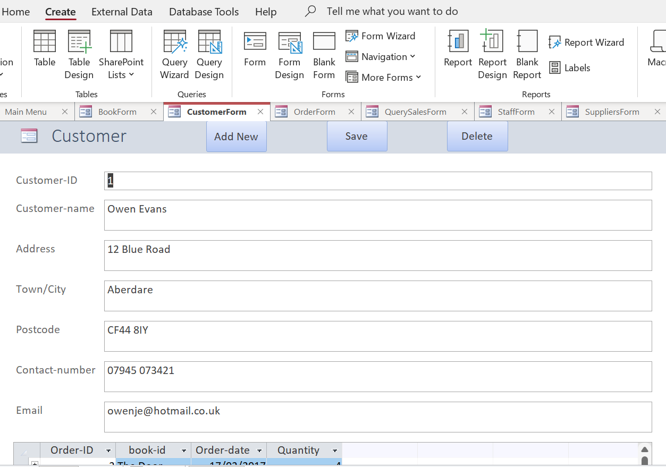

Book Search Button

If you are wanting to search for a specific book in the database, then you can do so by clicking the Book Search button. This shows the following:

Enter the books name that you want to view, and the relevant report will be shown.

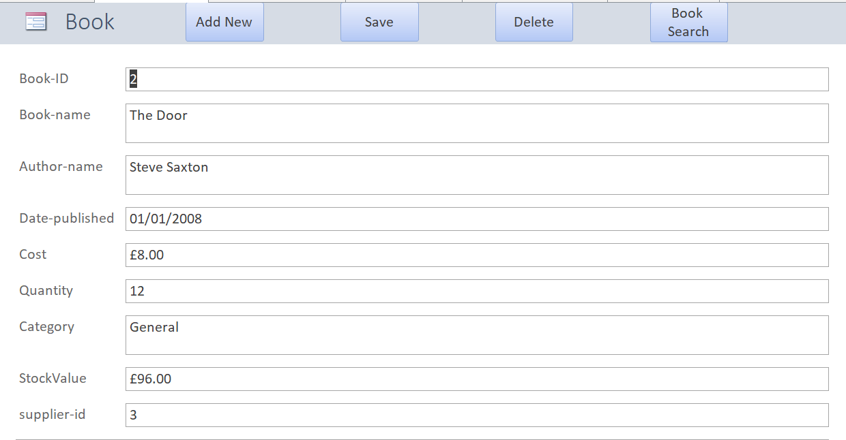

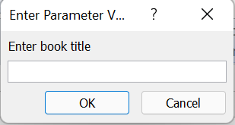

Invoice Button

If you want to view an invoice for a certain sale, then you can use the invoice button on the Sales form. Doing so will show the following:

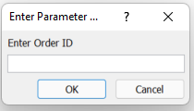

Enter the order ID that you are wanting to view, and the database will run a report for that particular order, showing the details.

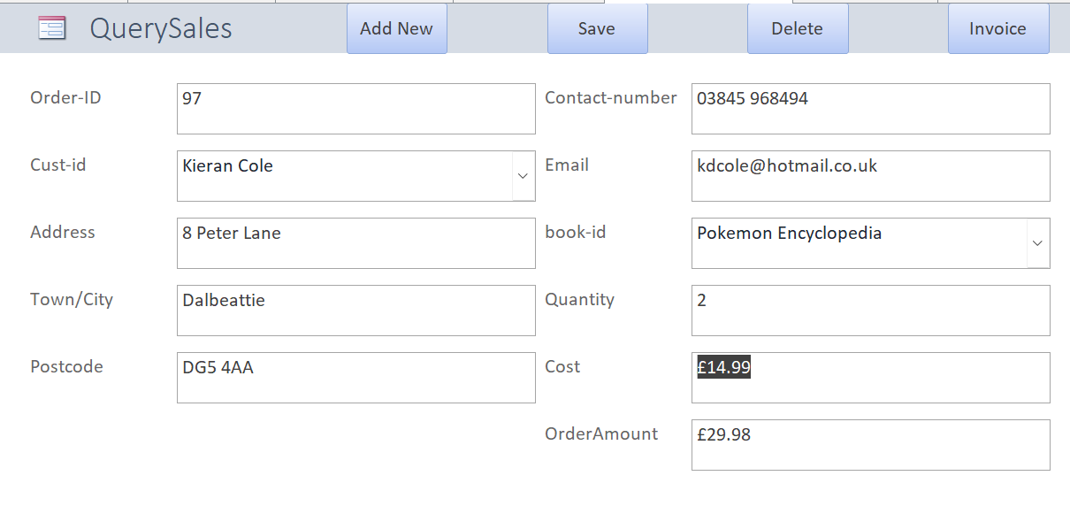

References

[1] C. Singla, "Functional vs Non Functional Requirements", GeeksforGeeks, 2020. (Online). Available: https://www.geeksforgeeks.org/functional-vs-non-functional-requirements/. (Accessed: 28- Apr- 2022).

[2] Visual Paradigm Online, "What is System Context Diagram?", Onlinevisual-paradigm.com. (Online). Available: https://online.visual-paradigm.com/knowledge/system-context-diagram/what-is-system-context-diagram/. (Accessed: 28- Apr- 2022).

[3] R. Ibrahim and S. Yen, "Formalization of the Data Flow Diagram Rules for Consistency Check", International Journal of Software Engineering & Applications, vol. 1, no. 4, pp. 95-97, 2010. Available: https://www.researchgate.net/publication/47619337_Formalization_of_the_Data_Flow_Diagram_Rules_for_Consistency_Check. (Accessed 28 April 2022).

[4] Lucidchart, "What is an Entity Relationship Diagram (ERD)?", Lucidchart.com. (Online). Available: https://www.lucidchart.com/pages/er-diagrams/#section_8. (Accessed: 28- Apr- 2022).

[5] Microsoft, "Define relationships between tables in an Access database - Office", Docs.microsoft.com, 2022. (Online). Available: https://docs.microsoft.com/en-us/office/troubleshoot/access/define-table-relationships. (Accessed: 01- May- 2022).

[6] W3 Schools, "SQL Introduction", W3schools.com. (Online). Available: https://www.w3schools.com/sql/sql_intro.asp. (Accessed: 28- Apr- 2022).

