
The Role of Digital Transformation in Enhancing Customer Experience: A Case Study of Marks & Spencer UK
Component 1 – Business Research Proposal
Module code: LCLM6004
Module: Research Methods for Business

Student name:Daneil Nelson
Student ID number:2309115

Table of Contents
1. Introduction and Business Problem 3
1.1 Background 3
1.2 Organisational Background 3
1.3 Business Problem 3
1.4 Research Justification 3
2. Aim, Objectives and Questions 4
2.1 Aim 4
2.2 Objectives 4
2.3 Questions 4
3. Critical Literature Review 4
3.1 Digital Transformation in Retail 4
3.2 Customer Experience 5
3.3 Digital Technologies Improving Customer Experience 6
3.4 Relevant Theories and Models 7
3.5 Literature Gap 8
4. Research Methodology 8
4.1 Research Philosophy 8
4.2 Research Approach 8
4.3 Research Design 9
4.4 Data Collection 9
4.5 Data Analysis 9
4.6 Sampling Strategy 9
4.7 Reliability and Validity 9
4.8 Research Ethics 10
5. Business Relevance and Practical Implications 10
Reference list 11

1. Introduction and Business Problem

1.1 Background
The digital transformation has emerged as a strategic need in the UK retail industry as retailers are using artificial intelligence (AI), omnichannel retailing, mobile applications, self-checkout technologies and e-commerce as a means of enhancing customer interactions and operational effectiveness (Wolniak, Stecuła and Aydın, 2024). British shoppers desire AI-powered shopping assistants by 60%, and 53% anticipate shopping via social media by 2030, indicating that more retailers are prioritising digitally integrated and personalised shopping experiences (DHL Group, 2026). The customer experience has now been identified as a big source of competitive advantage since customer satisfaction, customer loyalty and customer purchasing behaviour directly depend on the customer experience.

1.2 Organisational Background
Marks and Spencer (M&S) is considered one of the most successful retailers in the UK with a reported revenue of 17.3 billion during the 2025/26 financial year with a market share of 10.2% of the UK clothing market (Marks & Spencer, 2026). The company has focused on digital transformation as part of its Reinventing M&S strategy, which has been achieved by investing in technology, online retail, personalisation aided by AI, a redesigned Sparks digital loyalty programme, and modernisation of the supply chain. M&S has also integrated Digital, Data and Technology plans in its business to enhance its omnichannel customer experience and efficiency in its operations.

1.3 Business Problem
Marks and Spencer (M&S) still has a long way to go to provide a seamless customer experience on both its web-based and brick-and-mortar platforms despite significant investment in digital transformation. The online orders, click-and-collect services and digital payments were disrupted by the 2025 cyberattack, which proves the vulnerability of its omnichannel operations. Since about one-third of M&S clothing and home sales are made online, the ability to have a robust and unified digital customer experience has become a strategic necessity to keep customers satisfied, loyal and competitive (BBC, 2025).

1.4 Research Justification
The study is necessary due to the fact that, although M&S invests a lot in digital transformation, there are few studies that have investigated how these efforts have a cumulative effect on customer experience in the UK retail industry. The study, in terms of academics, adds to the literature by discussing digital transformation with a single-case study of M&S based on the latest secondary evidence. In practice, the results can help the management to review digital strategies, enhance the integration of the omnichannel and focus on future investments in technologies to enhance customer satisfaction and business performance.

2. Aim, Objectives and Questions

2.1 Aim
The research aims to explore how digital transformation has the potential to improve customer experience at Marks & Spencer UK by conducting qualitative research using secondary data.

2.2 Objectives
- To investigate digital transformation projects in Marks and Spencer UK
- To examine how digital transformation can help improve customer experience
- To determine issues that impact digital transformation at M&S
- To prescribe a way of enhancing customer experience by tackling digital transformation

2.3 Questions
- Which digital transformation initiatives have been adopted at M&S?
- What does digital transformation do to improve customer experience at M&S?
- What issues does digital transformation in M&S have?
- How can M&S enhance customer experience by changing its digital transformation?

3. Critical Literature Review

3.1 Digital Transformation in Retail
Digital transformation in retail is the process of deploying digital technology in the business activities to enhance the business processes, customer experiences and organisational performance (Kao et al., 2022). It has graduated to using simple e-commerce platforms to sophisticated technologies like artificial intelligence (AI), data analytics, mobile apps and omnichannel retailing that facilitate a smooth shopping process. Omnichannel customer experience (OCX) is the assessment of customer experiences of the retailer through its omnichannel, which underscores the significance of the inclusion of digital and physical contacts with customers (Rahman et al., 2022).
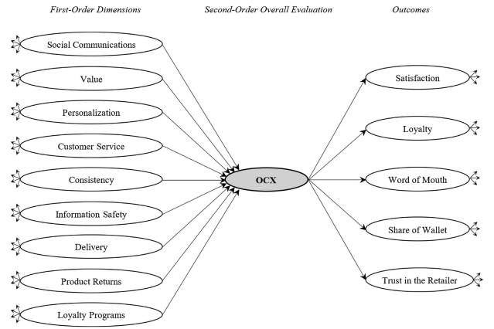
Figure 1: OCX
(Source: Rahman et al., 2022)
On the same note, the use of in-store technology has been the order of the day in order to improve the retail experience (Grewal et al., 2023). Nonetheless, as much as digital transformation enhances customer satisfaction, efficiency in operations and competitive advantage, it is also associated with such challenges as high implementation costs, cybersecurity concerns, integration of technologies and resistance to new technology by customers.

3.2 Customer Experience
Customer experience (CX) is the total experience and reactions that customers have had because of interactions with a retailer during the customer journey, which includes the pre-purchase, purchase and post-purchase phases (Hermes and Riedl, 2021). Customers in the context of omnichannel retailing should experience a seamless and consistent experience both on the online and offline touchpoints.
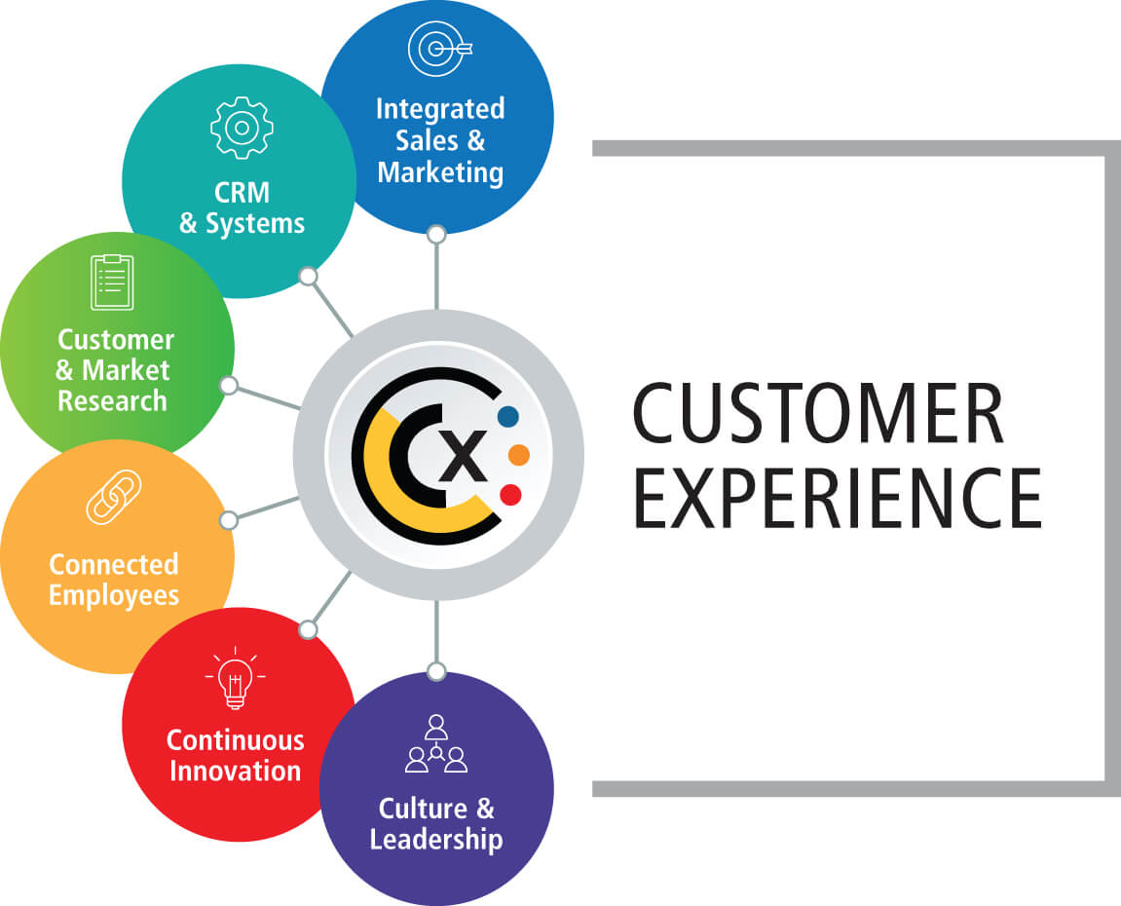
Figure 2: Customer Experience
(Source: Totara, 2026)
The significance of customer experience has been a major strategic focus of service research and management as it plays a major role in creating a competitive advantage (Gahler, Klein and Paul, 2023). Likewise, omnichannel customer experience (OCX) is customer evaluations of their experiences across the retailer's omnichannel. Customer Experience Management (CEM) framework recommends organisations to balance all their customer touchpoints in order to maximise customer satisfaction, foster customer loyalty and build strong customer relationships in the long term (Dzreke, 2025). A good customer experience management hence leads to enhanced customer retention, enhanced brand perception and sustainable performance.

3.3 Digital Technologies Improving Customer Experience
The use of digital technologies has largely changed consumer experience as retailers can now provide more personalised, seamless and faster services. Artificial intelligence (AI) is used to support personalised recommendations and chatbots, whereas big data analytics is used to help retailers comprehend customer preferences and buying behaviour (Rane, 2023). Mobile applications, self-service technologies and omnichannel retailing are also convenient as they blend the online and offline shopping experience. The cross-channel integration also has an effect on customer experiences and it also leads to changes in perception and behavioural intention. The omnichannel customer experience is enhanced by AI systems using personalisation, consistency and flexibility (Nguyen and Mogaji, 2023). But, to ensure successful implementation, there is a need to have a good technology integration in place, strong data management and customer trust to optimise satisfaction, loyalty and long-term competitive advantage.

3.4 Relevant Theories and Models
Technology Acceptance Model (TAM)
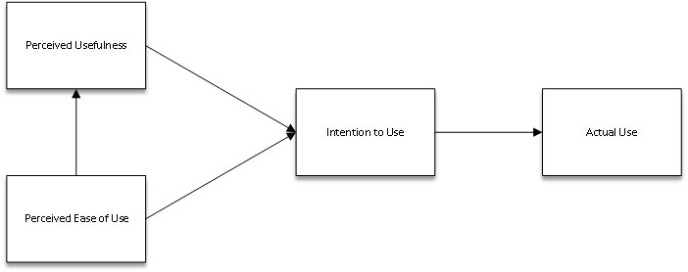
Figure 3: TAM
(Source: Marikyan and Papagiannidis, 2026)
Technology Acceptance Model (TAM) is a model that explains that users will be more likely to adopt the technology when they find it useful and easy to use. The model is popularly used to comprehend customer adoption of digital technologies like mobile applications, AI-based services and self-service systems. TAM has been identified as having long-term ramifications on management research ( Musa et al., 2024). Thus, TAM offers a suitable model to examine the impact of the digital initiatives of M&S on the adoption of digital retail services by customers.
The Resource-Based View (RBV)
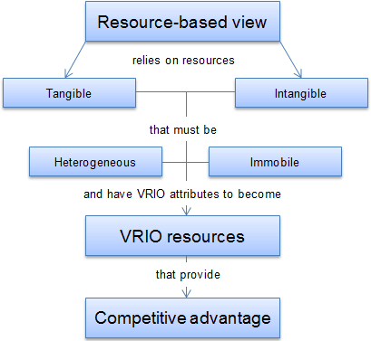
Figure 4: RBV
(Source: Jurevicius, 2026)
The Resource-Based View (RBV) implies that sustainable competitive advantage is gained by organisations through valuable and hard-to-copy resources, such as digital capabilities (Liang and Tian, 2024). Digital resources can be used to establish a competitive advantage and maintain it. Therefore, RBV backs up this research by describing how the company's investments in online technologies, data potential and omnichannel systems can empower customer experience and enhance the long-term business performance of M&S.

3.5 Literature Gap
The available research tends to discuss the topic of digital transformation and the use of technology in the retail industry on a broad level, with little emphasis given to Marks and Spencer. Moreover, there is a paucity of studies that synthesise publicly available organisational and industry evidence to measure the effect of digital transformation on customer experience in M&S; thus, this study fills this gap by a qualitative case study using secondary data and thematic analysis to offer insights that are specific to the context.

4. Research Methodology

4.1 Research Philosophy
The research philosophy used in this study is the interpretivist approach since it aims at comprehending the impact of digital transformation on customer experience using the interpretation of already published evidence as opposed to measuring it objectively (Sarfraz, Kurdi and Rafiq, 2025). Interpretivism is suitable in culling out meanings, organisational practices and customer-related insights as manifested in the company reports, academic literature and industry publications. The philosophy helps to get a better idea of how digital initiatives are characterised, used and perceived in the context of Marks and Spencer (M&S).

4.2 Research Approach
The research method that will be applied is an inductive research method due to the fact that the study will be developed to come up with themes based on the available secondary evidence rather than to test the pre-established hypotheses. An inductive approach enables the patterns and insights to be developed intuitively during the process of reviewing qualitative data (Laari, 2025). This method is suitable since the study examines the role of digital transformation in customer experience, based on reported organisational experiences.

4.3 Research Design
The study will be qualitative and will only involve Marks and Spencer UK in the case study. A case study helps conduct detailed research of the digital transformation in a real organisational setting. It enables a thorough comprehension of the digital initiatives of M&S, customer experience strategies and operational issues, which is why it is appropriate to answer the research purpose.

4.4 Data Collection
The research will be based on secondary sources only of credible information that is publicly available. They are M&S Annual Reports, Sustainability Reports, Investor Presentations, the official company site, industry reports released by peer-reviewed academic journals, trade media in the retail business and reliable news media. The secondary data is suitable as it gives complete, up-to-date, and affordable data and allows analysing organisational strategies without having to access primary participants (Bernardi et al., 2023).

4.5 Data Analysis
Thematic analysis will be used to analyse data in accordance with the six steps of Braun and Clarke: familiarisation with the data, coding, generating themes, reviewing themes, defining and naming themes and producing the final report (Ahmed et al., 2025). Such an approach is suitable as it will allow the systematic recognition and interpretation of recurrent patterns between a wide range of qualitative secondary sources, which will be insightful in the context of digital transformation and customer experience.

4.6 Sampling Strategy
Purposive sampling will be used to identify pertinent secondary sources in the research (Tajik, Golzar and Noor, 2024). Peer-reviewed journal articles published in the past 2-6 years, official M&S publications, and quality industry reports are also used as inclusion criteria. The sources that are not credible, relevant or have enough evidence will be omitted to keep the quality and relevance of the analysis.

4.7 Reliability and Validity
Triangulation of data will be used to increase reliability and validity in the use of data, where two or more sources of academic, organisational and industry data will be utilised to confirm findings. Peer-reviewed literature and official company documents will be used as a priority in order to enhance credibility. Dependability will be enhanced with a transparent search and analysis process. Nevertheless, because secondary data can be used, this could restrict access to up-to-date customer perceptions and internal organisational data.

4.8 Research Ethics
Only publicly available information will be used in the study, and ethical principles of research will be adhered to. To prevent plagiarism and give the original authors credit, all sources will be properly referenced in Harvard style (Weerawardane and Byrne, 2021). Any copyright considerations will be adhered to and interpretation of findings will be done in a fair manner in order to maintain honesty, transparency and academic integrity in the research process.

5. Business Relevance and Practical Implications
This research will provide Marks and Spencer (M&S) with both strategic and operational knowledge that will prove highly beneficial. The research will be strategic in helping the company identify the effectiveness of its digital transformation initiatives in boosting its omnichannel integration, its digital customer relationship, customer satisfaction and customer loyalty, and its decision-making regarding digital investment. Such real-life lessons about the potential influence of digital technologies on customer experience could serve managers with the purpose of concentrating future innovation and maintaining a competitive advantage in the UK retail sector.
In terms of operations, the results can be used to determine how to enhance the functionality of mobile applications, use artificial intelligence in personalised services, enhance usability and navigation on websites, and create more efficient personalised marketing strategies. This kind of improvement would be utilised in a more integrated and seamless customer experience on and off-line. On the academic side, the study will add to the existing body of literature on digital transformation in UK retail by offering a qualitative case study of Marks and Spencer based on the secondary evidence in the recent past.

Reference list
Ahmed, S.K., Mohammed, R.A., Nashwan, A.J., Ibrahim, R.H., Abdalla, A.Q., Ameen, B.M.M. and Khidhir, R.M. (2025). Using Thematic Analysis in Qualitative Research. Journal of Medicine, Surgery, and Public Health, [online] 6(6), p.100198. doi:https://doi.org/10.1016/j.glmedi.2025.100198.
BBC (2025). M&S cyber attack: What we know about it and the impact it’s having. BBC. [online] 1 May. Available at: https://www.bbc.com/news/articles/c0el31nqnpvo [Accessed 10 July 2026].
Bernardi, F.A., Alves, D., Crepaldi, N.Y., Yamada, D.B., Lima, V. and Rijo, R. (2023). Data quality in health research: An integrative literature review. Journal of Medical Internet Research, [online] 25(25), pp.e41446-e41446. doi:10.2196/41446.
DHL Group (2026). DHL’s E-Commerce Trends Report 2025: AI and social media reshaping online shopping in UK - DHL - United Kingdom. [online] DHL. Available at: https://www.dhl.com/gb-en/ecommerce/uk/content-hub/press-centre/dhls-e-commerce-trends-report-2025.html [Accessed 10 July 2026].
Dzreke, S.S. (2025). Developing holistic customer experience frameworks: Integrating journey management for enhanced service quality, satisfaction, and loyalty. Frontiers in Research, [online] 2(1), pp.90–115. doi:10.71350/30624533110.
Gahler, M., Klein, J.F. and Paul, M. (2023). Customer Experience: Conceptualization, Measurement, and Application in Omnichannel Environments. Journal of Service Research, 26(2). doi:https://doi.org/10.1177/10946705221126590.
Grewal, D., Benoit, S., Noble, S., Guha, A., Ahlbom, C.-P. and Nordfält, J. (2023). Leveraging In-Store Technology and AI: Increasing Customer and Employee Efficiency and Enhancing their Experiences. Journal of Retailing, [online] 99(4), pp.487–504. doi:https://doi.org/10.1016/j.jretai.2023.10.002.
Hermes, A. and Riedl, R. (2021). Dimensions of Retail Customer Experience and Its Outcomes: A Literature Review and Directions for Future Research. HCI in Business, Government and Organizations, pp.71–89. doi:10.1007/978-3-030-77750-0_5.
Jurevicius, O. (2026). Resource-Based View. [online] Strategic Management Insight. Available at: https://strategicmanagementinsight.com/tools/resource-based-view/ [Accessed 10 July 2026].
Kao, L.-J., Chiu, C.-C., Lin, H.-T., Hung, Y.-W. and Lu, C.-C. (2022). Evaluating the Digital Transformation Performance of Retail by the DEA Approach. Axioms, [online] 11(6), p.284. doi:10.3390/axioms11060284.
Laari, L. (2025). Inductive-Deductive Qualitative Data Analysis Logic in Health Sciences Research: A Framework for Analysing Qualitative Data. International Journal of Qualitative Methods, 24. doi:10.1177/16094069251381706.
Liang, D. and Tian, J. (2024). The Impact of Digital Transformation on the High-Quality Development of Enterprises: An Exploration Based on Meta-Analysis. Sustainability, [online] 16(8), p.3188. doi:10.3390/su16083188.
Marikyan, D. and Papagiannidis, S. (2026). Technology Acceptance Model: A Review. [online] Open.ncl.ac.uk. Available at: https://open.ncl.ac.uk/theories/1/technology-acceptance-model/ [Accessed 10 July 2026].
Marks & Spencer (2026). 2026 Annual Report. [online] Available at: https://corporate.marksandspencer.com/investors/our-performance-updates/2026-annual-report?tab=financial [Accessed 10 July 2026].
Musa, H.G., Fatmawati, I., Nuryakin, N. and Suyanto, M. (2024). Marketing research trends using technology acceptance model (TAM): A comprehensive review of researches (2002–2022). Cogent Business & Management, 11(1). doi:https://doi.org/10.1080/23311975.2024.2329375.
Nguyen, N.P. and Mogaji, E. (2023). Artificial Intelligence for Seamless Experience Across Channels. Springer eBooks, pp.181–203. doi:10.1007/978-3-031-33898-4_8.
Rahman, S.M., Carlson, J., Gudergan, S.P., Wetzels, M. and Grewal, D. (2022). Perceived omnichannel customer experience (OCX): Concept, measurement, and impact. Journal of Retailing, [online] 98(4), pp.611–632. doi:10.1016/j.jretai.2022.03.003.
Rane, N. (2023). Enhancing Customer Loyalty through Artificial Intelligence (AI), Internet of Things (IoT), and Big Data Technologies: Improving Customer Satisfaction, Engagement, Relationship, and Experience. [online] Social Science Research Network. doi:10.2139/ssrn.4616051.
Sarfraz, M., Kurdi, B. Al and Rafiq, M. (2025). How Digital Marketing Shapes Consumer Decision-Making Employing (AIDA) Model with Respect to Consumer Knowledge and Consumer Experience. International Journal of Management and Marketing Intelligence, [online] 2(1), pp.39–48. doi:10.64251/ijmmi.66.
Tajik, O., Golzar, J. and Noor, S. (2024). Purposive Sampling. Purposive Sampling, [online] 2(2), pp.1–9. doi:10.22034/ijels.2025.490681.1029.
Totara (2026). How to build great customer experience with customer training - Totara Learning. [online] Available at: https://totara.com/us/articles/how-to-build-great-customer-experience-with-customer-training/ [Accessed 10 July 2026].
Weerawardane, D. and Byrne, P. (2021). An introduction to critical thinking, academic writing and Harvard referencing. [online] Repository.uwl.ac.uk. Available at: https://repository.uwl.ac.uk/id/eprint/8456/ [Accessed 10 July 2026].
Wolniak, R., Stecuła, K. and Aydın, B. (2024). Digital Transformation of Grocery In-Store Shopping-Scanners, Artificial Intelligence, Augmented Reality and Beyond: A Review. Foods, 13(18), p.2948. doi:https://doi.org/10.3390/foods13182948.

