Now that I have completed the check on the contracts I will either send them back to the customer/ client signed if I am happy with it or I will need to send over the list of queries which I have. As a subcontractor in the industry we work for many different companies on many of their sites. Therefore we do not want to approach them in a bad manor which may cause disputes. Therefore it is very important to respond with the contract review sheet in a professional manor.
The first step in doing this will be to draft an email to the main contractor which highlights my concerns with the contract. Initially I will be asking them to review, amend and resend the contract in order to proceed with the works. However on a larger contract it may require a meeting to discuss and run through these details again. Some contractors may not be happy to move on what has been outlined in the contract which we will then have to make a decision on. An example of an email I will be sending to clients/ customers can be seen below.
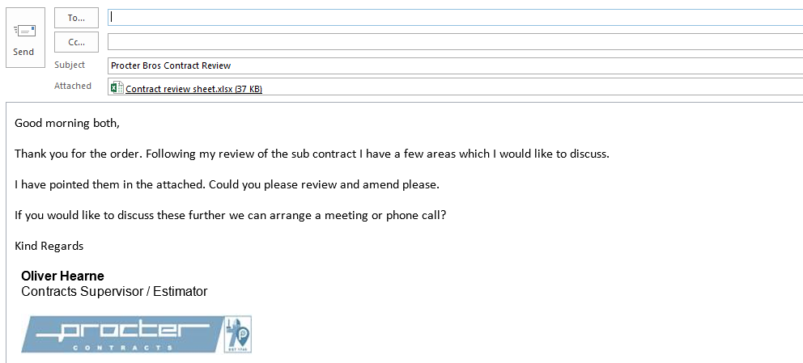

If the client/ customer comes back and refuses to amend the contract then as a company we will have to make a decision on whether we are happy to continue with these issues in the contract and run the risk of it affecting us in the future. Or de we refuse the work due to the risks which may occur with the problems in the contract.
From my learning with my senior contracts manager I have concluded that when we are dealing with regular customers which we have a good working relationship with I am able to let some clauses go pending on the potential risk which I will need to forecast. Also with our regular customers/ clients, this risks carried in the contract will also be reflected in the value of the job. We have discussed that any jobs which are less than £50,000 we have more allowance as we are dealing with less costs. However with anything above the £50,000 I must try everything I can to persuade them to change the clause in the contract to avoid losing the work.
When it comes to dealing with new customers there is a desire to keep them happy as you want them to develop into regular customers who sub-contract lots of work to us. Therefore it is important we do not upset them by claiming there are many issues with their contract. However, as they are a new customer we do not know much from our background check and therefore they could include clauses which put us at risk and therefore we must challenge them. It is a difficult decision but the best interest of the company has to be priority and that is insuring safety when signing onto any contract.

