

University of Wales Trinity of St David:
Ordnance Munitions and Explosives

Academic Year 2024 - 2025

Lewis Gray (2224230)

Safety and Hazard Assessment

Supervisor: Austin Clark

October 2024

Academic Integrity Declaration
I declare that:
- the thesis submitted has been written by me alone.
- the thesis submitted has not been previously submitted to this university or any other.
- that all content, including primary and/or secondary data, is true to the best of my knowledge.
- that all quotations and references have been duly acknowledged according to the requirements of academic research.
I understand that to knowingly submit work in violation of the above statement will be considered by examiners as academic misconduct.

Contents
Academic Integrity Declaration 2
Part 1: Risk Assessment 5
Risk Matrix 5
Assessment of SA80 Service Rifle 5
Part 2: ALARP Justification 7
Introduction 7
Description of Identified Hazard 7
Risk Reductions and Justifications 8
Robust Maintenance Procedures 8
Training 8
Adequate Storage 9
Rejected consideration 9
Conclusion 9
References 11

Part 1: Risk Assessment

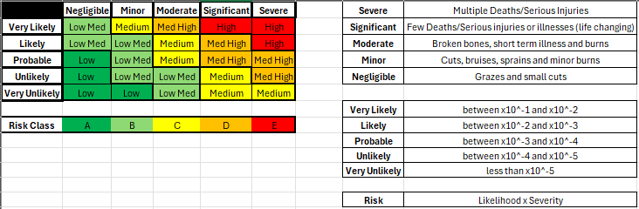
Risk Matrix

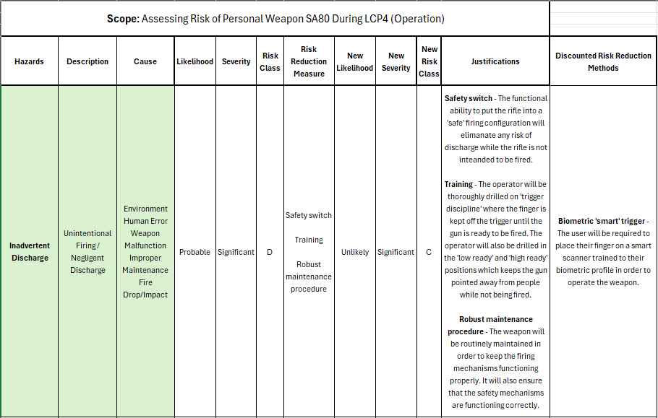
Assessment of SA80 Service Rifle

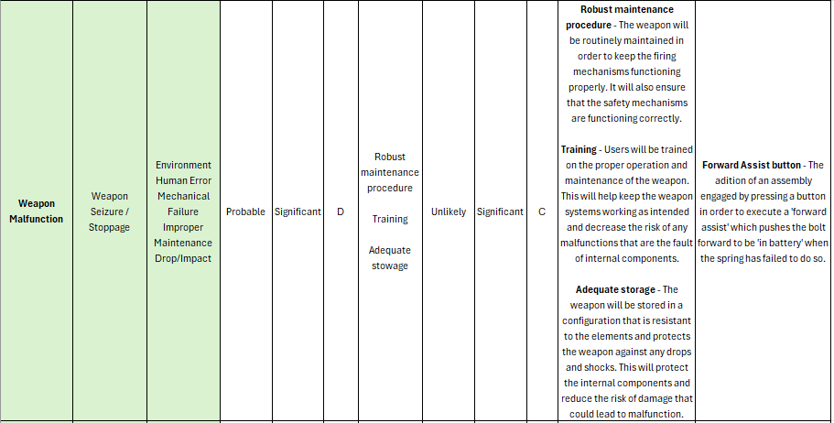

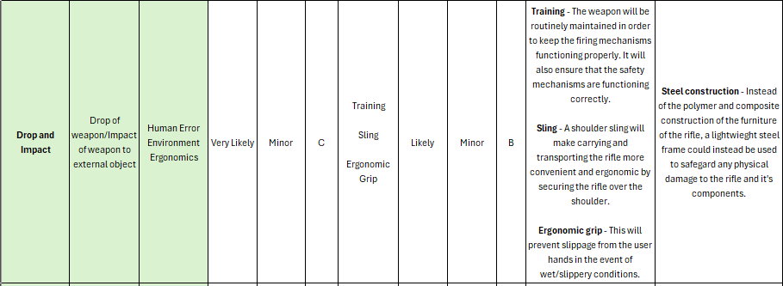

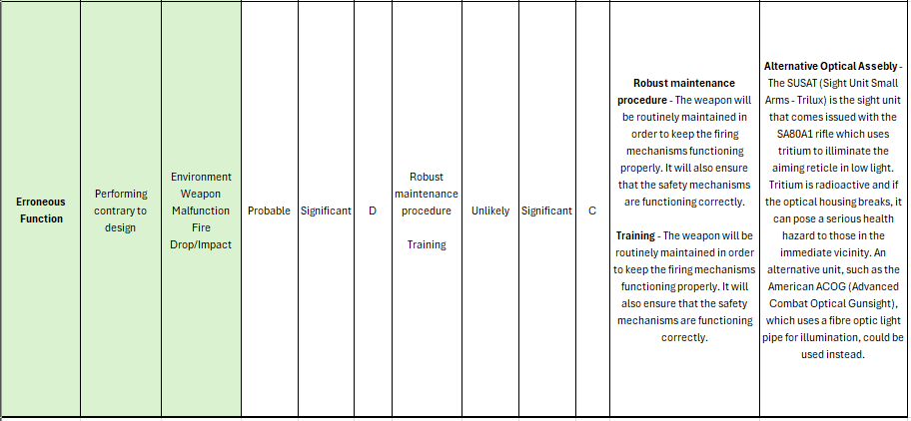

Part 2: ALARP Justification

Introduction
The ALARP (As Low As Reasonably Practicable) justification will be conducted on the malfunction of the weapon due to a range of factors, including but not limited to, the theatre environment in which the weapon is situated in, user error when operating the weapon system, the failure of the weapon’s internal mechanical parts, poor maintenance and the result of a drop and/or impact.

Joint Service Policy (JSP) 815 provides the framework for the Defence industry to ‘deliver its duty of care’ obligations towards those in its employment by establishing a system of assurance in minimising the risks posed to workers by established hazards. These assurance mitigations are carried out in accordance with the three Lines of Defence (LOD) principal in mind. It is also the responsibility of the Defence companies to improve the health and safety of their respective workforces by employing safety measures to reduce the likelihood of injury via an established hazard using the ALARP principal [1]. JSP 185 is compliant with the International Organisation for Standardisation (ISO) document 45001. ISO 45001 is the standard regarding occupational management systems and pertaining to safety and was developed to combat and mitigate any factors that could pose serious reputational and physical harm to the employer and any employees [2]. ISO 45001 has been implemented in over 80 countries across the world [3].

Description of Identified Hazard
The malfunction of a live firearm can have a range of consequences, ranging from health and safety breaches such as misfires and squib rounds, to reputational damage and loss of trust in the manufacturer. A serious weapon malfunction could cause a catastrophic failure in the rifle such as the snapping of the firing pin, which the SA80 was prone to [4], would render the firearm useless and a fault like this being endemic in the design of the weapon would erode the user’s confidence in the platform and the manufacturer. Other aspects of the hazard are more serious and pose a danger to the user and others around them such as squib rounds; where rounds fired from the weapon do not have enough energy to exit the barrel, thus creating a blockage which will cause the next round fired to potentially cause the weapon to blow itself apart in the user’s hands, and ammunition cook off which results in the detonation of a chambered round.

Risk Reductions and Justifications

Robust Maintenance Procedures
In order to prevent any malfunctions with the weapon system, the users will be instructed on to clean and insect their rifles after every use. The close attention paid to key components known to be an issue such as the rifle bolt, firing pin, and any issues with the extractor will help identify faulty and/or damaged parts before they become a risk to the health and safety of the operator.
A robust maintenance procedure will also remove the buildup of foreign materials such as dirt and dust from the rifle housing. The buildup of such materials have been known to cause issues with the trigger blade being prevented from tripping the sear and engaging the hammer to fire a round.
These issues endanger the life of the operator by preventing the proper operation of the rifle and given the jobs of those who carry it, an unreliable rifle has the potential to be a death sentence. By improving the way the equipment is maintained, the reliability can be improved without the need to recall, redesign and reissue the weapons which would cost millions of pounds. Although a redesign would offer better results, a healthier maintenance routine is more convenient and cost-effective to implement.

Training
There are many serious weapon malfunctions that can be brought about due to the improper use of the rifle due to poor training and poor discipline. A ‘cook-off’ occurs when a round chambered detonates from the heat of the chamber after prolonged periods of automatic fire. This phenomenon is most commonly observed in closed bolt automatic weapons, such as the SA80.
It requires that the residual heat of the chamber is conducted through the cartridge case until the kindling point of Nitrocellulose, the most common component in modern propellants, is achieved. It is not particularly difficult to get a rifle chamber to this temperature with prolonged periods of automatic fire as the autoignition temperature Nitrocellulose is relatively low at 170 °C [5].
One way to avoid this is to train operators to avoid prolonged periods of automatic fire which generate the heat needed to cause the autoignition of modern propellants. Operators should be trained to take careful, aimed shots which is aimed at decreasing the rate at which heat builds up in the barrel and avoid cook-offs.

The SA80 also does not feature ambidextrous ejection ports like other modern service rifles such as the German H&K G36. This means that soldiers who are left-handed must learn to operate and fire their weapon with their right hand. This is because spent casing are ejected from rifle on the right hand side and in order to stabilise the gun in a left handed grip, the user’s forearm is positioned in a way that puts it in the path of the casings as they are ejected. These casings are very hot and can cause burns.
While it is practical to implement ambidextrous ejection ports, it is also very expensive as that would require a partial redesign of the rifle’s bolt assembly. It is therefore more than adequate to train left-handed soldiers to shoot with their right, as has been done for decades in the British Army with success at very little additional cost.

Adequate Storage
Protection from environmental factors while in storage is very important in maintaining the reliability of the weapon, which contributes to the safety of the user and those around him. A robust storage container used while in transit that is insulated against extreme temperature changes can help protect the internal components and prevent any unnecessary malfunctions that could be detrimental to the user’s health. Sand, for instance, can choke the rifle and cause it to seize. A robust container, with a strong seal, can protect the rifle while being stored in an operational theatre, so that when the user comes to operate it, it is in a good condition and has not been damaged by the elements.
A good quality gun case can cost around £150 on the civilian market [6], requesting a bulk order as part of a military contract could reduce this number to a more acceptable amount.

Rejected consideration
A common issue with the SA80 is the tendency of the bolt to remain out of battery after being cycled. This is known as ‘out of battery firing’ and can result in severe damage to the weapon system, damaging or destroying key components such as the bolt assembly, firing pin, springs and the receiver assembly. It can also result in severe injury to the operator and those standing in proximity; shrapnel from the rifle can cause serious wounds to the hands, arms, face and even torso of users if the weapon is fired out of battery.
To correct this, a ‘forward assist’ is employed to manually move the bolt forward into battery. On the British SA80, where forward assists are commonly used due to the frequency with which the rifle jammed, the assist was done by striking the charging handle with the left hand. American Armalite rifles, however, use a button located on the receiver assembly to hit the bolt forward so the extractor catches the rim of the casing. This assembly is much more convenient as it does not require the user to take their hand off the grip of the weapon.
It was, however, rejected on the basis that it would be too costly and inconvenient to employ as a complete recall and redesign would be required to implement this system. The current technique used to assist the SA80, while simple, is effective and only requires simple training. The procedure is not complex and is just as effective as the button system.

Conclusion
In conclusion, the implementation of the aforementioned risk reductions in order to maintain risks at a level that is as low as reasonably practicable (ALARP). The introduction of a vigorous maintenance regime will mean the weapons are in a good state of condition which will reduce the risk of weapon malfunction due to the failure of mechanical parts. The specialised training operator will receive on the handling and use of the rifle will help reduce the risk of human influenced failures which can pose a risk to the health and safety of the user and those in the immediate area. Training will help to reduce the risk of squib rounds and cook offs when using the rifle for extended periods of time. The introduction of a robust storage container, resistant to the extremes of operational theatre conditions, will help the weapon remain in good condition while in transit or in storage while in combat zones. Environmental factors such as sand, mud and snow can cause mechanical parts to seize and fail, damaging the trust the user has in the system and also potentially causing injuries.
A button configuration to implement a forward assist was considered but was rejected due to being too expensive to introduce, combined with the simple and effective method already employed to execute the assist on the SA80.

References

[1] | Defence, Ministry of, “Defence Safety Management System SMS Framework JSP_815,” September 2024. [Online]. Available: https://assets.publishing.service.gov.uk/media/66f14a2276558d051527abc6/Defence_Safety_Management_System__SMS__Framework__JSP_815_.pdf#:~:text=ement%20arrangements%20for%20safety%20policy%20are%20laid%20out%20in%20JSP. [Accessed October 2024].
[2] | International Standard for Organisation (ISO), “Occupational health and safety management systems — Requirements with guidance for use,” March 2018. [Online]. Available: https://www.iso.org/standard/63787.html. [Accessed October 2024].
[3] | International Standard for Organisation, “Occupational Health & Safety Management System Implementation (SMS),” [Online]. Available: https://www.iso45001guide.com/#:~:text=Implemented%20in%20more%20than%2080%20countries. [Accessed October 2024].
[4] | O. Steward, “The British SA80 Assault Rifle: Was it ahead of its time?,” UK Defence Journal, 1 January 2018. [Online]. Available: https://ukdefencejournal.org.uk/the-british-sa-80-assault-rifle-was-it-ahead-of-its-time/#comments. [Accessed October 2024].
[5] | PubChem, National Library of Medicine, [Online]. Available: https://pubchem.ncbi.nlm.nih.gov/compound/44263835. [Accessed October 2024].
[6] | “Case Club,” [Online]. Available: https://www.caseclub.com/product-category/case-club-cases/gun-cases/single-rifle-cases/. [Accessed October 2024].

